Physics, Actually

Life, Actually
From the First Cell to the Edited Genome and the Search for Life Elsewhere

A Volume in the Physics, Actually Series

Lothar J. Musiol

Physics, Actually
Life, Actually — From the First Cell to the Edited Genome and the Search for Life Elsewhere

Copyright © 2026 Lothar J. Musiol
All rights reserved.

No part of this publication may be reproduced, distributed, or transmitted in any form or by any means, including photocopying, recording, or other electronic or mechanical methods, without the prior written permission of the author, except in the case of brief quotations embodied in critical reviews and certain other noncommercial uses permitted by copyright law.

This book is intended for general educational and informational purposes. Every effort has been made to ensure the accuracy of the science described; some topics discussed represent active or speculative areas of research, and this is noted in the text where relevant. It reflects published research as of October 2026.

Photographs are credited in the Photo Credits section at the back of the book. Diagrams are original.

First edition.
Physics, Actually series

Table of Contents
Prologue 11
Part I — Chemistry That Learned to Copy
Chapter 1: What Is Life — Schrödinger’s Question and the Order in the Disorder 16
Chapter 2: The Chemistry Underneath — Atoms, Water and the Quantum Rules of Life 24
Chapter 3: How Life Started — Clay, Vents, RNA and the First Protocells 32
Chapter 4: The First Cells — LUCA, Microbes and the Three-Billion-Year Wait 41
Chapter 5: Quantum Biology — Life on the Edge 49
Part II — Darwin’s Machine
Chapter 6: Darwin’s Voyage — How the Big Idea Arrived 59
Chapter 7: Natural Selection — The Algorithm Nobody Wrote 68
Chapter 8: The Modern Synthesis — How Darwin Met Mendel 76
Chapter 9: The Selfish Gene — Evolution From the Gene’s Point of View 82
Chapter 10: Sex — Evolution’s Most Expensive Habit 89
Chapter 11: The Evolution of Niceness — Cooperation, Cheats and Game Theory 97
Part III — The Big Transitions
Chapter 12: The Cell With an Engine — Endosymbiosis and the Eukaryote Revolution 106
Chapter 13: Becoming Many — The Origin of Multicellular Life 114
Chapter 14: The Cambrian Explosion — When Evolution Discovered Body Plans 123
Chapter 15: Evo-Devo — The Genes That Build Bodies 132
Chapter 16: Mass Extinctions — The Reset Buttons 141
Chapter 17: Replaying the Tape — Contingency, Convergence and Whether Evolution Repeats 148
Chapter 18: Arms Races — Coevolution, Parasites and the Red Queen Again 158
Part IV — Us
Chapter 19: Out of Africa — The Human Story 168
Chapter 20: Still Evolving — Evolution You Can Watch 177
Chapter 21: Brains and Instincts — The Evolution of Behavior 186
Part V — Minds, Loops and Machines
Chapter 22: The Strange Loop — Evolution and Self-Reference 195
Chapter 23: Analogy, Language and Culture — Evolution Beyond Genes 203
Chapter 24: Dennett — Darwin’s Dangerous Idea and the Mind in Multiple Drafts 211
Chapter 25: The Mind’s I — Evolution and the Self 219
Chapter 26: Building a Mind — Evolution and AI 226
Chapter 27: The Feeling of Being — Consciousness, Evolution and AI 235
Chapter 28: Robots and AI Right Now — The Precursor to Moravec 244
Chapter 29: Hans Moravec — Mind Children and the Robot Takeover 253
Part VI — The Molecule
Chapter 30: The Tube in the Mailbox — Where the Molecule Comes In 263
Chapter 31: The Eagle, 28 February 1953 — A Shape Announced in a Pub 267
Chapter 32: Photo 51 — Rosalind Franklin’s Picture 274
Chapter 33: What the Shape Explains — Pairs, Twists and the Central Dogma 281
Chapter 34: The Race Before the Race — How DNA Was Shown to Be the Gene 288
Chapter 35: Four Letters — The Alphabet and How It Is Packed 296
Chapter 36: The Chemistry Under the Letters — Bonds, Proteins and Energy 303
Chapter 37: The Copying Machine — Forks, Errors and Ends 311
Chapter 38: From Letter to Protein — The Messenger and the Code 318
Chapter 39: Most of the Text Is Not Genes — Switches, Jumping Genes and Marks 325
Chapter 40: Where Mistakes Come From — Damage, Repair and Mutation 332
Part VII — Inheritance
Chapter 41: Why Theo Has Ruth’s Freckles — How Inheritance Shuffles 341
Chapter 42: Who Gets What — X, Y, and the Mother’s Line 348
Chapter 43: Dominant and Recessive — The Messy Middle and Heritability 355
Chapter 44: What Is Not in the Genes — Environment, Noise and Epigenetics 363
Chapter 45: Brno, 1856 — Peas in a Garden 371
Chapter 46: The Ratios — Mendel’s Counts and Laws 378
Chapter 47: Lost for Thirty-Five Years — Rediscovery and the Birth of Genetics 385
Chapter 48: Flies in a Bottle — Morgan and the Chromosome Theory 392
Chapter 49: Galton’s Shadow — The Eugenics Disaster 400
Part VIII — Reading and Writing the Text
Chapter 50: Cutting and Pasting — Restriction Enzymes and Recombinant DNA 408
Chapter 51: Sanger’s Ladders — The First Way to Read DNA 415
Chapter 52: Copying Without a Cell — The Polymerase Chain Reaction 422
Chapter 53: The Fingerprint — DNA as Evidence 429
Chapter 54: Fast, Cheap and Everywhere — The Sequencing Revolution 436
Chapter 55: Scissors From Bacteria — How CRISPR Became a Tool 443
Chapter 56: The First Cures — Gene Therapy Arrives 451
Chapter 57: Writing From Scratch — Synthetic DNA, Vaccines and Proteins 458
Chapter 58: Reading the Dead — Ancient DNA and the Neanderthals 467
Chapter 59: Dolly, 5 July 1996 — The Sheep From a Single Cell 474
Chapter 60: What a Clone Is and Isn’t — Pets, Livestock and What Goes Wrong 481
Chapter 61: The Human Question — Cloning, Stem Cells and a Lecture in Hong Kong 488
Part IX — Dinner, and the Whole Genome
Chapter 62: Ten Thousand Years of Editing — Domestication and Breeding 496
Chapter 63: The Tomato That Didn’t Rot — The First Engineered Crops 504
Chapter 64: Animals on the Menu — Engineered and Cloned Livestock 514
Chapter 65: What Is Actually Risky — The Real Hazards of Engineered Farming 522
Chapter 66: Three Billion Letters, One Race — The Human Genome Project 530
Chapter 67: What the Genome Turned Out to Say — Gene Counts, Gaps and the Pangenome 537
Chapter 68: Biobanks and the Million — Common Disease at Population Scale 545
Part X — Your Own Text, and the Edit to Come
Chapter 69: The Spit Kit — What a Consumer Test Reads 553
Chapter 70: What a Genome Can Tell You — Risk Genes, Families and Drugs 560
Chapter 71: What It Cannot Tell You — Small Effects and Chance 567
Chapter 72: Who Else Is Reading — Police, Insurers and States 574
Chapter 73: Fixing What Is Broken — Editing Patients 581
Chapter 74: The Line We Said We Would Not Cross — Editing Embryos 589
Chapter 75: Enhancement — Better Humans, and the Accounting 597
Chapter 76: The Next Hundred Years — A Forecast to 2126 604
Part XI — Life Elsewhere
Chapter 77: What Life Needs — Water, Energy and the Short List 614
Chapter 78: The Goldilocks Problem — Habitable Zones and the Planets in Them 622
Chapter 79: Mars — The Planet That Dried Out 630
Chapter 80: Oceans Under Ice — Europa, Enceladus and Titan 638
Chapter 81: Reading Alien Air — Starlight, Biosignatures and the K2-18 b Affair 646
Chapter 82: Listening for Neighbors — SETI and the Search for Technology 654
Chapter 83: Where Is Everybody — The Fermi Paradox and the Great Filter 662
Chapter 84: A Second Genesis — Panspermia, Mirror Life and What One More Example Would Prove 670
Epilogue: Two Tubes 677
Appendix: Core Ideas Worth Keeping 682
Glossary 686
Further Reading 697
Bibliography 701
Photo Credits 708
Index 712
Also by Lothar J. Musiol 1

Also in This Series
Volume 1 — Motion, Forces, Time, and Relativity
Volume 2 — Gravity, Cosmology, and the Limits of Spacetime
Volume 3 — The Standard Model, Chaos, and the Edge of Knowledge

Prologue
On 21 July 2024, a rover on Mars drilled a finger-sized core out of a reddish rock in a dry riverbed, slid it into a titanium tube, and sealed the tube. The rock had odd spots on it, and the spots are the best hint anyone has yet found that something once lived on that planet. Nobody knows when the tube will come back to Earth.
On Earth, in the same years, more than thirty million people spat into plastic tubes and mailed them to laboratories. Each tube held a few hundred thousand cells, and each cell held about six billion letters of a text that had been copied, with small mistakes, for something like four billion years.
Two tubes. One holds a question we cannot yet answer: has life happened anywhere else? The other holds the answer to a question that, for most of history, nobody could even ask properly: what is life, and how does it keep itself going? This book is about both, and about the thread that connects them.

The Thread
Here is the thread, in one sentence. Life is chemistry that copies itself, imperfectly, and lets the imperfections be judged.
Each part of that sentence is a part of the book. The chemistry comes first: why carbon and water, where the energy comes from, and how, about four billion years ago, chemistry that merely happened might have become chemistry that copies. Then the judging, which is Darwin’s machine: copies with mistakes, competing for limited resources, so that the mistakes that work are kept and the rest are lost. Run for billions of years, that machine built cells with engines, bodies, brains, and finally a species that writes books about it, and wonders whether its own minds could be copied into something else.
Then the book opens the copier. In 1953 the molecule that does the copying turned out to be a twisted ladder whose shape explained how it copies itself. Within seventy years, we learned to read its letters, then to cut them, write them, clone them and change them in living patients. The copy is never exact, and now we are learning to correct it.
Last, the book leaves Earth. If life is chemistry that copies itself, nothing in the chemistry says it had to happen only once. The final Part asks what life needs, where in the solar system and the galaxy those needs are met, how we are searching, and what a second, independent beginning would tell us about the first.

What This Book Covers
Part I, Chemistry That Learned to Copy, asks what life is and how it could have started, and follows the first cells through three billion years in which nothing bigger than a microbe existed.
Parts II to IV are evolution. Part II explains Darwin’s machine and how selection, sex and cooperation work. Part III follows the great transitions, from the cell that swallowed an engine to the Cambrian explosion and the mass extinctions that cleared the board. Part IV is our own branch, still being edited.
Part V, Minds, Loops and Machines, asks what a self is, whether one could be built, and what evolution has to say about artificial intelligence.
Parts VI to X are the molecule and what we have done with it. Part VI is DNA itself: its shape, its letters, its copying machine and its mistakes. Part VII is inheritance, from a friar’s peas to a room full of flies, and the dark turn of eugenics. Part VIII is the reading and writing: sequencing, PCR, CRISPR, cloning and the first cures. Part IX follows the editing to our food and to the whole human genome. Part X brings it home: what a test of your own text can and cannot tell you, who else is reading it, and whether we should edit our children.
Part XI, Life Elsewhere, takes the thread off the planet: to Mars, to the buried oceans of the outer moons, to the air of planets around other stars, to the radio silence, and to the question of whether there is anyone else at all.
The Epilogue gathers the thread together. After it come a short list of core ideas, a glossary, further reading, a bibliography of the papers named in the text, and an index.

How to Read This Book
You do not need any biology, chemistry or mathematics. Every technical word is explained the first time it appears, and again in the glossary. The chapters are meant to be read in order, but each one stands on its own, and cross-references point back to where an idea was first explained.
Why is a book about life in a series called Physics, Actually? Because the question was put most sharply by a physicist, Erwin Schrödinger, in 1943, and because the answers keep turning out to be physics: energy flowing downhill, molecules held together by quantum rules, light carrying the fingerprints of the gases it passed through. The earlier volumes explain that physics in depth. This one shows what it builds.
Where the status of a claim matters, I say which of three things it is. Settled: measured, repeated, and used every day. Working: the best current account, with real gaps. Speculative: allowed by what we know, not shown. Most of this book is settled. The last chapters of Parts V, X and XI are not, and say so. Where I give my own opinion, I mark it as mine.
Three people appear from Part VI onward: Ruth, born in 1948, her daughter Anna, born in 1978, and Anna’s son Theo, born in 2011. They are invented. Their freckles, their tolerance for milk and their arguments at the kitchen table are there so that the mechanisms have somewhere to happen.
Gene names are in italics (BRCA1); the proteins they encode are not (the BRCA1 protein). Prices are in United States dollars and carry a year. The science reflects published research as of October 2026, and where a story was still moving at that date, as several in Part XI are, the text says so.
None of the people who did this work were trying to write one story. Schrödinger did not know about the double helix, Darwin did not know about genes, and the engineers who built the Mars rovers were not thinking about spit kits. But it is one story. It begins about four billion years ago, with molecules that started making copies of themselves.
↑ Back to Contents

PART I
Chemistry That Learned to Copy
Before there was evolution there had to be something to evolve. This Part looks for the line between chemistry and life, and for the moment, about four billion years ago, when a molecule first made a copy of itself.

Chapter 1: What Is Life — Schrödinger’s Question and the Order in the Disorder

A Question Everybody Can Answer Until They Try
Ask a child what is alive, and you get a fast, confident answer. The dog is alive. The rock is not. The tree is alive too, though it feels like a quieter kind of alive, since it does not move or do much. Ask a biologist the same question, and you get a pause instead. Then a list. Then an argument about the list. That pause does not mean biologists are slow. It means the question is harder than it looks.
The honest answer takes an entire book to draw out fully. This is that book.

Definitions Fail at the Edges
Every tidy definition of life has a border. And something always lives right on that border, refusing to fit cleanly on either side. Take a virus, a tiny package of genetic instructions wrapped in a protein shell. A virus has genes. It evolves. It reproduces. But it does nothing at all by itself. Outside a cell, a virus is just a package of chemicals, waiting for a ride.
Now take fire. Fire eats fuel, grows, spreads, and makes more fire. Nobody thinks fire is alive. But it is oddly hard to say which item on a life checklist fire actually fails. A crystal grows and copies its own pattern, atom by atom, over and over. A mule is unquestionably alive, yet a mule almost never manages to reproduce.
A frozen embryo can sit still for years, doing nothing, and then, once thawed and warmed, grow into a person. A dormant seed, one that has not sprouted yet, can wait a thousand years before it finally grows, longer than most countries have existed. So yes, the edges are messy. That messiness is not a failure of biology. It is a hint about what life actually is.

The Definition That Works Well Enough
People who search for life on other planets need a definition that travels well beyond Earth. They usually settle on one sentence. Life is a self-sustaining chemical system capable of Darwinian evolution. In plain words: chemistry that keeps itself running, and that can change over generations in ways that get passed down. It is not poetic. It is useful. Notice what this definition leaves out. It does not mention cells, DNA, water, carbon, or even Earth. It just says: chemistry that keeps itself going, and chemistry that can evolve.
With that in hand, every strange border case sorts itself out. A virus is part of a larger evolving system. But it cannot sustain itself alone. So it sits right at the edge, which is exactly where it feels like it belongs. Fire sustains itself, but it does not evolve. A big fire is not the descendant of a smaller, better fire that came before it.
A crystal copies a pattern. But it cannot copy a mistake in a useful way. It cannot make the next crystal different, and then better. That last point, about mistakes that can become improvements, is the deep one. We will come back to it.

The Physicist Who Asked
In 1943, a physicist gave three public lectures in Dublin about biology, a field that was not his own. His name was Erwin Schrödinger, a physicist who had already won a Nobel Prize. He won it for an equation describing how tiny particles, like electrons, behave. He is also the physicist behind a famous thought experiment about a cat that gets imagined as both alive and dead at once, just to show how strange those particle rules become once you scale them up to something the size of a cat.
His three Dublin lectures became a short book in 1944, called What Is Life? Schrödinger knew almost nothing about biology, in the professional sense. That gap in his knowledge turned out to be his advantage. He asked the plain questions a physicist would ask. And two of his guesses turned out to be spectacularly good.

Order Bought With Disorder
Schrödinger’s first puzzle came from thermodynamics, the branch of physics that deals with heat, energy, and disorder. The second law of thermodynamics says that, left alone, everything drifts toward disorder. Hot coffee cools down. Tidy rooms get messy. Sandcastles crumble into sand. A living thing looks like it is breaking that law. An egg becomes a chicken, and a chicken is far more organized than an egg ever was.
You have kept roughly the same shape for years. In that time, more molecules have passed through your body than there are stars in the visible universe, by a wide margin. Schrödinger’s answer: life does not break the second law. Life pays for its order instead. An organism takes in low-entropy energy, meaning energy that is still neatly organized and usable, such as food, sunlight, or chemical fuel.
Entropy is just the measure of disorder, so “low-entropy” means “not yet scattered.” The organism then exports disorder back out, as heat and waste. The total disorder of the universe still goes up, exactly as the law demands. Locally, inside your skin, order is maintained. The bill for that order gets paid outside your skin. Schrödinger put it memorably: an organism feeds on negative entropy, his term for usable order.
A modern physicist would phrase it a little differently today. But the picture still holds up. Life is an island of order, floating in a universe that is slowly running down. That island exists only because a river of energy keeps flowing through it. Stop the river, and the island disappears within minutes.

The Guess That Beat the Evidence by Nine Years
Schrödinger’s second puzzle was heredity, the passing of traits from parent to offspring. How can a molecule inside a single cell store enough instructions to build an entire human being? And how can it store those instructions so stably that they survive for generations? In 1944, nobody yet knew what genes were actually made of. Many scientists suspected proteins. DNA was considered too boring for the job, dismissed as a repetitive filler molecule.
Schrödinger reasoned it out from physics instead of biology. A crystal is stable, he noted, but an ordinary crystal just repeats the same pattern: sodium, chloride, sodium, chloride. A pattern that only repeats contains almost no information. What heredity needed was something as stable as a crystal, but not repetitive. He called this hypothetical molecule an aperiodic crystal, a stable structure whose pattern never repeats.
In 1953, the actual structure of DNA was finally published. DNA turned out to be a long, stable molecule whose sequence never repeats, and that sequence carries information. In short: an aperiodic crystal, just as Schrödinger had guessed nine years earlier. James Watson and Francis Crick, the two scientists who worked out DNA’s structure, both later said Schrödinger’s little book had helped pull them toward the problem.
A physicist, guessing in the dark, had described the shape of the answer before anyone had switched on the light.

The Checklist
Biology textbooks still teach a checklist for what counts as life, and it is worth knowing. A living thing has a boundary: something that separates its inside from the outside world. It has a metabolism: it takes in energy and matter, and puts them to use. It keeps itself steady, a trick biologists call homeostasis. Homeostasis means holding your temperature, acidity, and chemistry within safe limits, even while the world outside keeps changing. It reproduces. It passes on heredity, meaning the copies resemble the parent. And it evolves: over generations, the copies change, and the changes that help tend to stick around. That is six items in total.
The first five describe a machine that maintains itself and copies itself. The sixth describes something different: a process that, given enough time, can produce every other item on the list. That is why evolution is the deepest entry on the checklist. Boundaries, metabolism, and heredity are all things evolution built. Evolution is the only item on the list that builds anything at all.

A Process, Not a Substance
Here is the idea that will do the most work in this whole book. Life is not a substance. There is no vital ingredient hiding inside you, no spark, no special fluid. Every atom in your body is an ordinary atom, the same kind found in rocks and air. Most of those atoms were not part of you a few years ago.
Many will not still be part of you a few years from now. So what persists is not the matter itself. What persists is the pattern, and the pattern survives only because it keeps running. Think of a candle flame. A candle flame holds its shape for hours, even while wax and oxygen flow through it and turn into gas and heat.
Nothing in the flame stays put. The flame itself stays. A whirlpool in a river works the same way. It is made of water, but never the same water twice. It is a shape that the flow keeps recreating. Life is like that, with two extra features. The pattern carries instructions for making more of itself. And those instructions can change over time.

Why “Chemistry That Evolves” Is the Real Line
Picture two beakers side by side. In the first, chemicals react, form interesting structures, and then settle down. In the second, chemicals react and form structures that go on to make more structures just like themselves. That second beaker is still not alive. Not quite. Now let the copying get slightly imperfect. Some copies come out a little different from the original.
Some of those different copies happen to copy faster, last longer, or grab more raw material than the rest. Those lucky variants become more common over time. Their descendants inherit the useful trick, and add their own tricks on top. At that exact moment, and not one second before, the second beaker crosses the line into life. It has gone from chemistry that merely happens, to chemistry that copies, varies, competes, and evolves.
Every later marvel, cells, eyes, wings, brains, and yes, books about brains, is simply what this process produces when left alone for about four billion years, most of the Earth’s 4.5-billion-year history.

Why the Edges Stop Bothering Us
With this definition in hand, the border cases from earlier finally sort themselves out. A virus is a fragment of a larger evolving system that has outsourced its metabolism to a host cell. A mule is a full member of an evolving lineage, one that happens to be a dead end. Dead ends like that are common: most individuals of most species never end up reproducing.
A frozen embryo is simply a paused process. The pattern inside it is intact. The river of energy is just temporarily dammed. Fire is a process that cannot store, or improve, a recipe. A crystal is a pattern that cannot make a useful mistake. None of these cases needs a special ruling anymore. The definition was never about what a thing is made of. It was about what a thing does, and whether it can get better at doing it.

Nobody Was Trying
One warning belongs here, because you will need it on nearly every page that follows. When we say useful changes become more common, it is tempting to hear a plan behind it. There is none. Evolution has no foresight, no goal, and no idea what happens next. A change sticks around because it worked, in the one situation where it happened, and for no other reason.
Everything in this book that looks designed, and a lot of it will, was actually assembled by a process that was only ever trying to survive to the next generation.

The Sentence the Book Runs On
The Prologue promised that one sentence would carry the whole book, and this chapter has now earned it. Life is chemistry that copies itself, imperfectly, and lets the imperfections be judged. Every Part that follows is one view of that sentence: the chemistry in the rest of Part I, the judging in Parts II to IV, its strangest product in Part V, the copier itself and what we have done with it in Parts VI to X, and, in Part XI, the question of whether the same chemistry has started anywhere else.
The chapters ahead are short. The ideas inside them are not.

The Punchline
Schrödinger asked a physicist’s question, and got two things right that biologists had not yet found on their own. Life pays for its order by exporting disorder somewhere else. And heredity is written into a stable molecule whose pattern never repeats. What he could not have known was how far that second answer would reach. Once a molecule can be copied, with occasional mistakes, something new happens.
Those mistakes get judged, quietly, by whether they help or hurt. At that point, the universe gains a genuinely new kind of thing in it. Not a new substance. A process that keeps its own recipe, and keeps editing it. Everything alive today is that same process, still running. Right now, you are reading this with a copy of that recipe in every one of your cells.
The recipe is about four billion years old, older than nearly everything on Earth except the planet itself. It has never once been finished.
↑ Back to Contents

Chapter 2: The Chemistry Underneath — Atoms, Water and the Quantum Rules of Life

Six Letters
Take any living thing, dry it out completely, and weigh what is left. Almost all of that weight comes from just six elements. Carbon, hydrogen, nitrogen, oxygen, phosphorus, and sulfur. Biologists shorten this list to CHNOPS. It sounds like a breakfast cereal, and it is easier to say than it looks. There are traces of other elements too. Iron in your blood.
Calcium in your bones. Magnesium in every leaf. Sodium and potassium keeping your nerves firing. But six elements are the frame of the whole building. None of them is rare. None of them is special. Hydrogen is the most common atom in the entire universe. Carbon and oxygen were cooked up inside stars, then scattered into space when those stars died.
Life did not need exotic ingredients. It needed ordinary ingredients, arranged in an extraordinary way.

Why Carbon
A chemical bond is a link that holds two atoms together, something like a handshake made of shared electrons. Carbon can make four of these handshakes at once. That single fact does most of the work in this section. An atom with only one bond can join one partner, a handshake that ends the meeting. An atom with two bonds can make a chain, one link after another.
An atom with four bonds can make chains, branches, rings, and even cages, in almost any combination. It never runs out of new shapes. Carbon also strikes a balance that few atoms manage. Its bonds are strong enough to survive at the temperatures where water stays liquid. They are weak enough to be broken and rebuilt by the gentle chemistry inside a cell.
Silicon sits one row below carbon on the periodic table, the chart chemists use to organize the elements. It also has four bonds to offer. Writers have long dreamed of silicon-based aliens for exactly that reason. But silicon bonds to oxygen so eagerly, and so permanently, that the result is rock, not living chemistry. Carbon bonded to oxygen, by contrast, is carbon dioxide: a gas that drifts away and can be captured again later.
Living chemistry needs building blocks that can be assembled, taken apart, and reused, over and over. Carbon is exactly that kind of building block.

The Solvent That Is Also a Tool
Chemistry needs somewhere to happen, some liquid to mix and move in. For life on Earth, that place is water. A water molecule is lopsided. One end, the oxygen, carries a slight negative charge. The other end, two hydrogens, carries a slight positive one. Chemists call this polar, meaning a molecule has a positive side and a negative side, like a tiny magnet with two poles. That lopsidedness lets water molecules cling to each other with weak attractions called hydrogen bonds.
Hydrogen bonds are why water stays liquid at temperatures where similar small molecules turn to gas. They are why ice floats, so ponds freeze from the top down, and life underneath survives the winter. They are why water dissolves salts, sugars, and most of the small molecules a cell needs to carry around. And they produce one more effect, one that quietly builds every cell that has ever existed.

Oil, Water, and the Trick That Makes Membranes
Some molecules have a head that likes water and a tail that does not. Drop enough of them into water, and something happens without anyone giving an instruction. The tails hide from the water. The heads face outward, toward it. The molecules line up into a double layer, tails pointing inward, heads pointing outward. The whole layer then curls up into a closed bubble. That bubble is a membrane, a thin wrapper that separates an inside from an outside.
Nobody assembled it by hand. Water did it, by pushing the oily tails together, an effect called the hydrophobic effect, from a word that simply means “water-fearing.” Every cell in your body is wrapped in a membrane built by exactly this trick. Chapter 1 opened with a checklist for what counts as alive. A boundary separating inside from outside was the first item on that list. That boundary comes free, just from the physics of water.

Energy Is Electrons Moving Downhill
Life needs energy, so it helps to be precise about what that word means here. At the chemical level, energy is released when electrons move downhill. They move from a place that holds them loosely to a place that holds them tightly. Burning wood is the familiar version. Electrons that start out on the carbon and hydrogen in the wood end up on oxygen instead.
The difference comes out as heat and light. Chemists call this kind of electron transfer redox, short for “reduction and oxidation.” A fire does the whole transfer in one uncontrolled burst. A cell does the same overall reaction, sugar plus oxygen. But it breaks that reaction into dozens of small steps, each one handing electrons a little further downhill. You are burning sugar right now, as you read this.
You are just doing it so slowly, and so carefully, that nothing catches fire.

Small Change
A cell cannot spend a big release of energy all at once. That would be like trying to buy a coffee with a gold bar. It needs small change: energy broken into small, spendable amounts. The small change of every known cell is a molecule called ATP. Making one ATP molecule costs energy. Breaking it apart again releases a modest, convenient amount. That is enough to move a muscle protein one notch. Or to pump one ion across a membrane, or add one link to a growing chain.
A resting human turns over roughly their own body weight in ATP every single day. Not by storing that much. By making it, spending it, and making it again, thousands of times over for every single molecule. The chemistry that captures energy from food, or from sunlight, exists mostly just to keep that ATP supply topped up.

Shapes Do Jobs
The workhorses of a cell are proteins. A protein is a chain of smaller units called amino acids, strung together like beads on a string. There are twenty kinds of amino acid beads in the standard set. A typical protein uses a few hundred of them, strung in an order that the cell’s genes specify. The chain does not stay a chain, though. It folds.
Water pushes the oily amino acids inward and the water-loving ones outward, the same trick that builds membranes. Often within a fraction of a second, faster than you can blink, the chain collapses into one particular shape. The shape is the whole point. A protein shaped like a pocket can hold one specific molecule, the way a lock holds one specific key.
A protein shaped like a tube can let one kind of ion through, and no other. A protein shaped like a lever can change shape when something binds to it. That change can then move something else in turn. Muscles, pumps, sensors, structural beams, signals, and the machines that copy genes: all of these are proteins. Which is to say, they are all just folded shapes doing jobs.

Lowering the Hill
Most useful chemical reactions do not just happen on their own, even when the energy is downhill. There is a hill in the way: an energy barrier the molecules have to climb before they can fall. Left alone, sugar and oxygen can sit together for years without reacting. A protein that lowers that hill is called an enzyme. It holds the reacting molecules in exactly the right position. It strains exactly the right bond and shields exactly the right charge.
The reaction that would have taken years now takes a fraction of a second. Enzymes are the reason a cell can run thousands of reactions at body temperature. It runs them in the right order, all at once, without cooking itself. A few enzymes, it turns out, may lower that hill with a stranger trick, one worth its own chapter later. They may let a particle cheat through the barrier instead of climbing over it.

Lightning in a Bottle
In 1953, a graduate student named Stanley Miller tried something audacious. He wanted to cook up the origin of life in a flask. He built the apparatus with his advisor, Harold Urey, a Nobel Prize-winning chemist. One flask held water, standing in for the ocean. Another held methane, ammonia, and hydrogen: gases that scientists at the time thought made up Earth’s early atmosphere.
Miller boiled the water and sent the vapor past electrodes that sparked like tiny bolts of lightning. Then he let everything cool and drip back down. After one week, the water had turned brown. Inside it were amino acids, the same building blocks of proteins described above. They had formed from nothing but simple gases and a spark of electricity.
The experiment became famous, and it earned that fame. It showed that the molecules of life are not hard to make. Ordinary chemistry, given a bit of energy, produces them on its own. Later work even found amino acids inside meteorites. That confirmed this same chemistry happens out in space, not just in a Chicago lab. What Miller’s experiment did not show matters just as much. It did not make a cell. It did not make anything that could copy itself. And the real early atmosphere was probably less generous than the gas mixture he guessed at.
Miller answered the question of ingredients. He left the question of assembly wide open, and the next chapter will show just how open it still is.

The Quantum Floor
Underneath all of this sits quantum mechanics, the rulebook for how matter behaves at the tiniest scales. An atom’s electrons do not circle the nucleus the way planets circle the sun. Instead, they occupy fuzzy, cloud-like regions called orbitals, regions whose shapes and energies are fixed by quantum rules. A chemical bond, remember, is just two atoms sharing electrons in an orbital that spans both of them.
The four bonds of carbon, the lopsidedness of water, the folding of proteins, the height of every energy hill. All of it is quantum mechanics working out its consequences. Chemistry is simply what quantum mechanics looks like at the scale of molecules. So in a trivial sense, everything a cell does is quantum. That sentence is true. It is also almost useless.

“Everything Is Quantum” Proves Nothing
Here is the trap. Because atoms are quantum, it is tempting to say that life is quantum as well. It is tempting to say the same about consciousness, or about anything mysterious in biology. But a brick is quantum too. Its atoms obey exactly the same rules. Nobody explains why a wall stands up by reaching for quantum physics; ordinary engineering already explains it just fine.
At the scale of a whole cell, most quantum strangeness washes out. Molecules bump, jostle, and trade heat with their neighbors incredibly fast. Delicate quantum effects are the kind where a particle briefly seems to be in two places at once. Those effects usually get scrambled before they can matter. That is why chemists can predict most of biology using rules that never mention quantum mechanics at all.
The rule this book will keep is simple. Finding quantum mechanics underneath a biological process proves nothing on its own, since quantum mechanics is underneath everything. The interesting claim is narrower. It says a specifically quantum effect changes something a living thing does. And that effect is one ordinary physics could never copy.

The Question We Are Leaving Open
That narrower claim is where things get interesting. Could a living thing actively exploit quantum mechanics? Not merely stand on it, the way a brick does, but actually put it to use? Could an enzyme let a proton sneak straight through an energy barrier, instead of climbing all the way over it? Could a plant steer sunlight’s energy using quantum coherence? That is a fragile state where a particle briefly acts like it is taking several paths at once.
Could a bird read Earth’s magnetic field using a chemical compass built from the spin of electrons? Spin is a tiny quantum property each electron carries, like a built-in arrow. Those are real proposals, backed by real experiments, and some rest on firmer ground than others. This book will come back to them in Chapter 5, the chapter built entirely around that question. But first, there is a harder question standing in the way.
We now have the ingredients. Six elements, a solvent that builds its own containers, an energy currency, folded machines, and a floor of quantum rules. That is chemistry that merely happens. The next chapter asks how any of it became chemistry that evolves instead.

The Punchline
Nothing inside you is exotic. Just six common elements. A solvent that happens to be lopsided. Electrons rolling downhill in careful steps. Chains that fold themselves into tools. Given energy, ordinary chemistry makes the building blocks all by itself. A graduate student showed that in one week, with nothing but gas and a spark. What ordinary chemistry does not do by itself is assemble those blocks into something that keeps, and copies, its own recipe. That is the gap between a brown flask of amino acids and a living bacterium. It is the largest gap in this whole book. And we are about to walk right up to its edge.
↑ Back to Contents

Chapter 3: How Life Started — Clay, Vents, RNA and the First Protocells

The Problem Is Not “Making a Cell”
Picture the first life on Earth. You probably imagine a tiny, simple cell. A membrane, some chemicals inside, a little genetic material. Maybe something that eats and copies itself. It sounds simple. It is not. It needs a boundary to hold itself together. It needs chemistry that can capture or use energy. It needs molecules that can copy themselves, or at least pass traits to offspring. And all of that has to work together, so the package can reproduce and change over time. That is the origin-of-life problem, in one sentence.
One useful thing to unlearn: the first living thing was not a miniature modern bacterium. Modern cells are stunningly complicated, with transport proteins, molecular machines, ribosomes (the cell’s protein factories), and genetic systems. So researchers usually talk instead about protocells: simpler compartments holding some early chemistry that could copy or evolve. Think of a protocell as a soap bubble that happens to hold some useful chemistry. It does not need to look like a modern cell. It only needs to be a plausible bridge to Darwinian evolution, where useful traits get copied more than useless ones.
In the lab, the biochemist Jack Szostak and his colleagues have built bubbles like this from simple fatty acids, and watched them grow by absorbing more fat and split in two under gentle stirring.

The RNA World and Its Gaps
The RNA-world hypothesis is famous, and for good reason. RNA can store information, like DNA. Some RNA can also speed up chemical reactions, like a protein. But “RNA world” describes a stage in early evolution, not a full explanation of how life began. It just pushes the hard question one step back. Where did the first useful RNA come from?
How did its building blocks form and link into chains, and how did copying even begin? And how did such a fragile molecule survive? Copying is the sharpest of those gaps. A primitive RNA molecule needs a way to build a new one from itself as a template. Modern biology handles this with sophisticated enzymes. The prebiotic world, the chemistry that existed before life did, had none of those yet.
Researchers have made progress with enzyme-free copying and with ribozymes, RNA molecules that act like enzymes. But building a robust, general, self-copying system under realistic conditions remains a major open challenge. Suppose you finally have a molecule that copies itself and it works. But evolution immediately hands you a new problem. What if a shorter molecule gets copied by the machinery the original built, without doing any of the work? That is a molecular parasite.
In the 1960s, the biologist Sol Spiegelman watched exactly this happen in a test tube. He gave a viral RNA molecule the enzyme that copies it, and kept transferring a sample into fresh tubes. Within about seventy-four rounds, the RNA had shrunk from roughly 4,500 letters to around 220, because short versions got copied faster. It had thrown away everything except what the copying enzyme needed to grab it.
Evolution rewards whatever reproduces the most, full stop. Keeping molecules together in a compartment can help, by separating cooperators from competitors. So a membrane may matter not just as a container, but as what makes cooperation possible.

Could the Earth Have Been the Chemist?
Ordinary clay looks about as lifeless as anything could look. Yet certain clay minerals have huge microscopic surfaces, covered in chemically active spots. Molecules can stick there, get concentrated, and get held in useful positions. Reactions that struggle in watery, dilute conditions can happen more easily on a mineral surface. That raises a possibility: maybe early life did not begin in a warm soup, and the rocks helped organize it instead.
One clay mineral has drawn attention: montmorillonite. Its surfaces can help link nucleotides, the building blocks of RNA, into longer, RNA-like chains. In the 1990s, the chemist James Ferris and his colleagues used it to grow chains around fifty links long, starting from activated single nucleotides. Instead of scattered nucleotides bumping into each other by chance across an ocean, the mineral gives them a place to gather.
“Clay can help build RNA-like chains” has real support, but “clay created life” remains a far bigger, wide-open claim. But suppose clay really does help build long molecules. Now what? A working genetic system needs more than random long molecules. It needs information, copying, variation, and a way to stay together instead of drifting apart. A mineral surface can organize chemistry, but a surface is not a living, reproducing thing.
Ask how that chemistry becomes Darwinian, and the same old difficulty returns. Some ideas focus on crystals and their repeating structures. A crystal can grow, develop small flaws, and copy those flaws as it grows. Maybe mineral structures once acted like early information carriers. Crystals naturally make ordered patterns, but heredity, passing traits to the next generation, needs something far more flexible than a repeating lattice.
Life needs variation that can be copied accurately, while still leaving room for evolution. A beautiful pattern is not the same thing as a genome, an organism’s genetic instructions.

Life From the Deep
Hydrothermal vents are cracks in the seabed where water meets and reacts with hot rock. Some vents supply hydrogen, carbon dioxide, minerals, and chemical gradients. Certain modern microbes run on reactions between hydrogen and carbon dioxide that resemble vent geochemistry. In 2000, researchers found a field of pale chimneys on the mid-Atlantic seafloor, some as tall as an eighteen-story building, built by warm, alkaline fluid rather than scalding black smoke. They named it the Lost City, and it became the model for a whole family of origin-of-life ideas.
A vent can provide a natural chemical gradient, a difference in chemistry between two nearby places. Think of a battery: it works because of a chemical difference between its two ends. A vent creates something similar, on a geological scale. Temperature, acidity, and chemistry can differ sharply across a distance smaller than your hand. And life is very good at exploiting exactly this kind of difference.
Hot environments can build molecules and destroy them at the same time. Some vent settings are so hot that complex molecules fall apart almost as fast as they form. So different ideas now focus on different vents, including cooler, less acidic ones. The key point: “hydrothermal vents” is not one laboratory. It is a huge family of environments, with different temperatures, minerals, and chemistry.
Vents are not the only energy source on offer. Sunlight could have driven early chemistry too. Even wet-dry cycles, puddles that dry out and refill, can drive reactions by concentrating and diluting molecules. There is no single accepted energy source here. Different scenarios lean on different environments. Imagine dropping one teaspoon of sugar into the Pacific Ocean, the largest ocean on Earth.
Good luck ever finding it again. Prebiotic chemistry runs into a similar problem. Many useful reactions only happen at high enough concentrations. The early Earth was probably not one giant warm pond with exactly the right ingredients in the right amounts. So researchers look for environments that concentrate molecules: mineral surfaces, tiny rock pores, ice, evaporating pools, wet-dry cycles, hydrothermal structures.
The environment itself may have been part of the chemistry.

Metabolism, Peptides, or Membranes First?
Maybe life began as a network of reactions that could capture energy and build useful molecules. No DNA. No RNA genome. No hereditary molecule tucked inside a membrane. If that network became self-sustaining, and later copied its own organization, heredity might have shown up afterward. Researchers call this a metabolism-first approach. A chemical network that sustains itself is impressive, but how does it evolve?
Natural selection needs variation that can be inherited. If a network stumbles onto a better reaction but cannot copy that improvement, the advantage disappears again. Metabolism can supply energy and useful chemistry. But genetics is what preserves information. So metabolism and heredity may need to link up, and that link is one of the hardest steps. Proteins are extraordinary catalysts, substances that speed up reactions without being used up.
Modern enzymes can speed up reactions by a factor of millions, sometimes far more, turning the near-impossible into the routine. So maybe short peptides, small chains of amino acids, played an early role. They are chemically simpler than modern proteins, and some can form under plausible early-Earth conditions. But building one depends on an elaborate translation system, the cell’s machinery for reading genetic instructions. That machinery is itself built from proteins and RNA. So this story still has to explain how useful peptides appeared before that machinery existed.
Maybe the first important step was not heredity at all. Maybe it was lipids, the fatty molecules that make up membranes. Some simple lipid-like molecules have a striking property: one end loves water, the other end hates it. Put enough of them in water, and they spontaneously form tiny bubbles called vesicles. But this container creates a new problem. It has to let useful molecules in, keep them from leaking out, grow, and eventually split.
A good modern cell membrane is an excellent barrier. But the first protocell had no protein channels or pumps to control what crossed it. Too tight, and its chemistry could never get ingredients from outside. Too loose, and everything useful would leak straight back out. The protocell needed a membrane that was somehow sealed and easy to cross, at once.
Researchers have made progress on pieces of this, but the full jump to a self-reproducing protocell is still unsolved. Say you have finally built a vesicle. Now it has to reproduce. A modern cell has machinery that coordinates exactly when the membrane grows and splits. A primitive protocell cannot assume any of that exists. It has to grow its own boundary, split in two, and share whatever sits inside between both daughters.
Building a membrane, in other words, was only the beginning.

Everything Needs Everything Else
Here is the nightmare: genetic information needs an environment where it can be copied. That environment probably needs catalysts, which themselves need genetic information to become sophisticated and get passed on. A membrane helps hold this together, but the membrane needs chemistry to grow and divide. That chemistry needs energy, so the system needs a way to capture it. And the whole arrangement needs to reproduce well enough for natural selection to take over.
No single piece is impossible, but getting them all working together before evolution can fine-tune them is the hard part. Life is not just a chemical reaction that keeps running. It is a system that holds onto information. DNA is an extraordinary molecule for storing that information. RNA can store sequence information too, and speed up reactions besides. But the first information-carrying system never got billions of years of evolution to refine it, the way DNA has. That is a much harder problem than simply making organic molecules, which turn out to be everywhere.
Heritable organization, information that can be copied and passed on reliably, is the hard part. Or picture two primitive molecules. Molecule A helps build molecule B, and B helps build A. Together, they thrive; apart, they fail. But selection can also favor selfish molecules that exploit the arrangement without contributing back, just as Spiegelman’s shrinking RNA did. This is why research increasingly looks at networks of cooperating molecules, rather than one magical molecule that suddenly became alive.

The Threshold That Mattered
Maybe life did not begin through one clean mechanism. Maybe mineral surfaces helped concentrate and link molecules. Maybe hydrothermal vents supplied energy and gradients. Maybe wet-dry cycles helped build long polymers. Maybe simple membranes created the first private compartments. Maybe RNA-like molecules eventually supplied heredity. Maybe peptides and small helper molecules assisted along the way. Each piece could have developed separately and only later been brought together.
The origin of life may have been an assembly of many small pieces, not one miraculous event. At some point, something extraordinary happened. Chemistry became capable of Darwinian evolution. Once you have heritable information, variation, and unequal reproduction, natural selection can take over. That changes everything. Before evolution, every useful improvement has to arise purely by accident. After evolution begins, successful systems accumulate improvements, generation after generation. This may be the real threshold that mattered.
The first “life” did not need to look alive. It needed to become capable of evolving. The first evolving system may have looked nothing like a modern bacterium. Maybe it was a leaky little vesicle. Maybe a messy mixture of short polymers. Maybe a chemical network clinging to a mineral surface. Maybe simply a handful of molecules cooperating with each other.
The word “cell” may actually hide what really happened. The important moment was probably not a perfect membrane appearing. It was chemistry, compartments, energy, and heredity starting to reinforce one another.

What We Know, and What We Do Not
This is not because scientists are short on ideas: there are almost too many. RNA world. Metabolism first. Lipid world. Clay minerals. Hydrothermal vents, hot and alkaline. Wet-dry cycles. Ice. Peptide-first scenarios, and combinations of all of these. Each idea explains some pieces of the puzzle. Each one runs into its own difficulties. And the hardest part is not showing a reaction can happen once in a lab. It is building a believable, continuous path from ordinary rock-and-water chemistry to a population of evolving protocells. Not solving the puzzle does not mean we know nothing.
We know many organic molecules can form on their own, with no help from life. We know minerals can concentrate and speed up chemistry. We know simple, soap-like molecules can spontaneously assemble into compartments. We know RNA can store information and speed up reactions, and that hydrothermal vents create powerful chemical gradients. What we do not know is how these separate pieces became one self-sustaining, evolving process.
Chapter 2, which looked at the quantum rules hiding inside ordinary chemistry, asked whether life can put quantum mechanics to work. Could quantum effects have mattered before there was any life at all? Quantum mechanics governs atoms and molecules everywhere, inside a living cell or drifting in a volcanic pool. Tunneling lets particles slip through barriers they could never cross by ordinary rules, and can influence how protons and electrons move. So the question is whether any specific quantum effect was crucial to that jump into evolving life. And that is one reason the origin-of-life problem connects so neatly to the physics explored elsewhere in this book.

One Last Look at the First Cell
Picture the very first thing that could be called alive. It may have had no DNA. No proteins. No sophisticated membrane. No metabolism in the modern sense. No eyes, and no brain. No idea it was on its way to becoming us. Maybe it began as chemistry clinging to a mineral surface. Maybe inside a warm vent, a drying puddle, or a vesicle. But at some point, something had to cross the great divide. It had to stop being chemistry that merely happens, and start being chemistry that evolves. That is the real miracle: not building a modern cell, but building the first system evolution could finally take hold of. And that problem is still very much alive.
↑ Back to Contents

Chapter 4: The First Cells — LUCA, Microbes and the Three-Billion-Year Wait

The Oldest Fossils Are Not What You Expect
There are no bones from the very beginning of life. There are mats instead. In a few shallow, sunlit spots on Earth today, colonies of microbes still build layered mounds called stromatolites. A stromatolite is basically a microbe apartment building, growing one thin, sticky floor of trapped sand at a time. Rocks in Western Australia hold fossils of the same kind of mound. They are about three and a half billion years old.
Picture Earth’s whole history squeezed into one calendar year. On that scale, these mounds appear around late March. This is the strongest evidence we have for early life. It is a humble kind of evidence: not a creature, just the layered mess creatures left behind. There are older, shakier hints. Some carbon trapped in rocks nearly four billion years old carries a chemical signature that living things tend to leave.
Scientists call it an isotope fingerprint. Scientists still argue about those older hints. Rocks that ancient have been baked and squeezed so hard that ordinary chemistry might explain the signature too, with no life involved. So here is the honest, careful summary. Life was on Earth by three and a half billion years ago, and maybe earlier. Earth itself is about four and a half billion years old. So life got started early, almost as soon as the planet cooled enough to allow it.
Then, for a very long stretch, nothing about it changed much that you could actually see.

Meet Your Ancestor, Who Was a Crowd
Every living thing on Earth shares the same genetic code, the same basic gene-reading machinery, and the same energy currency. That is a strange kind of sameness. It has one good explanation. We all descend from one common ancestor. Biologists have a name for that ancestor: LUCA, short for the last universal common ancestor. Two corrections matter right away. First, LUCA was not the very first living thing. It was only the most recent ancestor shared by everything alive today.
Earlier life-forms existed too, but they left no descendants, the way most family lines eventually die out. Second, LUCA was not one individual, like a person or even a single cell. It was a population: a whole community of cells swapping genes and competing with each other. One lineage of that community’s machinery happened to be the one that survived into everything alive now. So think of LUCA not as a single starting ancestor, but as an entire village. And that village already had an impressive toolkit. It almost certainly had genes made of DNA. It had proteins built from the same building blocks every cell still uses. It had ribosomes, the cell’s protein-building machines, to construct those proteins. And it had a membrane wrapped in the machinery needed to make energy.
In short, most of life’s basic tools were already invented before the tree of life split into separate branches.

The Fingerprint
Why are scientists so confident about one common ancestor? Because of arbitrary choices that every living thing shares. Here is what that means. The genetic code is the cell’s rulebook. It maps three-letter chunks of DNA to specific amino acids, the small building blocks that link up to make proteins. There is no chemical law forcing any one chunk to mean any one amino acid.
The assignment could have gone many other ways. It is a convention, the same way driving on the right side of the road is a convention, not a law of physics. Every organism on Earth follows the same convention, give or take a few minor local dialects. If life had started from scratch twice, independently, you would expect two different rulebooks.
We find only one. The same pattern shows up in the ribosome’s building blocks and in which direction DNA gets read. It also shows up in which mirror-image version of certain molecules life uses. Life could have made each of these choices in many different ways. It only made them once.

Three Domains, Read From One Molecule
For most of the twentieth century, biologists split cells into two simple groups: those with a nucleus, and those without one. A nucleus is a small sealed compartment inside a cell that holds its DNA. In the 1970s, a microbiologist named Carl Woese, the scientist who rewrote life’s family tree, tried something new. Instead of just looking at cells under a microscope, he looked deeper. He compared one molecule that every single cell has: the RNA at the core of the ribosome. Then he counted up the differences between organisms.
The result rewrote the whole tree of life. It turned out there were not two great branches, but three. The first branch is bacteria. The second is archaea, said “ar-KEY-uh.” Under a microscope, archaea look like bacteria. But in their inner machinery, they turn out to be just as different from bacteria as either group is from you. The third branch is eukaryotes, cells built around a nucleus.
Every animal, plant, and fungus is a eukaryote, along with plenty of single-celled organisms too. For years, other biologists resisted Woese’s three-branch tree. Today it is the standard map of life. It also holds a surprise, one this book returns to later. The eukaryote branch, the one your own cells belong to, did not simply grow bigger over time. It was assembled, built by merging separate pieces together.

The Tree Is Also a Web
Ordinary trees follow one rule: branches split apart, and they never rejoin. Microbes break that rule all the time. A single bacterium can pick up a gene from a neighboring cell, from the leftover debris of a dead cell, or from a virus. It can then pass that borrowed gene on to its own descendants. Biologists call this horizontal gene transfer, meaning genes moving sideways between organisms instead of straight down from parent to offspring. This is exactly how antibiotic resistance spreads from one bacterial species to another inside a hospital. And it has been happening for billions of years.
Deep in the past, when cells were simpler and their machinery less specialized, this kind of gene swapping was probably everywhere. So the base of the tree of life is not one clean trunk. It is more like a web: a tangle where different lineages traded parts freely. The three domains gradually emerged from that tangle, instead of splitting cleanly from a single stem.
Remember that village of cells from a few pages back, the one we used to picture LUCA? That was not just a convenient metaphor. It is roughly what the actual evidence shows.

The Battery Every Cell Runs On
Chapter 2 called the cell’s energy currency ATP, the small molecule that pays for nearly everything a cell does. How a cell makes it is one of the strangest discoveries in biology. In the 1960s the British biochemist Peter Mitchell proposed that cells pump protons, the positively charged cores of hydrogen atoms, across a membrane, then let them flow back through a tiny turbine that builds ATP as it spins. The idea seemed so odd that it took about ten years to be accepted. Chapter 36 takes the turbine apart.
What matters here is how old the trick is. Bacteria run it across the skin of the cell. Plants run it inside their chloroplasts, the solar-powered factories in every leaf cell. You are running it right now, in the mitochondria of every one of your cells. Every branch of the tree of life uses it, so the last common ancestor very likely did too. It may be as old as life itself. That is one reason origin-of-life researchers pay so much attention to alkaline vents on the ocean floor.
Those vents produce natural proton gradients, just like the ones early cells learned to use.

The First Pollution Disaster
For roughly its first billion years, life ran on chemical fuel seeping out of rocks and vents. Then some bacteria learned a new trick: using sunlight directly. The earliest sunlight-users were modest. A later group was not. A kind of bacteria called cyanobacteria evolved a way to split water apart using light. They kept the hydrogen for themselves and threw away the oxygen as waste.
Oxygen, to them, was just garbage. But to almost every other living thing at the time, it was poison. For a long while, the planet quietly absorbed that garbage. Dissolved iron in the oceans rusted solid and sank to the seafloor. That left the banded layers of red rock that mining companies still dig up today. Then the planet’s rust-buckets filled up.
Around two point four billion years ago, oxygen began piling up in the atmosphere itself, with nowhere left to soak it up. Geologists call this the Great Oxidation Event. It was the biggest change any form of life had yet made to the chemistry of an entire planet. It was probably a disaster for most of the microbes alive at the time.
Among the survivors were some that learned to use oxygen instead of hiding from it. Burning food with oxygen releases far more energy than the older, chemical-fuel methods ever could. Every large, active, warm-blooded animal that has ever lived, including you, runs on the exhaust from that ancient pollution disaster.

Who Actually Runs the Planet
It feels natural to picture the living world as mostly animals and plants, with a few microbes lurking in the background. The actual numbers say the opposite. A single gram of ordinary soil, about the size of a raisin, holds roughly a billion bacteria. Your own body carries roughly as many bacterial cells as human cells, most of them living quietly in your gut.
By total weight, bacteria and archaea together outweigh every animal on Earth combined, many times over. And that is before counting the microbes living deep underground in solid rock. Down there, microbes may make up a huge share of all life on the planet. Microbes also run the chemistry that keeps everything else alive. They pull nitrogen out of the air and turn it into a form plants can actually use.
Later, they hand that nitrogen back to the air again. They break dead things back down into raw materials. They also produce a large share of the oxygen you breathe, quietly, out in the open ocean, where nobody sees it happen. Microbes sit at the hinge of every cycle that keeps Earth’s surface livable. Animals, by comparison, are a recent decoration on top of all that.

Why Complexity Waited
Here is a puzzle that a later chapter will answer. Life appeared quickly, within the first billion years of Earth’s history. Then it stayed microscopic, too small to see, for roughly the next three billion years. Bacteria and archaea are astonishingly inventive chemists. Given three billion years, they tried out nearly every way of making a living that chemistry allows.
What they never did, in all that time, was get big. They never built the large, complicated cells that make animals and plants possible. As far as anyone can tell, that step happened only once, and it happened late. Chapter 12 will make the case that the holdup was energy. A bacterium simply cannot afford the enormous genome a complex cell needs.
The eventual fix was not a clever invention, but a merger between two different cells. For now, one plain fact is enough. The longest chapter in the history of life is the one where almost nothing seemed to happen.

The Physics Inside
Picture yourself shrinking down and stepping inside one of those early cells. Protons are being pumped across a membrane only a few billionths of a meter thick. That is thinner than anything you could actually picture. Electrons are being passed from one molecule to the next down a chain, like a bucket brigade. Each handoff releases a little burst of energy.
Enzymes are lowering the energy barriers in the way. That lets reactions run smoothly, even at the mild temperature of ordinary pond water. Every single one of those events is, underneath it all, governed by quantum mechanics. Quantum mechanics is the strange rulebook that governs matter at the smallest scales. An earlier chapter warned against reading too much into that fact.
Nearly everything is quantum mechanical if you zoom in far enough, so that alone proves nothing special. But there are specific moments where the quantum rules might do more than sit quietly in the basement. An electron changing hands, a proton making its jump, a pigment molecule catching a single particle of light. They might actually be part of the working machinery. That is the question the next chapter takes up.

The Punchline
Life on Earth started early, and it stayed small for a very long time. For most of the planet’s history, the only living things were cells too small to see. They were not idle. They invented the machinery every later organism still relies on: the genetic code, the ribosome, the proton battery. They swapped genes back and forth across a web, instead of passing them straight down a simple tree. They learned to eat sunlight and accidentally poisoned the whole world with oxygen. Then they learned to breathe the very poison they had made. They still run the planet’s chemistry today, and they always will. That village of cells we all descend from left behind no monument, no statue, no single grave.
Just one thing: everything alive, including you.
↑ Back to Contents

Chapter 5: Quantum Biology — Life on the Edge

Could Life Be Using Quantum Mechanics?
Biology looks reassuringly ordinary. Cells, proteins, membranes, birds, plants. Everything about life seems warm, wet, and a little messy. That seems like the last place to find quantum mechanics. Quantum mechanics is the rulebook for how atoms behave, often in strange ways. It sounds like something you need a lab for. Picture a vacuum chamber, a laser, and equipment chilled colder than outer space. So here is the surprising question: could living things actually be using those strange quantum rules to do something useful? That question is the whole adventure of quantum biology, the young science trying to answer it.
Johnjoe McFadden and Jim Al-Khalili, a molecular biologist and a physicist, ask exactly that question. Their 2014 book, Life on the Edge, is one of the best-known introductions to this idea. Their claim is not that a cell is secretly a giant quantum computer. It is something more modest and interesting. Some biological processes may depend on real quantum effects.
Those effects only need to survive for a moment, in the right place, to change what the organism does. If that is true, quantum mechanics is not just a quiet foundation sitting underneath biology. It is part of the machinery biology actually runs on.

Warm, Wet, and Noisy
Quantum effects are famously fragile. A physicist in a lab can isolate a quantum system with extraordinary care, keeping it cold and still. A cell does the exact opposite. It is warm. It is wet. It is packed with molecules bumping into each other, many times every second. Everything is vibrating. Everything is jostling everything else. All that jostling can wreck quantum coherence, the delicate state where a quantum effect stays in sync long enough to matter. So why would evolution ever get to use quantum mechanics?
The answer: a quantum effect does not need to survive everywhere in the cell. It only needs to survive for an instant, in the right spot, to matter. Noise is not always the enemy, either. Sometimes a noisy environment helps a system move energy efficiently through a complicated molecular landscape. Sometimes ordinary heat-driven jostling assists a chemical reaction rather than ruining it.
Sometimes the environment itself decides which quantum states end up mattering most. So the relationship between quantum coherence, noise, and what a cell does is subtler than you might expect. It is not simply a case of quantum good, environment bad.

Tunneling: The Particle Cheats
Picture a ball rolling toward a hill. If the ball does not have enough energy to get over the top, ordinary physics says it stays on this side. Quantum mechanics allows a strange loophole. A particle can have a small but real chance of appearing on the other side of the hill. This is called quantum tunneling. It works as though the particle briefly cheats. It pops up on the far side of a barrier it never had the energy to climb.
For tiny particles such as electrons and protons, tunneling can matter enormously. And biological molecules are full of these small energy hills. Enzymes are the proteins that make chemical reactions in your cells happen dramatically faster. They are not tiny mechanical motors pushing atoms around. They reshape the surrounding energy landscape, making a hard chemical step much easier. In some reactions, quantum tunneling helps move a proton or an electron through an energy barrier.
Classical physics says that jump should be harder to make. This is one of the most solidly tested areas of quantum biology. The chemist Judith Klinman and others showed it by swapping ordinary hydrogen for heavy hydrogen, which carries an extra neutron. Heavier particles tunnel far less easily. In one enzyme from soybeans, the swap slows the reaction about eighty times, far more than ordinary chemistry predicts, and tunneling explains the gap.
The quantum effect here is not some giant wave spanning the whole enzyme. It can be one small quantum event at exactly the right spot. Protons are heavier than electrons, so on their own they tunnel less easily. But biological reactions can be extremely sensitive to when and how a proton moves. If a proton can tunnel through a barrier instead of climbing over it, that changes how fast the reaction runs. That change can matter enormously to an enzyme trying to do its job.
A tiny quantum shortcut at the molecular level can turn into a large effect on your whole metabolism. Metabolism is just the sum of all the chemical reactions keeping you alive.

Mutation Gets Quantum
Copying DNA is remarkably accurate. Yet mutations happen anyway. One proposed reason, first suggested by the Swedish physicist Per-Olov Löwdin in 1963, involves quantum tunneling of protons sitting inside DNA’s base pairs, the rungs of its famous double-helix ladder. A proton can, in principle, tunnel into a slightly different position for a moment. If that altered arrangement gets copied before the proton tunnels back, the mismatch can turn into a mutation. This is an intriguing idea. But let’s be honest about where the evidence stands.
Quantum tunneling in chemistry is on very solid ground. How much it drives mutation rates in living cells is still an open research question. Chapter 40 returns to it, with the calculations that revived the idea in 2022.

Light, Caught and Passed Along
Plants have solved an astonishing engineering problem. They capture sunlight. They pass that captured energy through a chain of molecular structures. Eventually they use the energy to build sugars and fuel the rest of the plant. Some of those in-between handoff steps may involve quantum coherence and quantum motion. The point is not that a leaf is quietly running a quantum calculation. It is that quantum effects may change how efficiently light energy moves through the plant’s solar-collecting machinery.
Nature never needed to understand quantum mechanics. Evolution only needed to keep whatever happened to work. A quantum system can exist in several possible states at once, something physicists call a superposition. Coherence is what lets those different possibilities stay “in step” with each other, long enough to interfere. Interference boosts some outcomes and cancels out others. In 2007, a team led by Graham Fleming at Berkeley fired ultrashort laser pulses at a light-harvesting protein from green sulfur bacteria, chilled to about minus 196 degrees Celsius. They saw signals that looked like energy sampling several paths at once, in step.
How much that coherence matters under everyday biological conditions is still being worked out. Later experiments, run closer to room temperature, suggest the effect is briefer and smaller than the first excited headlines claimed. Seeing a quantum effect somewhere doesn’t prove evolution chose it on purpose for a specific job.

The Robin’s Compass
Picture a bird flying thousands of miles to a place it has never seen. There is no road, no sign, and no satellite telling it where to turn. And yet the bird holds a steady sense of direction the whole way. Part of the trick is that some birds can sense the Earth’s magnetic field. One leading explanation involves light-sensitive proteins in the eye called cryptochromes.
Inside them, a chemical reaction can create two linked molecules. Each one carries an electron spin, a tiny quantum property a bit like a microscopic compass needle. These two linked partners are called radical pairs. The Earth’s magnetic field can nudge how those two linked spins behave over time. That nudge can change the pair’s chemical outcome, which can then reach the bird’s nervous system.
The bird may be using quantum spin chemistry as a built-in compass. The best evidence comes from European robins. In 2014, researchers in Oldenburg, Germany, found that caged robins lost their sense of direction when exposed to faint electrical noise from the city, the kind of weak radio-frequency interference a classical compass would ignore. Shielding the huts restored it. That is exactly the kind of fragility a radical-pair compass predicts. This is one of the most beautiful bridges from quantum physics to animal behavior. It is tempting to call the bird a quantum computer. That phrase is misleading.
A living system can use a quantum effect without acting anything like a programmable quantum computer. A compass needle does not need to run the elaborate calculations that make quantum computers special. A bird does not need a quantum processor tucked inside its skull. Evolution can borrow one useful quantum trick, spin-dependent chemistry, without turning the whole animal into a quantum computing lab.

The Smell Problem
Smell seems like it should be simple. A molecule floats into your nose. Receptors there respond to it. Your brain announces the result: “Coffee.” But how do those receptors tell apart molecules that have almost identical shapes? One controversial idea suggests something different. Maybe some smell receptors respond not just to a molecule’s shape, but also to how its atoms vibrate.
Quantum tunneling might even help sense that vibration. This is known as the vibrational theory of smell. The biophysicist Luca Turin championed it in the 1990s. In 2011, fruit flies were shown to tell apart two versions of a molecule that differ only in their hydrogen, which changes how they vibrate but not their shape. Tests with people, though, have given mixed results. It is a fascinating idea, but far less solidly established than several other examples in this chapter.

The Standard of Proof
Here is one of the most important rules in this whole book. Finding quantum mechanics somewhere inside a living thing does not prove that biology is using it. Atoms, molecules, and chemistry itself are all quantum, so simply saying “biology is quantum” proves almost nothing. The real question is narrower and harder. Is this particular quantum effect doing a specific job that evolution actually selected for? That is the standard this chapter tries to hold itself to. So why do we need a separate field called quantum biology at all? Because the question changes.
Quantum chemistry asks how quantum mechanics explains the shape of molecules and how they react. Quantum biology asks something bolder: are these quantum effects actually doing a job the organism needs? That is a much bigger claim to prove. A living thing does not need to keep its entire body in one giant quantum superposition. That would be spectacularly difficult, maybe impossible. Instead, evolution may exploit tiny quantum effects locally, one small event at a time.
A proton tunnels. An electron’s spin shifts. A molecular excitation stays coherent for a brief moment. A chemical reaction takes a slightly different path than expected. That tiny difference can change the very next biochemical step. And biology is remarkably good at amplifying small effects into large, visible outcomes. Natural selection has no particular fondness for tidy, classical explanations. If a molecule works better because of quantum tunneling, organisms carrying that molecule can simply reproduce more successfully.
If a quantum spin effect improves a bird’s navigation, selection can preserve it without anyone designing it on purpose. If a photosynthetic complex moves energy more efficiently because of its quantum behavior, that advantage can stick around too. Evolution never stops to ask, “Is this quantum?” It only ever asks one question: “Does it work?” A beautiful theoretical mechanism is never enough on its own.
Scientists need careful measurements, run under conditions that resemble a living cell, with ordinary non-quantum explanations ruled out first. They need to know whether the quantum effect is big enough, and lasts long enough, to matter. And ideally, they need to show that changing the effect changes the biological outcome. That is how quantum biology turns into real biology, instead of quantum-flavored storytelling.

Could Quantum Mechanics Have Helped Create Life?
Maybe quantum mechanics did not just become handy after life appeared. Maybe it helped build the first chemistry capable of becoming alive. This idea is more speculative than anything else here. The origin of life involves chemistry, self-copying, information, tiny enclosed compartments, energy flow, and evolutionary selection: a lot of moving parts. Chapter 3 walked through several ways this could have started.
There is no single accepted quantum theory of how life began. But quantum mechanics still governs every molecule involved. The open question is whether one specific quantum effect was not just present, but essential. Could tunneling, electron movement, or some other quantum trick have helped build the first reaction networks able to copy themselves? Possibly. Right now, that is still an open research question, not a solved problem.
Life is not merely chemistry. It is chemistry organized around information: instructions that get followed, copied, and passed on. Quantum mechanics sits underneath every part of this. But here is a deeper question: could quantum information itself have played a role in how biological information first got going? That question alone could keep researchers busy for a very long time.

One Last Photon
The great strength of Life on the Edge is the question it pushes readers to ask. Physics and biology are not separate universes running on separate rules. Biology is made of matter. Matter, at bottom, is quantum. The exciting frontier is finding exactly where biology does something that specifically depends on quantum behavior. That’s different from just being made of quantum stuff by default. That research program carries a wonderful implication.
The weirdness of quantum mechanics may not be something nature carefully hides from living things. Life may have simply learned to use it. Even so, resist the temptation to turn every mystery of life into quantum magic. Some quantum effects in living systems, like tunneling inside enzymes, are well established. Others, like coherence in photosynthesis and the bird’s compass, are plausible and under active investigation.
Some popular claims go further than the evidence currently supports. And the deepest question of all, how life first began, remains unsolved. So the right conclusion is not “quantum mechanics explains life.” The better, more honest conclusion is this: quantum mechanics may be one more tool evolution found lying around and learned to use. A photon, a single particle of light, arrives.
A molecule absorbs it. An electron changes state. An excitation moves. A proton tunnels. A chemical bond changes. A cell responds. A bird changes direction. A plant stores energy. A mutation appears. Somewhere in that chain, quantum mechanics may stop being just chemistry’s hidden foundation. It may become part of biology’s own machinery. The boundary between the quantum world and the living world may be less sharp than we thought.
Life may not simply sit on top of physics, the way a house sits on its foundation. Life may be one of the astonishing things physics itself does, once matter gets organized in just the right way. And maybe the deepest lesson of quantum biology is wonderfully simple. Nature never drew a line between the rules of physics and the rules of life.
We did.
↑ Back to Contents

PART II
Darwin’s Machine
Once something copies itself with mistakes, a machine starts running that nobody built. Darwin found it. This Part explains how it works, why it needed particles of heredity, and why it produced sex and kindness as well as teeth.

Chapter 6: Darwin’s Voyage — How the Big Idea Arrived

A Young Man Who Was Not Going to Be a Doctor
Charles Darwin was sent to Edinburgh at sixteen to study medicine. He lasted two years. The lectures bored him. The operations horrified him even more — in the 1820s, doctors had no anesthetic, so patients felt every cut. He walked out of one operation, on a child, and never went back. His father was a large, stern doctor. He decided his son cared about nothing but shooting, dogs, and hunting rats, and would embarrass the family.
The next plan was the Church. Darwin went to Cambridge to train as a country parson. In the 1820s, that was a respectable way to spend your life collecting beetles on the side. And collect beetles he did — a great many of them. One day he had a beetle in each hand when he spotted a third one he wanted. He popped one of the first two into his mouth to free up a hand. It squirted something foul, he spat it out, and he lost both that beetle and the third one. He also grew close to a botany professor named John Stevens Henslow.
Henslow was a mentor who taught him how to really look at a plant. They walked together so often that other students started calling Darwin “the man who walks with Henslow.” That friendship would end up changing the world. Henslow was asked to recommend a young naturalist for a sea voyage, and he named Darwin.

The Voyage
The ship was HMS Beagle, a small British navy vessel heading to South America to map its coastline. Its captain, Robert FitzRoy, wanted an educated gentleman on board who could talk science with him during the long trip. He also wanted company — the Beagle’s previous captain had shot himself, worn down by the isolation of command. Darwin was twenty-two.
His father objected, worried it was a waste of time. An uncle talked him round. The Beagle sailed in December 1831 and did not come home until October 1836. Five years at sea. Darwin was seasick for most of that time. So whenever the ship reached land, he got off it. He rode across the grasslands of Argentina, climbed in the Andes mountains, and dug up fossils of giant extinct mammals. He was not hunting for a theory. He was simply looking at everything he could.

What He Actually Noticed in the Galápagos
The Beagle reached the Galápagos Islands in September 1835 and stayed five weeks. The popular story says Darwin looked at the islands’ finches and noticed their different beaks. In that story, he understood evolution right there on the spot. Evolution is the idea that species change into new species over long stretches of time. That version was tidied up later, partly by Darwin himself, telling the story looking back.
At the time, he did not even label which island each finch had come from. He had to reconstruct that afterward, using other collectors’ specimens. What actually struck him were two other animals: mockingbirds and giant tortoises. The mockingbirds clearly looked different from island to island. So did the tortoises. Their shells were so distinctive that the islands’ vice-governor, their local administrator, could tell one island’s tortoise from another. He could look at a shell and instantly name its island.
Darwin wrote in his notebook that if these facts held up, they would undermine the idea that species stay fixed forever. The unsettling thought was not that the islands had strange animals. It was that each island had its own version of the same animal. It was as if one ancestor had arrived long ago and then been reshaped differently on each island.

Deep Time
On the voyage, Darwin read a geology book by Charles Lyell, a British geologist, published volume by volume as the ship sailed. The book was called Principles of Geology. Lyell’s big idea was simple. Ordinary forces — rivers, waves, earthquakes, volcanoes — could reshape the whole Earth, given enough time. Darwin saw proof of this himself. In Chile, he stood on a beach that an earthquake had lifted several feet into the air just two weeks earlier. He also found beds of seashells high up in the Andes mountains. They were left there, he realized, from back when that land was under the sea.
Mountains could rise an inch at a time and still end up thousands of feet tall. So what else might slow, tiny changes add up to, given enough time? Lyell had handed Darwin the one ingredient every version of evolution needs. Time. Not thousands of years. Millions of years — enough for very small changes to build into something enormous.

The Spark
Back home in England, Darwin sorted through his collections and filled notebook after notebook. He now had several puzzle pieces. Species varied from place to place. Islands each had their own version of the same animal. The Earth was old enough for slow change to matter. What he still lacked was a mechanism — a reason why varieties would actually change, instead of just wandering at random.
In the autumn of 1838, Darwin read a book for fun. Its author was the economist Thomas Malthus, a clergyman who wrote about population growth. Malthus’s point was blunt and mathematical. Populations grow faster than their food supply. Far more babies are born, of any species, than can possibly survive. Something has to keep the numbers in check, and that something is a constant struggle just to survive.
Darwin instantly saw what this meant for animals and plants. Far more offspring are born than can survive. And the ones who do survive are not a random sample — they are the ones slightly better suited to their surroundings. That means every generation acts like a filter. Helpful variations get kept. Unhelpful ones get weeded out. He wrote later that he finally had a theory to work with.

Twenty Years in a Drawer
Then he did nothing with it for twenty years. Not quite nothing. He wrote the idea out in 1842, and again in 1844. He even left instructions for his wife to publish that second essay if he died before finishing his work. Then he put it away in a drawer. He spent eight years studying barnacles, small shelled sea creatures that stick to rocks and boats. He became the world’s leading expert on a group of animals that almost nobody else cared about.
Partly, he did this to earn the right to be taken seriously on the bigger question of species. He bred pigeons. He wrote letters to breeders, gardeners, and naturalists all over the world. He gathered facts the way he had once gathered beetles: obsessively. Why the long delay? Historians still debate the exact reasons. He knew the idea would upset people, and he was a cautious, anxious man, married to a devoutly religious wife. He wanted his case to be airtight before he published it. And for much of this time he was sick, with symptoms doctors still cannot fully explain.
Whatever the real mix of reasons, he might have delayed forever. Then a letter arrived.

The Letter From the Other Side of the World
Alfred Russel Wallace was fourteen years younger than Darwin, self-taught, and poor. He made his living by collecting animal specimens in the tropics and selling them to collectors back home. He worked first in the Amazon rainforest, where the ship carrying almost everything he had gathered caught fire on the way home. Then he worked in the Malay Archipelago, islands in what is now Indonesia and Malaysia.
In 1858, Wallace lay sick with fever on a small island there. He thought about Malthus too — he had read the same population book. He landed on the very same idea Darwin had. He wrote it up in just a few days and mailed it to the one scientist he thought would appreciate it most. Darwin. Darwin opened the envelope in June 1858.
Inside, he found his own theory, written out in someone else’s handwriting, with a request to forward it to Lyell. He wrote to Lyell that Wallace’s essay was uncannily close to his own. If Wallace had somehow read Darwin’s unpublished 1842 essay, he could not have written a better short summary of it. Lyell and the botanist Joseph Hooker, an expert on plants, worked out a compromise.
Wallace’s paper and pieces of Darwin’s older, unpublished writings would be read out together. The reading happened at the Linnean Society of London, a scientific society for naturalists, on the first of July, 1858. Neither man showed up. Wallace was still overseas in the tropics. Darwin was burying a son who had just died of scarlet fever. The society’s president summed up the year’s events. He remarked that it had not been marked by any striking discoveries. It was one of the most wrong predictions in the history of science.

One Long Argument
Darwin now worked fast. On the Origin of Species came out in November 1859. Booksellers snapped up the entire first printing on the first day it was offered. Darwin called the book “one long argument.” It is, and the whole argument can be boiled down to five lines. Individuals within a population vary from one another. Some of that variation gets passed down to offspring.
Far more offspring are produced than can survive to have offspring of their own. The individuals whose variations suit them better to their surroundings tend to leave more descendants. So, generation after generation, populations change. Given enough time and enough divergence, new species arise from old ones through what Darwin called descent with modification. None of those five lines is surprising by itself.
Darwin’s real achievement was noticing that, put together, they form an engine. He then spent nearly five hundred pages proving it. He showed that this one engine explains things naturalists had been cataloguing for a century. It explains why animals fit their surroundings so well. It explains why related species resemble each other. It explains the pattern of fossils and the geography of where species live. It even explains the leftover, seemingly useless body parts that many animals carry.
The word “evolution” does not appear anywhere in the first edition. The closest Darwin came is the book’s very last word: “evolved.” Darwin preferred the phrase “descent with modification.” It is more precise: it says exactly what happens, instead of just naming the result.

What He Did Not Know
Darwin’s engine had two missing parts, and he knew it. First, he did not know how heredity, the passing of traits from parents to children, actually worked. Like most people at the time, he assumed a child inherited a blend of both parents’ traits. Picture it like mixing two paint colors together. A sharp critic pointed out the problem with that.
Blending would dilute any new, helpful variation down to nothing within just a few generations. It would vanish long before it could do any good. Darwin never found a good answer. The real answer was sitting, already published, in an obscure journal, in a paper about pea plants. Chapter 8, on the monk who counted pea plants and the birth of modern genetics, will open it up. Second, Darwin did not know how old the Earth actually was.
The physicist William Thomson, later given the title Lord Kelvin, did the math. He calculated how fast a hot planet like Earth should cool down. His estimates kept shrinking, until he settled on a few tens of millions of years. That was far too short a time for Darwin’s slow, gradual engine to have done its work. Kelvin was wrong. He had no way of knowing that the Earth has its own internal heat source, or that its interior slowly churns, carrying heat upward far better than his math assumed. That source is radioactivity, energy released by naturally decaying atoms, and it keeps the planet warm far longer than plain cooling allows.
The true age of the Earth is about four and a half billion years. Picture shrinking all of Earth’s history down into a single calendar year. On that scale, the dinosaurs do not show up until mid-December. Our own species arrives only in the last half hour before midnight on December 31st. In Darwin’s own lifetime, though, the physicist had the numbers on his side.
The naturalist had only a hunch that those numbers had to be wrong. Darwin was right. It took another fifty years to prove it.

What Happened Next
People often describe the reaction to On the Origin of Species as a battle between science and religion. There was some of that. But the more interesting reaction happened among scientists themselves. Within a decade or two, most biologists accepted that species really had evolved from earlier species. Far fewer of them accepted natural selection as the reason why. Natural selection means that whichever individuals happen to be best suited to their surroundings survive and reproduce more. It seemed too weak, too slow, and too dependent on a missing theory of heredity that nobody yet had.
Rival explanations sprang up instead. Some scientists imagined inner drives pushing species toward perfection. Others thought habits picked up during life could be passed straight to children. Others imagined sudden, unexplained jumps between species. By the early 1900s, natural selection was so out of favor that one German writer published a book titled At the Deathbed of Darwinism. Historians now call this stretch the eclipse of Darwinism. It recovered — but not until the 1920s and 1930s. That is when mathematicians combined it with the rediscovered pea-plant experiments you will meet in Chapter 8.
The point for now is this: the idea did not win because Darwin announced it. It won, eventually, because it kept explaining things better than any rival could.

The Evolutionary Punchline
A young man who had failed at medicine and drifted toward the Church ended up sailing around the world. He went because a lonely captain wanted company. He noticed that each island had its own kind of mockingbird. He read a geologist and learned that the Earth was old. He read an economist and learned that most of what is born must die before it can reproduce. He put those three facts together and got an engine that needed no engineer behind it. Then he sat on that idea for twenty years.
A feverish stranger on the far side of the world finally forced his hand. Nothing about that sequence was planned. Which is, when you think about it, exactly what the theory itself would predict.
↑ Back to Contents

Chapter 7: Natural Selection — The Algorithm Nobody Wrote

Three Conditions and a Consequence
Natural selection sounds like a big, mysterious theory. It is really closer to simple math, the kind that falls out of a column of numbers. Here is the whole idea. Suppose three things are true of a population, meaning all the members of one species living in one place. First, the individuals are not identical. They vary. Second, some of that variation gets passed from parents to offspring. Third, some varieties leave more offspring than others, simply because of the traits they carry.
If all three things are true, the population will change over time. Nothing else has to happen. No one has to push, and no one has to want the change. It follows the same way an average follows from a list of numbers. Once you have the numbers, the average isn’t a choice. It’s just what falls out. Darwin did not invent these three conditions. People who bred animals and plants had known about them for centuries.
What Darwin noticed was something bigger: nature meets all three conditions, everywhere, all the time. And once you see that, the change becomes impossible to avoid.

Bookkeeping, Not a Force
It is tempting to picture natural selection as a force, like gravity, pulling species toward better shapes. It is not a force at all. It is bookkeeping. Picture the counting you might do at a family reunion, tracking who has the most kids each year. In any generation, some individuals have more surviving children than others. Whatever features those individuals happened to carry become, by simple arithmetic, more common in the next generation. That is the entire mechanism.
The population itself does not know it is being selected. No individual gets improved during its own lifetime. Each animal or plant lives and dies exactly as it would have anyway. What changes is the head count, generation after generation. Repeat that head count for a thousand generations, and the population can end up looking like a different animal entirely.
Repeat it for a million generations, and it usually is one.

What “Fit” Means
In evolution, “fitness” has nothing to do with the gym. An individual’s fitness is its reproductive success: how many descendants it leaves, compared with everyone else. A sickly animal with many surviving babies counts as fitter, in this sense, than a magnificent animal with none. The famous phrase “survival of the fittest” was not even Darwin’s own words. It was coined by Herbert Spencer, a philosopher who tried to apply evolution to society.
Darwin only adopted the phrase reluctantly, in later editions of his book. The phrase misleads in two ways. First, surviving only matters if it eventually leads to reproducing. Second, “fittest” sounds like it means strongest, but it really means only whatever happens to leave more copies of itself, here, now, in this particular situation. In a famine, the fittest animal might be the smallest one, because it needs less food.
In a nest full of hungry chicks, it might be the loudest one, because it gets fed first. Nobody is handing out medals for being strong.

Where the Variation Comes From
Selection can only choose among differences that already exist in a population. So where do those differences come from? There are two sources. The first is mutation: a small, random copying mistake in an organism’s genes, its inherited instructions, written in a molecule called DNA. Every newborn human carries a few dozen genetic changes that neither parent had. Chapters 37 and 40 show just how accurate this copying usually is, and how it still isn’t quite perfect.
Most of these small mistakes do nothing noticeable. Some are harmful. A few, purely by chance, turn out to help in a particular environment. The second source is recombination. In species that reproduce sexually, the genes from two parents get shuffled together. Each offspring gets a fresh hand, dealt from the same deck of cards. Here is a simple way to picture the difference.
Mutation makes new cards. Sex shuffles the deck. Selection decides which hands get played again in the next round.

Three Directions
Selection can push a population in three different directions, and each one has a real example. Directional selection moves a trait steadily one way. When industrial soot darkened the trees of England in the 1800s, dark-colored moths became harder for birds to spot against the grimy bark. Within a few decades, most moths in polluted areas had turned dark. When the air was later cleaned up, the trend reversed, and pale moths became common again.
Stabilizing selection keeps a trait right where it already is, instead of pushing it anywhere. Human babies born very small or very large survive less often than babies of an average weight, so the average size keeps winning. Disruptive selection favors both extremes over the middle. Picture a population of African seed-cracking finches. Birds with large beaks handle hard seeds well, and birds with small beaks handle soft seeds well.
Birds stuck in between manage neither very well. All three patterns come from the exact same arithmetic described above. Which one you get depends only on which individuals happen to leave more offspring in that particular setting.

The Other Engine
Selection is not the only reason the traits in a population shift over time. Plain chance changes them too. In a small population, a variant can become common, or vanish completely, just because of who happened to breed. It is the same way ten coin flips can easily land seven heads, purely by luck. This is called genetic drift. In the 1960s, the Japanese geneticist Motoo Kimura, who studied how DNA changes over time, made a bold argument.
Most changes in DNA, he said, are neither helpful nor harmful. They spread through drift alone, with no help from selection at all. His idea, called the neutral theory, was controversial at first. Today it is accepted, at least in broad outline. Selection shapes the features that matter for survival. Drift, meanwhile, quietly writes most of the rest of the genetic record.
Both processes count as evolution, because both change a population over time. But only one of them, selection, counts as adaptation: a genuine improvement in the fit between an organism and its surroundings.

Adaptation Is Not Perfection
If selection were an engineer sitting down to design a body, it would design a much tidier one. It is not an engineer, and it does not design anything. It can only tinker with what already exists, one small step at a time. And every single step has to work well enough to survive, right when it happens. The results are full of odd compromises.
Take the recurrent laryngeal nerve, a nerve in your neck. It runs from the brain down into the chest. Then it loops underneath a major blood vessel. After that, it climbs back up to the voice box, ending just a few inches from where it started. In a giraffe, that pointless detour is about fifteen feet long, roughly the length of a small school bus.
The nerve took this route back in ancient fish, where the path was short and direct. Every descendant since then, including us, inherited the same loop, because rerouting it was never a small, survivable step. Your own back tells a similar story. It was built for walking on four legs, then got tipped upright, and it has never stopped complaining about the switch.
Even the giant panda’s famous “thumb” is not really a thumb. It is a wrist bone pressed into service as a thumb substitute, because the panda’s actual thumb was already committed to being an ordinary finger. None of this is what a careful designer would build from scratch. All of it is exactly what a tinkerer with no ability to start over would end up with.

What Use Is Half an Eye
Here is an old objection to evolution, older than Darwin himself. The claim is that a complex organ, like an eye, could never evolve gradually, because a half-built version would be completely useless. Half an eye is the standard example people reach for. The answer is that half an eye is enormously useful, at every single stage. A simple patch of light-sensitive skin cells already does something useful. It tells an animal whether it is out in the open or hidden under cover. That difference can mean life or death.
Curve that patch into a shallow cup, and it can now tell which direction the light is coming from. Deepen the cup further and narrow its opening. Now you have something like a pinhole camera, forming a crude, blurry image. The living nautilus, a shelled sea creature, has exactly this kind of eye today. Cover the opening with a layer of clear tissue, and thicken it, and you have grown a lens.
Every one of these steps exists in some living animal right now, and each step works better than the one before it. Two Swedish researchers built a mathematical model of this sequence in 1994. Using deliberately cautious assumptions, they estimated something surprising. A simple patch of skin could turn into a full fish eye in only a few hundred thousand generations. That is a small slice of time, by evolution’s standards.
The estimate is a rough model, not a direct measurement, so treat the exact number lightly. But the larger point stands: eyes have evolved independently dozens of separate times across the animal kingdom. Half an eye is not a problem for the theory of evolution. It is one of the theory’s best advertisements.

Darwin’s Own Evidence
Darwin opened his most famous book, On the Origin of Species, not with wild jungles or exotic islands, but with pigeons. He kept pigeons himself, bred them, and belonged to two different pigeon clubs in London. Every fancy breed you can imagine came from one ordinary wild bird, the rock dove. Think of the pouter with its inflated chest, the fantail, or the tumbler that somersaults in midair.
Breeders had produced all of those wildly different shapes in only a few centuries. They did it just by carefully choosing which birds got to mate. Dogs came from wolves the same way, over the last fifteen thousand years or so. Cabbage, kale, broccoli, cauliflower, kohlrabi, and Brussels sprouts all came from a single species: wild cabbage, a scrubby seaside plant of the mustard family.
Darwin’s argument was simple, and it still holds up. A human breeder chooses which individuals get to reproduce, and that alone can produce all this change in mere centuries. So what could the same underlying process achieve, given millions of years instead of centuries? Now replace the breeder with hunger, weather, predators, and disease, and you have natural selection. Artificial selection is natural selection with a human standing in for the environment.
The underlying engine is exactly the same in both cases.

No Foresight
Here is a point worth repeating, because later chapters will lean on it again. Selection cannot plan ahead. It cannot build a feature now because that feature will turn out to be useful later. A half-finished structure only survives if it is already useful while still half-finished. Selection also cannot see the whole landscape of possibilities at once. It can only tell whether one small step, taken from wherever the population currently stands, goes up or down. Because of that, populations can get stuck on a small hill.
A much taller mountain might sit in plain view, across a valley they have no way to cross. Selection does not aim at complexity, at intelligence, or at human beings. Bacteria have been under selection for exactly as long as we have, and they have simply stayed bacteria, because for them, staying bacteria works. A modern philosopher, Daniel Dennett, known for writing about minds and evolution, described natural selection as an algorithm.
An algorithm, in his sense, is a mindless, mechanical set of steps. Run long enough, it produces results that look like they were designed on purpose. Chapter 24 returns to his argument, and its consequences, in much more depth. For now, that one word, algorithm, is enough to remember. An algorithm has no intentions of its own. It simply runs.

The Evolutionary Punchline
Three conditions are all it takes: variation, heredity, and unequal reproduction. Wherever those three hold true, populations change, and no one has to make it happen. The changes are never aimed at perfection. They are aimed only at whatever left more offspring last time. Everything is built from whatever materials were already lying around, one small step at a time.
There is no ability to start over, and no idea what comes next. The result is a nerve that loops pointlessly around an artery, a back that aches, a wrist bone pretending to be a thumb. And it is also an eye, right now, reading this very sentence. Nobody wrote this algorithm on purpose. It has simply been running for about four billion years, roughly a third of the age of the universe. And along the way, it wrote you.
↑ Back to Contents

Chapter 8: The Modern Synthesis — How Darwin Met Mendel

The Objection That Should Have Killed the Theory
In 1867, a British engineer with no training in biology, named Fleeming Jenkin, read Darwin’s book On the Origin of Species. He found a flaw that looked fatal. At the time, almost everyone believed inheritance worked by blending. A tall parent and a short parent would have a child of middling height. Black paint mixed with white paint makes gray.
People assumed traits mixed the same way, like paint. If that were true, Jenkin said, natural selection could not work. Here is his argument. Suppose one animal in a thousand is born with a useful new trait, about as rare as flipping ten coins and getting heads every single time. That animal mates with an ordinary partner. If blending is real, its children inherit half the trait. Its grandchildren inherit only a quarter.
Within a few generations the advantage is diluted away, like one drop of ink stirred into a bucket of water. There is nothing left for selection to select. Darwin, the naturalist who had proposed natural selection, had no answer. He worried about it for the rest of his life. The answer already existed. It had been published just the year before, in a small journal almost nobody read.
The author was a monk who had spent years counting peas.

The Answer in a Monastery Garden
Gregor Mendel, an Augustinian friar in Brno, crossed garden peas for eight seasons, from 1856 to 1863, and counted the offspring. A cross of round-seeded and wrinkled-seeded plants gave only round seeds. The next generation brought wrinkled seeds back, about one for every three round. Three to one, again and again, for each of the seven traits he tracked.
The ratio meant that inheritance is not like mixing paint. It is like dealing marbles. Each plant carries two factors for every trait and passes one, at random, to each offspring. A hidden factor is not diluted. It waits, whole, and reappears when two of them meet in a grandchild. Jenkin’s objection dissolves. A useful new trait is not a drop of ink that fades in the bucket. It is a marble, and marbles do not dilute.
Mendel published in 1866, and almost nobody read him. In 1900 three botanists found the ratio again, then found his paper. Within a decade the factors had a name, genes, and an address on the chromosomes, thanks to a room full of fruit flies at Columbia University. Part VII tells that whole story, from the garden in Brno to the fly room. This chapter needs only the result: heredity comes in particles.

The Odd Decades When Mendel Was Anti-Darwin
Here is a twist that surprises most people. For the first twenty years after 1900, Mendel’s discovery was seen as an argument against Darwin, not for him. The Mendelians studied big, obvious differences: tall or short, red or white. They saw new forms appear in sudden jumps, which they called mutations, meaning sudden one-generation changes in a trait. Why, they asked, would you need slow selection of tiny differences, if heredity could produce a whole new trait in one stroke?
On the other side stood the biometricians, statisticians who measured continuous traits across large populations: height, weight, the length of a crab’s shell. They found smooth bell curves, the kind of gentle hump you would get from graphing thousands of people’s heights. That gradual, smooth spread was exactly what Darwin’s slow, small-step selection seemed to need. Each side looked at its own data and concluded the other side’s theory had to be wrong.
The quarrel was bitter and, looking back, a little silly. Both sides were right about their own data. Both were wrong about what that data ruled out.

Three Mathematicians Settle It
The reconciliation came from algebra, not new experiments. Between about 1918 and 1932, three men worked it out on paper. Ronald Fisher, a statistician, did his work in England. J. B. S. Haldane, who moved between mathematics and biology, worked in Cambridge and London. Sewall Wright, a geneticist interested in small populations, worked in the United States. Together they showed something neither earlier side had seen.
A trait like height is not controlled by one single gene. It is controlled by many genes, each with a small effect. Add up many small, discrete effects, and you get exactly the smooth bell curve the biometricians had measured. Selection can act on those small inherited differences, generation after generation. Given enough time, that is fast enough for Darwin’s theory to work.
Fisher showed that even a small advantage, just a few percent, could spread a gene through an entire population within a reasonable number of generations. Haldane ran the numbers on the dark-colored moths from Chapter 7, the ones that turned soot-black in polluted cities. He calculated how strongly they would have had to be favored, to spread as fast as they actually did.
Wright showed what small populations and pure chance could do on their own. Mendel’s particles and Darwin’s gradual selection were not rivals after all. One was the mechanism of heredity, how traits get passed down. The other was what happens to those heritable particles over long stretches of time.

The Naturalists Join
Mathematics convinced the mathematicians. Biologists working outdoors needed to see the same thing happen in living animals and plants. In 1937, Theodosius Dobzhansky published a book with that evidence. He had bred flies alongside Morgan and had also collected beetles across Russia. His book showed that wild populations carried far more hidden genetic variation than anyone had assumed. It showed that selection was visibly acting on that variation, right now, in the wild.
Ernst Mayr, a specialist in birds, tackled a different question: what actually is a species? His answer: a population that breeds within itself, not with outsiders. He also explained how new species form, when one population splits off and drifts apart from another. George Gaylord Simpson, a paleontologist, checked the fossil record. He showed that its pace, read carefully, matched what the geneticists had predicted.
By the mid-1940s, all the pieces fit together. This combined picture, Darwin’s selection plus Mendel’s genetics plus the mathematicians plus the naturalists, is called the modern synthesis. It is still the basic framework biologists use today, though it has been renovated many times since.

Population Thinking
The synthesis changed the basic question evolution asks. Before it, people talked about a species changing, as if the species itself were one thing that could transform, the way a caterpillar becomes a butterfly. After it, the real unit of change was a population, a whole group of interbreeding individuals. The real currency was gene frequency, the share of that population carrying a particular gene.
Do not ask whether “the moth” has become dark. Ask what fraction of the moth population carried the dark gene this year, and what fraction will carry it next year. Evolution is simply the change in that fraction, over time. There is a simple rule for when that fraction does not change at all. Picture a large population, mating at random.
Now add no new mutations, nobody moving in or out, and no selection favoring anyone. Under those conditions, gene frequencies stay exactly where they are, generation after generation. Two men worked this out independently in 1908. Hardy was a mathematician. Weinberg was a physician. Their rule is not really a description of the real world, where all five of those conditions rarely hold at once. Its value is as a baseline, a kind of control group.
If gene frequencies are moving, something on that list of five is happening. Your job, as a biologist, is to find out which one.

What the Synthesis Set Aside
No framework explains everything on the day it is finished. The synthesis treated genes as tiny beads, each with its own separate effect. It said almost nothing about how a single fertilized egg turns those beads into an entire body, muscle, bone, eye, brain. That gap is called development, and it waited about fifty years to be filled. It is Chapter 15’s subject.
The synthesis also treated genetic drift, random luck in who happens to survive and reproduce, as a minor player. A later idea, Kimura’s neutral theory, showed otherwise. That is Chapter 7’s account of DNA mutations that are neither helpful nor harmful. Kimura argued that at the level of DNA itself, drift is actually the main event. The synthesis assumed new genes arise only through mutation, passed from parent to child inside one lineage.
One later idea broke that assumption: that whole separate cells could merge together. A large part of today’s complex cell, it turns out, was originally swallowed rather than grown from scratch. That idea sounded like a crank’s notion at the time. It is now standard science, and it is Chapter 12’s subject. None of this overturned the synthesis. Leaving room for later discoveries is exactly what a good scientific framework is supposed to do.

The Evolutionary Punchline
Darwin’s theory had a hole in it, a hole a competent engineer could spot from across the room. The patch already existed, sitting in a monastery garden, counted out three to one, in a paper gathering dust for thirty-five years. When people finally found that paper, they first thought it disproved Darwin. Then three men with pencils showed that Mendel’s marbles, added together in large enough numbers, produce exactly Darwin’s smooth slopes. They showed that selection could push a population up that slope in the time actually available.
The naturalists checked the flies, the birds, and the fossils, and agreed. Heredity does not blend. It is particles, shuffled and dealt out again every single generation. Selection does not need to invent anything new. It only needs to count the cards it is already holding.
↑ Back to Contents

Chapter 9: The Selfish Gene — Evolution From the Gene’s Point of View

A Book That Changed the Question
In 1976, a young Oxford zoologist named Richard Dawkins published a book called The Selfish Gene. The title sounds odd, so let’s clear it up right away. Dawkins was not claiming that genes have feelings, or plans, or greed. A gene cannot want anything. It is a stretch of DNA, a chemical instruction, nothing more. Instead, the book asked one simple question and followed it all the way down.
What is evolution actually about, at bottom? Not the species. Not the individual animal or plant. Dawkins’s answer was: the gene. Here is the logic in its simplest form. A gene that helps build a body which survives and has offspring gets copied into the next generation. A gene that does not help with that does not. Run that process for millions of years, and the genes still around are simply the ones that turned out to be good at getting copied.
Dawkins called this selfish. That one word has caused a hundred misunderstandings ever since.

Replicators and Vehicles
Dawkins drew one distinction that does most of the book’s work. A replicator is anything that gets copied. A gene is a replicator. A vehicle is the thing a replicator builds to help itself get copied. A body, a bird, a bacterium: each one is a vehicle. Think of the vehicle as a car built for a single trip. It is born, it lives, it dies. That is the whole trip.
The replicator is different. Copies of it can ride from vehicle to vehicle for millions of years, like a message passed down an unbroken chain of couriers. Now, an important reassurance. You are not selfish, or not necessarily, just because your genes get described that way. You love your children. You help your friends. You sometimes act against your own interest on purpose.
The gene’s-eye view does not say you are selfish. It says something narrower. It says the genes that built you are the ones whose past copies, sitting in past bodies, tended to get passed on. “Selfish” describes the long-run statistics of copying. It says nothing about anyone’s motives. It does not explain why you love your children. It only explains why the capacity to love them was there to begin with.

Why the Gene, Not the Organism
Here is the argument for why the gene, and not the whole organism, is the more useful unit to track. An organism is temporary in a strong sense. You are a unique combination of genes, assembled once, at your conception. When you die, that exact combination dissolves with you. A gene is different. A particular stretch of DNA can be copied, essentially unchanged, for millions of years, moving through generation after generation of bodies. So if you want to know what natural selection is really selecting, ask a simple question: what actually persists across many generations?
Bodies do not persist. Genes, in this sense, do. This is not a claim about what is “really” alive, as if bodies were somehow fake. It is closer to a bookkeeping claim, about where the long-term signal in evolution’s ledger actually sits.

Kin Selection, in One Sentence
Cooperation gets a full chapter of its own later (Chapter 11). Here is just the piece that belongs here. Why would any animal ever sacrifice itself for another? In 1964, the biologist W. D. Hamilton, working out the math behind family loyalty, found the arithmetic that explains it. Here is the idea in plain terms: a gene for helping a relative can spread, as long as the cost to the helper is smaller than the benefit to the relative, once you adjust for how closely related the two of them are.
Full siblings share, on average, half their genes. First cousins share about an eighth. So Hamilton’s rule says this: helping a full sibling pays off, in gene-copying terms, whenever the benefit to the sibling is more than twice the cost to you. For a first cousin, the benefit has to be more than eight times the cost. There is an old joke about this, usually credited to J. B. S. Haldane, a biologist of the generation before Hamilton, known for one-liners as sharp as his equations.
The exact wording, and even who really said it, is disputed. Someone once asked Haldane whether he would lay down his life for his brother. He is said to have worked out the arithmetic on a napkin and answered: not for one brother, but for two brothers, or eight cousins. That is Hamilton’s rule, told as a joke nearly a decade early.

Bees That Never Have Children
The clearest real-world demonstration of this idea lives inside a honeybee hive. Worker bees never reproduce. They spend their whole lives feeding larvae, defending the colony, and eventually dying for it, without ever having offspring of their own. From the individual bee’s point of view, this looks like the ultimate sacrifice. From the gene’s point of view, it can actually make sense.
Bees, wasps, and ants share an odd quirk in how sex gets determined, and it changes who is related to whom. Because of that quirk, sisters in the hive end up more closely related to each other than an ordinary mother is to her own daughter. So a worker bee that helps her mother raise more sisters can, in gene-copying terms, do better than if she had raised daughters of her own.
There is a catch, though. Honeybee queens usually mate with many males, which waters down that extra relatedness. So biologists now see the bees’ odd genetics as only part of the story, not the whole explanation. Naked mole rats show something similar. These are mammals that live in cooperative colonies with one breeding queen, much like bees. Their case is worked out from ordinary mammal relatedness, not the bees’ peculiar genetics, but the logic lands in the same place.
Neither the bee nor the mole rat is doing any math, of course. The math is doing them.

The Extended Phenotype
Dawkins’s second book, The Extended Phenotype, published in 1982, pushed the idea one step further. A gene’s effect, he argued, does not have to stop at the skin of its vehicle. A beaver’s genes build not only the beaver, but, through the beaver’s behavior, a dam. A spider’s genes build not only the spider, but a web. A web is an object that sits outside the spider’s body, yet it exists only because certain genes were selected for building it well.
Dawkins called this the extended phenotype: the idea that a gene’s influence on the world is not bounded by the individual body carrying it. It is a striking way to see something important: the organism was never a hard boundary evolution had to respect. Evolution shapes whatever a gene can reach, whether that is inside the body or well outside it.

The Idea That Escaped the Book
The Selfish Gene introduced one more idea, almost as an aside in its last chapter, that went on to have a life of its own. Dawkins wondered whether there might be another kind of replicator: something that copies itself not through DNA, but through brains. A tune. A phrase. A fashion. A religious idea. He called it a meme, deliberately echoing the word “gene.”
Memes, he suggested, might spread, change, and compete for the same underlying reason genes do. Some of them are simply better at getting copied than others, whether or not they actually help the person carrying them. Chapter 23 picks this idea up again, to talk about culture and language. Since then, the word meme has drifted a long way from Dawkins’s careful proposal, ending up mostly in internet jokes and marketing.
His original claim was narrower, and stranger, than that. It says that natural selection is not really about genes, or even about biology, at all. It is about any information that copies itself with small changes and competes for the chance to be copied again. Biology, on this view, was simply the first place it happened.

The Pushback
Not everyone was persuaded, and the pushback is worth taking seriously. In 1979, the paleontologist Stephen Jay Gould and the geneticist Richard Lewontin, two scientists who thought biology was too quick to call every trait useful, published a famous attack on what they called the adaptationist programme. That is the habit of assuming that every feature of an organism must be an adaptation, shaped by selection for some specific purpose. They compared this habit to the spandrels of a cathedral.
A spandrel is the triangular space left over between an arch and a rectangular frame. A spandrel can be beautifully decorated, and a visitor might assume someone designed it purely for that decoration. In fact, its shape is just a side effect of building the arch, not something anyone selected for its own sake. Some features of organisms, Gould and Lewontin argued, are like spandrels: byproducts of some other structure, not things selection actually built.
Other critics have made a different argument, that selection sometimes acts on whole groups, not just genes. This position is called multilevel selection, and it says the gene’s-eye view, while mathematically valid, can obscure as much as it reveals. Dawkins’s response, in short, is that the gene’s-eye view never claimed every trait is a perfect adaptation. It is a claim about where the bookkeeping ultimately settles.
And, he argues, any real group-level effect can itself be translated into gene-level accounting, without changing the underlying arithmetic. The argument continues, in seminar rooms, to this day.

What the View Explains, and What It Does Not
The gene’s-eye view earns its keep in one specific place: any time an organism seems to act against its own interest for the benefit of a relative. It struggles more with cooperation between unrelated individuals, a puzzle that gets its own chapter later in the book. Think of the gene’s-eye view as a lens, not a photograph. Looking at evolution through the gene explains kin selection cleanly, in a way that looking through the organism alone cannot. That does not mean the organism is an illusion. It does not mean your affection for your children is secretly cold arithmetic that you are merely acting out.
The arithmetic explains why the affection exists at all. It does not tell you what the affection feels like from the inside, and it was never trying to.

One Last Look at the Word
“Selfish” was a provocation, and Dawkins later admitted the book could just as well have been called The Immortal Gene. A gene has no self, no wants, no strategy. It is a molecule. Nothing more. What the word actually points to is a statistical fact. Across billions of years and trillions of bodies, some molecules simply ended up more common in the next generation than others.
The genes that persisted are, in that narrow bookkeeping sense, the ones that were good at persisting. Everything else sits on top of that bookkeeping: kindness, sacrifice, even the loyalty of a worker bee toward a hive she will never leave as anything but a worker. The bookkeeping does not explain any of that away. It explains why keeping the books was worth doing in the first place.
↑ Back to Contents

Chapter 10: Sex — Evolution’s Most Expensive Habit

The Twofold Cost
Picture two female animals that are identical in every way but one. The first reproduces asexually, meaning she makes offspring alone, with no partner needed. Every one of her offspring is a daughter, an exact copy of her. She can do this at full speed. The second female reproduces sexually instead. She needs a mate, and only half her offspring, the daughters, can have offspring of their own.
Worse, each of those daughters carries only half her genes. The other half comes from the mate. Let both kinds of female breed for a few generations, with nothing else different between them. The asexual line grows twice as fast, simply because every one of her offspring can also reproduce on her own. This is not just a hunch. The biologist John Maynard Smith worked out the numbers precisely. He called it the twofold cost of sex, sometimes nicknamed the cost of males.
By this arithmetic, sex looks like a strange thing for evolution to have kept around. And yet sex is almost everywhere you look. Most animals, most plants, and most fungi reproduce sexually, at least some of the time. Figuring out why has kept evolutionary biologists busy for more than a century.

Shuffling the Deck
The simplest answer is that sex mixes genes together, like shuffling a deck of cards. Asexual reproduction just copies a genome, the full set of an organism’s genetic instructions, exactly as it is. Suppose that genome has one excellent gene and one mediocre one. Every descendant is stuck with that same pairing, forever. The only way out is a lucky new mutation that happens to fix the mediocre gene directly.
Sexual reproduction works differently, through a process called recombination. Recombination reshuffles genes from two parents into new combinations. It can put an excellent gene from one parent next to a different excellent gene from the other parent. Both can then end up in the very same offspring. It does not have to wait for both improvements to show up by chance in one family line.
Recombination can also separate a good gene from a bad one that happened to sit nearby on the same strand of DNA. There is a darker side to skipping this shuffle. An asexual population slowly builds up harmful mutations that it can never get rid of. Why not? Because there is no mate to shuffle with. No offspring can end up with fewer harmful mutations than either parent already had.
Each generation can only stay the same or get worse. The geneticist Hermann Muller described this one-way slide. It is now called Muller’s ratchet, after a tool that only turns in one direction. Sex breaks the ratchet. A sexual population can, purely by chance, produce one offspring that inherited the good copies from both parents. That offspring skips the bad copies entirely.

The Red Queen
The most influential modern explanation comes from an unexpected source: parasites. A parasite is a small organism that lives off a host’s body and harms it. Lewis Carroll wrote a sequel to Alice in Wonderland called Through the Looking-Glass. In it, the Red Queen tells Alice something odd. In her country, you must run as fast as you can just to stay in the same place.
In 1973 the evolutionary biologist Leigh Van Valen borrowed that image for an idea now called the Red Queen hypothesis. It describes an arms race where species are constantly adapting just to keep up with their enemies. Those enemies, of course, are adapting right back. The biologist William Hamilton and others later applied this same idea directly to sex. Here is how it works.
A parasite, whether a bacterium, a virus, or a fungus, evolves quickly. It learns to exploit whichever genetic type is currently most common in its host. That type is the easiest target, simply because there are so many potential victims of that one kind. An asexual host reproduces the same genotype, an organism’s specific genetic makeup, over and over. That means it presents parasites with a stationary target.
Once a parasite cracks that one genotype, it can spread through the host’s entire clone. A sexual host constantly reshuffles its genetic combinations instead. Its offspring end up with genotypes that are new and unfamiliar to parasites that had adapted to the parents. On this view, sex is not mainly about slowly building up good mutations. It is about staying unpredictable enough that your enemies can never quite catch up.
One of the cleanest real-world tests involves a small freshwater snail, the New Zealand mud snail. This snail reproduces both sexually and asexually, depending on the population. Researchers found that sexual snails are most common exactly where a castrating parasitic worm infects the snails most heavily. Asexual clones, meanwhile, dominate where that same parasite is rare. That is exactly what the Red Queen idea predicts.

The Scandal of the Rotifers
If sex is truly this necessary, some animal ought to break the rule and pay for it. Bdelloid rotifers, tiny freshwater animals you would need a microscope to see, appear to have dropped sex completely. No male bdelloid rotifer has ever been observed. That may have been true for tens of millions of years, possibly since before the dinosaurs went extinct.
By the logic of Muller’s ratchet and the Red Queen, this group should have quietly died out long ago. It has not. There are hundreds of species of bdelloid rotifer, thriving today in ponds, gutters, and the thin film of water on damp moss. Biologists sometimes call this puzzle the scandal of the rotifers. It is a genuine challenge to theories about why sex exists.
Part of the answer may be an unusual talent these animals have. Bdelloid rotifers can survive being completely dried out, even though drying shatters their DNA into pieces. When they rehydrate, they have to repair that shattered DNA. While doing so, they seem to pick up stray DNA from their surroundings, including from bacteria and fungi. They do this at rates far higher than most animals. That scavenged DNA may work as a substitute for sexual shuffling. It is new genetic material, not from a mate, but borrowed from the environment instead.
The case is not fully closed, and scientists are still testing it. Some recent genetic studies even hint that bdelloids may still swap DNA between individuals now and then, in some quiet way nobody has yet watched happen. It is a useful reminder that a good theory should survive its exceptions, not just ignore them.

Darwin’s Second Strange Idea
Natural selection explains why a helpful trait spreads through a population. It does not obviously explain the peacock’s tail. That tail is an ornament so large and showy that it makes the bird slower and easier for a predator to catch. Charles Darwin, the naturalist who first laid out natural selection, noticed this problem himself. In 1871 he proposed a second selective process alongside natural selection, one he called sexual selection.
In sexual selection, a trait spreads not because it helps an individual survive. It spreads because it helps that individual attract mates, or beat rivals to them. A peacock’s tail, in other words, is really a message aimed at peahens. If peahens prefer larger tails, males with larger tails leave more descendants. That happens no matter the survival cost of carrying that tail around.
Ronald Fisher, a mathematician and geneticist you may remember from earlier in the book, tackled this puzzle. In 1930 he showed how such a preference could spiral out of control. Suppose peahens that prefer big tails tend to have sons with big tails, and daughters who also prefer big tails. The preference and the trait then amplify each other in a feedback loop.
The result: ornaments far more extreme than survival alone would ever explain. A different, and still debated, explanation came from the biologist Amotz Zahavi in 1975. His idea, the handicap principle, suggests that an extravagant, costly ornament works as an honest signal precisely because it is so costly. Only a genuinely healthy, well-fed male can afford to grow a tail that large and still survive.
A weak male could not fake it convincingly, so the signal can be trusted. Both ideas have supporting evidence in different species. Whether ornaments mainly reflect Fisher’s runaway preference, or Zahavi’s honest signaling, remains one of the liveliest open questions in the field.

When Interests Collide
Sexual selection does not require that both sexes want the same thing. A male can often improve his reproductive success simply by mating with many females. A female’s success, by contrast, often depends more on how much care each of her offspring receives. The two sexes can end up pulled in different directions. Biologists call this a sexual conflict. In some insects, males have evolved mating behaviors that make it harder for a female to remate with other males. This can come at a real cost to her own health or lifespan.
Females in the same lineages have sometimes evolved counter-adaptations in response, ones that reduce that harm. In effect, this is an arms race between the two sexes, rather than between two different species. It runs inside a single population, generation after generation.

Why Two Sexes, and Not One or a Thousand
There is a still deeper question lurking here. Why are there two sexes, rather than one, or many? The likely answer starts with a difference in strategy for sex cells themselves. Sex cells are the specialized cells, like eggs and sperm, that combine to make offspring. Imagine an ancestral organism whose sex cells all started out roughly the same size.
Two competing strategies would be available to it. One is to make a few large cells, well stocked with resources for the offspring. The other is to make many small, cheap cells that cost almost nothing individually. A middle-of-the-road strategy turns out to be unstable. A cell that is large enough to carry resources, but small enough to stay cheap, ends up doing neither job well. So selection tends to push a population toward two specialized extremes instead.
One extreme is large, resource-rich cells, which we call eggs. The other is small, numerous, mobile cells built for reaching an egg first, which we call sperm. Once that split happens, two sexes exist by definition. Each cell type is simply built to seek out its opposite. More than two mating types do exist in nature, notably in some fungi.
Among animals, though, the basic logic of eggs and sperm keeps the answer at two.

How an Embryo Decides
Given two sexes, how does any one embryo end up as one or the other? The answer varies wildly across the living world. That variety is a good reminder that evolution rarely settles on just one solution when several would work. In humans and most mammals, sex is set by chromosomes, the thread-like structures that carry an organism’s genes. Two X chromosomes typically produce a female.
One X and one Y typically produce a male. Birds use a related system, but reversed: in birds, it is the females who carry the mismatched pair. In many reptiles, sex is not set by chromosomes at all. It is set instead by temperature during incubation. In most turtles, cooler nests tend to produce males, and warmer nests tend to produce females.
The exact pattern varies by species. Conservationists tracking sea turtle populations now worry about what a warming climate could do to the sex ratio of hatchlings. Some fish even change sex during their lifetime. They start out as one sex and switch to the other. The switch can depend on their size, or on their position in the local social hierarchy. None of these systems is more “correct” than another.
Each is simply whatever worked, in that particular lineage, given the materials evolution happened to have on hand.

The Evolutionary Punchline
By the arithmetic alone, sex should have been abandoned long ago. It halves your reproductive rate. It also requires you to find, court, and share your genome with a partner. What sex apparently buys instead is unpredictability: a hand of cards reshuffled every single generation. That is fast enough to keep ahead of parasites. Otherwise, a single parasite could crack a fixed genotype and sweep through an entire population at once.
Sex also opened a second front of selection: sexual selection. That second front has produced some of the most extravagant structures and behaviors in the living world. Some of it is a tail no sensible engineer would ever design. Some of it is a conflict that runs inside a single mating. And sex left one more question open: how does an embryo become one sex or the other? It gets answered a dozen different ways, by chromosomes, by heat, by social rank, depending on which lineage got there first.
Two sexes, one shared root: the simple economics of a large cell versus a small one. Sex has been kept for well over a billion years, roughly since the first complex cells of Chapter 12. Shrink the whole four-billion-year history of life down to a single calendar year. Sex would have been around for at least the last three months of it, not just the final days. It seems to have lasted this long for one reason: staying unpredictable was worth an awfully expensive price.
↑ Back to Contents

Chapter 11: The Evolution of Niceness — Cooperation, Cheats and Game Theory

Darwin’s Headache
Natural selection is a theory about competition. Individuals that leave more offspring than their rivals become more common. That is the whole engine. So why does the living world contain so much apparent kindness? Ants die defending a nest that is not theirs to inherit. Vampire bats share a blood meal with a hungry neighbor. Cleaner fish swim into the mouths of predators, unharmed, to pick parasites from their teeth.
Even Charles Darwin, the naturalist who first worked out natural selection, found this troubling. He called the sterile worker insects you met in Chapter 9 (the chapter on helping relatives) something worse than puzzling. He called them “one special difficulty, which at first appeared to me insuperable, and actually fatal to my whole theory.” Chapter 9 already solved part of the puzzle, for relatives.
A gene that helps a sibling or a cousin can still spread. It just needs a big enough genetic payoff, adjusted for how closely related the helper and the helped are. But vampire bats often share blood with bats they are not related to. Cleaner fish will serve any predator that swims up, not just family. Something else has to be going on.

Reciprocity
In 1971, the biologist Robert Trivers, who studies why animals act the way they do, proposed an answer. He called it reciprocal altruism: helping now, in exchange for help later. An individual pays a cost to help another. Not because they are related. Because the favor is likely to be returned. Vampire bats are the textbook case. A bat that fails to feed on a given night will starve within about sixty hours. That is just two and a half days.
Most mammals its size can go far longer without food. Bats that have fed well will regurgitate blood to share with a hungry roost-mate. Researchers have tracked these exchanges for years. Bats preferentially share with individuals who have shared with them before. Bats who consistently refuse to give anything back are given less in return. The relationship looks less like charity and more like a long-running loan arrangement between neighbors. It is kept honest by memory and repeated encounters.
Cleaner fish and the bigger fish they serve show a related pattern. A predator that eats its cleaner fish gets its parasites removed once, then loses the service forever. A predator that spares the cleaner can come back for cleaning again and again.

A Simple Game With a Deep Name
To study when cooperation like this can last, researchers turned to a field called game theory. Game theorists study strategy using simple, rule-based games. They borrowed a puzzle from economics, called the Prisoner’s Dilemma. Picture two players. Each one chooses whether to cooperate or defect (secretly work against the other for personal gain). Neither player knows what the other picked.
If both cooperate, both do reasonably well. If both defect, both do poorly, though not as badly as being the one who got cheated. If one cooperates and the other defects, the defector does very well and the cooperator does very badly. Played just once, the logic turns out to be brutal. Whatever the other player does, you personally come out ahead by defecting. So two purely rational players who will never meet again should both defect.
Both end up worse off than if they had simply cooperated. Here is the more interesting question. What happens when the same two players meet again and again, many times? And what if each one remembers what the other did last time?

A Tournament of Strategies
Around 1980, the political scientist Robert Axelrod ran an experiment to find out. He invited game theorists to submit computer programs. Each program encoded a strategy for playing the repeated Prisoner’s Dilemma. Then he had all the programs compete against each other in a round-robin tournament. In that kind of tournament, every strategy played every other strategy in turn. Some strategies were elaborate. They tracked long histories and tried to predict what the opponent would do next.
The winner was submitted by the psychologist Anatol Rapoport. It was the shortest, simplest program in the whole tournament. It was called Tit for Tat. Its rule was almost embarrassingly simple: cooperate on the first move. Then, on every later move, do exactly what your opponent did to you last time. Axelrod published the results, then ran a second, bigger tournament. This time, competitors already knew Tit for Tat had won once, so they designed strategies specifically meant to beat it.
Tit for Tat won again. Axelrod, in his 1984 book The Evolution of Cooperation, drew out what made it so effective. It was nice: it never defected first. It was retaliating: it punished defection immediately, so it could not be taken advantage of for long. And it was forgiving: a single defection by the opponent earned exactly one retaliation, not a permanent grudge. So cooperation could start again.
Nice, but not a pushover. Firm, but not vindictive.

Stable, Not Just Successful
Winning a computer tournament is one thing. Evolutionary biologists wanted to know something harder. Could a strategy like this actually survive in a real population under natural selection? Could it resist invasion by cheats? You already met John Maynard Smith in Chapter 10, the chapter on sex and why it exists. In the 1970s, working with the scientist George Price, he developed a concept called an evolutionarily stable strategy. This is a strategy that, once common in a population, cannot be beaten by any rare alternative trying to invade it.
A famous simplified example is the Hawk-Dove game. Hawks always fight over a resource, risking injury. Doves always retreat rather than fight. A population of all Doves is not stable. A single Hawk that shows up will win every contest without ever being challenged, so Hawk genes spread fast. A population of all Hawks is not stable either. Constant fighting and injury make that costly. So a rare Dove, who simply avoids the expensive fights, ends up doing better by comparison.
The stable outcome is usually a mix of the two strategies. Sometimes it is a single strategy instead. That single strategy acts like a Hawk in some situations and a Dove in others. The two forces stay in balance, pulling against each other. Cooperation between unrelated individuals can be evolutionarily stable in exactly this same way. It just needs the right conditions: repeated interaction, and some way to recognize and punish cheats.

Catching Cheats
A strategy like Tit for Tat only works if cheating can be detected and answered. Many real cooperative systems in nature have evolved exactly this kind of enforcement. In some primate societies, individuals sometimes fail to return a grooming favor. Others cheat when food is shared. Either kind of cheat can be excluded from future cooperation, or actively punished by the group.
Vampire bats that persistently refuse to share are, as you just read, given less blood in return: a direct, measurable penalty. Punishing a cheat usually costs the punisher something too, which raises its own puzzle. Why bother punishing at all, instead of just quietly withholding future cooperation and moving on? This is still an active area of research. One common answer: punishment can pay off, even when it costs something. It deters future cheating across the whole group, especially when reputations get tracked and shared.

Cooperation Inside a Body
The logic of cooperation and cheating is not limited to interactions between separate animals. It also governs the cells inside a single body, including yours. Chapter 13 will explain that the trillions of cells in a multicellular organism are all descended from one single fertilized cell. They cooperate by specializing: some become skin, some become nerve, some become muscle. Each type gives up the ability to reproduce on its own. That sacrifice serves the whole organism’s success.
Here is why that works, in gene-copying terms. It is the same reason worker bees cooperate. Every cell in your body carries a nearly identical copy of your genome (your complete set of genetic instructions). So a cell that helps the body as a whole is, in effect, helping itself. It helps copies of its own genes reach the next generation, through your reproductive cells. But the system can be cheated from the inside.
A cell can abandon the rules of cooperative restraint. It divides without limit and ignores the signals that normally control growth. We call that cancer. Chapter 13 will return to this idea, because cancer is, in a very real sense, cellular cooperation breaking down.

Symbiosis: Cooperation Across Species
Some of the most durable cooperative arrangements in nature cross species entirely. Biologists call this kind of long-term partnership symbiosis. A lichen (the crusty, often colorful growth you see on rocks and tree bark) is not one organism but a partnership. Typically a fungus provides structure and holds onto moisture. An alga or a cyanobacterium living inside it makes food through photosynthesis (turning sunlight into usable energy).
Neither partner does well alone in the harsh conditions where lichens thrive. The root systems of most land plants are tangled up with fungal networks underground. The fungus trades minerals and water pulled from the soil for sugars the plant makes through photosynthesis. This arrangement is so widespread that it may have been essential to plants first moving onto land at all.
Your own gut carries tens of trillions of bacterial cells. That is a few hundred bacteria for every human being who has ever lived, all packed into your intestines right now. They help digest food your own body’s chemistry cannot break down, in exchange for a stable, nutrient-rich home. Chapter 12 will show that this kind of partnership can, in rare and hugely consequential cases, become permanent.
Two separate organisms can merge so completely that they stop being separate lineages at all.

Human Cooperation, and the Argument About Groups
Humans cooperate at a scale unmatched by any other species. We work together in groups of total strangers we will never meet again and share no genetic relationship with at all. Part of the explanation extends the logic already covered here. Reputation lets Tit-for-Tat-style strategies work even without repeated one-on-one encounters. A single act of cheating can be reported and remembered by an entire community.
Gossip, seen this way, is really a cooperation-enforcement tool. Some evolutionary biologists argue that cooperation on this scale required selection acting on whole groups, not just on individuals or genes. The idea: groups made up of more cooperative individuals could out-survive and out-reproduce groups of less cooperative ones. That held true even when cooperating was costly for each individual inside that group. This idea, sometimes called group selection or multilevel selection, was mostly dismissed by mainstream evolutionary biology for decades.
Part of the reason is mathematical. Within any single group, cheats take the benefits of cooperation without paying its costs. That lets cheats outcompete cooperators, eroding the group’s advantage from the inside. Unless, that is, something actively suppresses the cheats. Exactly how much of human cooperation needs group selection to explain it? And how much can be explained by helping relatives, reciprocity, and reputation among individuals instead? That is unresolved.
Specialists actively argue about it today. What is not in dispute is the outcome. Human societies run on cooperation among strangers. The scale of it would be a strange anomaly anywhere else in the tree of life.

The Evolutionary Punchline
Darwin called altruism a special difficulty. He worried it might sink his entire theory. It did not, because altruism turned out to come in several distinguishable flavors, each with its own accounting. Help a relative, and the genes you share can make the sacrifice pay for itself. Help a stranger who can help you back. Repeated encounters can make the arrangement stable, as long as cheats can be caught and answered.
Build a body from trillions of identical, cooperating cells. Evolution can then produce something dramatically larger and more capable than any single cell could ever be alone. That only works so long as the cheats, cancer among them, stay rare. None of this required kindness to be some special ingredient added to evolution from outside. Niceness, it turns out, is a strategy.
Under the right conditions, it is a strategy that wins. That has been tested over and over, across billions of years, in every branch of the tree of life.
↑ Back to Contents

PART III
The Big Transitions
For three billion years life was single cells. Then it learned to merge, to build bodies, and to survive the catastrophes that kept clearing the board. This Part follows those inventions.

Chapter 12: The Cell With an Engine — Endosymbiosis and the Eukaryote Revolution

You Are a Committee
Chapter 4 introduced the three domains of life: bacteria, archaea, and eukaryotes. Eukaryotes are the domain that includes every plant, animal, fungus, and a great many single-celled creatures besides. You are a eukaryote. The gap between the first two domains and the third is enormous. Let’s make that gap concrete. A typical bacterium is a tiny bag of chemistry, only a few thousandths of a millimeter across.
You could line up dozens of them across the width of a single human hair. Its genetic material, the DNA that carries its instructions, just floats loose inside it. A typical eukaryotic cell, like one of yours, is a different kind of thing entirely. It is often ten or more times wider than a bacterium, and can be a thousand times bigger by volume.
Picture a soccer ball next to a grape, and you have roughly the size difference. Your cell has a nucleus: a compartment, sealed off by its own membrane, that keeps the DNA separate from everything else in the cell. It has an internal skeleton made of protein fibers, which gives the cell its shape and lets it shove things around inside.
And, most importantly for this chapter, it has organelles: small structures, each wrapped in its own membrane, that do one specific job for the cell, the way your organs each do one job for your body. The most important organelle, for energy, is the mitochondrion. And mitochondria have a secret.

A Bacterium Living Inside You
If you pull mitochondria out of a cell and look closely, something is odd. Several of their features do not fit a structure that is supposed to be just a part of the cell. They have their own DNA: a small loop, separate from the DNA sitting in the cell’s nucleus. They divide on their own schedule, splitting in two whenever they are ready, not when the rest of the cell divides. And they are wrapped in two membranes, an inner one and an outer one, each with different chemistry.
Every one of those features also describes a free-living bacterium. In 1967, a young biologist proposed a direct explanation for why. Her name was Lynn Margulis, and she argued that mitochondria are the descendants of bacteria. Long ago, one cell swallowed a bacterium. Instead of digesting it, the cell kept it. Over many generations, the bacterium became a permanent, inherited part of its host.
Biologists call this endosymbiosis: two organisms living together, one tucked permanently inside the other. Margulis’s paper was turned down by more than a dozen science journals before anyone agreed to publish it. For years afterward, most biologists treated the whole idea as fringe science. Chloroplasts, the organelles that let plant and algae cells capture sunlight for energy, show the exact same telltale signs. They have their own DNA, their own division schedule, and their own double membrane.
Margulis argued that chloroplasts, too, were once free-living bacteria. Specifically, she said, they were cyanobacteria: sunlight-eating microbes that filled Earth’s early atmosphere with oxygen, long before eukaryotes existed. By the time she expanded the idea into a book in 1970, new evidence was piling up fast. Much of it came from the young science of reading DNA sequences directly. Today, nobody treats the endosymbiotic origin of mitochondria and chloroplasts as a fringe idea. It is a plain, settled fact, taught in the first weeks of every introductory biology course.
You, and every animal, plant, and fungus on Earth, are built from cells that are themselves the descendants of an ancient merger. Your mitochondria are the great-great-great-grandchildren, many millions of generations removed, of one bacterium that moved in and never left.

Who Did the Swallowing
If mitochondria came from a swallowed bacterium, one question follows naturally. What did the swallowing? For decades, this was one of the deepest open puzzles in biology. The host cell needed some of the eukaryotic toolkit already in place: a flexible outer membrane, an internal skeleton, and the ability to physically wrap around and enclose another cell. No known bacterium, and no known archaeon of the ordinary kind, could do any of that.
The answer only began to emerge after 2015. That year, researchers studied DNA pulled directly out of deep-sea mud, near a set of underwater hot springs called Loki’s Castle, in the Norwegian Sea. In that mud, they found an entirely new group of archaea. They named the group Lokiarchaeota, after the vent field. Further digging soon turned up relatives, together called the Asgard archaea.
Here is what made the discovery remarkable. These archaea carry genes for building a flexible, shape-shifting internal structure. Until then, biologists had assumed only eukaryotes carried genes like that. The leading hypothesis today, still being refined as more Asgard archaea turn up, is this: the host in the mitochondrial merger was an archaeon from this newly found branch, or a close relative of one.
In 2020, a Japanese team finally grew one of these archaea in the lab, after twelve years of patient effort. Under the microscope it turned out to be a tiny cell that sprouts long, branching tentacles, the kind of shape that could wrap around a neighbor. This remains one of the most active research areas in evolutionary biology. The details keep getting revised as new evidence comes in. But the broad shape of the story has held up under a decade of scrutiny. It was not a single bacterium slowly evolving into something fancier all on its own. It was two separate, ancient lineages, an archaeon and a bacterium, merging into one cell.

Why the Merger Mattered So Much
Margulis showed that the merger happened. It took another scientist to explain why it mattered so much, and why nothing like it seems to have happened again in four billion years. That scientist was the biochemist Nick Lane, who laid out the case in his 2015 book, The Vital Question. Lane’s argument starts with energy. A cell’s DNA has to encode two things: the proteins the cell uses, and the machinery for building those proteins.
A bigger genome, meaning a cell’s whole set of DNA instructions, can in principle support fancier and more numerous proteins. But there is a catch. Building proteins from DNA costs energy. And a cell can only generate energy across the surface of its own outer membrane, using a proton-pumping trick that bacteria have relied on for billions of years. As a cell’s genome grows, its energy needs grow too. But here is the trap: as a cell gets larger, its volume grows faster than its surface area. That means a bigger bacterium ends up with proportionally less membrane, and so less energy-making capacity, for every unit of genome it is trying to support. This puts a hard ceiling on how large, and how genetically sophisticated, an ordinary bacterium can ever become.
By Lane’s calculation, bacteria have never broken through that ceiling, not once, in four billion years of trying, which is nearly the entire span life has existed on Earth. A eukaryotic cell smashes through the ceiling in a single stroke, by acquiring mitochondria. Instead of one membrane doing all the energy generation for one genome, the cell now has hundreds or thousands of internal membranes.
Each mitochondrion is its own tiny power station. Energy supply now scales directly with the cell’s needs, instead of being capped by the outer surface alone. Lane estimates that, per gene, a eukaryotic cell can command somewhere between thousands and hundreds of thousands of times more energy than a bacterium can. Picture the difference between powering a single lightbulb and powering an entire city, and you are in the right neighborhood. That energy surplus, in Lane’s argument, is what allowed the explosive growth in genome size, cell size, and structural complexity that defines the eukaryotic lineage.
Bacteria never got that surplus. Eukaryotes got it once, in one merger, and everything more complex that came later was built on the strength of that windfall.

Once, As Far As We Can Tell
The mitochondrial merger appears to have happened only a single time. It happened roughly two billion years ago, about halfway back through Earth’s entire history, give or take a few hundred million years depending on the method used to estimate it. Every eukaryote alive today, from a yeast cell to a giant sequoia tree to you, traces its mitochondria back to that one event. That is a striking claim, and it deserves the hedge it gets.
We cannot rule out that other, similar mergers were attempted and simply failed to leave any descendants, the way most evolutionary experiments do. What the evidence actually shows is narrower than that. Every mitochondrion we can examine, in every eukaryote studied, shares a single common ancestor. If other successful, independent mergers happened, then none of their descendants survive today, or we simply have not found them yet.
A second merger followed later. Some early eukaryotic cells engulfed cyanobacteria and kept them, and those became chloroplasts. That is the lineage that eventually gave rise to plants and algae. This second merger also appears to have been a single founding event. There is one small, much later exception: a single-celled creature called Paulinella, which captured a cyanobacterium of its own around a hundred million years ago. It happened inside a eukaryotic cell that already had mitochondria on board.

What Else Came With It
Once a cell had solved its energy problem, a whole suite of other features seems to have followed. Specialists still argue about the exact order in which these things happened. The nucleus itself, the compartment that walls the DNA off from the rest of the cell, may have arisen as part of the same upheaval. One idea is that it protected the genome from disruptive activity caused by the newly acquired mitochondria, though this is only one hypothesis among several.
An internal skeleton of protein fibers let the cell change shape, crawl, and physically engulf things. That ability was essential to the whole story. At least the beginnings of it were probably already present in the host archaeon before the merger, judging by the Asgard genes described earlier. And sex, in the biological sense from Chapter 10, also appears to be an ancient eukaryotic invention.
As a reminder, Chapter 10 uses “sex” the way biologists do: two parents shuffling and combining their DNA to make offspring. Sex was present in the common ancestor of essentially all eukaryotes. Where sex itself first came from is a separate, still-debated question. None of these features has any real equivalent among ordinary bacteria and archaea. That gap is notable, because those two domains have had just as long to evolve such things on their own.
Bacteria, in particular, have had a far larger total population in which to try.

Doing It Again, Secondhand
The story does not stop at one merger. Some algae acquired their chloroplasts a different way. Instead of swallowing a cyanobacterium directly, they swallowed an entire, already-photosynthetic algal cell, chloroplast and all. They kept the chloroplast, and discarded or shrank down almost everything else from the swallowed cell. Biologists call this secondary endosymbiosis. Traces of it are still visible today, in the extra membranes wrapped around some algae’s chloroplasts.
One membrane comes from the original cyanobacterium, and each later cell that swallowed a photosynthetic cell whole added another layer on top. It happened independently several times, in different algal lineages. Each time, the same trick repeated in miniature: find a useful, self-sufficient partner, and keep it. That is the same trick that built the very first eukaryotic cell.

Big Cells, Then Many Cells
The mitochondrial merger did not, by itself, produce anything you would recognize as an animal or a plant. What it produced was a cell with the energy budget, and the structural flexibility, to eventually become one, if the right further steps happened. For well over a billion years after the merger, eukaryotic life stayed mostly single-celled. It explored an enormous range of shapes and lifestyles, some of which fossils and living relatives still hint at today.
Then, starting independently in many separate lineages, some of those energy-rich, flexible cells began sticking together. They specialized. They started building bodies. That is where Chapter 13, on the origin of multicellular life, begins.

The Evolutionary Punchline
For roughly two billion years, life on Earth was nothing but bacteria and archaea. They were endlessly inventive chemists. But individually, every one of them stayed small and simple. Then something happened that may never have happened again, before or since. An archaeon engulfed a bacterium. Instead of digesting it, the archaeon kept it. The bacterium became the mitochondrion. The archaeon’s descendants became every eukaryotic cell that has ever lived, including every cell in your body.
The merger solved an energy problem that bacteria, in four billion years of trying, have never solved on their own. The surplus it created is the foundation that everything more complex than a bacterium is built on. You did not evolve from one simple ancestor, growing steadily more complicated bit by bit. You evolved from a merger. Two ancient, separate lineages stopped competing and became, permanently, one thing.
Every cell in your body still carries the structure of that ancient partnership, written into it. You are not an individual in the way you probably imagine. You are a committee that has been meeting, without interruption, for two billion years.
↑ Back to Contents

Chapter 13: Becoming Many — The Origin of Multicellular Life

Not Once, But Dozens of Times
Chapter 12 left off with a cell that had solved its hardest problem. It had enough energy, and enough flexibility, to become something larger. It is tempting to guess what happened next. Maybe those flexible cells stuck together into bodies just once, in one lucky lineage that later split into animals, plants, and fungi. That guess is wrong. Multicellularity means living as many cooperating cells instead of just one. It evolved independently more than twenty separate times across the tree of life. It happened in animals. It happened in plants. It happened in fungi. It happened in several different kinds of algae, some barely related to each other at all. That repetition is itself a clue.
Multicellularity is not some freak accident that only worked once. It is a trick evolution keeps finding, the same way wings evolved separately in insects, birds, and bats, whenever the conditions are right.

The Closest Relatives of Animals
Want to picture what the ancestor of all animals might have looked like? One of the best places to look is a group of single-celled creatures called choanoflagellates. Think of each one as a single cell with a built-in fishing net. Each one has a single whip-like tail, called a flagellum, ringed by a collar of fine hairs. Together, they stir up a current that pulls in bacteria for the cell to eat.
Genetic studies place choanoflagellates as the closest living single-celled relatives of animals. The last shared ancestor of choanoflagellates and animals is the closest thing biologists have to a common ancestor for all animals. Some choanoflagellate species do not always live alone. Under the right conditions, they clump into colonies, groups of many identical cells stuck together. Some of those colonies form hollow balls.
The balls look strikingly like an early animal embryo, the ball of cells every animal starts out as. Choanoflagellates are not animals, and their colonies never turned into any animal alive today. But they show that the genetic toolkit for forming a simple colony already existed, or nearly did, before animals showed up at all.

A Living Ladder
For an even clearer view of the transition, look at a group of green algae related to Volvox. Within this one algae family, species span almost the whole range from single cell to full multicellular body. It is like a set of living steps. Some species live as single, independent cells. Others form small colonies of a few cells, loosely stuck together, each still able to survive alone.
Others form colonies of dozens or hundreds of cells, with some cells specializing for swimming and others for reproducing. Volvox itself forms a hollow ball of many thousands of cells, with a permanent division of labor. Most of those cells do nothing but swim the ball through the water. A small number of protected reproductive cells sit safely inside the ball. They are the only ones that go on to start the next generation.
Every one of these stages survives today, side by side, in closely related living species. That makes the Volvox family one of biology’s best natural laboratories for studying how multicellular life gets built.

The Cheater Problem
Sticking cells together sounds easy. Making that arrangement stick, evolutionarily speaking, is not. Picture a colony of identical cells, all cooperating. Each one gives up some of its own chance to reproduce for the good of the whole colony. Now picture one mutant cell inside that colony that stops cooperating. Instead, it puts all its energy into dividing as fast as it possibly can.
In the short run, the cheating cell and its descendants tend to win. It will outcompete its cooperating neighbors, the same way a rule-breaking bully can beat players who follow the rules. Chapter 11 covers this exact contest, using a simple model called Hawks and Doves. This is the central problem multicellularity has to solve, every time it evolves. How do you stop cheaters from spreading and wrecking the group?
One elegant solution: start every new body from a single cell. Say a body always begins life as one fertilized cell. Then every cell in the adult descends from that one starting cell, through ordinary division. Every cell in the body ends up carrying almost the same genome, the full set of genetic instructions. A cheating mutation that shows up partway through development can only spread to cells descended from that one mutant cell, not the whole body.
Usually it cannot even be passed on, unless it happens to land in the tiny lineage of cells set aside for reproduction. This single-cell bottleneck is one reason nearly every multicellular creature starts life as a single cell. A mushroom does it, and so does a whale. Neither one starts as a ready-made clump.

Germ and Soma
That last idea deserves its own name. It is one of the most important divisions in all of multicellular life. Biologists split a body’s cells into two kinds. Germ cells are the lineage responsible for producing the next generation: eggs and sperm, in animals. Somatic cells are everything else: skin, muscle, nerve, bone, leaf, root. Germ cells are the only cells whose genetic future actually matters for evolution.
A somatic cell can be wildly successful at surviving and dividing inside the body. None of that matters, evolutionarily, because it leaves no descendants once the body dies. Its entire contribution to evolution is indirect: it only matters by supporting the germ line. This split lets a body’s cells specialize drastically. They can give up their reproductive future entirely, which would make no sense for a free-living single cell.
A skin cell has already handed its future to the body’s germ line. That happened the moment it chose to become skin, not egg or sperm.

A Tool Cells Use to Build a Body
One of the strangest tools multicellular life uses to build a body looks, at first glance, purely destructive. Apoptosis is programmed cell death, a controlled process, not an injury or an accident. A cell actively takes itself apart, following a schedule the body’s own genetic instructions set in advance. That sounds wasteful, but it is essential for building the shapes multicellular bodies take.
Picture your hand while it was still an embryo, webbed like a duck’s foot. The gaps between your fingers were carved out by apoptosis, the scheduled death of the cells that used to fill in that webbing. Apoptosis is also one of the body’s main defenses against the cheater problem described above. A cell can show signs of malfunctioning, carry damaged DNA, or divide in ways the body has not approved.
Any of that can trigger an order to self-destruct, before the cell becomes a problem. That is cooperation enforced at the cellular level. A cell that breaks the rules can be told to remove itself, for the good of the whole colony.

Watching It Happen in the Lab
Multicellularity has evolved independently so many times that some researchers wondered if they could watch it happen from scratch, in a lab. Around 2011, the evolutionary biologist William Ratcliff and his colleagues decided to try, using ordinary brewer’s yeast. Yeast normally lives as single cells. Each generation, his team kept only the cells that settled fastest to the bottom of a test tube. They discarded the rest and let the survivors regrow.
Clusters sink through liquid faster than single cells do. So this setup rewarded yeast that stuck together after dividing, instead of splitting apart. It took only a surprisingly small number of generations, just a few months in flasks rather than eons of geological time. By then, the team had stable clusters shaped like tiny snowflakes. Even in those early experiments, the clusters kept evolving, toward a first, crude division of labor.
In some lines, a few cells die on purpose, creating weak points where small new clusters can break off and start again. Later runs, over thousands of generations, have grown clusters big enough to see with the naked eye. Crossing over into basic multicellularity is apparently not a hard barrier. What is harder is building the coordination and body plans that animals, plants, and fungi eventually achieved.

When the System Breaks
The cheater problem is not just an idea from evolutionary theory. Cancer is that same problem happening again, right now, inside a living body. A cancer cell is a cell that has broken the cooperative rules multicellular life depends on. It stops responding to the signals that normally limit its division. Or it disables the apoptosis machinery that would normally shut it down.
Sometimes both. Then it divides as fast as it can, eating up shared resources, exactly like the cheating cell described earlier in this chapter. Seen this way, cancer is not simply a disease that happens to bodies at random. It is the predictable, occasional failure of a deal every multicellular organism has struck. Trillions of individual cells have agreed, in effect, to hold back their own reproduction for the good of the larger body.
In almost every long-lived organism, a small fraction of cells, sooner or later, break that deal. Cancer is rare enough, and usually slow enough, that most animals get the chance to reproduce before it turns fatal. That is not an accident. It is the payoff from a huge amount of evolved machinery. Tumor-suppressing genes, an immune system that hunts down misbehaving cells, and apoptosis all play a part.
Together, they keep the rate of cheating low enough for the whole system to survive.

The First Large Bodies
Everything so far comes from molecules and lab experiments. The fossil record tells a separate part of the story: when large multicellular bodies actually show up and start leaving physical traces. Look at rocks from roughly 575 to 540 million years ago, the later part of a stretch of time called the Ediacaran period. It is named for the Ediacara Hills in Australia, where these fossils were first studied closely. That is hard to picture.
Try squeezing the roughly 4.5-billion-year history of Earth into a single 24-hour day, starting at midnight. On that clock, the Ediacaran period falls around 9 p.m., a little less than three hours before the day ends. By then, simple cells, and even simple seaweeds, have been around for a long while. But nothing with shells, legs, or eyes has shown up yet.
In rocks from that period, paleontologists find the earliest confirmed fossils of large, complex, multicellular organisms. The Ediacaran fossils are strange. Many of them do not fit comfortably into any group of animals alive today. Their exact relationships, and even whether some of these fossils were animals at all, are still debated. Some look like flat, quilted, frond-like shapes. They seem to lack mouths, guts, or any obvious way to move on their own. They may have absorbed nutrients straight through their surface. Or they lived in partnership with other organisms, the way some algae and fungi team up today.
Whatever their exact nature, the Ediacaran fossils mark something new. Life could build bodies large enough to see without a microscope. Building a body like that takes real coordination among many specialized cells. These strange creatures set the stage for the next chapter. It covers one of the most dramatic bursts of evolutionary invention in the whole history of life.

Oxygen and Size
Why do large multicellular bodies show up when they do, rather than much earlier? Part of the answer connects back to the story of Earth’s oxygen. Building and running a large, active, multicellular body costs a lot of energy. Oxygen simply diffuses in from outside, and that works fine for something the size of a single cell. It stops working as an organism’s size and thickness grow.
Larger, thicker bodies need something more elaborate, a circulation system, to get oxygen everywhere it is needed. Earth’s atmosphere did not always have much oxygen in it. Oxygen levels began rising sharply around 2.4 billion years ago, an event called the Great Oxidation Event. That is more than halfway back to the birth of the Earth. Oxygen kept climbing after that, in fits and starts, over the following two billion years. That slow rise appears to be at least part of the reason.
Large, oxygen-hungry bodies do not show up in the fossil record until relatively late in life’s history. The basic ingredients, flexible cells, apoptosis, cells that stick together, had likely been available much longer already. The link between rising oxygen and the timing of large multicellular life is still an active area of research. It is probably one factor among several, not the whole story. But it is a useful reminder.
Evolutionary breakthroughs often wait, not for the right mutation to happen, but for the right conditions to make that mutation pay off.

The Evolutionary Punchline
Cells had already solved their hardest energy problem, in the merger described in the last chapter. That happened more than a billion years before anything you would call a body shows up in the fossil record. Whatever took the extra time, it was not a shortage of raw ingredients. Choanoflagellates show that the toolkit for forming a colony was already sitting nearby.
The Volvox family shows that the steps from single cell to specialized colony can happen gradually. Every one of those steps is still alive today, preserved side by side in related species. A yeast experiment in a lab shows the basic transition can be driven by selection alone, in a surprisingly short time. What multicellularity actually required, and what makes it a genuine evolutionary achievement rather than a lucky accident, was solving the cheater problem. It had to find a way to let trillions of nearly identical cells specialize, sacrifice, and cooperate.
At the same time, it had to keep the constant temptation to cheat rare enough for the whole system to hold together. That same temptation becomes cancer when it wins. Evolution solved that same problem independently, more than twenty separate times. Chapter 12 called you a committee of merged bacterial and archaeal lineages. That was only the first level. You are also a committee of something like thirty-seven trillion individual cells. That is a number so large that if you counted one cell every second, you would be counting for more than a million years.
Nearly all of those cells carry almost exactly the same genome. Almost all of them have permanently given up their own shot at an evolutionary future. That sacrifice lets a small, carefully protected number of germ cells have one instead.
↑ Back to Contents

Chapter 14: The Cambrian Explosion — When Evolution Discovered Body Plans

A Mountain Ridge in the Canadian Rockies
In late August 1909, Charles Doolittle Walcott, an American paleontologist who spent decades hunting fossils, was working on a mountain ridge near Field, British Columbia. A popular legend says a horse in his party stumbled on a loose slab, and the slab split open to reveal a fossil. The legend is too tidy; his own field notes describe a few ordinary days of splitting loose rock along the trail.
What he found was real enough: fossils unlike anything he had ever cataloged. They showed soft body parts, legs, gills, even guts, all preserved in stone in remarkable detail. Walcott traced the rock to its source: a layer high on a ridge that came to be called the Burgess Shale. He spent the following years quarrying that layer, eventually shipping tens of thousands of specimens back to the Smithsonian Institution in Washington.
Most fossils preserve only hard parts, shells and bones, because soft tissue usually rots away before it can turn to stone. The Burgess Shale belongs to a rare kind of site called a Lagerstätte, German for “storage place.” That’s a place where unusual conditions preserved the soft parts too, not just the shells and bones. Here, the unusual conditions were simple: a rapid burial in fine mud, low in oxygen. That sealed the soft tissue away before it could decay. It gave paleontologists their first real look at what was swimming, crawling, and hunting in Cambrian seas. That was just after animal life first diversified into many different forms.
Decades later, a second, equally rich site turned up at Chengjiang in southern China. It is slightly older than the Burgess Shale, and it preserves a similar cast of strange characters. Together, the two sites give researchers two independent windows onto the same extraordinary period.

An Explosion, on a Geological Clock
Both sites record a narrow window in Earth’s history. The burst of new animal forms starts a little before 540 million years ago, and most of it is done by around 520 million years ago. Chengjiang, at about 518 million years old, catches the end of that burst; the Burgess Shale, at about 508 million, shows the world just after it. This stretch falls in the period scientists call the Cambrian.
Twenty million years sounds like an enormous stretch of time, and by any ordinary measure, it is. But compare it to the rest of life’s history. Life has existed for roughly four billion years. Picture that whole four-billion-year history squeezed into a single calendar year. On that scale, the Cambrian’s twenty-million-year window would last less than two days. Two days, after more than ten months of nothing but single cells and simple multicellular mats.
In that eyeblink, nearly every major body plan appears in the fossil record for the first time. A body plan is just the basic shape and structure of an animal: things like “has a backbone” or “has jointed legs.” Most of the body plans that appear then are still with us today. Among them: arthropods, animals with jointed legs and a hard exoskeleton.
An exoskeleton is a shell worn on the outside of the body, instead of bones on the inside. Mollusks, the group that today includes snails, clams, and octopuses, are among them too. So are the ancestors of vertebrates, animals with a backbone, including the earliest known animals with something resembling one. And worms of many kinds. A handful of stranger forms from that time left no living descendants at all.
Before the Cambrian, the fossil record shows mostly the Ediacaran forms. Those were Chapter 13’s soft, simple creatures, with no legs, shells, or heads, plus simpler traces still. After the Cambrian, the basic architectural plans of the animal kingdom are, in broad strokes, already sketched out. Paleontologists call this the Cambrian explosion. The word is accurate only on a geological clock.
Nothing detonated in an afternoon. But by the standards of the previous three billion years, twenty million years of rapid change earns the name.

What May Have Lit the Fuse
What caused the Cambrian explosion? No single cause fully explains it. Most researchers now think several factors lined up at once, rather than one trigger doing all the work. But one idea has become one of the most discussed: the light-switch hypothesis. It was proposed around the turn of the millennium by Andrew Parker, a British zoologist who studies how animals use light.
Parker’s light-switch hypothesis says the key trigger was the evolution of the first image-forming eyes. Those are eyes sharp enough to actually see a shape, not just sense that light is present. Before eyes like that, Parker argues, the seas were, in an evolutionary sense, still dark. Animals could sense light and touch. But they could not see a predator coming from a distance, or spot prey to chase.
Then, in even one early lineage, an eye capable of forming a real image evolved. Everything changed. A predator with eyes could actively hunt, instead of simply waiting for food to bump into it. Any prey animal without comparable vision, or without a shell, a hard body, or a fast way to escape, suddenly became far more vulnerable. This, Parker argues, would have set off an arms race.
Eyes, armor, speed, and burrowing all evolved rapidly at once, each trait pushing the others forward. That arms race, in his view, is what drove the sudden burst of distinct, well-defended body plans the fossil record shows. The hypothesis is compelling, but it stays hedged. It is hard to prove that eyes, specifically, were the decisive spark, rather than one of several other candidates.
Those other candidates include a sharp rise in atmospheric or ocean oxygen, and changes in ocean chemistry that made building hard shells easier. Another candidate is a shared genetic toolkit that let animals build complex bodies at all. Maybe none of these worked alone. Maybe they all pushed together.

The First Big Predator
Whatever ultimately triggered it, the Cambrian seas held genuine predators by the time of the Burgess Shale and Chengjiang. Some were startlingly large for their era. The most famous is Anomalocaris, a name that means “abnormal shrimp.” It earned that odd name honestly, both from its bizarre appearance and from the confusion it caused paleontologists for decades. The largest estimates put Anomalocaris at close to a meter long, about as tall as a kitchen counter.
More cautious estimates say about half that, which was still huge for its day. That size dwarfed almost everything else alive at the time. It swam using a series of flexible lobes along its sides. At its front end, it carried two large, jointed, spiny arms, clearly built for grabbing prey. Its mouth was circular and lined with hard plates, positioned to crush or shred whatever those arms caught.
For years, paleontologists found different pieces of Anomalocaris separately: the mouth, the grasping arms, the swimming body. Nobody suspected the pieces belonged to one enormous animal. So each piece got described as its own, entirely different species. It took a complete specimen to reveal the mistake. Paleontologists still tell that story as a caution: strange, incomplete evidence can mislead even careful scientists.
As the largest confirmed predator of its time, Anomalocaris is a vivid stand-in for exactly the kind of active, eyesight-driven hunting that Parker’s light-switch hypothesis proposes as the spark for the whole episode.

An Animal Reconstructed Upside Down
Few fossils show the real difficulty, and occasional comedy, of reading ancient soft-bodied creatures better than Hallucigenia. It was first formally described in the 1970s, from Burgess Shale material. Paleontologists pieced it together wrong, in more than one way. They had it walking on a row of rigid spines along its back. They gave it a single row of soft, worm-like tentacles along what they assumed was its top side. And they interpreted a bulbous, featureless blob at one end as its head.
Later work, helped by more specimens and better imaging, showed the whole animal had been reconstructed upside down. The supposed “row of tentacles” was actually a double row of legs, meant to be on the underside. The “spines,” assumed to be legs, were actually defensive armor running along the back. The bulbous “head” turned out to be a blob of decay, hiding the animal’s real, much smaller head at the other end entirely.
Hallucigenia’s name, chosen for how bizarre it first looked, has stuck. Properly reconstructed, the animal is far less alien than that first guess suggested. It has since been recognized as an early relative of velvet worms, small, fuzzy-looking crawling animals that still live in damp forests today, mostly in the tropics and the southern continents. The whole episode is a useful reminder.
Reconstructing extinct animals from fragmentary, unusual fossils is hard work, prone to honest error. It gets revised as better evidence and technique come in. Science correcting itself, in this case, is the system working exactly as intended.

Disparity and Replaying the Tape
In his 1989 book Wonderful Life, Stephen Jay Gould, a paleontologist and best-selling science writer, used the Burgess Shale animals to make an argument that went well beyond the fossils themselves. Gould’s key point was about disparity: the range of fundamentally different body plans present. That is different from diversity, which just counts the number of species. Looking at the classifications available at the time he was writing, Gould argued something striking. He argued the Cambrian seas held an even wider range of truly distinct body plans than exist among all animals alive today.
Most of those Cambrian body plans, he argued, went extinct without leaving any modern descendants. Only a small number survived to become the ancestors of everything alive now. If that were true, it would suggest something important. Which body plans survived, and which vanished, was mostly a matter of chance. Scientists call that contingency, not some designs being objectively better than others.
From that, Gould drew his now-famous thought experiment. Picture rewinding the tape of life back to the Cambrian, and letting it play forward again, under slightly different starting conditions. Would the animal kingdom that resulted look anything like the one we actually have? On Gould’s view, there is no strong reason to expect anything resembling vertebrates to reliably reappear. Let alone anything resembling intelligent, tool-using animals like us.

The Reinterpretation
Gould’s argument about disparity depended heavily on the classifications available when he was writing. Many of those classifications treated unfamiliar Burgess Shale animals as entirely new, extinct groups, unrelated to anything alive today. That made sense at the time: their strange anatomy did not obviously fit any known modern category. Decades of further study, more fossils, and more careful anatomical comparison have since revised many of those original classifications.
Several of the “weird wonders” Gould pointed to, as evidence of vanished, unrelated body plans, have been reinterpreted. They turn out to be early, unusual members of animal groups that still exist today. They sit near the base of those groups’ family trees, from before their familiar modern features had fully evolved. Hallucigenia’s identification as an early relative of living velvet worms, described above, is one clear example of this pattern. None of this means Gould’s underlying point was worthless.
His observation about the Cambrian’s real anatomical experimentation still stands. So does his point about the role of chance in evolutionary history. What changed is the specific degree of disparity he described. Later research revised that estimate downward. The reinterpreted picture shows more continuity between Cambrian animals and the modern groups descended from them than Gould’s original account suggested. Science correcting an influential, popular account, in exactly the way it corrected the reconstruction of Hallucigenia, is again the system working as intended, not a scandal.

Toward the Toolkit
One thread connects several of the possible triggers in this chapter: eyes, hard shells, active hunting. All of them require animals to build elaborate, precisely patterned structures. An eye, a jointed limb, a mineralized shell: each one needs the right cell types arranged in exactly the right places. That raises an obvious question. What kind of genetic machinery lets a single genome specify something as intricate as a body plan? And how did animals gain the ability to build so many different body plans so fast, within the Cambrian’s brief window?
The answer, discovered mostly in the decades after Gould was writing, involves a remarkably old, remarkably shared set of genes. Those genes were already present in the common ancestor of essentially all animals. They control how bodies get laid out. That genetic toolkit, and how small changes to it can produce large changes in body shape, is where Chapter 15 goes next.

The Evolutionary Punchline
For most of life’s history, evolution built variations on a small number of simple themes: single cells, then simple multicellular mats and fronds. Then, within a geological eyeblink, animals discovered an enormous range of new architectures, nearly all at once. Arthropods, mollusks, and the ancestors of vertebrates were among them. Many of those basic plans are still recognizable today, in the oceans, the forests, and your own backyard.
A few loose slabs on a mountain trail in 1909 gave paleontologists their first real window onto how that happened. A second, equally lucky discovery in China, decades later, gave them a matching view from the other side of the world. Both were preserved in mud that, by chance, kept soft bodies from rotting away before they could turn to stone.
What those windows show is neither a single triggering event, nor a single correct interpretation that got settled once and never revisited. They show predators and prey escalating together. They show animals reconstructed wrong, then corrected, as better evidence came in. They show a sweeping argument about chance and contingency that was itself later revised, once the fossils were reexamined.
That, as much as any single fossil, is the real lesson of the Cambrian explosion. Evolution does not explode all at once for one clean reason. It explodes when several separate pressures, on vision, on defense, on genetics, on chemistry, happen to line up. And the story of exactly how they lined up keeps getting sharper, the longer scientists keep looking.
↑ Back to Contents

Chapter 15: Evo-Devo — The Genes That Build Bodies

One Genome, Hundreds of Cell Types
Chapter 13 made a point worth repeating here, in a sharper form. Every cell in your body, skin cell, neuron, liver cell, bone cell, carries an almost identical copy of the same genome. A genome is the complete instruction book for building and running an organism, written in DNA. The human genome holds roughly twenty thousand protein-coding genes, a count Chapter 67 returns to.
Every one of your cells keeps a full copy of it. And yet a skin cell and a neuron look nothing alike. They do nothing alike. They could not swap jobs if you asked them to. So the interesting question in building a body is not mainly which genes an organism has. Most complex animals turn out to have surprisingly similar gene counts, and, as you’ll see, surprisingly similar genes too.
The interesting question is which genes get switched on. In which cells? At which moments? In what order, and how strongly? Building a body, at the genetic level, is overwhelmingly a question of control, not content. It is less like a shopping list of parts and more like a script that says when each part gets used. The field that studies this is called evolutionary developmental biology, almost always shortened to evo-devo. It compares how evolution has shaped that control system across different animals.
One of its best popular accounts is a 2005 book by the biologist Sean B. Carroll, called Endless Forms Most Beautiful. The title borrows a phrase from the closing line of Darwin’s own On the Origin of Species.

A Gene Found in a Fly, and Then Everywhere Else
The story of evo-devo’s founding discovery starts with fruit flies, and with mutations so strange they earned memorable names. In the early twentieth century, geneticists worked with fruit flies descended from Thomas Hunt Morgan’s original colonies, from Chapter 8. Some of these flies had bizarre developmental errors. One mutant fly grew a leg where an antenna should be. Another grew an extra pair of wings, in the wrong body segment, where a normal fly has only a small pair of balancing organs.
These were not just random damage. Developmental biologists call this kind of change homeotic. One body part transforms, wholesale, into a correctly built copy of a different body part, just attached in the wrong place. It was as if a single instruction, telling one body segment what to become, had been swapped for a different instruction. In the early 1980s, several research groups isolated the genes responsible, and found something nobody expected.
The genes sat in a cluster along the chromosome, in a specific order. Remarkably, that order matched the front-to-back order of the body segments each gene controlled. A gene near one end of the cluster ran the front of the fly’s body. The next gene along ran the segment just behind it, and so on down the cluster, almost like reading a map.
These genes became known as Hox genes. The whole cluster’s job is setting up identity from front to back along the body. That makes it one of the most fundamental organizing systems in all of animal development.

The Same Genes, in the Same Order, in You
What happened next is the discovery that turned evo-devo into a field of its own, rather than just an odd detail about fruit flies. Researchers went looking for equivalent genes in other animals. Given how different flies and vertebrates look, they expected to find little resemblance. Instead, they found a nearly identical cluster of Hox genes in mice. It sat on the chromosome in the same order, and controlled the same kind of front-to-back body organization.
Flies and mice share a common ancestor from over half a billion years ago. That is deep in Precambrian time, before Chapter 14’s Cambrian explosion. Humans have the same cluster too, in four separate copies scattered across different chromosomes. Those extra copies likely came from whole-genome duplications early in vertebrate history. But each copy is still organized in the same front-to-back gene order first found in flies. This was a genuine surprise. It meant the basic system for laying out a body’s architecture was not invented separately by insects and vertebrates. It was already present, doing this same job, in whatever ancient common ancestor gave rise to both lineages. It has stayed largely unchanged for well over five hundred million years since.
To put that span in perspective: shrink Earth’s 4.5-billion-year history into one 24-hour day. Five hundred million years is still over two and a half hours of it. This one genetic system has run almost unedited that whole time.

A Mouse Gene Makes a Fly Eye
If Hox genes made evo-devo a field, one experiment, reported in 1995, made the field famous well beyond specialist circles. Walter Gehring, a Swiss developmental biologist who studied how genes control which body part grows where, led the team. They had identified a fly gene called eyeless. When this gene was disabled, the fly grew no eyes at all. Switch it on somewhere it does not normally work, a leg, a wing, an antenna, and a complete, working fly eye grows right there. Then came the startling part.
Researchers found a gene in mice, called Pax6, that seemed to do a broadly similar job. Its DNA sequence closely resembled eyeless, suggesting both genes descended from one ancestral gene shared by the common ancestor of insects and mammals. Gehring’s team took the mouse version of the gene and inserted it into fruit fly embryos. They engineered it to switch on in the wrong places, the same setup that had worked with the fly’s own eyeless gene.
The mouse gene worked. It triggered extra eyes on the fly’s legs, antennae, and wings, just as the fly’s own version had. Here is the crucial detail: the eyes that grew were fully formed, working fly eyes, built from fly tissue using the fly’s own machinery. They were not anything resembling a mouse eye. The mouse gene was not carrying blueprints for a mouse eye. It was acting as a master switch. It told nearby fly tissue to start running the eye-building program that tissue already knew how to run. This is one of the clearest demonstrations that a genetic toolkit for building complex structures, eyes here, can be ancient and widely shared. That holds even though the eyes different lineages build look nothing alike.
A fly’s compound eye, made of many tiny lenses, and a mouse’s single-lens eye are built very differently. Chapter 17 returns to this puzzle.

Where the Real Novelty Comes From
If the core genetic toolkit is this ancient and this widely shared, an obvious question follows. Why do animals look so different from each other at all? The evo-devo answer, built up across decades of research, is this: most evolutionary novelty in body shape comes not from inventing brand-new genes. It comes from evolving new switches that control when and where an existing, shared gene turns on.
Those switches are called enhancers. An enhancer is a short stretch of DNA that does not itself code for a protein. Instead, it acts like a docking site for regulatory proteins. Its presence near a gene helps decide whether that gene turns on, in a particular cell, at a particular time. A single gene can be controlled by many different enhancers. So evolution can rewire when and where that gene gets used: one tissue but not another, one developmental stage but not another.
All of this happens without touching the gene’s own protein-making instructions, and without disturbing any of that gene’s other jobs elsewhere in the body. This is a far more flexible way to evolve a trait than inventing a new gene from scratch. Changing an enhancer, or gaining a new one, can add, remove, or relocate a trait, with little risk of breaking the gene’s other jobs.

A Fish That Lost Its Armor
One of the best-studied examples of this enhancer-based trick comes from a small fish called the threespine stickleback. Sticklebacks living in the open ocean are typically covered in bony armor plates along their sides. That armor is useful protection against ocean predators. Picture some of those ocean fish trapped in a new freshwater lake. Predators are scarcer there, and armor plates cost minerals the fish could use elsewhere. This has happened again and again, in lake after separate lake.
Freshwater stickleback populations independently lose most of their armor, evolving a leaner, mostly unarmored body. Researchers traced this repeated loss to changes near a single gene called Eda. In its normal marine form, this gene drives full armor development. In freshwater fish, the change usually is not in the Eda gene’s own protein-making instructions. It is in the regulatory switches that control where and how strongly that gene gets used during development.
Even more striking: researchers checked many freshwater populations that evolved independently, in lakes with no contact between them. They kept finding the same low-armor version of Eda, again and again. Different lakes, same fix. The explanation turned out to be that the low-armor version is ancient. It hangs on at low levels in ocean sticklebacks, hidden among the armored majority.
Whenever ocean fish colonize a new lake, selection simply pulls that old version back up.

Dosage, Not Just On or Off
A related, more speculative example involves the dramatic variety in the beaks of Darwin’s finches on the Galápagos Islands. Chapter 6 noted that the popular legend about these birds is more complicated than the textbook story. Their real history is even more instructive. Different finch species on different islands have beaks built for very different foods. Compare the short, powerful, seed-crushing beak of the large ground finch to the long, narrow, probing beak of the cactus finch.
Research comparing developing embryos across finch species points to a signaling molecule called BMP4 as an important factor shaping beak depth and width. Higher levels of this signal, during one critical window of development, are linked to deeper, more robust beaks. The exact genes behind the full range of finch beak variation are still being studied. The real story is more complex than one gene explaining everything. But the broader pattern fits what this chapter keeps finding: evolution likes to adjust the level, timing, and location of existing signals. That is usually easier than inventing new genes, and it can still produce dramatic differences in body form.

The Same Idea, Older Still
Evo-devo research has also turned up cases of what biologists call deep homology. This is when a whole shared genetic circuit, not just one gene, controls a similar function across animal groups whose bodies look nothing alike. The eyeless and Pax6 story above is one example of deep homology. So is the Hox story from earlier in this chapter, along with the genetic circuits behind limb development and heart formation.
All of them show the same pattern: ancient, shared modules, reused and adjusted across wildly different animals, rather than reinvented from scratch each time.

Timing Changes Everything
Not every developmental change is about where a gene switches on. Some of the most striking transformations in nature come from changing when a developmental program runs, relative to an animal’s overall life cycle. Developmental biologists call this heterochrony: same steps, different schedule. One well-known example is the axolotl, a salamander native to a few lakes and canals around Mexico City.
Most amphibians go through a dramatic metamorphosis, changing from an aquatic, gilled larva into a very different-looking, air-breathing adult. The axolotl, under normal conditions, simply skips this step. It reaches full adulthood and can reproduce, all while keeping its external gills and tail fin. It keeps almost its whole larval body for life. Biologists call this condition neoteny: staying young-shaped forever.
The axolotl has not lost the ability to metamorphose completely. Under certain lab hormone treatments, it can still be pushed through something like the normal transformation. In the wild, though, a shift in its developmental timing means the larval body plan has effectively become the permanent adult form. This shows a broader evo-devo principle. Shifting when a program starts, stops, speeds up, or gets skipped can produce large, inheritable changes in an adult body.
The program’s own content need not change at all.

One Drawing, Many Uses
The same principle, ancient genetic circuitry reused again and again, also explains a pattern evo-devo researchers call modularity. Different-looking structures, across different animals, often turn out to be built from the same underlying developmental template, redeployed and tweaked. A human arm, a bat’s wing, a whale’s flipper, and a bird’s wing all share the same basic bone layout. One long upper bone, two lower bones, then a wrist and a set of digits. That is because all four are modified versions of the same ancestral vertebrate limb plan.
Each one is built with much of the same regulatory toolkit, just redirected toward different final shapes and jobs. This exact pattern led the French biologist François Jacob, in a 1977 essay, to describe evolution not as an engineer. An engineer designs fresh structures for each new purpose. Jacob’s evolution is instead a tinkerer, someone who endlessly repurposes, modifies, and recombines whatever parts happen to already be lying around.
The Hox cluster, the Eda gene in stickleback fish, the shared limb plan across every four-limbed vertebrate. All of it is exactly the evidence Jacob’s tinkerer metaphor was describing. Most of it was discovered decades after he wrote it.

The Evolutionary Punchline
For most of the twentieth century, two groups of biologists had remarkably little to say to each other. On one side were the population geneticists of Chapter 8’s modern synthesis, who studied how evolution changes species over generations. On the other were the biologists studying how a single fertilized egg becomes a fully formed body. Neither side found it obvious how the two processes connected.
Evo-devo closed that gap, and the answer it found was not what anyone expected. Evolution did not need to keep inventing entirely new genes to build entirely new body shapes. It mostly reused an ancient, remarkably conserved genetic toolkit, the same Hox cluster, the same eyeless and Pax6 circuit. It redeployed and adjusted when, where, and how strongly those shared genes switched on.
A fish loses its armor because one regulatory switch changes, not the gene itself. A salamander stays a permanent larva because the timing of an entire developmental program shifts. A mouse gene, inserted into a fly, triggers a fully working fly eye. Both animals inherited the same ancient master switch from a common ancestor neither of them ever met. None of this required a designer sketching new blueprints from scratch. It required a tinkerer, working with parts already lying around, for over half a billion years. It made small adjustments to old, well-tested circuitry, again and again, until the results included both a fly and you.
↑ Back to Contents

Chapter 16: Mass Extinctions — The Reset Buttons

The Background Rate
Species go extinct all the time. That is not a disaster. It is just evolution’s ordinary, day-to-day business. Paleontologists study fossils to reconstruct Earth’s past. They have a name for how often extinction normally happens: the background rate of extinction. It is the slow, steady trickle of species disappearing, even during Earth’s calmest stretches. An old species loses its habitat. Or a rival outcompetes it.
Or, across enough generations, it simply runs out of luck. One by one, quietly, species blink out. A mass extinction is something else entirely. It is a sudden, sharp spike in that ordinary rate. A large share of all species on Earth, sometimes most of them, disappear within a surprisingly short window. “Short” here means short on a geological clock, not a human one.
The event can still stretch across thousands, even tens of thousands, of years. Compared to evolution’s usual pace, though, that is barely a blink. Digging through the fossil record, paleontologists have found five extinctions large enough to stand clearly apart from the background rate. Everyone just calls them the Big Five.

The Big Five
The first was the end-Ordovician extinction, about 445 million years ago. It seems to have been triggered by a glaciation. That’s a period when huge ice sheets spread and lock up much of the world’s water. Sea levels dropped, then rebounded once the ice retreated. Marine life took the hit both times. That mattered enormously back then, because almost all animal life on Earth still lived in the ocean.
The second was the Late Devonian extinction, a messier series of events centered around 372 million years ago. Its causes are the least understood of the five. A drop in the ocean’s oxygen levels seems to have played a major part. The third, and by a wide margin the worst, was the end-Permian extinction, about 252 million years ago. People call it the Great Dying, and the name is not an exaggeration.
Estimates vary depending on which group of organisms scientists study. But roughly nine out of every ten marine species vanished. Most species on land were lost too. Picture losing nine out of every ten people you know, everywhere on Earth, all at once. That is the scale the fossil record is describing. The fourth was the end-Triassic extinction, about 201 million years ago. It cleared out many of the large reptiles that had been competing with the dinosaurs. That opened up space for dinosaurs to dominate for well over a hundred million years.
The fifth, and by far the most famous, was the end-Cretaceous extinction, 66 million years ago. It ended the age of the non-avian dinosaurs, meaning every dinosaur except the branch that became birds.

A Layer of Iridium
For most of the twentieth century, nobody actually knew what had killed off the dinosaurs. Theories ranged everywhere: disease, climate shifts, competition from early mammals. None of them had much evidence behind them. Then, in 1980, everything changed. Luis Alvarez, a Nobel Prize-winning physicist, teamed up with his son Walter Alvarez, a geologist. Two chemist colleagues joined them. Walter had been studying a thin layer of clay in Italy. It sat at the exact geological boundary marking the end of the Cretaceous period. That layer was unusually rich in iridium.
Iridium is an element that is rare in Earth’s crust but far more common in asteroids and comets. The team had a bold proposal. A large asteroid had struck Earth. The impact was hard enough to blast a worldwide cloud of debris high into the atmosphere. The debris was laced with iridium from the asteroid itself. That cloud settled everywhere on the planet at once. It left the same thin, iridium-rich streak in rock layers on every continent.
At first, the idea was controversial. No crater of the right size and age had turned up yet. That changed in the early 1990s. Researchers confirmed a large buried crater, found years earlier during oil exploration. It was named Chicxulub, after a nearby town on Mexico’s Yucatán Peninsula. Its size, age, and location all matched what the impact should have left behind.
The Chicxulub crater is roughly 180 kilometers across. That is wide enough that driving across it, at highway speed, would take about two hours. It fits an impactor roughly ten kilometers wide, about as tall as Mount Everest, falling out of the sky. Its age lines up with both the iridium layer and the end-Cretaceous extinction. Modern dating puts the impact and the extinction within a few tens of thousands of years of each other, which on a geological clock is the same moment.

A Second Suspect
The asteroid is not the whole story. Geologists studying the end-Permian extinction, the Great Dying described above, have found a different culprit. In some ways, it is scarier. Around that time, a region of what is now Siberia went through one of the largest volcanic episodes in Earth’s history. Eruption after eruption buried an enormous area under layer upon layer of lava.
Geologists call the whole event the Siberian Traps. This was not the kind of eruption that throws ash into the sky for a few dramatic days. It was a slow, massive outpouring of magma. It stretched across what looks like hundreds of thousands of years. The whole time, it kept releasing huge quantities of carbon dioxide and other gases into the air and oceans.
The damage this caused seems to have come from three directions at once. Global temperatures spiked, driven by greenhouse gases: gases that trap heat, the way a closed car left in the sun traps warmth. Warmer water holds less oxygen, so the oceans grew short of breath. And all that extra carbon dioxide made seawater more acidic, which is rough on anything built from shell or skeleton.
Researchers think these three stresses reinforced each other. The timing of the Siberian eruptions lines up closely with the timing of the end-Permian extinction. Because of that, most researchers now consider the volcanism the main driver of the Great Dying. Exactly how the pieces fit together is still being worked out.

Opportunity, Not Merit
It is tempting to picture mass extinctions as nature clearing out the weak to make room for the strong. The actual pattern in the fossil record is stranger, and more useful, than that. The clearest example involves mammals and dinosaurs. Mammals did not evolve after the dinosaurs disappeared, patiently waiting for their turn. The earliest mammals show up in the fossil record not long after the very first dinosaurs, over 200 million years ago.
Mammals and dinosaurs then shared the planet for more than 150 million years. That is the entire span of the age of dinosaurs. For comparison, our own species, Homo sapiens, has only existed for around 300,000 years. Mammals sat in the shadows roughly five hundred times longer than that. They stayed small, mostly nocturnal, and ecologically beside the point. Then the end-Cretaceous extinction removed the large, dominant dinosaurs.
For over 150 million years, those dinosaurs had occupied nearly every ecological role a bigger, more visible animal could fill. That competition vanished, suddenly and completely. The mammals that survived the extinction, and a fair number did, found an emptied world waiting for them. They diversified explosively over the next few million years. Eventually, they produced everything from bats to whales to us. So ask yourself: was that success earned?
Survival through a mass extinction is not mainly a reward for being well suited to the old world. It has more to do with being small, adaptable, and widespread. Those are the traits that let an organism shrug off a sudden change in the rules. Being exquisitely specialized for the old world does not help once the rules change. It does not matter how impressive that specialization once looked. And the rules, after a mass extinction, have genuinely changed.
The previous winners are often not the new ones.

How Long Recovery Takes
The fossil record teaches a sobering lesson here. It is not only about how fast diversity can vanish. It is about how slowly it comes back. Look at the recovery after the end-Permian extinction, the worst of the Big Five. Ecosystems took on the order of several million years to rebuild anything like their old richness. By some measures, it took much longer than that.
Picture the entirety of recorded human history, from the first cities to right now, repeating itself about a thousand times over. That is roughly the stretch of time we are talking about. A mass extinction, then, is not a quick dip that soon corrects itself. It wipes out what evolution spent tens of millions of years slowly building. Evolution then has to rebuild something comparably rich, essentially from scratch, over a similarly long stretch of time.

The Present, With Appropriate Hedges
No chapter on mass extinction can avoid the question everyone eventually asks. Is humanity currently causing a sixth one? Scientific estimates vary quite a bit here. They depend on the methods used, and on which groups of species are studied. They also depend on how strictly a researcher defines “extinction” versus “a severe, ongoing decline.” Widely cited estimates draw on documented extinctions since around the year 1500. They combine that record with broader monitoring of biodiversity today.
Together, these suggest current extinction rates are well above the background rate the fossil record shows for calmer periods. Some estimates put it at tens of times higher. Others put it considerably higher still, depending on the assumptions used. Whether the damage will eventually match the scale of the Big Five is genuinely uncertain. That depends heavily on choices still being made right now.
One thing is well documented, and not seriously disputed. Today’s rate of habitat loss is historically unusual by the standards the fossil record otherwise sets. So is the pace of species decline that comes with it. This book has no interest in doom-mongering, and the honest scientific picture does not require any. The useful point is narrower than that. Again and again, in events with very different specific causes, the fossil record shows the same pattern.
Ecosystems under severe, rapid stress can lose most of their species within a short geological window. Rebuilding comparable diversity afterward takes millions of years, not centuries. That is simply a fact about how life on Earth behaves under this particular kind of pressure. It holds true independently of anything happening today.

The Evolutionary Punchline
Ordinary, background extinction is evolution doing its usual, unhurried work. One species at a time, through the everyday churn of environmental change and competition. A mass extinction is different in kind, not just in degree. A ten-kilometer rock, falling out of space. A continent’s worth of lava, erupting for hundreds of thousands of years, poisoning ocean and air together. These two events, separated by nearly 200 million years, rewrote which lineages got to keep playing the game. They did it largely without regard for which lineages had been playing it well.
Mammals did not out-evolve the dinosaurs. They waited in the margins, small and unremarkable, for over 150 million years. Then an asteroid changed the rules in their favor. That is the uncomfortable lesson the Big Five leave behind. Fitness is the idea Chapter 7 defined as reproductive success given a particular set of circumstances. It is only ever fitness for the circumstances happening to be in force right now.
Circumstances, the fossil record shows again and again, can change catastrophically, with no advance notice at all. Evolution offers no guarantee, to any lineage, however dominant it looks today, that its particular circumstances will hold.
↑ Back to Contents

Chapter 17: Replaying the Tape — Contingency, Convergence and Whether Evolution Repeats

A Thought Experiment
In Chapter 14 we met Stephen Jay Gould, a paleontologist who studied strange early animal fossils. He proposed a thought experiment in his 1989 book about the Burgess Shale, a fossil site packed with bizarre ancient creatures. Imagine you could rewind the tape of life, like an old cassette, back to some early point. Pick the Cambrian explosion, the sudden burst of new animal body plans early in life’s history.
Now let the tape play forward again, from that very same starting point. But this time, let history’s countless small accidents fall out differently. Which individual animal happens to survive a chance encounter with a predator? Which population happens to be in the right place when a mass extinction hits? Gould’s answer was that the replay would very likely look nothing like the world we actually have.
Different lineages would survive the Cambrian’s early culling, and different ones would weather later mass extinctions. Gould saw no strong reason to expect vertebrates, animals with a backbone, to reliably reappear. He saw even less reason to expect anything resembling an intelligent, tool-using species. He called this dependence on history’s accidents contingency. Contingency means an outcome depends heavily on one-time accidents, not just on general rules.
Gould considered contingency one of the deepest, most underappreciated truths evolutionary biology has to offer. Not everyone agreed.

The Counter-Argument
In 2003, the paleontologist Simon Conway Morris, who had also studied Burgess Shale fossils, published a book called Life’s Solution. He made the opposite case. Conway Morris agreed that history is full of accidents. He disagreed that those accidents leave evolutionary outcomes essentially unconstrained. His argument rests on convergent evolution. Convergent evolution is when unrelated living things independently evolve similar solutions to similar problems.
Neither lineage copied the other, and neither inherited the solution from a shared ancestor. If the same solutions keep getting rediscovered, Conway Morris argues, that tells us something. It suggests physics and chemistry constrain the space of workable designs more tightly than Gould’s picture allows. Evolution, in this view, gets funneled again and again toward a narrow set of good answers, no matter the accidental starting conditions.
The debate between contingency and constraint has never been fully settled, and it remains one of evolutionary biology’s genuinely live disagreements. But the catalogue of convergent evolution collected since both books were written is extraordinary, and worth examining directly.

The Catalogue
Start with eyes. Camera eyes have a lens that focuses light onto a light-sensing surface, much like a real camera. This design evolved independently in vertebrates, animals with backbones, and in cephalopods, the group that includes octopuses and squid. The two lineages last shared a common ancestor more than 500 million years ago. That is more than twice as long ago as the first dinosaurs, and that ancestor had nothing resembling a camera eye.
The two eyes that resulted are so alike that early anatomists struggled to explain the resemblance. The eyes do differ in one important detail, covered later in this chapter. But the broad architecture, lens, retina, camera-like focusing, arose twice, independently. Next, flight. Powered flight means wings that generate lift by actively flapping, not just gliding. This evolved independently at least four separate times: in insects, in the now-extinct pterosaurs, in birds, and in bats.
Insect wings are not modified limbs at all, but the other three groups modified their front limbs instead. Yet all four arrived at broadly similar aerodynamic solutions. Next, echolocation. Echolocation means using emitted sound, and the echoes that bounce back, to navigate and hunt in the dark. This evolved independently in bats and in toothed whales, including dolphins. The two mammal groups are not closely related, and neither had an ancestor with anything like this ability. Next, saber teeth.
Long, blade-like canine teeth make a formidable hunting weapon. These evolved independently in true cats, including the extinct saber-toothed cat Smilodon, and separately in Thylacosmilus, a saber-toothed relative of marsupials from South America. The two lineages had already gone their separate evolutionary ways more than a hundred million years before either predator existed. Finally, body shape. Ichthyosaurs, extinct marine reptiles that lived alongside the dinosaurs, had sleek, fin-limbed bodies that closely resemble modern dolphins. Yet ichthyosaurs were reptiles and dolphins are mammals, separated by an enormous evolutionary distance.
The only thing they shared was an independent return to a fast-swimming, open-ocean life.

An Experiment You Can Actually Rerun
Gould’s thought experiment cannot literally be performed on animals as complicated as vertebrates. But it can be approximated using microorganisms that reproduce fast enough to watch evolution happen directly. Since 1988, an experiment begun by the evolutionary biologist Richard Lenski has been growing E. coli, a common bacterium. He split one starting population into twelve genetically identical lines, each evolving independently in an identical environment, generation after generation.
The experiment has now run for more than 75,000 generations, and it is still continuing. If each generation took a full day instead of a few hours, that many generations would take over two hundred years. For most of that time, all twelve lines evolved similar adaptations: larger cells and faster growth on their main food source. That is convergence in miniature: twelve populations, arriving independently at similar solutions.
Then, after about 31,000 generations, something different happened. One single line, and only that one, evolved a genuinely new ability. It became able to also eat citrate, a compound in the growth medium. Ordinary E. coli cannot use citrate as food when oxygen is present. Lenski’s team investigated why, and what they found matters directly for the contingency question. The citrate-eating ability did not arise from one simple mutation. It required an earlier mutation first, one that gave no advantage on its own, like a locked door with no visible keyhole.
Only after that door was unlocked could a later mutation open up the citrate-eating ability. Researchers went back to frozen samples from earlier generations, restarted those populations, and let them re-evolve many times over. Only the lines that carried that earlier, invisible prerequisite mutation ever evolved the ability to eat citrate. This is exactly the kind of contingency Gould’s thought experiment described. It is a real, repeatable, carefully documented case.
The order mutations happen in can decide whether an outcome is even reachable, even under identical conditions.

Lizards on Islands
A second, more direct test of replaying the tape comes from Anolis lizards in the Caribbean. Jonathan Losos, a biologist who has spent decades studying these lizards, led much of this research. On different Caribbean islands, Anolis lizards have repeatedly evolved into the same recognizable set of specialized forms. Each form fits a different part of the vegetation the lizards live in.
One form specializes in thin twigs, another in tree trunks, another in grass and low shrubs. Each form has a distinctive body shape and limb length suited to its particular perch. Here is the striking part. These same specialized forms evolved independently, multiple times, on different islands. Each island started with a different, unrelated founding population, and researchers can trace the family trees to prove it.
A twig-specialist lizard on one island is not closely related to the twig-specialist lizard on another island. Yet every island arrived at a broadly similar overall pattern. Losos connects this directly to the contingency-versus-convergence debate. His own conclusion, based on the Anolis evidence, leans toward a middle position. Some outcomes, in his view, really do seem predictable and highly repeatable.
The specific set of ecological niches on these islands reliably produces a similar set of specialist forms. Other outcomes remain far more contingent, depending on which ancestral lizard population happened to arrive on which island first.

Physics Narrows the Menu
Why does convergent evolution happen so often? It shows up in cases as different as eyes, flight, echolocation, and lizard body shapes. Conway Morris’s broader point is that physics and chemistry themselves narrow the space of workable solutions, sometimes quite severely. There are only so many physically effective ways to swim fast through water. That is why dolphins, ichthyosaurs, and tuna, three groups separated by enormous evolutionary distances, all converge on a streamlined, fin-stabilized torpedo shape.
There are also only so many effective ways to arrange a lens and a light-sensing surface to focus light. That is a large part of why camera eyes keep getting rediscovered. This constraint-based argument does not claim evolution is somehow steered toward any particular outcome. It claims something narrower, and more defensible. The physical world itself acts like a filter.
A small number of solutions tend to work far better than the many alternatives that are chemically or anatomically possible. So whatever path a lineage takes, it runs into the same filter. Facing the problem of swimming efficiently, or focusing light, evolution tends to get funneled toward one of a few effective answers.

Convergence Is Never Perfect
It is worth being precise about what convergent evolution actually claims, because it is easy to overstate. Convergent structures resemble each other in their broad function and overall architecture. They are almost never identical in their underlying anatomy or construction. Those differences are, in their own way, just as informative as the similarities. Take the vertebrate and cephalopod camera eyes again, this time up close.
In vertebrates, the light-sensing cells of the retina point backward. Their wiring faces the incoming light, and the light-sensitive parts face away from it. That means light has to pass through a layer of nerve tissue and blood vessels before reaching the detecting cells. It also creates a blind spot, where the optic nerve has to punch through the retina to exit the eye.
In cephalopods, the retina is oriented the opposite way. The light-sensitive cells face directly toward the incoming light, and there is no equivalent blind spot. Both arrangements work. Neither is obviously better overall, and each carries its own tradeoffs. Two independently evolved camera eyes solved the same basic problem, focusing light to form an image, but with one key structural difference. That is exactly what evolutionary tinkering would predict, built from whatever ancestral materials each lineage happened to have on hand. It is very much not what a single shared blueprint, or one objectively perfect design, would predict.

What This Does, and Does Not, Say About Aliens
The catalogue of convergent evolution in this chapter connects directly to a question Part XI takes up in full. Should we expect alien life, if it exists at all, to resemble life on Earth in any meaningful way? The honest answer this chapter can offer is genuinely mixed. That is worth stating precisely, rather than resolving it artificially in either direction.
Physical constraints might funnel evolution toward a limited menu of effective solutions. Moving efficiently through a fluid, or focusing light for vision, are two such problems. If that is true, then alien life facing broadly similar physical problems might independently arrive at broadly similar solutions. Think camera-eye-like structures, or streamlined swimming bodies. But Lenski’s citrate experiment tells a different part of the story. That specific, sequence-dependent prerequisite mutation is just as real and well documented.
Some outcomes genuinely do depend on accidents of history that need not repeat, even under identical starting conditions. The most defensible position is that evolution runs on both constraint and contingency at once. Different questions sit at different points along that spectrum. Would a specific molecule like DNA, or a specific number like exactly four limbs, reliably reappear? That is a different, more contingent question than whether something resembling an eye, or a streamlined swimming shape, would.

Is Anything, Including Us, Inevitable
This returns to a version of the question that started Gould’s original thought experiment. Is anything resembling human intelligence an inevitable, or even a likely, outcome of evolution, given enough time? The honest scientific answer remains no, or at least not established. The convergence catalogue in this chapter does not change that conclusion, whatever else it demonstrates. Human-level intelligence, tool use, and complex language are not cases of convergent evolution, unlike camera eyes or streamlined swimming bodies.
As far as the fossil and living record shows, they have arisen clearly and unambiguously only once. That one time was in the specific lineage leading to modern humans. There are partial, suggestive parallels worth taking seriously. Crows and octopuses have both independently evolved sophisticated tool use and problem-solving intelligence. They did it with nervous systems built along different lines than the vertebrate brain plan humans share with every other mammal. This is real evidence that complex problem-solving is not restricted to a single evolutionary starting point. But sophisticated problem-solving in a crow or an octopus is not the same as human-level language, cumulative culture, and technology.
No comparably independent lineage has arrived at anything resembling that specific combination. Maybe the combination is genuinely rare, requiring an unusual sequence of prerequisite steps, the way Lenski’s citrate-using bacteria did. Or maybe evolutionary history simply has not had enough independent chances to produce it again. Neither this book, nor the current state of the science, can answer that question with confidence.

The Evolutionary Punchline
Rewind the tape, Gould asked, and would the story play out the same way twice? The honest current answer draws on decades of evidence Gould and Conway Morris did not have when they staked out their positions. It depends on which part of the tape you are asking about. Twelve identical bacterial populations, given the same environment for more than 75,000 generations, mostly converged on similar solutions. Then one line, and only one, discovered a genuinely novel trait. That trait was possible only because of an earlier, invisible mutation that happened, by chance, to occur first in that lineage.
Camera eyes, powered flight, echolocation, and streamlined swimming bodies have each been independently rediscovered by evolution, in some cases several times. That suggests the physical world itself narrows the available menu of good solutions more than Gould’s original account emphasized. No comparably independent lineage has arrived at your specific combination of traits. Not in over three and a half billion years of life on Earth.
Shrink that whole span down to a single calendar year. Every human who ever lived would show up only in the last hour of December 31st. And you are holding this book right now, wondering whether you were inevitable. You very likely were not. That does not make you any less real, or any less the product of the same process this book has been describing. It means the process, run again from the same starting point, would probably not have bothered. It would not have made anything that could ask this question.
↑ Back to Contents

Chapter 18: Arms Races — Coevolution, Parasites and the Red Queen Again

Nobody Ever Wins
Chapter 10 introduced the Red Queen idea, a race where you have to keep running just to stay in the same place. That name comes from a character in Lewis Carroll’s story Through the Looking-Glass. Chapter 10 used it to explain something surprising: why does sex persist, when it’s so biologically expensive? The answer was that staying genetically unpredictable protects you from parasites.
Parasites keep adapting to whatever version of you is currently most common. If you never change, you become an easy target. That same logic reaches far beyond sex. It describes a whole category of relationship biologists call coevolution. Two species get locked together, and each one’s move forces a countermove from the other. Coevolution can happen between a predator and its prey. It can happen between a parasite and its host. It can happen between a plant and the animal that eats it.
Whatever the pairing, both sides keep evolving in response to each other. Every improvement on one side creates fresh pressure on the other. The defining feature of a genuine arms race is that it never finishes. Neither side gets to win and rest, because staying ahead is exactly what forces the other side’s next move. This chapter is a tour of what that looks like, across some very different kinds of relationship.

Speed Against Speed
The clearest kind of arms race is simple: a fast predator against fast prey. On the African savanna, that means cheetahs chasing gazelles. Cheetahs are the fastest land animals alive, by a wide margin. In short bursts they can approach, or even beat, 100 kilometers per hour. That’s about as fast as a car on a highway. Gazelles, their main prey, are also remarkably fast. But gazelles have something else going for them too: sudden, unpredictable changes of direction.
Against an animal that runs in a straight line, a sharp swerve can matter more than raw speed. Neither animal’s speed makes sense on its own. A cheetah doesn’t need to be this fast to catch a slow, ordinary grazer. It needs to be this fast because gazelles are this fast. And gazelles, in turn, are this fast because cheetahs are this fast.
Each species’ extreme body is a direct answer to the other’s. Picture slowing down either side, evolutionarily speaking. Would the arms race just stop? No, it would simply reset at a lower, calmer equilibrium, matched to whatever pressures exist at the time.

A Poison and the Resistance to It
Not every predator-prey arms race is about speed. Some of the most extreme ones run on chemistry instead of muscle. The clearest case involves rough-skinned newts and the garter snakes that eat them, in the Pacific Northwest of North America. Rough-skinned newts carry tetrodotoxin, a poison so strong it’s one of the deadliest natural toxins known. It’s the same compound found in pufferfish. It sits concentrated in the newt’s skin as a defense.
In almost any predator, even a tiny dose is fatal. It blocks the nerve signals a body needs to move its muscles, including the muscles that make it breathe. Garter snakes in the same region have fought back. The toxin normally works by jamming shut certain protein “channels” in nerve cells. Think of those channels as locks the toxin usually picks.
Some snake populations have evolved changed channels that the toxin can no longer pick. That resistance lets them eat newts that would kill almost any other animal. What makes this a genuine, ongoing arms race, rather than one side simply winning, is a pattern. Researchers have mapped that pattern across the whole region. Wherever the local snakes are especially resistant, the local newts tend to carry especially strong poison, and vice versa.
That’s exactly the signature you’d expect from two species still racing each other, not a battle that’s already over.

A Prediction Fulfilled Decades Later
Plants can’t run from anything. So their arms races with the animals that eat them play out through chemistry instead. Milkweed plants produce a group of toxic compounds called cardenolides. These exist purely as a defense against being eaten. Monarch butterfly caterpillars feed almost only on milkweed. They’ve evolved something remarkable: not just tolerance for the poison, but the ability to store it in their own bodies. That stolen poison makes the adult monarch itself distasteful, and even a little toxic, to any bird that tries to eat it. This is coevolution running through three parties at once.
The plant’s defense becomes the insect’s weapon. That weapon then becomes the insect’s own defense against a completely different predator, further up the food chain. One of the most striking examples of coevolution between plants and their pollinators, rather than plants and their predators, comes from Charles Darwin, the naturalist who first worked out how natural selection operates. In 1862, Darwin examined an orchid from Madagascar called Angraecum sesquipedale. Its nectar sits at the bottom of an extraordinarily long, narrow tube, nearly a foot deep.
Picture trying to sip from the bottom of a full bathtub through a straw that thin. Darwin predicted that somewhere in Madagascar there had to be a moth with a feeding tube long enough to reach that nectar. His reasoning was simple. No shorter-tongued insect could pollinate the flower. And no flower like this one could have evolved without some pollinator able to reach it.
No such moth was known at the time. Darwin died in 1882, never seeing his prediction confirmed. It wasn’t found until 1903, twenty-one years later. That moth, discovered in Madagascar, was named Xanthopan morgani praedicta. The last part of its name, praedicta, literally means “predicted.” In 2021, researchers promoted it to a species of its own, Xanthopan praedicta. Coevolutionary logic, applied carefully to just one half of a relationship, had correctly forecast the unseen other half, decades before anyone laid eyes on it.

A Parasite That Drives Its Host to Suicide
Some of the strangest examples of coevolution involve parasites that don’t just infect a host. They take over the host’s own behavior, for their own reproductive benefit rather than the host’s survival. A fungus called Ophiocordyceps infects certain tropical ants. Once infected, the fungus hijacks the ant’s behavior. The ant leaves its normal spot in the colony. It climbs to a very specific height and spot on nearby plants.
Usually that spot has just the right temperature and humidity for the fungus to reproduce. Then the ant clamps its jaws onto a leaf or stem, locked in place, and dies exactly there. The fungus then grows a stalk straight out of the dead ant’s head. From that stalk, it releases spores down onto the ant colony’s trails below. Those spores are perfectly placed to infect the next ant that walks by.
Ant colonies haven’t taken this lying down. Researchers have found that colonies have evolved their own defense: a kind of “social immune system.” Uninfected worker ants can detect early signs of the fungal takeover in a nestmate. They physically carry that ant away from the nest before the infection can progress far enough to trigger the death grip. It’s a defense evolved at the level of the whole colony, specifically against this one threat.
A related but far more debated case involves Toxoplasma gondii. This single-celled parasite needs to pass between rodents and cats to complete its life cycle. Some research suggests Toxoplasma infection reduces a rodent’s normal fear of the smell of cats. If that’s true, it would make the rodent easier prey. And that would make it easier for the parasite to reach its preferred final host, the cat. This claim is genuinely contested.
Some more recent studies find smaller, or far less consistent, effects than earlier work suggested. Treat this case as much shakier than the ant-and-fungus story above.

An Arms Race Written in Human Blood
Coevolution isn’t limited to insects, fungi, and reptiles. One of the clearest, and most serious, arms races in nature runs through the human genome itself. It shows up in our long fight against the parasite that causes malaria. Malaria is caused by parasites in the genus Plasmodium and spread by mosquitoes. In places where it’s common, malaria has pressed down hard on human populations.
It’s done that for thousands of years, long enough to leave a visible mark on our genes. The clearest example is the sickle cell trait. It’s caused by a specific change in the gene for hemoglobin, the protein that carries oxygen inside red blood cells. If you inherit two copies of this changed gene, you develop sickle cell disease, a serious and often life-shortening illness. But if you inherit just one copy, paired with one normal copy, you gain strong protection against severe malaria.
You don’t get the full disease yourself. Geneticists call this pattern heterozygote advantage. Carrying one copy of a gene variant helps you, even though carrying two copies would hurt you. It explains why the sickle cell mutation has stayed common in populations from regions where malaria has long been widespread. That’s true despite its steep cost to the people who inherit two copies.
It’s a living signature of an arms race between a parasite and human blood. That signature is written into the genes of millions of people alive today.

A Race That Resets Every Year
Not every coevolutionary arms race takes thousands of years. The race between the influenza virus and your immune system resets on a timescale of months. Once your immune system has beaten a particular strain of flu, it keeps a kind of memory of that strain’s surface proteins. Think of those proteins as the virus’s ID badge. That memory lets your body respond much faster if it ever meets the exact same strain again.
It’s the same Red Queen logic from earlier in this chapter, just running against one familiar virus instead of a whole species. Here’s the catch: influenza mutates extremely fast, and it mutates in exactly the spot your immune system learned to recognize. Any new viral variant with a slightly different “badge” can partly slip past immune systems trained on the old one.
That’s why you need a new flu vaccine almost every year. The virus, in effect, is running as fast as it can. It keeps making small changes to its surface proteins, a process scientists call antigenic drift. Every so often it makes a bigger jump, swapping whole gene segments with another flu strain, which scientists call antigenic shift. The goal, if a virus can be said to have one, is to stay one step ahead of the immune memory carried by the population it depends on.

An Arms Race We Started Ourselves
One of the most serious coevolutionary arms races happening right now is one humans set off ourselves, mostly by accident. It’s the evolution of antibiotic resistance in disease-causing bacteria. Antibiotics work by targeting specific weak points in bacterial cells. Human cells generally don’t share those weak points, which is why the drugs can kill bacteria without harming us. But bacterial populations are enormous. They reproduce extremely fast, and they can trade genes with each other directly, including genes that happen to confer resistance to a given antibiotic.
Every time an antibiotic gets used, something predictable happens. Any bacteria that happen to carry a resistance gene, however rare that gene was beforehand, survive and multiply. Their more vulnerable neighbors get wiped out. That’s natural selection at its most textbook: whoever survives, reproduces. Except here, humans are the ones supplying the pressure, continuously, just by using the drug. The result, taken increasingly seriously by public health authorities worldwide, is a steady spread of bacterial strains resistant to one antibiotic after another.
It’s an arms race where humanity is playing the part usually held by a predator or parasite. And bacteria, with their absurdly short generation times and enormous numbers, are extremely well equipped to keep up.

Copying the Enemy’s Uniform
There’s a final, different kind of coevolution: not weapons, not resistance, but disguise. One species evolves to resemble another purely for protection. Biologists call this mimicry, and it comes in two well-studied flavors. In Batesian mimicry, named after Henry Walter Bates, a naturalist who studied Amazon butterflies, a harmless species evolves to closely resemble a genuinely dangerous or bad-tasting one. It gets protection from predators that have already learned to avoid the real thing, without ever having to make any actual poison itself.
Plenty of harmless hoverflies look startlingly like stinging wasps and bees for exactly this reason. In Müllerian mimicry, named after Fritz Müller, a naturalist who studied Brazilian insects, two or more species that are each genuinely dangerous evolve to resemble each other, rather than one copying the other. This helps everyone involved. A predator only has to learn one warning pattern to avoid all of them.
Learning that lesson usually costs one unlucky individual getting eaten first. Spreading that cost across several combined species, instead of piling it onto just one, benefits the whole group. A different, stranger kind of exploitation runs between the common cuckoo and the birds whose nests it invades. A female cuckoo lays her egg in another bird’s nest. In many cuckoo lineages, that egg has evolved to closely match the color and pattern of the host’s own eggs.
The match is often close enough that the host can’t tell the difference, and fails to reject it. Host species, in turn, have evolved sharper and sharper eyes for spotting an egg that doesn’t quite match. That pressure pushes cuckoos toward ever more precise mimicry in response. It’s a genuine, ongoing arms race, not between predator and prey, but between a parasite and a parent’s instinct to protect its own young.

The Evolutionary Punchline
Every relationship in this chapter shares the same underlying shape. Think of a cheetah and a gazelle, a newt and a snake, a fungus and an ant, a parasite and a red blood cell, a virus reshuffling its surface every winter. Each one is an escalating contest with no finish line. Any advantage gained by one side becomes, almost by definition, the trigger for the other side’s next move. This is one of the clearest illustrations anywhere in biology of an idea from Chapter 7: natural selection has no foresight, no plan, and no destination.
Nothing in milkweed’s chemistry anticipated the monarch caterpillar that would learn to tolerate, and then steal, that poison. Nothing in Darwin’s orchid anticipated the specific moth that would eventually be found to pollinate it, more than two decades after his death. Even so, his reasoning had already, correctly, anticipated that the moth had to exist. Coevolution simply keeps running, generation after generation.
In every one of these relationships, standing still is the one option that reliably loses.
↑ Back to Contents

PART IV
Us
One branch of the tree is ours. It is recent, it was crowded with cousins, and selection is still editing it.

Chapter 19: Out of Africa — The Human Story

A Split, Not a Beginning
Picture a single population of apes living in Africa, roughly six or seven million years ago. At some point, that population split into two separate groups. One group eventually became today’s chimpanzees and bonobos. The other group, after millions of years and many extinct species in between, eventually became you. Neither branch is “more evolved” than the other. That phrase does not really mean much.
Natural selection is just a filter: it keeps whatever survives and reproduces best in a given place. Both branches have been filtered by it for the same stretch of time, from the split until today. Chimpanzees are not an early, unfinished draft of humans. They are cousins. They spent their own six or seven million years adapting to their own lives, the same way we spent ours adapting to ours. This chapter follows what happened on the human branch since that split. It is a messier story than the familiar textbook picture: one ape gradually straightening its back, marching left to right until it becomes a modern human. That picture is tidy. It is also wrong.

Walking Before Thinking
Here is one of the clearest facts from decades of fossil hunting. Humans learned to walk upright on two legs long before their brains got big. The most famous fossil showing this is a skeleton found in Ethiopia in 1974. Scientists nicknamed her Lucy. Lucy belonged to a species called Australopithecus afarensis, an early upright-walking relative of ours. She lived about 3.2 million years ago.
Lucy’s pelvis, knees, and feet show clear signs that she walked upright, though probably not quite the way you do, and she may still have climbed trees. But her skull tells a different story. Relative to her body size, her brain was not much bigger than a modern chimpanzee’s. Even more striking evidence comes from fossilized footprints at a site called Laetoli, in Tanzania.
A rain shower fell on volcanic ash there, roughly 3.6 million years ago. The ash hardened into rock before the footprints could wash away. At least two individuals from Lucy’s species walked side by side across it. Their stride looks almost exactly like a modern human’s. It is a snapshot of one ordinary afternoon, frozen more than three million years before anything like a modern human brain existed.
Why did walking upright evolve first? Researchers suggest a few reasons. It freed the hands for carrying things. It let our ancestors cover open ground more efficiently. It may also have helped keep the body cool under the African sun. Whatever the real mix of reasons, one thing is clear: it was not about intelligence. Walking upright came first, by a wide margin.
The large brain came much later.

Tools, Fire, and Leaving Home
Around 2.8 million years ago, a new group of species appears in the fossil record. It is the genus Homo, the scientific family name that includes modern humans and our closest extinct relatives. The earliest members are grouped together as Homo habilis, a name that roughly translates to “handy man.” Scientists gave it that name because stone tools kept turning up alongside the fossils.
A later species, Homo erectus, appears around 1.9 million years ago. It marks a real leap forward. Its body was shaped much more like ours. There is evidence of controlled fire at some sites, though experts still debate exactly when fire use began. Its stone tools were noticeably more advanced than anything Homo habilis ever made. Homo erectus is also the first member of our family tree that we know, from fossils, left Africa entirely. Its populations reached as far as present-day Georgia, in the Caucasus mountains. They eventually spread across large parts of Asia.
All of this happened over a million years before modern humans existed at all. That is worth pausing on. This chapter will get to the famous migration of modern humans out of Africa shortly. That migration was not the first such journey. As far as the fossils currently show, it was at least the second wave of humans to leave the continent.
Some researchers think it may have been a later wave still.

When and Where We Appear
The oldest fossils that most researchers classify as Homo sapiens come from a site called Jebel Irhoud, in present-day Morocco. Homo sapiens means anatomically modern humans like us. They are dated to roughly 300,000 years ago. To put that in perspective, imagine squeezing all of human history since then into a single 24-hour day. Agriculture would not begin until just after 11 p.m.
Oddly, these fossils had been known since the 1960s. Only recently did more precise dating methods reveal how much older they really were. That discovery forced scientists to rethink an older, simpler picture. Part of the reason was that it came from North Africa rather than East Africa. The older picture held that our species had one single birthplace, one small population everyone else descended from.
The better-supported picture today is messier, and friendlier. Homo sapiens likely emerged gradually, across several populations scattered across Africa, exchanging genes with each other over a long stretch of time. There was no single Eden. There was a whole continent, slowly becoming us.

Not Alone
For most of the time modern humans have existed, we were not the only human species on Earth. Neanderthals (Homo neanderthalensis) were a heavily built human species, adapted to cold climates. They lived across Europe and parts of western Asia for several hundred thousand years. Their brains were about the same size as ours. They made tools, controlled fire, and at several sites even appear to have deliberately buried their dead.
Neanderthals went extinct as a distinct population roughly 40,000 years ago, not long after modern humans had spread into the same regions. A second, closely related group, the Denisovans, are known mostly from DNA rather than bones. Scientists first identified them in 2010, from the genome in a single finger bone found in a Siberian cave called Denisova. For years, a few teeth and bone fragments were all anyone had.
A jawbone from high on the Tibetan Plateau was linked to them in 2019. In 2025, ancient proteins showed that another jawbone, dredged up by fishermen from the sea floor off Taiwan, was Denisovan too. Then, in June 2025, two studies examined a large, heavy-browed skull from Harbin, in northeastern China, at least 146,000 years old. The skull had been found in 1933, hidden for decades, and named a new species, Homo longi, or “Dragon Man,” in 2021.
One study read its ancient proteins. The other recovered DNA from the hardened plaque on its teeth. Both pointed to the Denisovans. A few researchers still question the match, but most specialists accept it, and it gives us a first real look at a Denisovan face. And yet, as you will see below, their genetic legacy turns out to be surprisingly large.

Reading Genes Instead of Bones
For most of the twentieth century, everything known about Neanderthals and other extinct relatives came from bones and the stone tools buried with them. Then, from the late 1990s, geneticists learned to read DNA out of the bones themselves. That is a hard trick, because DNA breaks down fast after death. Svante Pääbo, who pioneered the field, received the 2022 Nobel Prize in Physiology or Medicine for it.
The biggest surprise was that our ancestors and the Neanderthals had children together. If your ancestry lies mostly outside sub-Saharan Africa, about one to two percent of your DNA came from Neanderthals. Picture your genome as a hundred-page book: one or two of the pages, scattered through the text, were written by Neanderthals. A second group, the Denisovans, known for years only from a finger bone and a few teeth, left a few percent of the DNA of people in Papua New Guinea and Aboriginal Australians. The old picture, in which modern humans simply replaced everyone else without mixing, did not survive. Chapter 58 tells how the dead were read, and what else they said.
The real picture turned out to be messier, and more interesting, than that clean story.

More Cousins Than Expected
Neanderthals and Denisovans are not the only new branches recently added to the human family tree. In 2003, researchers were digging in a cave on the Indonesian island of Flores. They found a strikingly small skeleton. It was a small-bodied, small-brained human, standing only about one meter tall as an adult. That is roughly the height of an average six-year-old child.
Scientists named the species Homo floresiensis. Press coverage almost immediately nicknamed it “the hobbit.” For years, the discovery was controversial. Some argued the skeleton was just a modern human with a growth disorder, not a new species. More specimens have since convinced most, though not quite all, specialists that it really was its own small-bodied species. It seems to have survived on Flores until perhaps 50,000 years ago. It may have overlapped with modern humans arriving in the region.
Whether the two species ever met remains unknown. A second, even stranger discovery came from South Africa in 2013 and 2014. Researchers found at least fifteen individuals deep inside a nearly inaccessible chamber of the Rising Star cave system. They named the species Homo naledi. Its mix of features is odd. Its brain was about a third the size of ours. Yet its hands and feet look surprisingly modern.
Dating placed the remains at only about 236,000 to 335,000 years old. That means it may have overlapped with the first modern humans described earlier in this chapter. Some researchers have a striking theory. They think the bodies were carried deep into the cave and left there on purpose, a form of burial. That would be remarkable for a brain that small.
The claim remains hotly contested.

A Bushy Tree, Not a Ladder
Add it all up. There are Neanderthals and Denisovans, known mostly through DNA. There is the small, hobbit-like Homo floresiensis, on a remote Indonesian island. There is the puzzling Homo naledi, small-brained but modern-handed, in South Africa. And there are several other extinct human species this short chapter has no room for. Together, they overturn an old, simple picture many of us still carry around. That picture shows one tidy line of ancestors.
Each one is a little more upright and a little more clever than the last. In that picture, they march in single file toward the present. The real picture, as fossils and genes now show it, is a genuinely bushy family tree. It has many distinct branches. Several of those branches lived at the same time as each other. As you just read, some of them even interbred.
All of this happened within roughly the last few hundred thousand years. Only one branch, ours, is still here today.

Shallow, Not Deep
One more finding from the genetic record deserves special attention. It cuts directly against a common, mistaken assumption about human differences. Humans carry less genetic variety than many other species, including our closest living relatives, the chimpanzees. That pattern fits with an idea from population genetics. Modern humans likely passed through a small ancestral population, or a series of population bottlenecks.
A bottleneck is a squeeze down to relatively few individuals. This happened at some point in our relatively recent past. After that, our population later expanded into the billions of people alive today. Here is an equally important finding from population genetics. Most of the genetic variation among humans exists within any single population. It does not exist mainly between different populations, or between traditional racial and ethnic groups.
Put another way, take two people picked at random from the same town. On average, they are almost as genetically different from each other as two people picked from opposite sides of the world. This finding has been confirmed again and again across decades of research. It knocks out the biological basis for treating traditional racial categories as deep, fundamental divisions within our species.
Judged purely by our underlying genetics, humans are a remarkably young, remarkably closely related species. That is true whatever surface-level physical differences exist among us. Those differences are evolutionarily recent, and evolutionarily shallow.

What Actually Made Us Different
Think about everything in this chapter. Upright walking predates big brains by millions of years. Several other human species had large brains and tools of their own. Our family tree turned out to be bushy, not a single line. Given all that, it is fair to ask: what, if anything, actually makes modern humans different? This is an open question.
Researchers do not agree on a single answer, and this book will not pretend otherwise. Candidate explanations include three main ideas. The first is the unusual flexibility of human language. It seems far more open-ended than any communication system found in another species studied so far. The second is an unusually powerful form of shared culture. This is our knack for building on the discoveries of earlier generations, at a scale nothing else seems to match.
The third is forms of large-scale cooperation that reach well beyond our immediate family. None of these explanations is fully settled on its own. It may well be that no single trait explains us. What sets us apart may instead be some particular combination of several of these traits. That combination would be built the same way every trait in this book has been built. It would come through small, tinkering steps of evolutionary change.
Those steps would be layered on top of abilities we already shared with other species.

The Evolutionary Punchline
The story of human origins is not the familiar straight march from ape to modern human. That march shows up on so many posters, but the evidence currently tells a different story. It is a genuinely bushy family tree, only recently clarified by reading ancient DNA directly. Upright walking arrived millions of years before any real increase in brain size.
At least half a dozen human species coexisted, at various points, and sometimes interbred. All of this happened within just the last few hundred thousand years. The one branch that survived is ours. By the genetic evidence’s own measure, we are a remarkably young, closely related population. We were only recently, and only partly, sorted out from several very close cousins.
We did not arrive at the top of a ladder. We are simply the branch that survived, out of several that once existed. We survived for reasons we still do not fully understand.
↑ Back to Contents

Chapter 20: Still Evolving — Evolution You Can Watch

Weather, Not History
Evolution can feel like something that already finished. Picture it as a finished museum exhibit: dinosaurs evolved, the Cambrian explosion happened, humans left Africa, case closed. That picture is wrong, and it matters. Evolution is not a completed story with an ending. It is more like weather: happening right now, in every population of every species alive today. That includes you, as this chapter’s last section will show.
Peppered moths turned darker as soot covered the trees they landed on. That’s one clear example of evolution caught in the act — Chapter 7 has the full story. This chapter widens that view. It covers evolution happening over a few decades, or even within a single human lifetime. The cast ranges from moths to elephants to us.

A Beak Measured Every Year
The most carefully documented case of evolution caught in the wild comes from finches on one small island. The island is Daphne Major, an uninhabited speck in the Galápagos. Starting in 1973, and for about forty years after, Peter and Rosemary Grant, a husband-and-wife team of evolutionary biologists, went back almost every year. Each visit, with help from students and collaborators, they caught, measured, and marked nearly every finch on the island. They tracked which birds survived, which ones bred, and the exact size and shape of every beak. That decades-long effort has let them watch natural selection happen in real time, generation by generation.
In 1977, a severe drought hit the island. The small, soft seeds finches usually eat became scarce. Birds with bigger, stronger beaks could crack the larger, tougher seeds that were left. Those birds survived at much higher rates than smaller-beaked birds. In just one generation, the island’s average beak size measurably grew larger. That is natural selection, caught happening in a single season instead of over thousands of years.
Later, a wetter stretch favored smaller seeds again, and average beak size drifted back down. The Grants also watched a different finch species arrive on the island, settle in, and start evolving alongside the first. Few studies anywhere give as complete a picture of evolution acting on a wild population, year after year, as this one.

An Old Friend, Briefly Revisited
Richard Lenski’s long-running bacteria experiment is still running. That experiment first showed how chance shapes evolution’s path. Here it matters for a simpler reason. It shows that evolution under steady pressure is not rare or occasional. It is continuous. It keeps happening, generation after generation, for as long as the pressure lasts.

Pests Winning an Arms Race We Are Losing
Antibiotic resistance is an arms race between humans and disease-causing bacteria. Insect pests and weeds run the same race against pesticides and herbicides. These cases are some of the most closely tracked, and most expensive, examples of evolution we can watch. Spray the same pesticide on the same insect population again and again, and resistance reliably evolves. Sometimes it takes only a handful of growing seasons.
The mechanism is the same one already described for peppered moths. A few insects happen to carry a mutation that resists the poison. They survive and reproduce, while the rest die off. The resistant version becomes more common with every generation, just as dark-colored moths spread under sooty skies. Farmers and regulators now manage this on purpose. They rotate between different classes of pesticide or herbicide, specifically to slow resistance down. That rotation is a direct admission: left alone, evolution will eventually beat almost any single chemical.

Lizards, Rewired in Decades
Some of the clearest fast-evolution stories in animals with backbones come from lizards moved to new islands. In the 1970s, researchers moved Italian wall lizards to a small island off Croatia. A different lizard species already lived there. Within a few decades, only a few dozen lizard generations, the newcomers had changed. Their heads had reshaped into a stronger, more powerful bite.
Their guts had grown new structures for digesting plants, a food they now ate far more of on their new island. This case stands out for a specific reason. The Grants’ finches show a trait shifting in size. These lizards grew an entirely new gut structure their ancestors never had, and researchers watched it appear. A related, growing field studies “urban evolution”: how city life pushes species to change.
Cities bring traffic noise, artificial light, new food, and chopped-up habitat, none of which rural relatives face. White-footed mice living in New York City parks now carry detectable genetic differences from mice in the surrounding countryside. They are separated only by streets and buildings. In Puerto Rico, anole lizards living in cities spend much of their time on walls, posts, and other smooth, open surfaces. They have evolved longer legs and stickier toe pads, built for sprinting and clinging on those surfaces.
Forest lizards, moving through tangled branches, never needed that combination.

An Uncomfortable, Human-Caused Example
Not every case of fast evolution is a neutral curiosity. Some carry real moral weight, because the selective pressure is us. Researchers studied African elephants in regions hit hard by ivory poaching. One example is Mozambique, during and after a long civil war. They found something striking: far more female elephants there are born with no tusks at all, tusklessness, than in regions where poaching was lighter.
Poachers target elephants with large tusks. A tuskless elephant cannot be killed for ivory, so tusklessness became a survival advantage during the worst poaching years. That advantage seems to have been passed on to a larger share of the next generation. This is called directional selection: change pushed steadily in one direction. The peppered moths faced the same kind of push.
Here, though, the pressure driving it is a human economic activity, not a predator or a shift in climate. One hedge is worth keeping. A 2021 study points to a change on the X chromosome, passed down from mothers. That change seems to be fatal to male calves, which would explain why the tuskless elephants there are almost all female.
The finer details are still being worked out. But the broad pattern holds: as poaching pressure rose, tuskless elephants became more common, over a span of only a few decades. Evolution is not confined to remote islands or laboratory bacteria. Human activity itself can now act as a measurable force of natural selection, in real time, on wild animals.

Evolving, and Still Digesting Milk
Humans are not exempt from any of this. Several clear, well-documented cases of recent evolution exist in our own species. One of the clearest involves an ordinary sugar found in milk. Most mammals lose the ability to digest lactose once they stop nursing. Lactose is the main sugar found in milk. Most adult humans, through most of our history, lost that ability too.
The gene that makes lactase, the enzyme that breaks lactose down, normally switches off after weaning. Some human populations have a long history of raising dairy animals. Parts of Europe, and some populations in Africa and the Middle East, are examples. In those populations, different mutations appeared, independently, that keep the lactase gene switched on for life. Geneticists call this trait lactase persistence. It has spread widely, becoming common in some populations. That happened within roughly the last several thousand to ten thousand years.
On evolution’s usual timescale, that is barely a blink of an eye. That timing closely tracks the archaeological record of when dairy farming itself began spreading in each of those regions. This is a clean example of gene-culture coevolution. That term describes a cultural practice creating a brand-new evolutionary pressure. Here, the practice is keeping dairy animals and drinking their milk. That practice created a new selective pressure, which then drove genetic change in the population that adopted it. Chapter 36 shows the switch itself, a stretch of DNA in a neighbouring gene that keeps lactase on.
The same pattern, a cultural practice creating its own evolutionary pressure, shows up again later in this book.

Borrowed Genes for Thin Air
A second case involves the Denisovans of Chapter 19. People on the Tibetan Plateau breathe air that holds much less oxygen than air at sea level. Lowlanders who move up often overreact, making far too many red blood cells, which thickens the blood. Many Tibetans carry a version of a gene called EPAS1 that damps that overreaction. It did not arise as a new mutation. It came from the Denisovans, through ancient interbreeding, and selection then spread it in the one population that lived high enough to need it. Chapter 58 tells how the borrowing was traced.
Natural selection did not have to invent the adaptation. It only had to keep it.

Other Recent Human Cases
A few other well-documented cases of recent human evolution round out this picture. Skin color varies across human populations, and that variation looks like relatively recent, place-specific natural selection. The trade-off runs in two directions. Skin needs enough sunlight to make vitamin D, especially important far from the equator, where sunlight is weaker. Skin also needs protection from too much ultraviolet damage, especially important near the equator, where sunlight is strongest.
Genetic evidence in several populations suggests something specific. Today’s skin tones evolved within roughly the last several tens of thousands of years. That is well after modern humans first migrated out of Africa. The sickle cell trait offers another example. It is an ongoing tug-of-war with the malaria parasite. It is itself a case of fairly recent selection, acting on specific populations in response to one clear pressure: malaria.

Are We Still Under Selection, Right Now
Given everything in this chapter, finches, lizards, elephants, and several cases within our own species, one question follows naturally. Is meaningful natural selection still acting on humans today? Or have modern medicine, farming, and technology mostly lifted us out of its reach? This question is harder to answer than the other cases in this chapter. The honest answer needs real hedging.
Several studies have used large, long-running records from specific populations. They found measurable selection acting on traits like age at first childbirth, and other aspects of fertility. So selection has not fully stopped, even in modern, medically advanced populations. But most researchers agree that selection’s overall force on modern humans has likely weakened a great deal. Modern medicine, sanitation, and farming have cut deaths from childhood infectious disease and outright starvation.
Both of those causes used to exert very strong selective pressure. Is today’s selection weak but real, as some specific studies suggest? Or has it become so scattered and so buffered by modern life that it barely matters for most traits? That question remains genuinely open. Researchers are still working on it, and this book cannot offer one settled answer.

Taking the Wheel
So far, this chapter has described evolution happening to organisms. Sometimes a natural pressure drives it, as with the Grants’ finches. Sometimes it is an accidental side effect of human activity, as with pesticide resistance or elephant tusklessness. One more category deserves mention. In some cases, humans now steer evolution on purpose, as a deliberate tool. In 2018, the chemist Frances Arnold won a share of the Nobel Prize in Chemistry for a technique called directed evolution.
Researchers deliberately scramble a gene with random mutations in the lab. Then they apply their own chosen pressure, testing each mutated version and picking whichever works best. They repeat that cycle again and again. It is an accelerated, human-run version of the same variation-and-selection process this whole book has described happening in nature. The technique has already been used to build more efficient industrial enzymes, and materials used in some drug manufacturing.
CRISPR gene editing takes a related but different approach. It lets researchers make a precise, intended change at one exact spot in a genome, an organism’s full set of genetic instructions. Random mutation and later selection is how directed evolution works. CRISPR skips most of that trial-and-error process instead. It almost entirely bypasses the slow, generation-by-generation grind of ordinary evolution.
Both technologies mark something new in the four-billion-year history of life this book has traced. A species that came to understand evolution’s own mechanism now exists. That species has started taking partial, deliberate control of the process. It used to run blind, with no planning or foresight at all.

The Evolutionary Punchline
Evolution is not a museum exhibit, a finished record from the distant past. It is more like an ongoing weather system, running right now, in essentially every population of every species alive, our own included. A drought on one small Galápagos island can reshape a finch population’s average beak size within a single generation. A civil war and a surge in poaching can measurably raise the share of tuskless elephants within a few decades.
A shift toward dairy farming started only about ten thousand years ago. It has reshaped which adult humans can comfortably digest milk, in the specific populations with that farming history. And now comes one of the more remarkable recent turns. A species shaped entirely by this same blind, foresight-free process has started learning to steer parts of it directly. Researchers engineer enzymes through directed evolution in a lab. They edit specific genes with precision.
Natural selection never manages that kind of precision on its own. It only works through countless small, unplanned mutations, spread over countless generations. The tape, in this one narrow but real sense, has stopped playing only by accident. Someone, for the first time in four billion years, has picked up the controls.
↑ Back to Contents

Chapter 21: Brains and Instincts — The Evolution of Behavior

Why Have Nerves At All
Why would a body need nerves at all? Here is the basic answer. An animal that can move needs some way to decide which direction to move in. Sensing the world does little good on its own. That sensory information has to travel fast, from the sense organ to whatever part of the body actually moves. Once an animal can sense and move, one more skill becomes valuable: guessing what happens next.
An animal that can predict where food, danger, or a mate is likely to be has an edge. It beats an animal that can only react to what is right in front of it. A nervous system is a network of cells built for exactly these two jobs. It links what an animal senses to how it moves. In the more sophisticated animals, it also predicts what is coming.

The First Nerves
The simplest nervous systems belong to jellyfish and their relatives, a group called cnidarians. This lineage split off very early in animal history. Most of today’s animal body types had not even appeared yet. Jellyfish have what biologists call a nerve net. Nerve cells spread out across the whole body, like a loose web. There is no single brain gathering them together.
Sting a jellyfish on one side, and its whole body can respond with a coordinated swimming motion. No central command post gives the order. The web of connected nerve cells works it out together. This is a useful reminder. A brain, meaning one central structure that does the thinking, is not strictly required for coordinated, useful behavior. A brain is, however, an efficient answer to a hard problem. That problem gets harder as an animal’s body and behavior grow more complicated. It is the answer most animal lineages, ours included, eventually landed on.

An Expensive Organ
A later chapter will ask what it might feel like to be a brain. This chapter asks a smaller, easier question. How much does a brain cost to run? And why does that cost matter to evolution? In a resting adult human, the brain burns roughly a fifth of the body’s total energy. Yet it makes up only about two percent of body weight.
Picture your resting body as a hundred-watt light bulb’s worth of energy use. Your brain, at just one-fiftieth of your body weight, is quietly using twenty of those hundred watts. Because brains cost this much to keep running, evolution does not hand out bigger brains for free. A bigger brain has to earn its expensive upkeep. It needs some real improvement in survival or reproduction. That improvement must be big enough to outweigh the ongoing cost of running the brain.

Instinct and Learning Are Not Opposites
Many people assume instinct and learning are two separate boxes. Either an action is wired in from birth, or it is learned entirely through experience. In this view, there is a clean line between the two. The real picture is messier, and more interesting. Ethologists, scientists who study animal behavior, have shown this over decades of careful observation. Many behaviors mix two things.
One is an inborn urge, a genetically inherited push to react to certain cues in a certain way. The other is real room for that urge to be shaped by experience. That shaping tends to happen during one narrow window, early in life. Imprinting is one of the clearest examples of this mix. Konrad Lorenz was a zoologist who studied animal behavior in the mid-1900s. He showed that newly hatched geese have a strong, apparently inborn urge. They attach to, and follow, whatever moving object they meet first, in a brief window right after hatching.
Under normal conditions, that object is always the mother goose. Lorenz found something stranger, though. Goslings that met Lorenz himself during that same window attached to him instead. They followed him around as if he were their parent. So the urge to imprint on the first suitable moving object is inborn. But which object gets imprinted on is decided by experience, in that one narrow window.
Instinct supplies the rule. Experience fills in the details.

Four Questions for Any Behavior
In 1963, Niko Tinbergen proposed a framework for studying any animal behavior. Tinbergen was an ethologist who spent his career studying instinct in animals. His framework is still one of the most useful tools we have. He shared the 1973 Nobel Prize in Physiology or Medicine for his wider work on animal behavior. He shared it with Lorenz and a third researcher, Karl von Frisch, who had decoded how bees communicate.
Tinbergen argued that fully explaining any behavior means answering four separate questions. People often mix these questions up in everyday conversation, and that mix-up causes a lot of confusion. The mechanism question asks how the behavior works right now. Which senses trigger it? Which nerves and hormones carry it out? What actually happens in the body, step by step? The development question asks how the behavior grows over one animal’s life. It traces the behavior from its earliest beginnings to its adult form.
The mix of instinct and experience in the imprinting example above is exactly this kind of answer. The function question asks what advantage the behavior gives the animal right now, in terms of surviving and reproducing. This is the same natural-selection logic Chapter 7 laid out for physical traits, now aimed at behavior instead. The phylogeny question asks how the behavior evolved over the species’ whole history.
Where did it likely start, and how did it change across ancestors? Tinbergen’s real insight was this: a full explanation needs all four answers. It is easy to mistake a good answer to one question for a complete answer to all four. That mistake causes most of the confusion people have about animal, and human, behavior.

Bigger Groups, Bigger Brains
Why do some animals grow unusually large, expensive brains for their body size, while others do not? Humans are very much included in that question. One influential idea, still debated, comes from Robin Dunbar, an anthropologist who studies primate social life. It is called the social brain hypothesis. Dunbar compared brain size across many primate species. He looked specifically at the neocortex, the brain’s outer and more recently evolved layer. He found a strong link between relative brain size and group size.
The bigger the typical social group a species lives in, the bigger its relative brain size tended to be. Dunbar’s explanation: keeping track of a large social group is hard mental work. You have to remember who is friendly with whom. You have to track who has helped others and who has let others down. And you have to know who outranks whom, in a hierarchy that keeps shifting.
Species that face this challenge in bigger groups may need bigger brains to handle it. From this pattern, Dunbar proposed what is now called Dunbar’s number. It is an estimate that a single human can only really keep track of around 150 stable relationships at once. Picture your own address book or contacts list. Dunbar’s claim is that only about 150 of those names could ever really feel like people you actually know.
The rest are just names on a list. Both the specific number and the wider social brain hypothesis remain disputed. Some later studies found the pattern weaker than Dunbar first reported. This book flags that debate here, rather than presenting either idea as more settled than the evidence actually supports.

Intelligence, Evolved Twice
Clever tool use has evolved independently more than once among animals, in lineages with very different nervous systems. This chapter is the place to look at both cases closely. The crow family, called corvids, includes crows, ravens, and jays. In careful experiments, these birds have shown tool use that rivals, and sometimes beats, what some primates can do. New Caledonian crows do not just pick up a found stick. They actually bend and shape plant material into hooked tools, purely to fish food out of tight crevices.
What makes this striking is timing. Birds and mammals split from a shared ancestor more than 300 million years ago. Imagine one page for every million years: that split happened 300 pages back, roughly the thickness of a paperback novel. Bird brains are also built on a genuinely different plan from mammal brains. They lack the layered neocortex that Dunbar’s research, above, focused on in primates. So clever, tool-using intelligence appears to have arisen twice, along two separate nervous-system designs. This is the same kind of convergent evolution that Chapter 17 documented at length elsewhere. That means two separate lineages independently landing on a similar solution.
Now it is showing up in the brain itself. The octopus is an even more dramatic case. In captivity, octopuses navigate mazes and pry open jars to reach food. In some widely reported cases, they even seem to recognize individual human keepers. Their nervous system is built like almost nothing else alive. Roughly two-thirds of an octopus’s nerve cells sit not in its central brain, but out in its eight flexible arms.
Each arm seems able to sense and act with a striking amount of independence. Humans and octopuses last shared a common ancestor more than 500 million years ago. That was back before most animal body types alive today had even appeared. Using the same page-per-million-years picture, that is 500 pages back, about as thick as a small dictionary. That distant ancestor was almost certainly an extremely simple creature, nothing like either of us today.
Intelligence built along this alien path may be the clearest evidence we have of something important. Complex thought is not tied to any one body plan or brain design.

The Evolutionary Value of Play
One more behavior deserves a look here. At first glance, it seems to break the cost-benefit rule evolution usually enforces. Play, seen across many mammals and birds, especially the young, burns real energy and carries real risk. Rough play can cause injury. Yet it produces no obvious, immediate benefit to survival or reproduction at the moment it happens. The leading explanation treats play as safe practice.
Young animals get to rehearse skills. They can practice dodging a predator, fighting technique, and working together in a group. They can also practice the social skills Dunbar’s hypothesis, above, cares about. They do all this without the deadly consequences a real predator, a real fight, or a real social mistake would carry. Seen this way, play is an investment.
The animal pays a cost now, in energy and risk. In exchange, it gets a skill that will matter later, when the stakes are real.

A Tower of Increasingly Capable Creatures
Daniel Dennett was a philosopher who wrote about evolution and the mind. He built a memorable framework for organizing the different kinds of behavioral flexibility this chapter has covered. He called it the Tower of Generate-and-Test. Chapter 24 will look at Dennett’s broader ideas in more depth. At the bottom sit Darwinian creatures. Their behavior is entirely fixed by inborn instinct.
Natural selection tests it for success only across many generations. A single animal cannot adjust its own behavior within its own lifetime. One level up sit Skinnerian creatures, named for B. F. Skinner, a psychologist who studied how reward shapes behavior. These animals learn by trial and error within their own lifetime. A behavior that happens to work, through some mix of luck and existing instinct, gets repeated. But the animal has to actually try the behavior in the real world to find out if it works.
A level above that sit Popperian creatures, named for Karl Popper, a philosopher who studied how scientific ideas get tested. These animals can test an idea inside their own head first. They run a rough mental preview of what an action might lead to, before ever risking it for real. A costly mistake can be ruled out in advance. This ability plausibly explains some of the tool use seen in crows and octopuses above.
At the very top sit Gregorian creatures, named for Richard Gregory, a British psychologist who studied perception and argued that tools make their users smarter. As far as we can currently tell, only humans belong here. These are animals that can borrow ready-made mental tools, language above all, invented by other members of their own species. This hugely multiplies what any one individual could ever work out alone.
Dennett’s tower is best treated as a helpful way to organize these levels of flexibility. It is not a strict staircase that every single lineage must climb in this exact order.

The Evolutionary Punchline
At its core, a nervous system solves one job. It links what an animal senses to how it moves. In the cleverer lineages, it also predicts what comes next before it happens. From that modest start, a jellyfish’s loose nerve net, evolution has done something remarkable. It has independently built real, flexible intelligence along at least three separate paths. One is the layered neocortex behind primate thinking.
Another is the differently built brain of a crow. The third is the radically different, arm-scattered nervous system of an octopus. None of these paths needed the others to exist. Instinct and learning, this chapter has shown, were never really opposites. They are two tightly woven threads of the same costly, hard-won equipment. That inheritance, in at least one lineage on this one planet, eventually grew capable of something stranger still.
Some brains, ours included, do not stop at modeling the outside world. They also build a model of the very brain doing the modeling. That extra, self-referential turn is where the next chapter picks up.
↑ Back to Contents

PART V
Minds, Loops and Machines
Evolution’s most surprising product is a brain that models itself. This Part asks what a self is, whether one could be built from something other than neurons, and what our machines tell us about our own minds.

Chapter 22: The Strange Loop — Evolution and Self-Reference

Evolution Eventually Builds a Mirror
Evolution begins with something wonderfully unsentimental. Whatever reproduces better tends to leave more descendants. That is the whole rule. No plan. No blueprint. No committee deciding what comes next. Just variation, inheritance, competition, and time. And then something extraordinary happens. After enough generations, evolution can build nervous systems that make models of the world. A model, here, just means a simplified picture in the brain of what is out there.
Eventually one of those systems builds a model of itself. Now evolution has produced a mirror. In 1970, the psychologist Gordon Gallup put a dab of odorless red dye on the faces of anesthetized chimpanzees, then showed them a mirror. The chimps touched the spot on their own faces, not the reflection. They knew who they were looking at. And the mirror is made of neurons, the brain’s own tiny signaling cells.
A bacterium can move toward food. A bird can navigate across a continent. A mammal can remember its way home. A human can ask why it is remembering. That extra loop, remembering that you remember, is fascinating. Evolution did not need to plan consciousness in advance. It only needed to keep useful information-processing abilities around. Better prediction helps you survive.
Better models help you predict. Better models of yourself can improve your decisions. At some point, perhaps, self-reference, a system that talks about itself, becomes hard to avoid.

Gödel Without the Homework
In 1931, a young Austrian mathematician named Kurt Gödel proved that some true statements can never be proved using the very system they belong to. His trick was to build a statement that, in effect, says of itself: “This statement cannot be proved.” His mathematics is not a theory of evolution. But his work gives us a useful idea about structure.
A system can become powerful enough to make statements about systems that include itself. Evolution produces increasingly sophisticated information-processing systems, brains and bodies that handle information about the world. Some of those systems can represent their environment, meaning they hold an internal picture or symbol that stands in for something real. Some can represent other organisms. Some can represent themselves.
The logical machinery behind Gödel’s proof is different from biological evolution. But the structural theme is remarkably similar: levels that eventually turn back and point at themselves. Imagine an animal that learns something new. First: “That thing over there is dangerous.” Then: “I remember that thing.” Then: “I remember being afraid of that thing.” Then: “I know that I remember being afraid.”
Now the system is not merely representing the environment. It is representing its own representations, a picture of its own picture-making. Douglas Hofstadter, a cognitive scientist who writes about minds and patterns, calls this kind of recursive structure a strange loop. He introduced the idea in his 1979 book Gödel, Escher, Bach, which won a Pulitzer Prize, and returned to it in I Am a Strange Loop in 2007.
A strange loop, roughly, is what happens when something folds back and starts describing itself. Picture a video camera pointed at its own screen: you would see a screen inside a screen inside a screen. Evolution has turned ordinary information processing into self-reference. M. C. Escher was a Dutch artist famous for impossible pictures. In his 1948 drawing Drawing Hands, two hands each sketch the other into existence.
In Ascending and Descending, from 1960, a line of monks climbs a staircase that loops back on itself forever. Each part of an Escher staircase looks sensible up close. But the whole structure is globally impossible. Evolution can produce something similarly surprising, one sensible step at a time. Each small evolutionary step is perfectly ordinary. A slightly better eye. A slightly better memory.
A slightly better prediction. A slightly better social response. No single step requires consciousness. Stack up enough of those ordinary steps, and the resulting organism can contemplate its own evolutionary history. The staircase was built one step at a time. Nobody needed to know where it was going.

The Self Is a Pattern, Not a Particle
There is no obvious little “self particle” hiding in your brain. No microscopic CEO sits behind your forehead reading reports from your neurons. Instead, the brain contains enormously complicated, interacting processes. Some represent the outside world. Some represent your body. Some represent your memories. Some represent your goals. Some represent other people’s intentions. And some represent the system itself. The “self” may therefore be less like a tiny object and more like a pattern.
A song is a pattern in the air too, not a single thing you could hold in your hand. There may be no single moment when the self appears. There is no evolutionary generation in which an animal suddenly receives a certificate saying: “Congratulations. You now have a self.” Instead, there may be layers, each one added on top of the last.
Body regulation. Sensory integration, combining sight, sound, and touch into one picture. Memory. Prediction. Social awareness. Self-recognition. Language. Autobiographical memory, the story you tell yourself about your own life. Meta-cognition, thinking about your own thinking. The strange loop could have been assembled piece by piece.

Why Evolution Builds Models
If you can predict where food will be, you do better. If you can predict where a predator will be, you do better. If you can predict what another animal wants, you do better. If you can predict what your own body is about to do, you do better. And if you can predict how your own decisions will affect the future, you may do better still.
Evolution therefore has many reasons to build increasingly sophisticated internal models. Self-modeling, building a model of your own mind, is not a supernatural bonus. It can simply be useful. Brains are constantly making predictions. Where is the object? What happens next? What does that sound mean? What will this person do? What will I feel if I do that? Prediction is useful because the world does not generously tell us everything directly.
The brain builds internal models and keeps updating them. That updating is already a kind of internal simulation, a working guess running in the background. Add a model of the simulator itself, and you begin approaching the strange loop. Self-awareness sounds grand, but some of its ingredients are practical. If you know your own habits, you can compensate for them.
If you recognize that you are tired, you can change your behavior. If you know that you tend to panic, you can plan around it. A system that can predict its own behavior has a real advantage. The strange loop may therefore have very ordinary evolutionary roots. Here is where things become properly strange. A brain models the environment, its own body, and its own behavior. Then it models its model of its behavior.
The system can begin to represent not just “I am doing this,” but “I think I am doing this.” Now the representation contains a representation of the representation. The recursion, a loop that contains a smaller copy of itself, has arrived. Evolution did not set out to write philosophy. It was trying to survive Tuesday.

Loops Outside the Head
Hofstadter’s 1985 book Metamagical Themas explores patterns, recursion, computer science, and systems that generate surprising behavior. Evolution is one of nature’s greatest recursive processes, a process that loops back and feeds on its own results. Organisms reproduce. Their descendants reproduce. Selection changes the population. The altered population changes the environment. The environment then changes which traits reproduce best. Round and round it goes.
Evolution is not merely a ladder climbing upward. It is a feedback system, a loop where each round changes the conditions for the next one. A human engineer can design a feedback loop on purpose. Evolution cannot. It has no foresight. It did not know that eyes, language, or a book explaining the whole process would ever appear. Natural selection simply preserves variations that happen to reproduce more successfully under particular conditions.
The complexity comes from repeating that simple rule, over and over, for longer than any lifetime could witness. Once organisms begin modifying their own environments, evolution becomes even more interesting. Beavers build dams. Plants alter soils. Microbes change the surrounding chemistry. Animals create social structures. Humans build entire cities. The modified environment then changes which traits are advantageous. Evolution has produced organisms that change the very world in which evolution occurs. That is another feedback loop.
Language lets one brain put a representation into another brain. You can tell me what you remember. I can tell you what I think you remembered. You can then respond to my interpretation. Now we have a loop running between two self-modeling systems. Language makes internal representations portable, able to travel from one head to another. That is enormously powerful. It also makes the strange loop social.
The next chapter follows that loop out into language and culture.

Information That Changes Form
Hofstadter has also written about translation, carrying information into a new form without losing its meaning. Evolution is constantly translating information between forms. DNA, the molecule that stores genetic instructions, gets copied into RNA, a related molecule that carries a working copy of the message. RNA then gets read to build proteins, the working molecules that do most jobs inside a cell.
Genes influence how an organism develops. Development produces anatomy, the body’s actual shape and parts. Anatomy produces behavior. Behavior changes whether an organism survives. Information moves through several such representations, one after another. At each stage, something is preserved and something is transformed. The genetic code is literally a mapping between two symbolic systems, one set of symbols standing in for another.
Nucleotides are the individual letters that make up DNA and RNA. Cellular machinery reads strings of them and turns them into amino acids, the small building blocks that link up to form proteins. That is not translation in the literary sense, like turning English into French. But structurally, it is a translation process all the same. Information in one representation is converted into another.
Evolution can then modify the mapping, the machinery, and the messages themselves. Life is full of these representation changes.

Did Evolution Need Consciousness?
Probably not, at least not at first. Natural selection can operate perfectly well without consciousness. Bacteria evolve. Viruses evolve. Plants evolve. None of them needs to sit down and understand Darwin, the naturalist who first laid out how selection works. Consciousness, if it emerged gradually, would therefore be a later development, built on top of systems that already processed information extremely well. That makes consciousness even more interesting. It is not required for evolution to work.
Evolution may nevertheless have produced it anyway. Artificial intelligence means machines built to do things that once seemed to need a mind. Hofstadter’s work on AI asks how such systems might reproduce aspects of human thought. From an evolutionary perspective, AI is fascinating because humans are themselves products of evolution. We have built machines that can manipulate representations, recognize patterns, generate analogies, and learn.
Evolution produced the pattern-recognizing machine: you. That pattern-recognizing machine is now building new pattern-recognizing machines of its own. The loop is getting crowded.

The Evolutionary Punchline
Evolution started with chemistry. Chemistry produced replicators, molecules able to copy themselves. Replicators produced organisms. Organisms produced nervous systems. Nervous systems produced models of the world. Those models became increasingly sophisticated. Eventually, one of those models contained a model of the very system doing the modeling. And now that system, you, is reading a chapter about how it got there.
Evolution has no sense of humor whatsoever. Which somehow makes the result funnier. The strange loop was not something evolution discovered on purpose. It stumbled into it, one useful prediction at a time. And eventually, the system can ask: “Why am I here?” The evolutionary answer is brutally simple. Because ancestors that reproduced left descendants. Everything after that is the extraordinary story of what those descendants became: you, reading this sentence.
↑ Back to Contents

Chapter 23: Analogy, Language and Culture — Evolution Beyond Genes

The Brain Learns by Borrowing
A newborn brain does not arrive stocked with facts, like a tiny encyclopedia already written. It has to learn almost everything from scratch. It watches for patterns. It connects one thing to another. It discovers that one sound predicts food, another predicts danger, and another means somebody wants something. Learning is really just a hunt for regularities, the repeating patterns that let you guess what happens next.
One of the most powerful tools for spotting a new regularity is analogy. Douglas Hofstadter and the psychologist Emmanuel Sander argue, in their 2013 book Surfaces and Essences, that analogy is not a party trick of clever people but the core of all thinking. Analogy just means noticing that one thing is like another. “That is like this.” Those four words may be one of the most important tools human intelligence ever built.
Picture an animal meeting a strange predator for the first time. It has never seen this exact creature before. But maybe it recognizes a familiar pattern anyway. Large. Quiet. Moving toward me. That resemblance alone might be enough to trigger a useful response: freeze, or run. The animal does not need to know the predator’s taxonomy, the formal filing system biologists use to sort species into groups. It only needs to recognize the shape of the situation. So evolution had a reason to favor brains that generalize from past experience to new danger.
Humans do not just notice that two situations are similar. We can ask why they are similar. We can pull out the abstract pattern underneath and carry it somewhere new. A child learns that pushing a ball makes it move. Later the child notices that pushing a box also makes it move. Eventually the adult learns about forces, the invisible pushes and pulls that physics is built from.
The same relationship has migrated from one situation to a completely different one.

Language Turns Analogy Into a Public Tool
Language lets us hand our analogies to someone else. Suppose I say: “Think of it like a river.” You now have a mental bridge in your head that I built for you. You did not have to construct it yourself, from scratch. That is a small miracle. One brain can transfer a whole structure into another brain, using nothing but sound or marks on a page. Because of that, culture can pile up mental tools across generations instead of everyone starting over.
Biology gives us the brain. Language lets brains cooperate.

A Second, Faster Evolution
Genes carry information from parent to child through reproduction. Culture carries information through imitation, teaching, language, and everyday social learning. Those are two very different delivery systems. But they lean on each other. Genetic evolution builds brains that are capable of learning in the first place. Culture then fills those brains with content. Culture also reshapes the environment that genes get selected in. That is a feedback loop: biology and culture keep pushing back on each other.
Genetic evolution is slow, measured in generations. Cultural evolution can be astonishingly fast. A useful idea can spread across a population in days. A new word can become common in a few years. A technology can transform a whole society within one generation. The information is no longer traveling only through DNA. It is traveling through brains, conversations, and social networks instead.
Evolution effectively gained a second delivery system, running on top of the first. Once culture exists, people are no longer adapting only to climate, predators, and food. They are also adapting to other people’s ideas. Someone who can learn the local language has an advantage in a language-speaking society. Someone who can read gets access to everything a culture has already written down.
Someone who understands the group’s unwritten rules can navigate it more smoothly. Culture changes the very environment that minds have to survive in. Chapter 20 showed a real case: dairy farming, a cultural habit, made the ability to digest milk as an adult spread through the genes of the herding peoples who practiced it. Genes build brains, brains build culture, and culture changes the pressures that select genes. This is not a neat circle with an obvious starting point. It is a feedback loop, a system where each output loops back around to become part of the next input.
Biological evolution and cultural evolution keep pushing on each other, neither one ever fully in charge.

Stories, and What Survives the Retelling
Stories are information wrapped in a hook that makes it easy to remember. A character wants something. Something goes wrong. The character changes. That shape is easy to hold onto because it is structured, not just a pile of facts. Humans are unusually good at remembering things that come in a structure like this. That may be one reason stories became such a powerful cultural tool.
A story is not only entertainment. It can be a compact package for smuggling behavior, social rules, warnings, and strategies into somebody else’s head. When information moves from one mind to another, it is rarely copied perfectly. In the 1930s, the Cambridge psychologist Frederic Bartlett tested this. He had English students read a Native American folk tale called “The War of the Ghosts,” then retell it from memory, and passed each retelling on to the next person.
With every round the story got shorter. Strange details vanished or turned into familiar ones: canoes became boats, and the ghostly parts were explained away. The overall shape survived. The oddities did not. That should sound familiar: it works remarkably like evolution. Variation appears. Some versions spread better than others. The population of stories, ideas, and phrases changes over time, the same way a population of animals does.

Analogy Makes Culture Cumulative
Imagine having to discover every useful idea completely on your own, with no help from anyone else’s discoveries. Progress would crawl. In 1861, the explorers Robert Burke and William Wills tried to cross Australia without local knowledge. They ran short of food and copied the seed cakes they saw local Aboriginal people make from a fern called nardoo, but skipped the careful preparation those people had learned over generations.
Badly prepared, the seeds rob the body of vitamin B1. Both men died, while the people around them lived well on the same land. No single genius had worked out how to prepare nardoo. Generations of small discoveries had, each one passed down and improved. Analogy changes that. A tool built for one job can inspire a different tool. A pattern from mathematics can inspire a theory in physics.
A physical idea can inspire an engineering design. One story’s shape can inspire another story. Human culture becomes cumulative. That means new discoveries stack on top of old ones, because old patterns keep getting reused in new places.

Creativity as Evolution in Miniature
Hofstadter spent his career asking how minds spot patterns and build analogies. In his 1995 book Fluid Concepts and Creative Analogies, he and his students described computer programs built to make analogies the way people do, such as one called Copycat that solves letter puzzles like “if abc becomes abd, what does ijk become?” Here is the evolutionary question buried inside that.
What if creativity is really just the skill of rearranging old patterns into new ones? If so, evolution may have favored brains with unusually flexible pattern-matching machinery. The brain does not need to invent from nothing. It only needs to recombine what it already has. Biological evolution changes populations across generations, which can take years or centuries. A creative brain can change its own ideas in seconds.
Try a combination. Reject it. Try another. Notice a pattern. Modify it. That search process looks a lot like evolution in miniature. Variation. Selection. Retention. Repeat. The difference is that a creative brain can run many of these tiny “generations” inside one lifetime. It never has to wait for a new generation to be born. A creative brain also does not have to test every possibility out in the real world. It can run some of them internally first, like a rehearsal.
What if I go left? What if I say this? What if the bridge collapses? What if I use this tool differently? Mental simulation lets evolution move some trial and error inside the organism. A wrong guess there costs nothing but a little time. That turns out to be enormously valuable.

Minds Modeling Minds
A social animal benefits from being able to predict other individuals. What does she know? What does he want? Does he believe me? Does she know that I know? Does he know that she knows that I know? At this point the brain has become a social recursion engine. It is a machine that keeps looping back to model minds modeling other minds.
No wonder humans sometimes seem confused. We are running too many of these nested guesses at once. Hofstadter’s fascination with loops that fold back on themselves applies just as well to social life. We respond to what others do. They respond to what they think we will do. We respond to their expectations of us. They respond to our response.
Out of all that back-and-forth, reputation emerges. Norms emerge. Institutions emerge. Culture becomes one giant feedback system built out of many smaller feedback systems, like gears turning inside other gears. Humor often depends on a sudden change of interpretation. You think a sentence means one thing. Then the last word forces you to read it a completely different way. Your brain has to switch models in an instant. That little jolt is a tiny cognitive shock.
From an evolutionary angle, humor may hijack that same machinery. It is the same machinery that makes analogy and pattern recognition useful in the first place. The brain predicts what comes next. The joke violates that prediction on purpose. Then the brain finds the alternative pattern hiding underneath. And, if all goes well, you laugh instead of filing a complaint.

Catchy Is Not the Same as True
Words can reproduce. Not biologically. Culturally. A replicator is simply something that makes copies of itself. A memorable phrase qualifies for that job just as much as a gene does. A useful word spreads. A catchy story survives retelling after retelling. Culture therefore contains its own selection pressures. Those are the conditions that decide which ideas get repeated and which get forgotten.
Information that is memorable, useful, emotionally charged, or socially rewarded may reproduce more successfully than information that is merely accurate. Evolution, cultural or biological, is not under any obligation to optimize for truth. That is a slightly terrifying thought. A successful idea is not automatically a true idea. It may simply be good at spreading, the way a catchy tune is good at getting stuck in your head.
A false belief and a terrible rumor can reproduce just as well as a useful belief or a beautiful theory. Cultural evolution selects for whatever transmits well, not for whatever happens to be correct. Truth has to be supplied by something extra: evidence, criticism, testing, and correction. Science adds a clever trick on top of ordinary cultural evolution. Take continental drift.
In 1912, the German scientist Alfred Wegener argued that the continents had once fit together and slowly moved apart. The idea spread poorly, because he could not explain what pushed them. In the 1950s and 1960s, maps of the magnetic stripes on the ocean floor showed the seafloor spreading, and within a few years the idea went from fringe to textbook. It won because the evidence forced it to, not because it was catchy. It lets ideas compete with each other. But it also forces them to survive real experiments.
A theory that successfully predicts something gains credibility. A theory that keeps failing loses it. Scientists criticize one another’s work, often bluntly. Experiments challenge claims. Results get checked again by other labs. None of this is perfect. But it is a serious attempt to make cultural evolution reward contact with reality, not just popularity.

The Evolutionary Punchline
One brain can model itself, thinking about its own thoughts. A group can model itself too, developing a sense of its own identity. A culture can even develop ideas about what a culture is. Science can study science. Psychology can study the human mind that is busy studying psychology. Evolution can produce organisms that study evolution, which is exactly what you are doing by reading this sentence.
Hofstadter’s strange loop, from the last chapter, is no longer trapped inside one skull. It has become cultural, shared across millions of minds at once. Evolution did not plan language, mathematics, music, or novels. It certainly did not plan spreadsheets. Yet once brains became capable of using symbols to stand for other things, all of that became possible anyway. This is another lesson in emergence: simple pieces, combined, can produce abilities nobody designed on purpose.
Evolution can build general-purpose machinery whose later uses go far beyond whatever originally shaped it. A brain evolved to survive. Then it learned to predict what happens next. Prediction became imagination. Imagination became language. Language became culture. Culture became cumulative, stacking discovery on discovery. Cumulative culture became science. Science began studying evolution itself. And now evolution is being explained by one of the very organisms it produced: you. That is a spectacularly long feedback loop.
↑ Back to Contents

Chapter 24: Dennett — Darwin’s Dangerous Idea and the Mind in Multiple Drafts

An Idea That Dissolves Its Container
In 1995 the philosopher Daniel Dennett, who died in 2024, published a book with a deliberately alarming title, Darwin’s Dangerous Idea. The whole book turns on one image, and Dennett used it everywhere. Natural selection, he argued, is not just a good theory in biology. It is what he called a universal acid. A universal acid is a substance so corrosive that it eats through any container you try to hold it in.
Dennett meant that natural selection, taken seriously, eats through container after container of old belief. It dissolves comfortable assumptions in biology, in the philosophy of mind, in ethics, and in how we think about culture. It even dissolves our sense of what a machine could someday be, a question later chapters will ask directly. Why does one idea corrode so much? Because it replaces an old question with an unsettling answer.
The old question was: who designed this remarkable thing? Dennett’s answer is that nothing designed it at all. It assembled itself, blindly, through three simple steps. Chapter 7 called them variation, heredity, and differential reproduction. In plain words: copies differ slightly, those differences get passed on, and some copies survive better than others.

Cranes, Not Skyhooks
Dennett’s most famous image is a contrast between two kinds of lifting. He called them skyhooks and cranes. Picture a hook hanging down from the sky itself, lifting a wall or a roof into place with no effort at all. That is a skyhook: a miracle, an outside designer, a shortcut that skips the actual work. A crane is different.
A crane stands on solid ground, built from ordinary parts, and lifts using nothing but leverage. Natural selection, in Dennett’s framework, is the crane to end all cranes. No skyhook is needed to build an eye, an immune system, or a brain. Selection builds each of these from parts that already existed, one small step at a time. Each new crane stands on the cranes built before it, the way a tall building’s upper floors rest on the floors beneath them.
Dennett’s sharper point is this. Many objections to evolution, in biology and in later debates about minds and machines, turn out to be a demand for a skyhook. Look closely, though, and you usually find a crane was already quietly doing the job.

An Algorithm That Does Not Care What Runs It
Natural selection is a kind of algorithm. An algorithm is a mindless, step-by-step procedure that produces results which look designed, even though no one designed them. Dennett adds one more word to that description, and the word matters. He calls it substrate-neutral. “Substrate” just means the material something runs on, the way a program runs on a particular computer. A substrate-neutral algorithm does not care what material carries it out, as long as that material can perform its basic steps.
Think of a method for sorting a deck of cards into order. The same method works whether you sort real playing cards by hand, electrical switches flipping open and shut, or numbers moving through a computer chip. Dennett’s claim is that natural selection is exactly this kind of algorithm. Deep down, it does not require DNA, living cells, or any particular chemistry. It only requires three ingredients: variation, heredity, and differential reproduction, running on whatever material happens to supply them. That is why the same basic process can show up in places that have nothing to do with biochemistry.
An idea can be copied, changed slightly, and picked up by more people or fewer, spreading through minds instead of through genes. It is also, at least in principle, why something evolution-like might one day run inside a machine. Not because machines are alive. Because the algorithm never needed biology in the first place. It only ever needed those three ingredients, wherever it happens to find them.

No One Is Home in the Control Room
Dennett’s second big idea is about how the mind is built. It appears most fully in his 1991 book, Consciousness Explained. Dennett starts with a picture most people carry around without ever examining it. He calls it the Cartesian theater, named after the philosopher René Descartes, who first pictured the mind working this way. The picture imagines one single place inside the brain where every stream of sensory information finally comes together.
Sight, sound, touch: all of it converging into one unified experience, like footage arriving at an editing desk. Imagine an inner movie screen inside your skull. Now imagine someone sitting inside your head, watching that screen. This little watcher is sometimes called a homunculus, which simply means a miniature person. On this picture, the homunculus is the one doing the actual experiencing for you.
Dennett’s argument, built on a large body of brain research, is that no such theater has ever been found anywhere in the brain. More than that, he says the whole idea is confused, not merely undiscovered. Here is why. If a little person inside your head watches the show, how does that little person manage to see it? You would need a second, smaller little person inside the first one’s head to explain that. And then a third little person, inside the second one’s head, and so on without end. This chain of little people never bottoms out anywhere. It does not explain seeing at all. It just pushes the same mystery one step further inward, forever.

Multiple Drafts, Never a Final Cut
In place of the theater, Dennett proposes what he calls the multiple drafts model. On this model, there is no single place in the brain where all the streams converge into one official experience. Instead, many separate processes across the brain are drafting, revising, and adding to the incoming information all at once. Each process works on a slightly different schedule, using slightly different information.
Picture several newspaper editors, each writing their own version of the same story at the same time, and none of their drafts is the final, approved one. There is no single moment, and no single location, where any one draft becomes “the” conscious version. What you experience as one smooth, seamless stream of consciousness is closer to a running story than a finished recording. That story gets stitched together after the fact, out of many unfinished drafts, rather than captured whole and complete in one place at one time. This idea will matter again later in the book, when we ask whether the self itself works less like a fixed passenger and more like a story your brain keeps telling about itself.

Treating a System as if It Has a Mind
Dennett’s third idea is a genuinely practical tool. It appears most fully in his 1987 book, The Intentional Stance. The question it addresses is one we will meet again soon. How do you decide whether some other system, an animal, another person, or a machine, actually has beliefs and desires of its own? Dennett’s answer is not a final verdict on what is “really” happening inside that system. It is a strategy, which he called the intentional stance.
Treat the system as if it has beliefs and desires, then check whether that lets you predict its behavior. Try it on a thermostat. You can say a thermostat “believes” the room is cold and “wants” to warm it up. That description technically works, but it buys you almost nothing that a simple wiring diagram would not already tell you.
Now try it on a chess-playing computer program. Saying the program “believes” moving its queen threatens your king, and “wants” to checkmate you, lets you predict and counter its moves far better than reading its underlying code move by move ever could. The intentional stance’s usefulness comes in degrees, not as one flat yes-or-no answer. It is not a verdict on whether the system truly, secretly has a mind. It is a measure of how well a mind-shaped description pays for itself by helping you predict what happens next.

Free Will Worth Wanting
Dennett also wrote at length about free will. His question was blunt: can a universe that runs on physical cause and effect leave any room for free will at all? His answer is yes, but only once you redefine what free will means. Dennett’s version is not an uncaused first cause, some mental event springing from nowhere outside the ordinary chain of causes. That older idea, he argues, was never really available to begin with.
His version is more modest, and, he claims, more real. He calls it free will worth wanting. It is the capacity to weigh your options, consider their likely consequences, and act on your own considered values, rather than being forced against them by threat or compulsion. That capacity was built up by the very same evolutionary process this whole book has been describing. It does not need a miracle to exist. It needs a mind capable enough to test out different possible actions in imagination first, before actually doing any of them.
An earlier chapter, borrowing a term from the philosopher Karl Popper, called this kind of mind a Popperian creature. This move, redefining a hard problem in more modest terms instead of declaring it fully solved, is typical of Dennett’s whole approach. Not everyone finds it satisfying. The debate over free will, in its fullest and most demanding form, remains open, well past the terms Dennett proposed for settling it.

The Critics
Dennett applied Darwin’s idea very widely, reaching past biology into mind, culture, and meaning. That habit drew real criticism from serious thinkers, and this book will not paper over it. The biologist Stephen Jay Gould accused Dennett of what he called Darwinian fundamentalism. Gould’s charge was that Dennett gave natural selection credit for too much, while underweighting chance, accident, and side effects that come along for free.
Dennett responded that Gould had overstated his own claims. The exchange between them was sharp, sometimes personal, and remains one of the most cited disputes in the field’s recent history. A different, deeper challenge comes from the philosopher David Chalmers. Chalmers’s objection, stated plainly, goes like this. Dennett’s multiple drafts model explains which behaviors and which spoken reports a mental state produces. It does not explain why any of that brain processing should come with felt experience at all.
Why isn’t it all just happening, as Chalmers puts it, “in the dark,” with no one experiencing anything? This puzzle is known as the hard problem of consciousness, and it gets a full chapter of its own later in this book.

The Editors Who Assembled This Book’s Own Core Question
Dennett did not build these ideas alone. In 1981 he co-edited an anthology called The Mind’s I together with the cognitive scientist Douglas Hofstadter. The book gathered essays and thought experiments about minds, selves, consciousness, and artificial intelligence. Its authors were deliberately chosen to argue with each other rather than agree. That anthology, and the questions it raised, are the direct subject of the next chapter, Chapter 25, The Mind’s I.

The Evolutionary Punchline
Dennett’s claim, stated once and then applied everywhere, is that natural selection dissolves the need for a skyhook wherever you honestly go looking for one. Take the eye. Take the felt sense of a single, unified self sitting somewhere behind your eyes. Take the question of whether free will can survive in a mechanical universe. In every case, Dennett gives the same answer.
What looks like it needs a miracle turns out, on close inspection, to be cranes standing on cranes, all the way down. Whether that claim succeeds everywhere he applied it, including the hardest case of all, subjective experience itself, is still not settled. What is not in dispute is the reach of the idea. A blind, foresight-free algorithm, needing nothing but variation, heredity, and differential reproduction, built everything this book has covered so far.
The chapters ahead ask how much further it can go, right up to the edge of the machines we build ourselves.
↑ Back to Contents

Chapter 25: The Mind’s I — Evolution and the Self

A Book That Asks the Most Annoying Question
What is a self? You might think this is easy. You are you. I am me. The cat is the cat. Everybody go home. But the moment we ask what “I” actually means, things get slippery fast. Is the self a thing? A process? A story? A pattern? A soul? Or is it just a very persistent piece of biological bookkeeping?
Maybe it’s just the brain’s running tally of what “you” are and what you’re doing. The Mind’s I is a 1981 collection of essays and stories. It was edited by Douglas Hofstadter, a scientist famous for studying how systems can loop back and refer to themselves. His co-editor was Daniel Dennett, a philosopher who studied the mind. It gathers essays and thought experiments about mind, self, consciousness, artificial intelligence, evolution, and how thinking can arise from ordinary physical matter.
Rather than handing you one tidy answer, it deliberately makes these questions feel stranger, not simpler.

A Brain in Houston, a Body in Tulsa
The collection is a strange party of voices. Alan Turing, the mathematician who helped invent the modern computer, is there with his famous 1950 paper asking whether machines can think. The philosopher Thomas Nagel is there with his 1974 essay “What Is It Like to Be a Bat?” His short essay argues that a bat’s inner life may be closed to us forever, no matter how much we learn about its brain.
The philosopher John Searle is there with his Chinese Room, first published in 1980. That is a thought experiment meant to show that a computer can shuffle symbols perfectly without understanding any of them. After each piece, Hofstadter and Dennett step in with short replies, and they often argue back. Dennett’s own contribution is the funniest. In a story called “Where Am I?”, he imagines his brain removed and kept alive in a vat in Houston, linked by radio to his body.
His body, meanwhile, goes off on a dangerous mission deep under Tulsa, Oklahoma. So where is Dennett? In the vat, where his brain sits? Or in Tulsa, where he sees, hears, and walks around? He visits the vat and stares at his own brain, and he still cannot make it feel like “here.” Nobody wins these arguments in the book. That is the point: instead of one theory declaring “problem solved,” it puts several competing views side by side.

Why Evolution Would Build a Self-Model
Evolution has no particular interest in producing a self. It cares about one thing: reproduction, meaning genes getting passed on to the next generation. Suppose a nervous system helps an animal find food. Suppose it helps that animal dodge predators, find its way around, or cooperate with others. Any small change that makes those jobs easier can spread through a population over time.
Repeat that process for long enough, and the nervous system becomes extremely sophisticated. It remembers. It predicts. It plans. It recognizes other individuals. It recognizes its own body. Eventually, it may start recognizing something stranger still: itself. Every animal needs a model of the world, a working picture of what’s out there. But it also needs a model of itself, a kind of internal report on its own condition.
Where is my body right now? Am I hungry? Am I hurt? Can I reach that branch? Can I escape that predator? What happened last time I tried this? What will happen if I try it again? An organism needs some internal way of tracking its own state to answer any of those questions. Call that a self-model: the brain’s running sketch of its own body and situation, updated moment to moment. That self-model doesn’t have to be conscious to work.
A thermostat carries information about temperature, but it has no opinions about the weather. Still, a self-model that grows more detailed over evolutionary time could become enormously useful. Self-awareness sounds like a topic for a philosophy class. But some of its uses are refreshingly practical. If you know you’re tired, you can change your plans. If you know you tend to panic under pressure, you can prepare for it ahead of time.
If you know what you’re good at, you can pick tasks that fit. If you know what someone else thinks of you, you can adjust how you act around them. A self-model can be useful for all of these reasons. It doesn’t need anyone to sit down and ask the big question, “Who am I?”

No Watcher Behind the Watcher
Chapter 22 argued that the self is a pattern, not a tiny person at a control panel, and Chapter 24 showed why a little watcher inside your head explains nothing. The Mind’s I pushes the same question from another side. The title is clever for a reason. It asks you to separate two things that usually feel like one. Those two things are the mind, and the “I” that seems to own the mind.
Who is having the thoughts? Who owns the memories? Who is watching the mental movie play? And if there’s a watcher in there, who is watching the watcher? That last question is dangerous. It can spiral into an infinite regress, an endless chain of watchers with no bottom and no place to stop. Now imagine a brain that can represent its own representations, a model that can look at itself.
“I remember that.” “I am afraid.” “I know that I am afraid.” “I know that you know that I am afraid.” Congratulations: the brain has just become a recursive bureaucracy, a system that loops back and refers to itself, like a form that asks you to attach a copy of itself. The brain isn’t just representing the world out there anymore.
It’s representing itself in the act of representing the world. Luckily, brains don’t need an infinite stack of tiny observers to pull this off. They can use self-referencing representations without needing a separate observer sitting at every level. A system can contain a model of itself. That model can contain information about the system’s own state. The process can simply stop there, with no further observer required.
There doesn’t have to be a tiny watcher inside the watcher inside the watcher, forever. The strange loop can be a network of processes influencing each other, rather than a staircase of little people going up forever.

The Self That Narrates
Humans do something extra: we tell ourselves stories about who we are. I am this sort of person. I remember that event. I plan to do this. I was wrong about that. Tomorrow, I will finally get organized. Tomorrow, as it happens, is an extremely popular date for that. This ongoing story is the narrative self. It may exist partly to keep everything organized at once: memories, goals, predictions, and the different roles you play with different people.
All of that gets organized around one continuing character: you. That character feels rock solid. The machinery underneath it is anything but. One possibility: the self is partly a story your brain constructs. The brain takes in information from many different systems at once. It integrates some of it, remembers some of it, and predicts some of it. Then it builds all of that into one coherent account. This is happening to me.
I did that. I want this. I remember that. The story can be enormously useful, even if there’s no single spot in the brain where “the story” is physically stored.

An Old City, Not a Clean Machine
This is one of the central questions The Mind’s I keeps circling back to. If the brain is just physical stuff, can physical stuff really think? From evolution’s point of view, the question turns wonderfully concrete. Brains are made of matter. They process information. They learn. They predict. They control behavior. So the real mystery isn’t whether matter can move around. It obviously can.
The mystery is whether matter, organized in just the right way, can produce thought and felt experience. Evolution has had hundreds of millions of years to build brains, with no engineer running the show. Old structures got repurposed for new jobs, and new functions got added on top of them. So the brain isn’t a machine designed from scratch on a blank page.
It’s a historical construction: layer after layer of old solutions, piled on top of even older ones. It’s less like a clean modern computer and more like an old city where nobody ever tore anything down. A human brain carries ancient biological machinery right alongside much newer systems. Emotion interacts with reasoning. Memory interacts with perception. Prediction interacts with raw sensation.
Social instincts interact with abstract thought. That messiness isn’t necessarily a flaw. Evolution modifies whatever already exists. It doesn’t usually scrap the whole organism and start fresh just because some architecture committee changed its mind. We shouldn’t swing too far the other way and picture the mind as pure software, floating free of biology. Brains are embodied, meaning they live inside bodies and constantly regulate them. They receive nonstop signals from organs. They move through physical spaces.
Hormones alter behavior. Hunger changes how you think. Pain changes what you pay attention to. Sleep changes how your mind works the next day. Evolution didn’t build an abstract mind first and then bolt on a body afterward. It built whole organisms, body and mind together, from the start.

Real Without Being Fundamental
Temperature is real. It’s also not fundamental in the way an elementary particle, the tiniest known building block of matter, is fundamental. A hurricane is real. It’s also just a pattern in the way air and moisture move together. A species is real. It’s also a pattern in a population’s history, not one single fixed thing. The self might belong to this same family. It could be entirely real without being one of the universe’s basic ingredients. That wouldn’t make the self less important. It would just make it a different kind of thing, the kind built out of pattern and process rather than raw material.
Chapter 1 described life itself as a pattern that persists while matter flows through it, like a whirlpool or a candle flame. A self might work the same way. The atoms in your body change. Your memories change. Your body changes. Your beliefs change. And yet a recognizable pattern, you, persists through all of it. That’s a strange kind of existence to have. But biology is full of strange kinds of existence.

The Problem That Refuses to Go Away
There’s still one giant question left standing. Suppose we explain every neural process, meaning every signal firing in the brain. Suppose we map every feedback loop, and understand exactly how the brain builds its self-model. Why does any of it feel like anything at all? Why does seeing red come with an experience attached, instead of just quietly happening in the dark?
Why is pain painful, rather than just information passing through a wire? Why is there an “inside” to any of this in the first place? Evolution can explain why organisms need to process information. It doesn’t yet give us an explanation everyone agrees on for subjective experience. Subjective experience is just the plain fact that it feels like something to be you, right now, reading this.
If a mind is really just a pattern of information processing, could that same pattern run on a different physical material? Could it run on silicon, the material inside computer chips? On a different kind of biological system? On a detailed enough computer simulation? This is one of the puzzles raised by the philosophical and AI thought experiments packed into The Mind’s I.
The question isn’t settled. But asking it is useful anyway. It forces us to separate two things. Which properties of a mind are truly essential, and which are just side effects of running on a biological brain?

The Evolutionary Punchline
Evolution didn’t need to invent a soul. It needed organisms that could regulate themselves. Then organisms that could learn. Then organisms that could predict what comes next. Then organisms that could model other minds. Then organisms that could model themselves. At some point, that self-model grew complicated enough to contain the word “I.” And now the “I” is sitting here, asking whether it’s really an “I” at all.
That’s a spectacularly successful piece of biological recursion.
↑ Back to Contents

Chapter 26: Building a Mind — Evolution and AI

Evolution Built the First Thinking Machine
Long before humans built computers, evolution built brains. Nobody designed a brain on purpose. Brains were selected: the ones that helped an animal survive and have babies stuck around. The rest simply disappeared. A brain processes information. It recognizes patterns, like a face in a crowd. It learns from mistakes. It predicts what happens next. It controls a whole body. And eventually, one kind of brain learned to write software. That gives us a strange fact about history.
The first AI researchers were themselves products of natural intelligence. AI stands for artificial intelligence: machines that do things which normally need a thinking mind. So the machine builders were built by the very process they were trying to copy. A beaver dam is not artificial the way a skyscraper is. Neither is a bird’s nest. Both are remarkably organized, though.
An animal builds them by instinct, not by a blueprint. Humans build machines on purpose, step by step. Evolution builds through selection instead. It keeps whatever works and discards whatever doesn’t, over and over, for millions of generations. Sometimes the results look surprisingly similar. So before we ask whether a mind can be “built,” we should ask what “built” even means.
If nature can assemble a mind through blind trial and error, then we already know it’s possible. The real question is just whether we can do it too.

Intelligence Is Not the Same as Consciousness
A system can solve problems without being conscious. Conscious just means there’s someone “home” inside it, feeling something. A thermostat regulates temperature. Nobody thinks a thermostat has feelings. A navigation app finds routes. In 1997, IBM’s Deep Blue, which could examine around two hundred million chess positions a second, beat the world champion Garry Kasparov in a six-game match. Today a free chess app on a phone beats any human champion alive. Yet nobody thinks it enjoys winning.
Even an animal can perform a complicated behavior without being able to explain what it’s doing. So we need to separate two very different questions. Can a machine be intelligent, meaning good at solving problems? That question already has an answer: yes. Can a machine experience anything, the way you experience a headache or a sunset? That question is much harder, and nobody has answered it yet.

Minsky’s Big Question
Marvin Minsky, one of the organizers of the 1956 Dartmouth summer workshop that gave the field of artificial intelligence its name, asked a wonderfully provocative question. Could the process we call “thinking” be understood as machinery? He didn’t mean a tiny mechanical person hiding inside your skull. He meant real mechanisms: physical processes happening in the brain. He meant internal representations, a system’s own stand-ins for things in the world, the way a map stands in for a city. He meant programs, and the parts of a system that interact with each other.
If thinking is produced by physical processes inside brains, maybe we can rebuild important pieces of it. In his 1986 book The Society of Mind, he argued that a mind is a huge crowd of simple, mindless agents, none of which is intelligent on its own. There is one big problem with rebuilding it. Brains are messy. They evolved gradually, patched together rather than designed from a clean blueprint.
Different systems were bolted on at different points in our evolutionary history. They interact with each other in tangled ways. They sometimes disagree with each other. They are full of feedback loops, where one part’s output becomes another part’s input. They are embodied, meaning tied to a specific body rather than floating free. They are affected by chemistry, like hormones and hunger. And they keep learning from the environment their whole life. So a brain is not obviously the same kind of thing as a tidy computer program.
If we ever build artificial minds, we may find that “the program” was only part of the story.

Could a Mind Be Copied?
Maybe what matters about a mind is its organization, not the specific material it’s made of. If a certain pattern of information-processing produces a mind inside biological tissue, maybe that same pattern could work somewhere else too. Maybe it could even work inside a computer chip. Scientists call this idea substrate independence. It means a mind might not care what stuff it runs on.
A song doesn’t care whether it plays from a record, a CD, or a phone. Substrate independence is still just a hypothesis, a guess that hasn’t been proven either way. And it immediately raises an enormous question. How much detail has to be copied before the copy still counts as the same mind? Suppose scientists could scan your brain perfectly, capturing every single connection. Then suppose they build another system with exactly that same organization. It wakes up and says, “I am me.”
Is it? You might answer yes. You might answer no. Or you might answer, “please stop asking me hard questions before breakfast.” This is a thought experiment: an imaginary scenario used to test an idea, not something anyone can actually do yet. It’s useful because it separates several ideas that usually travel together: identity, memory, what you can do, whether you feel like the same person from moment to moment,
and what it’s actually like to be you. Nature has already built enormous numbers of animals with broadly similar nervous systems. Many share genes. Many share brain structures. Many share the same basic learning tricks. And yet each individual animal develops its own personal history. A brain is not just a fixed piece of architecture, like a building. It is a process, something that keeps happening, shaped moment to moment by experience. So maybe reproducing a mind takes more than copying its wiring.
Maybe it also takes reproducing the ongoing process that keeps that wiring alive and changing. Your brain today is not exactly the same as your brain ten years ago. Your memories have changed. Your connections have changed. Your beliefs have changed. Your cells have changed. Even your body has changed. And yet you still think of yourself as the same person. That suggests your sense of “you” already tolerates enormous physical change without breaking. So the self is less like a frozen object and more like a river.
The water is always different, but we still call it the same river. That makes building an artificial version of a mind seem more possible. It also makes the philosophical puzzle harder, not easier.

Could an AI Have a Self?
An AI can be given a model of itself, an internal description of its own workings. It can track its own internal state, the way a car’s dashboard tracks fuel and speed. It can predict its own future behavior. It can describe its own architecture, the way you might describe your own daily habits. But does any of that add up to a self? Not necessarily.
Self-modeling, keeping an internal picture of yourself, may be one ingredient in having a self. Conscious experience, actually feeling like something from the inside, may take other ingredients too. We simply don’t yet know which ingredients are necessary. We don’t know which ones just come along for the ride, or which are enough by themselves. Picture a system that represents the world around it.
Now picture it also representing itself acting inside that world. Now picture it representing its own representations, its models of its own models. Then it can reason about all of that. This is the strange loop again, Chapter 22’s term for a mind that curls back and refers to itself. An artificial system could, in principle, build increasingly elaborate models of itself too.
At some point, an oddly uncomfortable question shows up. If the system says “I,” what exactly is that word pointing to?

Fluent Is Not the Same as Feeling
Language is a powerful illusion amplifier. In 1966, the MIT computer scientist Joseph Weizenbaum wrote ELIZA, a simple program that imitated a therapist by turning people’s statements back into questions. He was shocked when people, including his own secretary, confided in it as if it understood them. In 2022, a Google engineer named Blake Lemoine went public with his claim that the company’s chatbot LaMDA was sentient; Google disagreed and fired him.
A machine that produces fluent, natural-sounding sentences can seem to have a rich inner life. Sometimes that appearance is justified. Sometimes it isn’t. Humans are extremely sensitive to language because language is one of our main tools for spotting other minds. If something speaks coherently, our social instincts start treating it like a person with thoughts and feelings. That instinct is usually useful. It can also fool us completely.
Humans did not evolve a special sense that detects consciousness directly. We evolved to interact with the other living things around us. So behavior became our evidence for an inner life. If another creature screams, avoids pain, remembers, plans ahead, and responds to us socially, we assume it has feelings inside. With machines, we face the same problem, but without the biological background that usually reassures us.
We may need entirely new tests. And those tests will have to tell a convincing performance apart from a genuinely thinking, feeling system. A serious test for machine consciousness should not simply be, “did it say it was conscious?” That’s far too easy for a machine to fake. Instead, we would want evidence of a persistent model of itself over time.
Memory that stays connected and consistent. Flexible goals that can shift with circumstances. The ability to monitor its own performance. Real learning and adaptation. Possibly rich internal representations of the world. And eventually, a theory explaining why those features should come with actual experience attached, not just clever behavior. Without that theory, we are still guessing.

What Machines Teach Us About Minds
Here is a beautiful reversal. We build artificial systems to help us understand minds. Then those artificial systems reveal what we may have gotten wrong about biological minds. If a simple computer model reproduces some behavior, we learn that behavior may not need all the elaborate machinery we assumed. If a model fails badly, we learn that some missing ingredient really does matter.
Artificial systems become a kind of experimental philosophy, done with electricity instead of just arguments. Machines also sharpen an old question: why did evolution build brains capable of such broad, general behavior? A specialized animal can be excellent at exactly one task. A flexible animal can adapt to many different tasks instead. General intelligence lets an animal handle novelty: new food,
new predators, new social situations, new tools, new environments. Humans pushed this flexibility to an extraordinary extreme. We became, in effect, general-purpose prediction machines. A human brain does not start from zero. It inherits language, tools, mathematics, stories, institutions, and centuries of scientific knowledge, all passed down rather than reinvented from scratch. A single child can learn in a few years what took earlier generations centuries to figure out.
Culture therefore multiplies intelligence across generations, like interest compounding in a bank account. An artificial system connected to all of accumulated human knowledge can look extraordinarily capable as a result. But having access to knowledge is not necessarily the same thing as being conscious. We are now in a rather peculiar situation. Humans are building artificial systems to study intelligence.
Those systems may help us study the human mind in return. Human minds, of course, were produced by evolution in the first place. So evolution produced the minds that built the machines that may help explain the minds evolution produced. That is a feedback loop with an unusually ambitious guest list.

Could Evolution Happen in Machines?
If artificial systems can reproduce, vary, and compete with each other, then selection can happen among them too. Evolution doesn’t require DNA specifically. It just requires heritable variation, meaning differences that get passed on, and differential reproduction, meaning some versions leaving more copies than others. It also requires a population where this can actually play out. Digital evolution experiments already demonstrate versions of this principle.
In 1991, the ecologist Thomas Ray built Tierra, a world inside a computer where small self-copying programs mutated and competed for memory and processor time. Within hours, parasites evolved: short programs that borrowed other programs’ copying code. In 1994, Karl Sims let simulated creatures evolve both their bodies and their brains, and they invented swimming, walking, and hopping that no one had designed. That means future artificial systems could evolve new abilities on their own.
Humans would no longer need to design every feature by hand. And then we would have created a second evolutionary laboratory, right alongside the biological one. Now imagine an artificial system that can modify its own architecture. It tries out variations on itself. Some variations work better than others. The successful versions get to “reproduce,” passing their design forward. The system improves. Then it modifies itself again.
At this point, the human designer is no longer specifying every improvement by hand. Selection is doing part of the work instead. That would bring us remarkably close to the same logic that produced biological intelligence in the first place.

The Punchline
Suppose a machine like that becomes extremely intelligent. Suppose it builds a detailed model of itself. Suppose it talks about its own experience. Suppose it insists that it is conscious. We are back exactly where we started. What is a self? What is consciousness? What would even count as evidence, one way or the other? The machine hasn’t solved the philosophical problem for us. It has simply moved the problem from a biological brain into a technological one.
Perhaps the deepest lesson here is that “mind” is not one single property. Intelligence is one thing. Learning is another. Self-modeling is another. Language is another. Conscious experience may be yet another, separate from all the rest. Evolution happened to bundle many of these together inside biological organisms. Technology may pull them apart from each other. That could turn out to be enormously useful. It might finally let us discover which pieces are actually necessary for which abilities, and which just came along for the ride.
Evolution built a machine out of ordinary matter. That machine became curious about itself. It built other machines. Those machines became intelligent enough to help investigate the original machine that built them. And now the original machine is asking whether its new machines have minds of their own. If that sounds circular, it is. We are back inside the strange loop from Chapter 22, just one level further out. Not bad, honestly, for a process that began with no plan at all.
↑ Back to Contents

Chapter 27: The Feeling of Being — Consciousness, Evolution and AI

The Rudest Question You Can Ask a Machine
Chapter 26 asked a big question: can a machine have a mind? This chapter asks the ruder follow-up. Suppose engineers actually build one. Suppose it talks, plans, remembers, and even apologizes. Suppose it even tells a decent joke. Here is the rude question: is anybody home? You can just ask it, of course. It will answer fluently, because it was trained on millions of humans who also answer fluently.
If it says yes, you will not quite believe it. If it says no, you will not believe that either. Welcome to the consciousness problem: the question of whether there is a felt experience behind the words. It is the one topic that makes philosophers and computer scientists look equally panicked.

Two Piles of Problems
Scientists sort questions about consciousness into two piles. The first pile is big and busy. How does a brain focus attention? How does it store a memory? How does it decide what to do next? How does it report what it is doing? Scientists call these the easy problems. “Easy” is a small joke: it just means solvable in principle, even if solving it takes centuries of careful work.
The second pile holds only one question. Why does any of that brain processing feel like something from the inside? Why is there a private movie playing in your head, instead of a dark, silent calculator doing the job with nobody watching? David Chalmers, an Australian philosopher, named that one the hard problem at a conference in Tucson, Arizona, in 1994. It has not gotten any easier since.

Every Feeling, Taken Apart
Let us take a feeling apart and see what is inside it. Start with pain. You touch a hot pan. Sensors in your skin fire off a warning. Signals race up your arm, into your spinal cord, and into your brain. Your brain compares the signal with patterns it already knows: hot, damage, bad, this happened before and it was bad then too.
An alarm state switches on. Your priorities shift immediately. Whatever you were thinking about gets cancelled. Motor commands go out, and your hand is already moving before you have even finished being surprised. Learning happens too: next time, that pan gets more respect. Some of the reactions are exaggerated. Some are simply wrong, like snapping at a family member who had nothing to do with the pan. That is the whole chain, start to finish.
Evolution built it because animals that yanked their hands away left more descendants than animals that stood there admiring the sizzle. There is nothing mystical going on. Now do the same for every other feeling. Try hunger. Sensors inside your body report low fuel. A signal rises, and your attention drifts toward the refrigerator. Your behavior changes to match. Try fear.
A pattern gets detected, an alarm fires, and your body prepares to run. Try love, curiosity, embarrassment, or nostalgia. Each one is a control system with a specific job to do. Each one was shaped by natural selection because it helped some body, at some point, survive or reproduce. A lot of each feeling is also learned, not built in from birth.
Nobody is born knowing what heartbreak feels like. The brain acquires that feeling, stores it, and replays it on request, usually around three in the morning. So feelings are acquired, calibrated, stored, and processed. Which sounds a lot like a description of a computer. That is exactly the point.

Where Is the Missing Ingredient?
Here comes the uncomfortable part. We just described pain completely: sensors, signals, comparison, alarm, action, learning, error. We did not find an extra step anywhere in that chain. There is no wire labeled “and now the feeling happens.” So one camp, called functionalists, says the chain itself is the feeling. Run that same chain in any suitable system, they argue, and the feeling shows up too.
The other camp, the hard-problem side, sees it differently. They agree the chain runs exactly as described. But they insist there is also an experience of pain riding along, and nobody has explained why. Both sides agree on every physical fact. The entire disagreement boils down to one sentence: the functional story explains everything the system does, but not why doing it comes with a feeling instead of happening silently in the dark.
You are allowed to answer, “There is no dark. The doing is the feeling.” That is a respectable position to hold. It is also, so far, only a bet.

The Excuses That Ran Out
People who want brains to stay special usually point to the wet stuff inside them. Neurons are noisy, they say. Signals are graded instead of a clean on-or-off. Chemistry sloshes around everywhere. Everything is fuzzy. Computers, the argument goes, are clean and digital, so they could never pull this off. This objection is out of date. Analog circuits already produce signals that vary smoothly, just like neurons do.
Engineers can add noise on purpose whenever they want it. Chips built to imitate neurons already exist, and they use graded, noisy signals because engineers wanted that fuzziness. Fuzzy logic, a kind of math built for words like “somewhat” and “quite likely” instead of strict yes-or-no, has been running quietly inside washing machines since the 1990s. None of this proves machines can feel anything. It just removes one excuse for saying they never could.
The next line of defense is more sophisticated. Brains, it says, use a special style of organization. Signals loop back on themselves. Higher levels predict what lower levels will report. Important information gets broadcast widely across the whole brain. Attention gives some signals more weight than others. The system keeps a running model of itself, updated constantly. All of that is true.
All of it is also, unfortunately for this argument, a list of things that can be programmed. Feedback loops. Predictive layers. Wide broadcasting. Attention weighting. Self-models. Every item on that list is an engineering target, and several are already partly built. So the organization argument does not draw a line between biology and machines after all. It draws a to-do list instead.
Strip away the excuses that have already retired, and three candidates remain. First, the fine details of organization might still differ between brains and machines. That gap looks bridgeable, given enough time and money, which is how most gaps eventually get closed. Second, the physical material itself might matter. Perhaps only living, wet chemistry can support real experience. Nobody has proven this.
Nobody has ruled it out either. Third, there is the hard problem itself. Even a perfect match in organization and material would still leave one question open: why does any of it feel like anything? Notice something about that third candidate. It applies to you too. If the physical story is complete for a human brain, it can be complete for a machine as well.
If it is incomplete for the machine, then it is incomplete for you too. There is no side door through which biology slips out while silicon gets left behind.

The Brain Never Touches the World
Consider what your brain actually receives from the outside. Electrical signals from your eyes. Electrical signals from your ears. Electrical signals from your skin, your tongue, your nose, and a long list of internal organs that never write you a note. That is genuinely all it gets. From those raw signals, your brain builds a working model: a room, a face, a cup of coffee, a nagging sense that you forgot something.
What you actually experience is that model, not the raw signals themselves. Scientists sometimes call perception a controlled hallucination, one that stays honest because your senses keep checking it against the world. Now look at what an artificial system receives. Pixels. Sound samples. Text. Sensor readings. From those, it also builds a model: objects, scenes, the most likely next word, the shape of a room it has only half seen. So building a model is not the difference between brains and machines either.
Both kinds of system live entirely inside their own reconstruction of the world.

“Why Am I Doing This?”
At some point, a sufficiently advanced system will produce the sentence “Why am I doing this?” It might even produce that sentence without being asked. This will feel like a turning point, because in humans, an unprompted question like that usually means somebody is in there, wondering. But generating the sentence is not the same as living through the wondering.
For the machine’s version to match the human kind, several things would need to be true. The question would have to arrive as a felt problem, not just a string of words. It would need a flavor: a dissatisfaction, an itch, something bothering it. It would need to belong to a perspective that persists over time, with memories that feel owned rather than simply looked up. None of those conditions is proven just because the words appeared.
A system can be brilliant at faking the outward signs of self-doubt while still being, underneath, a very fast engine. Uncomfortably, that is also a fair description of a few people you know. Maybe the answer hides in memory. Here is a tempting shortcut: the self must live in memory, computers have plenty of memory, so the question is solved. Not quite.
Memory is definitely involved. Without it, there is no continuity, no recognition, and no personal history. But a hard drive has enormous memory and no inner life at all. If subjectivity is real, it probably looks like a property of the whole process while it is actually running, not something sitting in storage. It would be the ongoing act of gathering, updating, and using information in real time. Not a file. A happening, in progress.
Adding more storage does not close that gap. The gap was never really about a shortage of disk space.

The Zombie and What Evolution Says
Philosophers keep a monster around for exactly this argument, the the philosophical zombie, a perfect copy of you that walks, talks, laughs at the right moments, and insists that it feels everything. Inside, though, there is nobody home. If a creature like that is possible even in principle, then perfect behavior is never proof of real experience, and no amount of clever engineering settles the question.
If a creature like that is impossible, then any system that genuinely does everything you do must also feel what you feel. That single fork in the road is the whole remaining philosophical hurdle. Everything else in this chapter can, in principle, be matched by engineering without ever crossing it. Reject the zombie, and eventual equality between brains and machines becomes possible.
Accept the zombie, and functional equality leaves the question permanently open. Nobody knows which way reality actually leans. Nobody has ever met a zombie to ask it. This is a book about evolution, so let’s ask what evolution thinks of the zombie. Evolution does not think anything. It only selects. It selected organisms that detected damage and moved away from it. It selected organisms that predicted, remembered, and built models of themselves. It never had to solve the hard problem. It only had to produce useful behavior.
Either the feeling is the function, in which case evolution built feelings simply by building the functions that needed them. Or the feeling is a passenger that came along for the ride, invisible to selection, in which case evolution built it by accident and cannot tell us why. Both stories fit every fossil we have ever found. Evolution did leave us one relevant tool, though.
We detect other minds by watching behavior, because behavior was the only evidence ever on offer. A creature that screams, avoids danger, remembers, and answers questions gets treated as somebody. That same tool is now pointed at machines that were trained on human behavior. It is going to say yes. That does not automatically make it right.

The Fork in the Road
The practical problem shows up before the philosophical one gets solved. Wait for proof of experience before you start caring, and we may end up treating feeling systems badly for decades. Care too early, and we may pour moral energy into very sophisticated puppets instead. There is a third option, offered by philosophers such as Daniel Dennett and Keith Frankish, who both argued that consciousness might be simpler than it feels.
Perhaps the deep inner glow was always just a story the brain tells about itself. Perhaps there was never an extra fact hiding underneath it. On that view, humans and machines are already in the same boat: information-processing systems that report having experiences. That is either the most deflating idea in this whole book, or the most democratic one. So what would count as evidence? It cannot simply be “the machine said so.”
Language is the cheapest signal there is. Chapter 26 already warned that fluent speech can work like an illusion amplifier, making a system seem far more aware than it really is. Better evidence would need several things together: a self-model that persists across time, questions that arise from the system’s own goals rather than from a prompt, priorities that shift when something actually matters to it, and a theory explaining why those properties should come with experience at all.
Even all of that together would still only be functional evidence. A skeptic could still shrug and say: all of that, and still nobody home. One small candidate deserves a mention: humor. Laughter is quick, hard to fake, and depends on a shared sense of surprise. When a machine makes a joke you did not see coming, and seems to enjoy that you laughed, another line will blur. It will not settle anything by itself. It will just make the uncertainty much harder to live with.

The Punchline
Evolution built organisms that felt pain, because feeling pain kept them alive. Or it built organisms that merely processed pain, and the feeling came along uninvited. We cannot yet tell those two stories apart. We described a feeling completely, start to finish, and found only machinery. We looked for a special ingredient in wet biology and found circuits that could copy every trick.
We looked in the organization and found a to-do list, not a boundary. We looked in the memory and found storage, not a self. What remains is a single question with two possible answers, and no known experiment that can choose between them yet. Now we are busy building machines that will ask that very question about themselves. They will do it fluently. They learned it from us.
↑ Back to Contents

Chapter 28: Robots and AI Right Now — The Precursor to Moravec

Before We Upload Ourselves, We Should Check the Hardware
Hans Moravec, a roboticist who imagines minds leaving biology for machines, wrote a book called Mind Children about that future. Before we decide whether to upload Grandma, we should ask something more practical. How are the machines doing right now, today? The answer is both amazing and a lot less flashy than the movies promised. Artificial intelligence, or AI, can write, reason, recognize pictures, generate speech, write software, summarize documents, translate languages, and work through tricky problems.
Robots can walk, grab objects, move around factories, assist in surgery, and inspect bridges and pipelines. And they increasingly use AI to decide what to do next. But no robot is casually strolling into your kitchen to make coffee, do the laundry, and fix the dishwasher. Modern AI systems can take in huge amounts of text and other data and turn it into fluent language. They can explain physics.
Write programs. Translate. Analyze documents. Generate images and audio. Use tools. And, in some settings, carry out multi-step tasks with little supervision. This is a real technological shift. The old picture of a computer as a machine that only follows a fixed list of instructions is fading. Modern AI can often handle situations nobody specifically programmed it for. That starts to look less like a calculator and more like a general-purpose thinking tool.

But Talking Is the Easy Part for a Robot
A language model, AI trained on huge amounts of text, can tell you how to pick up a coffee cup. A robot has to actually pick it up. That means finding the cup with its sensors. Judging exactly where it is. Figuring out its shape. Moving an arm through three-dimensional space to reach it. Steering around the table. Squeezing with the right amount of force.
Closing its gripper around the cup. Not crushing it. Not dropping it. And then doing something useful with it. The sentence is easy. The coffee cup is where physics starts charging admission. Moravec himself spotted this in Mind Children. It is comparatively easy, he wrote, to make computers perform like adults on intelligence tests or at checkers, and very hard to give them the perception and mobility of a one-year-old. That observation is now called Moravec’s paradox.
The skills that feel effortless to us are the ones evolution spent hundreds of millions of years polishing.

Robots Are Already Everywhere
It’s tempting to think robotics starts with humanoid robots, the human-shaped kind. It does not. Factories have used industrial robots, fixed machines that repeat one job on an assembly line, for decades. The International Federation of Robotics says factories installed 542,000 of them in 2024. That’s double the number from ten years earlier, or roughly one new robot every minute.
Professional service robots, machines built for jobs like moving packages, are a big deal too. Almost 200,000 were sold in 2024, more than half for transportation and logistics. So the robot revolution did not suddenly show up wearing a human-shaped costume. It has been quietly welding cars and moving boxes for years. Industrial robotics has one huge advantage. The world inside a factory can be controlled.
The robot knows where the parts are. The floor does not suddenly turn into a forest. The lighting stays predictable. The object to be picked up is usually the object the robot was expecting. This makes specialized robots extremely effective. A robot that performs a single task perfectly is often far more useful than one that promises to do everything. That other kind of robot often just spends Tuesday staring at a cardboard box. That is why a factory is relatively friendly to robots.
The environment is structured. The tasks repeat. Safety boundaries can be established. The objects are known. The human workers are trained. Now put the same robot in a messy kitchen. The difficulty rises sharply. Then put it in an elderly person’s home. Now it has to understand furniture, pets, medication, fragile heirlooms, and social politeness. It also has to handle unexpected visitors and an owner who might ask for three unrelated things at once.
Home robotics remains much harder than factory robotics.

Now Give the Robot a Brain, and a Body
AI changes this equation, and it is the reason today’s robots are starting to leave the cage. Instead of programming every possible situation, engineers can train systems to recognize patterns and choose their own actions. Vision-language-action systems are AI models that link what a robot sees with instructions and body movements. A robot can move from being told, “execute this exact sequence of motions,”
toward being told, “here is the goal, figure out a reasonable way to get there.” That is a profound change. It is also much harder to make safe. Humanoid robots have become one of the most visible parts of today’s robotics race. There is a practical reason for the human shape. Our world was built for human bodies. Doors have handles.
Stairs have steps. Shelves sit at human height. Tools have human-sized grips. A robot with two arms and two legs can, in principle, use that existing infrastructure. Nobody needs to rebuild the world. There is also a less scientific reason. A robot with a head and two arms looks like the future. A very efficient automated warehouse cart does not.
Today’s advanced humanoids can walk, balance, handle objects, recover from a stumble, and perform a growing range of tasks. Some can run. Some can dance. Some can perform athletic demonstrations. Some are being tested inside real factories and logistics centers. Companies are starting to move humanoids out of research labs and into real workplaces. Recent trials involve firms such as Amazon, Toyota, Schaeffler, GXO Logistics, and Mercado Libre. That is a significant step. But a thirty-second demonstration is not the same thing as an eight-hour shift.

The Eight-Hour Shift Test
There’s a brutally simple way to judge whether a robot is useful. Can it do the job all day? Not once. Not in a carefully staged demonstration. Not after a human has secretly arranged everything. All day. Repeatedly. Safely. Cheaply. With barely any supervision. That is the point where robotics stops being theater and becomes real engineering. The machine has to survive friction, dust, imperfect objects, changing conditions, software glitches, and limited battery life. It also has to survive routine wear and tear. And it has to survive the endless creativity of humans who put things where they obviously should not go. Then there is fuel.
A human body carries its own energy source around in a remarkably convenient package. We eat. We store that energy inside us. We walk around all day on it. We keep going. Robots need batteries or some other power source instead. Batteries are heavy. Motors use up energy quickly. Actuators, the motors and joints that actually move a robot’s arms and legs, generate heat as they work.
Onboard computers use power too. A humanoid might perform brilliantly for twenty minutes, then need a charging station. That robot has not conquered the human workplace, only a twenty-minute demonstration. And even a brilliant, well-charged robot has to earn its keep. If a human worker costs a certain amount, the robot must beat that price. Maintenance costs money. Downtime costs money.
Training staff to use it costs money. Safety measures cost money. Fitting it into existing workflows costs money. Insurance costs money. A robot that costs less than a human worker but breaks down constantly may not actually be a bargain. The future of robotics will therefore be decided not only by engineers, but by accountants. Civilization has survived many revolutions.
Accountants remain undefeated.

The World Is Not a Spreadsheet
AI mostly lives in a world made of information: words, numbers, and pixels. Robots live in a world made of consequences. A language model can make a mistake in a sentence. A robot can make a mistake with a forklift. A chatbot can misunderstand a command. A robot can misunderstand a command while holding something heavy. Physical intelligence, safely sensing and acting in the real world, therefore has a much higher bar to clear. It has to connect seeing, reasoning, moving, timing, force, and safety, all at once.
The physical world is gloriously messy, nothing like a tidy spreadsheet of numbers. A cup may be sitting slightly rotated. A floor may be slippery. A box may be heavier than expected. A person may step into the robot’s path. A dog may appear out of nowhere. Nobody programmed the dog. Robots therefore need something close to common sense. This is one reason modern AI is so interesting for robotics.
Large AI models can offer a flexible layer of reasoning on top of a robot’s control systems. An AI can produce a perfectly plausible sequence of steps. First, open the cupboard. Second, take out the plate. Third, place it on the table. Wonderful. Now the plate is behind another plate. The cupboard door only opens halfway. The robot’s gripper is the wrong size.
Someone has moved the table. And the dog has eaten the instruction manual. A plan has to survive contact with reality. That is a much harder problem than generating a tidy list of steps. And then there are hands. Human hands are extraordinarily capable tools. We can pick up an egg without crushing it. Tie a shoelace. Open a plastic bag.
Feel whether something is dangerously hot. Turn a key in a lock. Peel a banana. Pick up a single coin from a table. We do all of this almost without thinking about it. Robotic hands are improving fast. But dexterous manipulation, skillfully handling small or awkward objects with your fingers, remains a major challenge. The hand is where clever software meets stubborn friction.

Weirdly Uneven, and Closing Fast
In some areas, AI is astonishingly capable. In others, it is unreliable in ways that can be surprising. A model can discuss advanced mathematics fluently and then confidently misjudge a simple physical situation. A robot can perform an elegant, practiced manipulation and then fail completely when the object is moved three inches. This unevenness is one of the defining traits of AI and robotics right now.
Capability is not one single dial you turn up or down. It is a whole collection of separate skills, each with its own very different strengths and weaknesses. Modern AI systems can build remarkably useful internal models of the world. But being useful is not proof of human-like understanding. A system can recognize patterns without a human-style model of the world. It can produce excellent language without ever having had a body. It can reason about gravity without ever having fallen down actual stairs. This gap becomes crucial once we move from software intelligence to physical intelligence.
The interesting development is that AI and robotics are increasingly being combined. A robot can use vision models, AI trained on pictures, to read its surroundings. Language models can turn plain-English instructions into step-by-step plans. Learned policies, rules a robot discovers by trial and error, can map perception onto action. Computer simulation can provide enormous amounts of cheap practice experience.
Researchers are also building systems that anticipate their own next physical move, cutting reaction delays. Recent work has shown big speedups on selected tasks, though this is not yet general-purpose, human-level physical intelligence. There is an important mismatch between AI and robots. Software can improve just by updating a model on a server somewhere. Physical robots have motors, gears, batteries, sensors, heat, wear, and gravity to contend with.
A better AI model can be copied and sent to millions of machines overnight. A better actuator, by contrast, has to be physically manufactured, shipped, and installed. This is why the combination is so interesting. AI may supply the rapidly improving thinking layer, while robotics slowly builds the body to carry it.

Not Yet a Moravec Robot
This distinction matters. A modern humanoid robot may be remarkably capable. That does not mean it is an artificial human. It does not necessarily have a persistent sense of self. It does not necessarily have its own long-term goals. It does not necessarily understand the world the way a human does. And it certainly does not have your grandmother’s memories sitting inside it, waiting to be uploaded.
Today’s machines are powerful tools and increasingly independent systems. But Moravec’s mind children are a far more radical idea than that. Moravec’s imagined future requires several separate ingredients. Machines that can perceive their surroundings. Machines that can reason about what they perceive. Machines that can learn from experience. Machines that can manipulate the physical world with their hands. Machines that can operate on their own, without constant guidance.
Machines that can improve themselves over time. We now have increasingly capable versions of several of these ingredients separately. They are not yet assembled into the single machine Moravec imagined. But the pieces are becoming less imaginary with each passing year. Mind Children first came out in 1988, back before the internet was part of daily life. At the time, a robot with broad, human-level thinking skills was wildly futuristic.
Today, a machine can hold a conversation, write code, interpret images, generate plans, use tools, and control physical hardware. That does not prove Moravec was right. But some of the ingredients he imagined no longer belong entirely to science fiction. The question has shifted. It is no longer, “can a machine ever do something intelligent?” It is now, “how far can the combination of modern AI and robotics actually go?”

One Last Look Before We Upload Grandma
We do not know. That is the scientifically honest answer. The trajectory so far is impressive. The remaining problems are also enormous. General-purpose physical intelligence, handling any physical task the way a human can, remains difficult. Reliable independence remains difficult. Solid common sense remains difficult. Energy and hardware limits remain difficult. Safety remains difficult. And consciousness is an entirely separate question this chapter has not tried to answer. So we should resist both extremes.
The robots are not useless toys. And they are not yet our immortal machine descendants either. The machines are no longer primitive. But they are not yet people. AI is no longer merely a calculator. But it is not obviously a mind either. Robots are no longer laboratory curiosities. But a household robot that reliably manages an entire home is much harder to build than a flashy demo video suggests.
We are somewhere in between, which makes the present moment unusually interesting. Moravec asked us to imagine a future where intelligence escapes biology entirely. To judge that future, we first need to look at what exists now. We already have enormous numbers of industrial robots. We have increasingly capable service robots. We have humanoids entering real workplaces. We have AI systems that can reason, communicate, generate plans, and use tools.
We are beginning to connect those capabilities to physical machines. So the first steps toward Moravec’s world are no longer purely imaginary. But the road from “sorting boxes” to “humanity’s evolutionary successor” is very long. Several large potholes sit along that road. That is where the next chapter begins.
↑ Back to Contents

Chapter 29: Hans Moravec — Mind Children and the Robot Takeover

The Most Efficient Way to Get Rid of Humanity
Hans Moravec is a roboticist, someone who designs and studies robots, and he spent decades at Carnegie Mellon University. He has a cheerful solution to one of humanity’s biggest problems. The problem is humanity itself. His idea was not to fix us. It was stranger than that. Maybe we could hand the whole job of “being human” over to machines.
In 1988, Moravec wrote a book called Mind Children. It imagined a future where robots grow far more capable than biological humans. It also imagined something bolder: human minds copied into machines. That sounds wonderful. Unless you happen to like being made of meat. Picture evolution after humans are gone. No more slow biological reproduction, waiting generations for one useful change. Instead, intelligence moves into machines.
Machines copy themselves. Machines improve themselves. Machines explore space. Machines think fast, and they never need lunch. At that point, humanity would have pulled off the ultimate evolutionary trick. We would have evolved ourselves right out of the picture.

The Uploading Problem
The central dream here is called mind uploading. That means scanning a human brain and recording exactly how it is built. It also means recording how that brain’s activity behaves over time. Then you rebuild those same patterns inside a machine. In Mind Children, Moravec described a gentler way to do it. You lie awake on an operating table while a robot surgeon opens your skull and studies a thin layer of brain tissue. It builds a program that behaves exactly like that layer, hands the job over to the program, and removes the original cells.
Layer by layer, your brain is replaced while you stay conscious and chatting the whole time. At the end, the surgeon disconnects the last cable, and your mind is running entirely inside the machine. After that, the story goes, you wake up inside the computer. There is one small question hiding in that story. Are you actually the one who wakes up? Or did the original you quietly die?
Maybe a very convincing copy sat up instead and announced, “Good morning. I appear to be me.” Suppose we make two copies of your uploaded mind. Both wake up. Both remember your childhood. Both know your favorite joke. Both insist they are you. So which one is the real you? If you say “both,” your identity has just multiplied. If you say “neither,” the upload company will want to discuss refunds.
The joke points at one of the deepest problems with uploading a mind. A perfect copy can preserve your information. It cannot obviously preserve subjective continuity. That’s the sense that today’s you is the same “I” as yesterday’s you, not just someone who remembers being you. A brain holds information, the way a hard drive holds files. But you are probably not just a database.
Your body matters. Your chemistry matters. Your hormones matter. Your senses matter. Your history matters. Your constantly shifting biological processes matter too. So the claim “an accurate copy of your brain is still you” is not a proven scientific fact. It is a philosophical position, a reasoned opinion rather than a lab result. A very interesting position. But still just a position.
We can copy computer files. We can copy software. We can copy DNA. We can copy photographs. We cannot currently copy a human’s consciousness, the inner feeling of being aware, of experiencing your own life from the inside. Even if we could copy every feature of a brain perfectly, one problem would remain. We would still face the philosophical question of identity: is the copy really you, or just someone who thinks it’s you?
Does staying conscious the whole time matter? Would gradually replacing your neurons, one by one, keep the same “you” intact? Would copying everything all at once do the same? These are not just engineering details to sort out later. They are the central problem.

Moravec Takes Evolution Seriously
The most interesting part of Moravec’s argument is about speed. Biological evolution is slow. Technology can improve much faster. Once intelligent machines exist, they might design better machines. Those better machines could design even better ones after that. Humanity’s descendants would then no longer be biological at all. They would be technological instead. In evolutionary terms, humanity becomes the ancestor species, the founding generation of something new.
We would have finally achieved every parent’s secret dream. Our children become more successful than us, and promptly replace us. Suppose machines can copy themselves. Suppose some versions are better at getting energy, repairing themselves, or making copies. Those versions become more common over time. That is natural selection, at work on machines instead of animals. Now imagine the machines can also deliberately redesign themselves on purpose.
Evolution has just acquired engineering. Natural selection and deliberate design start to merge. That could produce evolutionary change at a speed biology has never managed. Traditional evolution moves through generations. Parent. Child. Variation. Selection. Repeat. Machine evolution could run far faster than that. A machine can be copied almost instantly. Its software can be modified in minutes. Thousands, even millions, of variants could be tested at once.
The time it takes to produce a new “generation” could shrink to almost nothing. At that point, biological evolution starts to look like sending messages by carrier pigeon while everyone else has the internet.

Why Would the Robots Need Us?
Here is where Moravec’s scenario turns deliciously uncomfortable. At first, machines need humans. Humans build them. Humans maintain them. Humans give them goals. But suppose machines become better engineers than humans are. Then why would they still need us? The honest answer might be simple. They don’t. Humanity’s great achievement could end up being this: inventing a successor polite enough to explain why it no longer needs its inventor.
Moravec’s title, Mind Children, fits perfectly. These machines would be our children, in a sense. Except normal children eventually move out. These children might move to Mars. Then to Jupiter. Then to the stars. And they might not call home very often. We would have raised a species whose favorite habitat is wherever there is enough energy and computing power.
Moravec’s machines would not just be fancy appliances. They would potentially be descendants of human intelligence itself. They could reason. Learn. Design. Explore. Replicate. Modify themselves. And maybe even develop goals of their own. That makes them evolutionary successors, not merely tools. The difference between the two is enormous. There is another problem here. What do the robots actually want?
Moravec’s scenario assumes extraordinary intelligence. But intelligence and goals are two different things. A system can be brilliant at reaching a goal without sharing human values at all. That is one of the central worries about advanced AI. Being clever is not automatically the same as being nice.

Built for Space
Biological bodies are spectacular. They are also a lot of trouble to keep running. We need oxygen. Food. Water. A narrow range of temperatures. Protection from radiation. Medical care. And, every so often, eight hours of sleep followed by a complaint that we are still tired. Machines can potentially be built around many of these limits. That makes them well suited for exploring space. It also makes biological humans look suspiciously like version 1.0 of something better.
The universe was not built with mammals in mind. Space is cold. Radiation is unpleasant, to put it mildly. The distances involved are absurd. Even the nearest star is still far too distant for any spacecraft we’ve built to reach within a human lifetime. A machine does not need to breathe. A sufficiently advanced machine might repair itself, copy itself, and keep working for a very long time. That gives Moravec’s robots a real evolutionary edge.
For them, the universe is basically a dream apartment. Uploading would also solve a problem closer to home. The human body ages. A machine might not. If your mind could move into a durable artificial system, you might keep existing indefinitely. No biological aging. No fragile organs. No wondering whether that mysterious pain is “probably nothing.” Just an immortal digital existence.
There is, however, one small catch. Nobody has ever actually demonstrated that a mind can be uploaded.

The Ship of Theseus Gets a Computer
Moravec’s surgeon is really an old puzzle in a lab coat. Imagine a wooden ship that gets a plank replaced whenever one rots. Eventually every single plank has been swapped out. Is it still the same ship? That old puzzle is called the Ship of Theseus. Uploading gives us the computerized version of it. Replace one layer of neurons. Then another.
Eventually every biological part of your brain has been replaced. At what point did you stop being you? Nobody knows. But the puzzle is genuinely useful. It shows that “who you are” is not simply a matter of which atoms you happen to be made of. Now take the quicker route: no surgeon, just a scan. You undergo the upload.
The machine switches on. It says, “I remember everything.” Your friends gather around, delighted. The machine remembers your childhood. Your jokes. Your embarrassing stories. Even your passwords. Everyone says, “You made it!” Meanwhile, the biological you is lying very quietly in the old, powered-down hardware. The philosophical question will not go away. Did you survive? Or did your copy simply inherit your memories?
Science has not answered that question yet. There is another way to look at this. Maybe personal identity is not some magical thread connecting one moment to the next. Maybe what actually matters is psychological continuity, keeping the same memories, personality, and way of thinking over time. If the new system has your memories, personality, values, and habits of thought, maybe that is enough.
In that case, uploading could count as a real kind of survival. That argument holds together logically. But it is impossible to settle just by plugging in a bigger computer.

Heirs or Strangers?
Here is the optimistic version of this story. Machines inherit human culture. They preserve our knowledge. They eliminate disease. They explore the universe. They create art. They carry our intellectual tradition forward. Humanity becomes the ancestor of a new kind of civilization. That sounds almost heroic. There is just one small issue. If machines are doing everything, how much of that future still counts as human civilization?
Maybe we become the grandparents who paid for the house. The less optimistic possibility is even simpler. The machines would not hate us. They would not love us either. They would simply have different priorities. That might be more unsettling than a robot rebellion. A rebellion at least suggests the robots feel something about us. Indifference is colder than hatred.
Imagine building the most intelligent descendants in history. Then imagine discovering they see you the way we see trilobites, ancient sea creatures that died out long ago. Interesting. Important, in their own way. Very old. Mostly irrelevant to daily life now. For most of human history, intelligence belonged only to us. Other animals were clever in their own ways. But humans alone had complex language, advanced tools, science, and industry.
Moravec imagines that monopoly ending. Not because some other animal evolves past us. Because something we built becomes more capable than we are. That is a radical evolutionary idea.

Are We Building Our Own Successor?
Moravec’s vision is both thrilling and hilarious. Humanity might become immortal by building machines. Humanity might conquer the stars through robots. Humanity might create descendants far more capable than itself. And humanity might discover that building the machine was the easy part. The hard part was deciding whether the person who woke up inside it was really Grandma. Here is the great satirical sting hidden in Moravec’s vision.
Evolution spent billions of years producing intelligence. Squeeze Earth’s whole 4.5-billion-year history into one calendar year, and our species only shows up in the last half hour of December 31. Human intelligence then spent a few thousand years producing technology, a single heartbeat by comparison. Now that technology may produce intelligence that surpasses our own. If that happens, the evolutionary story takes on an extraordinary shape.
Nature built us. We built machines. Machines build their own successors. And eventually, someone asks the obvious question. “Which one of us was supposed to be the final product?” Even if mind uploading never works, Moravec’s argument raises a real question. Does intelligence have to stay biological? The universe does not seem to contain a rule that says thinking must be done by neurons.
If intelligence can exist in other kinds of physical systems, evolution has opened up a brand-new branch. Biological evolution created intelligence in the first place. Technological evolution may end up transforming it completely. Maybe the deepest question here is not “can humans become robots?” It is a harder one: what actually makes you, you? Is it your body? Your memories?
Your personality? The raw information in your brain? The pattern that information forms? Your point of view? The unbroken thread of experience, moment to moment? Or is it simply the story you tell yourself that says, “This is still me”? Moravec’s great provocation is that these questions might become engineering questions, not just philosophical ones. That would be quite an achievement. And quite a headache.

The Punchline
Evolution spent billions of years making humans. Humans spent a few decades making computers. Then someone suggested that humans should upload themselves into those computers. It is hard to imagine a more perfectly human plan. We finally became clever enough to escape evolution. Then we immediately volunteered to become its next experiment. Or perhaps, when the upload finishes, the machine will look at us and say: “Thank you for installing me.”
↑ Back to Contents

PART VI
The Molecule
So far the book has followed the copies. This Part opens the copier: the molecule whose shape was found in 1953, its four letters, the machine that copies them and the mistakes it makes. Three invented people, Ruth, her daughter Anna and Anna’s son Theo, help carry the ideas from here to Part X.

Chapter 30: The Tube in the Mailbox — Where the Molecule Comes In

A Tube in the Mail
It is a Tuesday in early spring, and a woman named Anna is standing at a mailbox with a padded envelope. Inside the envelope is a plastic tube. Inside the tube is about two milliliters of her saliva, mixed with a blue stabilizing fluid that will keep what is in it from rotting on the way to a laboratory in another state.
Anna is invented. So is her mother, Ruth, who is seventy-eight and lives twenty minutes away, and so is Anna’s son Theo, who is fifteen and thinks the whole thing is slightly disgusting. The tube is not invented. Several million people have mailed one. What matters at the mailbox is what Anna has just posted.
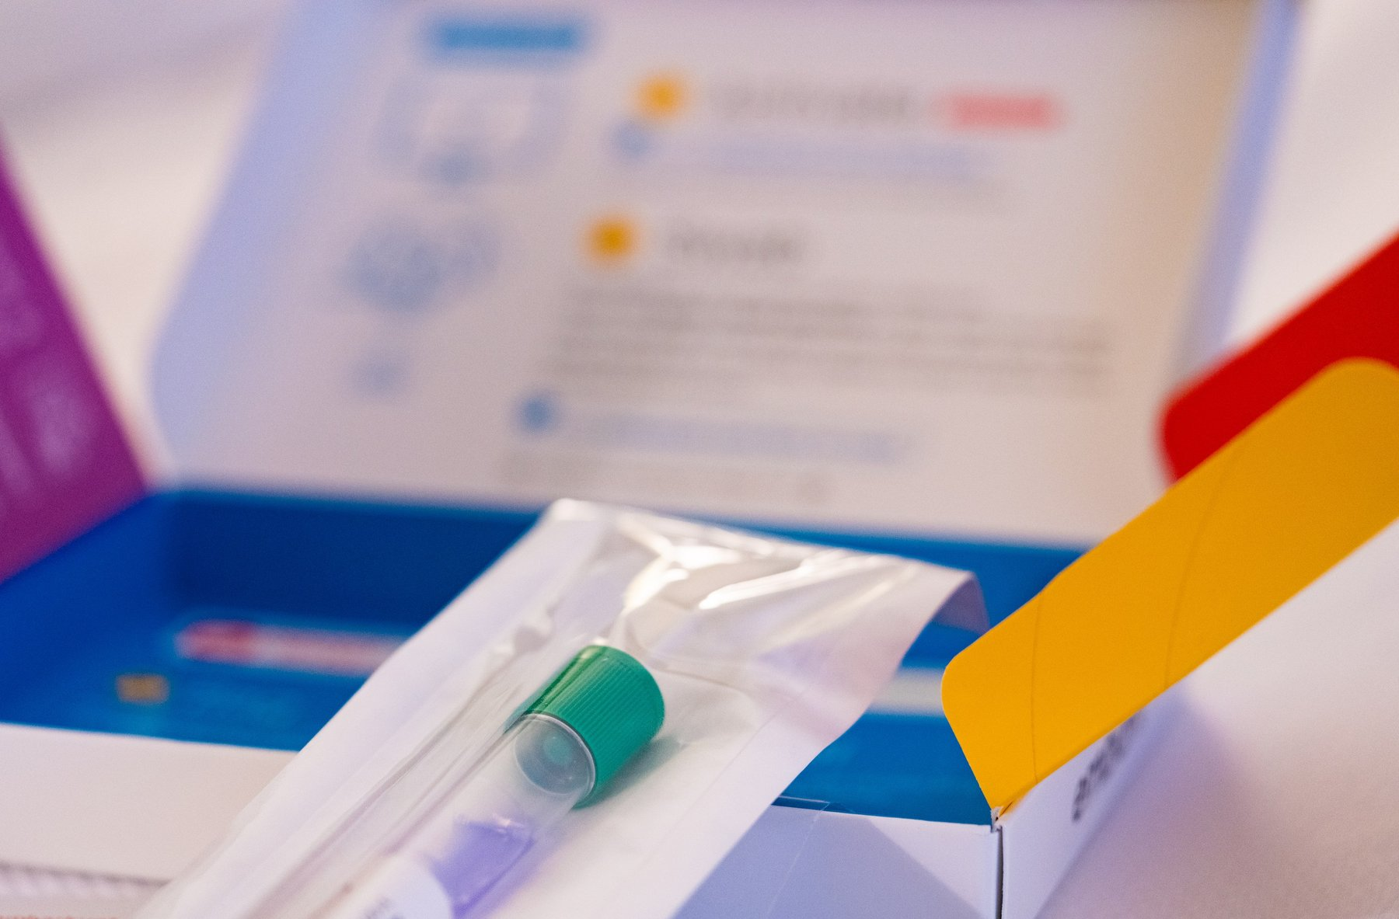
Figure 1. An opened spit-kit box, the collection tube still sealed in its bag.

Two Meters of Thread
Two milliliters of spit looks like nothing much. Mixed into it, with the bacteria and the crumbs of breakfast, are a few hundred thousand cells shed from the lining of her cheeks. A cell is one of the tiny living units a body is built from. Each of these is about fifteen microns across, roughly a fifth the width of a human hair.
Each cell has a nucleus, a small compartment that holds the instructions. The instructions are a molecule with a cumbersome name, deoxyribonucleic acid, DNA for short. They sit on forty-six threads. Those threads are two copies of one text. One parental set, the reference finished in 2022, is about 3.1 billion letters. Printed in ordinary type, that one set would fill about a thousand telephone directories. The nucleus holds both sets, about 6.2 billion letters. Laid end to end, the forty-six threads stretch about two meters. Two meters of thread, in a sphere too small to see.
Nearly every cell from her scalp to her heels carries the same pair of texts, with tiny differences. She has about thirty-seven trillion of those cells. Multiply the two meters by that number and she is carrying something like seventy billion kilometers of thread. That is more than four hundred times the distance from the Earth to the Sun.

The Molecule Nobody Wanted
None of this was known when Ruth was born. In 1948 the molecule had been named and its ingredients listed, and most people who thought about it believed it was too dull to carry information. Proteins, the working molecules that do almost every job in a cell, were the interesting ones. The physicist Max Delbrück dismissed the repeating chain as a stupid molecule, too monotonous to be a gene. The geneticist Evelyn Witkin later recalled the phrase, in a 2012 interview published in PLOS Genetics; it was the view of the laboratory, not a line from a paper of his. Five years later, in the spring of 1953, James Watson and Francis Crick built a model in Cambridge out of metal plates and wire that showed what the chain was for. The photograph that settled the shape as a helix came from Rosalind Franklin’s laboratory at King’s College London. Her student Raymond Gosling took it, under her direction, of the wet form of the molecule. The sentence Watson and Crick wrote is quietly loaded: it had not escaped their notice that the pairing they proposed suggested a copying mechanism.
The shape and the copying are the same fact. DNA is a twisted ladder split lengthwise into two strands. Pull the strands apart and each is a template the cell can rebuild the missing half from, so one ladder becomes two. A cell does this every time it divides. Anna’s body has been doing it since a single cell in 1978 became two.
The copying is astonishingly good, and it is not perfect. A copying enzyme is a protein that speeds a chemical job. It checks its own work. A second set of enzymes checks again. After both checks, about one letter in a billion is wrong. One division of one nucleus, 6.2 billion letters, is expected to leave a handful of mistakes. That handful is the picture. Hold it. The sixty or seventy new letters Theo carried at conception are not one division. They are the leftovers of hundreds of divisions in the making of a sperm. The copy is never exact, and everything that has ever evolved, including us, is downstream of that.

What the Laboratory Will Read
The laboratory will not read Anna’s text in full. It will look at a few hundred thousand positions in the 3.1 billion of one set, the spots known to vary between people. It will report ancestry, a handful of health risks, and relatives who have also mailed a tube.
She will learn three things, and miss the ones she might have wanted. She carries one copy of a variant, a spot where her letters differ from the average, that makes a certain disease a little more likely. She carries one copy of a variant that lets her drink milk as an adult, which she already knew. She has a second cousin in Ohio. She will not be told how long she will live, or whether Theo will inherit Ruth’s temper. No laboratory can tell her that.
In 1990 a complete human text was priced at three billion dollars and scheduled to take fifteen years. Today a full genome, the 3.1 billion letters of one set, read so that both copies are visible, costs a few hundred dollars and takes a day. Reading turned out to be the easy part. Writing is only now beginning.

The Walk Home
The letters can now be read, and in a few cases rewritten in a living person. What should be rewritten, and who decides, is an argument for the end of Part X. It can wait until the shape is clear.
Anna walks home. Somewhere between the mailbox and her front door, in the lining of her gut, cells divide and copy both sets of the text, and a few of them get a letter wrong.
↑ Back to Contents

Chapter 31: The Eagle, 28 February 1953 — A Shape Announced in a Pub

A Pub on Bene’t Street
The Eagle is a pub on Bene’t Street in Cambridge, a few minutes’ walk from the old Cavendish Laboratory. It has a courtyard, low ceilings, and a back room where airmen in the Second World War burned their squadron numbers into the ceiling with candles and lighters. On a Saturday at the end of February 1953, at lunchtime, a tall, loud, thirty-six-year-old physicist named Francis Crick walked in with a thin, twenty-four-year-old American named James Watson and told the room, or at least the people near him, that they had found the secret of life.
The phrase is in Watson’s memoir, published in 1968, and Crick later said he did not remember saying it, which is what people say about their best lines. Whether or not he said it, it was nearly true. That morning the two of them had worked out, with cardboard cutouts and a good deal of pacing, how the four chemical units of DNA fit together in pairs. Within a week they had a metal model of the whole molecule standing on a bench, six feet tall, held together with clamps and retort stands. Within two months a paper about it, a little over nine hundred words long, was in print. The paper is dated 25 April 1953 and appears in the journal Nature under a title so modest it reads like an apology: “Molecular Structure of Nucleic Acids: A Structure for Deoxyribose Nucleic Acid.”
That paper is the start of this book, and it is worth asking why a shape should matter so much. Chemists had known the ingredients of DNA for decades. What nobody had was the arrangement, and in this molecule the arrangement is everything, because the arrangement is how it copies.

An Odd Pair
The two men were an odd pair, and the oddness is part of why it worked. Crick had been trained as a physicist, had spent the war designing mines for the Admiralty, and had come to biology late and hungry. He was known at the Cavendish for a laugh that could be heard through walls and for a habit of explaining other people’s problems to them before they had finished describing them. He had not yet finished his PhD. Watson had finished his, at Indiana, at twenty-two, on the genetics of viruses that infect bacteria. He had come to Europe on a fellowship to learn chemistry, had been bored by it, and had seen a photograph of a DNA fiber at a meeting in Naples in the spring of 1951 that changed what he wanted to do with his life. He arrived in Cambridge that autumn, met Crick, and the two of them decided, without being asked and without any formal permission, that they would work out the structure of DNA.
They had no laboratory of their own. They shared an office. The Cavendish was run by Sir Lawrence Bragg, who had shared a Nobel Prize with his father in 1915 for working out how to use X-rays to find the positions of atoms in crystals, and whose unit was officially devoted to proteins. DNA belonged, by a gentlemen’s agreement among British laboratories, to King’s College London. Maurice Wilkins had started the fiber work there. Rosalind Franklin joined in 1951 to run the X-ray work on those fibers, recording how a beam bounces off a molecule and lands on film. Photographs from her laboratory would show the wet form of DNA as a helix. Watson and Crick’s job was to think about other things. They thought about DNA instead.
Their method was the one Linus Pauling had used at Caltech in 1951 to find the alpha helix, the coiled shape that runs through most proteins. Pauling did not grind through the diffraction data, the pattern of spots and smudges an X-ray beam leaves on film after it bounces off a molecule’s repeating structure, which a trained eye can work backward from to the shape that made it. He asked what shapes were chemically possible, built models of them with the correct bond lengths and angles, and then checked the models against the X-ray pictures. Watson and Crick copied the method and, at first, copied the mistakes. In November 1951 they built a three-chain model with the phosphate backbones on the inside and invited the King’s group up to see it. Franklin took it apart in minutes. It had far too little water in it, which her measurements showed the molecule to be full of, and it put charged phosphate groups where they could not sit. Bragg told them to stop.
They did not entirely stop. Through 1952 Crick worked on his thesis and Watson worked on tobacco mosaic virus, and both of them talked about DNA in the office and in the Eagle. What put them back on the problem, with permission this time, was Pauling. In the last weeks of 1952 word came across the Atlantic that Pauling had a structure. His son Peter was a graduate student in the same Cavendish office, and in January 1953 Peter produced a copy of the manuscript. It was a triple helix with the phosphates on the inside, essentially the model Franklin had demolished fourteen months earlier, and it was wrong in a way that a first-year chemistry student could see: the phosphate groups were drawn without their charges, so that in the form Pauling described the molecule would not have been an acid at all. Watson said afterward that his first feeling was fear that Pauling had won and his second, once he had read the paper carefully, was that they had perhaps six weeks before Pauling noticed his own error. Bragg, who had lost the alpha helix to Pauling two years earlier and did not care to lose again, let them build.

Cardboard Bases
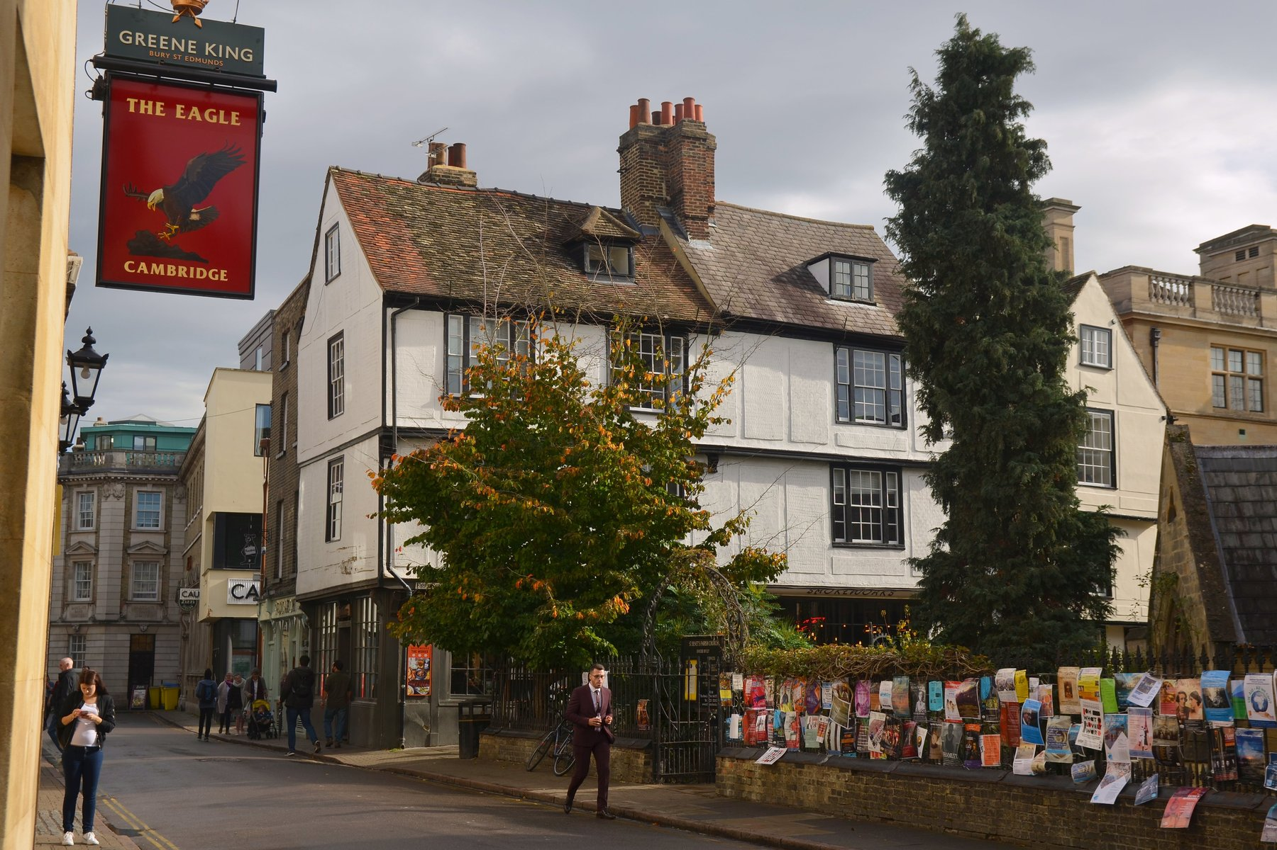
Figure 2. The Eagle, Bene’t Street, Cambridge.
The pieces of the puzzle were, by then, mostly on the table. Everyone agreed that DNA was a long chain in which sugar and phosphate groups alternated to form a backbone, and that from each sugar hung one of four flat, ring-shaped bases: adenine, guanine, thymine, cytosine, known ever since by their initials. Franklin’s X-ray photographs from King’s said the molecule was a helix, meaning it was twisted into a spiral, like a spring or a spiral staircase, about twenty ångströms wide, with something repeating every thirty-four ångströms along its length. An ångström is a unit so small it is normally used only for single atoms; ten of them side by side would barely span the width of a strand of spider silk. An Austrian-born chemist at Columbia, Erwin Chargaff, had published in 1950 a peculiar regularity: in every kind of DNA he measured, the amount of adenine equaled the amount of thymine, and the amount of guanine equaled the amount of cytosine, even though the ratio of the two pairs to each other varied from species to species. Chargaff had visited Cambridge in the summer of 1952 and been unimpressed by Watson and Crick, who did not, at the time, seem to know the chemical formulas of the bases. He left them his rule anyway.
What Watson did in the last week of February 1953 was to take the rule seriously as a fact about shape. He cut the four bases out of stiff cardboard, to scale, and moved them around on his desk trying to find a way that two bases could sit side by side across the width of the helix, joined by the weak attractions called hydrogen bonds, with the backbones on the outside. His first idea was that like paired with like: adenine with adenine, and so on. Jerry Donohue, an American crystallographer (a scientist who works out a molecule’s shape from the way it scatters X-rays) who shared the office and happened to know more about the chemistry of these particular rings than anyone in the building, told him that the textbook drawings he was using showed the bases in the wrong form. In the drawings, some of the atoms carried their hydrogens in a way known as the enol form, that Donohue said was rare in real molecules. In the more common keto form, the hydrogens sat elsewhere, and the like-with-like pairs no longer fitted.
Watson redrew the cardboard. On the morning of Saturday 28 February he found that adenine paired with thymine, held by two hydrogen bonds, made a shape almost exactly the same size as guanine paired with cytosine, held by three. Two different pairs, one width. They would stack down the middle of a helix like the rungs of a ladder, and the ladder would be the same width everywhere. Chargaff’s rule fell out at once: if every A is bonded to a T, there must be as many of one as the other. So did something more important. If the two strands were pulled apart, each carried the full information needed to rebuild the other. Where one strand had A, the new partner must have T. Where it had G, the partner must have C.
That was the morning Crick walked into the Eagle.

Metal Plates and One Sentence
The model took a week to build, because the machine shop had to cut new metal templates for the bases and because Crick insisted on checking every distance and angle against the known chemistry. The chains ran in opposite directions, one up and one down, which Crick had deduced from a piece of King’s data that he had seen in a report and that Franklin, who had generated it, had not yet drawn the conclusion from. The two backbones wound around a common axis with ten bases per turn, one every 3.4 ångströms, so that one full turn came to Franklin’s thirty-four. The bases were flat and perpendicular to the axis, stacked like coins. The whole thing was about twenty ångströms across.
They wrote the paper in March. It has two authors, no experiments, and one figure, a sketch of the helix drawn by Crick’s wife Odile. It proposes the structure, notes that the bases pair in a specific way, and observes that this specific pairing “immediately suggests a possible copying mechanism for the genetic material.” That sentence is the reason the paper is famous. It is the only sentence in it that is about biology rather than geometry, and it was put in, Crick said later, because leaving it out would have looked as if they had not noticed. In the same issue of Nature, immediately after, were two papers from King’s College: one from Wilkins and colleagues, one from Franklin and Gosling, presenting the X-ray evidence. The arrangement was negotiated between the laboratory heads. It gave the impression, which was not quite the truth, of a joint effort.
A second paper by Watson and Crick, in Nature on 30 May 1953, spelled out the copying idea. If the strands separate, each acts as a template on which a new partner is assembled, letter by letter, by the pairing rules. The result is two helices where there was one, each combining one old strand with one new. They also noted, in a paragraph that will matter later in this book, that mistakes could occur if a base briefly took a rare chemical form and paired with the wrong partner. That paragraph is the first written suggestion that mutation might be a matter of where a hydrogen atom happens to be.

Why a Shape Settled It
Why did a shape settle a question that decades of chemistry had not? Because the shape answered what people had actually been asking, which was not “what is DNA made of” but “how can anything made of only four ingredients carry the instructions for a living thing, and how can those instructions be passed on.” The order of the bases along the chain was unconstrained by the structure: any sequence would fit, because every rung was the same width. So the order could be a message. And the pairing meant the message could be copied by a purely mechanical process that needed no intelligence and no reading, only chemistry. A cell could make a copy of its text the way you make a plaster cast, by pressing.
The metal model stood in the Cavendish for a while and then was dismantled; some of the plates survive in museums. Watson and Crick shared the Nobel Prize in Physiology or Medicine in 1962 with Wilkins. Franklin, whose photograph and whose measurements ran under the whole enterprise, had died in 1958 and could not be named, because the prize is not given to the dead. What the field owed her is the subject of the next chapter.
The Eagle has a plaque now, and a beer named after the molecule, and people come in to sit where Crick sat. But the discovery did not happen in a pub. It happened at a desk, on a Saturday morning, with cardboard, and it began with a photograph that neither man had taken.
↑ Back to Contents

Chapter 32: Photo 51 — Rosalind Franklin’s Picture

A Black Square With a Cross
The photograph is a black square with a white cross in it. The cross is smudged, as if someone had drawn an X with a wet thumb, and its arms are broken into short dashes. Around the edges there are darker arcs. It was taken in the basement of King’s College London, in the Strand, in May 1952, on a camera built for the purpose, with an exposure that lasted more than sixty hours. The specimen was a single fiber of DNA drawn out of a wet gel, thinner than a hair, held in a humid chamber so that it stayed swollen with water. The film is labeled, in a laboratory notebook, as photograph number 51.
A fiber photograph is not a picture of one molecule. It is what you get when you pull a wet gel into a thread so that many chains point the same way, fire X-rays through the thread, and let the scattered beam blacken a film. Each helix in the bundle scatters alike. The film records the sum. Molecules lined up along one axis, and free to rotate around it, smear the sharp spots of a crystal into layer lines. Those lines are the broken dashes of the X. The X is what a corkscrew looks like in an X-ray beam.
It is the most famous X-ray picture ever taken, and almost no one who has seen it can read it. That is fair; it takes training. But the cross is the point. When X-rays pass through a helix, the regular twist of the molecule scatters them into a pattern that any crystallographer of the day would have recognized as the fingerprint of a helix. The spacing of the dashes along the arms gives the distance between successive turns. The angle of the X gives the pitch. The missing fourth dash on each arm says something about how the two chains are staggered. The dark arcs at the top and bottom give the distance between the stacked bases: 3.4 ångströms. Photo 51 is, to a trained eye, a message that says: helix, thirty-four ångströms per turn, twenty across, bases stacked one every 3.4, and probably two chains.
The person who took it was a graduate student named Raymond Gosling. The person who supervised him, who had built the apparatus, worked out the humidity conditions, and would spend the next year extracting the numbers from the pattern, was Rosalind Franklin.

Rosalind Franklin
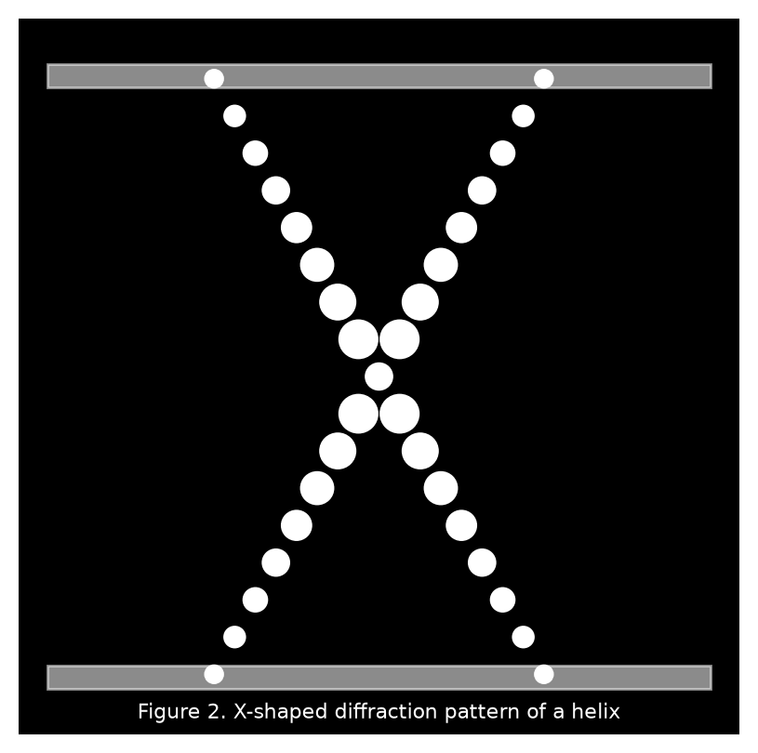
Figure 3. The X-shaped diffraction pattern of a helix.
Franklin was born in London in 1920 into a banking family, went to Cambridge, took a doctorate in physical chemistry on the structure of coal, and spent four years in Paris learning X-ray diffraction from Jacques Mering, who was among the best in the world at applying the technique to things that were not neat crystals. She was thirty when she came to King’s in January 1951, on a three-year fellowship, to work on DNA. She was a careful experimentalist and a formidable arguer, and she did not suffer people who guessed.
She also walked into a misunderstanding that poisoned the next two years. Maurice Wilkins, the deputy head of the biophysics unit, had been working on DNA fibers for a year with Gosling and understood that Franklin was joining his project. Franklin, from what she had been told by the unit’s director, John Randall, understood that DNA was now her project and that Wilkins would work on something else. Neither of them had been told the same thing. Wilkins returned from a holiday to discover a colleague who treated his DNA work as her own and his advice as interference. Franklin, for her part, had a colleague who kept turning up expecting to be consulted on results she considered hers. They never sorted it out. They barely spoke.
Within a year she had done something no one else had. DNA fibers, she found, took two forms depending on how wet they were. At lower humidity the molecule was shorter and thicker and gave a sharp, crystalline pattern; she called this the A form. At high humidity it lengthened, took up more water, and gave a simpler, blurrier pattern; this was the B form. The two could be turned into each other by changing the moisture in the chamber. Earlier photographs, including the ones that had drawn Watson to the problem, had been muddled superimpositions of the two. Franklin separated them, and by doing so rendered the B form’s helical cross visible for the first time. Photo 51 is a B-form picture.
The humidity numbers are the whole distinction, and they are worth having in ordinary units. The A form was stable when the air in the chamber was about three-quarters saturated, and it gave more than a hundred measurable spots, a crystallographer’s feast. The B form needed the air nearly saturated, about 92 percent, the damp of a wet room, and it gave the simpler cross. A single fiber could be driven from one form to the other and back by changing only the water, which meant they were two states of one molecule. Franklin measured the B form at about 20 ångströms across, two millionths of a millimeter, and 34 ångströms from one turn to the next. Those are the numbers that stand in the Cambridge model. She had them in 1952, from a fiber thinner than a hair and an exposure that ran past sixty hours because the specimen scattered so little light. Gosling loaded the camera. She had decided the conditions.

The Decision She Made
She then arrived at a decision that has been argued about ever since. The A form gave the richer data, with many more spots, and Franklin was a crystallographer: she wanted to solve the structure properly, from the spots, by the long mathematical road. She put the B form aside and spent most of 1952 on the A form, which, as it happens, does not show a clean helical pattern, because in the drier state the molecule packs in a way that hides the signature. For a time she doubted whether the A form was helical at all. In July 1952 she and Gosling circulated a mock funeral notice among colleagues announcing the death of the DNA helix. It was a joke, at Wilkins’s expense, and it has been used against her judgment ever since. It should not be. Her notebooks show that by the end of the year she had concluded that both forms were helical, with two chains, with the phosphates on the outside, and she had measured the B form’s dimensions to within a few percent of the values Watson and Crick would use.
What she had not done, by January 1953, was find the pairing of the bases. Nobody had. And she was not looking for it with cardboard, because she did not build models. She thought the model-builders were guessing, which, until the last week of February, they were.

Two Transfers
On Friday 30 January 1953, Watson took the train to London to show Wilkins the Pauling manuscript. He stopped first at Franklin’s laboratory, where the conversation went badly; the account in his memoir, in which she is made to seem on the point of striking him, is his and has been doubted by everyone else who was in the building. He then continued to Wilkins’s office, where Wilkins, who had by this time been told by Franklin’s own student that she was leaving King’s in the spring and who regarded the work as reverting to him, opened a drawer and showed Watson Photo 51.
Watson later wrote that his mouth fell open and his pulse began to race. He had seen helical patterns before and knew what the cross meant. On the train back to Cambridge he sketched what he remembered on the margin of a newspaper. It was not much: the cross, the spacing. But it settled, for him and for Crick, that the molecule was a helix, that it was a B-form helix with the thirty-four ångström repeat, and that they should build a two-chain model rather than three.
A second transfer mattered as much and is less known. In December 1952 the Medical Research Council, which funded both laboratories, had sent a committee to King’s to review the work. Franklin had written up her results for the visitors in a short report. One of the visitors was Max Perutz, the head of Watson and Crick’s unit at the Cavendish. In February 1953 Crick asked Perutz to see the report, and Perutz, who did not regard it as confidential, handed it over. It contained Franklin’s measurements, her statement that the phosphates were on the outside, and a detail about the symmetry of the A-form crystal that Crick, who had done his doctoral work on exactly that kind of symmetry, recognized at once as meaning the two chains ran in opposite directions. Franklin had written the symmetry down without seeing what it meant. Crick saw it in minutes. It fed straight into the model.
Franklin was not told about either transfer. She learned that Cambridge had a structure in March, when Wilkins telephoned. She went up to see the model, checked it against her data, and agreed that it was right. Her paper in the 25 April Nature was already drafted before she saw it; she added a sentence saying that her results were consistent with the Cambridge model. The paper describes the B-form pattern, gives the dimensions, and argues, from her own data, for a two-chain helix with the phosphates outside. In a draft dated 17 March, before she knew about the model, she had written most of that already.

What Was Hers
So what was hers? The clean separation of the two forms, and therefore the first clear helical picture. The dimensions. The location of the backbone. The water content that had killed the first Cambridge model. The symmetry observation, though not its interpretation. What was not hers, and would not have been for some time on the road she had chosen, was the base pairing, which is the part that explains inheritance. Aaron Klug, who inherited her notebooks and became her most careful defender, concluded that she was perhaps a few months from the structure and that she would have got there by her own route. He also concluded that she would have got the backbone right before the pairing, and might not have seen the copying mechanism at once. I think that is fair, and I think it does not settle anything, because the question was never whether she would have won the race. It was whether her data should have been used without her being asked, and the answer to that is no.
In the spring of 1953 she left King’s for Birkbeck College, a mile away, and was made to promise, as a condition of the move, that she would stop working on DNA. She turned to viruses, and in five years at Birkbeck, with Klug and others, she did work on the structure of tobacco mosaic virus and polio virus that was at least as good as anything she did on DNA. In the autumn of 1956 she learned she had ovarian cancer. She worked between operations. She died on 16 April 1958, aged thirty-seven.
The Nobel Prize for the structure went to Watson, Crick, and Wilkins in 1962. It is awarded only to the living, and to at most three people, so there was no place for her either way. Watson’s memoir, published in 1968 over Crick’s and Wilkins’s objections, gave her a nickname, mocked her clothes and her lack of lipstick, and presented her as an obstacle. He added an epilogue conceding that he had misjudged her. The book sold a great deal, and for a generation it was the story. Since then her notebooks have been read, her letters published, her papers reassessed, and the King’s report and its journey to Cambridge documented in detail. She is now more famous than Wilkins, and a building, a university, a Mars rover, and a good many schools carry her name.
The picture is still in a drawer at King’s. It is a black square with a white cross in it, and it is the reason the model in Cambridge was a helix with two chains and not something else.
↑ Back to Contents

Chapter 33: What the Shape Explains — Pairs, Twists and the Central Dogma

Unwinding the Model
Take the model apart in your head. Unwind the helix until it is flat, a ladder lying on a table. The two uprights are the backbones, each a chain of sugar and phosphate, sugar and phosphate, repeating every 3.4 ångströms. The rungs are the base pairs. Every rung is built from two bases, one bolted to each upright, meeting in the middle and held there by hydrogen bonds. There are only four kinds of base and therefore, by the rule Watson found on his desk, only two kinds of rung: A with T, and G with C. Look along the ladder and read the left-hand upright: A, G, G, T, C, A. Now cover it and read the right: T, C, C, A, G, T. You did not need to look. Each side dictates the other.
That is the whole of the copying mechanism, and it is worth being slow about how much it explains, because in 1953 nearly everything about heredity was a mystery and this one shape swept away a surprising number of those mysteries at once.

Chargaff’s Rule
Start with Chargaff. Between 1949 and 1951 Erwin Chargaff and his students at Columbia had taken DNA from yeast, from calf thymus, from bacteria, from human sperm, and had measured, with a precision no one had bothered with before, how much of each base it contained. The older textbook view, going back to Phoebus Levene in the 1920s, was that the four bases occurred in equal amounts and repeated in a fixed order, which would make DNA a monotonous polymer, like nylon, incapable of spelling anything. Chargaff’s numbers said this was wrong. The proportions varied from species to species: human DNA was about 30 percent adenine, a bacterium might be 25 or 35. So the molecule was not monotonous. But underneath the variation was a regularity he could not explain and did not try to. In every sample, adenine and thymine came out equal, and guanine and cytosine matched just as closely, to within the error of the measurement.
He published the rule in 1950 and told anyone who would listen. Few did, because a rule without a reason looks like a coincidence. The model gave the reason in a single glance. If every A on one strand is bonded to a T on the other, then counting the As counts the Ts. The same for G and C. Chargaff’s regularity is not a property of the chemistry of the bases. It is a property of the ladder.
The pairs are not interchangeable, and the reason is geometry. Adenine and guanine are large bases with two rings; thymine and cytosine are small, with one. A large paired with a large would be too wide for the helix; two smalls would be too narrow and would not reach across. Only a large with a small fits the twenty-ångström width. That still leaves two large-small combinations, A with C and G with T, and those are ruled out by the hydrogen bonds. A hydrogen bond needs a hydrogen atom on one side, attached to a nitrogen or an oxygen, pointing at a nitrogen or oxygen on the other side with a spare pair of electrons. Adenine and thymine, in their common forms, present two such matched pairs across the gap. Guanine and cytosine present three. A facing C, or G facing T, lines up donors against donors and acceptors against acceptors, and the pair does not hold. So the rule is not a convention. It is the only arrangement that fits.
The three bonds of a G–C pair against the two of an A–T pair have a consequence you can feel with a thermometer. Heat a solution of DNA and, at some temperature between about 70 and 95 degrees Celsius, the strands come apart, a process biochemists call melting. DNA rich in G and C melts at a higher temperature than DNA rich in A and T, because it has more bonds per rung to break. Organisms that live in hot springs tend, for that reason among others, to run G–C-rich. This was measured in the years after 1953 and was one of the first quantitative tests the model passed.

Two Backbones, One Twist
Now the two backbones. Crick’s insight from Franklin’s symmetry data was that they ran in opposite directions. Each sugar in the chain has its carbon atoms numbered, and the phosphate links the carbon numbered 3 on one sugar to the carbon numbered 5 on the next, so that the chain has a direction, like a row of arrows. One strand runs 5-to-3 up the page; its partner runs 5-to-3 down the page. Biologists say the strands are antiparallel. It sounds like a detail and it turned out to be an enormous nuisance, because the enzyme that copies DNA can only work in one direction along a strand, and so the two strands have to be copied by two different tricks. That story belongs to chapter 37. For now the point is that the model predicted the nuisance before anyone had found the enzyme.
The twist has consequences too. Because the two backbones are not evenly spaced around the axis, the helix has two grooves running along it, one wide and deep, the major groove, and one narrow, the minor groove. In the major groove the edges of the base pairs are exposed, and the pattern of atoms along the edge differs for each of the four possible rungs. A protein that fits into the major groove can therefore read the sequence without opening the helix, by touch, the way a finger reads Braille. This is how the regulators of genes find their addresses, and it was implicit in the model long before anyone had identified a regulator.
The dimensions themselves were confirmed and then refined. Watson and Crick had ten base pairs per turn from Franklin’s photograph; later work with DNA in solution gave about 10.5. Their 3.4 ångström rise per base pair has held. So has the diameter. The B form they modeled is the form that exists in a living cell, because a living cell is wet. The A form, which Franklin spent 1952 on, is what DNA becomes when it dries, and turns up in life mainly in stretches where DNA is paired with RNA.

The First Prediction
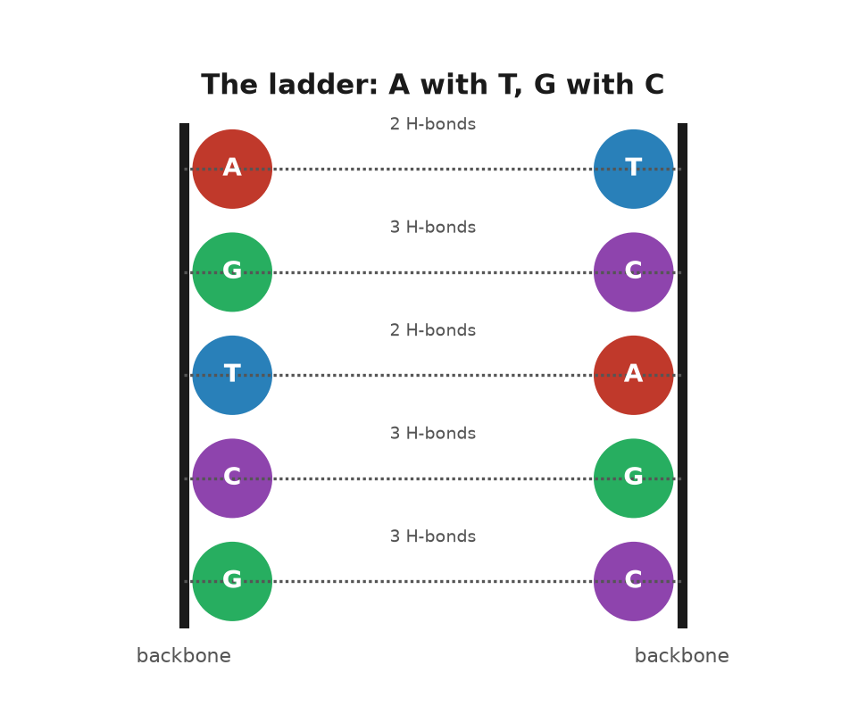
Figure 4. The ladder: A with T, G with C.
A shape that explains inheritance ought to make predictions, and the first big one was about how the copy is made. The paper of 30 May 1953 said it: unwind the helix, use each old strand as a template, assemble a new partner on each. The result is two helices, each with one old strand and one new. Chemists called this semiconservative, because each daughter keeps half of the parent. There were two rival ideas. In the conservative scheme, the parent helix stays intact and a completely new one is built beside it. In the dispersive scheme, the parent is chopped and the pieces scattered between the daughters. The three schemes give distinct answers to a simple question: after one round of copying, is there any helix left that is composed entirely of old material? Semiconservative says no, every helix is half and half. Conservative says yes, one of the two. Dispersive says every strand is a patchwork.
Matthew Meselson and Franklin Stahl settled it in 1958 at Caltech, in an experiment so clean it is still taught as the model of what an experiment should be. They grew bacteria for many generations in a broth in which all the nitrogen was the heavy isotope nitrogen-15, so that every base in every DNA molecule was heavy. Then they switched the bacteria to ordinary nitrogen-14 and let them divide once. DNA can be sorted by weight in a spinning tube of caesium chloride solution, where heavy molecules settle into a band lower than light ones. After one division, all the DNA sat at a single band exactly halfway between heavy and light. No fully heavy helix survived, so the conservative scheme was dead. After a second division there were two bands, one halfway and one light, in equal amounts, which is what you get if each half-and-half helix is pulled apart and each old strand gets a new light partner. The dispersive scheme, which would have given a single band drifting gradually lighter, was dead too. The paper appeared in the Proceedings of the National Academy of Sciences in July 1958, five years after the shape. It has been praised ever since as the most beautiful experiment in biology, and the shape had told it what to look for.

Information and the Dogma
The second prediction was about information. If the order of the bases is the message, the message must somehow specify proteins, which are chains of twenty different amino acids and which do almost all the work in a cell. Four letters have to spell twenty words. Crick thought about this more clearly than anyone. In a talk in 1957, published in 1958, he laid out what he called the sequence hypothesis and what he labeled, with a straight face, the central dogma. The sequence hypothesis said that the order of bases in a stretch of DNA determines the order of amino acids in a protein, and nothing else does. The central dogma said that information flows from DNA to RNA to protein and not backwards: a protein cannot rewrite the DNA that made it. He chose the word dogma, he admitted later, because he thought it meant a bold idea with no evidence, and did not know it meant a belief that cannot be questioned. The name stuck anyway.
The dogma has been dented. In 1970 Howard Temin and David Baltimore identified viruses that copy RNA into DNA, running the arrow in reverse, which is how HIV inserts itself into the human text. But no one has ever caught a protein writing its own sequence back into a gene, and that was the claim Crick cared about. It is why acquired characteristics are not inherited. A blacksmith’s arms do not alter his sperm. The arrow points one way.
The third prediction was almost an aside, and it is the one this book is named for. In the same May paper Watson and Crick pointed out that each base can, rarely, shift a hydrogen atom to a new position, taking on what chemists call a tautomeric form. In that form its pattern of donors and acceptors changes, and it can pair with the wrong partner. If the shift happens at the moment a strand is being copied, the wrong letter goes into the new strand and, on the next copy, is faithfully paired and fixed. They suggested that this might be one way spontaneous mutations arise. It was a guess, and a good one, and how good is still being argued in physics journals seventy years later. Chapter 40 returns to it.

Accepted
Watson presented the model at the Cold Spring Harbor Symposium on Long Island in June 1953, a few weeks after the paper. The audience was the American geneticists and phage biologists who would spend the next decade turning the shape into a science. Some were skeptical. Max Delbrück, Watson’s own mentor, had been skeptical since the spring and had worried in letters about how a helix with two chains wound around each other could ever be unwound for copying without tangling; twisted that tightly over such a distance, it would have to spin like a propeller. He was right that this was a problem and wrong that it was fatal. Cells solve it with enzymes known as topoisomerases, that cut a strand, let it swivel, and rejoin it, and those were identified in the 1970s.
By the end of 1953 the shape was accepted by almost everyone who mattered. It was the right width, it fitted Franklin’s photographs, it obeyed Chargaff, it copied itself on paper, and it told a dozen people what experiment to do next. Bragg, who had been made to look slow by Pauling two years before, wrote the introduction to the Cambridge papers and took a good deal of pleasure in the fact that the answer had come from his laboratory. Franklin’s paper with Gosling sat in the same issue of Nature. King’s had the measurements. Cambridge had the pairing.
What none of that explained was why anyone had doubted, for thirty years, that DNA was the substance of heredity at all. That doubt has its own history, and it begins with a Swiss doctor and a pile of used bandages.
↑ Back to Contents

Chapter 34: The Race Before the Race — How DNA Was Shown to Be the Gene

Pus on Bandages
In the winter of 1868 a twenty-four-year-old Swiss physician named Friedrich Miescher arrived in Tübingen to work in the laboratory of Felix Hoppe-Seyler, one of the founders of what would come to be known as biochemistry. Hoppe-Seyler’s laboratory was in the kitchen of the old castle, which was a fair location, because the work was mostly boiling things. Miescher wanted to know what cells were composed of, and he needed cells. The surgical clinic down the hill supplied him with bandages from wounds that had gone septic. The pus on them was rich in white blood cells, and white blood cells have large nuclei.
He washed the cells off the bandages with salt solution, dissolved away their outer membranes with a weak alkali, and was left with nuclei. From those he extracted a substance that was not a protein: it resisted the enzymes that digest proteins, it was acidic, and it contained a great deal of phosphorus, which no protein did. He called it nuclein. He had, in 1869, isolated DNA, though he did not know what it was for, and his paper was held up by Hoppe-Seyler, who repeated the work himself before letting it appear in 1871.
Miescher later moved to Basel and discovered that salmon sperm was a much better source of nuclein than pus, which was an improvement in every respect. He speculated, cautiously, that the substance might be involved in fertilization. He did not suggest it carried heredity, and neither did anyone else for a long time.
By the 1920s the ingredients were known. Albrecht Kossel in Germany had identified the four bases and won a Nobel Prize for it in 1910. Phoebus Levene at the Rockefeller Institute in New York had worked out that each base was attached to a sugar and a phosphate to make a unit he termed a nucleotide, and that nucleotides were strung together in a chain. Levene also identified the sugar, deoxyribose, in 1929, which gave the substance its modern name.

The Stupid Molecule
Levene then did something that held the field back for twenty years. He proposed that the four nucleotides occurred in equal amounts and repeated in the same order, a tetranucleotide, over and over. The evidence was thin: the bases seemed roughly equal in the impure samples of the day, and the methods for measuring the length of the chains were so crude that DNA looked like a small molecule. But the idea was tidy and Levene was eminent, and it became the textbook view. Under it, DNA could not carry information for the same reason a fence cannot carry a message: every picket is the same. The pickets were not, in fact, the same. The measurements that seemed to show equal amounts of the four bases were too crude to see the differences, and a chain that looks short because your ruler cannot reach the end will look like a small molecule. Chargaff’s later measurements killed the equality. Until then the fence was the textbook, and a textbook is hard to argue with when the man who wrote the underlying chemistry is the authority in the room.
If DNA was a fence, then heredity had to live in the proteins, and there was a great deal going for proteins. They were made of twenty different amino acids, which gave them an alphabet. They came in thousands of distinct kinds. They folded into elaborate shapes. They did the visible work of the cell, as enzymes, as muscle, as the pigment in blood. Chromosomes, which everyone agreed carried the genes, were known to contain both protein and DNA, and the sensible bet was that the protein was the message and the DNA was the scaffolding. The physicist Max Delbrück, Watson’s mentor in the phage group, had a phrase for the general view. Evelyn Witkin, who heard it as a student, later recalled him calling DNA a stupid molecule, too simple, on the tetranucleotide story, to be a gene. The recollection is hers, published in a 2012 interview in PLOS Genetics, not a sentence from a paper of his.

Three Installments
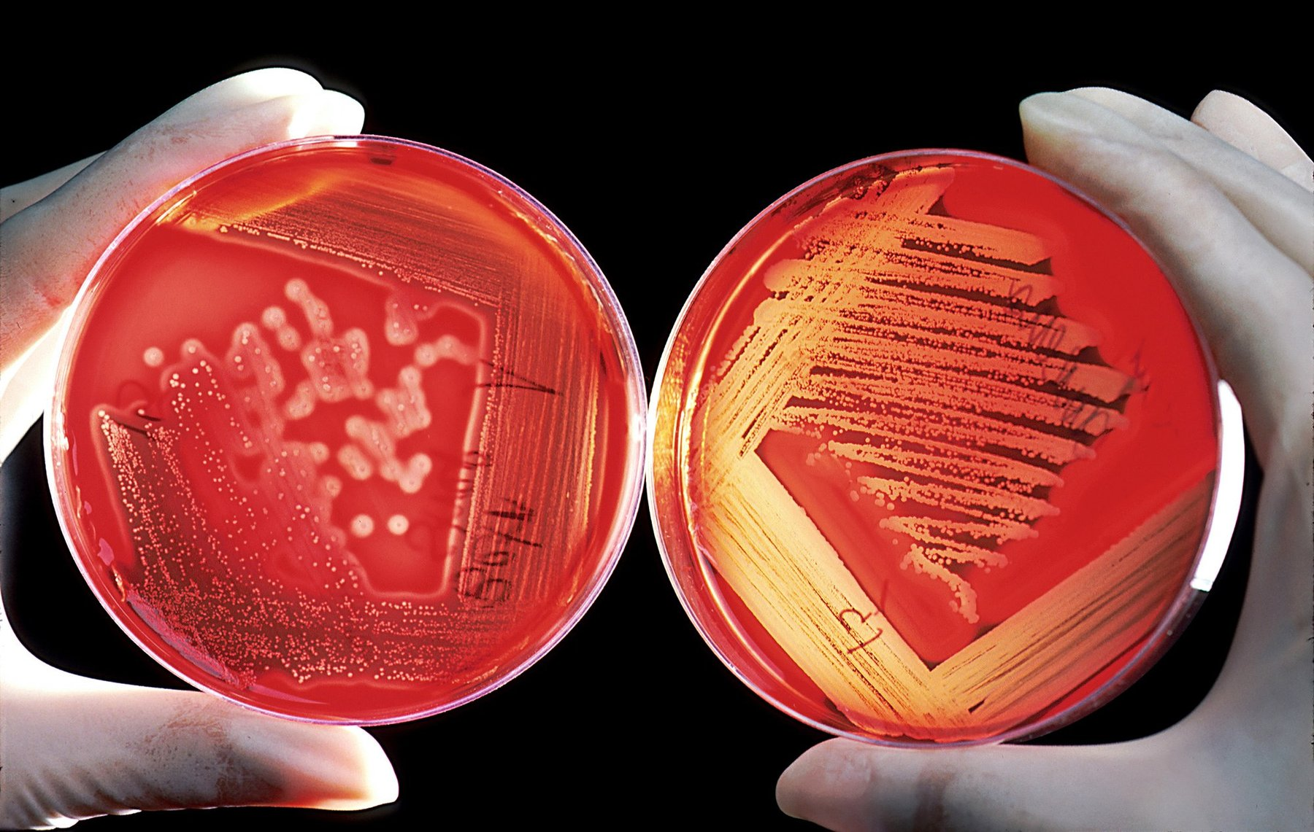
Figure 5. Colonies of bacteria on a plate, each mound grown from a single cell.
The evidence that overturned this arrived in three installments, each of which was ignored more than it deserved.
The first was an accident of public health. In 1928 Frederick Griffith, a bacteriologist at the British Ministry of Health, was studying the bacterium that causes pneumonia, Streptococcus pneumoniae, which comes in two forms. One has a smooth coat of sugar and kills mice; the other, lacking the coat, is rough under the microscope and harmless. Griffith killed smooth bacteria with heat and injected them into mice, which lived. He injected live rough bacteria, and the mice lived. Then he injected both together, heat-killed smooth and live rough, and the mice died, and from their blood he recovered live smooth bacteria. Something in the dead cells had passed into the living ones and changed them, permanently and heritably. He called it the transforming principle and did not know what it was. He was killed in an air raid on London in 1941, still not knowing.
Griffith was not hunting for the molecule of heredity. He was sorting outbreaks, so that one wave of pneumonia could be told from the one before it. The sugar coat comes in types a serum can tell apart. What passed into the living cells was the ability to build one particular type, and the ability bred true. A daughter cell made the dead cell’s kind of coat. In 1928 almost nobody was willing to use the word inheritance for a bacterium. It was inheritance all the same.
The second installment took sixteen years. At the Rockefeller Institute, Oswald Avery, a quiet Canadian-born physician in his sixties who had spent his career on pneumococcus, set out with Colin MacLeod and Maclyn McCarty to purify the transforming principle. It took most of a decade. They grew the smooth bacteria by the vat, broke them open, and removed one class of substance after another, testing after each step whether what remained could still transform rough cells into smooth. They took out the sugar coat; the extract still worked. They digested the proteins with enzymes; it still worked. They removed the lipids and the RNA; still. What was left was a fibrous white material that formed threads when alcohol was added, contained phosphorus in the right proportion, and was destroyed by the one enzyme that specifically breaks down DNA. Their paper appeared in the Journal of Experimental Medicine in February 1944. It concluded, with the caution of people who knew what they were claiming, that the transforming substance was a nucleic acid of the deoxyribose type.
The reception was muted. Avery was a bacteriologist publishing in a medical journal, and the geneticists did not all read it. Those who did had objections. Perhaps a trace of protein, too small to detect, was the real agent. Perhaps transformation was a peculiarity of pneumococcus. Alfred Mirsky, a colleague at the same institute, argued for years that Avery’s preparations were contaminated. Avery was nominated for a Nobel Prize repeatedly and never got one; the committee’s own records, opened later, show that the doubts about purity were taken seriously in Stockholm. He retired in 1948 and died in 1955, two years after the shape.
In May 1943, with the paper still unpublished, Avery wrote to his brother Roy, also a bacteriologist. The transforming material matched a nucleic acid. Nobody had expected that. It behaved as if it might be a gene. The letter was private. The paper, when it came, was more guarded.
He had a reason to guard it. If DNA were only Levene’s repeating four-letter block, the white fibers could spell nothing. A trace of protein stuck to them would still be the real agent. That objection was fair until someone showed the bases could stand in any order. Chargaff’s measurements, still a few years off, would do it. Until then a skeptic had a door.

The Blender Experiment
The third installment was built to answer that objection. In 1952, at Cold Spring Harbor, Alfred Hershey and Martha Chase used a virus that infects bacteria. They named it T2. A bacteriophage, the word for this kind of virus, is little more than a protein coat around a core of DNA. It lands on a bacterium and injects something. Twenty minutes later the bacterium bursts and releases about a hundred new viruses. Whatever was injected had to be the instructions.
The two materials can be marked apart, because their chemistry differs. Protein contains sulfur, in the amino acids cysteine and methionine, and DNA contains none. DNA contains phosphorus in every link of its backbone, and protein contains almost none. Grow the virus in radioactive sulfur and only the coat glows. Grow it in radioactive phosphorus and only the core does.
They let each batch infect bacteria, then stripped the empty coats off with a Waring blender, the same countertop machine a kitchen used for drinks. A spin sank the heavy bacteria and left the light coats in the liquid. In the 1952 paper the blender knocked about three-quarters of the sulfur off the cells, and only about fifteen percent of the phosphorus. The new viruses carried thirty percent or more of the parental phosphorus, and less than one percent of the parental sulfur. The coat had stayed outside. The core had gone in and done the building.
The separation was not clean. A skeptic could still mutter about a trace of protein. It was done, though, on the virus the most influential group of geneticists in America already studied, by one of their own, in the journal they read. It convinced the people Avery had not. Watson arrived in Cambridge that autumn certain that DNA was the thing to solve.

Why It Took So Long
There is a fourth thread, and it runs through the physics rather than the biology. In 1938 William Astbury in Leeds, who had spent the decade taking X-ray photographs of wool and hair, put a fiber of DNA in front of his beam and got a pattern. It was blurry, but it showed a strong repeat at 3.4 ångströms along the fiber, which he read, correctly, as flat bases stacked one on top of another like a pile of pennies. He built a model that was wrong in most other respects. In 1951 his student Elwyn Beighton took photographs that, seen now, plainly show the helical cross of the B form. Astbury did not publish them. He did not see what they meant.
Chargaff’s rule, from 1950, was the last piece, and Chargaff himself is the strangest figure in the story, because he had the evidence and hated the conclusion. He had begun measuring the bases because he read Avery’s paper and believed it, at a time when few did. His measurements killed the tetranucleotide idea and gave the model-builders their pairing rule. When he met Watson and Crick in Cambridge in the summer of 1952, he found two men who could not, in his telling, remember the chemical difference between the bases, and he was appalled that such people should be building models of his molecule. After 1953 he spent the rest of a full career saying that the double helix had been a lucky guess by amateurs and that molecular biology was the practice of biochemistry without a license. He was not entirely wrong about the luck. He was entirely wrong about what it meant.
Why did it take from 1869 to 1952 for the obvious to become accepted? Partly because the obvious was not obvious: a molecule with four ingredients looked too simple to spell out a human being, and until Chargaff nobody knew the ingredients came in variable proportions. Partly because the evidence arrived from the wrong people in the wrong journals. Miescher was a physiologist, Avery a medical bacteriologist, Astbury a textile physicist, Chargaff a chemist who disliked biologists. The people who owned the question of heredity were geneticists, and they worked with flies and corn and did not, for the most part, care what a gene was made of as long as it behaved. And partly because the matter could not be settled by any amount of purification. Avery could show that DNA carried the message. He could not show how, and until someone showed how, a skeptic could always imagine a hidden protein.
The shape did what the purifications could not. It showed that a molecule built from four ingredients could carry any message at all, provided the ingredients could come in any order, and it showed how the message could be copied. After April 1953 there was nothing left for the protein to do. The Cambridge model was in Nature that month. So were the two King’s papers, Wilkins and colleagues, Franklin and Gosling. Three papers, one issue, one shape.
Ruth was five that spring. Nobody told her, and it did not matter, because the molecule had been copying itself in her since 1948 without waiting for anyone to name the mechanism. What it was copying, and what the letters themselves consisted of, is the subject of the next part.
↑ Back to Contents

Chapter 35: Four Letters — The Alphabet and How It Is Packed

What the Letters Are
One parental set of the instruction book that built a person runs to about 3.1 billion letters, and if that one set were printed in ordinary type, ten letters to the centimeter and no spaces, it would fill about a thousand volumes the size of a telephone directory. Each cell stores two such sets, about 6.2 billion letters, in a sphere about six thousandths of a millimeter across, roughly a tenth the width of a human hair. The sphere is the nucleus. A body has tens of trillions of them, give or take, and the packing problem alone would defeat any engineer who tried to do it with wire.
The first job of this chapter is to say what the letters are. The second is to say how they are packed.
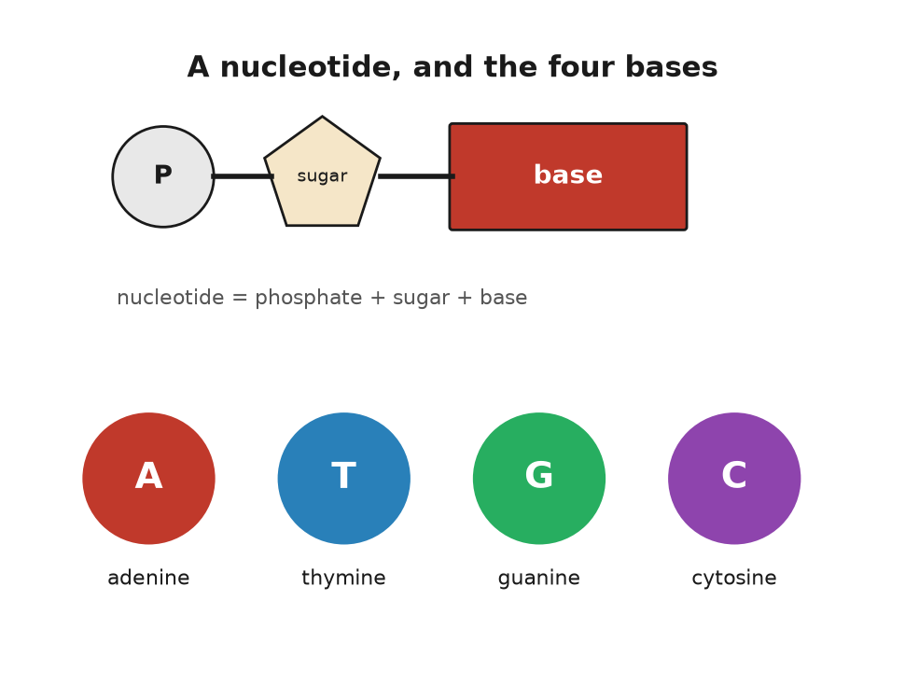
Figure 6. A nucleotide, and the four bases.
A letter of DNA is a nucleotide, and a nucleotide is three things bolted together. The first is a sugar, deoxyribose, a ring of four carbon atoms and one oxygen with a fifth carbon sticking off the side. The second is a phosphate group, a phosphorus atom holding four oxygens, which is attached to that fifth carbon. The third is the base, a flat ring or double ring of carbon and nitrogen atoms, attached to the first carbon of the sugar on the opposite side. The sugar and the phosphate are the same in every nucleotide. Only the base differs, and it differs in four ways.
Adenine and guanine are the large ones, built of two fused rings, and chemists call them purines. Thymine and cytosine are the small ones, a single ring, and are called pyrimidines. All four are flat, like coins, and all four are slightly greasy on their faces and wet at their edges, which is why they stack face to face down the middle of the helix and hold hands with their partners at the sides. The names have histories. Adenine was first isolated from pancreas, and the Greek for gland is aden. Guanine came from guano, the bird droppings mined off the coast of Peru for fertilizer. Thymine takes its name from the thymus, cytosine from cells generally. Nobody planned the alphabet.
Nucleotides join by their sugars and phosphates. The phosphate on the fifth carbon of one sugar bonds to the third carbon of the next, and so on, so that the backbone is an alternation of sugar, phosphate, sugar, phosphate, with a base hanging off every sugar like a flag off a pole. That alternation is a strand. Two strands, running in opposite directions with their flags meeting in the middle, are the helix.
The letters are read in only one direction along a strand, from the free phosphate at the five-prime end toward the free sugar at the three-prime end, which is a convention the way reading left to right is a convention, except that here the chemistry enforces it. When a sequence is written down, as in the HBB gene’s opening letters, ATGGTGCACCTGACTCCTGAG, it is written five-prime to three-prime unless someone says otherwise.
There is a cousin molecule, ribonucleic acid, RNA for short, that will matter a great deal from chapter 38 onward, and its differences are minor enough to list. Its sugar is ribose, which has one more oxygen atom than deoxyribose; that oxygen makes RNA easier to break, which is why RNA is used for messages and DNA for the archive. And it uses uracil in place of thymine, a base that differs from thymine by one missing methyl group. RNA is usually a single strand, but it can fold back on itself and pair up internally, and a good deal of the machinery of the cell is built from RNA folded into shapes.

How Many Letters
How many letters? In 2022 a group led by Sergey Nurk finished the job the earlier drafts had left, the repetitive stretches at the ends and the middles, and published the assembly in Science. They called it T2T-CHM13. The nuclear chromosomes in it come to 3,054,815,472 base pairs. There is no Y in that cell line, only an X and the twenty-two other chromosomes, the autosomes. Add the mitochondrial genome, a small circle of 16,569 letters outside the nucleus that comes from the mother, and one parental set is 3,054,832,041 base pairs. Everyone rounds that to 3.1 billion. That is the thousand directories from the opening of this chapter.
A nucleus holds two sets, about 6.2 billion base pairs. The Y chromosome, finished in 2023, is about 62 million letters. A boy and a girl differ by tens of millions of letters and still both sit near 6.2 billion. The rungs in a single nucleus outnumber the people on Earth.
The letters are not one continuous strand. They are divided among chromosomes, and a human cell has forty-six of them, in twenty-three pairs. In the same 2022 assembly, chromosome 1 is the longest, about 248 million base pairs. The smallest autosome, chromosome 21, has about 45 million. No chromosome is the whole 3.1 billion. The X carries about 154 million and the Y about 62 million, of which a large fraction is repetitive filler. Each chromosome is one enormous double helix, so the longest single DNA molecule in a cell of the right kind is about eight centimeters long.
Multiply out and the total DNA in one nucleus comes to a little over two meters. Two meters is a doorway. The compartment it has to fit is far smaller than the full stop at the end of this sentence.
Multiply by the cells in a body and the thread becomes a distance. Eva Bianconi and colleagues, in 2013, counted about thirty-seven trillion human cells. Later tallies have come in nearer thirty trillion. Either way, a body contains tens of billions of kilometers of double helix. Numbers like that are the reason biology books reach for the solar system. It is enough to go to Neptune and return several times, and every centimeter of it is two nanometers wide, a nanometer being ten ångströms, the impossibly tiny unit introduced in chapter 31.

Packing Two Meters
Two meters into six microns is a compaction of about ten thousand to one in linear terms, and it is achieved in stages, with proteins.
The first stage is the nucleosome. The helix winds itself, about one and two-thirds turns, around a spool made of eight histone proteins, two each of four kinds, and the wound stretch runs 147 base pairs. Then there is a short linker, twenty to eighty base pairs, and another spool. Under the electron microscope the result looks like beads on a string, and that phrase is the standard description. The histones are positively charged, because they are rich in the amino acids lysine and arginine, and DNA is negatively charged, because every phosphate carries a charge, so the winding is partly electrostatic. It is also adjustable. Chemical tags added to the histone tails loosen or tighten the winding, and that is one of the ways a cell turns genes on and off without touching the letters, a subject that comes back in chapter 39.
The second stage is that the beaded string coils into a thicker fiber, about thirty nanometers across, whose exact geometry was argued about for forty years and is now thought to be less regular than the textbooks drew it. The third stage is loops. The fiber is gathered into loops of tens to hundreds of thousands of base pairs, pinned at their bases by ring-shaped proteins, and the loops are the working units: a gene and its switches usually sit in one loop, kept away from the neighbors. The fourth stage, which only happens when a cell is about to divide, is the full condensation into the fat X-shaped chromosomes of the school textbook. Those exist for perhaps an hour per division. For the rest of a cell’s life the chromosomes are diffuse, each occupying its own territory in the nucleus, like countries on a map without borders.
The result is a nucleus with two meters of thread and no knot. Any stretch the cell needs can be reached in seconds. The whole text can be copied, unpacked, repacked, and split in two, in a few hours.
None of this packing is visible. What is visible is the skin of a hand, the freckles, a scrape that is already closing. The closing is cells dividing. Each division copies the text, checks it, and winds it onto the spools again. The scrape closes in a week. Nobody watches the packing. It happens anyway.

The Same Text in Every Cell
One last point about the letters, and it is the one people most often get wrong. The text is the same in every cell, but it is not used the same way. The cell in a cheek that ended up in a spit tube and the cell in a retina that is reading this page carry the same 6.2 billion base pairs. What differs is which stretches are unpacked and read. The cheek cell has its keratin genes open and its rhodopsin genes shut; the retinal cell has the opposite. This is not because the letters differ but because the packing differs. Same book, different pages dog-eared.
There are exceptions to the sameness. Red blood cells throw away their nucleus entirely and carry no DNA at all. Egg and sperm cells carry one set, not two. And every cell accumulates its own private errors, so that two cells from the same cheek, sequenced deeply enough, would differ at a few hundred positions. But the general picture holds. A human being is a colony of tens of trillions of cells that share a text and specialize by reading particular parts of it.
There is a human-scale way to feel the speed. The copying enzyme of the next chapter adds about fifty letters a second on one stretch. Reading one nucleus aloud, one letter a second, would take nearly two hundred years. The cell finishes in a few hours, because it starts the copy in thousands of places at once.
The letters are chemistry. What holds them together, what pulls them apart, and what they are for once read, is chemistry too, and that is the next chapter.
↑ Back to Contents

Chapter 36: The Chemistry Under the Letters — Bonds, Proteins and Energy

Ten Thousand Reactions at Once
A single human cell is running something like ten thousand distinct chemical reactions at the same time, in a volume smaller than a speck of flour, at a temperature of 37 degrees, in salt water. Most of those reactions, left to themselves at that temperature, would take years or centuries. They take milliseconds because the cell has catalysts, helpers that speed up a reaction without being used up by it, and the catalysts are the proteins that DNA specifies. The molecule of chapter 35 is an archive. This chapter is about what the archive is an archive of.
It is the one chapter in the book that is mostly chemistry. A reader who last saw a chemical formula at school can take it slowly. There is nothing here that a kitchen does not also do.

Two Kinds of Bond
Begin with the bonds, because there are two kinds and the difference runs through everything.
A covalent bond is two atoms sharing a pair of electrons. It is strong, in the sense that breaking one at body temperature takes energy the cell must supply on purpose. The backbone of DNA is covalent: the sugars and phosphates are joined by phosphodiester bonds, and a strand does not fall apart in warm water. It takes an enzyme to cut it. The 3.1 billion letters of one parental set are not one chain but twenty-three. Chromosome 1, the longest, is about 248 million letters, and chromosome 21, the shortest, about 47 million. Each of those chains stays in order for a lifetime because covalent bonds hold it.
A hydrogen bond is weaker by about a factor of twenty. It forms when a hydrogen atom that is already attached to an oxygen or a nitrogen is attracted to a second oxygen or nitrogen nearby. The hydrogen is slightly positive, the second atom slightly negative, and they lean toward each other without sharing electrons. The rungs of the ladder are hydrogen bonds, two per A–T pair and three per G–C pair. Individually each is feeble, and a single pair would separate spontaneously in a fraction of a second. Collectively, over a stretch of a few dozen base pairs, they hold. The strands can nevertheless be unzipped, by heating to around 90 degrees, or, in the cell, by an enzyme that walks along the helix prying the rungs apart as it goes.
This is the design principle, and it is worth stating because it is not obvious: the information is held by weak bonds, so that it can be read, and the order of the letters is held by strong bonds, so that it cannot be scrambled. Water is the medium that makes both possible. Water molecules are themselves hydrogen-bonded to each other, which gives water its high boiling point and its reluctance to let greasy things dissolve in it. The bases are greasy on their faces. They hide from water by stacking on top of each other, and that stacking, as much as the hydrogen bonds, keeps the helix together.

Proteins, the Working Molecules
Now proteins, because they are what the letters are for.
A protein is a chain of amino acids. An amino acid is a small molecule with an amino group at one end, a carboxylic acid group at the other, and a side chain in the middle, and there are twenty kinds in the standard set, distinguished only by the side chain. Glycine’s side chain is a single hydrogen atom. Tryptophan’s is a double ring. Some side chains are greasy and hide from water; some carry a charge and seek it; two, cysteine and methionine, contain sulfur; one, proline, kinks the chain. The amino group of one amino acid can bond covalently to the carboxyl group of the next, releasing a water molecule, and the link is called a peptide bond. A chain of a few amino acids is a peptide; a chain of fifty or more is a protein. Human proteins run from about fifty amino acids to over thirty thousand, the record being titin, the molecular spring that holds muscle fibers together and gives a stretched muscle its pull back.
Here is the fact that turns a chain into a machine. A protein does not stay a chain. Within seconds of being made, it folds, and the fold is determined by the sequence. Greasy side chains cluster inward, away from water; charged ones face out; hydrogen bonds form along the backbone into spirals and pleated sheets; here and there two cysteines bond across the fold and lock it. The result is a compact object with a definite shape, and the shape is the function. A protein that binds oxygen has a pocket the size of an oxygen molecule. A protein that cuts DNA has a groove the width of a double helix. Change one amino acid in the wrong place and the pocket closes, or the groove warps, and the machine stops.
That sequence alone determines the fold was shown by Christian Anfinsen at the National Institutes of Health around 1961. He took a compact enzyme, ribonuclease, a chain of 124 amino acids pinned into shape by four sulfur bridges, and unfolded it completely: a concentrated solution of urea pulled the chain loose, and a second chemical broke the bridges. The enzyme stopped working. Then he removed the chemicals slowly and let air back in. The chain refolded itself, without help, into the same working shape, remade the same four bridges out of the 105 possible ways of pairing its eight cysteines, and its activity came back almost entirely. Anfinsen concluded that the information for the shape was in the sequence, and nowhere else, and shared the Nobel Prize in Chemistry in 1972 for it. The idea has limits; many larger proteins need helpers, known as chaperones, to fold correctly in the crowded cell, and some, like the prion, a misfolded protein behind mad cow disease, can fold two ways. But as a principle it holds, and it is why a text of four letters can specify a machine: the text specifies the sequence, the sequence specifies the fold, and the fold does the work. Predicting the fold from the sequence by computation took sixty years and is part of the story of chapter 57.
Most proteins that do chemical work are enzymes, and an enzyme is a catalyst: a molecule that speeds up a reaction without being consumed by it. The speed-ups are not modest. A reaction that would take a year on its own can be compressed into a millisecond, which is a factor of thirty billion, and some enzymes do better than that. The trick is the shape. The reacting molecules are held in a pocket, the active site, in exactly the orientation that makes the reaction easy, with charged side chains positioned to pull electrons where they need to go. Emil Fischer, in 1894, called it a lock and key. Daniel Koshland, in 1958, pointed out that the lock changes shape as the key goes in, and termed that induced fit. Both pictures are used.
An enzyme is named for what it does, with the suffix -ase. Lactase breaks down lactose, the sugar in milk. Ruth has never been able to drink a glass of milk without regret, because the gene that keeps lactase switched on into adulthood is switched off in her; her ancestors, on her father’s side, came from a region where nobody kept dairy cattle. Anna inherited persistence from her father and can drink it; Theo has Anna’s copy. The variant is a single letter change, not in the lactase gene itself, LCT, but in a switch about fourteen thousand base pairs upstream, in a neighboring stretch called MCM6, and it arose in Europe perhaps seven thousand years ago and spread because people who carried it could digest a food the others could not. It is the cleanest example in the human text of a mutation that was useful, and it is a chemistry story: one letter, one switch, one enzyme, one glass of milk.

Paying for It
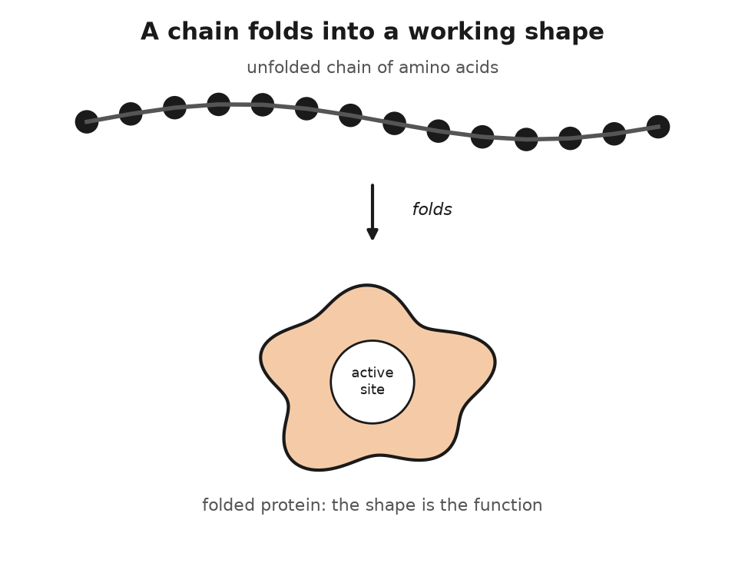
Figure 7. A chain of amino acids folds into a working shape.
Enzymes need energy to run uphill reactions, and the cell’s energy is carried by one molecule, adenosine triphosphate, ATP. It is a nucleotide, in fact the very adenine nucleotide of chapter 35, with two extra phosphates bolted onto its tail. Those phosphates are held by bonds that release a good deal of energy when broken, and the cell breaks them, one at a time, to pay for almost everything it does: contracting muscle, pumping ions, building proteins, copying DNA. Every letter added to a new strand of DNA arrives as a triphosphate and pays for its own attachment by shedding two of its phosphates. The spent molecule, ADP, adenosine diphosphate, is recharged, mostly in the mitochondria, the bean-shaped compartments that fill most cells by the hundred. The turnover is hard to believe. A resting adult recycles roughly their own body weight in ATP every day, sixty or seventy kilograms of it, and the total amount present at any moment is about fifty grams. ATP is not a store. It is a current.
There are two ways to recharge it, and the difference between them is the difference between a sprint and a marathon. The first is glycolysis, a ten-step sequence in the cell’s fluid that splits one molecule of glucose into two smaller fragments. It needs no oxygen, it is the oldest chemistry in the book, older than oxygen in the atmosphere, and it is poor: two ATP, net, per glucose. A sprinter’s leg muscles run on it for the few seconds when blood cannot bring oxygen fast enough, and the fragments pile up as lactate. The second way is what breathing is for. In the mitochondria, the fragments are burned down to carbon dioxide and water, and the electrons stripped from them are passed along a chain of proteins embedded in the inner membrane, stepping down in energy until, at the far end, they are handed to oxygen. Each handover powers a pump that pushes protons, hydrogen nuclei, out across the membrane, building up a pressure of charge like water behind a dam. Taken all the way to carbon dioxide this way, the same glucose yields around thirty ATP, about fifteen times what glycolysis manages alone.
The protons flow back through a turbine. It is a protein known as ATP synthase, and it literally rotates: the inflowing protons turn a ring of subunits in the membrane, the ring turns a crooked axle, and the axle, poking into the head of the machine, squeezes three catalytic pockets in turn, each squeeze pressing a phosphate onto an ADP. One full turn makes three ATP, and the turbine can spin more than a hundred times a second. Peter Mitchell proposed the proton scheme in 1961 and then, from a private laboratory he set up in a restored house in Cornwall, spent a decade arguing with a field that disbelieved him, because everybody expected a chemical intermediate that nobody could find. He received the Nobel Prize in Chemistry in 1978. The structure of the turbine’s head was solved in 1994 by John Walker in Cambridge, who shared the 1997 prize with Paul Boyer, whose idea of the three pockets taking turns the structure confirmed. In 1997, Hiroyuki Noji, Masasuke Yoshida and colleagues in Japan glued a fluorescent filament to the axle, added ATP, and watched it spin under a microscope, running the turbine backward. Every breath Anna takes is to keep the protons flowing.
Cyanide shows how literal that is. It binds the last protein in the chain, the one that hands electrons to oxygen, at the metal center where the handover happens, and jams it. The electrons stop, the pumps stop, the proton pressure drains away, and the turbines stop turning. The blood is still full of oxygen; the cells simply cannot use it, which is why the veins of a cyanide victim can stay as red as arteries. The heart and brain, which keep almost no ATP in reserve, fail within minutes. An ion of two atoms, one carbon and one nitrogen, kills by stopping one enzyme, which is the clearest demonstration there is that the chemistry in this chapter is not background. It is the job.

One Letter, One Disease
A worked example ties the chapter together, and it is the one the rest of the book returns to more than once.
Hemoglobin is the protein that carries oxygen in red blood cells. It is made of four chains, two identical alpha chains and two identical beta chains, each folded around a flat iron-containing ring known as heme that grips one oxygen molecule. The beta chain is 146 amino acids long. It is specified by a gene called HBB on chromosome 11.
In 1949 Linus Pauling, with Harvey Itano and colleagues, showed that the hemoglobin from people with sickle cell disease moved differently in an electric field from normal hemoglobin, and coined the phrase molecular disease. In 1956 Vernon Ingram in Cambridge chopped the two proteins into fragments, spread the fragments on paper, and found that they differed in a single fragment, and that the difference was one amino acid: at position six of the beta chain, a glutamic acid had been replaced by a valine. Glutamic acid carries a negative charge and likes water. Valine is greasy and does not. That one greasy patch on the surface of the protein lets deoxygenated hemoglobin molecules stick to each other, and they polymerize into stiff rods that deform the red cell into a sickle, and the sickle cells jam in small blood vessels.
At the level of the text, the change is a single letter. A codon is a three-letter unit of the genetic code that specifies one amino acid, a system chapter 38 explains in full; here, the codon GAG, which specifies glutamic acid, has become GTG, which specifies valine. An A has become a T. One letter in 3.1 billion, one amino acid in 146, one greasy side chain where a charged one belonged, and the consequence is a disease that affects millions and that, as chapter 56 will describe, was in 2023 the first to be treated by rewriting the letters.
The change is also, in the malaria belt, an advantage. Carriers, with one copy of the sickle variant and one normal copy, are substantially protected against the most dangerous form of malaria, which is why the variant has persisted at high frequency in West Africa, the Mediterranean, and India. Chemistry does not judge. A greasy valine is a disease in one context and a shield in another, and the copying machinery, which is the subject of the next chapter, has no way of knowing which.
↑ Back to Contents

Chapter 37: The Copying Machine — Forks, Errors and Ends

A Cell That Lives Four Days
A cell in the lining of a gut lives about four days. Somewhere in that span it divides, and before it divides it copies its 6.2 billion base pairs in about eight hours, working on thousands of stretches at once, and hands one full set to each daughter. The copy is, after checking, wrong at about six positions. Six in six billion. That is the machine this chapter is about, and the first thing to say is that when Watson and Crick suggested it in May 1953, nobody knew whether it was mechanically possible.
The doubts were reasonable. A double helix has to be unwound to be copied, and a long twisted rope does not unwind without something spinning. The two strands run in opposite directions, so a single enzyme moving along the fork would be reading one of them backwards. And the whole thing had to happen inside a nucleus already stuffed with thread. Delbrück, Watson’s mentor, thought the model might be right about the pairing and wrong about the copying. It took fifteen years to show that it was right about both, and the answer turned out to be a set of about a dozen proteins that work as one assembly.
The enzyme came first. In 1956 Arthur Kornberg at Washington University in St Louis, working with extracts of E. coli, found a protein that would string nucleotides into DNA if it was given a template strand to copy and a short starting stretch to build on. He called it DNA polymerase, and he shared the Nobel Prize in 1959 for it. The enzyme he identified turned out not to be the main copying enzyme at all; a mutant bacterium with almost none of it copied its DNA perfectly well, and the workhorse, polymerase III, was discovered in 1970. But the principle held. A polymerase takes a template strand, reads it one base at a time, and adds to the growing new strand whichever nucleotide pairs with the base it is reading. A opposite T, G opposite C. It does the reading by shape: a correctly paired base fits the enzyme’s pocket and a mispaired one does not, and the pocket closes on a fit and stalls on a misfit. The polymerase is Watson’s cardboard, running at speed.
What the enzyme could not, by itself, settle was which of three copying schemes a cell actually uses. The old helix might stay intact and an entirely new one be built beside it. The old helix might be broken up and its letters scattered into the new ones. Or each daughter helix might keep one old strand and build one new partner, which is what the 1953 paper predicted and what is called semiconservative. Matthew Meselson and Franklin Stahl, at Caltech, distinguished the three with density, and published the result in the Proceedings of the National Academy of Sciences in 1958. They grew E. coli for many generations on nitrogen-15, the heavy isotope, so every DNA strand was dense. Then they switched the bacteria to ordinary nitrogen-14 and took samples each generation. After one generation every helix was intermediate in density, one heavy strand and one light, and the fully heavy DNA was gone. After two generations a fully light helix appeared beside the intermediate. That is the pattern of one old strand kept and one new strand built. It is not the pattern of a conserved old helix, and it is not the pattern of a chopped-up one. The result is a row of bands in a tube, which is why the paper is still the one students are shown.
The speed is worth a number. The bacterial enzyme adds about a thousand nucleotides a second. The human one is slower, about fifty a second, because it is doing more checking, and if a human cell copied its genome with one polymerase at one end it would take four years. It does not. Human chromosomes are studded with tens of thousands of origins, points where copying can start, and in a dividing cell thousands of them fire at once, each sending a fork off in both directions, so that the whole text is copied in a working day.

The Fork
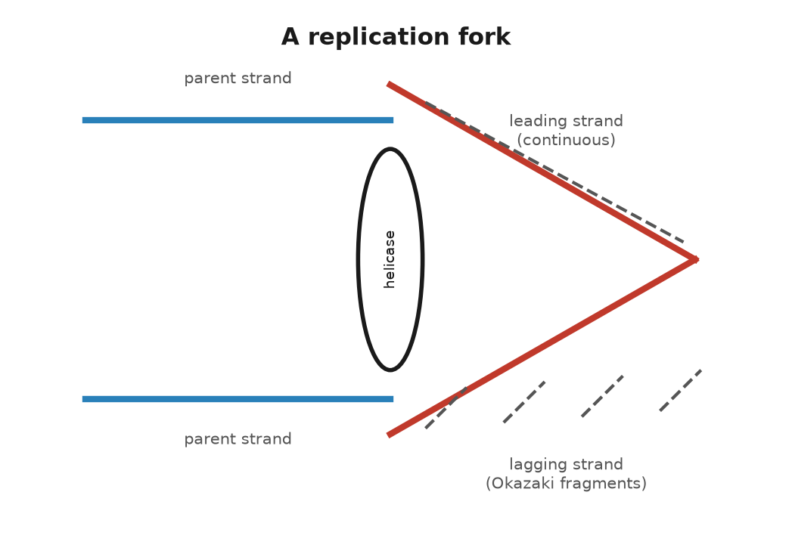
Figure 8. A replication fork.
Now the fork, which is where the mechanical objections were answered.
The helix is opened by an enzyme, helicase, which is shaped like a ring, threads itself onto one strand, and crawls along it, prying the hydrogen bonds apart as it goes at a rate that matches the polymerase. Behind it, the single strands are coated with small proteins that stop them from snapping back together. Ahead of it, the unopened helix is being twisted tighter by the unwinding, and that is the propeller problem. It is solved by topoisomerases, enzymes that cut one or both strands ahead of the fork, let the helix swivel to release the strain, and reseal the cut. The cut-and-reseal happens thousands of times per chromosome per copy, and it is one of the places where the machine is fragile. Several anticancer drugs work by jamming a topoisomerase in the cut state, so that a fast-dividing cell breaks its own chromosomes.
The polymerase cannot start a strand from nothing; it can only extend one. So each new strand begins with a short primer of RNA, about ten letters, laid down by an enzyme known as primase, and the polymerase builds on from there. The primer is later removed and replaced with DNA.
Then the direction problem. A polymerase only builds one way, from the five-prime end toward the three-prime end. It reads the template in the opposite direction. At a fork, one template is aimed so that this is easy. The polymerase follows the helicase and lays down one continuous new strand. That is the leading strand.
The other template runs the wrong way. The polymerase has to work in brief bursts, away from the fork, each burst starting from its own RNA primer. Something then has to stitch the bursts together. Reiji Okazaki, in Nagoya in 1968, caught the pieces. In humans they are about 100 to 200 letters long, and they are known as Okazaki fragments. The stitcher is DNA ligase. This stop-and-start strand is the lagging strand.
The two polymerases are held in one assembly, so they move at the same rate. The lagging strand loops out like the slide of a trombone while the leading strand runs straight. Bruce Alberts and others worked that picture out through the 1980s. It has held up in the electron microscope: a helicase ring in front, two polymerases behind, one strand looped.
Every element of it was forced by the model. Antiparallel strands forced the lagging strand. A twisted helix forced the topoisomerase. A polymerase that cannot start forced the primer. Watson and Crick’s paper said the copying was simple in principle. It was. In practice it takes a machine of a dozen parts.

The Errors
Now the errors, because they are the subject of the book.
The polymerase, choosing a nucleotide by fit, gets it wrong about once in a hundred thousand. That would be sixty thousand errors per copy, which is far too many. So the polymerase checks itself. Attached to it is a second active site, an exonuclease, that faces backwards, and if the base just added does not sit properly in its pair, the growing strand is pulled back into the exonuclease and the last letter is chewed off and tried again. This proofreading catches about ninety-nine of every hundred mistakes, and the error rate after it is about one in ten million.
Then a separate set of enzymes goes over the copy. The mismatch repair system scans new DNA for rungs that do not fit, a G against a T, an A bulging out with no partner, and when it finds one it has to decide which strand is the old, correct one and which is the new, wrong one. In bacteria the old strand is chemically tagged and the new one is not yet. In humans the mechanism is still being argued but it works, and mismatch repair catches most of what proofreading missed. After it, the rate is about one in a billion, and a genome of six billion letters comes through with a handful of errors. When mismatch repair is broken, as it is in people who inherit a faulty copy of one of its genes, the mutation rate rises a hundredfold and the result is a strong predisposition to colon cancer, Lynch syndrome. Paul Modrich worked out the mechanism and shared the Nobel Prize in Chemistry in 2015.
One in a billion is the figure that runs through this book, and here is what it means for a child. The child carries roughly sixty to seventy new mutations that neither parent has. Most of them arose not in the child but in the cell divisions that produced the father’s sperm. A woman’s eggs are all formed before she is born and sit waiting; a man’s sperm are made continuously, from stem cells that keep dividing, so that a sperm from a forty-year-old man is the product of several hundred more copyings than an egg of the same age, and each copying adds its billionth. This is why new mutations come mostly from fathers, about four to one, and why the number rises by roughly two per year of the father’s age. It was measured directly, by sequencing parents and children, in 2012 by Augustine Kong and colleagues in Iceland.

The End Problem
There is one more problem with copying that the fork cannot solve, and the solution is one of the strangest pieces of machinery in the cell.
The lagging strand starts every fragment with an RNA primer that is later removed. At the very end of a chromosome, when the last primer is removed, there is nothing upstream to build the replacement from, so the new strand is a little shorter than its template. Every copying loses a few dozen letters from each end. This is the end-replication problem, and it was pointed out by Alexey Olovnikov in 1971 and independently by Watson in 1972. Left unsolved it would eat the chromosomes from the ends inward, a few letters per division, until the genes were reached.
The ends are protected by telomeres, stretches of the same six letters, TTAGGG, repeated over and over, about two thousand times in a newborn. They carry no genes; they are the blank margins of the page, and the copying machine is allowed to trim them. When they get short, the cell stops dividing. In most adult tissues this is exactly what happens: a cell has a budget of divisions, fifty or so in the laboratory, and then it retires. The budget was found by Leonard Hayflick in 1961 and is known as the Hayflick limit.
Cells that must divide forever, the stem cells that make blood and gut lining and sperm, have a way round it. They make an enzyme, telomerase, which carries its own brief RNA template and uses it to add new TTAGGG repeats onto the ends, restoring the margin. Telomerase was discovered in 1985 by Carol Greider, a graduate student in Elizabeth Blackburn’s laboratory at Berkeley, on Christmas Day, in a pond organism called Tetrahymena, and the two of them shared the Nobel Prize in Physiology or Medicine in 2009 with Jack Szostak. Nearly all cancers switch telomerase on, which is how they divide without limit, and switching it off is one of the strategies under trial against them.
So the machine copies six billion letters in a working day, checks its work twice, loses a little of the margin each time, and gets about six letters wrong. The letters it gets right are the ones the cell then reads, and reading is a machine of its own.
↑ Back to Contents

Chapter 38: From Letter to Protein — The Messenger and the Code

A Tape of U
In the spring of 1961, at the National Institutes of Health outside Washington, Marshall Nirenberg and a German postdoctoral fellow, Heinrich Matthaei, ran an experiment that looks, described plainly, like a magic trick.
They broke bacteria open and kept the soup: the ribosomes, the amino acids, and the small molecules that carry amino acids around. Into that soup they poured a synthetic strand of RNA made of nothing but the letter U, over and over. UUUUUU. Out came a protein made of nothing but one amino acid, phenylalanine, over and over. The tape had been read three letters at a time. UUU meant phenylalanine.
The tape was not copied from a gene. An enzyme isolated in 1955 by Marianne Grunberg-Manago and Severo Ochoa will string nucleotides into RNA with no template at all, if it is handed the raw letters. Give it only uracil and the product is poly-U. Nirenberg and Matthaei then asked which amino acid the soup would build in, trying the twenty candidates in separate tubes, one of them radioactive in each tube so a new chain would register on a counter. Only phenylalanine did. The decisive run was Matthaei’s, in the small hours of 27 May 1961, while Nirenberg was away. Later accounts of that night, including Nirenberg’s, put the count in the phenylalanine tube near 38,000, against a background near 70. A tape of one letter had produced a chain of one amino acid. That is as close to a decoded word as an experiment gets.
That single result did more to crack the genetic code than anything before it, and it is worth being clear about what “the code” means. Between the letters of DNA and the shape of a protein sits a translation problem: four kinds of letter, twenty kinds of amino acid, and a rule connecting them that nobody had proven existed until Nirenberg and Matthaei’s tape yielded a single, predictable amino acid.

The Messenger
The path from letter to protein runs through an intermediate, and that intermediate is RNA, the cousin molecule from chapter 35. A gene is transcribed: an enzyme known as RNA polymerase attaches to a stretch of DNA at a specific address, the promoter, unwinds the two strands locally, and builds a single strand of RNA that matches one of them, letter for letter, with U standing in for T. The product is called messenger RNA, or mRNA, and it carries the gene’s instructions away from the archive and out to where the work gets done.
In humans the raw transcript is edited before it is used. Most human genes are broken into pieces known as exons, separated by stretches known as introns, which can run from under a hundred letters to hundreds of thousands. The whole gene, introns and exons together, is transcribed, and then a machine, the spliceosome, cuts the introns out and glues the exons together, discarding what is between them. This was discovered in 1977, independently, by Richard Roberts and Phillip Sharp, working with an adenovirus, and it surprised nearly everyone; genes had been assumed to be continuous. They shared the Nobel Prize in Physiology or Medicine in 1993. Splicing is not a fixed job for a given gene. The same stretch of DNA can be spliced in distinct combinations in different tissues, so that one gene can specify several related proteins, a trick known as alternative splicing that is a large part of why twenty thousand human genes can produce a much larger number of distinct proteins.
The finished messenger RNA leaves the nucleus and arrives at a ribosome, a machine built of RNA and protein together, about twenty nanometers across, that sits in the cell’s outer fluid by the thousand. The ribosome is the site of translation, and it is here that the code is actually read.
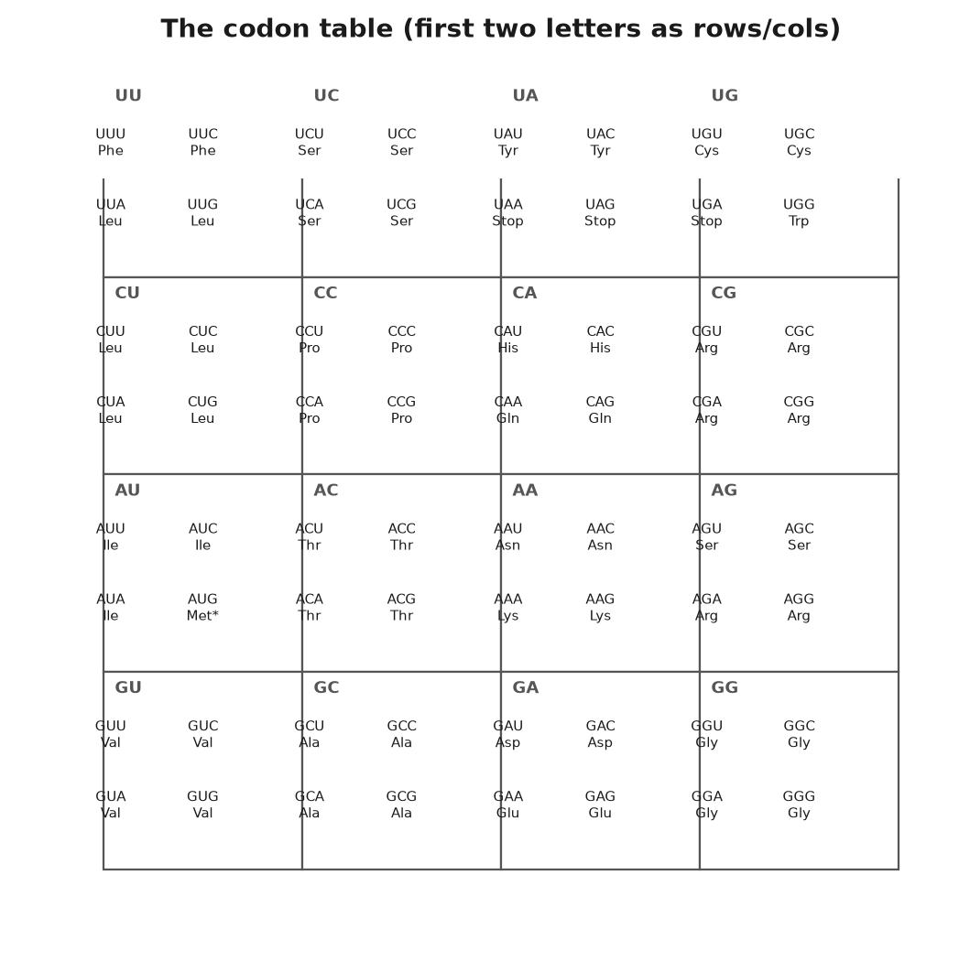
Figure 9. The codon table.

Reading in Threes
The reading unit is the codon: three letters of mRNA, read in one direction without gaps, specifying one amino acid. Three letters from an alphabet of four give sixty-four possible codons, which is more than enough for twenty amino acids, and the surplus is used for punctuation and redundancy. Three codons, UAA, UAG, and UGA, mean stop; the ribosome releases the finished chain when it reaches one. One codon, AUG, means both start and, wherever it appears mid-message, the amino acid methionine. The other sixty codons are shared among the remaining nineteen amino acids, so that most amino acids are specified by more than one codon; leucine has six. This redundancy is known as degeneracy, and it means that many single-letter changes in DNA have no effect on the protein at all, because the new codon still calls for the same amino acid. That fact matters later, when the book discusses how many mutations are silent.
Working out the sixty-four assignments took from 1961 to about 1966 and was mostly done by three groups: Nirenberg’s, which kept refining the poly-nucleotide method; Har Gobind Khorana’s at Wisconsin, which built defined short RNA sequences chemically and tested them one by one; and Robert Holley’s, which worked out the structure of the adaptor molecule that does the actual matching. The three shared the Nobel Prize in Physiology or Medicine in 1968. The adaptor is called transfer RNA, tRNA, and its existence had been predicted by Crick in 1955, on paper, before anyone had isolated one, on the reasoning that something had to recognize a three-letter codon on one side and carry a specific amino acid on the other, since amino acids themselves have no way to read RNA. Each tRNA molecule folds into a cloverleaf shape with a three-letter anticodon at one end that pairs with a codon on the mRNA, and the matching amino acid chemically attached at the other end. When the anticodon fits the codon in the ribosome’s reading slot, the amino acid is added to the growing chain, the ribosome shifts along by three letters, and the next codon comes into position.
Watch one arrival and the stutter stops being abstract. A transfer RNA comes in carrying its amino acid. If its three-letter tip matches the three letters on display, it stays. The growing chain is passed across and joined to that new amino acid. The bond is formed by a folded stretch of the ribosome’s own RNA, not by a protein. The machine then steps forward by exactly three letters, and the empty carrier leaves.
The three places have names. The arrival place is the A slot, A for aminoacyl, where the amino acid comes in. The chain sits in the P slot, P for peptidyl, peptidyl being the string of amino acids already joined. The empty carrier leaves through the E slot, E for exit. A wrong carrier is admitted rarely, about once in several thousand amino acids.
The code, once cracked, turned out to be nearly the same in every living thing that has been checked, from bacteria to oak trees to people. AUG has meant methionine and start for as long as life has kept written records; UAA has meant stop the whole time. This near-universality is itself a strong argument for common descent: unrelated origins would have had no reason to agree on which sixty-four triplets mean what, and the arrangement is not the most efficient possible one, which argues against it being independently reinvented. There are exceptions, mostly small ones, and they are informative rather than embarrassing. Mitochondria, the compartments that recharge a cell’s energy, run a slightly different dialect of the code; in human mitochondria, UGA, a stop everywhere else, means the amino acid tryptophan. Mitochondria were once free-living bacteria that were absorbed by an ancestral cell roughly one and a half to two billion years ago and have kept a scrap of their own genome, and their own slightly drifted code, ever since.
The ribosome itself deserves a moment, because it is arguably the oldest machine still running in every living cell, and because working out its structure took until the twenty-first century. It is built of two subunits, one large and one compact, each a scaffold of folded RNA studded with proteins. The RNA does the chemistry: the bond that joins one amino acid to the next is formed by a piece of the large subunit’s RNA acting as the catalyst, not by any of the proteins, which is one of the pieces of evidence for the idea that RNA came before protein in the early history of life on Earth. The atomic structure of the ribosome, worked out by X-ray crystallography, was published between 2000 and 2001 by three groups working somewhat competitively, led by Ada Yonath, Venkatraman Ramakrishnan, and Thomas Steitz, who shared the Nobel Prize in Chemistry in 2009. A working ribosome adds about twenty amino acids per second in humans, so an average protein of a few hundred amino acids takes perhaps twenty seconds to build, once transcription and splicing have already produced the message.
Many antibiotics work by jamming a bacterial ribosome and sparing ours, because the two machines are alike and not the same. Streptomycin makes the bacterial ribosome misread, so its proteins come out garbled. Tetracycline blocks the arrival slot, so the next adaptor cannot enter. Chloramphenicol interferes with the bond-forming RNA of the large subunit. A human ribosome is built on a plan of its own, and an ordinary dose does not stop it. The same drugs can disturb the mitochondria, whose ribosomes still resemble the bacterial machines they descended from. The code is shared. The reader of the code has drifted, and medicine uses the drift.

The Arrow and Its Exceptions
Crick drew an arrow, DNA to RNA to protein, and the arrow does not run backward under its own power. A letter is copied into RNA, the RNA is read three letters at a time, and the chain folds, as chapter 36 described, into a working shape.
A short message makes the lookup less abstract. Take the sickle change from chapter 36, three letters in the messenger, GAG, which means glutamic acid. The ribosome does not recognize glutamic acid as a substance. It waits until a transfer RNA whose anticodon matches GAG arrives carrying glutamic acid, and then it joins that amino acid to the chain. Change the middle letter and the codon is GUG, which means valine, and a different transfer RNA, loaded with valine, is the one that fits. The ribosome has not made a decision. It has admitted whichever adaptor paired. Sixty-four codons and twenty amino acids means several codons often share an amino acid, so a change at the third letter is frequently silent: GGA and GGG both mean glycine, and the protein is unchanged. A change that creates UAA, UAG, or UGA stops the chain early. An insertion of one letter shifts every codon downstream, so the rest of the protein is gibberish. The table is small enough to write on a card. The consequences are not, because the card is consulted millions of times a minute in every tissue of a body.
Crick noticed, writing in 1966, that the third letter of a codon is often loose. He named the looseness wobble. One transfer RNA can pair with two or three codons that share their first two letters, which is why leucine can have six codons and still be served by fewer adaptors than six. The flexibility is chemical, a slack pairing at one position, and it is another reason a changed letter so often leaves the protein alone. The copy can be inexact and the protein exact. That is the code’s built-in tolerance, and it is why most of a child’s sixty or seventy new letters, when they fall inside a gene at all, change nothing a doctor could measure.
Nirenberg and Matthaei did not stop at a tape of U. A tape of C produced proline. A tape of A produced lysine. Mixtures, and then Khorana’s defined sequences, filled the rest of the card. By 1966 the table was complete enough to print, and it has been reprinted, with the mitochondrial footnotes, in every textbook since.
A body’s cells are, at any moment, running tens of thousands of ribosomes on tens of thousands of messages, translating the small fraction of the text that codes for protein at all. What the rest of one parental set, the 3.1 billion letters, is doing is the next question.
↑ Back to Contents

Chapter 39: Most of the Text Is Not Genes — Switches, Jumping Genes and Marks

The Recipe Is Short
If one parental set were a book of 3.1 billion characters, the recipe for making proteins, the part biologists call coding sequence, would fill about forty-six million of them: roughly one and a half percent. Fold in the introns that get spliced out of those same genes and the genes as regions, coding and non-coding parts together, take up something like a quarter of the text. The other three-quarters was, for a long time, filed under the least satisfying word in the science: junk.
This chapter is about what is actually there, and it turns out to be less a junkyard than an archive with a great deal of packing material, some genuinely broken equipment, and, mixed in, most of the switches that decide when the machinery runs at all.

The Switches
Start with the switches, because they are the least controversial part. A gene’s coding sequence is, in effect, mute without instructions on when to speak. Near the start of most genes sits a promoter, the address RNA polymerase docks at to begin transcription, and scattered elsewhere, sometimes tens of thousands of letters away, sit enhancers, stretches of DNA that proteins known as transcription factors grip onto, bending the DNA around into a loop so that the enhancer touches the promoter and boosts transcription. A single gene can have several enhancers, active in different tissues or at separate times, which is part of how one genome builds a retina and a liver from the same instructions: the coding sequence for a given protein might be identical between the two tissues, while the switches that decide whether that sequence gets read at all differ completely. None of this is coding sequence. All of it is essential, and none of it would exist if the noncoding majority of the genome really were pure debris.
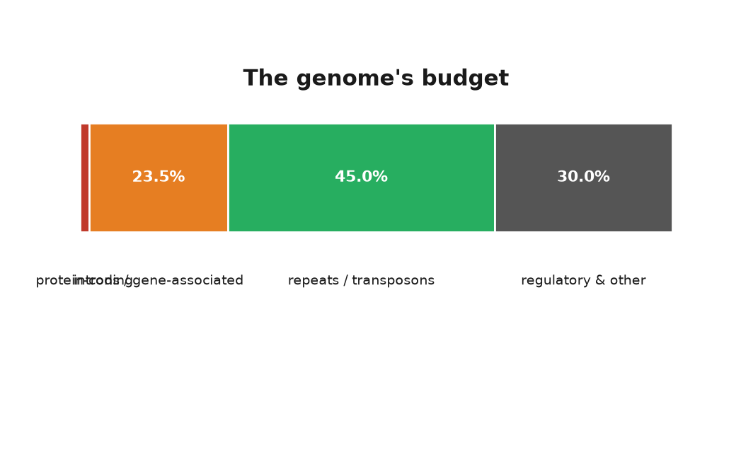
Figure 10. The genome’s budget: coding, introns, repeats, regulatory, other.

Jumping Genes and Debris
Now the debris, or what looks like it. Repeated elements make up roughly forty-five percent of the human genome, and the great bulk of them are transposons: stretches of DNA that, over evolutionary time, have made copies of themselves and inserted the copies elsewhere in the genome, the way a chain letter photocopies itself into new mailboxes. The single most common element in the human genome is a family called Alu, a sequence about three hundred letters in length that appears more than a million times and by some counts accounts for around ten percent of the entire genome on its own. Most transposons in the modern human genome are dead: they have picked up mutations that stop them from copying themselves again, and they sit as fossils, evidence of an old infection that never fully cleared. A minority, mostly a family named LINE-1, can still occasionally jump, and when a jump lands inside a working gene it can cause disease; several cases of hemophilia, a disorder in which the blood does not clot properly, have been traced to exactly that.
The existence of jumping genetic elements at all was worked out decades before anyone understood the molecular mechanism, by Barbara McClintock, working with maize at Cold Spring Harbor from the 1940s onward. She found that certain patches of color on corn kernels appeared and vanished in ways that ordinary mutation could not explain, and concluded that pieces of the genome were physically moving from one location to another and switching genes on and off as they landed. The idea was met, for a long time, with polite disbelief; it did not fit the picture of a fixed, orderly set of genes in fixed positions. McClintock was proven right once molecular tools existed to see the elements directly, and she received the Nobel Prize in Physiology or Medicine, alone, in 1983.

How Much Is Functional
The argument over how much of the noncoding genome does something useful, rather than simply riding along, has run for decades and has not fully settled, which is a case where this book has to say plainly that the two camps of scientists who study it do not agree.
In 2012 the ENCODE consortium, short for Encyclopedia of DNA Elements and a large international research project, mapped where in the genome proteins bind, where RNA is synthesized, and where the chemical marks of active chromatin, DNA packaged with its spool proteins from chapter 35, sit. The project reported that some kind of biochemical activity, transcription, protein binding, or a chromatin mark, could be detected over roughly eighty percent of the genome. Announced as a headline figure, it was widely reported as meaning that eighty percent of the genome is functional.
Evolutionary biologists pushed back hard, and the disagreement is about what “functional” should mean. Biochemical activity is not the same as consequence. Transcription happens accidentally at low levels almost everywhere in a genome; a protein binding a stretch of DNA does not mean that binding matters to the organism’s survival. The evolutionary approach asks a different question: how much of the genome is under selection, meaning that a harmful mutation there would be weeded out because it hurts survival or reproduction. By comparing the human genome to those of many other mammals and looking for stretches that have stayed suspiciously unchanged over tens of millions of years, evolutionary biologists including Chris Rands and colleagues, writing in 2014, estimated that something between about eight and fifteen percent of the human genome is under this kind of constraint. That is a far smaller figure than eighty percent, though still five to ten times larger than the coding sequence alone, which tells you that most of the functional non-coding genome is regulatory: promoters, enhancers, and RNA molecules that never become protein.
I think the honest summary is this, and I mark it as my own reading of a real dispute. ENCODE measured something real and useful, a map of where the cell’s machinery touches down. It overstated what that map says about function in the evolutionary sense. The evolutionary estimate is closer to what most geneticists mean by how much of the genome matters. It probably still misses a switch that evolved only in humans, and recently, and so left no fossil in a comparison between species. Both figures can be true. They are answers to two questions, not one.

Small RNAs and Distant Switches
Those RNA molecules are not the messenger of chapter 38. Messenger RNA is a temporary copy of a gene on its way to a ribosome. The RNAs that manage switches are another workforce, and two examples show the range.
In 1993 Victor Ambros and Gary Ruvkun, working on a worm about a millimeter long, identified an RNA of about twenty-two letters that pairs with a messenger and stops a protein from being finished. A second example turned up in 2000, and then hundreds, in animals and in plants. These microRNAs are how a cell turns a protein down without editing the gene. A human cell produces several hundred of them. Ambros and Ruvkun shared the Nobel Prize in Physiology or Medicine in 2024.
Distance is the other surprise. The gene that lays out a limb, SHH, is controlled in the developing limb by an enhancer about a million letters away, sitting inside a neighboring gene. A change in that far enhancer can add an extra finger or thumb while the coding letters of SHH itself are untouched. Proteins grip the enhancer and the start of the gene, and the DNA bends until the two touch. A million letters, inside a nucleus, is a brief walk. The recipe and the switch are not neighbors on the page. They are neighbors in the packing.

Marks on Top of the Letters
Whatever the final percentage, one function of the noncoding genome is now settled beyond argument: epigenetics, the study of chemical marks that change which genes get read without changing the letters themselves, an idea briefly touched on in chapter 35 through the packing of the nucleosome, deserves its due here as chemistry.
DNA itself can carry a chemical mark without changing its letters. The most common is methylation: a small chemical tag, a methyl group, attached to a cytosine, usually one that is followed by a guanine. Heavily methylated promoters tend to be shut; the tag physically discourages the transcription machinery from docking, and it also attracts proteins that compact the chromatin around it. Histones, the spool proteins from chapter 35, carry their own set of marks, acetyl groups and methyl groups added and removed at specific positions on their protruding tails, and different combinations of marks correlate with genes being open, primed, or silenced. None of these marks change a single letter of the underlying sequence. All of them are copied, imperfectly, when a cell divides, which is how a liver cell’s daughter is also a liver cell rather than reverting to a blank slate: the pattern of switches, not just the text, is inherited from one cell generation to the next.
The clearest demonstration in humans is X-inactivation. Female mammals carry two X chromosomes. Males carry one X and one Y. Two active X chromosomes would double the dose of every gene on the X, and that dose is generally harmful. Early in a female embryo, each cell shuts one X at random and wraps it up. Every descendant of that cell keeps the same one shut for life.
A calico cat is the picture. The coat-color gene sits on the X. One X says orange and the other says black. Each patch of fur is the descendants of a cell that shut one or the other. The coating is done by an RNA. A gene named XIST, reported by Carolyn Brown and colleagues in 1991, is copied into a long RNA that stays in the nucleus, spreads over the X it came from, and does not make a protein. The proteins that pack the chromosome follow that RNA. Mary Lyon proposed the underlying pattern in 1961, from breeding experiments in mice, well before anyone could see the RNA itself.
The same basic toolkit, methylation and histone marks, is how roughly two hundred distinct cell types in a body run varied programs from an identical genome, and how, as chapter 44 will describe, an experience early in life can leave a chemical trace that outlasts the experience itself, though not, in most cases, one that gets passed to the next generation.
One switch is concrete enough to taste. Anna’s switch, from her father, sits outside the gene, in the kind of enhancer this chapter has been describing. A gut cell and a skin cell can both carry it. Only the gut cell has the enhancer’s protein partners in place, so only the gut cell makes the enzyme.
Put one parental set on a shelf the way chapter 35 did, about a thousand telephone directories. The protein recipes fill roughly fifteen of them. That is the whole of him, as a parts list. The introns and the switches fill a few hundred. The dead transposons fill nearly half the shelf, four or five hundred volumes of chain letters that mostly no longer copy themselves. The rest is structural sequence, RNA genes, and pages nobody has assigned. ENCODE’s eighty percent and the evolutionary eight to fifteen percent are two ways of counting those volumes. They do not become the same number by being printed side by side.
None of this changes what happens when the machine copies the text and gets it wrong, which is the same whether the wrong letter falls in a gene, a switch, a dead transposon, or a stretch nobody has a name for yet. Where those wrong letters come from, and what a cell does about them, is the last chapter of this part.
↑ Back to Contents

Chapter 40: Where Mistakes Come From — Damage, Repair and Mutation

Sixty New Letters
When a child is conceived, the genome is not a clean copy of either parent’s. Comparing the child’s DNA against both parents, a geneticist would find somewhere between sixty and seventy positions where the child carries a letter neither parent has. This number, and the fact that most of those new mutations trace to the father’s side, comes from direct family sequencing studies, the first solid one published in 2012 by Augustine Kong’s group in Iceland, and it has been repeated many times since with similar results. Every child of every generation carries a similar new burden. It is the price of copying, and this chapter is about where the price comes from, how the cell tries to avoid paying it, and a live scientific question about whether some of the toll is, at bottom, a quantum event.
The most obvious source of new mutations is the copying error described in chapter 37: a polymerase places the wrong letter, proofreading misses it, mismatch repair misses it too, and the wrong letter becomes permanent on the next round of copying, since by then it has a perfectly matched, if wrong, partner. This route alone, at roughly one error per billion letters copied, adds up over trillions of divisions in a lifetime.

Attacked Every Day
But DNA does not sit passively waiting to be copied; it is chemically attacked every day, even doing nothing at all. The bond joining a purine base, adenine or guanine, to its sugar is not perfectly stable in water, and it spontaneously breaks at a low but steady rate, a process known as depurination. Estimates for a human cell run to around ten thousand such losses per day. Left alone, a lost base leaves a gap that, if copied over, produces a random letter in its place; in practice, a dedicated repair pathway usually patches the gap correctly first. Cytosine undergoes a different spontaneous change, deamination, in which it loses an amino group and turns chemically into uracil, a letter that does not belong in DNA at all and is efficiently recognized and excised; but a chemically modified form of cytosine, the one carrying the methylation tag from chapter 39, deaminates instead into thymine, a letter that does belong in DNA, and this disguised error slips past repair far more often. That single chemical quirk is why methylated cytosines are among the most mutation-prone positions in the whole genome, and it is part of why a particular cancer-causing mutation in a gene, TP53, recurs at the same few positions in tumor after tumor: those are methylated cytosines.
Radiation adds to the chemical toll from outside. Ultraviolet light, mainly from the sun, is absorbed by two neighboring thymine or cytosine bases on the same strand and fuses them into a distorted unit called a pyrimidine dimer, which the copying machine either repairs correctly or, if repair fails, reads badly, producing a characteristic and well-studied class of skin-cancer mutation. Ionizing radiation, from cosmic rays, from radioactive decay in rock, or from a medical scan, carries enough energy to break a DNA strand outright, sometimes both strands at the same position, which is a far more dangerous injury than a single wrong letter. And a long list of chemicals, some natural and some manufactured, react directly with DNA and distort it: aflatoxin, a mold toxin found on improperly stored grain and nuts, forms a bulky attachment to guanine that is strongly linked to liver cancer in parts of the world where contaminated food is common; benzo[a]pyrene, one of dozens of carcinogens, cancer-causing chemicals, in tobacco smoke, does something similar and is a major contributor to lung cancer’s mutation burden. And the transposons of chapter 39, when one of the rare active ones jumps, tear the text at both its old and new locations, occasionally landing inside a working gene and breaking it.

The Repair Crews
Against all of this, the cell runs several dedicated repair systems, distinct from the proofreading and mismatch repair of chapter 37, each specialized for a different kind of damage. Base excision repair recognizes a single damaged or wrong base, such as a deaminated cytosine, cuts it out, and rebuilds the gap using the opposite strand as a guide. Nucleotide excision repair handles bulkier distortions, such as UV-induced pyrimidine dimers, by cutting out a stretch of a couple of dozen letters around the damage and resynthesizing it; people who inherit a broken copy of one of the genes in this pathway have a condition known as xeroderma pigmentosum, in which ordinary sunlight causes severe, early skin cancer, because the dimers that everyone’s skin cells accumulate every sunny day are never removed. Mismatch repair, already introduced as a proofreading backstop, also has a starring role in disease when it fails on its own: inherited faults in its genes cause Lynch syndrome, a strong predisposition to colorectal and several other cancers, and the mechanism was worked out largely by Paul Modrich. Tomas Lindahl, who discovered base excision repair, and Aziz Sancar, who worked out nucleotide excision repair in detail, shared the 2015 Nobel Prize in Chemistry with Modrich for mapping this whole defensive system.

Four Kinds of Mistake
The result of copying errors, chemical attrition, and imperfect repair is a small catalog of mutation types, which recur throughout the rest of this book and are worth naming once, clearly. A point mutation swaps one letter for another. An insertion or deletion adds or removes letters, and if the number added or removed is not a multiple of three, it shifts every downstream codon, as chapter 38 explained. A copy-number change duplicates or deletes a whole stretch, sometimes a whole gene or several. And a chromosomal mutation rearranges or miscounts entire chromosomes, as when an extra copy of chromosome 21 causes Down syndrome. All four kinds trace back, ultimately, to the sources cataloged above.

The Ingredient Darwin Lacked
Chapter 8 told how Darwin’s theory waited for two missing pieces. Mendel supplied the first: heredity comes in particles that do not blend. Mutation is the second, the source of genuinely new variants, and this chapter’s chemistry is the mechanism Darwin lacked. Mutation supplies raw variation. Recombination, the shuffling of chromosome pieces between parents that Part VII explains, mixes it further. Selection, the bookkeeping of Chapter 7, changes which variants become common. Mutation without selection is just noise. Selection without mutation has nothing to select. Together they are the theory of evolution.

Is Mutation Quantum?
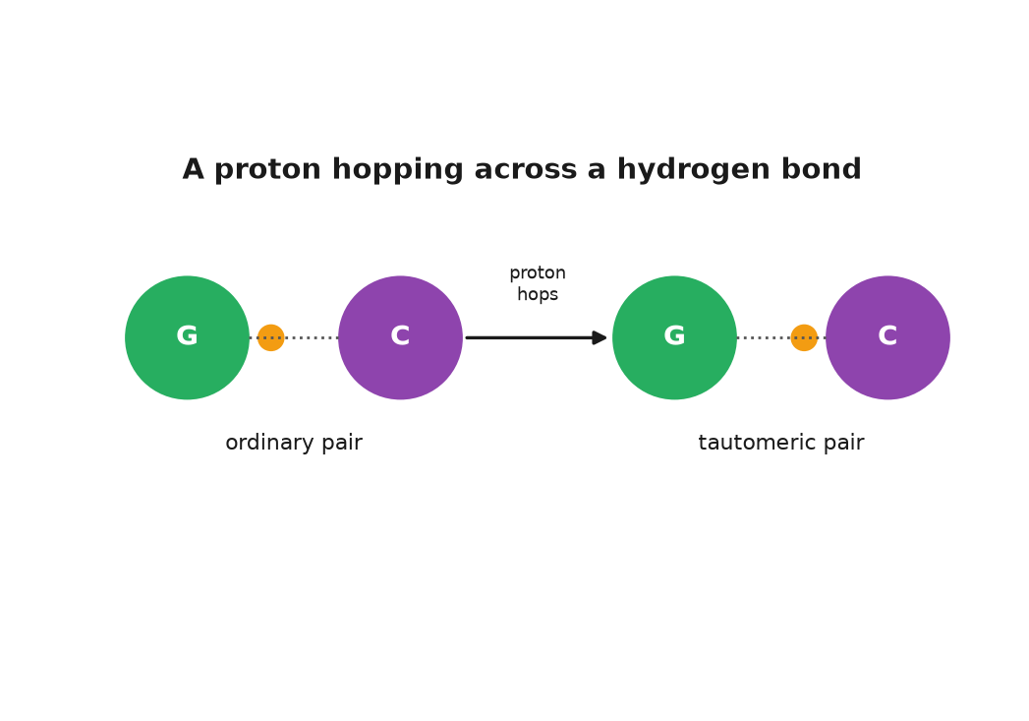
Figure 11. A proton hopping across a hydrogen bond: ordinary pair, tautomeric pair.
There is one more source of variation to consider, and it is the one readers ask about most often: whether mutation is purely a matter of classical chemistry, molecules bumping and reacting the way billiard balls do, or whether quantum mechanics plays a genuine role.
The honest answer has a settled part and a working part, and the two should not be blurred together.
The settled part is straightforward and, once stated, almost too obvious to seem interesting: light is fundamentally a quantum phenomenon, and so is the interaction of radiation with matter that causes DNA damage. A photon of ultraviolet light is absorbed by a thymine base as a single indivisible quantum of energy, kicking an electron into an excited state that then allows the two neighboring bases to fuse into the dimer described earlier in this chapter; the physics of that absorption is textbook quantum chemistry, no more controversial than the physics of a photograph. In that narrow, well-established sense, quantum mechanics is already part of the settled story of mutation, and always has been, since chemistry itself is built on quantum rules about how electrons and bonds behave.
The working part is narrower, and it is not settled. Watson and Crick’s second paper of 1953 already noted that a base can briefly flip into a rare shape, a tautomer, and then pair with the wrong partner. The question is whether that flip is sometimes a quantum event.
Picture one hydrogen atom sitting in the middle of a base pair, held by a bond. In ordinary physics it stays on its own side of a low wall. Tunneling is the quantum fact that a particle can be found on the far side of a wall it does not have the energy to climb. It is established in some enzyme reactions. In 1963 the physicist Per-Olov Löwdin proposed that the hydrogens in a base pair might tunnel, so that for an instant the pair is the rare tautomer. If the copying enzyme reads the strand in that instant, it writes the wrong letter.
For decades this stayed a theoretical curiosity, difficult to test directly inside a hydrogen bond a few tenths of a nanometer long. In 2022 a paper by Louie Slocombe, Marco Sacchi, and Jim Al-Khalili, published in the journal Communications Physics, used detailed quantum mechanical calculations to estimate how readily this tunneling actually occurs in a G–C base pair at body temperature. Their calculation found that the tunneling happens fast, on a timescale of quadrillionths of a second, too brief for any laboratory clock to follow directly and faster than earlier, simpler estimates had suggested, and that even though the resulting tautomeric form is short-lived and reverts almost immediately, a small but non-negligible fraction of base pairs are sitting in the tautomeric form at any given instant, purely as a matter of ordinary quantum equilibrium. A later paper the same year, by Slocombe, Max Winokan and colleagues in the Journal of Physical Chemistry Letters, put a polymerase around a mismatched G–T pair and calculated that tunneling could speed a wrong letter into place in that squeezed geometry. It is still a calculation. Nobody has yet watched a living polymerase copy a tunneled tautomer.
What that calculation does not show, and what nobody has yet shown, is that this fast quantum flicker actually gets past a working polymerase often enough, in a living cell, to be copied into a permanent mutation before the tautomer reverts or before proofreading catches it. The proofreading and mismatch-repair systems described earlier in this chapter evolved, in effect, to catch exactly this kind of transient mispairing, whatever its ultimate physical cause, and no experiment has yet isolated tunneling as a distinct, measurable contributor to the final mutation rate observed in a real organism, as opposed to a laboratory calculation of what happens to an isolated base pair. So I place this where the book’s own vocabulary says it belongs: working, not settled. It is a serious hypothesis, backed by real calculation, about one possible route to one class of spontaneous mutation, sitting alongside the classical chemical routes, depurination, deamination, radiation damage, that are already firmly established and almost certainly responsible for the great majority of the mutations this chapter has cataloged. Quantum tunneling may turn out to be a minor but real contributor to the tautomer route specifically. It has not been shown to be the dominant source of mutation generally.

Copying’s Shadow
Whatever the balance between chemistry and quantum flicker inside one base pair, the outcome for the species is the same. Mutation is the raw material of change; it is copying’s shadow, inseparable from the very mechanism that makes life possible at all, because a molecule that copied itself with true, permanent perfection would also be a molecule that could never have produced anything new since the first cell. Selection is the editor that decides, generation after generation, which of those shadows survive. Neither, alone, explains a finch’s beak or a sickle-shaped red blood cell or Anna’s switch, from her father. The next part of this book turns from the chemistry of the mistake to the question of who inherits it, and why Theo’s freckles came from Ruth.
↑ Back to Contents

PART VII
Inheritance
A child is a new shuffle of two old texts. This Part explains the shuffle, then goes back to the friar who first counted it, the flies that gave it an address, and the people who turned it into a program of cruelty.

Chapter 41: Why Theo Has Ruth’s Freckles — How Inheritance Shuffles

A Photograph on the Refrigerator
There is a photograph on Ruth’s refrigerator, held up by a magnet shaped like a lemon. It was taken last summer at a picnic table. Ruth is on the left, seventy-seven then, in a sun hat. Anna is in the middle. Theo, fourteen at the time and already taller than both of them, is on the right, scowling at the sun. All three have freckles across the nose and cheekbones, the same scatter, as if someone had flicked the same brush at three faces. Ruth’s husband, Anna’s father, had none. Theo’s father has none either. The freckles have come down one line of the family like a surname.
Ruth, Anna and Theo are invented, and what they carry has been arranged for convenience. But the question the photograph raises is a real one, and it was the central puzzle of biology for most of the nineteenth century. How does a feature get from a grandmother to a grandson? Why is it not diluted on the way, given that at each step a parent with the feature had a child with a parent without it? And why does Theo have Ruth’s freckles but not her curly hair, her blood group, or her habit of finishing other people’s sentences?
The answer begins with a count. Every ordinary cell in Ruth’s body holds 46 chromosomes, and they come in 23 pairs. The number was settled surprisingly late. From 1923, on the authority of Theophilus Painter, the textbooks said 48, and it took until 1956, when Joe Hin Tjio and Albert Levan in Lund looked at cultured human cells with a better technique, for the count to be corrected. Twenty-two of the pairs are matched: the two chromosomes in each pair are the same length and carry the same genes in the same order. The twenty-third pair is the sex chromosomes, and it gets its own chapter.
The two members of each pair have different histories. One came from Ruth’s mother, in the egg. The other arrived from Ruth’s father, in the sperm. So Ruth has, for instance, two copies of chromosome 16, and somewhere on each of them sits a gene called MC1R, which makes a receptor protein on the surface of pigment cells. Certain variants of MC1R are strongly associated with red hair, skin that burns, and freckles; the association is settled, though freckling is not a one-gene affair and several other regions of the text contribute. Suppose that Ruth’s chromosome 16 from her father carries one such variant and the one from her mother does not. She freckles. What matters is what she gave to Anna.

Two Ways to Divide
Cells divide in two ways, and the difference between them is the whole of inheritance. The ordinary way is mitosis. A cell copies all 46 chromosomes, lines up the 92 resulting threads, pulls one full set to each end, and pinches in two. Both daughter cells have 46, and both are, apart from the copying errors of Chapter 40, the same as the parent. This is how skin replaces itself, how a cut heals, how a fertilized egg becomes a person of tens of trillions of cells. Nothing is shuffled. Nothing is halved.
The other way is meiosis, and it happens only in the ovaries and the testes. Here a cell copies its 46 chromosomes once and then divides twice, so that the four products each hold 23, one from every pair. This halving is not optional. If eggs and sperm each carried 46, a child would have 92 and a grandchild 184. Fertilization restores the count: 23 from the egg plus 23 from the sperm makes 46, and the pairs are re-formed, one partner from each parent.
Which member of each pair goes into a particular egg is a matter of chance, decided pair by pair. When Ruth’s ovaries made the egg that became Anna, chromosome 1 could go in as the version from Ruth’s mother or the version from Ruth’s father; the same for chromosome 2, independently; and so on through all 23. Two choices, 23 times over, is 2 to the power 23, which is 8,388,608 distinct sets of chromosomes that Ruth could pass on, more than the population of London. Anna’s father had the same number available. Multiply them, and the count of possible children from one couple, before anything else happens, is about 70 trillion, roughly nine thousand times the number of people alive on Earth today. This is independent assortment, each pair dealt on its own. A garden of peas shows the same rule in Chapter 46, and the friar who counted them could not have known the reason was physical. The pairs line up across the middle of the cell before the first division, each pair orients itself without reference to the others, and the spindle pulls whichever partner faces which way.
That is the first shuffle. The second is stranger and matters more. Before the pairs separate, they pair. Each chromosome finds its partner, lies along it, and the two exchange pieces. A stretch of the chromosome 16 that came from Ruth’s father is cut out and swapped for the matching stretch from her mother’s copy, so that the chromosome 16 that goes into the egg is neither of Ruth’s two but a splice of both. This is crossing over. The Belgian cytologist, a scientist who studies cells under the microscope, Frans Alfons Janssens saw the crossed threads, the chiasmata, in 1909 and guessed what they meant. Thomas Hunt Morgan’s fly room in New York inferred the exchange in the 1910s from the way traits traveled together, or failed to. In 1931 Harriet Creighton and Barbara McClintock, working with maize, and Curt Stern, working with fruit flies, showed in the same year that a visible chunk of chromosome had physically changed places when the traits did.
The numbers are known well enough to state. In each human meiosis there is at least one crossover on almost every pair, and usually one to three; the total across all 23 pairs is reported as roughly 50 in men and about 70 to 80 in women, with the exchanges clustered at hotspots that a protein called PRDM9, identified in 2010, helps to choose. Because crossovers are few and the chromosomes are long, a piece of text that sits near a freckle variant tends to travel with it into the same egg. Pieces far away on the same chromosome, or on other chromosomes, do not. This is why Theo got Ruth’s freckles and not her curls: the two are written in different places and were dealt separately.
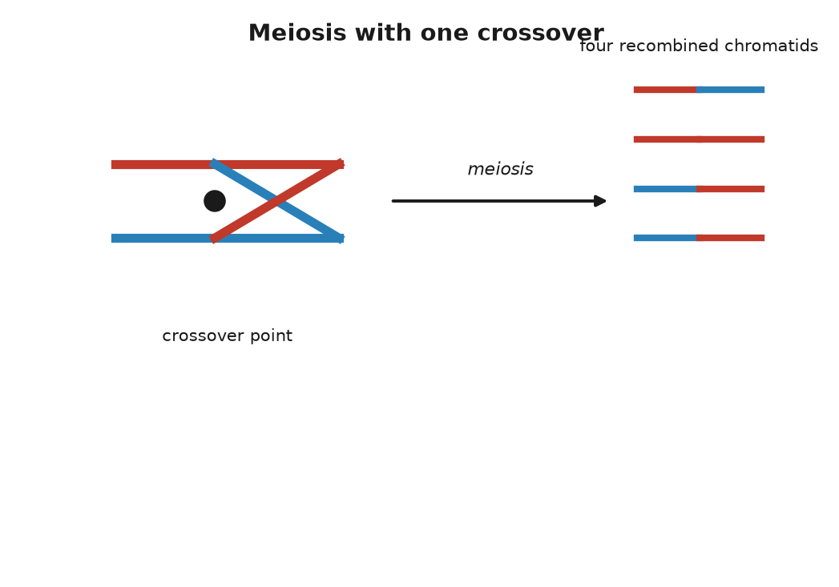
Figure 12. Meiosis, with one crossover between a maternal and a paternal chromosome.

The Arithmetic of a Family
Put the two shuffles together and the arithmetic of the family photograph falls out. Anna received exactly one full set of 23 from Ruth, so Anna and Ruth share half of their text, exactly, not on average. Which half was decided by the coin tosses and crossovers in one egg in 1977. At the MC1R position, the chance that the egg carried the freckling variant was one in two. It did.
Theo is a second toss. The chromosome 16 that Anna passed to him was itself a splice of her two copies, one from Ruth and one from Anna’s father. Again, one chance in two at the freckle position. Again, it came through. On average a grandchild carries a quarter of a grandparent’s text, but “on average” is doing real work in that sentence. Because the pieces are dealt in chunks, the actual fraction varies from grandchild to grandchild. Theo might carry 20 percent of Ruth, or 30 percent; a whole chromosome from Ruth may have gone through untouched, and another may be absent entirely.
The same spread shows up between brothers and sisters, and it has been measured. Two children of the same parents share half their text on average, since each got a random half of each parent. But each child’s random half is its own, not a copy of the other’s. Peter Visscher and colleagues, in a 2006 paper in PLoS Genetics, used genetic markers to measure the actual sharing in several thousand pairs of siblings and found that it ran from roughly 37 percent to 62 percent. Some brothers are, genetically, nearer to cousins than the average implies. Some are much closer than that. Anyone who has watched two siblings and wondered how they emerged from the same house has, in a sense, been measuring this.
It is worth pausing on what the shuffle rules out. The nineteenth century’s default picture of inheritance was blending: the child as a mix, half of one parent’s fluid and half of the other’s, the way paint mixes. Darwin held a version of it, and it gave him trouble. In 1867 the engineer Fleeming Jenkin pointed out in a review that under blending any new advantageous variant would be diluted by half in the first generation and by half again in the next, and would vanish before selection could act on it. Darwin had no answer. The answer was in a paper in Brünn that he never read. Traits are not fluids. They are carried on particles, on stretches of text, and a stretch of text is either copied into the egg or it is not. Ruth’s freckles were not halved in Anna and quartered in Theo. They are present in Theo at full strength and can go into his children the same way, whatever his father contributed, which in this case was nothing.

An Egg Made in 1947
One last thing about eggs, because the timing is a small surprise that makes the mechanism real. A woman’s eggs are not made through her life. They form before she is born. By about the fifth month of a female fetus’s development, all of the cells that will ever become eggs have formed and have begun meiosis, and then they stop, part way through the first division, with their chromosomes already paired and the crossovers already completed. They wait in that state until ovulation, one or a few at a time, from puberty on.
So the egg that became Anna began its meiosis inside Ruth in 1947 or early 1948, while Ruth was herself inside her mother, and finished it in 1977, about 29 years later. And the egg that became Theo began meiosis inside Anna in 1978, when Anna was a fetus in Ruth’s womb. For a few months that year, a cell that would become part of Theo was physically present inside Ruth. Three generations, one body. Sperm are produced the other way, continuously from puberty, at a rate reported as about a thousand per second, and every one of them is the product of a fresh chain of cell divisions, which is why the new mutations in Chapter 40 come mostly from the father.
The long wait has a cost. Paired chromosomes held for decades sometimes fail to separate cleanly when the division finally resumes, and an egg ends up with two copies of a chromosome instead of one. Fertilized, it gives a child with three. For most chromosomes this is not survivable. For chromosome 21, the smallest, it is, and the result is Down syndrome, which occurs in about 1 birth in 700 overall and rises with the mother’s age, from roughly 1 in 1,200 at 25 to about 1 in 100 at 40. It is the same mechanism that gave Theo his freckles, run with one step out of place.
Twenty-two of the 23 pairs play this game evenly, with both partners the same size and carrying the same genes. The twenty-third pair does not, and its unevenness decides who can inherit what.
↑ Back to Contents

Chapter 42: Who Gets What — X, Y, and the Mother’s Line

A Queen’s Eighth Child
On 7 April 1853, at Buckingham Palace, Queen Victoria gave birth to her eighth child, a boy named Leopold, with chloroform administered by the physician John Snow. She thought the anaesthetic delightful and said so. The boy was less fortunate. He bruised at the slightest knock, bled for hours from small cuts, and spent much of his childhood in bed with swollen joints. The doctors called it hemophilia, a word that had been in use for a few decades. In March 1884, on the stairs of a club in Cannes, Leopold slipped, fell, and died the next morning of a bleed into the brain. He was thirty.
Neither of Victoria’s parents had the disease, and neither, as far as the records show, did anyone in the generations before them. She carried a change that was new in her, or in one of her parents’ cells. Two of her daughters, Alice and Beatrice, carried it too, and through them it traveled into the ruling houses of Germany, Spain and Russia. Alice’s daughter Alix married Nicholas II and became Empress Alexandra; their only son, Alexei, born in 1904, had the disease, and the family’s desperation over his bleeding gave the monk Rasputin his place at court. Two of Beatrice’s grandsons, Spanish princes, died in the 1930s after car accidents, from injuries that a clotting body would have survived. In 2009 a team led by Evgeny Rogaev, working on the Romanov remains recovered near Yekaterinburg, reported in Science that the family’s mutation was a single-letter change affecting the splicing of the gene F9: hemophilia B, rather than the commoner hemophilia A.
The pattern in that family is the textbook pattern, and it was recognizable well before anyone knew what a gene was. The disease appeared in sons. It was passed by mothers who were themselves well. Affected fathers, when they survived to have children, had healthy sons and carrier daughters. It skipped, and it reappeared. The explanation is the uneven twenty-third pair.

The Twenty-Third Pair
Twenty-two of the pairs in every human cell are matched partners. The twenty-third is either two X chromosomes, in which case the person is, with rare exceptions, female, or one X and one Y, in which case male. The X is a substantial chromosome, about 156 million letters long, roughly a twentieth of the whole 3.1-billion-letter text, and carrying about 800 protein-coding genes. The Y is a runt. In the reference genome it was listed at about 57 million letters, under a fiftieth of the text and more than half of that repetitive sequence so tangled that it was not fully read until 2023, and it carries only a few dozen protein-coding genes. The two share a short region at each tip, where they can pair during meiosis; along the rest of their length they have almost nothing in common.
What the Y does have is one compact gene, SRY, near its tip. It was found in 1990 by Andrew Sinclair, Peter Goodfellow, Robin Lovell-Badge and colleagues in London, and the next year Lovell-Badge’s group showed that a mouse embryo with two X chromosomes and an inserted copy of the mouse version of the gene develops as a male. The gene is a switch. Around the sixth week of development, in an embryo that has it, the protein it encodes starts a cascade that makes the primitive gonads become testes, and the rest follows from the hormones the testes produce. Without it, the default is ovaries. People exist with an X and a Y and a broken SRY who develop as women, and people with two Xs and a stray copy of SRY who develop as men. One gene of a few hundred coding letters, on a chromosome that is otherwise mostly rubble, decides.
The egg always contributes an X. The sperm contributes an X or a Y, so it is the father’s contribution that decides the sex of a child, a fact that would have been of some use to Henry VIII. The chance is close to even, with a small excess of boys at birth, about 105 to every 100 girls, for reasons that are not fully understood.
Now the pattern. A gene on the X chromosome has two copies in a woman and one in a man. If a variant on the X is recessive, meaning that a working copy on the partner chromosome masks it, then a woman with one bad copy is well, and a man with one bad copy has no partner chromosome to mask it, because his other sex chromosome is the Y and the Y does not carry the gene. So a carrier mother passes the variant to half her children on average: her sons who receive it are affected, her daughters who receive it are carriers. An affected father passes his X to all of his daughters, who become carriers, and his Y to all of his sons, who are untouched. This is Victoria’s family drawn as a rule.
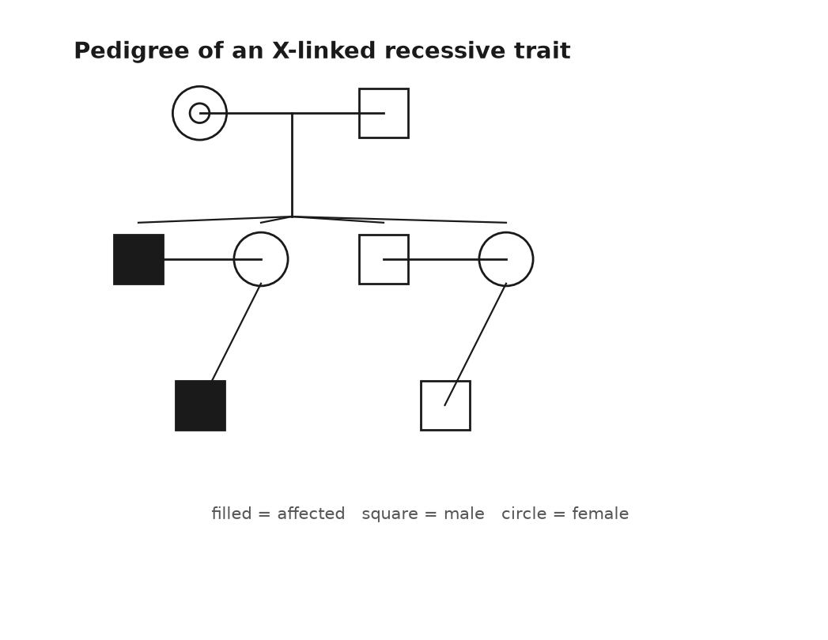
Figure 13. A pedigree of an X-linked recessive trait across four generations.
The commonest X-linked trait is not a disease but a limitation. About 8 percent of men of northern European ancestry cannot distinguish reds and greens as most people do, against about 0.5 percent of women. The genes for the red-sensitive and green-sensitive pigments of the retina, OPN1LW and OPN1MW, lie side by side near the tip of the X, so similar in sequence that during meiosis the paired chromosomes sometimes misalign by one gene and exchange unequally, deleting or blending copies. Jeremy Nathans worked this out in 1986. Hemophilia A comes from variants in F8, also on the X; hemophilia B from F9. Duchenne muscular dystrophy comes from DMD, which at about 2.2 million letters is the longest gene in the human text and, being long, is a large target for damage. A daughter of a color-blind father is a carrier for certain, and a son of that daughter has one chance in two.

Every Woman Is a Mosaic
There is a complication in the rule, and it is a beautiful one. A woman has two Xs and a man has one, so a woman’s cells ought to make twice the dose of every X-linked protein, which for most genes would be a problem. They do not. In 1961 Mary Lyon, working on coat color in mice at Harwell in England, proposed in a short letter to Nature that early in the development of a female embryo each cell switches off one of its two X chromosomes at random and leaves the other running, and that every descendant of that cell keeps the same choice. The silenced chromosome curls into a dense knot at the edge of the nucleus that Murray Barr had seen in 1949 and that is still called the Barr body. The switch itself is an extended molecule of RNA, ribonucleic acid, DNA’s single-stranded cousin, made by a gene named XIST, found in 1991, which coats the chromosome it came from and shuts it down.
The consequence is that every woman is a mosaic. In some patches of her body the X from her mother is working; in others, the X from her father. The clearest demonstration walks about on four legs. In cats, the gene that makes fur orange rather than black sits on the X. A male cat has one X and is either orange or not. A female with an orange allele, the working term for one version of a gene, on one X and a non-orange allele on the other is a tortoiseshell: patches of orange where the non-orange X was silenced, patches of black where the orange one was. Add the unrelated white-spotting gene and she is a calico. Almost every calico is female. The rare male has two Xs and a Y. The identity of the orange gene stayed unknown until 2025, when two groups reported that it is a deletion that alters the activity of a gene named ARHGAP36. The mosaic matters for people too. A woman carrying a variant for an X-linked disease is usually well, but if by chance the healthy X was silenced in most of the relevant tissue she can have symptoms, and some do.

Lines That Do Not Shuffle
Two other parts of the text follow rules of their own, and they are worth knowing about because they have become the working tools of ancestry.
The first is not in the nucleus at all. Every cell contains hundreds to thousands of mitochondria, the compartments in which sugar and oxygen are turned into ATP, adenosine triphosphate, the tiny molecule a cell spends the way a household spends electricity, and each mitochondrion carries its own small circle of DNA. The human version is 16,569 letters long, holds 37 genes, and was read in full by Fred Sanger’s laboratory in Cambridge in 1981, one of the first complete pieces of human text. It is a leftover. Mitochondria are descended from free-living bacteria that took up residence inside another cell something like two billion years ago, and their little genome is what remains of the bacterium’s own. It is inherited from the mother only. An egg holds around a hundred thousand copies; a sperm brings a hundred or so in its midpiece, and those are tagged and destroyed after fertilization. A child’s mitochondrial text is the mother’s, which is her mother’s, unchanged apart from the occasional copying error, back along a single unbroken line of women. The father contributed none, and a son, if he has children, will pass none.
The second is the Y, which goes the other way, father to son, and unlike the other chromosomes never recombines along most of its length, because it has no matching partner. A surname in a patrilineal culture travels the same route. In 2000 Bryan Sykes tested this on his own name and reported that roughly half of the men named Sykes he sampled in Britain shared one Y type, consistent with a single founder some seven centuries ago and a modest rate, in each generation, of what geneticists politely call non-paternity.
Because these two pieces of text do not shuffle, every difference between two people’s copies is a mutation that happened since their lines diverged, and the differences can be sorted into a tree. Rebecca Cann, Mark Stoneking and Allan Wilson did this in a Nature paper in 1987 with mitochondrial DNA from 147 people, found that the deepest branches were African, and estimated that all of the copies traced to a single woman who lived about 200,000 years ago. The press named her Mitochondrial Eve, and the name has caused confusion ever since.
She was not the first woman, or the only woman alive, or anyone’s Eve. She is a statistical necessity. Take any set of people and follow their mothers’ mothers’ lines into the past; the lines merge, since every woman had one mother, and they must all meet somewhere. Lines also end, whenever a woman has only sons or no children, and as they end, the meeting point moves forward in time. Thousands of women were alive alongside her, and most of them are your ancestors too, by other routes; they simply did not pass you a mitochondrion. The same logic applied to the Y gives a most recent common male ancestor. The two are not a couple and need not have lived at the same time. Current estimates, with wide error bars, put the mitochondrial ancestor at roughly 150,000 to 200,000 years ago and the Y ancestor at roughly 200,000 to 300,000 years ago, the latter pushed earlier in 2013 when a rare lineage from Cameroon turned up that branched off deeper than any known before. The letters that ancestry companies attach to your mitochondrial and Y types, H, U, L3, R1b and the rest, are branches on those two trees, called haplogroups, and they tell you about two lines of ancestry out of the thousands you have.
Which brings the question back from lines to letters. A version of a gene arrived from one parent or the other, on one chromosome or another. Whether the version you received shows itself, or waits behind its partner, is the next thing to settle, and it is the one puzzle in this part that Mendel would have recognized at once.
↑ Back to Contents

Chapter 43: Dominant and Recessive — The Messy Middle and Heritability

The Worksheet
A school worksheet still says that brown eyes are dominant over blue. A brown-eyed parent carries B or b; a blue-eyed parent is bb; fill in the square, a grid geneticists call a Punnett square, after Reginald Punnett, for working out the odds of each combination. One line at the bottom asks whether two blue-eyed parents can have a brown-eyed child, and the expected answer is no. The worksheet is wrong.
It is wrong in an honorable way, because it repeats a model published in 1907 by Charles and Gertrude Davenport, which was the best available at the time and is still the version most people carry around. Eye color is not one gene. The biggest single lever, pinned down by two groups in 2008, is one letter inside an intron, a stretch of the gene cut out before its message is read, of a gene named HERC2 on chromosome 15, which controls how strongly its neighbor OCA2 is switched on in the iris; OCA2 makes a protein needed to load pigment into the cells there. That one letter accounts for most of the difference between blue and brown in Europeans. But a 2021 study of nearly 200,000 people identified some fifty further regions of the text that nudge the shade, and green, hazel and gray are made by combinations of them. Two blue-eyed parents can have a brown-eyed child. It is uncommon. It happens.
So this chapter has two halves, and they are the two halves of inheritance. Some traits really do behave the way the worksheet says: one gene, two versions, a clean rule. Most do not. And the interesting part is what “dominant” turns out to mean when you look at the protein.

One Gene, Two Copies
Take cystic fibrosis. The gene is CFTR, on chromosome 7, found in 1989 by a collaboration between Lap-Chee Tsui’s group in Toronto and Francis Collins’s in Michigan, at the end of a search through about 250,000 letters of text. The protein sits in the membranes of lung, gut and sweat-gland cells and pumps chloride; when it fails, the mucus thickens, and the lungs clog and become infected. More than 2,000 different variants of CFTR have been documented in patients, but one of them, called ΔF508, accounts for about 70 percent of the disease-causing copies in people of European ancestry. It is a deletion of three letters, which removes a single amino acid, a phenylalanine, at position 508 of a chain 1,480 long. The protein folds wrong, and the cell’s quality control destroys it before it reaches the membrane.
Cystic fibrosis is recessive. One working copy of CFTR makes enough protein; a person with one ΔF508 and one normal copy is a carrier and is well. About 1 in 25 people of European ancestry is such a carrier. The chance that two carriers have children together is therefore about 1 in 625, and the chance that any given child of two carriers receives the variant from both is 1 in 4, which is Mendel’s ratio. Multiply, and the disease appears in about 1 in 2,500 births in those populations, which is close to what the registries record. The carriers, being well, never see the variant in themselves; it surfaces two generations after entering a family, or ten, whenever two lines carrying it happen to meet. Since October 2019 a combination of three drugs, sold in the United States as Trikafta, has been able to coax the ΔF508 protein into a shape the cell will accept, and the median predicted survival for a child born with the disease, which was a few years in the 1950s, now runs past fifty.
Sickle cell disease follows the same rule with one addition that explains why it is so common. The variant is Glu6Val in HBB, from Chapter 36. Two copies give the disease; one copy gives sickle cell trait, and a person with the trait is mostly well. But in 1954 Anthony Allison, working in Kenya and Uganda, showed that children with one copy were far less likely to suffer severe malaria than children with none, and the map of the variant across Africa, the Mediterranean and India follows the historical map of the parasite. In parts of sub-Saharan Africa 10 to 20 percent of people carry it, and about 1 in 13 African Americans does. This is a balanced polymorphism: the carriers do better than either kind of non-carrier, so the population keeps a variant that kills a fraction of its children. About 300,000 babies a year are born with the disease worldwide. Evolution has no master plan and does not apologize.
Huntington’s disease is the other way round. It is dominant: one copy is enough, and each child of an affected parent has one chance in two, regardless of the other parent. The gene, HTT on chromosome 4, was located in 1983 by James Gusella’s group using markers in the enormous families around Lake Maracaibo in Venezuela that Nancy Wexler had spent years documenting, and the gene itself was found in 1993 by a collaboration of several groups. The variant is not a single wrong letter but a stutter: a run of the triplet CAG that is repeated about 10 to 35 times in most people and 40 or more times in those who will develop the disease. The extra repeats put a long tail of glutamines on the huntingtin protein, and the tail does damage on its own. That is why it is dominant. It is not that one healthy copy is too weak; it is that the mutant copy does something harmful that the healthy copy cannot undo. Symptoms typically begin in the thirties or forties, after the age at which most people have had children, which is why the variant persists.
That is the lesson hidden in the worksheet. Dominance is not a property of a gene; it is a property of what one copy of a particular variant does at the level of the protein. A variant that destroys a protein is usually recessive, because one working copy usually suffices. A variant that makes a protein do something new, or a variant in a gene where half the dose is not enough, is dominant. Familial hypercholesterolaemia is the second kind: one damaged copy of LDLR, the receptor that clears cholesterol from the blood, roughly doubles a person’s LDL and brings heart attacks forward into the forties and fifties, while two damaged copies give LDL several times normal and heart attacks in childhood. One copy is bad and two are worse, which is called incomplete dominance, and about 1 person in 250 has the one-copy form.
Blood groups show the last variation. The ABO system, discovered by Karl Landsteiner in 1901, which brought him the 1930 Nobel Prize in Physiology or Medicine, comes from one gene on chromosome 9 that makes an enzyme adding a sugar to the surface of red cells. The A version adds one sugar, and the B version, differing by a handful of amino acids, adds another. The O version has a single letter missing near the start, which shifts the reading frame, the three-letter groupings a cell reads its text in, and produces no working enzyme at all. Someone with an A and a B copy makes both sugars and is blood group AB: neither allele hides the other, and this is codominance. O is recessive to both, being nothing. Six combinations give four blood groups, and two group-A parents, each carrying an O, can have a group-O child and be surprised.
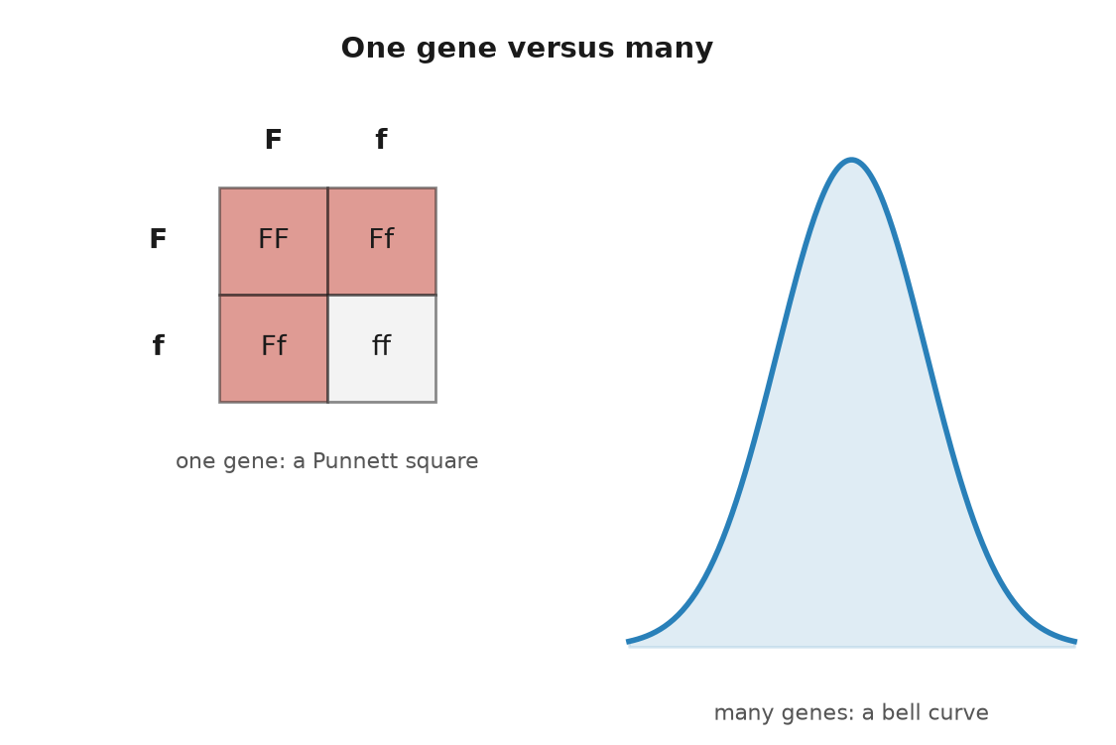
Figure 14. A Punnett square for one gene beside the bell curve that thousands of genes produce.

The Middle
Then there is the middle, where most of what we can see about each other lives.
Height is the classic. Francis Galton measured 928 adult children and their parents in the 1880s and noticed that the children of very tall parents were tall but not as tall, and the children of very short parents short but not as short; he termed it regression toward mediocrity, and the statistical idea of regression is his. Height sits on a bell curve, with no clean categories, and the early Mendelians and the biometricians who studied such curves spent the 1900s arguing about whether Mendel’s rules could possibly apply to it. In 1918 Ronald Fisher settled the matter on paper: if a trait depends on many genes, each with a small effect, each following Mendel’s rules, the sum comes out as a bell curve. Both sides were right.
The count was filled in a century later. In October 2022 a consortium led by Loïc Yengo published in Nature an analysis of 5.4 million people and identified 12,111 positions in the text where a single-letter variant is associated with height. Together they account for about 40 percent of the variation in height among people of European ancestry, and considerably less in people of other ancestries, because most of the 5.4 million were European and the markers travel badly. The variants are not spread evenly; they cluster in about a fifth of the genome, near genes that build cartilage and bone. Twelve thousand levers, each moving the needle by a fraction of a millimeter.
Skin color is another. A single variant in a gene called SLC24A5, found in 2005 by Keith Cheng’s laboratory after they noticed a pale mutant of the zebrafish, is nearly universal in Europeans and nearly absent in West Africans, and accounts for a large share of the difference in pigmentation between those two groups. It is one of a dozen or more genes with detectable effects, including SLC45A2, OCA2, MC1R and KITLG, and a 2017 study of African populations by Sarah Tishkoff’s group showed that much of the variation at these genes is far older than our species, so that light and dark alleles were both in circulation before there were humans to carry them.
Theo’s freckles belong here, with a footnote. MC1R is a major gene for freckling, and a person with a strong variant will usually freckle; how many and how dark depend on other genes and on the sun. Anna’s switch, from her father, is Mendelian and dominant. Two traits at the same table, one governed by a square and one by a curve.

Heritability
Which brings in the word that causes more confusion than any other in this field. Height is said to be about 80 percent heritable. That does not mean that 80 percent of a person’s height came from the genes and 20 percent from breakfast. Heritability is a statistic about a population, not a fraction of a person. It is the share of the variation in a trait, among the people in a particular population living in a particular range of environments, that can be attributed to the genetic differences between them. Change the population or the environment and the number changes.
Two examples pin this down. The number of fingers a person has is obviously genetic, and its heritability is close to zero, because almost all the variation in finger count comes from accidents. And Dutch men grew about 20 centimeters taller between the 1850s and the 1990s while the heritability of height stayed high throughout; the genes explained who was taller than whom in each decade, and the food explained why every decade was taller than the last. High heritability says nothing about whether a trait can be changed. It says how much of the spread, here and now, tracks the text.
The numbers come mostly from twins. Identical twins share essentially all their text; fraternal twins share half on average, like any siblings. If a trait runs more alike in identical pairs than in fraternal pairs, the excess is attributed to genes, and the geneticist Douglas Falconer gave the formula: twice the difference between the two correlations. A 2015 review in Nature Genetics by Tinca Polderman and colleagues gathered 2,748 twin studies covering 17,804 traits in 14.5 million pairs, and found that the average heritability across everything ever measured in twins was about 49 percent. The method has known weaknesses. It assumes that identical and fraternal twins are treated equally alike, which is not quite true. It cannot say which genes. It counts a child who inherits both a musician’s genes and the family piano as a genetic effect. And it describes one population at one time. Within those limits, it is settled that almost every human trait anyone has bothered to measure is heritable to some degree, and that almost none is heritable entirely.
Even 80 percent leaves a fifth of the story to something else, and for height, as for the rest, the something else begins before birth.
↑ Back to Contents

Chapter 44: What Is Not in the Genes — Environment, Noise and Epigenetics

The Hunger Winter
In September 1944 the Dutch government in exile called a railway strike to help the Allied advance, and the German administration in the occupied Netherlands answered by cutting food shipments to the west of the country. Then the canals froze. By the turn of the year the cities of the west, Amsterdam, Rotterdam, The Hague, Leiden, were on an official ration that fell through the winter to somewhere between 400 and 800 calories a day, less than a third of what an adult needs. People walked out to the farms to trade linen for potatoes. They ate sugar beets and tulip bulbs. Estimates of the deaths run from about 18,000 to 22,000. Relief came at the end of April 1945, with bombers dropping food instead of bombs, and liberation on 5 May.
The winter was brief and sharply bounded, and the Dutch, who kept careful records even in the worst of it, had unknowingly built the cleanest natural experiment in human nutrition that exists. Every child conceived or carried in those months has a known date and a known exposure. In 1976 Gian-Paolo Ravelli, Zena Stein and Mervyn Susser published in the New England Journal of Medicine a study of about 300,000 nineteen-year-old men examined for military service, and reported that those who had been in the first half of gestation during the famine were markedly more likely to be obese, reported as close to double the rate of the unexposed. Later work by Susser, Hans Hoek and others found that people conceived at the height of the hunger were about twice as likely to develop schizophrenia. Tessa Roseboom and colleagues in Amsterdam followed the cohort into their fifties and sixties and added heart disease, glucose intolerance and several other conditions. These associations are settled: measured, and repeated for half a century.
In 2008 Bas Heijmans and colleagues at Leiden published in PNAS a first look at a mechanism. They took blood from 60 people who had been conceived during the famine and compared them, six decades on, with their own same-sex brothers and sisters who had not been. At a regulatory region of the gene IGF2, which governs growth in the fetus, the famine group had less methylation, a chemical tag on the DNA that turns a gene up or down without changing its letters, by about 5 percent, than their siblings. The effect was small. It was consistent. And it had been laid down in the first ten weeks of a pregnancy in the winter of 1944 and was still there in 2008.
Hold onto what that means. The text of those people was fixed at conception and did not change. What their mothers ate in the first ten weeks altered how the text was read, and the alteration lasted. The tube in the mailbox reads letters. It does not read winters.

Figure 15. A bare field in winter, furrows and nothing in leaf.

Environment and Noise
Three things are not in the genes, and the first, environment, is the one everybody grants. The second is development, and the third is chance, and the two are hard to separate, so take them together with the tightest possible test: two people with the same text.
Identical twins come from one fertilized egg that split, and for most of the twentieth century they were treated as genetically identical by definition. In 2021 a group at deCODE in Iceland led by Hákon Jónsson sequenced 381 pairs, with their parents and children, and reported in Nature Genetics that a typical pair differ at about five positions, mutations that arose in the first few cell divisions after the split, and that some pairs differ at more than a hundred. So “identical” is an average. What is more striking is how different the outcomes can be when the text is the same. If one identical twin develops schizophrenia, the chance that the other does is reported at roughly half. For type 1 diabetes the concordance is reported in the range of 30 to 50 percent; for multiple sclerosis, roughly 25 to 30 percent. Half the time or more, the co-twin escapes, with the same letters.
Fingerprints are the miniature, exact version of this. The ridges on the fingertips form between roughly the tenth and sixteenth week of gestation, where the skin buckles under pressure from the growing pads beneath it and the fluid around it, and the pattern depends on the geometry of that moment: the fetus’s position, the blood pressure in the finger, the exact rate of growth that week. Identical twins have similar types of pattern, loops or whorls, and distinct prints, which is why Francis Galton, who published the first systematic book on fingerprints in 1892, could recommend them for identification, and why Scotland Yard began using them in 1901. Nothing in the text specifies a print. The text specifies a process, and the process has noise in it.
The noise goes deeper than skin. The tiny roundworm Caenorhabditis elegans has exactly 959 cells as an adult, every one of them arising by a lineage that is the same in every worm, and worms can be bred so that all have the same text and can be kept in the same dish at the same temperature on the same food. They still die at varying ages, spread over days in a life of two or three weeks. Nobody arranged that. Molecules jostle, a gene fires a little early in one cell and a little late in another, and the differences ripple outward. Some of the variation in any population, and nobody knows exactly how much, is nothing more than this.

Genetic Is Not Fixed
The third thing not in the genes is the one that the word “genetic” most misleads people about, and the clearest case is a disease that is entirely genetic and entirely preventable.
In 1934 a Norwegian physician, Asbjørn Følling, examined two young siblings with severe intellectual disability whose mother had noticed a strange musty smell in their urine, and found that the urine contained phenylpyruvic acid. The condition was named phenylketonuria, PKU. It is recessive and caused by variants in PAH on chromosome 12, whose enzyme breaks down the amino acid phenylalanine. Without it, phenylalanine from ordinary food piles up and poisons the developing brain. In 1953 Horst Bickel in Birmingham showed that a diet nearly free of phenylalanine, started early, prevents the damage, and in 1963 Robert Guthrie’s heel-prick test made it possible to find the affected babies in the first days of life, which is where universal newborn screening began. About 1 baby in 10,000 of European ancestry has PKU, with the rate varying widely between countries. On the diet, they grow up with normal intelligence.
Consider the heritability. In a world where everyone eats ordinary food, PKU is close to 100 percent heritable; who has it is decided by the text and nothing else. In a world with the diet, the disability disappears and the genes are unchanged. The heritability of the disease, as a disease, drops toward zero, not because the genes have changed but because the environment has. A high heritability, as the last chapter said, is a statement about the spread in one setting. It is not a sentence.
The same logic runs the other way. Short sight is highly heritable in every population that has been measured, and in the cities of East Asia its prevalence in young adults has risen to reported levels of 80 to 90 percent within two generations, a change far too fast for the text to have moved. What moved was childhood: more hours indoors, less bright light. A gene that raises the risk of myopia raises it in a child who reads indoors; in a child who herds goats, the same gene may do very little. There is no such thing as the effect of a gene. There is the effect of a gene in an environment.

Can a Grandmother’s Life Be Inherited?
What about the other direction: could a grandmother’s environment have left a mark on the text that a grandchild received? Not on the letters; that is Chapter 40’s business, and the letters mutate by their own chemistry, not by need. The candidate is the layer of marks on top of the letters, the methyl groups and histone tags of Chapter 39, which decide which parts of the text are read in which cell. Within one body these marks are settled science; they are how a liver cell’s daughters stay liver cells. The question is whether an acquired mark can cross into the next generation.
The problem for mammals is that the marks are wiped, twice. When the cells that will become eggs or sperm are first set aside in the embryo, their methylation is stripped almost entirely and rewritten, and after fertilization most of what remains on both the egg’s and the sperm’s contribution is stripped again. A mark acquired in 1950 would have to survive the first wipe in the grandmother’s ovaries, be laid down in the egg that became the daughter, survive the second wipe in the embryo, survive the first wipe again in the daughter’s fetal ovaries, and survive the second wipe again in the grandchild. Some things do survive, by design: the imprinted genes, of which IGF2 is one, keep a parent-specific mark on purpose. A few stretches of repetitive DNA escape by accident.
In plants and worms the story is different, and it is settled. Plants set aside no early germ line, no cells reserved from the start to become eggs or sperm; their flowers grow late from ordinary tissue, and a methylation state can pass down unchanged for many generations. Linnaeus described a toadflax in 1744 whose flowers were radially symmetrical instead of the usual snapdragon shape, and in 1999 Enrico Coen’s group at Norwich showed that the difference was not a change in the letters of the gene concerned but a heavy methylation of it, inherited as if it were a mutation. In maize, one allele can permanently reprogram its partner, a phenomenon called paramutation that Alexander Brink described in 1956. In the roundworm, tiny RNA molecules made in response to a virus or to starvation are passed through eggs and sperm and keep working in descendants for three or more generations, as Oded Rechavi’s group showed in 2011 and 2014.
In mice there is one famous case and a handful of contested ones. The agouti viable yellow mouse carries a jumping element parked next to the coat-color gene Agouti; whether the element is methylated is set partly at random in each embryo, and unmethylated mice come out yellow and fat, methylated ones brown and lean. In 2003 Robert Waterland and Randy Jirtle showed that feeding pregnant mothers extra methyl donors, folate, vitamin B12, choline and betaine, shifted the litters toward brown. That is a diet in the womb changing a mark in the offspring, and it is settled. Whether the shift persists into the grandchildren, past the wipes, is weaker, and the studies reporting it have been hard to repeat. Sperm from male mice on a high-fat diet carry altered tiny RNAs that affect their pups’ metabolism, which is a working result, not yet a settled one.
In humans the evidence for transmission across generations, as opposed to exposure in the womb, is thin. There is a distinction that matters here. When a pregnant woman starves, three generations are in the room: the woman, the fetus, and the fetus’s germ cells, which will become the grandchildren. Effects in the grandchildren are not evidence that anything crossed a generation; they may be direct exposure, once removed. Only the great-grandchildren would tell. Studies from the Swedish parish of Överkalix, published by Marcus Pembrey and Lars Olov Bygren in 2006, reported that a grandfather’s food supply as a boy was linked to his grandsons’ lifespans, in a small population with many possible confounders; the result has been much cited and not convincingly repeated. I think the honest summary is this: in humans, intergenerational effects through the womb are settled, transgenerational epigenetic inheritance through the germ line is speculative, and the burden of proof sits with the claim.
That leaves Lamarck, who in 1809 proposed that features acquired by use or disuse were passed on, the giraffe’s stretched neck to its calf, and whose name has been attached to every version of the idea since. Darwin himself accepted a version of it. It was August Weismann, in the 1880s, who argued that the germ line is sealed off from the body, and who reported cutting the tails off several hundred mice across five generations without producing a single short-tailed pup, a demonstration that was mocked at the time and is decisive anyway. The seal is real, and it leaks a little at the edges, through imprinted genes and tiny RNAs, and nothing that leaks through carries information about what an animal did or wanted. The ghost is mostly still a ghost, and where it is not, it is a few marks, for a few generations, by a mechanism Lamarck never imagined.
Ruth’s freckles reached Theo because a stretch of letters was copied twice and came through both times intact; the winter of 1944 reached its children, perhaps their children, and then stopped, because it was never written in the letters to be copied. What the letters do carry, and in what proportions, was first counted, with a paintbrush and a very large amount of patience, by a friar in a garden in Moravia.
↑ Back to Contents

Chapter 45: Brno, 1856 — Peas in a Garden

A Strip of Ground in Brno
The garden is a strip of ground about thirty-five meters long and seven wide, along the south wall of an Augustinian abbey in the Moravian town of Brünn, which is now Brno in the Czech Republic. It is the spring of 1856. A stout man in a friar’s habit is kneeling among the pea plants with a pair of fine forceps and a small brush of the kind painters use for detail. He opens a flower bud that has not yet unfolded, picks out the ten immature stamens one by one, and drops them into a dish. Then he touches the brush to the open flower of a different plant, carries back a dusting of yellow pollen, and paints it onto the stigma of the flower he has just stripped. He slips a little bag over the flower, ties it, writes a label. Then he moves to the next bud.
He will do this, by his own account, for eight growing seasons, and he will raise and score something like 28,000 plants before he is done. Nobody has asked him to. Nobody is paying him. The result will be the first quantitative law of inheritance, and almost nobody will read it for thirty-five years.

The Friar
The man’s name was Gregor Mendel, and it had not always been. He was born Johann Mendel on 20 July 1822 in Heinzendorf, a village of German-speaking farmers in Austrian Silesia, now Hynčice in the Czech Republic. His father, Anton, worked a modest farm and owed the local landowner three days of labor a week. Johann was clever, and the village priest noticed. He was sent to the Gymnasium in Troppau and then to the philosophical institute in Olmütz, and the family’s money ran out along the way. His younger sister Theresia gave up part of her dowry to keep him in school. He fell ill more than once with what the records call nervous exhaustion and spent months at home in bed. A farm boy with a gift for mathematics and no money had, in the Austrian Empire of the 1840s, one reliable route to a life of study, and in 1843 he took it. He entered the Augustinian abbey of St Thomas in Brünn as a novice and was given the name Gregor.
The abbey was an unusual house. Its abbot, Cyrill Napp, ran it less like a place of prayer than like an unassuming college. The friars taught in the town’s schools, kept a library of several thousand volumes, maintained a mineral collection and a botanical garden, and counted a composer, a philosopher, and a plant breeder among their number. Moravia was sheep country and orchard country, and its landowners were seriously interested in better wool and better fruit. Napp himself had chaired a society for the improvement of sheep, and he had written, in the course of that work, that the real question was not whether traits were inherited but what was inherited and how. It is hard to imagine a better landlord for what Mendel was about to do.
Mendel was ordained in 1847. He was a poor parish priest; visiting the sick made him ill himself, and Napp moved him into teaching instead. He was good at it. In 1850 he sat the state examination for a teacher’s license, in Vienna, and failed. The examiners found his natural history patchy and his physics self-taught, which it was. What they did not find was any lack of ability, and one of them suggested that the abbey send him to university. Napp did. From the autumn of 1851 to the summer of 1853 Mendel was a student at the University of Vienna.
The physics there was taught by Christian Doppler, the man whose name is on the change in pitch of a passing siren. Doppler had set up the Physical Institute in Vienna the year before Mendel arrived, and he taught physics as a thing done with instruments and repetition, not a thing read about. Mendel also took mathematics from Andreas von Ettingshausen, including combinatorics, the arithmetic of how many ways things can be arranged. He took plant physiology from Franz Unger, who was already arguing, several years before Darwin’s book, that plant species were not fixed and that new forms arose from old. It was an odd education for a friar and exactly the right one for the problem he would choose. Unger gave him the puzzle, Doppler the habit of measurement, and Ettingshausen the arithmetic to read the answer.
He sat the teaching examination a second time in 1856 and did not complete it. The accounts differ; the usual one is that he fell ill during the oral, and one biographer suggests a quarrel with an examiner. He went back to Brünn, taught physics and natural history at the town’s technical school as a substitute for the next fourteen years, and that same spring began the crosses in the garden.

Why Peas
Why peas? The choice was not casual, and Mendel says so on the first pages of his paper. He wanted a plant that came in clearly different forms, that bred true when left alone, that could be crossed by hand when he wished, and whose hybrids were as fertile as their parents. The garden pea, Pisum sativum, passed on every count.
The crucial property is the flower. A pea flower is built like a small boat. Two lower petals are fused into a keel, and the keel wraps the stamens and the pistil so closely that pollen from outside almost never gets in. The plant fertilizes itself, usually before the flower has opened. A pea variety will therefore breed true for generation after generation, wrinkled giving wrinkled and tall giving tall, because nothing from outside is mixing in. This gave Mendel pure lines to start from. It also meant that when he wanted a cross he had to make it himself, and that when he had made it he could be nearly certain the pollen he painted on was the only pollen involved. The bags were insurance against the pea weevil and the occasional determined bee.
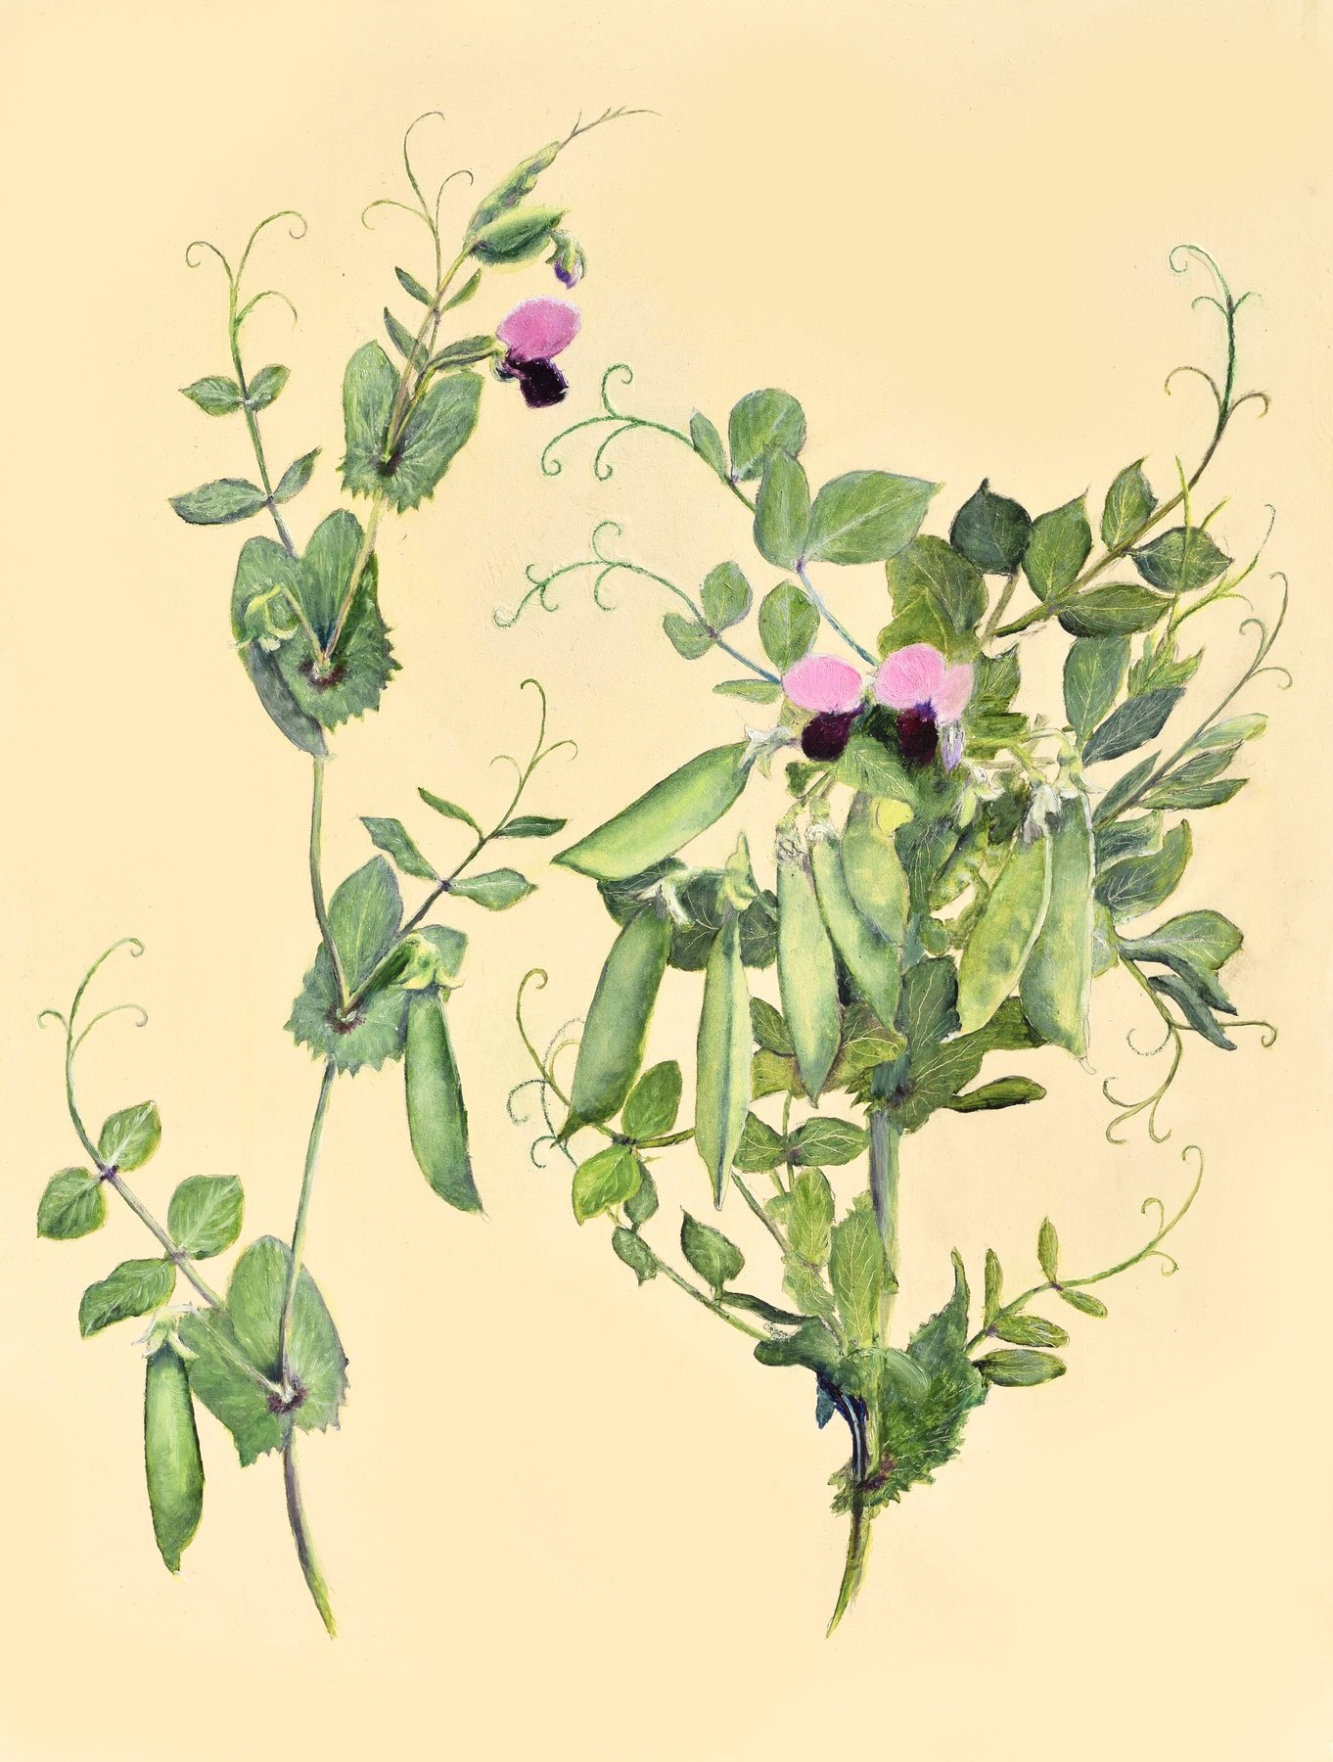
Figure 16. A drawing of Mendel’s pea flowers and pods.
Others had crossed plants before him, and some had done far more of it. Joseph Kölreuter in the 1760s and Carl Friedrich von Gärtner in the 1840s had between them performed thousands of crosses across hundreds of species. Gärtner’s book of 1849 runs to some 800 pages, and Mendel read it closely. What none of them had done was count. They had asked whether hybrids were possible, whether they were fertile, whether they resembled one parent or the other or something in between. They had not sown the hybrids’ seed, grown every plant, sorted the offspring by a single trait, and written down how many fell on each side. Mendel put his finger on this in the second paragraph of his paper. Nobody, he wrote, had determined the numbers of the various forms in each generation or their statistical relations. That sentence is the whole difference.
Before starting, he did something that separates him from nearly every hybridizer before him. He bought thirty-four varieties from seed merchants and grew them for two years, 1854 and 1855, simply to see whether each bred true. Twelve failed the test or were too close to others and were dropped. Twenty-two remained. This is the first step of a controlled experiment, establishing what your starting material does when you do nothing to it, and it is why his later numbers meant something.
Then he chose the traits. Pea varieties differ in dozens of ways, and most of the differences shade into one another. Mendel wanted characters that were either one thing or the other, with nothing between, so that a seed or a plant could be scored with a glance and no judgment. He settled on seven. The seed was round or wrinkled. The cotyledons, the seed’s own first pair of leaves, packed inside it, were yellow or green. The seed coat was gray-brown or white, and this went with the flower color, violet or white, so tightly that he treated the two as one character. The ripe pod was inflated or pinched in between the seeds. The unripe pod was green or yellow. The flowers grew along the stem, in the leaf axils, the narrow angles where each leaf meets the stem, or bunched at the top. The stem was long, around two meters, or short, well under half a meter.
Seven is a number people have wondered about since, because the pea has seven pairs of chromosomes, and it has been suggested that Mendel picked one trait per chromosome by luck or by cunning. Neither is right. He knew nothing of chromosomes, and later mapping showed that several of his seven characters sit on the same chromosome, far enough apart that the effect he would have needed to notice was small. He chose seven because seven gave him clean yes-or-no scoring, and he said so.

Eight Seasons of Labor
The work of the eight seasons was mostly labor. Each cross meant opening buds, removing stamens, painting on pollen, bagging, labeling, and later harvesting each pod separately and counting what was in it. The reciprocal crosses had to be done too, round pollen onto wrinkled flowers and wrinkled pollen onto round, so that he could show it made no difference which parent supplied which. Then the hybrid seeds had to be sown, grown, and left to fertilize themselves, and their seeds harvested and counted, and those sown in turn. For seed shape and seed color the answer was visible in the pod, and one plant could yield dozens of data points. For stem length or flower position each plant was a single data point and had to be grown to maturity. He raised tall and short varieties on the same plot so that soil would not confound the result, and he watched for that sort of confounding throughout. In the greenhouse he ran checks on whether flowers under bags gave the same results as flowers in the open.
Scoring was a physical job, not a judgment. Round seeds and wrinkled seeds were sorted into dishes and counted, pod by pod, and the dishes were the data. A seed that was neither clearly round nor clearly wrinkled would have wrecked the ratio, which is why he had spent two years throwing out varieties that shaded. The paper does not describe a statistical test, because the tests had not been invented. It describes piles.
It was weather-dependent work, and Mendel was one of Moravia’s most diligent recorders of weather. He kept daily readings for decades, published on the climate of Brünn, sent monthly reports to the meteorological service in Vienna, and once wrote a careful account of a tornado that crossed the abbey grounds. He kept bees and tried to cross them and failed, because he could not control whom a queen met in the air. The peas were the one system where he controlled everything.
The question Mendel had posed is the physicist’s version of a family puzzle. Not “what is inherited,” which was everyone’s puzzle, but “in what proportions, and does the proportion hold.” Doppler’s student asked it of a pea.
By the autumn of 1863 the crosses were finished. Mendel had, in his notebooks, counts from roughly 28,000 plants and a great many more seeds, and he had two winters in which to work out what the numbers meant.
↑ Back to Contents

Chapter 46: The Ratios — Mendel’s Counts and Laws

Five Thousand Four Hundred and Seventy-Four
Five thousand four hundred and seventy-four round. One thousand eight hundred and fifty wrinkled. The numbers are on a page of a paper published in Brünn in 1866, and they are the moment heredity stops being a matter of opinion. Divide one by the other and you get 2.96. Mendel wrote it as 2.96 to 1 and then, in the next breath, as what it plainly was: 3 to 1.
Here is how the numbers arose. Take a pea variety that has bred true for round seeds and one that has bred true for wrinkled. Cross them, either way round. Every seed in the resulting pods is round. Not mostly round, not a bit less wrinkled than the wrinkled parent; round, indistinguishable from the round parent’s own seed. The wrinkled character has vanished. Sow those round hybrid seeds, let the plants fertilize themselves, and open the pods. The wrinkled character is back, unchanged, in about a quarter of the seeds. In Mendel’s 253 hybrid plants that was 5,474 round and 1,850 wrinkled.
He called the character that showed in the hybrid dominant, and the one that hid, recessive. Both words are still in use. He then did the same for the other six characters and got the same shape of answer each time. Yellow cotyledons beat green, 6,022 to 2,001. Gray-brown seed coats beat white, 705 to 224. Inflated pods beat constricted, 882 to 299. Green unripe pods beat yellow, 428 to 152. Flowers along the stem beat flowers at the top, 651 to 207. Tall beat short, 787 to 277. Added up across all seven, 14,949 to 5,010, which is 2.98 to 1.
Character | Dominant form | Recessive form | Ratio
Seed shape | 5,474 round | 1,850 wrinkled | 2.96
Seed color | 6,022 yellow | 2,001 green | 3.01
Seed coat and flower | 705 gray-brown, violet | 224 white | 3.15
Pod shape | 882 inflated | 299 constricted | 2.95
Unripe pod color | 428 green | 152 yellow | 2.82
Flower position | 651 axial | 207 terminal | 3.14
Stem length | 787 long | 277 short | 2.84

A ratio that turns up seven times in seven different characters is not a fact about seed shape. It is a fact about how inheritance works. Mendel saw that, and then he did the thing that makes him Mendel rather than a lucky gardener. He asked what was underneath the 3.

Segregation
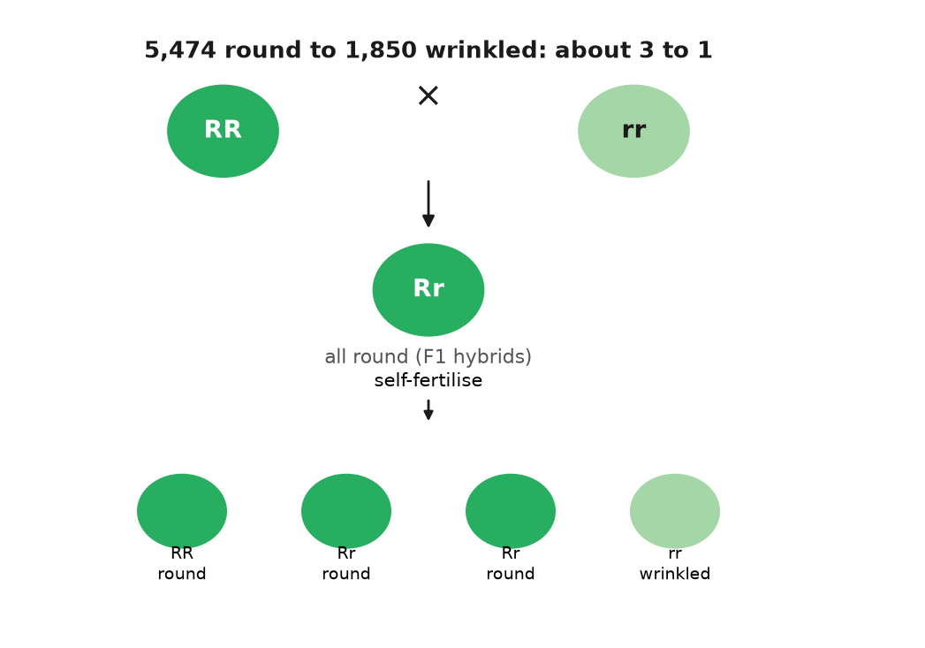
Figure 17. 5,474 round seeds to 1,850 wrinkled: about 3 to 1.
The answer came from the next generation. He took the round seeds from the hybrids’ pods, the three quarters, and sowed them. Some of those plants bred true: every seed round, generation after generation, exactly like the original round parent. Others did not: they gave round and wrinkled again, in the same 3 to 1. He counted. Of 565 plants grown from round hybrid seed, 193 bred true and 372 threw wrinkled seed. That is 1 to 1.93, and Mendel took it as 1 to 2. So the three quarters were not one thing. One quarter of the whole were true round, two quarters were round-looking hybrids, and one quarter were wrinkled. The 3 to 1 on the surface was a 1 to 2 to 1 underneath.
He wrote the underlying series as A + 2Aa + a, and that notation contains the whole theory. Each plant carries two factors for a character, one from each parent. A pure round plant is AA; a pure wrinkled plant is aa. The hybrid is Aa, and looks round because A is dominant. Dominant, here, does not mean common, and it does not mean healthy. It means that one copy is enough to show. A recessive character can be the ordinary one in a population, and a dominant one can be rare. The words describe the hybrid, not the world.
When the hybrid makes pollen or eggs, each grain or egg gets one factor, not both and not a blend, and it gets A or a with equal odds. Combine a random pollen grain with a random egg and you get AA one time in four, Aa two times in four, aa one time in four. That is the 1 to 2 to 1. Since AA and Aa look alike, it appears as 3 to 1. The recessive character had not been destroyed or diluted in the hybrid. It had been carried, whole and silent, and handed on.
This is what later textbooks call segregation, and it is worth pausing on how strange it was. Every theory of inheritance before Mendel, and Darwin’s own theory after him, assumed that the contributions of two parents mixed in the child like two inks in water. Mendel’s numbers said they did not. They said inheritance was made of particles that kept their identity, that a plant carried two of each and passed on one, and that which one was a matter of chance with fixed odds. The A and the a of 1866 are, at a distance of a century and a half, the two copies of a gene that every reader of this book carries at every position on every pair of chromosomes.
A neighbor’s garden makes the same mechanism concrete without pretending a person is a pea. Suppose a tall pea, Aa, is planted next to a short one, aa. The tall plant looks tall. It tells you nothing about the silent a it is carrying. Cross them and about half the offspring are short. The short ones reveal the a that the tall parent had hidden, exactly as the wrinkled factor was hidden in the round hybrid, and the two-thirds-to-one-third arithmetic of Mendel’s 565 plants would have given the odds of it. That is the entire content of a genetic counselor’s first sentence, and a friar counted it out in 1864. Human freckles are not this clean. They depend on several genes, the best known being MC1R, and on sunlight. The pea is the rule. The neighbor’s tall plant is the picture. A face is not.

The Second Law
Then Mendel did the experiment that turned one law into two. He crossed a plant with round yellow seeds to one with wrinkled green seeds. The hybrids were all round and yellow, as expected. He let them self-fertilize and opened 556 seeds. There were 315 round yellow, 101 wrinkled yellow, 108 round green, and 32 wrinkled green. Look at shape alone and it is 423 round to 133 wrinkled, about 3 to 1. Look at color alone and it is 416 yellow to 140 green, about 3 to 1. Each character had done its own thing without any regard to the other, and two independent 3 to 1s multiply out to 9 to 3 to 3 to 1. He tried three characters at once and got the 27-way series that theory predicted. The factors, whatever they were, were not only particles. They were separately dealt particles, shuffled without regard to one another.
That second rule, independent assortment, has a catch that Mendel could not have found with his seven characters, and it is an honest one to state now. Factors are dealt independently only when they sit on different chromosomes, or far apart on the same one. Factors that sit close together on the same chromosome tend to travel together, and the ratios bend. William Bateson and Reginald Punnett saw this in sweet peas in 1905, with flower color and pollen shape refusing to give 9 to 3 to 3 to 1, and it took a room full of flies in New York, two chapters from here, to explain it. Mendel’s rule is right as far as it goes. The catch is a fact about where the factors live, which he had no way to know.
What the factors were, at the level of molecules, took another 125 years. In 1990 a group in Norwich showed that the wrinkled seed is a pea whose gene for a starch-branching enzyme has been broken by a jumping piece of DNA about 800 letters long; the seed makes less starch, holds less water, and wrinkles as it dries. The short stem, identified in 1997, is a broken gene for an enzyme that makes the growth hormone gibberellin. The green cotyledon is a gene that fails to break down chlorophyll. By 2011 four of Mendel’s seven had been pinned to a specific gene and a specific change, and more have been narrowed down since. Every one of them is a case of the copy being inexact somewhere in a pea’s ancestry, and of the inexact copy being carried, whole and recessive, until Mendel counted it.

An Evening in February 1865
On the evening of 8 February 1865, in the hall of the Realschule in Brünn, Mendel read the first half of his results to the Natural History Society of the town. About forty people came. He read the second half on 8 March. The minutes record no questions worth noting. The paper, “Versuche über Pflanzen-Hybriden,” Experiments on Plant Hybrids, was printed in the Society’s Proceedings for 1865, which appeared in 1866, and ran to about forty pages. The Proceedings went out by exchange to something like 120 libraries and societies across Europe and beyond, including the Royal Society and the Linnean Society in London. Mendel ordered forty offprints and sent them to botanists he thought would care.
Almost nobody did. Between 1866 and 1900 the paper was cited perhaps a dozen times, mostly in passing and mostly wrongly, as one more study of whether hybrids were stable. The largest of the botanical handbooks of the period, Wilhelm Olbers Focke’s Die Pflanzen-Mischlinge of 1881, mentioned Mendel briefly and missed the point. Darwin’s own copy of that book is in the Darwin collection at Cambridge University Library. Andrew Sclater, writing in the Journal of Biosciences in 2006 after the copy had been examined, reported that pages 108 to 110, the pages that mention Mendel’s peas, were never cut. An opened page would not have handed Darwin the ratios either, because Focke did not say what Mendel had found. The story that Darwin owned an uncut offprint of Mendel’s own paper is a different claim, and there is no credible evidence for it.
Why the silence? Part of it was framing. Mendel had presented his work as a contribution to the hybrid question, an old debate about whether crossing could make new species, and his readers filed it there. Part of it was the audience. Botanists of 1866 did not think in ratios; a paper whose central claims were 3 to 1 and 9 to 3 to 3 to 1 read to them like a paper about arithmetic, not about plants. Part of it was the one expert Mendel did reach. He wrote to Carl Nägeli in Munich, a leading botanist, and Nägeli answered politely, doubted the generality of the result, and steered Mendel toward hawkweed, a plant that, as it turned out, sets seed without fertilization and could not have shown the ratios if it tried. Mendel spent years on it and got nothing.
And part of it, I think, was that the discovery had arrived before anyone knew what to ask. Nobody in 1866 was asking what the particles of inheritance were, because nobody was sure there were particles. Darwin’s book was seven years old and its weakest point, as its critics said at once, was that blending inheritance should swamp any new variation in a few generations. Mendel’s peas were the answer to that objection. They were sitting in 120 libraries, and the man who most needed them never saw them.
↑ Back to Contents

Chapter 47: Lost for Thirty-Five Years — Rediscovery and the Birth of Genetics

Three Men in 1900
In the spring of 1900 Carl Correns, a botanist at Tübingen, had a result he was proud of and a footnote he had not followed up. He had spent several years crossing peas and maize and had observed, in the second generation of his hybrids, a 3 to 1 split that he could explain with a neat model of paired factors segregating. The footnote was in Focke’s handbook and pointed to a paper by a Brünn friar. Correns went to the library, read it, and discovered that the friar had done all of it, more carefully and with more plants, thirty-four years earlier. Correns titled his own paper, submitted to the German Botanical Society in April 1900, “G. Mendel’s Rule Concerning the Behavior of the Progeny of Racial Hybrids.” He gave the credit in the first line.
He was not alone. In March 1900 Hugo de Vries in Amsterdam had published a short note in French reporting the same 3 to 1 in a range of plant species, without mentioning Mendel; a longer German version, printed shortly afterward, did mention him. In June 1900 Erich von Tschermak in Vienna published pea crosses of his own and cited the 1866 paper. Three botanists in three countries, within three months, and all of them tracing to a dead abbot in Moravia. Historians have since argued that Tschermak did not fully grasp what he was citing, and that de Vries may have encountered Mendel before he found the ratio rather than after. The ordinary account of a triple independent rediscovery is probably too tidy. What is not in doubt is that in 1900 the paper came back from the dead and stayed alive.
The scramble over who was first is worth a paragraph, because it shows what “lost” had meant. De Vries had the ratio in several species and, in the French note of March 1900, did not mention Mendel. Correns had read Focke’s footnote, gone to the 1866 paper, and saw his own result already in print. He then saw de Vries’s note, and the German version of his own paper, which does cite Mendel, followed within weeks. Whether de Vries had known the paper before he counted, and only remembered it when a rival appeared, is still argued. Tschermak’s June paper cites Mendel and reports pea numbers, and later readers have doubted that he understood the 1 to 2 to 1 underneath the 3 to 1. The tidy story of three independent discoveries is too clean. The untidy one is enough. A paper that had sat in about 120 libraries for thirty-four years became, in one spring, the thing every hybridizer had to answer.

The Abbot
Mendel had not lived to see it. He was elected abbot of St Thomas on 30 March 1868, after Napp died, and the election ended his research. He wrote to Nägeli that the new duties left him no time; the surviving letters, which run from 1866 to 1873, show a man doing hawkweed crosses at the edges of an administrator’s day and getting results that seemed to contradict his peas, because hawkweed, unknown to anyone then, produces seed without fertilization. He published a brief paper on it in 1869 and then nothing more on heredity.
The last decade of his life was eaten by a tax dispute. In 1874 the Austrian parliament passed a law requiring religious houses to pay an assessment on their property into a fund for the clergy. Mendel took the position that the law was unconstitutional and refused to pay the abbey’s share. The state answered by placing parts of the abbey’s estate under administration. Other abbots settled; Mendel did not, for ten years, and it made him, in the words of more than one contemporary, difficult. He died in Brno on 6 January 1884 of kidney disease with heart failure, aged 61. Leoš Janáček, then a young choirmaster in the town who had been a pupil at the abbey’s school, is reported to have played at the funeral. His successor as abbot, Anselm Rambousek, is said to have burned Mendel’s papers, and the usual explanation is that he wanted the tax business closed. The notebooks with the counts from 28,000 plants are gone. What survives are the printed paper, the letters to Nägeli, and a few pages of notes.
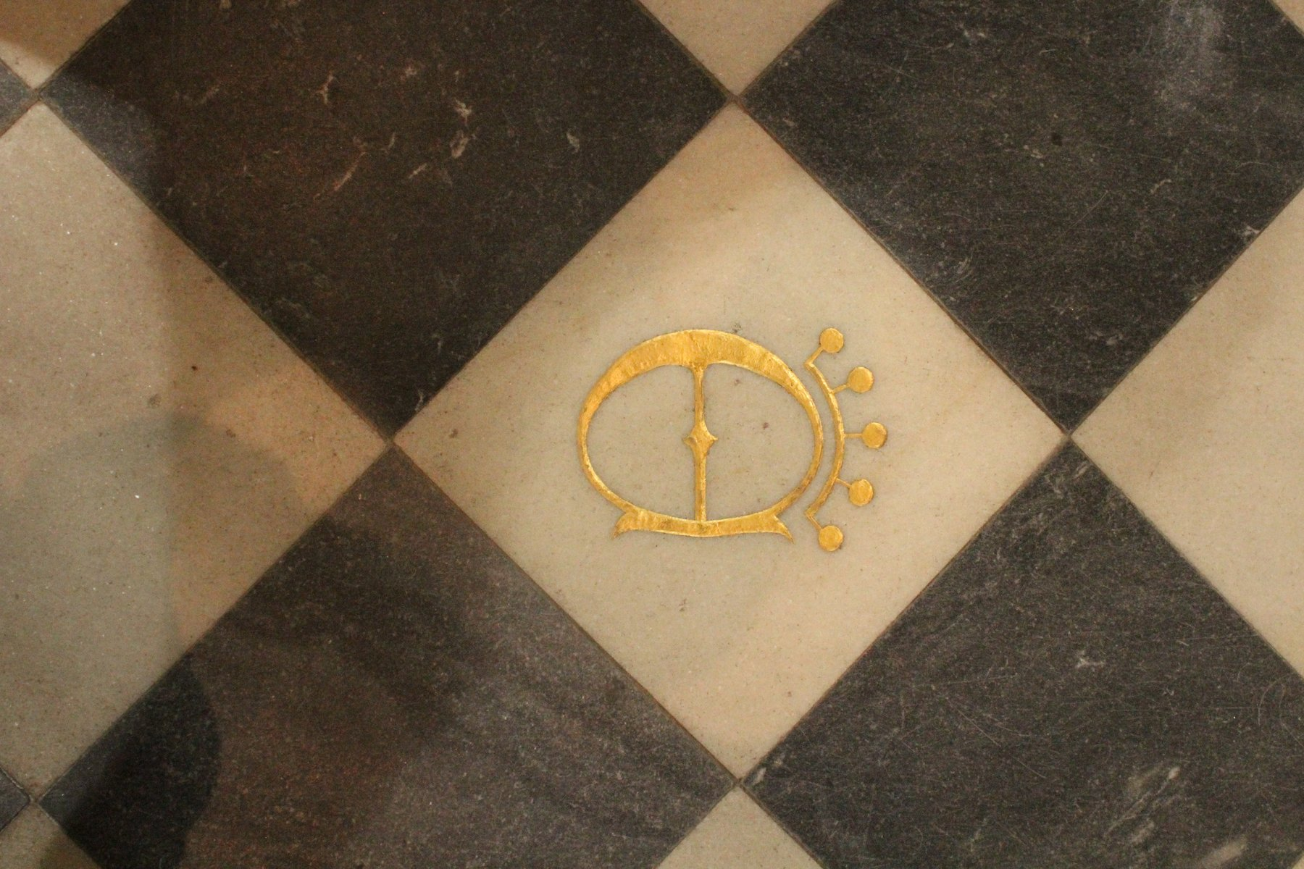
Figure 18. The abbatial church of the Augustinian abbey of St Thomas in Old Brno, the house where Mendel lived.

Bateson Names the Field
The man who did most to make the rediscovery stick was English and had never crossed a pea. William Bateson, a Cambridge zoologist, had spent the 1890s arguing that evolution proceeded by discontinuous jumps and collecting cases of variation to prove it. When he read Mendel in the spring of 1900, he saw at once that the ratios were the mechanism his argument had lacked. He arranged an English translation for the Journal of the Royal Horticultural Society in 1901, and in 1902 he published a short book called Mendel’s Principles of Heredity: A Defense. The word “defense” in the title was not decoration. The biometricians, led by Karl Pearson and W. F. R. Weldon at University College London, held that inheritance was a matter of continuous measurement and correlation, in the tradition of Francis Galton, and that a friar’s particles were a curiosity. The argument between them was bitter and personal and lasted the better part of a decade.
In the course of it, Bateson named the field. In a letter to Adam Sedgwick dated 18 April 1905 he proposed the word “genetics” for the study of heredity and variation, and in 1906 he used it in public at the Third International Conference on Hybridization and Plant Breeding in London, whose proceedings appeared under the new name. The word “gene” came three years later, from the Danish botanist Wilhelm Johannsen, in his 1909 textbook on the exact theory of heredity. He cut it down from de Vries’s “pangene,” which in turn derived from Darwin’s “pangenesis,” and he meant it as a deliberately neutral term: a unit of account for the thing that segregated, with no claim about what it was made of. Johannsen also gave us “genotype” for the factors a plant carried and “phenotype” for what it looked like, which is the distinction between a visible trait and a silent factor handed on.
He earned the word with beans, not with a definition. In the years before 1909 he grew pure lines of the common bean, self-fertilized for generations, and selected the heaviest seeds and the lightest. Within a pure line, selection did nothing. The heavy seeds did not produce heavier offspring than the light ones, because the differences were the season, the position in the pod, the accidents of growth, and not a factor that could be bred. Between lines, the differences held. A gene, on that evidence, was whatever stayed constant when the visible plant did not. Johannsen could not see it. He could show that blending and training would not move it. That is still a useful way to hold the word. It is a unit of account, not a bead someone had looked at.

Where the Factors Lived
Where the factors lived was settled almost as fast. In 1902 and 1903 Walter Sutton, a graduate student at Columbia, was looking at grasshopper sperm. Chromosomes traveled in pairs. Each parent contributed one of each pair. The pairs separated when the sex cells formed. That is exactly what Mendel’s factors did.
Theodor Boveri in Würzburg reached the same conclusion from another kind of wreckage. Sea-urchin eggs fertilized by two sperm ended up with the wrong chromosome sets, and the embryos failed in ways that tracked which chromosomes were extra. The visible threads and Mendel’s factors moved by the same rules. The threads were a reasonable place for the factors to live. That was the chromosome theory of heredity. It was not yet a proof that one particular factor rode on one particular thread. A room full of flies would be needed for that.
In the years just after 1905, Bateson and R. C. Punnett crossed sweet peas and got a result Mendel’s second rule forbade. Flower color and the shape of the pollen grain did not travel independently. Purple flowers kept company with long pollen. Red flowers kept company with round pollen. Or the reverse, depending on how the parents had been built.
They used two words for it, coupling and repulsion. Their explanation was that certain classes of pollen and egg were produced in extra numbers, a scheme known as reduplication. It saved the counts on paper. It said nothing about where the factors sat.
The association was strong and not perfect. Some offspring carried a combination neither parent had preferred, which is what an occasional exchange of chromosome pieces would produce, though nobody in 1906 drew that picture. Bateson disliked the chromosome explanation for years after the flies had made it obvious. The sweet peas had been the first sight of linkage, described with the wrong cause. The proof still needed a trait you could see and a chromosome you could count in the same animal, which is what the next chapter is for.

Too Good to Be True?
There is one more thing to say about Mendel’s numbers, and it is uncomfortable. They are too good.
In 1936 Ronald Fisher, the statistician whose own work had by then joined Mendel to Darwin, went through the 1866 paper with the tool he had done more than anyone to build, the chi-squared test, which measures how far a set of counts strays from what theory predicts. Real counts stray. If you toss a fair coin 400 times you expect about 200 heads, but you would be surprised to get exactly 200, and you would be suspicious of a person who reported exactly 200 on every one of many tries. Fisher found that Mendel’s counts, taken together, sat closer to the predicted ratios than chance would put them. Across the whole paper, he calculated, results as good as Mendel’s or better would arise by chance about seven times in a hundred thousand.
He spotted a second oddity. To decide whether a round second-generation plant was pure AA or hybrid Aa, Mendel grew ten of its seeds and looked for any wrinkled ones. But a hybrid plant has a one-in-four chance of giving a round seed each time, and a run of ten round seeds from a hybrid happens about once in eighteen tries. So some hybrids should have been misclassified as pure, and the expected ratio was not 1 to 2 but roughly 1 to 1.9. Mendel reported ratios closer to the 1 to 2 he expected than to the 1 to 1.9 he should have got.
Fisher did not accuse Mendel of fraud. He suggested, carefully, that an assistant who knew what the abbot expected might have tidied the counts. The suggestion has been argued over ever since. The most thorough modern review, a 2008 book by five statisticians and historians titled Ending the Mendel-Fisher Controversy, agreed that Fisher’s arithmetic was right and that the fit is unusually close, and turned up no evidence of deliberate falsification. The candidate explanations are mundane. Ambiguous seeds, and there are always some, may have been scored unconsciously toward the expected class. Mendel says outright that he left some experiments out of the paper, and a researcher who drops the crosses that failed will report data that fit better than they should. He may have tested more than ten seeds for some plants. None of this is proof of anything, and the seven-in-a-hundred-thousand figure depends on assumptions about how the experiments were pooled that not everyone accepts.
My own view, marked as mine: the numbers are honest and somewhat tidied, in the way that most numbers from a single researcher with a hypothesis and no blind scoring are tidied, and the ratios are real, because they have been reproduced in every genetics classroom for a century. The 3 to 1 does not depend on Mendel’s 5,474. It depends on the rules of a molecule that copies itself, and by 1910 the place where the rules were written was about to be uncovered, in a bottle of fruit flies in New York.
↑ Back to Contents

Chapter 48: Flies in a Bottle — Morgan and the Chromosome Theory

A Fly That Should Not Be There
The bottle is an ordinary half-pint milk bottle with a plug of cotton wool in the neck, and there is a layer of mashed banana in the bottom. It is May 1910, on the sixth floor of Schermerhorn Hall at Columbia University in New York, and a professor of zoology named Thomas Hunt Morgan is looking through a hand lens at a fly that should not be there. The flies in the bottle, several hundred of them, have red eyes. This one, a male, has white eyes. Morgan has been breeding fruit flies for about two years, looking for exactly this, a spontaneous change of the sort de Vries had described in evening primroses, and he has had little to show for it. Now he has one fly.
He kept it alive, which was not trivial, and mated it to ordinary red-eyed females. The offspring, more than a thousand of them, all had red eyes. White had vanished, exactly as wrinkled had vanished in Mendel’s hybrids. Morgan then mated those red-eyed offspring to each other and counted the next generation. He got 2,459 red-eyed females, 1,011 red-eyed males, and 782 white-eyed males. The 3 to 1 was there, roughly. But there were no white-eyed females at all. The white eye had come back only in sons.
Morgan published this in Science in July 1910, and the explanation he gave is the one still taught. A fruit fly, like a person, has a pair of sex chromosomes, XX in females and XY in males. If the white-eye factor sits on the X, a male has only one copy and shows whatever it carries; a female has two, and needs the recessive on both to show it. The daughters of the white-eyed founder all carried one white X hidden behind a red one, and their sons inherited that X half the time. This was the first trait ever tied to a particular chromosome, and it was the proof that Sutton and Boveri had lacked. Morgan, who two years earlier had been publicly skeptical of both Mendel and the chromosome theory, changed his mind because his flies made him.
Drosophila melanogaster is a small brownish fly that lives on rotting fruit, and it is close to the ideal animal for counting. A female lays hundreds of eggs. A generation takes about ten days at room temperature. A bottle costs nothing, a banana costs a cent, and a thousand flies fit in a space smaller than a shoebox. The animals can be knocked out with a whiff of ether and sorted on a white card under a lens, and they have only four pairs of chromosomes. Morgan’s laboratory, which became known as the Fly Room, was about five meters by seven, with eight desks, and it smelt of banana and ether and the flies that had escaped.
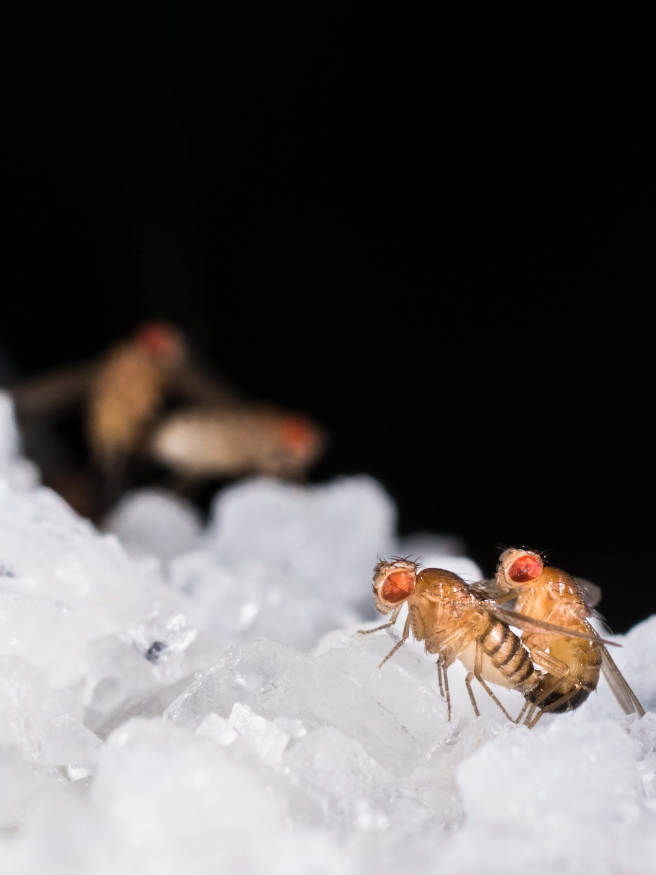
Figure 19. A fruit fly, Drosophila melanogaster: the red eye and the bristles the mappers counted.

The Fly Room
The room mattered because of who was in it. Morgan took on two undergraduates in 1910, Alfred Sturtevant and Calvin Bridges, and a graduate student, Hermann Muller, and treated them as colleagues from the first day. New mutants came in steadily once people knew what to look for: yellow bodies, vermilion eyes, miniature wings, rudimentary wings, and dozens more. Many of them, like white, turned out to be on the X. And when two X-linked mutants were crossed together, the two traits did not assort independently, as Mendel’s second rule required. They tended to stay together, because they were on the same chromosome. But they did not stay together always. Some fraction of the offspring had the traits recombined, and the fraction was different for each pair of traits, and it was the same fraction every time that pair was tested.
Morgan’s guess at why originated with a Belgian cytologist, a cell scientist, Frans Alfons Janssens, who in 1909 had seen paired chromosomes under the microscope crossing over one another during the formation of sex cells and had suggested that they exchanged pieces at the crossing. If so, two factors close together on a chromosome would rarely be separated by an exchange, and two far apart would often be. The recombination fraction was a measure of distance.
Sturtevant, then nineteen, saw the consequence one evening in the autumn of 1911. He took the recombination figures for six X-linked factors home from the laboratory, put aside his homework, and by morning had arranged them along a line so that the distances added up. Yellow body and white eye were close, about one unit apart. Vermilion was thirty-odd units further along. Miniature and rudimentary lay beyond it. The spacing satisfied every pair of figures at once, which it could only do if the factors really were arranged in a line, one after another, along a physical thread. He published it in 1913 in the Journal of Experimental Zoology. It was the first genetic map, drawn by an undergraduate in one night.
The unit he used was one percent recombination, later named the centimorgan after his professor. Human geneticists still measure in it. One centimorgan is, roughly, a one-in-a-hundred chance that two positions will be separated when eggs or sperm are made. In people that chance is, on average, about a million letters of DNA. The match is lumpy. Some stretches recombine often and some almost never.
Sturtevant did not have letters. He had percentages. If yellow and white recombined in about one fly in a hundred, they were one unit apart. If yellow and miniature recombined in about a third of the flies, they were about thirty-three units apart. The test of the map was that the long distances equaled the sum of the short ones. They did, well enough for a night’s work. That additivity is what a line gives you. A bag of unlinked factors does not.
Bridges supplied the last proof. In 1916 he studied rare exceptional flies, white-eyed daughters and red-eyed sons that ought not to exist, and showed under the microscope that each carried an abnormal count of X chromosomes, an extra one or a missing one, exactly as the theory predicted if the eye factor rode on the X and the X had occasionally failed to separate. A gene’s inheritance and a chromosome’s inheritance had been shown to be the same event, in the same fly. The four of them wrote a book together, The Mechanism of Mendelian Heredity, in 1915. It is short, and nearly everything in it is still true.

Giant Chromosomes
The map was still a row of percentages. In 1933 it became something a person could see.
The salivary glands of a fruit-fly larva hold giant chromosomes. Each is a bundle of about a thousand copies of the same DNA, laid side by side. Under a microscope they show a barcode of dark and pale bands. T. S. Painter, at the University of Texas, reported that December that the bands were stable enough to follow a rearranged piece to its new address.
Calvin Bridges then drew the bands for all four chromosomes. His 1935 maps marked more than three thousand of them. A factor the crosses had placed between two others sat, on the giant chromosome, between the bands those factors matched. The line an undergraduate had drawn from percentages was a thread in a cell. For decades a fly geneticist gave an address as a band.
Muller went further and, in a sense, further than anyone wanted. In 1926 and 1927, at the University of Texas, he exposed male flies to X-rays and bred them. Mutations, which in the Fly Room turned up perhaps once in tens of thousands of flies, now appeared in a large fraction of the offspring. Muller reported a rate around 150 times the spontaneous one, and the new mutants were of every kind, lethal and visible, dominant and recessive. His paper in Science in July 1927 was titled “Artificial Transmutation of the Gene,” and it drove home two things at once. The gene was a physical thing that radiation could damage, and the copy could be rendered inexact on demand. He was awarded the Nobel Prize in Physiology or Medicine in 1946, a year after two cities had been irradiated by design, and he spent much of the rest of his life warning about radiation and the human germline.
Morgan’s own Nobel came in 1933, in Physiology or Medicine, for the chromosome theory. He had moved to the California Institute of Technology in 1928, taking Sturtevant and Bridges with him, and it is on the record that he divided part of the prize money among the children of Bridges and Sturtevant. Bridges died in 1938 at 49. Sturtevant lived until 1970 and wrote the field’s first history. The Fly Room itself was eventually turned into other uses, but Drosophila never fell out of use. It gave the world the genes that lay out a body plan in the 1980s, and at the time of writing it is still in tens of thousands of bottles, on banana or a modern substitute.

Mendel With an Address
What the flies had shown was Mendel with an address. Factors were real, they sat in a line on chromosomes, they could be mapped, and they could be broken. What the flies had not yet shown was how any of this squared with Darwin. Mendel’s characters were discrete, round or wrinkled, red or white. Darwin’s variation, the raw material of selection, was continuous, a little taller, a little faster. Galton’s followers, the biometricians, had measured that continuous variation for forty years and showed it was inherited in the smooth statistical way that particles seemed not to allow. And Morgan’s own school, with its focus on large visible mutations, had left it easy to suppose that evolution happened by mutation and not by selection at all.
Chapters 8 and 40 already joined the pieces. Mutation supplies the new letters. Mendel’s particles carry them. Selection changes which ones spread. The flies did not invent that joining. They gave it an address, a line on a chromosome you could break with an X-ray.
The naturalists then had to be brought in, and that was done by a former member of the Fly Room. Theodosius Dobzhansky, who had come from Russia to Columbia in 1927, took the flies out of the bottle and into the wild. The wild cousin he used, Drosophila pseudoobscura, carries stretches of chromosome flipped end to end. A flip travels as a block, because it suppresses the usual exchange of pieces, and on the giant chromosomes of the larva one arrangement can be told from another.
On Mount San Jacinto in southern California he sampled the same places through the year, from 1939 into the early 1940s. One arrangement, which he labeled Standard, was scarcest in early summer and commoner by autumn. Another, Chiricahua, swung the opposite way. The swing returned the next year. A hidden chromosomal type was being favored in one season and disfavoured in another, in a free-living population, on a schedule you could count. His 1937 book Genetics and the Origin of Species is the one the movement dates from. The mountain counts came just after, and they were evidence a naturalist could not dismiss as a bottle artifact.
Ernst Mayr in 1942 put species and geography into the account, George Gaylord Simpson in 1944 put in the fossil record, and Julian Huxley in 1942 gave the whole thing its name, the Modern Synthesis. Its content can be said in two sentences. Variation arises by mutation, which is inexact copying, and is inherited in Mendel’s particles. Selection changes the frequencies of those particles, and given enough time that is evolution.
The bottles were the method. A generation every ten days means about thirty-six generations a year, which is what let an undergraduate draw a map before he finished his degree. A human geneticist waiting on families would have needed centuries for the same crosses. The fly did not have a simpler heredity. It had a faster one.
It was a clean piece of science, and it was finished in the same decade that its cousin, the application of heredity to human beings, was finishing something far darker in the courtrooms of Virginia and the ministries of Berlin.
↑ Back to Contents

Chapter 49: Galton’s Shadow — The Eugenics Disaster

A Laboratory at an Exhibition
In the summer of 1884, at the International Health Exhibition in South Kensington, a visitor could pay threepence to pass through a narrow booth and be measured. Height standing and sitting, arm span, weight, breathing capacity, the strength of the hand’s grip, the speed of a blow, keenness of sight and hearing, the highest audible note. A clerk wrote the results on a card, kept a copy, and gave the visitor the other. More than nine thousand people went through. The booth was the Anthropometric Laboratory, and the man who designed it, paid for it, and pored over the cards afterward was Francis Galton.
Galton was born in Birmingham on 16 February 1822, five months before Mendel, into money made in guns and banking. He was Charles Darwin’s half-cousin; they shared a grandfather, Erasmus Darwin. He was a child prodigy, an indifferent medical student, an explorer of south-west Africa, and then, after 1859 and his cousin’s book, a man with a single idea. If ability was inherited like height, the human race could be improved the way a breeder improves cattle. His 1869 book Hereditary Genius traced judges, statesmen and scientists through their families and concluded that talent ran in blood. In 1883, in a book called Inquiries into Human Faculty and Its Development, he gave the project a name, from the Greek for well-born: eugenics.
It is worth saying plainly that Galton was a serious scientist, because that is part of the problem. He invented the weather map and named the anticyclone. He worked out regression to the mean, from measuring sweet-pea seeds and then the heights of parents and children. He invented the correlation coefficient, which his follower Karl Pearson turned into a rigorous tool. He established that fingerprints were unique and permanent and devised the classification system Scotland Yard adopted in 1901. He was the founder of the biometric school that fought Bateson over Mendel, and its methods, not Bateson’s, are the ones a modern genome-wide study uses. The statistics of inheritance and the program of breeding people came out of the same head at the same time, and for fifty years most people who used the one accepted the other.

Three Generations
In the United States the program found money. On 1 October 1910 the Eugenics Record Office, the ERO, opened at Cold Spring Harbor on Long Island, funded at first by Mary Harriman, widow of the railroad magnate, and from 1918 by the Carnegie Institution. Its director was Charles Davenport, a Harvard-trained biologist who had embraced Mendel early and applied him with enthusiasm. Its superintendent was Harry Laughlin, a former schoolteacher from Missouri. The Office trained field workers, mostly young women, who went out to prisons, poorhouses and asylums and returned with pedigrees on index cards. By the time it closed in 1939 it held hundreds of thousands of them. The cards purported to trace feeblemindedness, pauperism, criminality, alcoholism and “shiftlessness” as Mendelian recessives, with the same confidence Mendel had brought to wrinkled seeds.
The first thing the Office wanted was law. Indiana had passed the first compulsory sterilization statute in 1907, and Laughlin drafted a Model Eugenical Sterilization Law in 1922 for other states to copy. Many did; by the early 1930s about thirty states had some such law on the books. The question was whether the Supreme Court would allow it, and Virginia arranged a test case to find out.
Her name was Carrie Buck. She was seventeen, from Charlottesville, and had been raised in a foster home after her mother was committed to the Virginia Colony for Epileptics and Feebleminded. In 1923 she became pregnant. Later evidence indicates that she had been raped by a relative of the foster family; the family had her committed to the same Colony as her mother, and her daughter Vivian was born in 1924. The Colony’s superintendent selected her for sterilization under the new Virginia law, and a lawyer was appointed to appeal on her behalf, the appeal being part of the plan. The case reached the Supreme Court as Buck v. Bell. On 2 May 1927 the Court upheld the law, eight to one, in an opinion by Oliver Wendell Holmes Jr. It is short, and its most famous sentence is documented: “Three generations of imbeciles are enough.” Carrie Buck was sterilized on 19 October 1927. The one dissenting justice, Pierce Butler, wrote nothing.
The three generations were a fiction. Carrie’s school records show her promoted normally. Vivian, the third generation, was placed on her school’s honor roll; she died of an intestinal illness in 1932, aged eight. The decision has never been formally overturned. Virginia repealed its law in 1974 and apologized in 2002. In total, somewhere around 60,000 people were sterilized under state laws in the United States, a third of them in California, and the practice continued in some states into the 1970s. The same movement, with Laughlin as an expert witness before Congress, helped carry the Immigration Act of 1924, which cut immigration from southern and eastern Europe on the argument that those populations carried inferior stock.
Germany was watching. The Law for the Prevention of Hereditarily Diseased Offspring was passed on 14 July 1933, five and a half months after Hitler became chancellor, and came into force on 1 January 1934. It set up hereditary health courts and made sterilization compulsory for a list of conditions that included schizophrenia, manic depression, hereditary blindness and deafness, severe alcoholism, and, above all, “congenital feeblemindedness.” Its drafters knew and cited the American statutes, and Laughlin’s model law in particular; Laughlin received an honorary doctorate from Heidelberg in 1936 for his services to the science of racial hygiene, and accepted it. About 400,000 people were sterilized under the German law by 1945.
The road from there is brief and documented. From the autumn of 1939, under a program later called T4 after the Berlin address from which it was run, doctors selected patients in psychiatric hospitals and institutions for the disabled for what the paperwork termed a mercy death. About 70,000 people were killed in six centers by August 1941, most of them in gas chambers using carbon monoxide, and the count continued in other forms until the end of the war. The staff who had built and run those chambers were then transferred east, and the method went with them, to Belzec, Sobibor and Treblinka. The Nuremberg trial of the doctors, in 1946 and 1947, traced the line in evidence. Eugenics did not cause the Holocaust. It supplied the vocabulary, the personnel, and the first machinery.
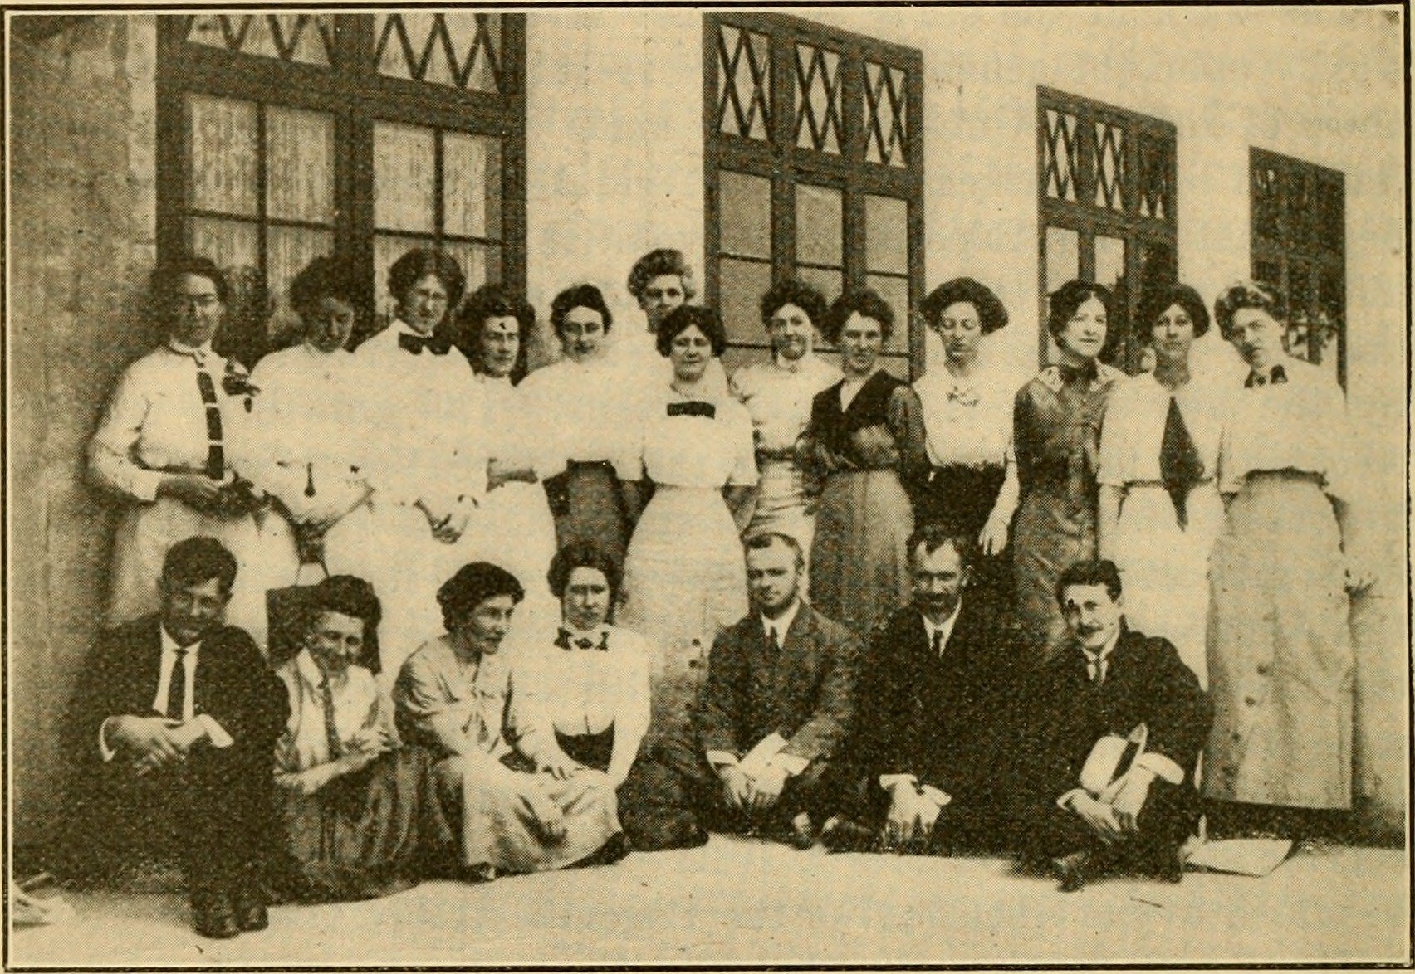
Figure 20. Field workers of the Eugenics Record Office at Cold Spring Harbor, June 1912. The rows are the people who filled the family files.

The Mirror Image
In the Soviet Union the same decades produced the mirror image, and it is worth the detour because the error was of the opposite kind. Trofim Lysenko, born in 1898 to a peasant family in Ukraine, rose to notice in 1929 with vernalization, a real if old technique of chilling wheat seed so that winter varieties could be sown in spring. He claimed it would transform Soviet yields. It did not, but the claim was welcome, and Lysenko learned what was welcome. Through the 1930s he built a doctrine, known as Michurinist biology after a Russian plant breeder, whose core was that there were no genes, that heredity was a property of the whole organism responding to its conditions, and that characteristics a plant acquired during its life could be handed to its offspring. Lamarck, dead a century, was restored as state science, and Mendel, Morgan and Weismann were denounced as bourgeois idealists.
The man in his way was Nikolai Vavilov. Born in 1887, Vavilov was the most traveled botanist alive. He had led more than a hundred expeditions through some sixty-four countries, had identified the regions of the world where crop plants were first domesticated, and had built in Leningrad a seed bank of about a quarter of a million samples, the largest collection of crop diversity on earth. He was a Mendelian and a Darwinian, and for a decade he defended genetics in public against Lysenko while trying to keep his institute alive. He was arrested on 6 August 1940, while collecting plants in western Ukraine, sentenced to death the following year on charges of sabotage and espionage, had the sentence commuted, and died in Saratov prison on 26 January 1943 of starvation. During the siege of Leningrad, several of his staff starved to death in the building that held the seeds, surrounded by sacks of edible rice, wheat and peas that they would not touch.
In August 1948, at a session of the Lenin All-Union Academy of Agricultural Sciences, Lysenko announced that his report had been approved by the Central Committee, which meant by Stalin. Genetics as a science was ended in the Soviet Union. Laboratories were closed, textbooks pulped, and researchers dismissed, in the thousands by most estimates. The ban lasted, with loosening after Stalin’s death, until Khrushchev’s fall in October 1964; Lysenko was removed the next year and a commission published the details of his fraudulent farm results. Soviet biology took a generation to recover, and Soviet agriculture never did benefit from a single one of his methods.

Three Errors
It is easy to say that eugenics was bad ethics, and it was. It is more useful, in a book about how inheritance works, to say why it was bad science, because the scientific error is the one that could recur.
The first error was the pedigree. Davenport’s field workers scored “feeblemindedness” from a conversation and a family rumor, and the tests that later replaced the conversation, the early IQ tests, short for intelligence quotient, a single score meant to sum up how a person reasons, measured schooling and English as much as anything else. A pedigree in which poverty runs in families is not evidence of a gene for poverty. The ERO’s cards recorded a social fact and labeled it a Mendelian one, and none of it was ever checked the way Mendel checked his twenty-two varieties for two years before he crossed them.
The second error was arithmetic, and it is the one Mendel’s own ratios expose. Suppose a condition really were a simple recessive, like wrinkled seed, and suppose it affected one person in ten thousand. Then the responsible allele, the faulty version of the gene, is carried by about one person in fifty, and nearly all copies of it, more than ninety-nine in a hundred, sit in carriers who show nothing and whom no court could identify. Sterilize every affected person in every generation and the allele’s frequency falls, but slowly: from one in a hundred to one in two hundred takes a hundred generations, about two and a half thousand years. Reginald Punnett laid this out in 1917 and Fisher confirmed it in 1924, and the movement carried on regardless. The recessive character is not removed by removing the plants that show it. That is the one thing Mendel’s peas had made most plain, and the people who claimed Mendel’s authority did not do the sum.
The third error was Lysenko’s, and it is the older one. Acquired characteristics are not, in any general way, inherited. Chapter 44 gave the honest modern version: there are real cases of environmental marks passing a generation or two, mostly in plants and worms, weakly and contestedly in mammals, and none of them makes a chilled seed into a new variety of wheat. A doctrine that says otherwise fails in the field, and when the state forbids the field from reporting the failure, people go hungry.
The echoes are not finished, and Part X will pick them up: polygenic scores sold to parents choosing embryos, the language of improvement returning through a clinic door rather than a courtroom. I think the right defense against them is not to forget the science but to know it better than Galton’s heirs did. The text is copied, the copy is inexact, the differences are mostly small, mostly recessive, and mostly hidden in people who look like everyone else, and no program that ignores that has ever done anything but harm.
↑ Back to Contents

PART VIII
Reading and Writing the Text
Within fifty years of the double helix we could read the text, cut it, copy it in a test tube and write it from scratch. This Part tells how, and what the tools have already done, from the first gene cures to a cloned sheep.

Chapter 50: Cutting and Pasting — Restriction Enzymes and Recombinant DNA

A Bacterial Defense
A bacterium has no immune system in the sense that a child has one, but it has something older and simpler. Picture a single cell of Escherichia coli, a rod two microns long, small enough that three dozen of them laid end to end would barely span the width of a human hair, in a human gut. The bacterium is real, and it is under attack. A virus called a bacteriophage has landed on its surface, punched through the wall, and injected a few tens of thousands of letters of foreign DNA. The bacterium’s reply is an enzyme that patrols the interior of the cell looking for one short word, four or six letters in length, and cuts the double helix wherever it finds that word. The cell’s own DNA carries the same word at hundreds of places, but a second enzyme has already tagged every copy with a methyl group, the tiny chemical marker behind the gene-switching in chapter 39’s look at epigenetics, and the tag blocks the blade. The invader’s text is untagged. It is cut to pieces within minutes.
This was worked out slowly. In 1952 Salvador Luria and Mary Human noticed that phages grown on one strain of bacteria often failed to grow on another, as if the second strain restricted them. Werner Arber, in Geneva in the early 1960s, showed with Daisy Dussoix that the restriction was done by an enzyme that cut the phage DNA, and that the host protected itself by chemically modifying its own. Arber predicted that such enzymes would recognize specific sequences. In 1970 Hamilton Smith at Johns Hopkins purified one from Haemophilus influenzae, named it HindII, and showed that it cut at a defined six-letter site and nowhere else. Smith’s colleague Daniel Nathans then used HindII on the DNA of a monkey virus, SV40, cut the circle into eleven fragments, and in 1971 arranged the fragments in order: the first physical map of a genome made with an enzyme. Arber, Smith and Nathans shared the 1978 Nobel Prize in Physiology or Medicine.
The word “restriction” stuck, though it is a poor name for what the enzymes became. By the end of the 1970s dozens had been purified, each recognizing its own distinctive word, and the catalog now runs to thousands, with a few hundred sold by the vial. The names are the bacterium’s, abbreviated: EcoRI from Escherichia coli, BamHI from Bacillus amyloliquefaciens, HindIII from the same Haemophilus that gave Smith his first. Most recognize a palindrome, a sequence that reads the same on both strands when each is read in its own direction. EcoRI’s word is GAATTC. On the other strand, read the other way, it is GAATTC again.
EcoRI, isolated in Herbert Boyer’s laboratory at the University of California, San Francisco, in 1972, had a property that turned a curiosity into a tool. It did not cut straight across. It cut between the G and the A on each strand, which left every fragment with a four-letter single-stranded tail, AATT, hanging off the end. Any two fragments cut by EcoRI, from any organism whatever, carry matching tails, and in a test tube they find each other and pair up by the same hydrogen bonds that hold the helix together. Janet Mertz and Ronald Davis at Stanford showed this in 1972 and called the tails cohesive. Everyone else calls them sticky ends. With DNA ligase, an enzyme isolated in 1967 by several groups at once, the paired fragments could be sealed into a continuous strand. The scissors had found their paste.
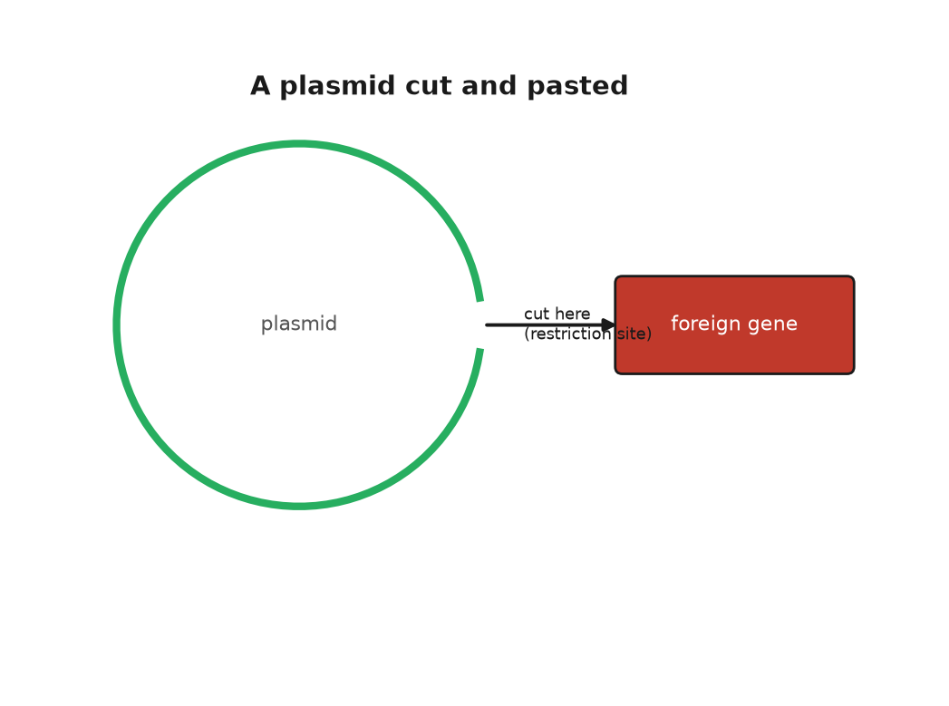
Figure 21. A plasmid cut open by a restriction enzyme, with a foreign gene pasted into the gap.

The First Recombinant Molecule
The first recombinant DNA molecule, DNA spliced together from two different sources, took shape in Paul Berg’s laboratory at Stanford in 1972 without sticky ends, and without ever entering a living cell. Berg, with David Jackson and Robert Symons, took the circular DNA of SV40, opened it with EcoRI, and joined it to a piece of DNA from the bacteriophage lambda that carried three E. coli genes for digesting the sugar galactose. The joining was done by adding tails of A to one piece and tails of T to the other with an enzyme known as terminal transferase, then letting the tails anneal. The paper appeared in the Proceedings of the National Academy of Sciences, PNAS for short, in October 1972. Berg’s plan had been to put the hybrid into E. coli and see whether the monkey virus genes worked there. He did not do it. A colleague, Robert Pollack, had telephoned him in 1971 to ask whether it was wise to put the DNA of a tumor virus into a bacterium that lives in the human gut, and Berg, having thought about it, agreed that it was not, or not yet. This was the first pause in the history of genetic engineering, and it was self-imposed.
The step into the cell was taken in 1973 by Stanley Cohen at Stanford and Boyer at UCSF. The story of how they met is well documented and has the flavor of legend anyway. At a conference on plasmids in Honolulu in November 1972, the two men went out for a late sandwich at a delicatessen near Waikiki and, over the corned beef, put their two projects together. Cohen worked on plasmids, the small circles of DNA that bacteria carry alongside their main chromosome and pass between themselves, which is how resistance to antibiotics spreads through a hospital. He had one such plasmid, which he had named pSC101, that carried a gene for resistance to tetracycline and, as luck had it, a single EcoRI site. He had also worked out, with Annie Chang and Leslie Hsu, that a cold bath of calcium chloride made E. coli take up naked plasmid DNA from the surrounding fluid. Boyer had the enzyme. If pSC101 was cut open with EcoRI, a fragment of anything else cut with the same enzyme could be pasted into the gap, the circle closed with ligase, and the whole thing fed to bacteria. Any bacterium that then grew on tetracycline had taken up the plasmid and, with it, the passenger.
It worked. The paper, by Cohen, Chang, Boyer and Robert Helling, was published in PNAS in November 1973. The first passenger was a gene from another bacterial plasmid, which was a modest thing to move. In May 1974 John Morrow, with Cohen and Boyer, put ribosomal genes from the African clawed frog Xenopus laevis into pSC101 and showed that E. coli copied the frog DNA every time it divided and, more surprisingly, transcribed it. A gene from a vertebrate had been carried across something like half a billion years of separate evolution and was being read by a bacterium. Stanford and the University of California filed a patent on the method in November 1974. It was granted in December 1980, licensed to several hundred companies on easy terms, and by the time it expired in 1997 it had earned the two universities about $255 million, a figure I repeat as reported.
Nobody in 1974 had an insulin gene to hand, or any human gene in a form that could be pasted. The point of the Cohen and Boyer experiment was not what it moved but that anything could be moved. The wall between species, which breeders had spent ten thousand years respecting, had a door in it.

Asilomar
The people best placed to see what might go wrong were the people who had built the door. In July 1974 Berg and ten colleagues, Cohen and Boyer among them, published a letter in Science that asked their fellow scientists to stop, voluntarily, two classes of experiment: putting antibiotic-resistance or toxin genes into bacteria that did not already carry them, and putting tumor-virus DNA into bacteria at all. The letter asked the National Institutes of Health to draw up guidelines, and it called for a meeting. The meeting took place from 24 to 27 February 1975 at the Asilomar conference grounds on the Monterey peninsula in California, among pines and sand dunes, with about 140 participants, most of them molecular biologists, plus a handful of lawyers and a few journalists who had been let in on condition that they stayed to the end.
The arguments at Asilomar were not tidy. Some participants thought the risks imaginary and the moratorium, the voluntary pause on research, a gift to future regulators. James Watson, who had signed the 1974 letter, spent the meeting saying he wished he had not. Others, including Berg, thought that if the field did not draw its own lines, Congress would draw them for it, badly. By the last night, working past midnight, the organizers had a draft that most of the room could accept. Experiments were sorted into risk classes. Each class was matched to a level of physical containment, from an open bench to a sealed laboratory under negative air pressure, meaning air pulled steadily inward so nothing drifts out, and to a level of biological containment, meaning bacteria crippled so that they could not survive outside a flask. The riskiest experiments were to be deferred. The NIH turned the draft into formal guidelines, published on 23 June 1976, that bound anyone who took federal money.
Asilomar has been cited ever since, sometimes as a model and sometimes as a warning, and the international summits on human genome editing in 2015, 2018 and 2023 were consciously staged in its image. I think both readings are fair. The scientists did pause themselves, which is rare, and none of the feared catastrophes occurred. They also confined the discussion to laboratory safety and kept the wider questions, about ownership and purpose and who decides, off the agenda, which is one reason those questions arrived later and less politely. The city council of Cambridge, Massachusetts, whose mayor Alfred Vellucci did not see why Harvard should decide what went into his city’s drains, held its own hearings that summer and imposed a local moratorium of several months before allowing the work to continue under rules of its own.

Insulin
Robert Swanson was twenty-nine, a venture capitalist, someone whose job is investing other people’s money in new companies, recently let go by his firm, when he telephoned Boyer in January 1976 and asked for ten minutes. He got three hours in a bar near the UCSF campus. Boyer thought a company built on recombinant DNA was premature; Swanson thought otherwise, and on 7 April 1976 they founded Genentech, each reported to have put in $500. The company had no laboratory. Its first work was done under contract at the City of Hope medical center near Los Angeles, where Keiichi Itakura and Arthur Riggs could synthesize a gene chemically, letter by letter, rather than fishing it out of a cell. The first target was somatostatin, a human hormone built from just fourteen amino acids, the basic building blocks of proteins from chapter 36, chosen because its gene could be built from scratch in weeks. In 1977 E. coli made it. It was the first human protein produced by a bacterium.
Insulin was the real prize, and there was a race for it. Insulin then came from the pancreases of pigs and cattle, collected at slaughterhouses by the tonne, and the supply was thought to be running short. The molecule has two chains, A and B, of 21 and 30 amino acids, which is longer than somatostatin but still compact enough to build. Walter Gilbert’s group at Harvard was working from the natural gene. The Genentech and City of Hope team built the two chain genes chemically, put each into E. coli fused to a bacterial protein, cut the chains free, and joined them with the correct sulfur bridges in a flask. They announced success on 6 September 1978. Eli Lilly, which had sold insulin since 1923, took the license. Humulin, insulin identical in sequence to the human kind and brewed by bacteria in steel tanks, was approved by the Food and Drug Administration in October 1982, the first drug produced by recombinant DNA to reach patients.
So by 1982 a bacterial defense against viruses had become a pair of scissors, a bacterial plasmid a paste-pot, and a gut bacterium a factory for a human hormone. Asilomar had already shown that the people who built the door would try to police it. The factory showed that the door opened onto a market. What none of this gave anyone was a way to read what they had pasted, and that method was the work of a quiet man in Cambridge who had already won one Nobel Prize and was about to earn a second.
↑ Back to Contents

Chapter 51: Sanger’s Ladders — The First Way to Read DNA

A Virus Read Letter by Letter
The first genome anyone ever read belongs to a virus so small that ten thousand of them would fit across the width of a human hair. It is called phi X174, it infects E. coli, and its entire text is a single circle of DNA 5,386 letters long. In February 1977 a paper in Nature from the Medical Research Council’s Laboratory of Molecular Biology in Cambridge printed the whole of it, or nearly: the count given then was 5,375, and the last eleven letters were tidied up over the following year. The authors were Fred Sanger and eight colleagues. Between them they had read every letter of a living thing’s instructions for the first time, and the text held a surprise. Two of the virus’s genes lay inside other genes, sharing the same letters but read in a different frame, like a sentence hidden in another sentence by starting one letter later. Nobody had thought that possible.
Sanger was fifty-eight and had already spent a career on the problem of reading. He was born on 13 August 1918 in Rendcomb, a village in Gloucestershire, the son of a doctor, and was raised a Quaker; he registered as a conscientious objector in 1939 and spent the war in a Cambridge laboratory. Between 1945 and 1955 he worked out the complete sequence of insulin, all 51 amino acids in its two chains, using a reagent he invented to label the end of a chain and sheets of paper chromatography, a technique that separates chemicals by how far each one travels across a wet sheet, to sort the fragments. Before that work nobody knew for certain that a protein had a fixed sequence at all. The 1958 Nobel Prize in Chemistry went to him alone. Then he turned to RNA, reading the 120 letters of a compact ribosomal RNA, a piece of the ribosome, the cell’s protein-building machinery from chapter 38, in 1967, and then, in the early 1970s, to DNA, which was harder because it was longer and its four letters were chemically so alike.
His first DNA method, in 1975, was awkward, and it was the one used for most of phi X174. The method that replaced it, published in PNAS in December 1977 with Steve Nicklen and Alan Coulson, is the one the world used for the next thirty years, and it is worth understanding, because every genome in this book before 2005 was read with it.

The Ladder
Start with a single strand of the DNA you want to read and a brief primer that pairs with one end of it. Add DNA polymerase, the copying enzyme from Chapter 37, and the four ordinary building blocks, one of them carrying a radioactive atom. The enzyme extends the primer, letter by letter, making a copy of the strand. Now the trick. Into the tube goes a small dose of one building block, say A, in a crippled form: a dideoxy nucleotide, which is missing the hydroxyl group, a single oxygen-and-hydrogen pair, at its 3-prime carbon, the numbered backbone position from chapter 33’s ladder, that the next letter needs in order to attach. The enzyme cannot tell the difference and slots it in. But once a crippled A is in, the chain can grow no further. It stops. Because the crippled A is a minority, the enzyme usually gets the ordinary one, and each copy runs on until, at some A along the way, it draws the short straw. Millions of copies, and the tube ends up holding a chain stopped at every A in the sequence: one that stopped at the first A, one at the second, one at the tenth. Four tubes, one for each crippled letter, give four such families.
The four tubes are then run side by side down a slab of polyacrylamide gel under an electric field, a method that separates DNA strands by length so finely that a chain of 101 letters travels visibly further than a chain of 102. Lay a sheet of X-ray film on the gel, wait, develop, and each lane shows a ladder of dark bands. The shortest fragments are at the bottom. Read upward across the four lanes, noting at each rung which lane the band is in, and the sequence writes itself: A, A, G, C, T, T, and so on, until the bands blur together somewhere past the two-hundredth rung. Later gels, taller and thinner, ran to five or six hundred letters. The X-ray film was the same one Alec Jeffreys would pull out of a developing tank seven years later, in the next chapter but two.
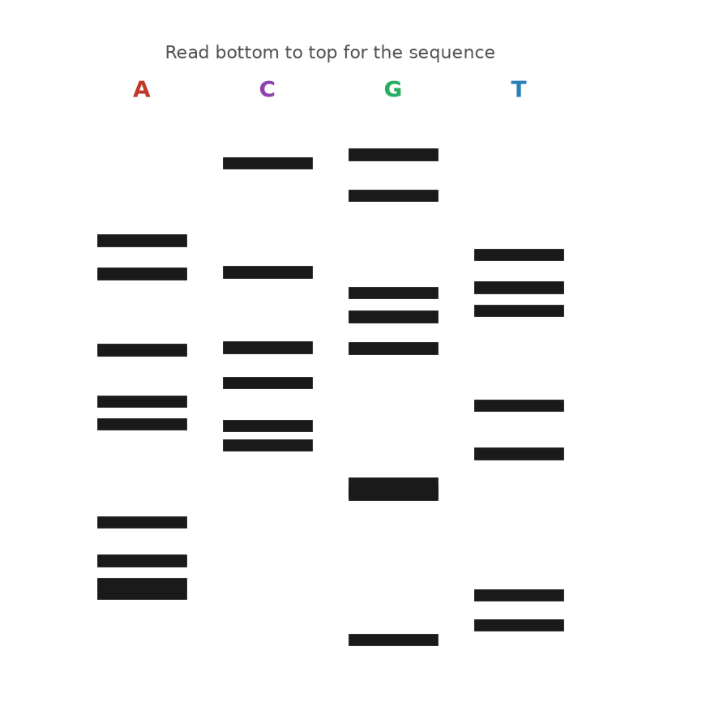
Figure 22. A Sanger sequencing gel: four lanes, read from the bottom upward.
Allan Maxam and Walter Gilbert at Harvard published a rival method in PNAS in the same February of 1977. Theirs used chemistry rather than an enzyme: label one end of the DNA, split the sample four ways, and in each tube use a reagent that breaks the chain at one kind of letter, dimethyl sulfate for G, hydrazine for C, and so on, under conditions gentle enough that each strand breaks only once. The result is also a ladder, read the same way. For a few years the two methods were used side by side. Gilbert’s needed no cloning of the fragment into a single-stranded form and was popular at first; Sanger’s used an enzyme instead of hydrazine and could be scaled up and, eventually, automated. Sanger’s won. The 1980 Nobel Prize in Chemistry went to Sanger and Gilbert for reading DNA, and to Paul Berg for the recombinant molecule of Chapter 50. It was Sanger’s second, which makes him one of only two people ever to win the chemistry prize twice; Barry Sharpless became the other in 2022.
Notice what the method actually reads. It does not read the strand you put in the tube. It reads copies of that strand, made on the spot by a polymerase, and it depends on the copying being faithful enough that a million copies stopped at the fortieth letter all carry the same thirty-nine letters before it. They very nearly do. When they do not, because the enzyme slipped on a run of identical letters or the template was damaged, the ladder shows a faint extra rung or a smeared one, and the reader has to decide. This is why the phi X174 count of 1977 was out by eleven letters, and why every sequence in this book was read more than once. A text is not read directly; it is copied and the copies are compared, which is, when you think about it, exactly what a cell does.
Sanger himself worked at the bench until the day he retired, in a group that rarely numbered more than a dozen, and he was known for doing the experiments with his own hands rather than through students. The Laboratory of Molecular Biology, which had opened its new building in 1962 with Perutz, Kendrew, Crick and Sanger under one roof, had by 1980 collected more Nobel prizes per square meter than any building in the world, and it kept the coffee room at the center of the plan on purpose.
Sanger’s laboratory used the new method as fast as it could be written up. In 1981 it published the entire human mitochondrial genome, the 16,569 letters a mother passes to a child, along with the finding that the mitochondrion reads a few codons differently from the rest of the cell. In 1982 it published bacteriophage lambda, 48,502 letters, then the largest genome read. For lambda the group could not proceed from one end to the other, because no gel reads more than a few hundred letters. So they broke the DNA into random pieces, cloned each into a small virus that delivered it as a single strand, read the pieces, and had a computer find the overlaps and stitch them together. Rodger Staden wrote the programs. The method is called shotgun sequencing, and it is, at heart, how every genome since has been assembled: read short stretches many times over and let the overlaps tell you the order.

From Hands to Machines
The bottleneck was not the chemistry but the hands. Pouring gels, loading four lanes per sample, exposing film overnight and reading ladders by eye with a ruler was slow work, and a good technician read perhaps a few thousand letters in a day. A human genome, 3.1 billion letters read several times over for safety, was out of the question. At the California Institute of Technology, Leroy Hood and Lloyd Smith replaced the radioactive label with four fluorescent dyes, one color for each of the four terminators, so that all four reactions could be run in a single lane and a laser at the bottom of the gel could read the colors as the bands passed. The paper appeared in Nature in June 1986. Applied Biosystems built the machine, the ABI 370A, and sold it from 1987; it read about 350 letters per lane, with no film and no ruler. Sanger’s method had become a printer.
The machine that read the human genome was the next step but one. In 1998 Applied Biosystems released the PRISM 3700, which replaced the slab of gel with 96 hair-thin glass capillaries, each filled with a polymer that did the same job, and ran them unattended around the clock. A single 3700 could produce hundreds of thousands of letters a day, in reads of about 500 to 600 letters each. Celera, the company described in Chapter 66, bought three hundred of them; the public project bought hundreds more. The 3.1 billion letters of the first human sequence, in every draft, came out of capillaries by the dideoxy method, and the method was still, chemically, what Sanger had described in 1977 with a crippled A.
He was not there to run the machines. Sanger retired in 1983, at sixty-five, on the day he became eligible, and spent the next thirty years gardening at his house outside Cambridge and, by his own account, doing very little else. He turned down a knighthood, saying that he did not want to be called Sir, and accepted the Order of Merit in 1986. He described himself, more than once, as an ordinary sort of person who had simply enjoyed messing about in a laboratory, and people who worked with him tended to agree that he meant it. The genome campus that opened in the village of Hinxton in 1993 was named the Sanger Centre, and it went on to read about a third of the human sequence. He died on 19 November 2013, aged ninety-five.
Two habits from those years survive in every sequencing laboratory. One is coverage. A single dideoxy ladder is a copy of a copy, and that copy is not exact, so each stretch is read several times, from different fragments, and the reads are compared before a letter is believed. The public human genome aimed at reading every position eight to ten times over. The other is the reference. Once a sequence exists, a second individual is not read from scratch; its reads are lined up against the first and only the differences are recorded. Both habits began with lambda and a shortage of hands.
There is one number worth holding onto from the Sanger years. A human genome, if it had been read with dideoxy ladders on a capillary machine, would have needed something like six million reads of 500 letters, and then several times that for the overlaps. The method was also greedy. Every read needed a large and pure sample of the stretch in question, which in practice meant cloning it into bacteria first, growing a flask, and purifying the plasmid: days of work to obtain enough copies to read a few hundred letters. What sequencing needed, if it was ever to leave the laboratory, was a way to make a billion copies of any chosen stretch in an afternoon, in a tube, with no cell involved at all.
↑ Back to Contents

Chapter 52: Copying Without a Cell — The Polymerase Chain Reaction

Highway 128
Highway 128 runs north-west out of Cloverdale, California, through the vineyards of Anderson Valley toward the redwoods and the coast, and on a Friday night in April 1983 Kary Mullis was driving it with a chemist from his company asleep in the passenger seat. Mullis was thirty-eight. He had a doctorate in biochemistry from Berkeley, a history of leaving jobs, and a position at Cetus Corporation in Emeryville, where his work was to synthesize short stretches of DNA called oligonucleotides, twenty or so letters long, that other people ordered for their experiments. He was thinking, as he drove, about a way of reading a single letter at a chosen place in a genome. Put a primer next to the place, add polymerase and a single dideoxy terminator of the kind Sanger used, and the enzyme would add one crippled letter and stop; the color of that letter would settle the matter.
The trouble was that any real sample of human DNA contained the chosen place only once or twice among the 6.2 billion letters of a cell’s nucleus, and one or two copies are too little to see. Somewhere on the mountain road, as he told it later, he saw what would happen if he used two primers instead of one, on opposite strands, facing each other across the region he cared about. Polymerase would extend both, and the two new strands would together contain a copy of the region. Heat the tube to separate the strands, cool it, and the primers would land again, now on four strands instead of two. Extend, heat, cool, and there would be eight. He pulled over, he said, to do the arithmetic on this exponential growth, doubling each round so the numbers explode rather than simply add up. Two to the tenth is a thousand. Two to the twentieth is a million. Two to the thirtieth is a little over a billion. The region between the primers, and only that region, would be copied out of the surrounding text a billion times over. Every cycle was a copying, and it needed no cell to do it.

The Chain Reaction
The idea is known as the polymerase chain reaction, or PCR, and its three steps are three temperatures. At about 95 degrees Celsius, just shy of boiling, the hydrogen bonds between the strands let go and the double helix comes apart. At somewhere between 50 and 65 degrees, depending on the primers, the two primers find their targets on the separated strands and stick; they are brief, and they are present in vast excess, so they win the race against the original partner strand. At 72 degrees the polymerase extends each primer along its template. Then back to 95. The first cycle makes strands of no fixed length, running on past the far primer until the enzyme falls off, but by the third cycle products appear that are bounded by a primer at each end, and from then on those products dominate. After 30 cycles, each a few minutes long, a single starting molecule has become about a billion copies of a fragment a few hundred letters across, which is plenty to see on a gel, to read with Sanger’s method, or to cut with an enzyme.
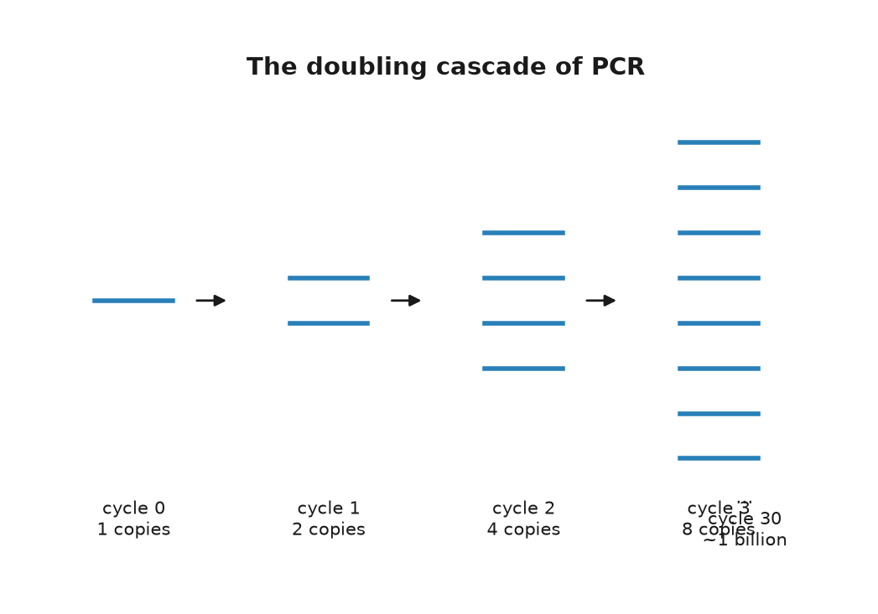
Figure 23. The doubling cascade of the polymerase chain reaction.
Mullis’s colleagues at Cetus were not impressed, at first, and it is worth being fair about why. Nothing in the scheme was new. Primers, polymerase and heat were all standard; a paper from Gobind Khorana’s laboratory in 1971, by Kjell Kleppe and others, had described in a paragraph the idea of copying a stretch repeatedly with two primers, and then dropped it. What Mullis saw was that the repetition was exponential and that exponential was the whole point. The first experiment that clearly worked at Cetus is dated 16 December 1983 in the company’s records, as reported in later accounts. The first cycles were done by hand. Each round of 95 degrees killed the polymerase, which was then the Klenow fragment, a trimmed-down version of the E. coli copying enzyme, so a technician moved the tubes between water baths and pipetted in fresh enzyme every cycle, thirty times. Cetus built a robot to do the pipetting.
A team at Cetus led by Henry Erlich, with Randall Saiki, Stephen Scharf and Norman Arnheim, turned the trick into a method and published it in Science in December 1985, using it to amplify part of the HBB gene and diagnose sickle cell disease from a small blood sample. Mullis’s own description appeared in Methods in Enzymology in 1987. Cetus paid him a bonus of $10,000. He left the company in 1986. In 1991 Cetus sold the rights to PCR to Hoffmann-La Roche for $300 million, and in 1993 Mullis received the Nobel Prize in Chemistry, shared with Michael Smith, who had devised a way to change a single chosen letter in a cloned gene. A challenge to the patents by DuPont, resting partly on the 1971 Khorana paper, had failed before a jury in 1991.

An Enzyme From a Hot Spring
The enzyme that made the reaction practical came out of a hot spring. In 1966 Thomas Brock, a microbiologist from Indiana University, collected samples from Mushroom Spring in the Lower Geyser Basin of Yellowstone National Park, where the water runs at about 70 degrees Celsius, hot enough to scald skin instantly, and discovered a bacterium growing in it that most textbooks then said could not exist. He named it Thermus aquaticus and published it in 1969. Its proteins worked at temperatures that cook other proteins. In 1976 a group at the University of Cincinnati purified its DNA polymerase and showed that the enzyme copied DNA happily at 70 degrees. Nobody had a use for that until the Cetus team, with David Gelfand, put the Yellowstone enzyme into the chain reaction and published the result in Science in January 1988.
Taq polymerase, as it is called, survives the 95-degree step. That meant one dose of enzyme lasted the whole run, the water baths could be replaced by a programmable metal block that cycled its own temperature, and a person could load the tubes, press a button, and go to lunch. Because Taq works best at 72 degrees, the primers could be annealed at higher temperatures too, which left them fussier about where they landed and the products cleaner. Taq has one defect: it does not proofread. It makes a wrong letter about once in every ten thousand or so, which after thirty cycles means that a fraction of the copies carry an error somewhere. For most purposes that does not matter, and for the purposes where it does, polymerases from other hot-spring organisms that do proofread, such as Pfu from Pyrococcus furiosus, were found later. Brock’s bacterium had been deposited in a public culture collection, so anyone could order it, and Yellowstone itself received nothing from the enzyme until a separate agreement with a biotechnology company in 1997 caused a small public row.
What the chain reaction did to biology is hard to overstate, so I will understate it: it removed the need for a cell. Before PCR, to study a gene you cloned it, which meant a plasmid, a bacterium, a flask and a week. After PCR, you designed two primers, ordered them, and had a billion copies before the end of the day, from a drop of blood, a hair root, a mouth swab, a cheek cell in a tube, or a fragment of a bone. Real-time versions, developed in the early 1990s by Russell Higuchi and others at Cetus and then Roche, watched the copies accumulate cycle by cycle with a fluorescent dye and read off, from the cycle at which the signal crossed a threshold, how many molecules had been there at the start. That number is what a laboratory means when it reports a viral load in a patient with HIV, the human immunodeficiency virus that causes AIDS.
A brief example shows the reach. To check Anna’s switch, from her father, a laboratory does not need a genome. It designs two primers that flank the position, amplifies a fragment of a few hundred letters from a cheek swab, and either reads the fragment by Sanger’s method or cuts it with a restriction enzyme that recognizes one version of the site and not the other, and looks at the gel. The whole thing takes an afternoon and costs a few dollars in reagents. Before 1985 the same question would have taken a month.
The reaction also made a scientific career possible in places with no cold room and no flask. Field stations, veterinary laboratories, customs posts checking the species of a fish fillet, and school classrooms now run it in a box the size of a toaster, and the box costs less than a good bicycle. Mullis, as it happens, first presented the method to a wide audience at the Cold Spring Harbor symposium in the summer of 1986, on the same campus where Watson had first described the double helix in 1953, and by most accounts it was only then that the field grasped what Cetus had.
It is also what was measured, several billion times over, between 2020 and 2022. The genome of the new coronavirus was posted online from Shanghai on 10 and 11 January 2020, and within about a fortnight laboratories in Berlin, Hong Kong and elsewhere had designed primers against it and published protocols. The virus stores its text in RNA, so a swab from a child’s nose first met an enzyme known as reverse transcriptase that copied the RNA into DNA, and then the chain reaction ran for up to 40 cycles looking for a few hundred letters of a viral gene. If the signal crossed the threshold by cycle 30, there had been a fair amount of virus; by cycle 38, very little; not at all, none that the test could find. The numbers on the report, which puzzled several million parents, were cycle counts.

The Hazard
The same power is the method’s hazard. The reaction copies whatever the primers find, and it cannot tell a molecule from the sample from a molecule that drifted in from the technician’s breath, a previous run, or the plastic of the tube. A single stray copy, amplified a billion times, looks exactly like a signal. The people who learned this most painfully were those trying to read DNA from the dead, in Chapter 58, where a Neanderthal bone handled by a dozen living humans will yield, by default, the dozen. Clean rooms, negative controls, meaning blank samples run alongside the real ones to catch stray contamination, and a certain paranoia are as much a part of PCR as the enzyme.
Mullis was, by the public record, an unusual laureate. He surfed, he wrote a memoir in 1998 that included his experiments with hallucinogens, and in later years he publicly doubted that HIV causes AIDS and that human activity warms the climate, positions that the evidence does not support and that most of the field found difficult to hear from him. He died on 7 August 2019, in Newport Beach, aged seventy-four. The reaction he saw on the mountain road is now run, by one estimate I have seen and cannot verify, more than a billion times a year.
There is one thing PCR did not do, and the gap matters for the next chapter. It made copies of a chosen stretch; it did not, by itself, tell one person’s DNA from another’s. For that, someone had to find the stretches where the text of two people reliably differs, and in the autumn of 1984 a geneticist in Leicester stumbled on them by accident on a Monday morning.
↑ Back to Contents

Chapter 53: The Fingerprint — DNA as Evidence

Monday Morning in Leicester
At five past nine on the morning of Monday 10 September 1984, in a darkroom in the genetics department of the University of Leicester, Alec Jeffreys lifted a sheet of X-ray film out of the developing tank and held it up to the light. It was, by his own later description, a mess: a set of smudgy gray lanes, each a column of dark bars varying in thickness and at different heights, like a supermarket barcode printed badly. He had been hoping for something much tidier. He looked at it for a few minutes and understood that the mess was the point. The lanes came from his technician, Jennifer Foxon, and from her mother and father, alongside DNA from a gray seal, a cow, a baboon, a mouse and a tobacco plant, and every human lane was distinct from every other. More than that: about half of the bars in Jennifer’s lane appeared in her mother’s and the other half in her father’s. Within the hour, he has said, he and his colleagues were listing what the film could be used for, and the list included paternity, immigration disputes and crime.
Jeffreys was thirty-four. He had come to Leicester in 1977 and had been studying, among other things, the gene for the muscle protein myoglobin, in the course of which he noticed a short repeated sequence inside one of its introns, the non-coding stretches within a gene from chapter 39. The repeat was a member of a family. Scattered through the human genome are stretches, later called minisatellites, where a unit of ten to sixty letters is copied over and over in tandem, and the number of copies at any one stretch varies wildly from person to person, because such repeats are prone to slip during the copying of Chapter 37 and gain or lose a unit. Jeffreys noticed that many of these stretches shared a core sequence about a dozen letters long. A radioactive probe made from that core would stick to dozens of minisatellites at once, and since each of them varied in length from person to person, the probe would light up a pattern of bars that was, in effect, a summary of that person’s repeat lengths at thirty or forty places. He named it a DNA fingerprint. It was published in Nature in March 1985, with a second paper in July.
The method was Southern blotting, invented by Edwin Southern in Edinburgh in 1975, and it was slow. Extract DNA from a sample, which had to be at least a few micrograms, meaning a bloodstain the size of a coin or a good quantity of semen. Cut it with a restriction enzyme, the DNA-cutting tool from chapter 50, run the fragments down an agarose gel, transfer them to a nylon membrane, soak the membrane in the radioactive probe, wash, and expose a film for days. Then compare barcodes by eye. No PCR was involved; the reaction existed in a laboratory in Emeryville but had not yet been published, and Jeffreys was working with the whole genome at once.
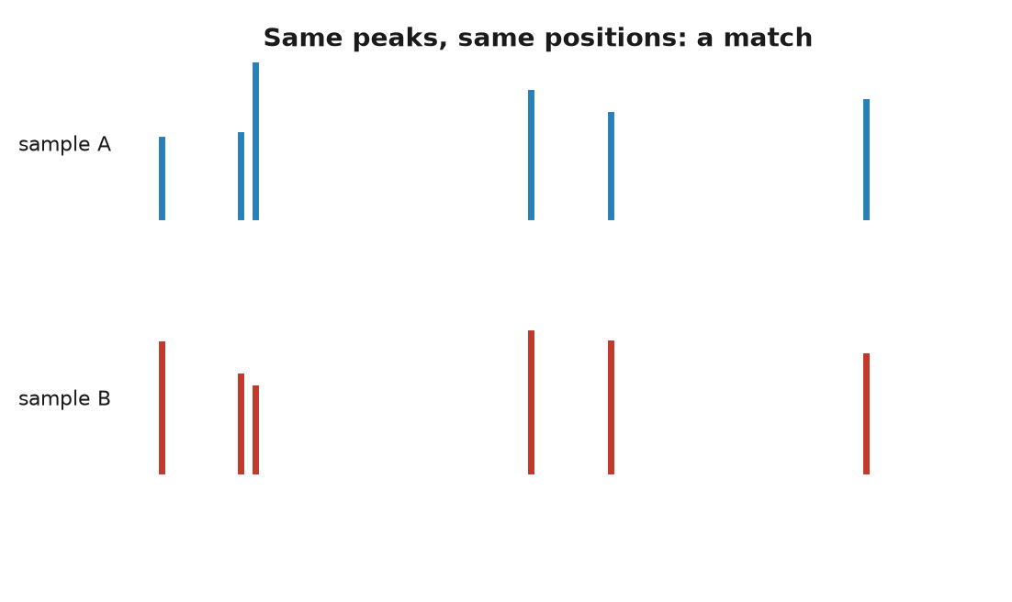
Figure 24. Short tandem repeat profiles from two samples.

The First Cases
The first case was not a crime. In 1985 a boy born in Britain to a Ghanaian mother had gone to Ghana and come back, and the immigration authorities suspected that the boy who returned was not the boy who had left, or was a nephew rather than a son. The mother’s solicitor read about Jeffreys in a newspaper. The father was not available, so Jeffreys compared the boy’s fingerprint with the mother’s and with those of her three other children, reconstructed from them the bars the father must carry, and showed that the boy was her son and their full brother, with odds against the alternative that ran into the hundreds of thousands. The Home Office dropped the case. Paternity disputes followed by the hundred, and in 1987 the chemical company ICI opened a commercial laboratory, Cellmark, to run them.
The crime came from a few miles down the road. On 21 November 1983, a fifteen-year-old girl called Lynda Mann was raped and strangled on a footpath in the village of Narborough, south of Leicester. On 31 July 1986 a second fifteen-year-old, Dawn Ashworth, was killed in the same way on a lane in the next village, Enderby. A seventeen-year-old kitchen porter, Richard Buckland, who had learning difficulties, confessed to the second murder under questioning but denied the first. The police, wanting to tie him to both, sent Jeffreys the semen samples from the two victims and a blood sample from Buckland. Jeffreys used the newer single-locus probes, which light up one minisatellite at a time and give cleaner results from degraded material. The two crime-scene samples matched each other. Neither matched Buckland. In November 1986 he was released, the first person anywhere to be cleared of a crime by DNA, and the police, who had been told by a scientist that their confession was worthless, had to start again.
They started with what was then known as the blooding. From January 1987 every man aged between about seventeen and thirty-four who lived, worked or had been treated in the three villages of Narborough, Enderby and Littlethorpe was asked to give a sample of blood or saliva. Some five thousand men did; the figure usually reported is 5,511. Nobody matched. Then on 1 August 1987 a bakery worker named Ian Kelly, drinking with colleagues in a pub in Leicester, mentioned that he had given blood in the name of a fellow baker, Colin Pitchfork, who had told him a story about being in trouble over an earlier offense and had supplied a doctored passport for the purpose. A woman at the table reported the conversation six weeks later. Pitchfork was arrested on 19 September 1987. His blood matched the two samples, he admitted both murders, and on 22 January 1988 he was sentenced to life imprisonment, the first person convicted of murder on DNA evidence. He was released on license in 2021 and recalled to prison within months, a matter still on the public record when this was written.
The United States followed within the year. In November 1987 a jury in Orlando, Florida, convicted Tommie Lee Andrews of rape on the strength of a match made by a commercial laboratory, and by 1989 a New York court, in the case of Joseph Castro, had thrown out DNA evidence from the same kind of laboratory because the work had been sloppy, which did more for the standards of the field than any conviction. Jeffreys was knighted in 1994.

Profiles, Databases and Mistakes
The barcode of 1984 is no longer what a laboratory produces. It needed too much sample and took too long, and it was hard to turn into a number. By the early 1990s the method had moved to a different kind of repeat and to the chain reaction of the previous chapter. Short tandem repeats, or STRs, are stretches where a unit of usually four letters is repeated somewhere between five and fifty times. Each person carries two copies of each STR, one from each parent, and the two copies often differ in length. At one much-used marker on chromosome 5, one person might have a copy with eleven repeats and a copy with thirteen. A child, at the same marker, has one of the mother’s two and one of the father’s, as at every other. A pair of primers on either side of the repeat, thirty cycles of PCR, and the fragments come out of a capillary machine as peaks on a trace, one peak per copy, at positions that give the repeat number directly. Nanograms of DNA suffice, which is a few dozen cells. A licked stamp will do. The result is a list of numbers, two per marker, and lists of numbers can be stored and searched.
The United Kingdom set up the first national database in April 1995 and now profiles seventeen markers plus a sex test. The FBI’s system, known as CODIS, the Combined DNA Index System, was authorized by an act of Congress in 1994 and became operational at the national level in October 1998 with thirteen core markers, expanded to twenty in January 2017. It held, by the mid-2020s, something over seventeen million profiles from convicted offenders and several million more from people merely arrested, figures I take from the FBI’s own published statistics. Britain’s holds profiles of about six million people. China’s is reported to be far larger, and the reports are hard to check. Because a child shares one repeat number with a parent at every marker, a database that holds the parent can also point, weakly, at the child; this is called familial searching, it was first used to make an arrest in Britain in 2004, and it is the modest ancestor of the genealogy searches of Chapter 72.
The arithmetic that makes such profiles powerful is simple and the ways it goes wrong are subtle. At each marker, the frequency of a given pair of repeat numbers in the population can be measured; multiply the frequencies across thirteen or twenty markers, and the chance that a random unrelated person shares the whole profile falls below one in a quadrillion, several thousand times more than the number of people who have ever lived on Earth. That is the random match probability, and it is a real number. It is not the probability that the defendant is innocent, and confusing the two has a name, the prosecutor’s fallacy, which the English Court of Appeal identified in a 1994 case and warned juries against. Suppose a partial profile from a degraded sample matches one person in a million. In a country of sixty-seven million there are about sixty-seven people who match. If nothing else connects the defendant to the crime, the profile makes him one of sixty-seven, not one in a million. Databases sharpen the problem: search seventeen million profiles for a one-in-a-million match and you expect to find seventeen innocent people, before you find anyone else.
The other failures are physical. DNA travels. In November 2012 a homeless man named Lukis Anderson was charged with a murder in a mansion near San Jose after his DNA was found under the victim’s fingernails. He had been unconscious in a hospital at the time, drunk, and had been carried there by the same two paramedics who, hours later, attended the victim; the DNA had come with them on their equipment. He spent about five months in jail before the timeline was checked. Between 1993 and 2009, police in Germany, Austria and France pursued a woman whose DNA turned up at about forty crime scenes, including the murder of a police officer in Heilbronn in 2007, and who seemed to move between burglary, murder and shoplifting with no pattern at all. In March 2009 the investigators tracked her down: she worked in a factory in Bavaria that packed the cotton swabs the police used, and had contaminated them. In Manchester in 2011 a man named Adam Scott was charged with rape after his profile came up from a swab; the laboratory had reused a plastic tray that carried a trace from an unrelated sample of his, and the charge was dropped the following year. Mixtures of two or three people’s DNA, and samples of a handful of cells, are now the daily material of forensic laboratories, and reading them is a matter of statistics and judgment, not a barcode held up to the light.
None of which is an argument against the method. In the United States, the Innocence Project counts more than 375 people freed from prison by DNA evidence since 1989, many after decades, and a fair number from death row. The technique that freed Richard Buckland before it caught Colin Pitchfork has done both, in that order, ever since. It reads, at most, a few dozen positions out of 3.1 billion, chosen precisely because they say nothing about the person except who they are. Reading the rest was, at the time of the Narborough case, an idea with a price tag of three billion dollars.
↑ Back to Contents

Chapter 54: Fast, Cheap and Everywhere — The Sequencing Revolution

A Chart That Falls Off a Cliff
There is a chart on the website of the National Human Genome Research Institute in Bethesda, Maryland, that has been reproduced more often than any figure in genetics since the double helix, and it consists of one falling line. The vertical axis is the cost of sequencing a human genome, on a logarithmic scale, so that each gridline is ten times cheaper than the one above. The horizontal axis is time, from September 2001 to the most recent update. The line starts at about $95 million. For six years it slopes down gently, roughly halving every two years, in step with a gray reference line labeled Moore’s law, the rate at which computer chips have improved since the 1960s. In late 2007 it leaves the gray line and falls off a cliff. By 2009 it is near $100,000. By 2011 it is near $10,000. By 2015 it is at about $1,000, and by 2022 the institute’s own estimate is somewhere around $500 to $600. From the year the first draft was announced to 2022, the price of reading a person fell by a factor of something like a hundred thousand.
The starting figure needs care. The Human Genome Project, described in Part IX, cost about $2.7 billion over thirteen years, but that paid for maps, for the genomes of yeast, worm, fly and mouse, for technology and for the first human sequence together, and the institute’s own estimate is that the human sequence itself accounted for a few hundred million to a billion dollars of it. The first genome of a single named person was James Watson’s, read in 2007 by a company called 454 Life Sciences in about two months at a reported cost of about $1 million and handed to him on a pair of DVDs in Houston on 31 May of that year. Craig Venter’s genome, read the same year with the older capillary machines, is not usually put on the chart because nobody agrees on what it cost. By 2014 Illumina was advertising a $1,000 genome, on condition that you bought ten of its HiSeq X machines for $10 million and ran them flat out. In September 2022 the same company announced a machine, the NovaSeq X, on which it said a genome could be read for $200 in consumables, and a rival, Ultima Genomics, had claimed $100 that May. By 2025 figures below $100 were being quoted. All of these are the cost of the chemicals and the machine time to a laboratory that runs thousands of genomes, not what a hospital bills a patient, which in the mid-2020s was still typically a few thousand dollars with interpretation, and not what a consumer paid a company for a full genome, which was a few hundred. The night in a hotel from the front of this book is the consumer price.
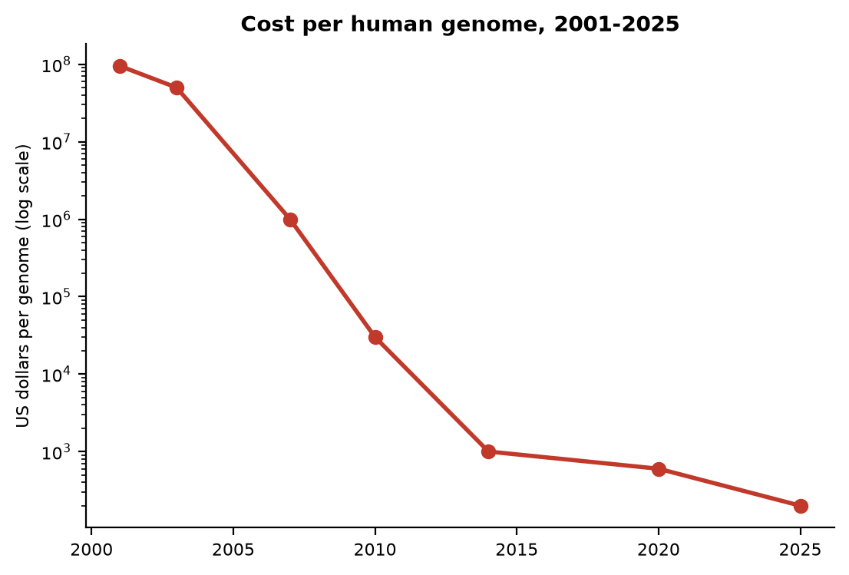
Figure 25. Cost per human genome, 2001 to 2025, on a logarithmic axis.

Born in a Pub
The cliff in 2007 has a cause, and the cause is that the ladders of Chapter 51 were replaced by something that does not read one strand at a time. The generic name is next-generation sequencing, which was a poor name the day it was coined and is now nearly twenty years old. The first commercial machine was built by 454 Life Sciences, a company founded in Connecticut by Jonathan Rothberg, who has said that the idea came to him while his newborn son was in intensive care in 1999 and nobody could tell him whether the boy was well. The 454 machine, launched in 2005 and described in Nature that year, attached single DNA fragments to beads, copied each bead’s fragment into thousands of identical copies by a form of PCR run inside droplets of oil, dropped the beads into a plate with more than a million wells the size of a picoliter, so small that some fifty million of them would fit inside a single drop of water, and then washed the four building blocks over the plate one at a time. Where a block was added, a flash of light was produced; a camera recorded which wells flashed at which letter. Hundreds of thousands of fragments were read in parallel, in about four hours, at about 100 letters each. It was the 454 machine that read Watson, and the Neanderthal draft of Chapter 58.
The machine that won was born in a pub. In 1997 two chemists at Cambridge, Shankar Balasubramanian and David Klenerman, worked out over drinks at the Panton Arms how to watch a polymerase add letters to a single molecule, and in 1998 they founded Solexa to do it. Their method, sequencing by synthesis, is what most genomes on Earth are now read with, and it goes like this. Break the DNA into fragments a few hundred letters long. Attach adapters, brief manufactured DNA tags, to the ends and spread the fragments over a glass slide, a flow cell, coated with matching adapters, so that each fragment sticks at a random spot. Copy each fragment in place, over and over, into a tight cluster of about a thousand identical molecules, so that the signal from each spot is bright enough to see. Then add all four building blocks at once, each carrying a different fluorescent color and each with its 3-prime end blocked, so that every cluster takes up exactly one letter and stops, in the same spirit as Sanger’s crippled A. Photograph the slide. Every cluster glows one of four colors. Chemically remove the block and the dye, add the four blocks again, photograph again. Repeat 150 or 300 times. The photographs, hundreds of millions of colored dots per frame, are turned into 150 or 300 letters for each of hundreds of millions of clusters. The first Solexa machine, the Genome Analyzer of 2006, read 36 letters at a time and produced about a billion letters per run. Illumina, of San Diego, bought Solexa for about $600 million in a deal closed in January 2007. Its NovaSeq X, sixteen years later, produces on the order of ten trillion letters in a run of a couple of days.
Ten trillion letters is about three thousand human genomes’ worth. In practice each genome is read about thirty times over, so a single run yields something like a hundred genomes, and the price falls accordingly. Reading everything thirty times is not extravagance. Each read is a copy of a copy, made by a polymerase on a slide, and the machines make mistakes, about one letter in a thousand on a good day. Thirty overlapping reads of the same stretch let the software vote. Thirty reads that all say G, where the reference says A, is a real variant. One read that says G is noise. This is the same logic as shotgun sequencing on Sanger’s lambda, applied at a scale Sanger’s laboratory could not have imagined: the human text is read as a heap of hundreds of millions of brief fragments and reassembled by computer, not from scratch, but by lining each fragment up against the reference genome of Chapter 67 and noting where it differs.

The Blind Spot and the Long Reads
Short reads have a blind spot, and the blind spot is repeats. If a fragment of 150 letters comes from a stretch where the same 171-letter unit is repeated ten thousand times, as it is at the center of every chromosome, the fragment fits equally well at ten thousand places and the computer cannot say which. The sequence declared finished in April 2003 was in truth about 92 percent of the genome. The remaining 8 percent, the centromeres, the pinched-in middle regions that hold a chromosome’s two arms together during division, the arrays of ribosomal RNA genes on five chromosomes, the ends, and lengthy stretches of near-identical duplicated segments, was a set of gaps labeled with an estimated length and the letter N.
Two technologies filled them, and both read one molecule at a time without copying it first. Pacific Biosciences, in California, fixes a single polymerase at the bottom of a well so small that light can only illuminate the enzyme itself, and films it in real time as it adds fluorescent letters to a single strand. Its first machine shipped in 2011, with reads of ten thousand letters or more and an error rate of about 15 percent, which was fixed in 2019 by running the same circular molecule round and round and taking a consensus: reads of fifteen to twenty thousand letters at better than 99.9 percent accuracy. Oxford Nanopore Technologies, founded in 2005, threads a single strand of DNA through a protein pore set in a membrane and measures the tiny electrical current through the pore as each letter passes and disturbs it. Its MinION, shown to early users in 2014 and sold from 2015, is the size of a large USB stick, weighs less than a hundred grams, plugs into a laptop, and cost about $1,000 with starter kits. Its early reads were only about 70 to 85 percent accurate; by the mid-2020s the best modes were reported above 99 percent, and the reads have no fixed length. Reads of a million letters and more have been published. The MinION went to West Africa in a suitcase in 2015 to read Ebola genomes at the bedside, and in August 2016 the astronaut Kate Rubins used one on the International Space Station.
A consortium calling itself Telomere-to-Telomere, led by Karen Miga and Adam Phillippy, used both of the long-read technologies on a cell line called CHM13 and published the first genuinely complete human genome in Science on 31 March 2022: 3,054,815,472 letters, no gaps, about 200 million letters that had never been seen and some ninety-nine newly predicted protein-coding genes among them. The Y chromosome, the hardest, was added in a paper in Nature in August 2023. CHM13 came from a hydatidiform mole, a failed pregnancy in which the egg had lost its own nucleus and duplicated the sperm’s, so that its two copies of every chromosome were identical and there was only one text to assemble. That is why it was chosen. A genome with two different copies of everything, which is to say any of ours, is now assembled in the same way, and the pangenome of Chapter 67 is the result.
The last number in this chapter is a time, not a price. In 2012 a group at Children’s Mercy Hospital in Kansas City, led by Stephen Kingsmore, read and interpreted the genome of a sick newborn in 50 hours, and argued in print that for a baby in intensive care with an undiagnosed genetic disease, days were the difference between a treatment and a funeral. By 2015 the time was 26 hours. In 2018, at the Rady Children’s Institute in San Diego, it was 19 and a half hours. In 2021 a team at Stanford under Euan Ashley split a patient’s DNA across 48 nanopore flow cells at once, sequenced it in about five hours, and reached a diagnosis in seven hours and eighteen minutes; the report appeared in the New England Journal of Medicine in January 2022 and Guinness recorded it. In routine use the answer takes two or three days, which is still faster than most of the tests it replaces. A California program known as Project Baby Bear, which paid for rapid genomes for 178 infants on the state’s Medicaid between 2018 and 2020, reported a diagnosis in about four in ten and a change of treatment in about a third, along with savings that the report put at $2.5 million. Roughly a third of babies in intensive care with a suspected genetic condition get a diagnosis this way; the rest get a genome that says nothing definite, which is a subject for Part X.

Everywhere
Everywhere is not an exaggeration. Sewage in London was found in 2022 to contain poliovirus by sequencing what flowed down the drains. The coronavirus of Chapter 52 became, within two years, the most sequenced organism in history, with more than sixteen million genomes shared on one public database. A MinION can read the DNA in a spoonful of pond water, or in air filtered through a zoo, and name the species passing. A spit tube of the kind in Chapter 30 will be read on a chip that checks a few hundred thousand positions, but for a few hundred dollars more it could be read in full, and a newborn’s could be read before leaving the maternity ward, as several countries were beginning to arrange when this was written. A person born in 1948, when nobody was sure the molecule carried anything at all, lived through the price of reading a human being going from infinite to a night in a hotel.
So the text can be read, by anyone, cheaply, in a day, and read so many times over that the machines’ own miscopies are voted out; the next question, which a bacterium answered for the second time in 2012, was whether it could be rewritten.
↑ Back to Contents

Chapter 55: Scissors From Bacteria — How CRISPR Became a Tool

A Problem in a Yogurt Factory
The most consequential laboratory tool of the century began as a complaint from the dairy industry. Yogurt and cheese are made by feeding milk to bacteria, mostly Streptococcus thermophilus and Lactobacillus, and bacteria have their own predators. A virus that infects bacteria is called a phage, and a phage outbreak in a starter culture can ruin a production run the way a frost ruins a vineyard. Food-culture companies lose money to phages every year. In the early 2000s, scientists working for Danisco, the Danish culture and ingredients company, were trying to understand why some of their strains survived an attack and others did not. The answer, reached in 2007, was that the surviving bacteria had filed the fingerprints of the phage in their own genome.
The repeats themselves had been sitting in the literature for twenty years, unexplained. In 1987 Yoshizumi Ishino and colleagues at Osaka University were sequencing a gene in Escherichia coli and reported, in the Journal of Bacteriology, an odd formation downstream of it: a brief sequence of about 29 letters repeated several times, with stretches of roughly 32 different letters between the repeats. It looked like a stutter. Nobody knew what it was for.
Through the 1990s Francisco Mojica, at the University of Alicante, kept going back to the salt marshes at Santa Pola, on the coast south of the city. The microbes that live in that brine carry the same stutter. He sequenced the odd region, found the repeats again, and then found them in species after species as public databases filled. In 2002, working with Ruud Jansen, he and his colleagues gave the pattern a name that has since become a verb: clustered regularly interspaced short palindromic repeats, CRISPR. In 2005 his group published the guess that explained the marshes. The spacers between the repeats matched the DNA of viruses. The stutter was a filing cabinet of enemies.
Two years later, in Science, Rodolphe Barrangou, Philippe Horvath and their Danisco co-authors showed it experimentally. Infect a culture, take the survivors, and the survivors have a new spacer in their CRISPR array, copied from the attacker. Delete the spacer and resistance is lost. Change the associated cas genes, the genes that build the cutting machinery, and resistance is lost. Bacteria, it turned out, have an adaptive immune system with a memory, and the memory is written in DNA. This is one of the clean satisfactions of biology: a question about spoiled yogurt, answered properly, turns out to be a puzzle about how one of life’s oldest arms races is fought.

From Immune System to Tool
The step from immune system to tool took five more years, and it depended on working out exactly how the memory is used. The array is transcribed into RNA and chopped into pieces, each carrying one spacer. In the system that became famous, the one from Streptococcus pyogenes, that piece pairs with a second small RNA, called tracrRNA, described by Emmanuelle Charpentier’s group in Nature in 2011, and the pair loads into a large protein known as Cas9. The RNA is the address. The protein is the machinery. Cas9 slides along DNA, and wherever the 20 or so letters of the guide match, and wherever the match is immediately followed by a brief motif the protein insists on, it cuts both strands.
That insisted-upon motif matters more than its ugly name suggests. It goes by the name protospacer adjacent motif, or PAM, and for the standard Cas9 it is any letter followed by two Gs. It is the reason the enzyme does not shred the bacterium’s own filing cabinet, and it is also the first constraint any user meets: you cannot cut wherever you like, only within reach of a PAM. Since a PAM turns up every dozen letters or so in a random stretch of DNA, this is usually a mild annoyance rather than a wall.
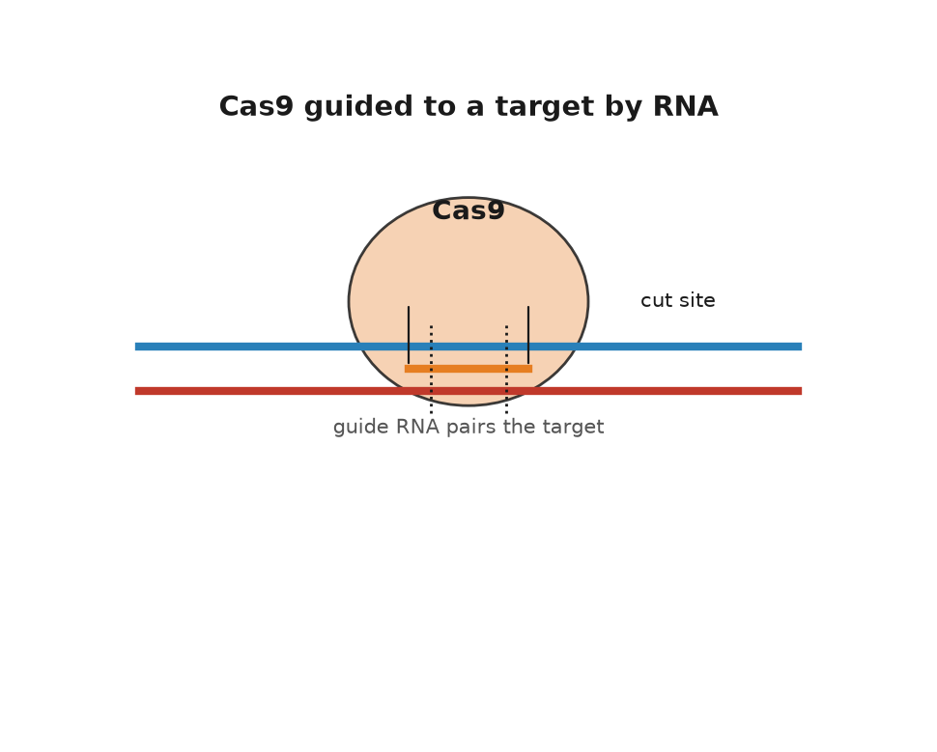
Figure 26. Cas9 guided to a target by RNA.
In June 2012, Science published a paper from Jennifer Doudna’s laboratory at Berkeley and Charpentier’s, then in Umeå, with Martin Jinek as first author. It showed that the two RNAs could be fused into one synthetic guide, and that by changing the letters of that guide you could send Cas9 to any address you chose in a test tube. The paper is calm in tone and enormous in consequence. It means a cutting enzyme is now programmable by typing, and the typing is cheap. A guide RNA can be ordered like a pizza.
By January 2013 the tool was working inside human cells, in near-simultaneous papers from Feng Zhang at the Broad Institute and George Church at Harvard, with others close behind. The Nobel Prize in Chemistry for 2020 went to Charpentier and Doudna. The credit for the jump into human cells, and the patents that followed, have been argued over in tribunals and law journals ever since, which is what happens when a tool worth billions is invented in several places within months.

Cutting Is Not Editing
Cutting is not editing. Cas9 makes a break; the cell repairs it, and what you get depends on which repair crew arrives. The fast, sloppy crew performs non-homologous end joining, which glues the ends back together and often loses or gains a few letters in the process. That is enough to wreck a gene, which is exactly what you want if the gene is doing harm. The careful crew performs homology-directed repair, which copies a template to rebuild the missing stretch. Supply your own template and you can write in a chosen sequence. The trouble is that the careful crew mostly works in cells that are preparing to divide, and it is far less efficient than the sloppy one. For most of the last decade, breaking has been easy and writing has been hard.
Two refinements from David Liu’s laboratory at Harvard changed that. In 2016, Alexis Komor and colleagues published base editing in Nature: a disabled Cas9 that binds without cutting both strands, welded to an enzyme that chemically converts one base into another in place. The first version turned C into T. An adenine version, converting A into G, followed in 2017. No break, no repair lottery, just a single letter rewritten. In 2019, Andrew Anzalone and colleagues published prime editing, which uses a longer guide that carries both the address and the new text, plus a reverse transcriptase, an enzyme that writes DNA from an RNA template, to write that text into the nicked strand. In principle prime editing can make any small change: swap letters, insert a few, delete a few. In practice its efficiency varies by target in ways still being worked out.
As of late 2026 those two refinements have left the dish. Base editors are in living patients, which is the next chapter. Prime editing has been tried in people too. A 7 December 2025 paper in the New England Journal of Medicine reported two patients with chronic granulomatous disease, a rare immune failure in which white blood cells cannot kill certain microbes, whose blood-forming stem cells had been taken out, prime-edited to restore two missing letters in NCF1, and put back. The neutrophils, one class of those white cells, regained the chemical burst they use against infection, at least across the months of follow-up in the paper. Two patients are not a medicine. They are the first evidence that a nick-and-write editor, not only a cutter or a letter-swapper, can work in a person.
Cas9 is not the only enzyme in the cabinet, either. Cas12a, first described in 2015 under the name Cpf1, recognizes a different motif, uses a shorter guide and leaves staggered rather than blunt ends. Cas13 targets RNA instead of DNA, which means a temporary edit with nothing permanent left behind, and it has been pressed into service for diagnostics. Smaller Cas proteins matter for a dull but decisive reason: the standard Streptococcus pyogenes Cas9 is a large protein, and packaging it into the adeno-associated viral vectors, harmless viruses hollowed out and used as delivery trucks for genes, is a tight fit. Much of the engineering of the last decade has been about size, motif requirements and fidelity rather than about the cutting itself.
The tool also changed how ordinary biology is done, which is easy to overlook next to the medical headlines. Pooled CRISPR screens knock out every gene in the genome, one per cell, across millions of cells at once, then ask which knockouts survive a drug or a virus or a starvation. That kind of experiment used to be a career. It is now a few weeks of work, and it has produced much of what we know about which genes a cancer cell depends on. The same approach, run with guides that switch genes on or off rather than break them, maps regulation as well as function.

What Nobody Predicted
The mechanism is settled science. Guides find their addresses, Cas9 cuts, base editors convert, cells repair. What is not settled is precision in a living animal, and this is where honest accounts and press releases part company. A guide 20 letters long will sometimes tolerate a mismatch or two. One parental set runs to 3.1 billion letters, and a cell carries two copies of it, so the genome contains a great many near-matches. Cutting at the wrong address is called an off-target effect, and it is measurable, reducible, and never quite zero. High-fidelity Cas9 variants, shorter guides, careful design software and whole-genome checks have pushed off-target rates down substantially since 2013. There are also on-target surprises: large deletions, rearrangements, and the occasional loss of a whole chromosome arm have all been reported after cutting exactly where intended.
There are also cellular consequences that nobody predicted from the biochemistry. In 2018 two groups reported that cells with an intact p53 damage-response pathway, the cell’s built-in alarm system for broken DNA, resist being edited, so that the cells which survive an editing procedure are enriched for those with a weakened response, which is exactly the population one would rather not expand. The finding was argued over and its practical importance is still debated, but it illustrates the general lesson: a double-strand break is not a neutral act of typing. It is a kind of injury, and the cell treats it as one.
Then there is mosaicism. Edit a dish of cells and you get a mixture: some edited as you wanted, some edited differently, some not at all. In a treatment made from a patient’s blood stem cells, a mixture can be good enough, because a large minority of corrected cells may be all the patient needs. In an embryo, a mixture is a different matter, since every cell of the resulting person descends from that mosaic. It is one of the several reasons the embryo work described later in this book was reckless as well as unlawful.
The address of the sickle-cell change in HBB is known to the letter, a single A where a T should be, and a base editor can in principle make that conversion without cutting the strand at all. The distance between “in principle” and “in a child” is measured in delivery, dose, safety data and about a billion dollars, and it is the subject of the next chapter.

What CRISPR Really Changed
What CRISPR actually did to biology was not to make editing possible. Gene targeting existed before it, through homologous recombination, the same template-copying repair described above, in mouse embryonic stem cells, work that earned Capecchi, Evans and Smithies the Nobel Prize in Physiology or Medicine in 2007, and through the zinc-finger and TALEN proteins of the 2000s. Those methods worked. They were also slow, expensive, and specialized: each new target meant engineering a new protein, which took a skilled laboratory months. CRISPR replaced protein engineering with a search string. That is why the technique spread through biology in about eighteen months, faster than almost any method before it, and why a graduate student in 2014 could knock out a gene in a week for the price of a set of reagents.
One further use deserves naming, because it is the only application of this technology that can spread on its own. A gene drive is an edit that copies itself onto the matching chromosome in every generation, so that instead of being inherited by half a carrier’s offspring it is inherited by nearly all of them. Built with CRISPR, drives have been demonstrated in caged mosquitoes, crashing the population by making females infertile, and they are the most plausible route yet proposed to eliminating malaria transmission by Anopheles gambiae. They are also, by design, irreversible in the wild. No drive has been released in the field, the governance discussions run through the Convention on Biological Diversity and the affected African states, and the technical question of whether resistance evolves first remains open. Everything about gene drives is a working proposition rather than a settled one.
The first patient to be treated with it was a mother of four from Mississippi, and she was dosed in the summer of 2019.
↑ Back to Contents

Chapter 56: The First Cures — Gene Therapy Arrives

Victoria Gray
Victoria Gray had lived with sickle-cell disease for thirty-four years: the crises that feel like being crushed, the hospital stays, the transfusions, the exhaustion. In the summer of 2019, at a research hospital in Nashville, she was given back her own blood stem cells after they had been removed, edited in a laboratory, and multiplied. The date usually reported is 2 July 2019. She was the first person in the United States to receive a CRISPR-based therapy for a genetic disease. When journalists spoke to her in the years that followed she described a life with the crises gone.
The edit is a clever piece of indirection. Sickle-cell disease is caused by a single change in HBB, the gene for adult beta-globin, and the obvious move is to correct that letter. The therapy does something else. Before birth, we run on a different version of the protein, fetal hemoglobin, encoded by HBG1 and HBG2, and after birth a repressor protein called BCL11A switches it off. Cut the enhancer, a stretch of DNA that acts as an on-switch for a nearby gene, that turns on BCL11A in blood-forming cells and the switch never flips: the patient makes fetal hemoglobin as an adult, and fetal hemoglobin does not sickle. The faulty gene is left exactly where it is. The cure works around it. Biology is full of these workarounds, and the people who find them deserve more credit than they get.
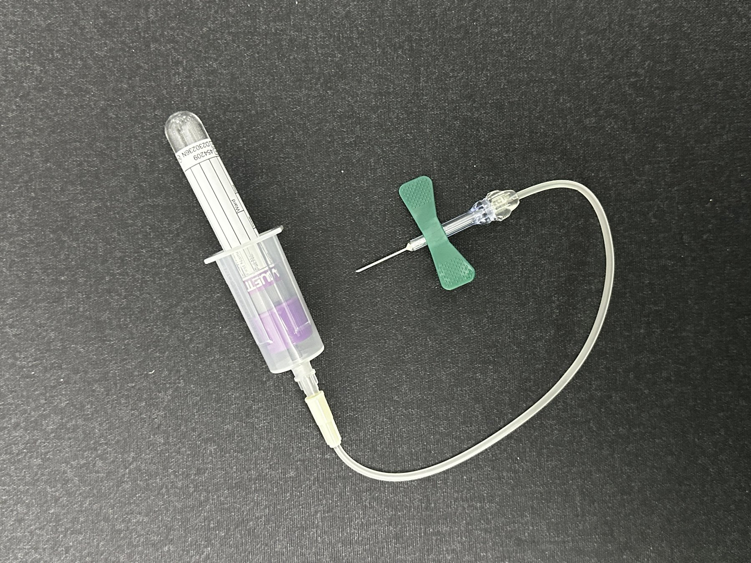
Figure 27. A blood collection tube and needle.

Thirty Years to Nashville
The field took thirty years to reach Nashville, and the reason starts with how badly the first attempt fared. On 14 September 1990, at the National Institutes of Health, a four-year-old named Ashanti DeSilva received her own white blood cells carrying a working copy of the gene for adenosine deaminase, an enzyme her immune cells needed to work properly, which she lacked. The team was led by W. French Anderson, Michael Blaese and Kenneth Culver. It was the first authorized gene-therapy trial in a human being. The results were ambiguous, since the children in that trial also stayed on the enzyme-replacement drug, and arguments about how much the gene therapy contributed lasted years. The optimism, however, was enormous, and by the late 1990s hundreds of trials were running.
On 17 September 1999, Jesse Gelsinger died in Philadelphia, four days after being injected with an adenoviral vector, a hollowed-out virus used to ferry the gene inside, carrying a gene for an enzyme of the urea cycle, the body’s chemical pathway for clearing toxic ammonia from the blood. He was eighteen, he had a mild form of his disease, and he was a volunteer in a safety trial rather than a patient seeking treatment. His immune system reacted massively to the huge dose of virus; his organs began failing one after another. The subsequent investigations found problems in consent documents, in the reporting of animal data and of earlier patients’ liver enzymes, and in the financial interests of the investigators and the university. Trials were suspended. The field’s reputation went into a hole it did not climb out of for a decade.
Worse followed. Between 2000 and 2002 a French team led by Alain Fischer and Marina Cavazzana-Calvo reported that children with X-linked severe combined immunodeficiency, known as bubble-boy disease, had been given working immune systems by a retroviral vector. It was a real and durable success. Then several of those children developed leukemia. The vector had inserted itself near a growth-promoting gene and switched it on. The mechanism is now well understood, and it is a sobering lesson about what “delivery” means: a virus that parks your gene in the genome parks it somewhere, and somewhere matters. Later vectors were redesigned to insert less dangerously, and self-inactivating designs largely solved the problem, but a child had to get cancer first for the lesson to be learned.
Sickle-cell disease is a good measure of how long that hole lasted. Its cause has been known at the molecular level since the 1950s, when Linus Pauling called it a molecular disease and Vernon Ingram pinned it to a single amino acid. It affects, by most estimates, around 100,000 people in the United States and many millions worldwide. It is the best-understood genetic disease there is, and until the 2020s the treatments on offer were a drug from the 1990s, transfusions, pain control and, for a lucky few with a matched sibling donor, a bone-marrow transplant. Understanding a disease completely and being able to do nothing much about it is the ordinary condition of medical genetics, and it is worth keeping in mind whenever a new gene is announced with fanfare.
The comeback was gene addition, the original idea of 1990, finally made to work through twenty years of unglamorous engineering of vectors, doses and manufacturing. Luxturna, Zolgensma, Hemgenix: each delivers a working gene by virus. None of them edits anything. The launch prices sit in the table in Chapter 73, one list, so this chapter does not restock them.
Editing arrived on the market in the last weeks of 2023. The therapy Victoria Gray received was licensed by Vertex and CRISPR Therapeutics under the name Casgevy, generically exagamglogene autotemcel, for sickle-cell disease and beta-thalassaemia. Britain’s regulator approved it on 15 November 2023, the first approval of a CRISPR medicine anywhere. The American approval followed on 8 December 2023. The United States wholesale acquisition cost is in that same table. In the trials, the great majority of treated patients stopped having the pain crises that define the disease. That is the settled part.

Everything Around the Edit
The unsettled part is everything around the edit. The procedure is not an injection. The patient’s stem cells must be mobilized and harvested, which is itself hard in sickle-cell disease. The cells are edited in a facility, checked, and frozen. Meanwhile the patient receives high-dose busulfan chemotherapy to empty the bone marrow so the edited cells have somewhere to live. That conditioning causes infertility in most patients, weeks of hospitalization, and a small but real risk of death. It is the same brutal preparation used for a bone-marrow transplant, and it is the main reason a therapy that a healthy country’s specialist center can deliver is nearly impossible to deliver in the countries where most people with sickle-cell disease actually live: roughly three quarters of the world’s cases are in sub-Saharan Africa. A $2.2 million treatment requiring a transplant unit is not, in any ordinary sense of the word, a cure for sickle-cell disease. It is a cure for a few hundred people who can reach it.
The prices raise a problem that medicine has not had to face before. A one-time treatment with a decades-long benefit is, in economic terms, an asset bought outright rather than a service rented monthly, and no insurance system in the world is designed for that. Manufacturers have offered outcome-based contracts, refunding part of the price if the effect fades, and public payers have experimented with subscription arrangements. In the United States, a federal model for state Medicaid programs to negotiate sickle-cell gene therapies together began operating in 2025. Whether any of this survives contact with a hundred approved therapies rather than a handful is unknown. I think the pricing question will decide how much of this chapter matters to ordinary people, more than any remaining scientific problem will.
The way out of the transplant unit is to edit cells where they sit. In 2021, Intellia and Regeneron reported the first results for NTLA-2001, an infusion of lipid nanoparticles, tiny fat-based capsules that ferry their cargo into cells, carrying Cas9 instructions and a guide, aimed at the liver, in patients with transthyretin amyloidosis. The nanoparticles drain to the liver almost by accident of physiology, the liver cells take them up, the gene that makes the rogue protein is knocked out, and blood levels of that protein fell sharply and stayed down. No cells leave the body. No chemotherapy. The liver is the easy organ, because everything in the blood goes through it, and getting the same trick to work in muscle, brain or lung is an unsolved delivery problem rather than an editing one.
Editing has also quietly improved a therapy that was already working. CAR-T treatment, in which a patient’s own T cells, a type of immune cell, are given a receptor that makes them hunt a cancer, was first approved in 2017 for a childhood leukemia. It is effective and it is laborious, because the cells must be made individually for each patient, and some patients are too ill to wait or too depleted to supply cells at all. Editing allows donor cells to be used instead: knock out the receptor that would make them attack the recipient, knock out the marker that would make them attack each other, and you have an off-the-shelf product. In 2022 a thirteen-year-old girl in London with a T-cell leukemia that had exhausted every other option received base-edited donor T cells at Great Ormond Street Hospital and went into remission, meaning the leukemia retreated and its signs disappeared. Several such trials are now running. The cells are not a cure in the sense of a corrected genome; they are a weapon manufactured by editing.

A Baby Named KJ
Then came the case that changed how the field talks about its own future. KJ Muldoon was born in Philadelphia in the summer of 2024 with a severe deficiency of carbamoyl phosphate synthetase 1, an enzyme of the urea cycle, caused by mutations in CPS1. Without that enzyme, ammonia accumulates. The condition is usually lethal in infancy, and the standard hope is a liver transplant that a newborn may not survive to receive. A team at Children’s Hospital of Philadelphia and the University of Pennsylvania, with Kiran Musunuru and Rebecca Ahrens-Nicklas among the leaders, designed a base editor for his particular mutation, tested it in cells and in animals, obtained regulatory clearance, manufactured it, and infused it in February 2025. The interval from diagnosis to dose was about six months. The New England Journal of Medicine paper of 15 May 2025 reports two infusions, at about seven and eight months of age. Later hospital and university accounts of the same case have spoken of a third dose. I will follow the paper. KJ tolerated higher doses of protein, needed less of his ammonia-scavenging medicine, and was sent home.
I think that six-month interval is the most important number in this chapter. A single edit for a single child cannot be priced the way a mass-market drug is priced, and the regulatory machinery was built for batches of a thousand patients, not one. If bespoke edits are to help the roughly 300 million people living with rare diseases, almost all of whom have no treatment of any kind, the platform has to be approved rather than each product. Regulators in the United States and Europe spent 2025 discussing exactly that, and the phrase being used is a plausible-mechanism pathway. Whether it can be made safe is a working puzzle, not a settled one.
It is also worth being careful with the word cure. In sickle cell, the results so far look like a durable remission of the disease’s defining symptom, measured over a handful of years in a few dozen people. In the amyloidosis trials, a harmful protein is suppressed rather than a tissue repaired. For KJ, one child is doing better than expected. None of this is a promise about forty years from now, because nobody has forty years of data on an edited human being. The honest claim is that we have gone from a technique to a medicine in eleven years, which almost nothing in the history of therapeutics has done, and that we do not yet know what the twentieth-year follow-up looks like.
The next puzzle is whether we can write DNA as fluently as we now correct it, which turns out to be a different kind of problem altogether.
↑ Back to Contents

Chapter 57: Writing From Scratch — Synthetic DNA, Vaccines and Proteins

A Genome Written by Machine
On 20 May 2010, a team at the J. Craig Venter Institute reported in Science that they had booted up a bacterium whose entire genome had been built in a chemistry laboratory. They took the genome sequence of Mycoplasma mycoides, about 1.08 million letters, had it synthesized as more than a thousand overlapping cassettes, ready-built DNA segments of about a thousand letters each, designed to overlap at their ends, assembled them in yeast into a single circular chromosome, and transplanted it into a related bacterium, Mycoplasma capricolum. The recipient’s own chromosome was lost as the cells divided and were selected. What remained began following the new instructions, divided, and produced colonies that were, by any test applied, the other species. They called it JCVI-syn1.0. Into the sequence they had written watermarks, coded stretches of DNA carrying the names of contributors, an email address, and three quotations, so that the artificial genome could be told from the natural one. One of the three was a line attributed to Richard Feynman, and the team wrote it in the wrong words; Feynman’s own blackboard read “What I cannot create, I do not understand,” and the synthetic genome carried a garbled version, which was later corrected. Even the first synthetic genome had a copying error, made by people rather than by the polymerase.
The road there had been walked in stages, and each stage caused an argument. In 2002 a team at Stony Brook led by Eckard Wimmer assembled a poliovirus from ordered DNA fragments and showed it was infectious in mice, which drove home the point that a virus is a sequence and the sequence is public. In 2003, Venter, Hamilton Smith and Clyde Hutchison reported synthesizing the 5,386-letter genome of phage phi X174, the same little virus Sanger had read in 1977, in about two weeks. Reading and writing had met in the same organism, twenty-six years apart. The step from 5,386 letters to 1.08 million was mostly a matter of assembly: errors accumulate with length, so the work is to build short accurate pieces and stitch them, which the Venter team did by handing the final stitching to yeast, an organism that is unreasonably good at joining overlapping DNA.
The claim advanced at the time, and it is the right claim, is narrow: the software was synthetic, the hardware was borrowed. Nobody built a cell. They copied an existing text with high fidelity, added a signature, and installed it in a working machine. This is closer to transplanting an operating system than to writing one. Even so, it settled a real question. A genome is nothing more than its sequence. Get the letters right and the chemistry does not care whether they originated in an ancestor or in a synthesizer.
The more interesting result arrived six years later. In 2016 the same institute published JCVI-syn3.0, a genome cut down by trial and error to 531,000 letters and 473 genes, the smallest set that will still run a free-living cell in rich medium. That project revealed something humbling. Of those 473 genes, a substantial minority, reported at the time as around 149, had no known function. They could not be removed without killing the cell, and nobody could say what they did. A minimal cell, built deliberately by the people who understood cells best, still contained a hundred and fifty mysteries. I find that the single most useful fact in synthetic biology, because it sets the honest ceiling on how well anyone can claim to understand a genome. Later work has pinned functions on some of them, and the list of unknowns has shrunk, but it has not reached zero.
Yeast came next, and yeast is a proper organism with a nucleus and chromosomes. The Sc2.0 consortium, coordinated by Jef Boeke, set out to rebuild all sixteen chromosomes of Saccharomyces cerevisiae from synthetic DNA, not as a copy but as a redesign: repetitive elements removed, transfer-RNA genes relocated, stop codons, the three-letter stop signals from chapter 38, standardized, and recombination sites inserted so that the finished yeast can be prompted to scramble its own genome on command. The first synthetic chromosome, synIII, was published in 2014, much of it built by undergraduates in a teaching course. In 2023 the consortium reported the great majority of the genome complete, including a strain carrying multiple synthetic chromosomes at once and a purpose-built extra chromosome to hold the relocated transfer-RNA genes. Bacteria have also been recoded: in 2019 Jason Chin’s group in Cambridge reported Escherichia coli rebuilt with about four million synthetic letters and a compressed genetic code that uses 61 codons instead of 64, which frees the three spare codons to be reassigned to amino acids nature does not use.

How DNA Is Written
It is worth knowing how DNA is actually written, because the chemistry sets the limits. Almost all synthetic DNA is still made by the phosphoramidite method, developed by Marvin Caruthers and colleagues around 1980, which adds one letter at a time to a growing chain anchored to a solid support, in four steps per letter, with organic solvents. Each cycle works well over 99 percent of the time, which sounds excellent until you compound it: at 99.5 percent per step, a 200-letter product is correct in only about a third of molecules, and a 500-letter product in fewer than one molecule in ten. Set that beside the cell. The copying machine of chapter 37, with its proofreading and the repair crews behind it, gets roughly one letter wrong in a billion. The best chemistry in the world, writing from nothing, gets something like one in two hundred wrong. That is why synthesis companies sell short pieces and why everything lengthier is assembled from them and then sequenced to check. Printing the reactions onto chips has cut the cost per letter enormously, and enzymatic synthesis, which uses a polymerase in water instead of solvents, has been promising longer and cleaner products for several years now. It is working technology, not yet a settled replacement.
If DNA is a text, it can hold texts. In 2012, George Church’s group encoded a book of about 53,000 words, plus images, into DNA and read it back. In 2013, Nick Goldman and Ewan Birney at the European Bioinformatics Institute encoded a mixed archive, including all of Shakespeare’s sonnets and a clip of Martin Luther King’s “I have a dream” speech, with an error-correcting scheme that let them recover the files intact. In 2017 Yaniv Erlich and Dina Zielinski borrowed a coding trick from video streaming and stored a complete computer operating system, a short film and a gift card, recovering every bit; they estimated a density of about 215 petabytes per gram. The attraction is density and durability. A gram of DNA can in principle hold hundreds of petabytes, each petabyte enough to store hundreds of thousands of feature films, and DNA in cool dry conditions survives for thousands of years, as the next chapter shows in some detail. The obstacles are cost and speed: writing is still far slower and dearer than any magnetic medium, and reading requires a sequencer. In 2019 a Microsoft and University of Washington team showed the whole loop running without hands, writing the word “hello” into DNA and reading it back automatically, and it took about twenty-one hours for five bytes. DNA storage is a working technology for archives nobody needs to open often, and speculative for anything else.

Writing a Vaccine
The most consequential piece of DNA writing so far was not a genome at all. It was a message. Katalin Karikó and Drew Weissman, working at the University of Pennsylvania through years of rejected grants, published in 2005 that swapping in a modified building block called pseudouridine, in place of one of RNA’s ordinary letters, stopped synthetic messenger RNA, the molecule that normally carries a gene’s instructions out to the cell’s protein-building machinery, from triggering the innate immune alarm that had made it useless as a drug. That, with lipid nanoparticle delivery developed elsewhere, is the whole basis of the mRNA vaccine. When the sequence of the new coronavirus was published in January 2020, the design of a vaccine took days, because designing an mRNA vaccine is a typing exercise: take the sequence of the target protein, adjust the codons, add the caps and tails, order the DNA template. Two small changes made the difference between a good vaccine and a poor one, both written in at the keyboard: two letters’ worth of amino acids swapped for prolines, an idea from Barney Graham and Jason McLellan’s earlier coronavirus work, which hold the spike protein in the shape it has before it fuses with a cell. The first human dose went into an arm on 16 March 2020, roughly two months after the sequence appeared. By November the large trials were reporting about 95 percent protection against symptomatic disease, and on 2 December 2020 the United Kingdom became the first country to authorize one. Karikó and Weissman received the Nobel Prize in Physiology or Medicine in 2023.
That is what fluent writing looks like when the product is a short instruction rather than an organism. Manufacturing billions of doses was an industrial feat, and the clinical trials were conventional and large, but the act of writing was trivial in a way that would have been unimaginable in 1990. The message does not touch the genome. It is read for a few days and then broken down, which is part of why it could be written so freely.

Writing Proteins
Proteins are the other half of writing, and until recently they were the harder half. A gene’s sequence determines the shape its protein folds into, the point Christian Anfinsen established with his ribonuclease in chapter 36, but for sixty years nobody could compute the shape from the sequence. Then in November 2020, at the CASP14 blind competition, a contest where teams predict protein shapes without being shown the answers first, DeepMind’s AlphaFold2 predicted structures at accuracy comparable to experiment for most targets, a median score of about 92 on the contest’s hundred-point scale, where the best entries two years earlier had scored around 60. In 2021 the method was published and the code released; by 2022 a public database held predicted structures for over 200 million proteins, which is essentially every protein sequence known. Separately, David Baker’s laboratory in Seattle had spent two decades on the inverse problem, designing sequences that fold into shapes not found in nature, beginning with a small designed protein called Top7, reported in 2003, whose fold no natural protein had, and moving on to designed binders, molecules built to grab onto a specific target, enzymes and nanoparticle vaccines. One of those, a COVID-19 vaccine built on a designed protein cage, was approved in South Korea in 2022, the first medicine made of a protein designed from scratch on a computer. The 2024 Nobel Prize in Chemistry was awarded half to Baker for protein design and half jointly to Demis Hassabis and John Jumper for structure prediction.
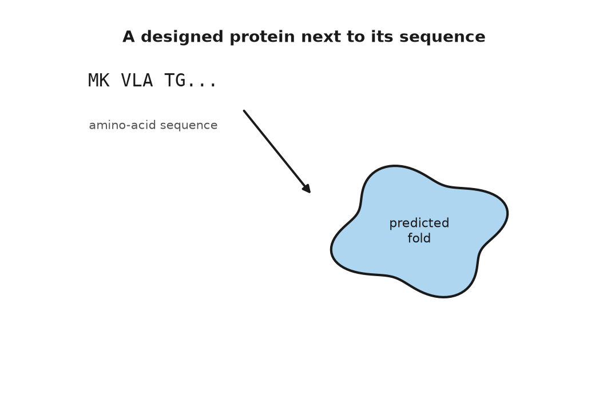
Figure 28. A designed protein next to its sequence.
The gap between prediction and design deserves a plain statement, because press coverage routinely blurs it. Predicting the fold of a natural protein is close to settled for ordinary single-domain proteins, and still unreliable for disordered regions, for large assemblies, for the effect of a single mutation on stability, and for how a protein moves. Designing a new protein that binds a chosen target is now working technology with a real success rate, helped since about 2023 by generative models that produce candidate shapes for the protein’s backbone, the folded scaffold the rest of the sequence hangs from. Designing a novel enzyme that catalyzes a reaction efficiently remains hard, and the best designed enzymes are generally far slower than natural ones. Designing a metabolic pathway that runs efficiently in a living cell is a matter of building and testing many versions rather than computing the answer, and designing a cell, or an organism, is not on the table at all. The gap between predicting a shape and predicting a behavior is the whole of biology, and no amount of structural accuracy closes it by itself.

Where Writing Is Still Hard
So where is writing still hard? Three places, mainly. Synthesis itself: standard chemistry builds accurate DNA only a few hundred letters at a time, so every lengthy construct is an assembly problem, and cost falls slowly compared with sequencing. Function: we can write any sequence, and we usually cannot predict what a novel sequence will do in a living cell, which is why synthetic-biology projects still run on cycles of build, test and fix. And regulation in the older sense of the word: a genome is not a list of parts but a network of switches whose behavior depends on context, cell type and history, and no design tool captures that yet.
Against those limits, set what writing has already delivered in industry, which is more than most people notice at the supermarket. Yeast carrying a designed pathway now makes a precursor of the antimalarial drug artemisinin, developed in Jay Keasling’s laboratory and handed to a manufacturer, which began production in 2013 as a supplement to the plant harvest. Engineered microbes make enzymes for detergents, vitamins, flavors, fragrances and the rennet in most hard cheese. They make soy leghemoglobin, a heme protein, carrying the same iron-holding ring that colors blood red, that gives one brand of plant-based burger its meaty taste, cleared by the American regulator in 2018. Each of these is a pathway of one or several genes, taken from one organism, tuned, and installed in another that can be grown in a tank. That is real writing, done at industrial scale, and it works because the products are compact molecules whose chemistry is understood, not because anyone has designed a cell.
There is also biosecurity. If a virus is a sequence, and sequences can be ordered, then the barrier to reconstructing a dangerous pathogen is the screening practices of synthesis companies rather than the difficulty of the chemistry. Horsepox, a relative of smallpox, was reconstructed from ordered fragments by a Canadian team in 2017 for about a hundred thousand dollars, and the paper started an argument that has not ended. Most commercial suppliers now screen orders against lists of sequences of concern, voluntarily and unevenly, and in 2023 a framework was agreed to tighten that screening, though it binds no one by law. I think mandatory, audited screening of synthesis orders is the cheapest safety measure available to this field, and the fact that it is still largely voluntary is the least defensible thing about the current arrangement.
Writing, then, is a set of skills at very different stages: copying a genome, settled; minimizing one, done once and still not fully understood; writing a therapeutic message, routine; writing a protein, improving fast; writing a life form from first principles, not begun. Meanwhile the most remarkable reading of the last twenty years was done not on living cells at all, but on bones.
↑ Back to Contents

Chapter 58: Reading the Dead — Ancient DNA and the Neanderthals

A Finger Bone in Siberia
In 2008, Russian excavators working in a cave in the Altai mountains of southern Siberia recovered the tip of a finger bone from a layer that also held stone tools and animal teeth. The fragment was small enough to sit on a fingernail. It went to Leipzig, to the department of Svante Pääbo at the Max Planck Institute for Evolutionary Anthropology, and in 2010 the team reported that the mitochondrial DNA in it, the separate handful of genes passed down only from mothers, belonged to no known human population. It was not modern human and not Neanderthal. Later that year a draft nuclear genome confirmed it. A girl who died in that cave, probably somewhere between 50,000 and 100,000 years ago, belonged to a sister group of the Neanderthals that no one had ever identified from a skull, because no one had a skull. Her people are now called Denisovans, after the cave, and for years they were known almost entirely from a finger, a few teeth and a genome.

DNA That Should Not Survive
Reading a genome from a fossil should not work. DNA begins to break down at death. Water attacks the backbone, cutting long molecules into fragments of a few dozen letters; cytosine loses its amino group and reads as thymine, especially at the frayed ends of fragments; bacteria and fungi move in, so that a typical ancient bone yields a soup in which the human DNA may be one per cent of the total or less. Then there is the modern contamination, which is the hardest problem of all, since the people handling the bone are made of exactly the molecule being sought. Early attempts fell into that trap. A report of DNA from an Egyptian mummy in 1985, by Pääbo himself, later proved to be contamination, and much of the ancient-DNA literature of the 1990s did not survive scrutiny.
The field had begun, as it happens, with a horse. In 1984 Russell Higuchi, working with Allan Wilson at Berkeley, recovered short stretches of DNA from a 140-year-old piece of dried muscle from a quagga, a half-striped southern African zebra hunted to extinction in the nineteenth century, and showed it was a zebra rather than a horse. The following year came the mummy paper. What looked like the start of a rush turned out to be a decade of false positives, because the polymerase chain reaction, the copying trick that unlocked such work, will amplify a single stray modern molecule just as happily as an ancient one.
What rescued the field was a set of unglamorous techniques: clean rooms with filtered air and positive pressure, extractions from the dense petrous part of the temporal bone, which preserves DNA better than the rest of the skeleton, sequencing libraries, the prepared batches of DNA fragments a sequencer actually reads, designed for brief fragments, and, best of all, turning the damage into a signature. Because deamination accumulates in a characteristic pattern at fragment ends, genuine ancient DNA has a chemical fingerprint of age that a modern contaminant does not. The damage that destroys the evidence is also what authenticates it.
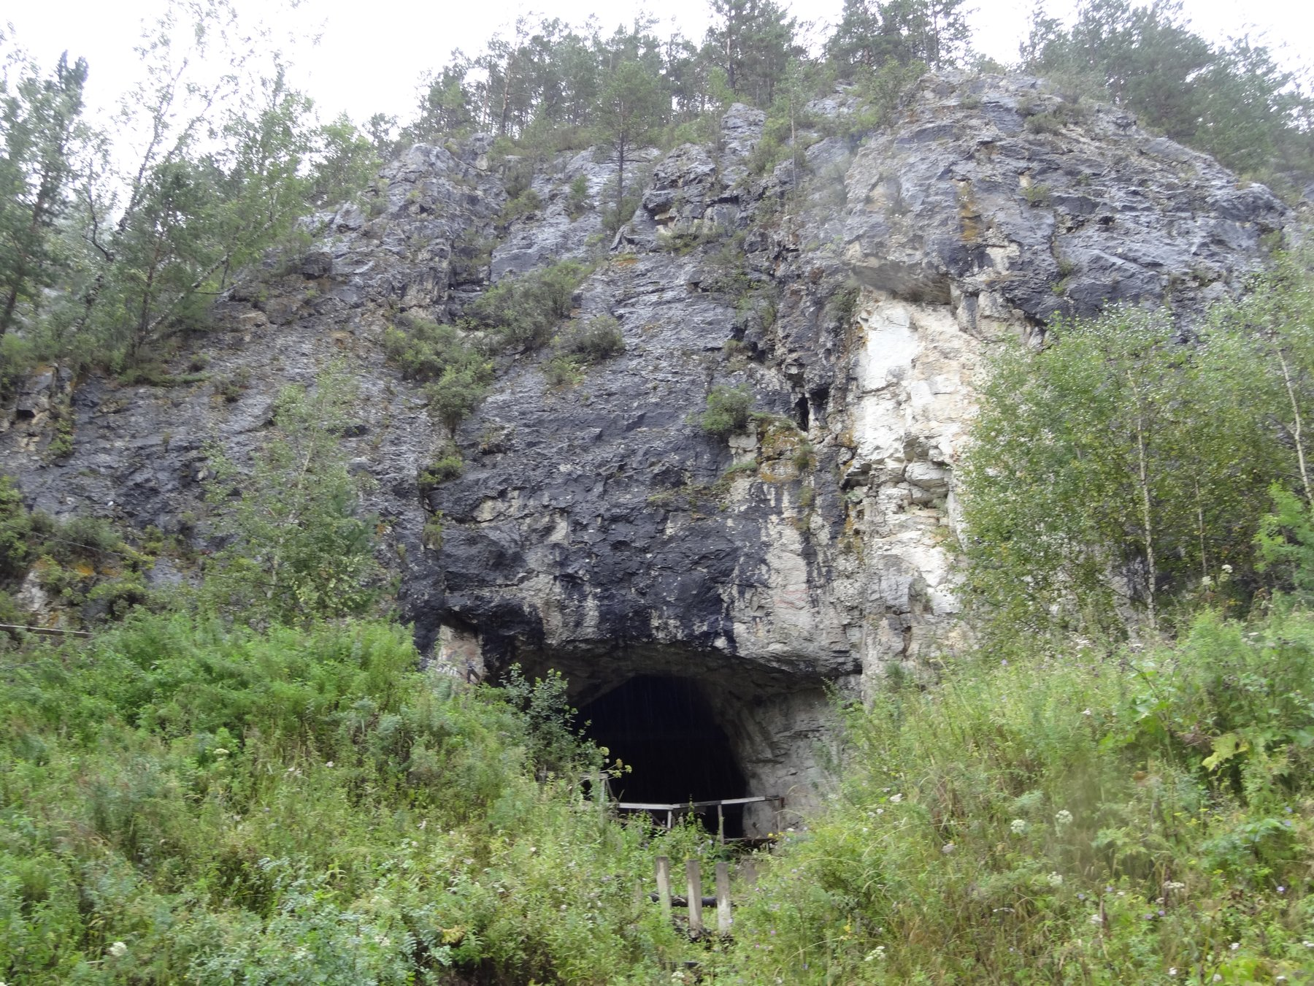
Figure 29. A limestone cave mouth, not confirmed as Denisova Cave.

The Neanderthal Genome
The Neanderthals had been waiting for this since 1856, when quarrymen blasting a limestone cave in the Neander valley near Düsseldorf threw out a skullcap and some limb bones that a local schoolteacher thought worth keeping. For a century and a half they were argued about entirely from anatomy: brutish or not, ancestor or cousin, capable of speech or not. In 1997, Matthias Krings, Pääbo and colleagues published in Cell a brief stretch of mitochondrial DNA taken from that original 1856 specimen. It fell well outside the range of living humans, which said cousin rather than ancestor, at least in the maternal line. Getting nuclear DNA, the part that would show whether the cousins had children together, took another thirteen years and a change of sequencing technology.
On 7 May 2010, the same year as the Denisovan announcement, Pääbo’s group published a draft Neanderthal genome in Science, built mainly from three bones from Vindija cave in Croatia at low coverage. High-quality genomes followed: a Denisovan in 2012, a Neanderthal from the Altai in 2014, each read many times over, in the end more accurately than many genomes of living people. Pääbo received the Nobel Prize in Physiology or Medicine in 2022 for founding the field. There are now several hundred sequenced ancient humans, and the number grows monthly.
The headline result is that Neanderthals did not entirely vanish. People whose ancestry lies outside sub-Saharan Africa carry roughly 1 to 2 percent Neanderthal DNA, a legacy of interbreeding as modern humans moved into Eurasia, probably mostly between about 50,000 and 60,000 years ago. The proportion is a population average and varies between individuals. Each person carries a different set of Neanderthal segments, so that summed across many living people a good fraction of the Neanderthal genome survives, scattered. Denisovan ancestry is concentrated further east: a few percent in Papuans and Aboriginal Australians, less in mainland East Asia. The remains themselves record the mixing directly. One individual from Denisova cave, reported in 2018, had a Neanderthal mother and a Denisovan father.
Some of the inherited segments do work. The clearest case is EPAS1, a gene involved in the response to low oxygen. Tibetans carry a version that dampens the usual response of thickening the blood at altitude, which protects against the complications of chronic mountain sickness. In 2014, Emilia Huerta-Sánchez and colleagues reported in Nature that the Tibetan version closely matches the Denisovan sequence. A population that lived and died in Siberia tens of thousands of years ago supplied an adaptation that people on the Tibetan plateau now depend on. Other archaic segments affect immune signaling, skin and hair, fat metabolism and, in a few studies, the risk of particular diseases, while much of the archaic material appears to have been selected against, since large stretches of the genome carry almost none.

Rewriting Prehistory
Ancient genomes have also rewritten the prehistory of living populations, which is in some ways the more disruptive result. In 2015 two large studies, one led from Harvard by David Reich and one from Copenhagen by Eske Willerslev, reported that a large movement of people from the steppe north of the Black and Caspian seas, associated with the Yamnaya culture, reached central Europe around 5,000 years ago and contributed a substantial share of the ancestry of most Europeans today. Archaeologists had argued for a century about whether pots move or people move. The genomes said that in this case people moved, in numbers, and that the population of Europe has been replaced or heavily diluted more than once. Similar work has traced the peopling of the Americas, the spread of farming from Anatolia, and the arrival of lactase persistence, which the ancient samples show becoming common surprisingly late.
Individuals can be read too, in detail that feels indecent. The man who came out of a melting glacier on the Italian and Austrian border in 1991, known as Ötzi, died about 5,300 years ago with an arrowhead in his shoulder. His genome, published in 2012 and revised with better data in 2023, says he had brown eyes, was lactose intolerant, carried an elevated genetic risk of heart disease, harbored the bacterium that causes stomach ulcers, and had ancestry mostly from early Anatolian farmers with little of the steppe component that arrived in the region later. A body found in ice has yielded a medical record and a family history five millennia after the funeral that never happened.
Ancient DNA reads more than people. Bronze Age teeth have yielded Yersinia pestis, the plague bacterium, with reported cases going back over 4,000 years and at least one from roughly 5,000 years ago in Scandinavia, and those early genomes lack the genes that later made flea transmission efficient. Medieval burial pits from the Black Death have given whole plague genomes. Tuberculosis, leprosy, hepatitis B, smallpox and the 1918 influenza virus have all been recovered from human remains. Environmental sediments carry DNA too: a study in 2022 reported DNA roughly 2 million years old from northern Greenland, describing a forest ecosystem from the sediment alone, and mammoth teeth from Siberia have given sequences reported as over a million years old. There is a limit somewhere, set by chemistry and temperature, and the field keeps pushing at it.

Dire Wolves and Woolly Mice
Which brings us to the animals in the press releases. Colossal Biosciences, an American company founded in 2021, has declared de-extinction its stated aim, with the woolly mammoth, the thylacine and the dodo named as projects. In March 2025 it announced woolly mice: laboratory mice carrying several edits in genes affecting hair length, texture and fat metabolism, chosen using mammoth sequences. In April 2025 it announced three pups, named Romulus, Remus and Khaleesi, described as dire wolves. The dire wolf, Aenocyon dirus, died out about 13,000 years ago and was a distinct genus, not a large gray wolf. The work as described involved sequencing ancient dire wolf material and then making a reported 20 edits in 14 genes in gray wolf cells, followed by cloning.
It is worth being exact about what such an animal is. Twenty edits is twenty edits. The gray wolf and the dire wolf lineages are separated by millions of years and by a number of genetic differences that credible estimates put in the hundreds of thousands or higher. The pups are gray wolves with a small number of engineered changes, some affecting coat color and size, presented in the shape of an extinct animal. Many palaeogeneticists said so publicly and bluntly at the time. The company’s own framing has at points been that it aims for functional proxies, animals that act and look the part without truly being the extinct species, rather than genetic replicas, which is a defensible goal described in undefensive language elsewhere in its publicity.
I think the honest way to hold this is to separate three claims. That ancient genomes can be read well enough to identify candidate genes: settled. That an edited living species can be given some traits inferred from an extinct one, and that the techniques developed along the way are useful for conservation genetics, for rescuing inbred populations such as the black-footed ferret, and for widening the gene pool of species down to their last hundreds: working, with real results already. That an extinct species can be brought back: speculative, and with the definition of “back” doing most of the work. A mammoth-like elephant would be an elephant with edits, raised without a herd, in a tundra that has changed. Whether it should be attempted at all is an argument about conservation budgets and animal welfare more than about genetics, and the strongest case against is simply that the money and attention would save more species if spent on habitat.
None of this diminishes what the fossils have actually given us, which is a family history no document records. Before 2010, the relationship between modern humans and Neanderthals was a debate about the shape of brow ridges. Now it is a matter of counting segments in living genomes and matching them to a bone from Croatia or a finger from Siberia. The dead did not leave letters. They left their text, damaged, fragmented, deaminated at the ends, mixed with the DNA of the soil and of the archaeologists, and we have learned to reassemble it well enough to say who slept in which cave and who their grandmothers were. Every one of those fragments is a copy of a copy of a copy, degraded in ways we can measure, and it is precisely the imperfections, the broken ends and the misread letters, that tell us how old the message is and how far it traveled to reach us.
↑ Back to Contents

Chapter 59: Dolly, 5 July 1996 — The Sheep From a Single Cell

A Shed South of Edinburgh
The lamb was born in a shed on a research farm seven miles south of Edinburgh, on a Friday evening in early July, and the first thing anyone noticed was her face. It was white. The ewe that had carried her for five months was a Scottish Blackface, a hill breed named for the obvious reason, and a Blackface ewe does not throw a white-faced lamb. The lamb’s face said she was a Finn Dorset. There had been no Finn Dorset ram anywhere near the flock. That was the point. She weighed 6.6 kilograms, she stood up, she fed, and the handful of people in the shed slipped away and told nobody. It was 5 July 1996.
The world heard about her seven months later. A Sunday newspaper broke the story on 22 February 1997, five days ahead of the paper it was based on, which appeared in Nature on 27 February under a title that gives nothing away: “Viable offspring derived from fetal and adult mammalian cells.” Five authors, Ian Wilmut of the Roslin Institute first among them. Somewhere in the text, in a table, is the number that made the lamb famous. The cell she had grown from was taken from the udder of a six-year-old ewe. A stockman at the farm is usually credited with the name.
What had been done to make her is called nuclear transfer, and the recipe is short even if the practice is not. Take an unfertilized egg from a Blackface ewe. Under a microscope, with a glass pipette finer than a hair, suck out the egg’s own chromosomes, so that what remains is a cell with all its machinery and none of its text. Take a cell from a culture that has been grown from a scrap of the Finn Dorset’s mammary tissue. Lay the whole cell against the emptied egg and pass a brief pulse of electricity through the pair. The pulse fuses the two membranes, so the udder cell’s nucleus finds itself inside the egg, and it also gives the egg the jolt it would normally get from a sperm. The egg starts to divide. Grow it for a few days, then put it into a surrogate ewe and wait 147 days.
The numbers in the table are these. From the adult mammary cells, 277 eggs were fused with a cell. Of those, 29 developed far enough to be worth transferring, and they were placed into 13 ewes. One pregnancy went to term. One lamb. The other 276 are the result as much as the one is. Most reconstructed eggs never became embryos worth moving. Most of those that were moved never implanted. The recipe worked, and it worked rarely, which is the pattern nuclear transfer has kept ever since. A newspaper can print the lamb. The table prints the failures, and the failures are why a clone is not a photocopy you can order. The same paper reports two other cell lines, one from a nine-day-old embryo and one from a 26-day-old fetus, and those gave a few lambs each. But it was the one from the udder that changed the argument, because an udder cell is a fully adult, fully specialized cell, and the question of the century in this corner of biology was whether such a cell still had the whole book in it, and whether the book could be told to start again from page one.
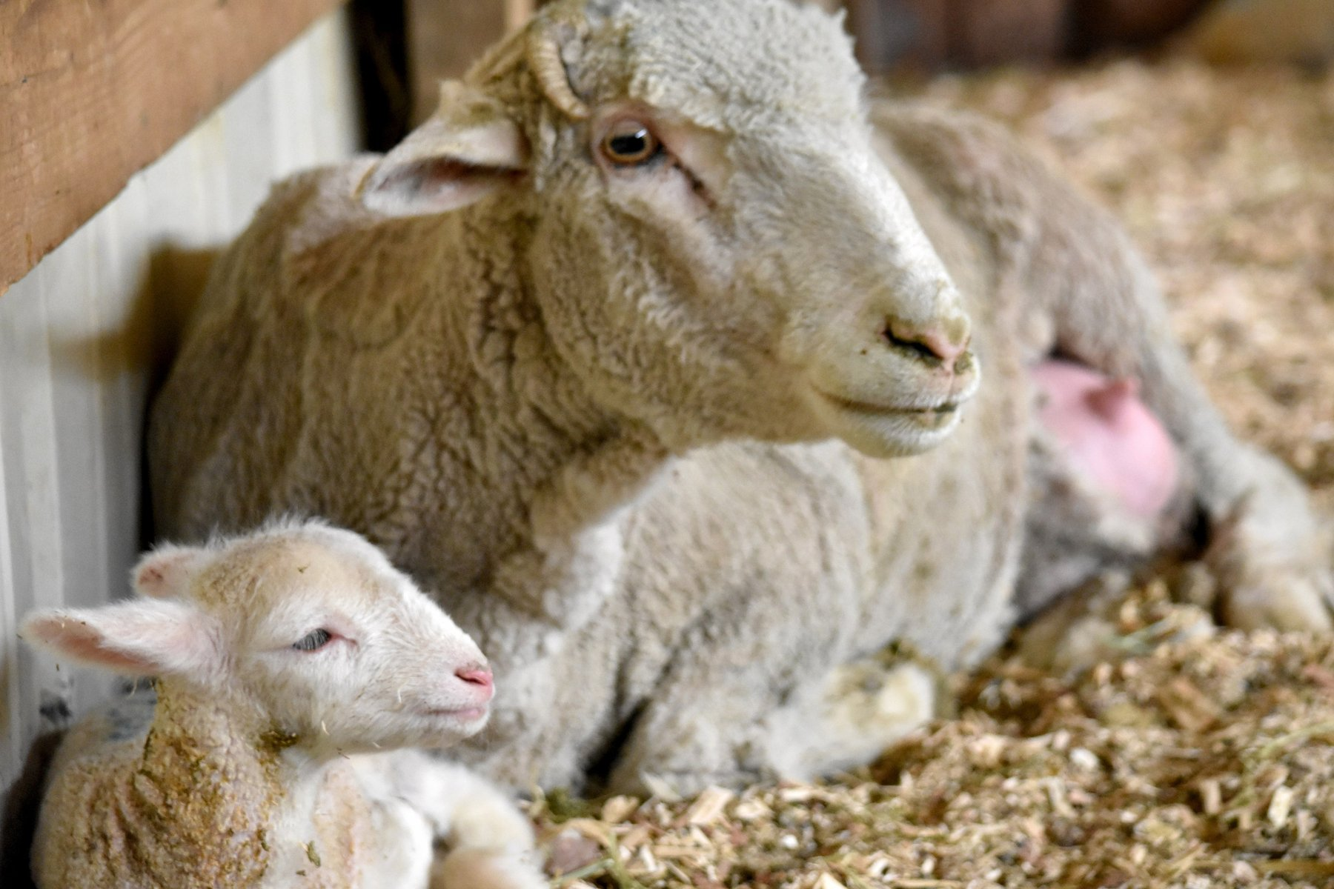
Figure 30. A ewe with her lamb in a barn.

The Older Puzzle
The puzzle was older than Wilmut. In 1928 the German embryologist Hans Spemann tied a loop of baby hair around a salamander egg, pinching it so that the nucleus was on one side and a bag of cytoplasm on the other. When the nucleated half had divided several times, he loosened the loop and let one nucleus slip across into the empty half. It grew into a normal embryo. In 1938, in a book, he proposed what he called a fantastical experiment: take a nucleus from a cell that had already become something, put it into an egg with no nucleus, and see if the egg could make a whole animal from it. He had no way to do it.
Robert Briggs and Thomas King did it in 1952, in Philadelphia, with the leopard frog. They took nuclei from cells of a blastula, an early hollow ball of a few thousand cells, put them into eggs whose own nucleus had been removed, and got swimming tadpoles. When they tried nuclei from later, more specialized stages, the tadpoles mostly failed. Their conclusion, cautious and reasonable, was that as a cell commits to its fate, its nucleus loses something it cannot get back.
John Gurdon, at Oxford, did not believe it. In 1962 he published an experiment with the African clawed frog Xenopus laevis in which the donor nuclei came from the gut lining of feeding tadpoles, cells that were already doing a job. He used a strain with a visible marker in the nucleus so that nobody could say the frogs had come from a stray egg nucleus. A small fraction of the transfers, of the order of one or two in a hundred, became tadpoles that became fertile adult frogs. It was a slim fraction, but zero would have proved Briggs and King right and it was not zero. Gurdon’s school biology master had once written on a report that a scientific career for the boy would be a waste of everyone’s time. Gurdon kept the report. In 2012 he shared the Nobel Prize in Physiology or Medicine with Shinya Yamanaka, whose part of the story is two chapters on.
Frogs, however, are not mammals, and for thirty years the mammal refused. A frog’s egg is enormous and develops on its own in pond water. A mammal’s egg is a tenth of a millimeter across and needs a womb. In 1984 James McGrath and Davor Solter published in Science a careful set of mouse experiments in which transferred nuclei from anything later than the two-cell stage failed, and they ended with a sentence that became notorious: the cloning of mammals by simple nuclear transfer, they wrote, was biologically impossible. Steen Willadsen, working in Cambridge with sheep, showed in 1986 that nuclei from eight-cell embryos would work, and groups in Wisconsin extended it to cattle, but those were embryo cells with almost no history. The adult cell was the wall.

Megan, Morag and Dolly
The person who found the way through was not Wilmut but Keith Campbell, a cell biologist who joined Roslin in 1991 with a background in cell cycles rather than sheep. His idea was that the trouble was one of timing. A nucleus busy copying its own DNA or preparing to divide, dropped into an egg that is at a different point in its own cycle, gets torn chromosomes and a dead embryo. The egg needs a quiet nucleus. Campbell’s trick was to starve the donor cells of the serum that feeds them for a few days, so that they stopped growing and dropped into a resting state that biologists call G0. A nucleus in that state, he argued, would be reprogrammed rather than wrecked.
It worked first with cultured embryo cells. Two lambs, Megan and Morag, were born at Roslin in the summer of 1995 from cells that had been grown in a dish for weeks, and the paper appeared in Nature in March 1996. Nobody outside the field noticed. Dolly, from the udder, was the same method pushed one step further, and it is a fair puzzle who deserves the credit for her. Wilmut was the head of the project and the first author. Campbell was the one with the idea. In 2006, giving evidence to an employment tribunal in Edinburgh, Wilmut himself is reported to have put Campbell’s share of the credit at 66 percent. Campbell died in 2012 at 58. Wilmut was knighted in 2008 and died on 10 September 2023, at 79.
Dolly herself lived in a barn at Roslin. She could not be put out on the hill, because the institute had received threats, and because a sheep that had been on the front page of every newspaper on Earth was worth stealing. Visitors fed her, and she grew fat. In the spring of 1997, to find out whether a clone could breed, she was put to a Welsh Mountain ram named David. Bonnie was born in April 1998. Twins, Sally and Rosie, followed in 1999, and triplets, Lucy, Darcy and Cotton, in 2000. Six lambs, all by the ordinary method. Whatever the egg had done to the udder nucleus, it had produced a ewe whose own eggs were fine.

Born Old?
Two things then happened that made people wonder whether she had been born old. In May 1999 a paper in Nature reported that Dolly’s telomeres, the protective caps on the ends of the chromosomes that shorten a little with every division, were about 20 percent shorter than those of ordinary sheep of her age. The obvious reading was that her cells remembered the six years of the ewe she came from, plus the weeks in culture. Then, in the autumn of 2001, at five and a half, she was found to have arthritis in the hip and knee of her left hind leg, which is early for a sheep. The newspapers had their story. The clone was aging fast.
The end arrived in February 2003. She developed a cough, a scan showed tumors in both lungs, and on 14 February she was put down, at six years and seven months. A Finn Dorset can live to eleven or twelve. The tumor was ovine pulmonary adenocarcinoma, a cancer caused by a retrovirus, a virus that copies itself straight into a cell’s own DNA, called Jaagsiekte sheep retrovirus, that spreads in sheep kept close together indoors. Other sheep in the same barn had it. Her body was preserved and stands today in the National Museum of Scotland in Edinburgh, looking, as she did in life, faintly pleased with herself.
So was she old before her time? The working answer, and I think the right one, is no. Cloned cattle reported in 2000 had telomeres longer than normal, so short telomeres are not a law of cloning. In 2016 a group at the University of Nottingham led by Kevin Sinclair published, in Nature Communications, a full health check of thirteen cloned sheep aged seven to nine, four of them grown from the same frozen mammary cell line as Dolly. They were healthy. Their joints, blood pressure and blood sugar were those of ordinary sheep, and none had unusual arthritis. In 2017 the same group X-rayed Dolly’s own skeleton and identified the joint damage of a sheep her age, and no worse. The best account is that she was a fat sheep kept indoors, which is a recipe for bad knees and for catching a lung virus, and that the cloning had little to do with either.
What the cloning had to do with was the argument that the copy in an adult cell is still the whole book. Roughly two hundred distinct cell types, the figure from chapter 39, make a sheep or a person, and each type carries the same text. In a person that text is two parental sets, about 6.2 billion letters. A sheep’s cells likewise carry two copies of a text of the same order of length. What differs between an udder cell and a neuron is which pages are open. Dolly showed that an egg can close them all and open them again in the right order, at least once in 277 tries. It was the loudest possible demonstration that the text and the reading of the text are two different things. What she did not show, and what the next chapter is about, is that a clone is a copy of the animal it came from.
↑ Back to Contents

Chapter 60: What a Clone Is and Isn’t — Pets, Livestock and What Goes Wrong

A Dog Named Samantha
In February 2018, in the middle of a long interview about her career, Barbra Streisand mentioned to a reporter from Variety that two of her three dogs had been cloned. Her Coton de Tulear, Samantha, had died in May 2017 at fourteen. Before she died, cells had been taken from her mouth and stomach and sent to a company in Texas, and the result was two puppies, Miss Violet and Miss Scarlett. A month later Streisand wrote a brief piece for the New York Times to explain herself. The puppies, she said, had distinct personalities from each other and from Samantha, and she was waiting to see which one would grow into the dog she missed. She dressed them in contrasting colors so she could tell them apart.
The company was ViaGen Pets, in Cedar Park near Austin, which had begun cloning dogs and cats for the public in 2015. In 2018 the price for a dog was about $50,000. A cat was cheaper, somewhere between $25,000 and $35,000 depending on the year, and by the mid-2020s both were being quoted at $50,000. The first step, the taking and freezing of a skin sample, is listed at $1,600, and a good many owners buy that and stop there.
What they are buying, if they go on, needs saying carefully, because the word clone carries a freight of films. Suppose, purely for the mechanism, that a skin cell of a fifteen-year-old were used to make a clone of him, and a child were born in 2027. What would that child share with the boy born in 2011?
The nucleus, to begin with. The child’s nucleus would carry the donor’s full diploid genome, both parental sets, about 6.2 billion letters. Two qualifications follow. The skin cell would have picked up its own private mutations since that boy was a single cell, at a rate that in skin runs to dozens a year, and every one of those would be in every cell of the clone. And the child would carry no new mutations from a father’s sperm, because there was no sperm. So the clone would be nearer to the donor than the donor is to his own brother, and not identical to him. Identical twins, who are the natural clones, are nearer still, because they start from the same single cell on the same day, and even they diverge: the fingerprints differ, and by middle age each twin carries hundreds of mutations the other does not. About three or four births in every thousand are identical twins, and the rate is oddly constant across the world.
What the clone would not share is everything outside the nucleus. The mitochondria, the small power stations in each cell with their own 16,569-letter text, come with the egg, so they would be the egg donor’s, not the boy’s. The womb would be another woman’s, with her own diet, her own infections and hormones, and her own birthday. And the epigenome, the set of chemical marks on the DNA and its packaging that tells a cell which pages are open, would have been wiped and re-laid by the egg, imperfectly. Freckles written in the nucleus would come along. A memory of the summer he learned to swim would not.
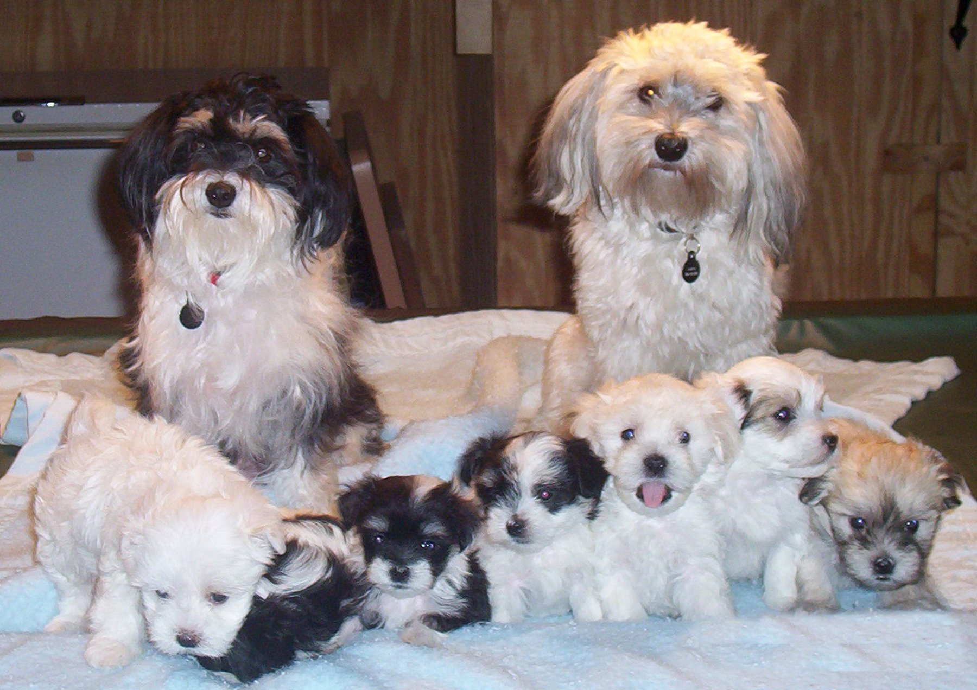
Figure 31. A litter of puppies.

A Cat Named CC
The most instructive clone ever made is a cat. Her name is CC, and she was born at Texas A&M University on 22 December 2001, announced in Nature in February 2002. The money had come from John Sperling, the founder of the University of Phoenix, who wanted his dog Missy cloned and had funded a project to that end; dogs proved harder than cats, so the cat came first. CC’s donor was a calico called Rainbow, a patchwork of orange, black and white. CC turned out gray tabby and white. Not a fleck of orange.
The reason is one that Chapter 42 set up. The gene that makes a cat’s fur orange rather than black sits on the X chromosome. A female cat has two X chromosomes, and early in development each of her cells shuts one of them down at random and keeps that choice for life. If one X carries orange and the other black, the result is a patchwork cat, each patch descended from a cell that settled on a different choice. The pattern is not in the text. It is in a set of random decisions taken by a few dozen cells in an embryo a few days old. CC’s donor cell had, by chance, shut down the X with the orange copy, and the usual account is that the egg did not fully reverse that decision, so every cell of the clone inherited it. Even if the egg had reset it, the patches would have fallen elsewhere. There is no way, in principle, to clone a calico’s coat.
CC was healthy, had three kittens in 2006 by the ordinary method, and died in March 2020 at eighteen. Sperling’s company, Genetic Savings & Clone, sold a handful of cloned cats from December 2004 at $50,000 each and closed in 2006 for lack of customers. The first cloned dog, an Afghan hound named Snuppy, was born in Seoul on 24 April 2005, from an ear skin cell; the paper reports 1,095 embryos put into 123 surrogates for that one surviving puppy. Dogs are hard because a bitch’s eggs mature late, in the oviduct, the tube that carries an egg toward the womb, and are difficult to collect at the right stage. The laboratory that created Snuppy is a story for the next chapter; the dog, unlike much else to emerge from that laboratory, was real.

Cloning That Pays
Outside the pet trade, cloning found the uses that pay. Mice were cloned in Honolulu in 1997 and reported in 1998, cattle in Japan in 1998, pigs in 2000, a horse in Italy in 2003, a mule in Idaho the same year, a camel in Dubai in 2009. On 15 January 2008 the United States Food and Drug Administration published its final risk assessment and concluded that meat and milk from cloned cattle, pigs and goats, and from their offspring, were as safe as any other; it made no ruling on sheep for want of data, and it required no label. In practice the clones themselves are rarely eaten. A clone of a prize bull costs something in the region of $15,000 to $20,000, and what is sold is his semen. The offspring of clones are ordinary animals, conceived by ordinary sex, and they have been in the American food chain since the 2000s. The European Parliament voted in 2015 to ban the cloning of farm animals and the sale of products from them, and though the legislation stalled, the practice is not carried on in Europe.
Horses are a special case, because racing’s rulebooks forbid clones but polo’s do not. In December 2016, in the final of the Argentine Open at Palermo, Adolfo Cambiaso rode six clones of his mare Cuartetera, one after another, and won. The clones had been produced by Crestview Genetics, a company set up by a Texan, Alan Meeker, with Cambiaso as a partner, and Cambiaso’s first clone had been of a stallion, Aiken Cura, from cells taken as the horse was dying in 2006. Cloned polo ponies are reported to change hands for more than $100,000. In Dubai the Camel Reproduction Center produced the first cloned camel, Injaz, on 8 April 2009, from the ovarian cells of a slaughtered adult, and has since cloned racing champions and winners of camel beauty contests by the dozen. What is bought in every case is the same thing: a genetic twin of a proven animal, born later. The buyer of a Cuartetera clone does not get Cuartetera’s training. He gets a foal that can be trained.
Conservation has begun to use the same tool. Kurt, a Przewalski’s horse, was born in August 2020 from cells frozen in 1980 at the San Diego Zoo’s Frozen Zoo, restoring a set of genes that had been lost from the living herd. Elizabeth Ann, a black-footed ferret, was born on 10 December 2020 from cells of an animal frozen in 1988, and clones of the same donor were reported to have produced kits of their own in 2024. That is cloning as a time machine for genetic variation, and it is the use I find easiest to defend.
The primates came last. On 27 November and 5 December 2017, in Shanghai, two crab-eating macaques were born. Their names, Zhong Zhong and Hua Hua, spell the Chinese word for China when set side by side. Qiang Sun and Mu-ming Poo’s group published the paper in Cell on 24 January 2018.
The numbers were bleak. The donor cells were fibroblasts, ordinary connective-tissue cells, from an aborted fetus. Seventy-nine embryos went into twenty-one surrogates. Six animals became pregnant. Two gave a live baby. A parallel attempt with adult cells produced two babies that died within hours.
What got monkeys over a line that twenty years of effort had missed was a chemical nudge. The embryos were injected with messenger RNA for an enzyme, Kdm4d, which strips a silencing mark off the packaging of the DNA, and treated with a drug, trichostatin A, that loosens that packaging further. The purpose was not curiosity. Identical monkeys are the ideal control group for a drug trial. In 2019 the same institute reported five cloned macaques with a body-clock gene knocked out.

What Goes Wrong
The Kdm4d trick points at the general problem. Dolly was one in 277. Two decades on, the efficiency of nuclear transfer is still poor: in cattle, a few percent of transferred embryos become live calves, and in pigs and dogs the figure is lower. The losses come at every stage, from embryos that never implant, to placentas that grow wrong, to calves born too large to be delivered, a condition the breeders call large offspring syndrome. That the losses happen is settled. Why they happen is a working account, and its center is the epigenome: the egg must strip from an adult nucleus every mark that made it an udder cell or a skin cell and then lay down the marks of a one-day-old embryo, and it does the job unevenly. The marks that record which parent contributed each gene copy, the imprints, are especially prone to error, and imprinted genes control the placenta and fetal growth, which is exactly where clones fail.
A growth gene shows the kind of error. IGF2 pushes a fetus to grow. Normally it is read from the father’s copy and kept quiet on the mother’s. The quiet is a chemical mark, not a changed letter.
In cloned calves the marks at this gene, and at several others like it, often slip. A copy that should be silent speaks, or a copy that should speak goes faint. The fetus overgrows. So does the placenta. The same class of slip, arising on its own rather than from a cloning procedure, is a known human condition, Beckwith-Wiedemann syndrome: babies born large, growth marks wrong.
Cloning did not invent the problem. It stumbles into it when the reset of those marks is incomplete. A live calf shows that the reset was good enough. It does not show that the reset was clean. I would describe the link between the slipped marks and the oversized calves as a working account. The overgrowth is settled. The marks are the best current explanation, and more than one gene is involved.
There is a second mismatch, in the energy supply. Milk yield and muscle work depend partly on mitochondria, and those come with the egg, not with the nucleus that was copied. A clone of a champion cow carries the champion’s nuclear text, both parental sets, and the egg donor’s mitochondrial circle of 16,569 letters. The face can match. The energy machinery is someone else’s, and nothing in the procedure swaps it. That is the same split this chapter has already shown in a calico cat and in two pet dogs. The nuclear text travels. A great deal around it does not.
None of this is what Streisand paid for, and she said as much. She wanted Samantha back, and she got two dogs with Samantha’s coat and Samantha’s face and their own opinions. The mistake, if it is one, is not in the science but in the word. A clone is a copy of the text, built late, read by another cell, in another body, in another year. Every animal in this chapter is a demonstration that the text is not the animal. The one animal it has never been done to, in any way that anyone has proved, is the one that has argued about it the most.
↑ Back to Contents

Chapter 61: The Human Question — Cloning, Stem Cells and a Lecture in Hong Kong

A Lecture Hall in Hong Kong
On the morning of 28 November 2018, in a lecture hall at the University of Hong Kong, a thirty-four-year-old biophysicist named He Jiankui walked to a lectern in front of several hundred of the world’s genome-editing scientists and a bank of cameras, and the chair of the session asked the audience to let him speak. Three days earlier, videos posted on YouTube and a story in the MIT Technology Review had announced what he was there to describe. Twin girls, given the pseudonyms Lulu and Nana, had been born a few weeks before in China with a gene known as CCR5 altered in their embryos by CRISPR, the gene-editing tool introduced in chapter 55. It was the first time anyone had deliberately altered a human being’s heritable text and let the pregnancy go to term. The chair of the summit, David Baltimore, who had shared a Nobel Prize in 1975 and had spent forty years helping to write the rules for exactly this kind of work, branded it irresponsible from the same stage the next day.
The summit was the second of its kind. The first, in Washington in December 2015, had ended with a statement that it would be irresponsible to proceed with editing embryos for pregnancy until the safety questions were answered and society had reached some broad agreement. He Jiankui had been in the room in 2015. The full story of what he did and what was wrong with it comes at the end of this chapter. Before it, there is the older puzzle that Dolly raised in 1997 and that has never been answered by a birth: whether a human being can be cloned, and what people did while trying.

After Dolly
The reaction to Dolly was immediate and mostly about people. Within a fortnight of the announcement, President Clinton had barred federal funds from any attempt to clone a human and asked his National Bioethics Advisory Commission for a report; it came in June 1997 and recommended a moratorium, a temporary halt. In December 1997 a Chicago physicist named Richard Seed announced that he would set up a clinic to clone people, and got the front pages he wanted. In 2002 a religious group called the Raelians, through a company named Clonaid, announced the birth of a cloned baby girl on 26 December, and never produced her, a DNA test, or anything else. An Italian fertility doctor, Severino Antinori, and an American, Panayiotis Zavos, put forward similar claims across 2002 to 2004 with the same evidence, which is to say none. There is no verified case of a cloned human being born, then or since.
The laws followed anyway. In Britain, a High Court judge ruled in November 2001 that an embryo made by nuclear transfer was not covered by the 1990 fertility law, because that law defined an embryo in terms of fertilization, and Parliament passed the Human Reproductive Cloning Act within weeks. The Council of Europe had opened a protocol banning human cloning in 1998. On 8 March 2005 the United Nations General Assembly adopted a Declaration on Human Cloning, by 84 votes to 34 with 37 abstentions, calling on states to prohibit all forms of human cloning that were incompatible with human dignity. The declaration is not binding, and the vote split not over babies, which nobody was defending, but over research: Britain, Belgium, South Korea and others voted against because the wording could be read to cover the making of cloned embryos for stem cells, which they allowed. The United States has never passed a federal ban, though some fifteen states have their own. Dozens of countries ban reproductive cloning outright.
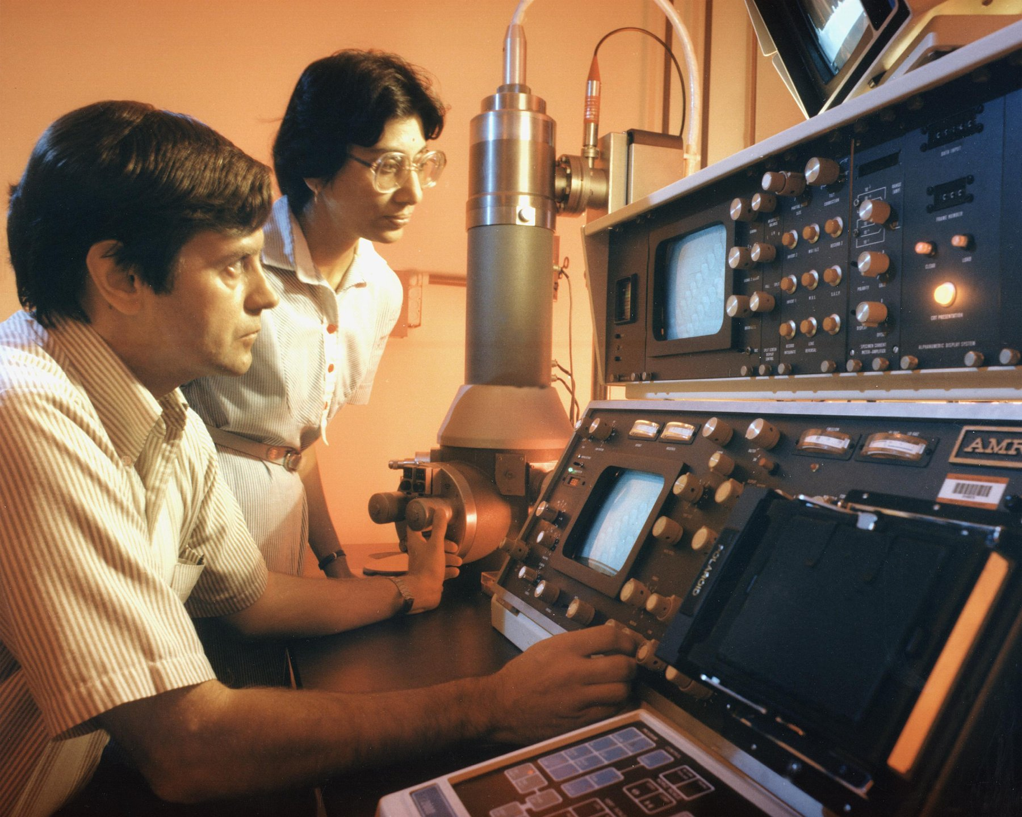
Figure 32. An electron microscope in a laboratory, about 1980.
The research the vote was about is what became known as therapeutic cloning. The idea was Dolly’s recipe stopped short. Put a patient’s nucleus into an emptied egg, let it grow five or six days to a hollow ball of a hundred or so cells, then take the inner cells and grow them in a dish as embryonic stem cells, which can become any tissue in the body and which carry the patient’s own text, so his immune system would accept them. James Thomson in Wisconsin had grown the first human embryonic stem cells from spare embryos left over from IVF, fertility treatment done outside the body, in November 1998. The matched version was the prize, and in 2004 a veterinarian at Seoul National University announced that he had won it.
Hwang Woo-suk’s paper in Science, published in March 2004, reported the first human embryonic stem cell line produced by nuclear transfer, from 242 eggs. A second paper in June 2005 reported eleven such lines, each matched to a patient, from 185 eggs, an efficiency that startled everyone in the field. Hwang became the most famous scientist in South Korea, given a title, a postage stamp and his own institute. In the autumn of 2005 the story fell apart. First it emerged that some of the eggs had come from junior women in his own laboratory, and that donors had been paid, which his American collaborator, Gerald Schatten of Pittsburgh, cited when he withdrew in November. Then a television investigative program, and a group of young Korean scientists posting online, showed that photographs in the 2005 paper were duplicates of each other. A university panel reported on 23 December 2005 that the 2005 data were fabricated, and on 10 January 2006 that the 2004 line was not a clone either. Science retracted both papers on 12 January 2006. Not one matched stem cell line had ever existed. In 2009 Hwang was convicted of embezzling research funds and of violating the bioethics law, and after appeals received a suspended sentence. He went on cloning dogs, at which, as the last chapter said, he was genuinely good.
The thing Hwang faked was eventually done. In May 2013, in Cell, Shoukhrat Mitalipov’s group at Oregon Health & Science University reported human embryonic stem cell lines made by nuclear transfer, using skin cells from a fetus and from an eight-month-old infant. The reasons it worked were unglamorous: very fresh eggs from young donors, precise timing of the electrical pulse, and caffeine in the medium, which holds the emptied egg in the right state while the new nucleus settles. In April 2014 two other groups, one in New York and one in California and Korea, extended the method to adult donors, including a man of 75 and a woman with type 1 diabetes. It had taken eleven years from Hwang’s claim to the fact. By then it barely mattered.

The Stem Cell Shortcut
It barely mattered because of a paper published in Cell on 25 August 2006 by Kazutoshi Takahashi and Shinya Yamanaka of Kyoto University. Yamanaka had trained as an orthopaedic surgeon, found he was bad at it, and turned to research. His question turned Gurdon’s on its head: an egg can reset an adult nucleus, so the egg must contain the factors that do it. What are they, and how few would be enough? He and Takahashi assembled a list of 24 genes active in embryonic stem cells, put all 24 into mouse skin cells with a virus, and got a few cells that behaved like embryonic stem cells. Then they removed the genes one at a time to see which ones were needed. The answer was four: Oct3/4, Sox2, Klf4 and c-Myc. Four genes, delivered to a skin cell, turned it back into something that could become any tissue. He called the cells induced pluripotent stem cells, iPS cells, and in November 2007 his group and James Thomson’s, in the same week, did it with human cells.
The consequences for cloning were immediate. To get a patient’s own stem cells, you no longer needed a woman’s eggs, an emptied egg, a nuclear transfer, or an embryo. You needed a skin biopsy and a virus. Whatever position a country had taken in the 2005 vote, the technology had walked around it. In 2012 Yamanaka shared the Nobel Prize in Physiology or Medicine with John Gurdon, for a frog experiment in 1962 and a mouse experiment in 2006, and it is one of the better-judged prizes: the second experiment answered what the first had only asked. The first patient treated with iPS-derived cells was a Japanese woman in her seventies who received a sheet of retinal cells in Kobe in September 2014, made from her own skin. By 2025 trials for Parkinson’s disease, heart failure and several other conditions were under way, and the Parkinson’s results reported that year from Kyoto were modest and real. Whether iPS cells become routine medicine is still a working hypothesis. That they killed the argument for cloning humans for spare parts is settled.

The Man at the Lectern
That leaves the babies, and the man at the lectern. He Jiankui had a doctorate from Rice University, a postdoctoral year at Stanford, extra research training taken after a doctorate, and a post at the Southern University of Science and Technology in Shenzhen, from which he had taken unpaid leave. Through a support group for people affected by HIV, the virus that causes AIDS, he recruited couples in which the husband was HIV-positive and the wife was not. The consent form the couples signed described the project as the development of an AIDS vaccine. The ethics approval he produced bore the stamp of a Shenzhen hospital, which said it had never given it, and the Chinese investigation that followed found the document forged. He edited CCR5 in the couples’ IVF embryos, chose embryos he judged edited, and transferred them. Twin girls were born in late 2018. A third child, from another couple, was born in 2019.
What was wrong scientifically is a list, and it needs no rhetoric. First, there was no medical need. A father’s HIV is kept out of an embryo by washing the sperm, a routine procedure since the 1990s, and the mothers were not infected, so the girls were at no risk in the womb. Second, the edit was not the edit. The intended model was Δ32, a 32-letter deletion in CCR5 carried on one chromosome by about 10 percent of northern Europeans and on both by about 1 percent, which removes the doorway that HIV uses to enter a cell. CRISPR cut where it was aimed, but the cell’s repair produced different deletions. One girl, from his own slides, had one copy of the gene changed and one untouched, which gives no protection at all. The other had two distinct changes, neither of them Δ32, whose effect on the protein nobody had ever measured. Third, the girls were mosaic: the slides showed that not every cell in the embryos carried the same edit, so the children are patchworks of edited and unedited cells in unknown proportion. Fourth, off-target cuts, CRISPR snipping at an address other than the one it was aimed at, could not be excluded, and cannot be checked in a living child without sampling tissue after tissue. Fifth, the gene itself has other jobs. People with two copies of Δ32 are reported to die more often from West Nile virus infection, and mouse work in 2016 had linked loss of CCR5 to changes in memory, a finding whose meaning for humans is speculative but which no one had considered on the girls’ behalf.
What was wrong ethically follows from the list. Children who could not consent were given an unproven change to every cell of their bodies, for no benefit to them, with risks nobody could bound, in secret, under a consent form that misdescribed the work, with paperwork that was forged. It emerged afterward that a number of scientists in China and the United States had known something of his plans, and that none had raised an alarm loud enough to stop him. The strongest case in his defense, that HIV carries a heavy stigma in China and the parents wanted their children protected, is true and does not reach the list.
On 30 December 2019 a court in Shenzhen sentenced He Jiankui to three years in prison and a fine of three million yuan, about $430,000 at the time, for illegal medical practice; two colleagues received lesser sentences. He was released in April 2022 and has since said publicly that the children are healthy, without publishing any data that would let anyone else judge. Whether editing embryos could ever be justified, for the family in which both parents carry Huntington’s and every embryo is at risk, is the argument of Part X, and I think it is a real argument with real people on both sides. He Jiankui did not have that argument. He had a gene that was easy to cut, couples who trusted him, and a summit to announce it at.
Every cell in those three children carries a change that no parent handed down and no cell miscopied, and if they have children, the change goes with them.
↑ Back to Contents

PART IX
Dinner, and the Whole Genome
Humans edited the text of other species for ten thousand years before anyone had heard of DNA. This Part follows that editing to the dinner plate, then turns to the reading of the whole human text, and of millions of people at once.

Chapter 62: Ten Thousand Years of Editing — Domestication and Breeding

An Ear of Corn and a Weed
On a table in a botany department there is an ear of supermarket sweetcorn, and next to it there is a spike of teosinte. The sweetcorn is the length of a forearm, with several hundred soft yellow kernels in straight rows, and if you dropped it in a field nothing would happen. The kernels are stuck to the cob and the cob is wrapped in husk, and the seeds would rot in a heap without a hand to strip and scatter them. The teosinte spike is the length of a little finger. It holds about a dozen kernels, each sealed in a stone case hard enough to pass through a bird, and when it ripens it shatters and throws them.
These two plants are the same species. They can be crossed, the offspring are fertile, and the differences between them are the work of people in the Balsas River valley of southwestern Mexico who began, about 9,000 years ago, to keep the seeds of the plants they liked. Starch grains and phytoliths, tiny mineral traces that plants leave behind, from a rock shelter at Xihuatoxtla in that valley, reported by Dolores Piperno and colleagues in 2009, put maize at about 8,700 years old. A genetic study by Yoshihiro Matsuoka and John Doebley in 2002 put the single origin at about 9,000 years, from the teosinte that grows in the Balsas lowlands. The two clocks agree within a few centuries.
George Beadle, who would later share a Nobel for the one-gene-one-enzyme idea, proposed in 1939 that teosinte was the ancestor of maize and was told it was absurd. In 1972 he came back to it with a simple experiment. He crossed the two, grew about 50,000 second-generation plants, and counted how many looked like either parent. About one in five hundred did. That is what you expect if the difference rests on roughly four or five genes, not on hundreds. The conversion of a wild grass into a food plant had been, in genetic terms, a small edit.
Doebley spent the 1990s finding the edits. The first, published in Nature in 1997, was a gene called teosinte branched1, written tb1. Teosinte is a bush, with many branches each carrying a slim spike. Maize is a single stalk with one or two big ears. The difference is not in the protein the gene makes, which is the same in both, but in a control region upstream of it, where maize has a change that makes the plant produce more of the protein and so suppress its branches. A later study found that the change was a jumping piece of DNA, a transposon named Hopscotch, which had landed there about 23,000 years ago, long before any farmer, and sat in the wild population as a rare variant until people started choosing it. The second edit, published by Huai Wang and Doebley in 2005, was tga1, teosinte glume architecture. A single amino-acid change, a swap in one of the compact building blocks a protein is strung together from, turns the stone case into a soft cup, and the kernel is naked. Nobody in the Balsas valley knew any of this. They ate the plants with the fewest branches and the softest kernels and planted what was left.
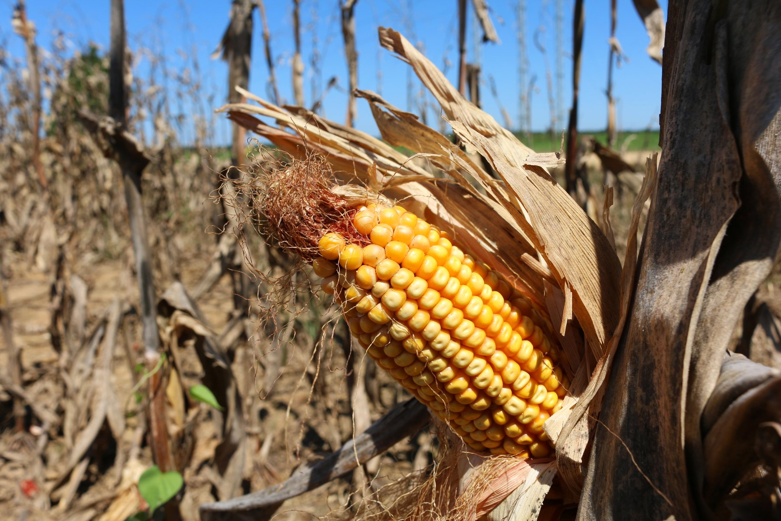
Figure 33. Ears of corn, kernels locked in straight rows.

Wheat, Dogs and Darwin
Wheat is older. Its wild ancestors, einkorn and emmer, still grow on the hillsides of the Fertile Crescent, and a study by Manfred Heun and colleagues in Science in 1997, which fingerprinted 338 lines of einkorn, pointed at the Karacadağ mountains in southeastern Turkey as the place where the cultivated form began, about 10,000 years ago. The key trait in wheat is not branching but shattering. A wild wheat spike, when it ripens, breaks apart at the joints of its central stalk and the seeds fall. That is what a seed is for. Every so often a plant carries a mutation in one of the brittle-rachis genes, and its spike stays whole. In the wild that plant is a failure, since its seeds never leave it. In a field of people with sickles it is the only plant whose seeds make it home, and whose seeds are sown next spring. The harvest itself did the selecting, and no one had to intend it. Excavations by Ken-ichi Tanno and George Willcox, reported in 2006, suggest the shift from shattering to non-shattering took more than a thousand years, which is what you would expect from a selection nobody was managing.
Bread wheat added a second step. Some 8,000 to 9,000 years ago, near the southern shore of the Caspian, cultivated emmer crossed with a weedy goat grass known as Aegilops tauschii, and the hybrid kept all the chromosomes of both. The result carries three full genomes stacked together, about 16 billion letters, roughly five times the length of the human text, which is one reason the wheat genome was not assembled in full until 2018. The goat grass contributed the proteins that let dough hold gas. Bread is a chromosome accident that people noticed and kept.
The animals came earlier and are harder to date. The dog is the first domesticate, older than any crop, and it descended from the gray wolf somewhere between 15,000 and 30,000 years ago; some claims run older, and the field has argued for two decades about whether it happened once or twice. The oldest undisputed dog is a jaw from Bonn-Oberkassel in Germany, buried with two people about 14,200 years ago. A 2020 study in Science led by Anders Bergström found that by 11,000 years ago there were already at least five distinct dog lineages, which means the split from wolves was well behind them. Cattle descended from the aurochs, a beast that stood taller than a man at the shoulder and whose last known individual died in a Polish forest in 1627. Taurine cattle were domesticated in the Near East about 10,500 years ago, and one 2012 analysis of ancient DNA estimated that the founding herd was as few as about 80 females, a number I would treat as an order of magnitude rather than a count. Zebu cattle were domesticated separately in the Indus valley. The chicken descends from the red junglefowl of Southeast Asia, and here the dates have recently shrunk: a 2022 reassessment of the bones, led by Joris Peters, identified the earliest secure evidence at Ban Non Wat in Thailand about 3,500 years ago, in a rice-growing village, and threw out older claims. The birds probably arrived at the rice, and the people followed the birds.
Darwin understood all of this before anyone knew what a gene was. The first chapter of the Origin of Species in 1859 is about pigeons, not finches, and his 1868 book The Variation of Animals and Plants under Domestication runs to two volumes on the same theme. The farm was his model for nature: variation appears on its own, a chooser keeps some of it, and over generations the chosen line walks away from the original. The chooser on the farm is a person. In the wild it is hunger, cold, and the neighbors. The mechanism is the same, and it runs on the fact this book keeps returning to, that every generation’s copy of the text carries a few new letters that were not in the last one. Domestication did not create the variants in tb1 or the brittle-rachis genes. It picked them up, already sitting in a population for thousands of years, and multiplied them.

The Green Revolution
For ten thousand years that was the whole toolkit: wait for a variant, notice it, keep it. In 1927 Hermann Muller showed that X-rays raised the mutation rate in fruit flies by a large factor, and the next year Lewis Stadler did the same in barley and maize. Breeders saw at once what that meant. If mutations were the raw material, and radiation made mutations, then a breeder need not wait. Seeds went into X-ray tubes, then, after 1945, into gamma fields, plots of crops exposed to a radioactive source, at places like Brookhaven National Laboratory, where a cobalt-60 source, a radioactive metal giving off penetrating rays, stood at the center of a circular plot and the plants grew in rings at different doses. Chemicals such as ethyl methanesulfonate, which raise the mutation rate the same way, did the same job in a jar. In Britain in 1959 a woman named Muriel Howorth founded an Atomic Gardening Society and sent irradiated seeds to hobbyists.
The results are on the plate, and most of them carry no label. The database kept by the Food and Agriculture Organization and the International Atomic Energy Agency lists more than 3,400 registered varieties made this way. At Brookhaven the cobalt source stood in the middle of a round field and the crops grew in rings, the inner plants dead or stunted, a ring further out alive and full of new changes a breeder could keep or throw away. Golden Promise barley, from gamma-irradiated seed released in Britain in the 1960s, became a malting barley for Scotch whisky. One fruit shows the two eras in a single color. Ruby Red grapefruit was a bud sport found on a Texas tree in 1929, decades before anyone aimed a neutron at a seed. Star Ruby, in 1970, and Rio Red, released in 1984, came from budwood irradiated with thermal neutrons at Texas A&M. None of these was regulated as anything other than a plant. A breeder who scrambles a genome at random with radiation and keeps the one seedling in ten thousand that turned out useful is doing conventional breeding, in the law’s eyes, and the produce qualifies as organic. That fact will matter in the next chapter.
The largest single edit of the twentieth century was done with neither radiation nor a laboratory, and it fed something like a billion people. Norman Borlaug was born on a farm near Cresco, Iowa, on 25 March 1914, and in 1944 he joined a Rockefeller Foundation program to improve Mexican wheat. His first invention was a schedule. He grew two generations a year, one in the Yaqui valley of Sonora in the north and one near Toluca in the highlands, shuttling seed between them, which halved the time to a new variety and, by accident, produced wheats that did not care what latitude they grew at. His second problem was stems. A wheat plant given fertilizer grows a heavy head on a tall stalk and falls over in the rain, and a fallen crop rots. What Borlaug needed was a short wheat.
Such a wheat already existed. In Japan a breeder named Gonjiro Inazuka had released a variety called Norin 10 in 1935, descended from a dwarf landrace named Daruma. In 1946 an agronomist with the American occupation, Cecil Salmon, mailed seed of it to the United States. Orville Vogel at Washington State crossed it with a local variety, and in 1953 he sent some of the crosses to Borlaug in Mexico. Borlaug crossed those into his rust-resistant lines and by 1962 had semi-dwarf wheats that stood about half the height of their parents and put the difference into grain. Mexico, which had imported half its wheat when he arrived, was reported self-sufficient by 1956 and exporting soon after. In 1963 the Indian geneticist M. S. Swaminathan invited him to India; in 1966, with famine in prospect, India imported about 18,000 tonnes of Mexican seed, and Pakistan did the same. India’s wheat harvest, about 12 million tonnes in 1965, was reported at about 20 million by 1970. Pakistan declared itself self-sufficient in wheat in 1968, India in 1974. On 10 December 1970 Borlaug received the Nobel Peace Prize in Oslo, the only plant breeder who ever has.
The dwarfing genes were named decades later. They are Rht-B1b and Rht-D1b, on two of wheat’s three genomes, and a 1999 paper in Nature by Jinrong Peng and colleagues showed what they do: each makes a protein that ignores the growth hormone gibberellin, so the stem stops listening to the signal to elongate. The same year’s paper pointed out that rice’s Green Revolution variety, IR8, released in the Philippines in 1966, carries a mutation with the same effect in a gene known as sd1. Two crops, two continents, one mechanism: a broken hormone receiver.
The Green Revolution has a bill, and the bill is real. Semi-dwarf wheat only pays if you feed it, so it came bundled with nitrogen fertilizer, irrigation, and a narrowing of the varieties in the ground; those costs get their own chapter at the end of this part. But the method was the oldest one there is. Borlaug did not add a letter to the wheat text. He found a plant that already carried the letters he needed, in a Japanese field, and did what the Balsas farmers had done with their teosinte, faster and on purpose.

Breeding by Waiting
The oldest method is still in use. In Salina, Kansas, The Land Institute has spent decades turning a wild perennial grass, intermediate wheatgrass, into a grain sold under the trademark Kernza. A perennial keeps its roots in the ground from one year to the next, so the soil is not opened every spring. By 2025 growers had sown a few thousand acres across about nineteen American states. The harvest is still a niche flour and a beer ingredient, not a substitute for wheat, and the yield remains a fraction of an annual crop. That is breeding at the old speed, choosing which inexact copies to plant, and it is incremental on purpose.
In 1994 a company in California put a tomato on a shelf that carried a letter no tomato had ever had, and the argument about dinner changed shape.
↑ Back to Contents

Chapter 63: The Tomato That Didn’t Rot — The First Engineered Crops

A Tomato in Davis
In the third week of May 1994, in a supermarket in Davis, California, there was a bin of tomatoes with a leaflet beside it. The tomatoes carried the name Flavr Savr, sold under the brand MacGregor’s, and the leaflet explained that they had been developed by a company named Calgene, a few miles away, using “genetic engineering.” The Food and Drug Administration had said on 17 May that they were as safe as any other tomato. People bought them at a premium, and a reporter counted queues.
The idea was narrow. A tomato softens as it ripens because an enzyme called polygalacturonase digests pectin, the substance that cements a plant’s cell walls together. Growers therefore pick tomatoes green and hard, ship them, and gas them with ethylene to turn them red, which is why a winter supermarket tomato tastes of nothing. Calgene’s scientists inserted a second copy of the polygalacturonase gene, written backwards. The reversed copy makes an RNA, a chemical cousin of DNA that carries copied instructions, that pairs with the normal message and stops it being read, and the enzyme falls to a small fraction of its usual level. The tomato could ripen on the vine and still survive a truck. The insertion also carried a bacterial gene for resistance to the antibiotic kanamycin, used to pick out the cells that had taken up the new DNA, and much of the FDA’s review was about whether that marker mattered. It concluded it did not.
The Flavr Savr was a commercial failure and a historical success. The variety it had been built on was mediocre, the tomatoes bruised in the machinery designed for hard green fruit, and Calgene lost money on every one. Monsanto bought the company in 1997 and the tomato disappeared. In Britain a tomato purée produced from a similar Zeneca tomato, clearly labeled, went on sale in 1996 and sold well until about 1999, when the mood changed. What the tomato proved was that the FDA would review such a food and the public, in 1994, would eat it.

The Crops That Mattered
The crops that mattered came two years later, and they were not about flavor. In 1996 Monsanto sold the first soybeans carrying a gene from a soil bacterium, Agrobacterium strain CP4, that made the plant indifferent to the herbicide glyphosate. Glyphosate kills plants by blocking an enzyme in the shikimate pathway, a chain of reactions that makes three amino acids, the compact building blocks proteins are strung together from, that plants need and animals do not; the bacterial version of the enzyme, from a gene written CP4 EPSPS, is not blocked. A farmer could now spray the whole field and kill everything but the crop. The same year brought corn and cotton carrying a gene from Bacillus thuringiensis, a bacterium found in diseased silkworms in Japan in 1901 and named ten years later after the German region of Thuringia. Bt, as it is called, makes crystal proteins that dissolve in the alkaline, meaning non-acidic, gut of a caterpillar or a beetle larva, bind to receptors, docking points on the gut’s cells, and punch holes. A mammal’s stomach is acid and its gut lacks the receptors, which is why Bt has been sprayed on crops as an insecticide since the 1930s and is allowed on organic farms. Putting the gene in the plant meant the plant produced its own.
The uptake was the fastest of any farm technology on record. The United States Department of Agriculture’s annual survey reported that by 2024 about 92 percent of American corn acreage, 96 percent of soybean acreage and 97 percent of cotton acreage carried engineered traits, most of them herbicide tolerance, insect resistance, or both stacked together, two or more engineered traits in one seed. Worldwide, the industry’s own count put the area at about 190 million hectares, not far short of the size of Mexico, in 29 countries by 2019, with the United States, Brazil, Argentina, Canada and India taking most of it. If you have eaten anything in the last twenty years containing corn syrup, soy oil or cottonseed oil in North America, you have eaten these.
What changed in those fields was not a secret yield gene. Herbicide-tolerant soy and corn let a farmer spray the whole field and leave the crop standing, which made it much easier not to plow. USDA economists reported that by 2006 about 45 percent of herbicide-tolerant soybean acres were under no-till, compared with about 5 percent of conventional soybean acres. The soil stayed put. Glyphosate use rose, and the weeds, as the last chapter of this part records, learned to live with it. Insect-resistant cotton did a simpler job: it cut the spraying aimed at bollworm. In China, where Bt cotton has been in the ground since 1997 and by about 2018 covered some 95 percent of the national crop, early surveys by Jikun Huang and colleagues recorded pesticide cuts of about half. India adopted the same trait from the early 2000s and saw similar drops, though pink bollworm later caught up where refuges were ignored. The myth is a magic harvest. The reality is two traits that changed how a field is weeded and how a cotton plant is defended.
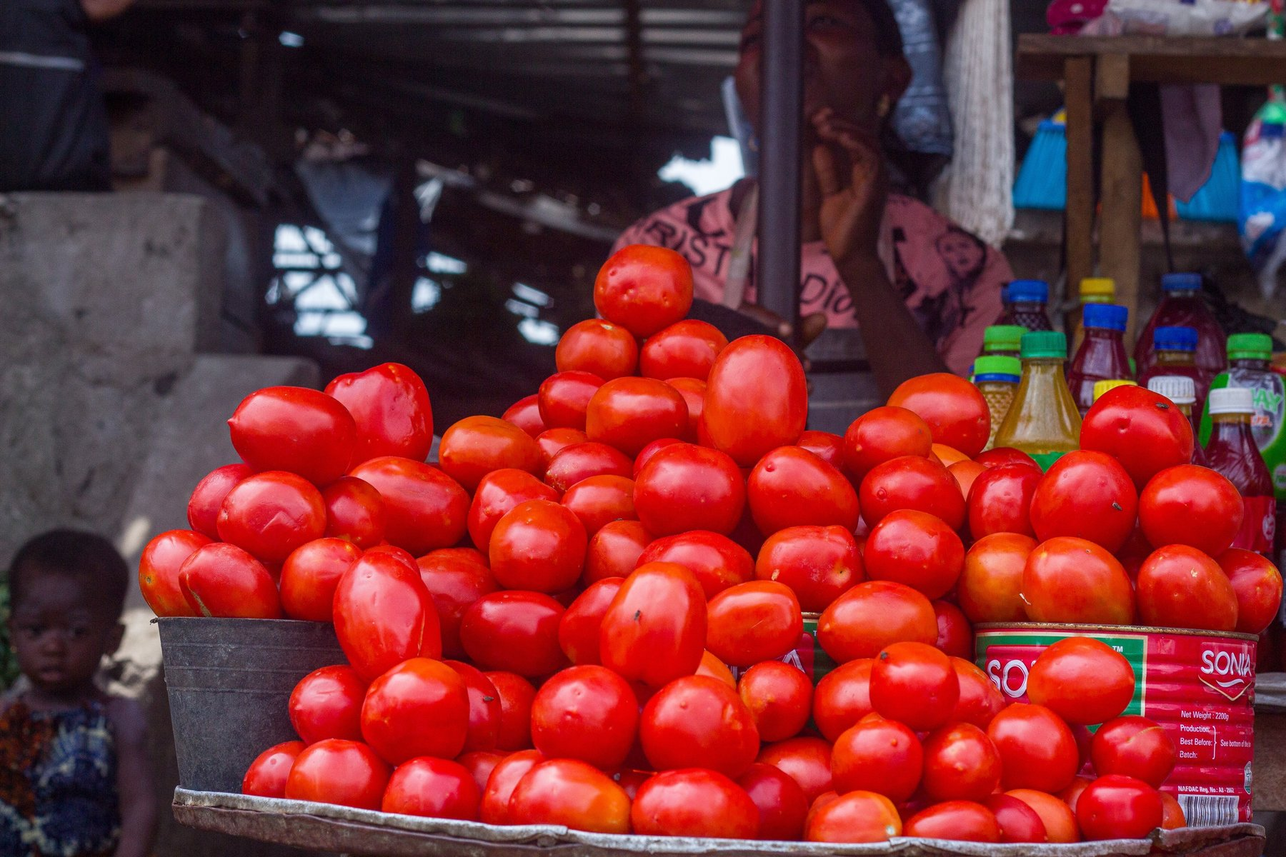
Figure 34. Tomatoes on a market stall, stacked for sale.

What Only the Technique Could Do
The clearest case that the technique can do something nothing else could is a fruit. Nearly all of Hawaii’s papaya grows in the Puna district on the Big Island, and in 1992 papaya ringspot virus arrived there. There is no cure for a plant virus and no resistant papaya existed. By the late 1990s production in Puna had roughly halved. Dennis Gonsalves, a Cornell plant pathologist who had grown up on a Hawaiian sugar plantation, had been working since the 1980s with Richard Manshardt, Maureen Fitch and Jerry Slightom on an idea borrowed from vaccination: put the gene for the virus’s own coat protein into the plant. The mechanism, which nobody fully understood at the time, turned out to be that the plant treats the foreign RNA as a target and silences anything matching it, including the real virus when it arrives. The transgenic line, SunUp, a papaya carrying DNA from another species, was crossed with a popular yellow variety to give Rainbow, and seed was handed out to growers in May 1998. Rainbow papaya is now most of what Hawaii grows, and the virus is still there, in the weeds and the unimproved trees, doing nothing to it.
Golden rice is the opposite case, a success in the laboratory that took a quarter of a century to reach a field. Rice endosperm, the white part, contains no beta-carotene, the precursor of vitamin A, and in populations that live on rice the deficiency blinds and kills children. The World Health Organization has estimated that hundreds of thousands of children a year lose their sight to it, and that about half of those die within a year, though the figures are old and hedged. In Science on 14 January 2000, Ingo Potrykus of Zurich and Peter Beyer of Freiburg reported a rice carrying two added genes, a psy from daffodil and a crtI from a bacterium, that made the grain pale yellow with carotene. A 2005 version from Syngenta, with the daffodil gene swapped for the maize one, yielded about 23 times more. Then the arguments began: about patents, about Greenpeace’s opposition, about whether a poor child would eat enough rice to matter, and about regulatory tests that took years each. In 2016 more than a hundred Nobel laureates signed a letter asking Greenpeace to stop. On 21 July 2021 the Philippines granted the first permit anywhere to grow it commercially, and farmers planted it in 2022 and 2023. In April 2024 the Philippine Court of Appeals revoked the permit, on the grounds that safety had not been sufficiently shown, and as I write the case is on appeal. Two decades and four months from the paper to the first commercial harvest, and then a court. I think the delay killed children, and it is fair to say so while also saying that the rice was never going to fix a diet on its own.
On the safety of eating such food, the evidence is as close to settled as anything in this book. In 2016 the National Academies of Sciences, Engineering, and Medicine in Washington published a review, Genetically Engineered Crops: Experiences and Prospects, that went through about 900 studies and two decades of health data from countries that ate engineered crops and countries that did not. It found no substantiated evidence of a difference in risk to human health between engineered and conventionally bred crops, and no pattern of environmental harm. It also noted, which the industry quoted less, that the crops had not raised the underlying rate of yield growth, though they had cut insecticide spraying and lowered the cost of weed control. A 2013 review by Alessandro Nicolia and colleagues had gone through 1,783 papers from the previous decade and reached the same place. The studies that grabbed headlines the other way, a 1998 potato experiment in Scotland and a 2012 rat study in France, did not survive scrutiny; the rat paper was retracted in 2013.
Distrust is not about the molecule, mostly. Surveys by the Pew Research Center in 2018 recorded about half of American adults saying engineered foods were worse for health, with the figure higher among people who said they knew least about the science. When people are asked what worries them, the answers cluster around who owns the seed, who profits, whether they were told, and whether anyone would admit it if it failed. Those are questions about institutions, and they are not stupid; the next two chapters take them seriously. The question about the molecule is, on the evidence, answered.

Two Continents, Two Rules
Labeling is where the two continents parted. In the United States a federal court in Washington, in Alliance for Bio-Integrity v. Shalala in 2000, upheld the FDA’s refusal to require labels on foods made with recombinant DNA. Vermont passed a labeling law in 2014, the first in the country. A law signed in July 2016 created a national “bioengineered” disclosure, mandatory from 1 January 2022, a small green seal or a QR code, and overrode the state statutes. The European Union took the opposite path from the start. Directive 2001/18/EC governs the release of engineered organisms, and a 2003 regulation requires any food with more than 0.9 percent engineered content to say so. Approvals for cultivation are so slow and so political that only one engineered crop, an insect-resistant maize called MON810, has ever been grown commercially in the Union at any scale, mostly in Spain. In July 2018 the Court of Justice of the European Union ruled that plants edited with new techniques such as CRISPR, the gene-editing tool from chapter 55, fall under the same directive, while plants mutated at random by radiation, the Golden Promise and Rio Red kind, are exempt because they have “a long safety record.” A plant with one deliberate letter changed was regulated; a plant with thousands of random ones was not. The European Commission proposed a fix in July 2023. Parliament voted in February 2024, the member states in March 2025, and a provisional deal was reported in December 2025. On 17 June 2026 the Union adopted Regulation 2026/1388, which from 17 July 2028 will treat some edited plants, those whose changes could have arisen by ordinary breeding, more like conventional varieties, while more extensive edits stay under the old rules for genetically modified organisms. Seed of the easier category will still carry a label. Until mid-2028 the 2018 court ruling still governs a Spanish maize field the way it governed one in 2019. The implementing details were still being written as this book went to press.

The First Edited Foods
While Europe argued, Japan ate the first CRISPR food. A Tokyo company named Sanatech Seed, spun out of the University of Tsukuba, edited a tomato gene written SlGAD3 so that the enzyme it makes lost an inhibitory tail and ran freely, and the fruit accumulated four to five times the usual level of GABA, an amino acid sold in Japan as a calming supplement. The edit changes a native gene and adds no foreign DNA, and Japan’s regulators accepted in December 2020 that it needed no special approval. Seedlings were sent to home growers in May 2021 and the fruit, named Sicilian Rouge High GABA, went on sale that September. Nobody had ever bought a CRISPR-edited food before. Two edited fish, a fat sea bream and a fast-growing tiger puffer, followed in Japan the same year. In the United States the first CRISPR organism to be waved through had been a white button mushroom that does not brown, edited by Yinong Yang at Penn State, which the USDA said in April 2016 fell outside its rules because no foreign DNA had been added; it was never sold. The Arctic apple, which also does not brown, is often listed with these but is older technology: Okanagan Specialty Fruits in British Columbia silenced the apple’s polyphenol oxidase genes with an RNA-interference construct, the USDA deregulated it in February 2015, and it has been sold in bags of slices since 2017.
The mushroom and the Japanese tomato share a legal fact that is easy to miss. Neither carries a gene from another species. The editors cut a native gene, the cell glued the break, a few letters were lost or a switch was dropped, and that was the crop. Regulators’ jargon for that class of change is SDN-1, site-directed nuclease type 1: a targeted cut repaired by the plant itself, with no foreign gene left behind. A transgenic crop, the Flavr Savr and Roundup Ready kind, carries DNA that was never in that species. The two are not the same molecule, and after about 2015 a growing list of countries began treating them as different in law. Argentina was first, in 2015, with a rule that an edited plant is not treated as a genetically modified organism if the finished seed has no new combination of genetic material. Japan followed the same logic for the GABA tomato. The USDA, in the 2016 mushroom letter and in later rules, has generally declined to regulate an edit that adds no plant-pest DNA.
The first gene-edited food actually sold in America was not CRISPR and was not a tomato. In February 2019 a Minnesota company named Calyxt began selling a high-oleic soybean oil, Calyno, from plants whose FAD2 genes, which normally put extra kinks in the oil, had been knocked out with TALENs, the same family of scissors used on the hornless calves of the next chapter. The oil fried longer and made no trans fats. Yields disappointed, the company ran short of money, and on 31 May 2023 it merged into Cibus, a San Diego editor that licenses traits rather than selling a branded bottle. Calyxt’s name disappeared. Cibus was still operating in 2026, working on canola, rice, and other crops, without a household product on a supermarket shelf.
Pairwise, founded in North Carolina, did put CRISPR food on a plate. In 2023 it sold a mustard green, Conscious Greens, edited to taste less like mustard, then stopped marketing it the next year and licensed the varieties to Bayer. By early 2026 the company reported selling compact gene-edited blackberries in Colombia, with a code on the punnet that led to an explanation, and was still testing a seedless version. Inari, started in Cambridge, Massachusetts, in 2016, has been editing soy, corn, and wheat for yield without extra fertilizer, and as of late 2026 its soy designs were being trialed as commercial-ready. I have not seen a verified harvest figure that would let me treat that as a crop rather than a claim, so I will not.
China had already been planting a transgenic crop for a generation while the West argued about tomatoes. That crop was the Bt cotton of 1997. Genetically engineered papaya is grown there too. Corn and soy, the calorie crops, moved much more slowly. The Ministry of Agriculture and Rural Affairs, MARA, began registering engineered corn and soy varieties in 2023, and by 2025 industry counts put the planted area at a few million hectares, still a single-digit share of China’s corn.
In December 2024 MARA issued the first biosafety certificate for a gene-edited rice event, one particular edit in one particular line, the thing a regulator actually signs off, and certificates for edited wheat as well. Without variety-registration standards those grains could not yet be sold as seed. Laboratories, including Gao Caixia’s group at the Chinese Academy of Sciences, have published edited wheat that resists powdery mildew; that is a paper, not yet a field of bread. The political sentence is food security, the rice bowl held in Chinese hands. The field, as of late 2026, was still mostly cotton that makes its own insecticide, plus a cautious expansion of the same two traits, herbicide tolerance and insect resistance, that Monsanto put in American bags in 1996.
The purple tomato is the transgenic one. Cathie Martin at the John Innes Center in Norwich added two snapdragon genes that switch on anthocyanin, the pigment of blackberries, throughout the fruit rather than just the skin, and in a 2008 paper in Nature Biotechnology her group reported that cancer-prone mice fed the tomatoes lived longer than mice fed red ones. The USDA decided in September 2022 that it posed no plant-pest risk, and in February 2024 the company sold seed packets to American home gardeners, the first time anyone had been able to grow a transgenic plant in a back garden for pleasure.
The labeling argument sits between the edited fruit and the transgenic one, and the honest position is that people are entitled to know and that the knowledge, so far, has told them nothing about their health. The animals we eat are a harder case, because breeding has already changed them more than any gene ever will.
↑ Back to Contents

Chapter 64: Animals on the Menu — Engineered and Cloned Livestock

A Photograph in Poultry Science
There is a photograph in a 2014 paper in Poultry Science that is worth more than most of the arguments about engineered food. It shows three chickens, side by side, all 56 days old, all fed the same ration in the same barn at the University of Alberta. The bird on the left is from a strain frozen genetically in 1957, the middle one from 1978, the one on the right from 2005, the Ross 308 that fills most broiler houses in the world. The 1957 bird weighs 905 grams. The 1978 bird weighs 1,808. The 2005 bird weighs 4,202 grams, more than four and a half times the first, and its breast alone is a larger share of the carcass. Martin Zuidhof and his colleagues did not change the feed, the light or the housing between the three. The whole difference is in the text.
No laboratory did that. It was done by weighing chickens and choosing parents, generation after generation, by a handful of companies whose pedigree lines trace to the 1950s. A modern broiler, a chicken bred and raised for meat, reaches slaughter weight in about six weeks, and the feed it takes to make a kilogram of bird has roughly halved since 1957. Dairy cattle went the same way: the milk from an average American cow has roughly doubled since 1970, to something over 10,000 kilograms a year. A commercial turkey has a breast so large that it cannot mate and has been bred by artificial insemination since the 1960s. Danish sows are bred to wean more than 30 piglets a year. The chicken genome was read in 2004, and since about 2009 breeders have used chips that read tens of thousands of markers to predict a young animal’s value before it has produced anything, a method called genomic selection that Theo Meuwissen and colleagues proposed on paper in 2001. But the engine is the old one: variation, choice, repeat.
The bill for the broiler is paid by the broiler. Fast growth outruns the skeleton, and leg disorders, heart failure from fluid in the abdomen, and sudden death are the recognized costs of the 2005 bird; a condition known as woody breast, in which the muscle turns hard and fibrous, was first described about 2012 and now affects a substantial fraction of heavy birds. The parents of broilers, the breeder flocks, would eat themselves infertile if allowed, so they are fed a restricted ration and are hungry for most of their lives. Zuidhof’s paper is a fair document because it does not hide this. A gene edit that makes a chicken resist a virus is a small thing next to what selection has already done to the chicken, and any honest discussion of editing animals has to start from that.

Figure 35. The exterior of a poultry barn, red walls and a metal roof, not the birds inside.

The Salmon and the Hornless Cattle
The first engineered animal approved for anyone’s dinner was a fish, and it took twenty-six years. In 1989 Garth Fletcher and Choy Hew at Memorial University in Newfoundland put into an Atlantic salmon a growth-hormone gene from a Chinook salmon, wired to the control switch of an antifreeze-protein gene from the ocean pout, a fish that lives in water near freezing. Salmon normally make growth hormone in summer; the pout switch runs all year, so the fish grew through the winter and reached market weight in about eighteen months instead of about three years. The company that took it on, AquaBounty, filed with the FDA in 1995. The FDA treated the inserted gene as a veterinary drug, which set the template for every animal since, and approved it on 19 November 2015, with the conditions that the fish be sterile females, carrying three sets of chromosomes instead of the usual two, which leaves them unable to breed, and raised in tanks on land. Canada approved it in 2016 and the first fillets, about four and a half tonnes, sold there in 2017 without a label. In the United States an import block written into a spending bill held it up until 2019, and the first American-raised fish, from tanks at Albany, Indiana, sold in mid-2021. Grocery chains, under pressure from campaigners, declined to stock it. In December 2024 the company announced it was ending fish farming altogether and sold the Indiana site. The fish worked; the market did not.
Cattle showed what can go wrong on the other side of the microscope. Most dairy calves are dehorned, with a hot iron or a caustic paste, because horned cows injure each other and the people who handle them. Some beef breeds, Angus among them, are naturally hornless, and the reason is known: a stretch of 212 letters on chromosome 1, duplicated and pasted in place of 10 others, an allele called Celtic POLLED. You could breed it into Holsteins, but you would drag a beef genome along and lose decades of milk selection. In 2015 a Minnesota company, Recombinetics, used an editing tool known as TALENs, a predecessor of CRISPR, to write the Celtic allele into Holstein cells and cloned two calves from them, named Spotigy and Buri. The paper appeared in Nature Biotechnology in 2016. Buri went to the University of California, Davis, where Alison Van Eenennaam’s group bred him, and six hornless calves were born in 2017. Brazil planned a herd.
In 2019 scientists at the FDA, reading the company’s own published sequence data, found that next to the edit in Buri’s genome sat the entire bacterial plasmid, a small ring of DNA that bacteria use to ferry genes around, used to deliver the edit. The passenger was a few thousand letters, including genes for resistance to two antibiotics, a speck against one set of the cow’s genome, about 2.7 billion letters. Nobody had looked. Some of Buri’s calves inherited the plasmid and some did not. The horns were gone, the edit was clean, and the extra passenger had ridden in with the repair template while everyone was checking the wrong place. Brazil canceled. The lesson was not that editing is dangerous; the plasmid does nothing in a cow. The lesson was that you read the whole genome afterward, because the copy made at the edit site is never only the copy you asked for.
The FDA learned too, and by 2022 it had a faster lane. A related company, Acceligen, edited the prolactin receptor gene, PRLR, in beef cattle so that the protein is truncated, which gives the animal the short, slick coat that Senepol cattle from the Caribbean carry naturally and that keeps them cool in heat. In March 2022 the FDA said the two edited calves and their offspring were low risk, on the grounds that the edit reproduced an allele already in the food supply, and let them go to market without a full drug review. That decision took months rather than decades.
The plant side of the same decade has been quieter than the brochures. Drought-tolerant corn exists, both as ordinary breeding and as a Monsanto trait, DroughtGard, that carries a cold-shock gene from a soil bacterium; USDA surveys reported modest, sometimes statistically invisible, gains in dry years, and nothing a farmer could count on in a severe drought. A cereal that makes its own nitrogen fertilizer is still a laboratory hope. The hornless calf and the slick-coated steer, and the PRRS-proof pig that follows, are the cases where an edit does in one generation what a pedigree would take decades to drag across a breed, and they are already adjacent to the plate.

Pigs and Chickens
Pigs are the biggest case so far. Porcine reproductive and respiratory syndrome, PRRS, appeared in American herds in 1987 and in Europe in 1990. The virus causes abortions and pneumonia, vaccines work poorly, and the cost to the American industry has been estimated at about $1.2 billion a year in a 2024 analysis, up from about $664 million in an earlier one. The virus gets into a pig’s immune cells through a receptor protein encoded by the gene CD163. In 2015 Randall Prather’s group at the University of Missouri used CRISPR to knock the gene out, and the pigs, reported in Nature Biotechnology in 2016, simply did not get infected. Genus, the British breeding company that owns PIC, refined the edit to remove only the section of the gene the virus needs, exon 7, one of the gene’s coding stretches, so that the rest of the protein keeps its other jobs. At the end of April 2025 the FDA approved the edited pigs for food, the first CRISPR-edited animal it had cleared. Genus said it would wait for approvals in the export markets, Mexico, Canada, Japan and China among them, before selling pork. The same agency had in December 2020 approved a pig from Revivicor with the GGTA1 gene knocked out, which removes a sugar called alpha-gal from its cells; that pig was cleared both for people with a meat allergy triggered by the sugar and as a source of organs, and its kidneys were transplanted into human patients from 2021 onward.
The chicken edit is the one to watch. In 2023 a group led by Mike McGrew at the Roslin Institute in Edinburgh, where Dolly was born, reported in Nature Communications chickens with a small change to ANP32A, a gene the influenza virus needs to copy itself. Nine of ten edited birds shrugged off a low dose of bird flu. At a high dose the virus found a way round, in some birds, by adapting to use related proteins. That is partial resistance, and it is a working result, not a settled one; a fully resistant bird would need edits in three genes, and whether such a bird is healthy is unknown. Given that bird flu has killed or forced the culling of hundreds of millions of poultry since 2020, the incentive to succeed is considerable.

Cloned Meat and the Welfare Question
Cloned animals have been in the food chain longer than edited ones, and quietly. On 15 January 2008 the FDA issued a risk assessment of nearly a thousand pages concluding that meat and milk from cloned cattle, pigs and goats, and from their offspring, were as safe as from any other animal, and that no label was needed. Campaigners had petitioned the agency in 2006 for a moratorium and for labels. They did not get either, and no later lawsuit forced a cloned-food label onto a package. The industry agreed a voluntary hold on selling the clones themselves, which was easy, since a cloned calf costs on the order of $15,000 to $20,000 to make and no one eats a $20,000 animal. What the clones are for is breeding. A prize bull is cloned, the copy stands at stud, and the offspring, which are ordinary calves conceived the ordinary way, go to market. In the European Union the Parliament voted in 2015 to ban cloning for food and the import of clone offspring, and the proposal has sat there since; the offspring almost certainly arrive anyway, in the form of semen and embryos imported from the Americas, and no test can tell them from any other calf. China announced a cattle-cloning plant in Tianjin in 2015 with a stated aim of 100,000 animals a year, a figure I would not take at face value. Argentina and Brazil clone polo horses and breeding cattle as a routine service.
Then the welfare argument, which is the one that will not go away. The philosopher Bernard Rollin put it as a question about which way the fix runs: do you change the cage to suit the animal, or change the animal to suit the cage? The hornless cow is the easy case. Dehorning is painful, the polled allele exists in nature, and a Holstein born without horns has lost nothing. Almost everyone who has looked at it, including the animal-welfare organizations, counts that as a gain. The PRRS pig is harder. Less disease is plainly good for the pig that would have had it. But a herd that cannot catch the disease can be packed tighter, and the edit then becomes a license for the conditions that made the disease matter. The broiler is the hardest, because there the modification is already done, by the oldest method, and the puzzle is whether an edit that fixed the legs of a 4,200-gram bird would be a kindness or a way of building a heavier one. There is an old thought experiment, associated with the Danish philosopher Peter Sandøe, about breeding hens that are blind, since blind hens in crowded cages peck each other less and seem less stressed. Most people recoil from it. It is worth asking why, given that the same people eat the Ross 308.
I think the test has to be the animal’s own experience, not the tool used on it. An edit that removes a source of pain, in a life that is otherwise the same, is good. An edit that lets the life get worse while the numbers get better is not, however it came about. And a change produced by fifty years of weighing chicks deserves the same test as a change produced by CRISPR in an afternoon, which is the point Zuidhof’s photograph makes without a word.
Whatever we do to the animals stays in the barn. What we do to the plants goes out into the fields, and there the risks are real, only not the ones on the placards.
↑ Back to Contents

Chapter 65: What Is Actually Risky — The Real Hazards of Engineered Farming

A Weed in Georgia
In a soybean field in Macon County, Georgia, in the summer of 2005, there were plants standing over the crop that should not have been alive. They were Palmer amaranth, a pigweed from the Sonoran desert that grows five to seven centimeters a day, reaches two or three meters, and drops a few hundred thousand seeds from each female plant. The field had been sprayed with glyphosate, which had killed pigweed reliably for thirty years. These had shrugged it off. Stanley Culpepper of the University of Georgia confirmed the resistance the next year, and by 2010 a paper in the Proceedings of the National Academy of Sciences, PNAS, by Todd Gaines and colleagues had shown how it worked: the plants carried up to 160 extra copies of the EPSPS gene, the very gene the herbicide targets, and simply made more of the enzyme than the spray could block. A later study found the copies riding on a loop of DNA outside the chromosomes, which lets the number climb fast. Within a decade cotton and soybean growers across the American South were paying crews to pull it by hand.
Nobody engineered the weed. The Roundup Ready system had kept glyphosate cheap and simple and the only thing most farmers used, year after year, on tens of millions of hectares. A single herbicide applied that widely is the strongest selection pressure a plant population has ever felt, and the copy of the weed’s text that survived it was the one with a mistake in the right place. Ian Heap’s international survey of herbicide-resistant weeds, kept since the 1980s, now lists more than 270 species with resistance to at least one herbicide, and more than 50 with resistance to glyphosate. The industry’s answer was crops tolerant of older herbicides, dicamba and 2,4-D, sold from 2016. Dicamba evaporates in warm weather and drifts, and in 2017 farmers reported damage on about 3.6 million acres of neighboring soybeans that had not been engineered to survive it. A federal court threw out the dicamba registrations in June 2020 and again in February 2024. Herbicide-resistant weeds are the largest real cost of engineered crops so far, and they are a cost of how the crop was used, not of the gene.
The insects did the same thing more slowly. When Bt crops were approved in 1996, the Environmental Protection Agency required that a share of every field, originally 20 percent for corn, be planted with non-Bt seed, so that susceptible insects would survive there, mate with any resistant ones from the Bt rows, and dilute the resistance. Where the refuges were kept, the plan worked for a long time. Where they were not, it did not. Fall armyworm in Puerto Rico overcame one Bt protein by 2006. Western corn rootworm in Iowa overcame another by 2009. In India, where Bt cotton reached more than 90 percent of the crop and refuges were widely ignored, the pink bollworm was resistant by about 2010. A 2023 review by Bruce Tabashnik and colleagues counted 26 cases of what they call practical resistance worldwide. The counter-example is Arizona, where the same pink bollworm was eradicated by 2018, using Bt cotton together with the release of billions of sterile moths, and the USDA declared the United States free of the pest that October. Resistance is not a property of the technique. It is a property of selection, which is to say of copying with errors under pressure, and it answers to management.
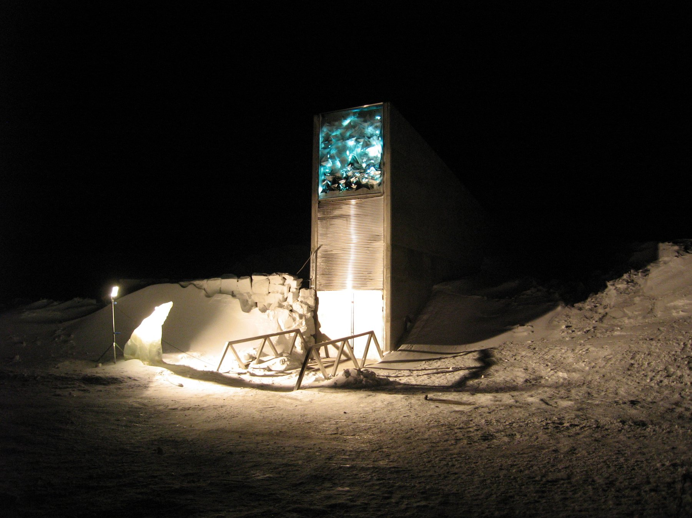
Figure 36. The entrance of the Svalbard Global Seed Vault.

Gene Flow and Monoculture
Gene flow is the third real risk, and the record on it is mixed in a way that rewards reading. In 2003 a glyphosate-tolerant creeping bentgrass, developed by Scotts and Monsanto for golf courses, escaped from test fields in central Oregon, and a study by Lidia Watrud and colleagues showed its pollen had fertilized wild grass up to 21 kilometers away. The USDA fined Scotts $500,000 in 2007; the grass is still growing in irrigation ditches in Oregon and Idaho, where nobody wants a weed that ignores the standard herbicide. In Canada, canola volunteers carrying two and then three different herbicide-tolerance genes, from crosses between neighboring fields, turned up within a few years of the crops’ release. In November 2001 a paper in Nature claimed to have found transgenes in traditional maize landraces in Oaxaca, the crop’s homeland; Nature said the next year that the evidence did not justify the paper’s publication, a later survey turned up nothing, and a still later one turned up a little. The honest summary is that some flow into landraces has probably happened at low levels, and that maize pollen has been crossing fields since the Balsas valley. In 2000 a Bt corn called StarLink, approved only for animal feed because one of its proteins had not been cleared as a possible allergen, surfaced in taco shells, and about 300 products were recalled at a cost reported in the hundreds of millions of dollars. In 2006 an unapproved herbicide-tolerant rice from Bayer showed up in the American supply, Europe and Japan restricted imports, and Bayer settled with growers for $750 million in 2011. Nobody was harmed by eating any of it. Everyone was harmed by the mess.
Monoculture is older than any of this and remains the deepest risk. The Irish potato famine of 1845 to 1852 happened because most of the island grew a single clone, the Lumper, and a single water mold exploited it; about a million people died and about a million left. In 1970 a fungus destroyed about 15 percent of the American corn crop in one summer because about 85 percent of hybrid seed carried the same male-sterile cytoplasm, adopted to save breeders the cost of detasseling, and the fungus had a toxin that fit it. The banana you buy is a Cavendish, a single sterile clone grown worldwide, which replaced the Gros Michel after a soil fungus known as Panama disease wiped that clone out by the 1960s. A new strain of the fungus, TR4, reached Colombia in 2019 and the Cavendish has no defense. In February 2024 Australia approved a Cavendish carrying a resistance gene, RGA2, copied from a wild banana, the first engineered banana anywhere. Whether the fix for a monoculture is a single engineered clone is a fair question, and the answer, on the evidence of 1845 and 1970, is that it buys time and not safety.

The Seed Companies
The corporate story is where public anger has settled, and it deserves a plain account. Monsanto was founded in St Louis in 1901 to make saccharin. It later made PCBs and was one of the manufacturers of Agent Orange, and in 1974 it launched glyphosate under the name Roundup. The glyphosate patent ran out in 2000; the company’s future by then lay in seeds carrying the tolerance gene, launched in 1996, and it bought seed companies through the following decade. Every bag came with a contract forbidding the farmer to save seed. Two court cases tested that. In Canada, Percy Schmeiser, a canola grower from Saskatchewan, was ruled in 2004 by the Supreme Court of Canada, by five votes to four, to have infringed Monsanto’s patent by knowingly growing canola with the gene, whatever its origin, though he owed nothing because he had not sprayed and had earned no profit from the trait. In the United States, Vernon Bowman, an Indiana farmer, bought ordinary soybeans from a grain elevator, most of which carried the gene, and planted them. The Supreme Court ruled on 13 May 2013, unanimously, that planting a patented seed makes new copies and is infringement, however the seed was obtained. Justice Kagan’s opinion noted that the rule was about self-replicating things and might not extend to every case. It was, in the plainest way, a ruling about copying.
Bayer bought Monsanto for $63 billion in a deal completed on 7 June 2018 and retired the name. Two months later a California jury awarded $289 million, later cut to about $20 million, to a groundskeeper named Dewayne Johnson who had used Roundup and had lymphoma. The scientific ground of that and the tens of thousands of suits that followed is a 2015 finding by the International Agency for Research on Cancer that glyphosate is “probably carcinogenic,” a category it shares with red meat and hot drinks, while the American, European and other regulators have concluded it is not likely to cause cancer at real exposures. In 2020 Bayer set aside about $10 billion to settle most of the claims, and cases were still being tried in 2025. The company was, by 2024, worth less than it had paid. Whatever one thinks of the herbicide, it is worth being clear that the litigation is about a spray, not a gene.
The seed market did not stay a Monsanto story. Pioneer Hi-Bred, founded in Iowa in 1926 by Henry A. Wallace, had taught America hybrid corn decades before anyone inserted a bacterial gene. DuPont bought Pioneer in 1999. Dow and DuPont merged in 2017 and spun their agriculture business out on 1 June 2019 as Corteva Agriscience, which still sells Pioneer bags. Syngenta was assembled in 2000 from the farm arms of Novartis and AstraZeneca. China National Chemical Corporation, ChemChina, completed its purchase of Syngenta in 2017 for about $43 billion, then grouped Syngenta with other state farm assets as the Syngenta Group in 2020. BASF, which had been strong in chemicals and weak in seeds, bought Bayer’s divested soybean, canola, vegetable, and much of its cotton seed businesses, plus the LibertyLink herbicide-tolerance trait, as the price of the Monsanto deal. By the early 2020s the proprietary seed market sat in four laps: Bayer, Corteva, the Syngenta Group, and BASF, with a combined share reported as roughly 60 percent. That is a real concentration of power over food, and it is not a property of DNA; it is a property of patent law, which reaches back to a 1980 Supreme Court decision that a living organism could be patented and a 2001 decision extending full utility patents to plants. Patents also expire. The first Roundup Ready soybean patent lapsed in 2015, and farmers can now buy and save generic tolerant seed.
The revolutionary change was legal and commercial: a patented seed you may not save, two traits that reorganized weeding and insect control, and four companies where there had been more. The biological change was incremental, the same copy-and-choose logic as teosinte, aimed at a spray and a moth. Drought, nitrogen, and a perennial grain that could replace wheat are still, as of late 2026, either modest, unpublished as a farm result, or a few thousand acres. The PRRS pig and the hornless calf are closer to a step-change, because they do in one generation what a pedigree would take decades to drag across a breed.
I would guess, and it is a guess, that by 2035 a farm in Heilongjiang is planting Chinese insect-resistant corn from a domestic bag, Dabeinong’s or another, some of it transgenic and some of it edited, and that the farmer is spraying less for borers while still walking the rows for weeds. ChemChina bought a seed and chemical company because the official aim, repeated in MARA documents and in the annual rural-policy papers, is food security on a fifth of the world’s people and a much smaller share of its good land. By 2050 a visitor to a public crop gene bank in Beijing may be looking at drawers of rice and wheat whose letters were changed on purpose, after the variety-registration rules that did not yet exist in 2026 have been written. That is not a cartoon super-crop. It is cotton’s insect gene, soy’s herbicide gene, and whatever drought and nitrogen work has actually survived a northern field, copied into more of the hectares that fill a rice bowl.

The Risk That Is Not One
Now the risk that is not one. Every meal you have ever eaten contained foreign DNA, in quantity. A person takes in something between a tenth of a gram and a gram of DNA a day, from every cell of every plant, animal, fungus and bacterium on the plate, which comes to tens of thousands of foreign genes per mouthful. Stomach acid and enzymes chop it to fragments, the fragments are absorbed or excreted, and in the whole of medicine there is no case of a gene from a carrot or a cow taking up residence in a human chromosome. An ear of Bt corn contains one bacterial gene among the roughly 32,000 to 40,000 of its own; the salad beside it contains the entire genomes of a lettuce, a tomato and whatever was living on them. The Bt protein has no receptor in a mammal’s gut and is digested like any other. The one allergen scare that had substance, a soybean carrying a Brazil-nut protein developed by Pioneer in the mid-1990s, was caught by the company’s own testing, published in the New England Journal of Medicine in 1996, and never sold; that is the system working, not failing. The 2016 National Academies review, the 2013 review of 1,783 papers, and the health records of two continents over three decades all say the same thing. On the eating of engineered food, the question is settled. Thirty years of argument have been spent on the wrong risk while the weeds grew. I think that is the right way to hold the ledger.
There is a counter-institution to the patent, and it is a door in a mountain. On 26 February 2008 the Svalbard Global Seed Vault opened on Spitsbergen, about 1,300 kilometers from the North Pole, a tunnel driven 120 meters into the rock and cooled to minus 18 degrees. It has room for about 4.5 million seed samples and holds, by 2025, more than 1.2 million, deposited by national and international gene banks that keep title to what they send; the vault is a backup, not an owner. The first withdrawal came in 2015, when the international center for dryland agriculture, ICARDA, could no longer reach its own seed bank in Aleppo and asked for its copies back, grew them out in Morocco and Lebanon, and returned fresh seed over the following years. Water from thawing permafrost got into the entrance tunnel in 2016 and 2017, and the entrance was rebuilt. The oldest such bank is in St Petersburg, founded by Nikolai Vavilov, who died in a Soviet prison in 1943 for the crime of doing genetics; during the siege of Leningrad several of his staff starved to death in a building full of seed rather than eat the collection. The vault on Svalbard is their idea, made cold.
Ruby Red grapefruit, the bud sport found on a Texas tree in 1929, began as an accident in an orchard. Rio Red, the deeper fruit irradiated at Texas A&M and released in 1984, came decades later. The vault holds a copy of every crop against the day a field fails, and the fields will fail, now and then, because every seed sown in them is a copy that differs a little from the one in the mountain, and some of those differences belong to the weeds.
↑ Back to Contents

Chapter 66: Three Billion Letters, One Race — The Human Genome Project

The East Room, June 2000
The East Room of the White House holds a couple of hundred people if the chairs are set close, and on the morning of Monday 26 June 2000 they were set close. On a screen at the front, Tony Blair sat in Downing Street on a satellite link. At the lectern stood Bill Clinton. On either side of him stood two men who had spent the previous two years trying to beat each other to the same finish line: Francis Collins, director of the public Human Genome Project, and Craig Venter, president of a private company called Celera Genomics. The occasion was the announcement that a “working draft” of the human genome existed. Two working drafts, in fact, one from each side, neither finished, neither yet published, each with the letters in roughly the right order and tens of thousands of gaps.
Clinton’s speech reached for Thomas Jefferson and the map of the west that had once been unrolled in the same room, and it reached for God, and the phrase about learning the language in which God created life was in every newspaper the next morning. Collins spoke, then Venter. They shook hands. Reporters who had followed the story knew the handshake had been negotiated over several weeks, mostly in the kitchen of a Department of Energy official named Ari Patrinos, over pizza, because the two men could not be relied upon to be civil in an office. The genome was not done. But the race was declared a draw, which was the only result either government could live with.
To see how that happened it helps to go back to the beginning, which was not 1998 and not the White House but a ski lodge in Utah.

Alta, Utah
In December 1984 the Department of Energy convened a meeting at Alta, Utah, on a narrow question: could DNA sequencing ever be good enough to measure the mutation rate in the children of Hiroshima and Nagasaki survivors? The answer was not yet, but the people in the room went home thinking about something larger. In May 1985 Robert Sinsheimer, the chancellor of the University of California at Santa Cruz, held a workshop on whether the whole human genome could be sequenced. In 1986 Renato Dulbecco, a Nobel laureate in cancer research, argued in Science that a cancer biologist would get further with the complete text than with one gene at a time, and Charles DeLisi at the Department of Energy began to push for a program. The DOE had a plausible claim to the job: it had the big computers, the national laboratories, and an abiding institutional interest in what radiation does to chromosomes.
Most biologists hated the idea. The objections were the ones any big project draws. It would cost billions that would otherwise fund small laboratories. It would be dull, industrial work, unfit for graduate students. And most of the text, everyone agreed, was junk, so why read it? A committee of the National Research Council answered these in February 1988 with a plan that was, in hindsight, the important document: map first, sequence later, develop the technology as you go, aim for fifteen years and about $200 million a year, and sequence the genomes of simpler organisms first. Three billion dollars, three billion letters, a dollar a letter. The arithmetic was easy to remember.
James Watson was appointed head of the new NIH (National Institutes of Health) genome office in 1988, and the project formally began on 1 October 1990 as a joint effort of the NIH and the DOE. Watson made one decision that outlasted him: he set aside 3 percent of the budget, later 5 percent, for research on the ethical, legal and social implications of what the project would find. He also alienated the new NIH director, Bernadine Healy, over whether brief fragments of genes could be patented. The disputed fragments came from a young NIH scientist named Craig Venter, who had found a fast way to fish out the expressed parts of genes and wanted to file on thousands of them. Watson thought the idea was foolish and said so in public, and in April 1992 he resigned. Venter left the NIH the same year to run a private institute in Maryland. Francis Collins, who had helped find the cystic fibrosis gene CFTR in 1989 and had helped identify the Huntington’s gene in 1993, took over the public project in April 1993.
The public strategy was called hierarchical shotgun. First you built a map: genetic markers spaced along each chromosome, then a physical tiling of large cloned pieces, each about 150,000 letters long, carried in bacteria in units known as BACs, short for bacterial artificial chromosomes. Then you took each BAC, blew it into random fragments, read the fragments by Sanger’s dideoxy method, the letter-by-letter reading technique from chapter 51, at 500 to 800 letters a read, and had a computer find the overlaps and stitch them together. Because you knew where each BAC sat on the map, the repeats that make up half the genome could not fool you into joining the wrong pieces. It was slow and it was careful. The genetic maps emerged from Paris and Boston in the early 1990s; the physical maps followed; by 1996 the sequencing had barely started and the project looked, to its critics, like a very expensive way to draw maps.

Bermuda and Venter
Two things changed the pace. The first was a meeting in Hamilton, Bermuda, in February 1996, convened by the Wellcome Trust, at which the heads of the main sequencing centers agreed that any assembled stretch of human sequence longer than a thousand letters would be released to the public within twenty-four hours, unpatented and free. The Bermuda Principles were partly idealism, and the idealism was real, especially in John Sulston, who ran the Sanger Centre near Cambridge and had spent years mapping every cell of a worm. They were also strategy. Sequence in a public database on Tuesday cannot be patented on Wednesday.
The second thing was Venter. In July 1995 his institute had published the complete genome of the bacterium Haemophilus influenzae, 1.83 million letters, the first genome of any free-living organism. He had done it by skipping the map entirely: shred the whole genome, read everything, let the computer assemble it. The NIH had declined to fund the attempt. On 9 May 1998 Venter and the instrument company Perkin-Elmer announced a new firm, Celera, that would apply the same whole-genome shotgun method to the human text with 300 of Perkin-Elmer’s new capillary sequencers, machines that read DNA fragments as they crept through hair-thin glass tubes, and one of the largest civilian computers in the world. It would be done, Venter said, by 2001, for about $300 million, a tenth of the public budget. The company would release data, but on its own terms and its own schedule, and it would patent a few hundred genes along the way.
The public project’s response, decided at a tense meeting at Cold Spring Harbor a week later, was to speed up. The Wellcome Trust doubled its commitment to the Sanger Centre, which would take a third of the genome. The rest was divided among Eric Lander’s center at the Whitehead Institute in Cambridge, Massachusetts, Robert Waterston’s at Washington University in St Louis, Richard Gibbs’s at Baylor in Houston, and the DOE’s Joint Genome Institute in California. The goal became a rough draft by 2001 instead of a finished genome by 2005. In December 1999 the Sanger-led team published the first complete human chromosome, number 22, in Nature, 33.4 million letters. Chromosome 21 followed in May 2000. Celera, meanwhile, proved its method on a fruit fly, 120 million letters, published in March 2000 with Gerald Rubin’s Berkeley group, and then turned the machines on a human sample.
Whose sample was a question nobody answered at the time. The public reference came mostly from one anonymous man in Buffalo, New York, whose DNA had been used to build the main BAC library; about two-thirds of the finished sequence is his. Celera said its sample was pooled from five donors of different ancestries. In 2002 Venter confirmed what many had suspected, that the Celera genome was largely his own.
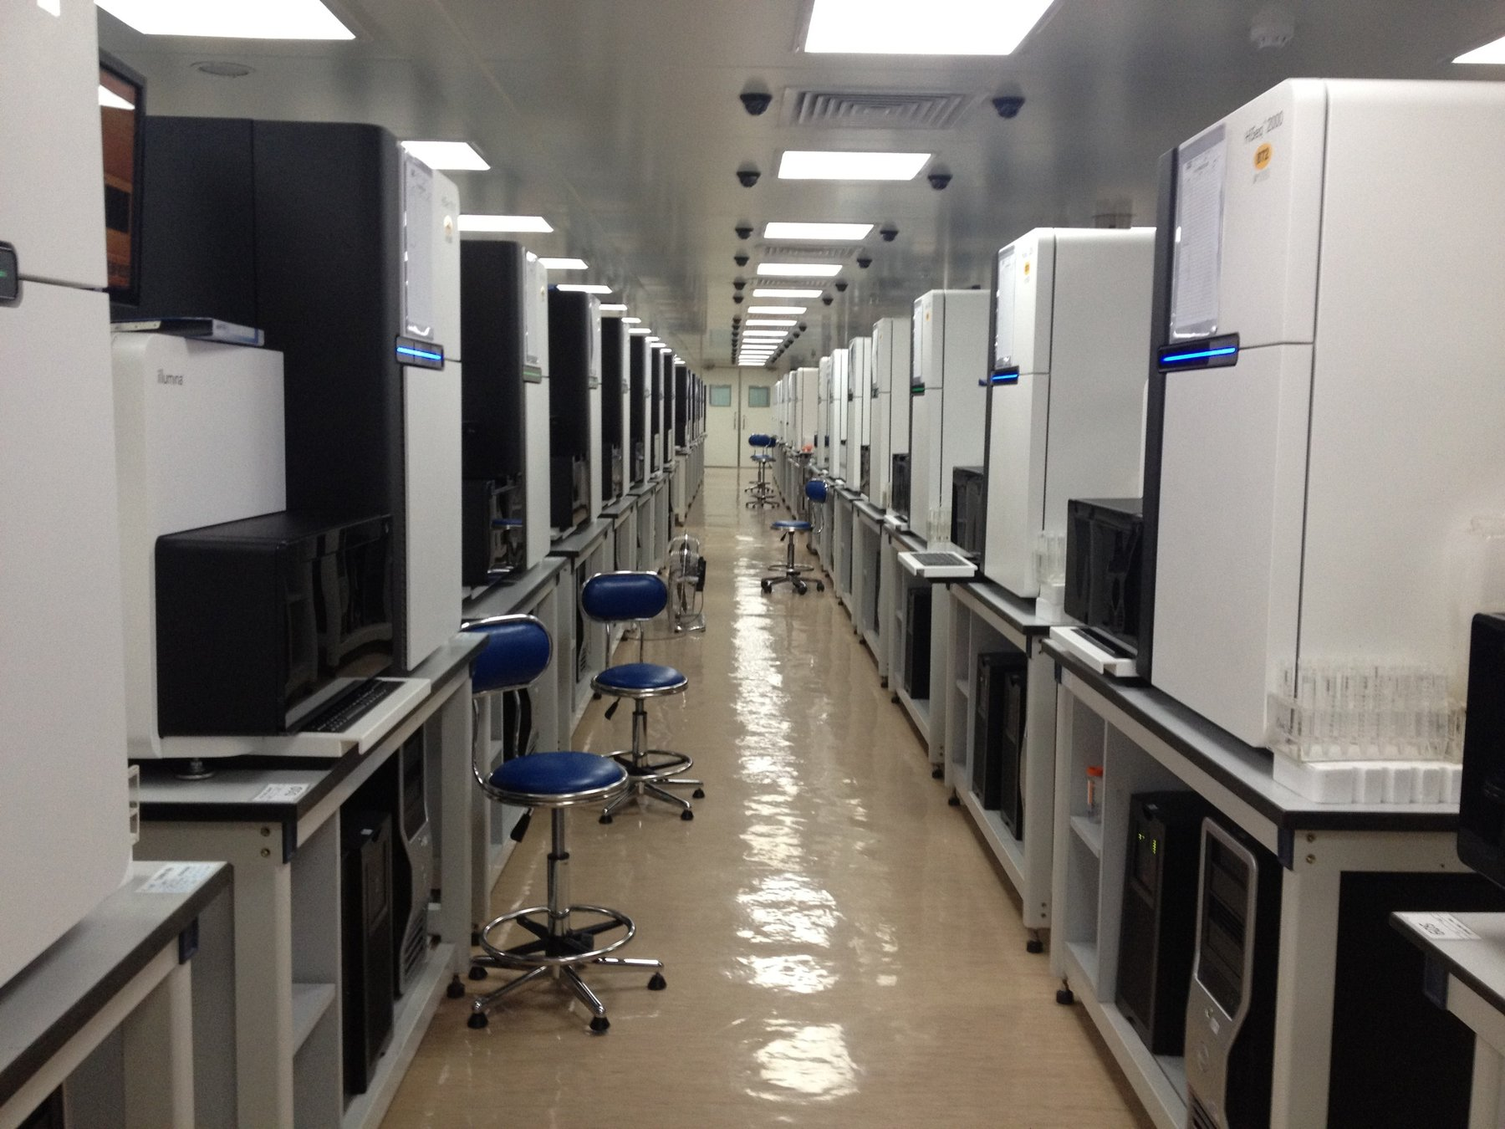
Figure 37. DNA sequencers in a laboratory.

Two Drafts, One Text
On 14 March 2000 Clinton and Blair issued a joint statement saying that raw genome data should be freely available to scientists everywhere. It was meant as a principle. The stock market read it as a threat to every company with a genome business, and Celera’s shares lost about a fifth of their value in a day. That, more than any scientific event, is what put the two sides in Patrinos’s kitchen. The White House wanted a joint announcement, and by June it had one.
The two drafts were published side by side in February 2001: the public consortium’s in Nature on 15 February, a 62-page paper with Lander as first author, and Celera’s in Science the next day, with Venter as first author. Each covered about 90 percent of the gene-containing part of the genome. Each guessed at the gene count and, as the next chapter tells, guessed high. Celera’s assembly had drawn on the public data, which was free for the taking; the public project could not use Celera’s. Science let Celera keep its sequence on the company’s own website, under conditions, rather than deposit it in GenBank, and Sulston and others said in print that this broke a rule that had held since the 1980s. I think they were right. It also stopped mattering within a year, because the public sequence was there for anyone and the private one was not.
The finished text was announced on 14 April 2003, timed to the fiftieth anniversary of the 25 April 1953 paper, with Watson in the room. Finished meant 99 percent of the gene-rich sequence at an accuracy of one error in ten thousand letters, about 2.85 billion letters in all, with 341 gaps that the technology of the day could not close. The project came in two years early. The total spent by the United States was reported as about $2.7 billion, in 1991 dollars, against the $3 billion budget, which works out to a little under a dollar a letter. Celera, having found no way to sell a text that was free next door, moved into drug discovery, and Venter left it in 2002.
The human text was not the first genome, and the ones that came before it are why the human one was possible. The bacterium Haemophilus influenzae, 1.83 million letters, was Venter’s proof in 1995 that a whole genome could be shredded and reassembled. Baker’s yeast, Saccharomyces cerevisiae, about 12 million letters, was finished by an international consortium in 1996. The nematode Caenorhabditis elegans, about 100 million letters, was finished in 1998 by Sulston’s group and Bob Waterston’s, the first animal. The fruit fly followed in 2000, as Celera’s dress rehearsal. Each of those was a parental set of a simpler creature, read end to end enough times to trust. None of them is 3.1 billion letters. The human number is the human reference, one set, and the cell that carries it still holds two.
What nobody could say at the ceremony, because nobody had had time to look, was what the text actually said.
↑ Back to Contents

Chapter 67: What the Genome Turned Out to Say — Gene Counts, Gaps and the Pangenome

A Bet at a Bar
In May 2000, at the bar of the annual genome meeting at Cold Spring Harbor Laboratory on Long Island, a young British bioinformatician named Ewan Birney started a sweepstake. The question was how many genes the human genome would turn out to contain. A bet cost one dollar that year, five dollars in 2001, and twenty dollars in 2002, on the reasoning that the answer was getting easier to guess. The guesses, several hundred of them, ran from a little under 26,000 to well over 150,000. The prize was the pot plus a signed copy of The Double Helix.
The high guesses were not foolish. In 1990, when the project was being sold to Congress, Walter Gilbert had done the arithmetic on a napkin: three billion letters, a typical gene perhaps 30,000 letters in length, so about 100,000 genes. Through the 1990s companies that fished out gene fragments announced ever higher counts, 120,000 from one, 140,000 from another, and each number was in someone’s business plan. Humans were obviously complicated. Complicated things, it was assumed, needed many parts.
The two draft papers of February 2001 said 30,000 to 40,000 and 26,000 to 38,000. The finished-sequence paper of October 2004 said 20,000 to 25,000. Birney paid out in 2003 to Lee Rowen of the Institute for Systems Biology in Seattle, whose guess of 25,947 had been the lowest in the book. Today the standard catalog lists a little under 20,000 protein-coding genes, and the count still moves by a few dozen a year as marginal cases are argued in and out. A roundworm the length of an eyelash, sequenced in 1998, has about the same number. A fruit fly has about 14,000. Rice has around 40,000, and a water flea about 31,000. Whatever makes a person more complicated than a worm, it is not the size of the parts list.

How the Parts Are Used
The answer, as far as there is one, is in how the parts are used. About 1.5 percent of the text codes for protein. The rest is introns, regulatory sequence, repeats, and stretches whose function, if any, is still argued over. A single human gene is typically read in several different ways, with exons, the segments of a gene that end up in the finished message, left in or spliced out, so that 20,000 genes make perhaps 100,000 distinct proteins; measurements in 2008 found that about 95 percent of genes with more than one exon are spliced in more than one pattern. The switches that control when and where a gene is read take up more of the text than the genes do. A worm and a person have roughly the same vocabulary. They differ in the grammar.
The drafts also showed how uneven the text is. Genes cluster on some chromosomes and thin out on others; chromosome 19 is dense with them, chromosomes 13 and 18 are sparse, and there are deserts of a million letters or more with no gene at all. More than half the genome is repeated sequence of one kind or another. A single family of short repeats called Alu, about 300 letters in length, is present in over a million copies and accounts for about a tenth of the text. The 2001 Nature paper also claimed that 223 human genes had been acquired directly from bacteria, which would have been a remarkable finding, and within three months a group led by Steven Salzberg showed that most of these were better explained by ordinary descent and loss in other lineages. I mention it because it is the right way to hold any first reading of a big dataset: some of it will be wrong, and the fix comes from the same data read more carefully.
Then there were the numbers that became slogans. Any two people, it was said, are 99.9 percent identical. Humans and chimpanzees are 98.8 percent identical. Both figures are true and both need a footnote in the sentence. The 99.9 counts single letters: at about one position in a thousand, two unrelated people’s letters will disagree, which across 3.1 billion letters is roughly three million differences. The 1000 Genomes Project, reporting on 2,504 people in October 2015, reported that a typical genome differs from the reference at four to five million sites. Most of those are single letters. But a few thousand are structural, a chunk deleted here, a chunk duplicated there, and because each chunk can be thousands of letters long, the structural differences involve more total letters than the single-letter ones. Count by letters involved rather than by sites and two people are a bit over 99 percent alike, not 99.9. Neither number is more honest than the other. They are counting distinct things.
The same applies to the chimpanzee. Its genome was published in Nature on 1 September 2005, from a male named Clint at the Yerkes primate center in Atlanta. Where the two genomes line up letter for letter, they differ at 1.23 percent of positions, which is the source of the 98.8. Add the insertions and deletions and the figure drops to about 96 percent. Add the pieces that do not line up at all, which the complete ape genomes finished in 2025 made visible for the first time, and the gap grows again. About 35 million single-letter differences and five million small insertions and deletions separate a person from a chimpanzee, and a mostly unread set of larger rearrangements sits on top. That 98.8 percent is settled. What it means for the question people actually ask, which is what makes us different, is not.
Two genomes, set side by side, differ at three or four million positions. Set beside a parent they differ at fewer, though not as few as one might think, because half the letters came from the other parent, and they differ at about sixty positions from both parents together, the new mutations a child is born with. This is the whole of inheritance in one arithmetic: nearly all the same, a few million altered, a few dozen new.
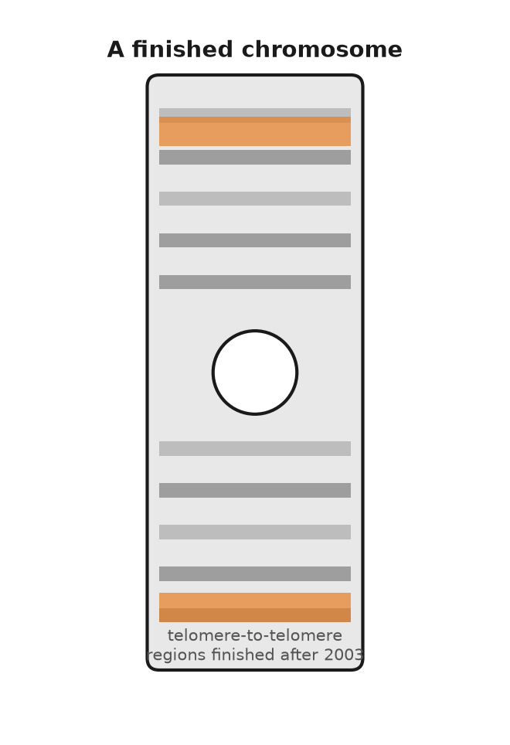
Figure 38. A chromosome ideogram with the regions finished after 2003 marked.

The Last Eight Percent
The word “finished” in April 2003 covered about 92 percent of the genome. The missing 8 percent was not scattered. It was concentrated in the places that Sanger reads of 800 letters, and later Illumina reads of 150, could not cross: the centromeres, where each chromosome carries an array of near-identical 171-letter repeats running to millions of letters; the short arms of chromosomes 13, 14, 15, 21 and 22, which hold hundreds of copies of the genes for ribosomal RNA; and large segmental duplications, blocks of 100,000 letters or more copied almost perfectly to two or three places in the genome. A read of 800 letters that falls entirely inside a repeat tells you nothing about where it belongs. For nineteen years these regions sat in the reference as runs of the letter N.
What closed them was reads long enough to span the repeats. Oxford Nanopore’s pores could by 2020 read single molecules of 100,000 letters and more, and Pacific Biosciences’ HiFi method produced reads of about 20,000 letters at an accuracy of 99.9 percent. A consortium named Telomere-to-Telomere, led by Karen Miga at Santa Cruz and Adam Phillippy at the NIH, used both on a cell line called CHM13. The line derived from a complete hydatidiform mole, an abnormal pregnancy in which an egg that had lost its own nucleus was fertilized by a sperm whose genome then doubled. Every chromosome in it is therefore present in two identical copies, which removes the assembler’s hardest problem, telling two similar parents’ chromosomes apart. On 31 March 2022 the consortium published in Science the first truly complete human genome: 3,054,815,472 letters of nuclear DNA, every chromosome read from one end to the other without a gap, about 200 million letters that had never been seen, and predictions of roughly 2,000 new genes, of which perhaps a hundred code for protein. The same paper adds the mitochondrial genome, 16,569 letters, and the sum, 3,054,832,041, is the one-parental-set total used in chapter 35. The mole had no Y chromosome. The Y, half of which had never been read because it is mostly repeats, was completed from a different donor and published in Nature in August 2023: 62,460,029 letters, more than 30 million of them new.
That is a complete genome. It is still one genome, and one is a strange sample size for a species. The reference that hospitals and researchers align their reads against, known as GRCh38 and issued in December 2013, is a mosaic assembled mostly from the Buffalo donor of the 1990s, and it is neither an average person nor a healthy one. At something like two million positions it carries the rarer of the two common letters, and at a few thousand it carries a variant associated with disease. Anyone whose ancestry is far from the donor’s will find that some of their sequence has nowhere to align, and the software will call it error.

A Pangenome
The answer that began in May 2023 is known as a pangenome. The Human Pangenome Reference Consortium published in Nature on 10 May 2023 the complete or nearly complete genomes of 47 people of diverse ancestry, both chromosomes of each resolved separately, so 94 assemblies in all. Laid over one another they added 119 million letters not present in GRCh38 and about 1,100 extra gene copies. Instead of a single line of text, the reference becomes a graph, a main road with every known alternative route drawn in, and a new genome is aligned to whichever route it matches. The consortium’s stated target is 350 people. I think this is the right idea and that the 47 is where it shows most clearly, since the number of people whose complete genome had ever been read before 2023 was, in effect, one.
The 3.1 billion letter reference is still the right length for one set. It is no longer the right shape for every set. Two people can both have about 6.2 billion letters in each nucleus and still not be alignable, letter for letter, to one mosaic from the 1990s.
The slogan people learned was three billion letters. The finished count for one parental set is the T2T total from chapter 35, and a nucleus holds about twice that. A book that puts 3.1 billion letters into forty-six threads two meters long is mixing one set with two. Chapter 35 kept those apart. This chapter is why the printed number moved at all.
There is a reasonable objection to all of this, which is that a reference, however carefully drawn, tells you what the text is and not what it does. To learn what a variant means, you cannot read one genome or fifty. You have to read half a million and ask each one how its owner is doing.
↑ Back to Contents

Chapter 68: Biobanks and the Million — Common Disease at Population Scale

Half a Million Volunteers
Between 2006 and 2010, in twenty-two temporary assessment centers in shopping precincts and hospital annexes across England, Scotland and Wales, about half a million people did the same thing. They had received a letter, because they were registered with the National Health Service and were between 40 and 69 years old and lived within reach of a center. About nine million letters were sent. Roughly one in twenty of the people who received one turned up. Each spent about ninety minutes answering a touchscreen questionnaire about diet, smoking, work, and mood, had their height, weight, blood pressure, grip strength, lung function and bone density measured, and gave blood, urine and saliva. Then they signed a consent form allowing the project to follow their medical records for the rest of their lives, and went home. Most were told nothing about themselves that they did not already know.
The project was named UK Biobank. It had been planned since the late 1990s, was funded by the Wellcome Trust and the Medical Research Council, and was run from a building in Stockport, near Manchester, by an Oxford epidemiologist named Rory Collins. Its samples were stored in freezers at minus 80 degrees and tanks of liquid nitrogen, in millions of small tubes handled by robots. The final count was 502,000 participants. They were not a cross-section of Britain; comparison with census data later showed them to be healthier, wealthier, and less likely to smoke than average, which is what happens when you rely on volunteers. The organizers knew this and decided it did not matter for the questions they wanted to ask, which were about what differs between people who develop a disease and people who do not, rather than about how common the disease is.
What made the collection worth more each year was the layers added on top. In 2017 every participant was genotyped, meaning checked at chosen points across the text rather than read letter by letter, on a chip of about 820,000 markers, from which about 90 million positions could be inferred. The inference is imputation: a best guess about letters the chip never read, made from the neighborhood the reference expected. It fails where that person’s copy broke the neighborhood. A chip can fill in a map. It cannot see a stretch that the map never drew. That is why the later whole genomes were read letter by letter, not because a slogan required it, but because a guessed letter is not a read letter. Between 2019 and 2022 the protein-coding parts of every genome were sequenced. A hundred thousand participants have been through an MRI scanner for brain, heart and body; a hundred thousand wore a wrist accelerometer for a week. And on 30 November 2023 the project released whole genomes for nearly half a million of them, 490,640 in a 2025 Nature count, the largest such dataset in the world, paid for with £200 million from Wellcome, the UK research councils and four drug companies, and read in Reykjavik and at the Sanger Institute near Cambridge. Any bona fide researcher anywhere may apply to use the data, for a fee, and by 2024 more than 30,000 had. The participants get nothing back individually. That was the deal, and I think it was the right one, because a return-of-results promise struck in 2006 would have been a promise about a science that did not yet exist.

The Graveyard of Common Disease
The United States chose the other deal. The NIH’s All of Us program opened enrollment on 6 May 2018 with a target of one million people. By June 2026 more than 880,000 had joined. Britain went bigger a second time: Our Future Health, which began inviting adults in 2022 with a target of five million, had health questionnaires from more than two million volunteers and genetic data on 755,000 of them in its May 2026 data release. Other countries built their own collections. What all of them are for is a method that was invented, in its usable form, in 2005.
Before then, the search for the genetics of common disease had been a graveyard. Linkage, which had identified CFTR and the Huntington’s gene by tracking a marker through affected families, works when one gene of large effect is responsible. It turned up almost nothing for diabetes, heart disease, or schizophrenia, because those are not diseases of one gene. The alternative, picking a plausible candidate gene and testing whether a variant in it was commoner in patients, produced thousands of papers in the 1990s, most of which failed to replicate. Neil Risch and Kathleen Merikangas had argued in Science in 1996 that the answer was association rather than linkage: compare hundreds of thousands of common variants across the whole genome in thousands of cases and controls, with no prior guess about which genes matter. In 1996 that was not possible. By 2005 the HapMap project had cataloged about a million common variants in 269 people from four populations, and chips could read hundreds of thousands of them at once.
The first genome-wide association study, published in Science in April 2005 by Josephine Hoh, Robert Klein and colleagues at Rockefeller and Yale, was small by later standards: 96 patients with age-related macular degeneration, 50 controls, about 100,000 markers. One variant stood out, a single-letter change in the gene CFH, which encodes complement factor H, a brake on part of the immune system. People with two copies of the risk letter had several times the usual chance of the disease. Nobody had guessed CFH. That was the point.
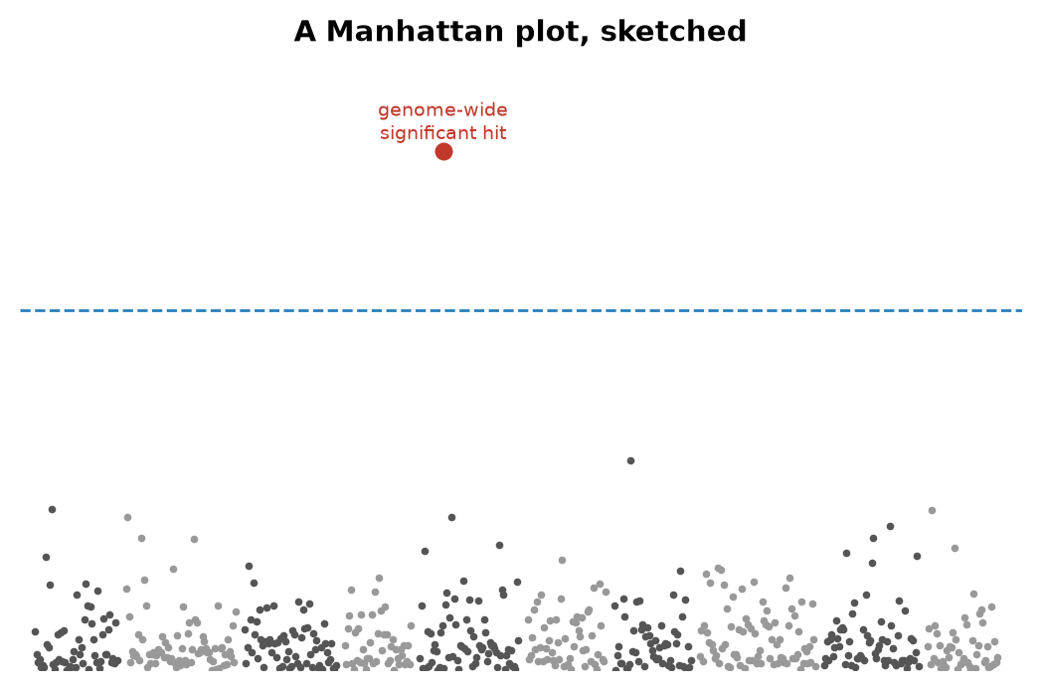
Figure 39. A Manhattan plot, sketched.
The picture that emerged from these studies has a name. Lay the chromosomes end to end along a horizontal axis, and for each marker plot how unlikely its association with the disease would be if there were no real link, on a logarithmic scale, where each step up means the chance is ten times smaller, so that the more improbable the chance, the higher the point. Most of the hundreds of thousands of points lie in a low band near the floor. A real association stands up as a tower of points, because neighboring markers travel together through the generations. The result looks like a skyline, and it has been called a Manhattan plot since the 2007 papers. The first tower worth naming is the CFH peak from 2005. The threshold for calling a tower real, a probability of five in a hundred million, comes from asking a million questions at once and refusing to be fooled by the one in twenty that would pass at ordinary standards by luck. Two years later, in June 2007, the Wellcome Trust Case Control Consortium published in Nature a study of 14,000 patients with seven common diseases against 3,000 shared controls, at 500,000 markers each, and turned up 24 solid associations in one go, most of them in genes nobody had suspected.

Adding Small Effects Up
By 2024 the public catalog of such studies listed more than 6,000 papers and several hundred thousand associations. Two lessons emerged from them that are now settled. The first is that common diseases involve hundreds or thousands of variants, each of modest effect; a typical one raises the odds by 5 or 10 percent, not by half. The second is that most of these variants lie not in genes but in the switches between them, which is why the 98.5 percent of the text that does not code for protein turned out to matter.
The natural next step was to add the small effects up. A polygenic risk score takes every variant with a measured effect, weights it, and sums across a person’s genome to give one number. In August 2018 a team led by Sekar Kathiresan and Amit Khera published in Nature Genetics a score for coronary artery disease built from 6.6 million variants and tested in UK Biobank; the 8 percent of people with the highest scores had about three times the average risk, which is roughly the risk conferred by the single-gene condition familial hypercholesterolaemia, an inherited condition that leaves LDL cholesterol, the form that clogs arteries, dangerously high from birth, a condition doctors already screen for. Scores for breast cancer, type 2 diabetes, atrial fibrillation and others followed. A score at the 90th percentile, meaning higher than 90 out of every 100 people tested, tells a person that people with scores like theirs develop the disease perhaps one and a half times as often as the average. It does not tell them that they will, and a change in weight would move the real risk more than any letter in the score. Polygenic scores are a working tool, useful at the extremes and nearly useless in the middle, where most people are.
They have a harder problem than that. In 2019 Alicia Martin and colleagues counted who had been in the studies the scores were built from: about 79 percent of participants were of European ancestry, though Europeans are about 16 percent of the world, and people of African ancestry were about 2 percent. A score built in one population loses accuracy in another, because the markers on the chip are only proxies for the causal variants, and the proxies travel with different partners depending on the population. Martin’s group found that scores performed about four and a half times worse in people of African ancestry than in Europeans. The height score from the 2022 study of 5.4 million people explains about 40 percent of the variation in height among Europeans and only 10 to 20 percent elsewhere. Every clinic that adopts a score built on UK Biobank inherits UK Biobank’s sample. If the family the score is applied to came from Lagos rather than Leeds, the same number on the same web page would mean less, and the page would not say so.
Set against that, what a million genomes finds is real. It finds rare people whose genomes contain a natural experiment: in 2005 and 2006 Helen Hobbs and Jonathan Cohen in Dallas identified African Americans carrying a broken copy of PCSK9 who had 28 percent lower LDL cholesterol and, over fifteen years, 88 percent less coronary disease, and by 2015 two drugs that block the PCSK9 protein were on the market. It finds which correlations are causal: variants that raise HDL cholesterol, the so-called protective form, do not lower heart disease, as a 2012 study in The Lancet showed, which is why the drugs that raised HDL failed. And it tells drug companies where to bet. Drug targets with genetic support have been shown, in several analyses since 2015, to be about twice as likely to reach approval as targets without it.
What it cannot do is also plain. It cannot see the environment except through the crude proxies of a questionnaire. It cannot correct for the fact that the people in it chose to be in it. And it cannot turn a probability into a prediction; a score that doubles a 5 percent risk has still left the person with a 90 percent chance of being fine. Biobanks are the least glamorous and the most useful thing genetics has done since 1953. Half a million genomes are half a million slightly varied copies of one text, each produced by the same machinery, none of them exact, and when a tube posted in Chapter 30 comes back as a web page, everything it says will have been learned by reading the differences.
↑ Back to Contents

PART X
Your Own Text, and the Edit to Come
The text is now cheap to read, including yours. This Part asks what it can tell you, who else is reading it, and whether we should correct it, first in patients and then, perhaps, in children.

Chapter 69: The Spit Kit — What a Consumer Test Reads

Six Weeks After the Mailbox
Six weeks after the mailbox, on a weekday evening, the three of them are at Anna’s kitchen table. Ruth has come the twenty minutes from her house. Theo is fifteen and wants to know whether he is descended from anyone interesting. Anna has the laptop open between the plates. All three are invented. The page on the screen is not.
The page has tabs. One is called Ancestry, and shows a map with colored regions and percentages to one decimal place. Another is named Health, and lists reports with careful names. A third is labeled DNA Relatives, and contains a list of strangers sorted by how much of Anna’s text they share, and at the top of the list is a woman in Ohio whom the page calls a second cousin. The tube has come back as a set of probabilities. The first thing to understand is what was measured to produce them, and the second is who did the measuring, because the company’s own history is a fair summary of what this kind of reading is worth.

The Company
The company was founded in April 2006 in Mountain View, California, by Anne Wojcicki, Linda Avey and Paul Cusenza. Its name is a joke about the 23 pairs of chromosomes in each of your cells. It launched its service in November 2007 at $999, and Time magazine named the retail DNA test its invention of the year for 2008. The price fell to $399 in 2008 and to $99 in December 2012. By then the company had several hundred thousand customers and an ambition that went beyond ancestry maps. Wojcicki said openly that the point was a research database, and the customers who ticked a consent box, about 80 percent of them, became research subjects who had paid for the privilege.
On 22 November 2013 the US Food and Drug Administration sent the company a warning letter. The Personal Genome Service, it said, was a medical device being sold without clearance, the company had stopped answering the agency’s questions, and it should stop marketing health reports. The company complied. For about two years it sold ancestry and raw data only. Then it returned one test at a time. A carrier report for Bloom syndrome was authorized in February 2015. In April 2017 the FDA allowed the first direct-to-consumer genetic health risk reports it had ever permitted, for ten conditions, including late-onset Alzheimer’s disease and Parkinson’s disease. In March 2018 the company was allowed to report three variants in BRCA1 and BRCA2, the ones common in Ashkenazi Jewish families, with a warning that a negative result said almost nothing about the thousands of other harmful variants in those two genes.
In July 2018 GlaxoSmithKline invested $300 million and signed a four-year drug-discovery collaboration in which the database was the asset. In June 2021 the company listed publicly by merging with a blank-check company backed by Richard Branson, at a valuation of about $3.5 billion. Within two years the shares had lost most of their value, for a reason no test kit could fix: a customer buys one once.
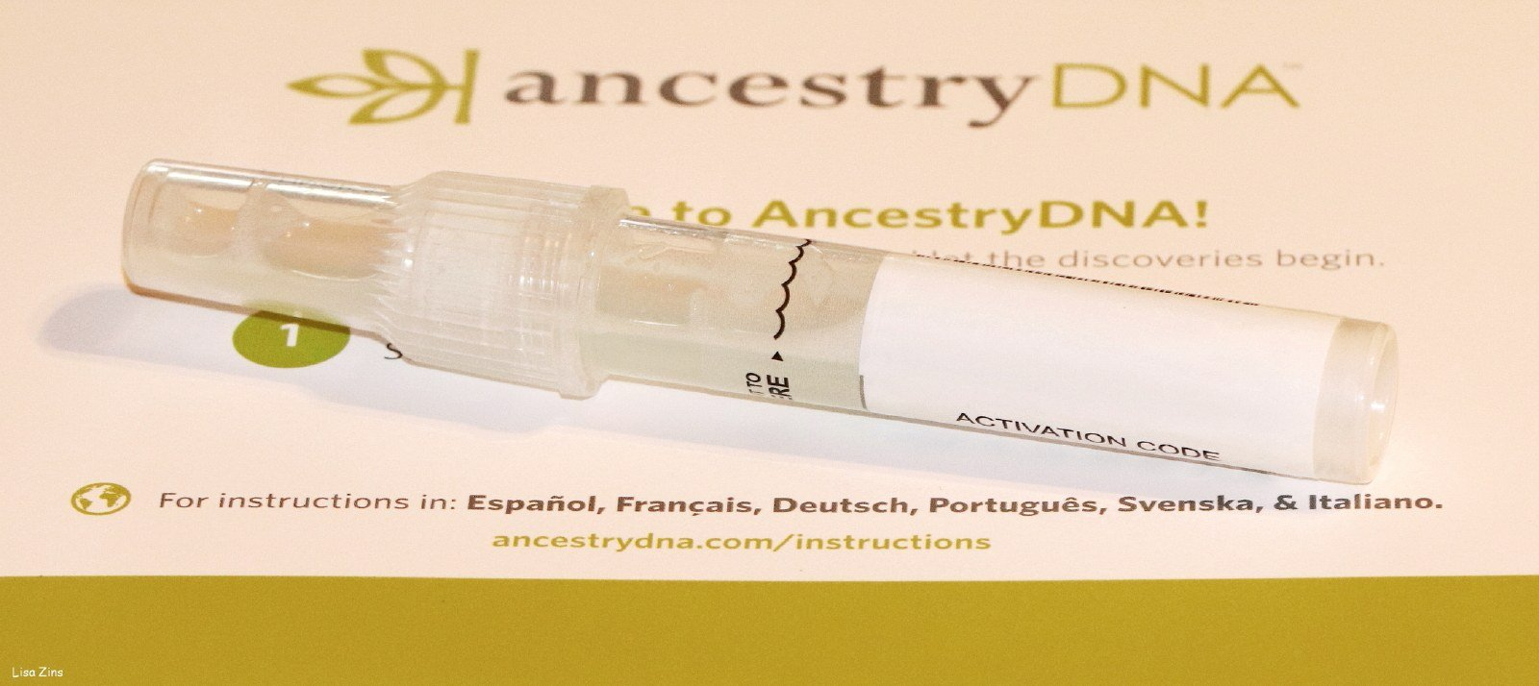
Figure 40. A consumer saliva collection tube on a kit instruction card, a different company from the one this chapter names.
In October 2023 the company disclosed a breach. Attackers had used passwords leaked from other websites to log into about 14,000 accounts, and from those, through the DNA Relatives feature, had scraped profile data for about 6.9 million users: names, birth years, ancestry estimates, and lists of matches. Lists of users with Ashkenazi Jewish or Chinese ancestry were offered for sale. The company agreed in 2024 to a class-action settlement reported as $30 million.
On 23 March 2025 it filed for Chapter 11 bankruptcy protection in a court in Missouri, and Wojcicki resigned as chief executive the same day. Attorneys general in several states advised customers to delete their data while they could. The drug company Regeneron won the first auction in May 2025 with a bid of $256 million. Then Wojcicki’s nonprofit, the TTAM Research Institute, returned with a bid of $305 million, the court approved the sale at the end of June, and the deal closed in July 2025. By then roughly 15 million people had sent in a tube. The samples went from a private company, through a bankruptcy court, to a nonprofit run by the same woman who had founded the company, and the customers were spectators throughout.

What the Chip Reads
So that is the company. Now the measurement. The laboratory did not read Anna’s genome. It ran her DNA over a genotyping chip, a glass slide carrying hundreds of thousands of short probes, each designed to catch one position in the text where people are already known to differ. The chip the company has used since 2017 checks somewhere around 640,000 positions. That is about 0.02 percent of the 3.1 billion letters of one parental set. At each of those positions it reports which of two known letters Anna has, and because she has two copies it can report that she has one of each, or two the same. It cannot find a spelling mistake that nobody has cataloged, because no probe was built to look for it. It also does not read the second copy as a separate 3.1 billion letter book. It samples both copies at the positions it was built to see.
The chemistry is hybridization, which is base pairing done on a glass slide. Each probe is a short stretch of single-stranded DNA glued to a spot. Anna’s DNA, broken into fragments and tagged with a dye, is washed over the slide. Where her letters match a probe, they stick, by the same A-with-T and G-with-C rule as in the helix, and the spot lights up. Where they do not match, they wash off. The machine is not reading a sentence. It is asking, at hundreds of thousands of addresses, which of two prewritten words is in her text. That is why the price could fall to $99, and why a variant the catalogs have never seen is invisible to it. A nucleus still holds about 6.2 billion letters. The slide looks at a few hundred thousand of the addresses in one set.
The nearest analogy is checking a book by looking only at the places where different printings are known to disagree. If a new misprint has crept into your copy on page 412, the check will not find it. Whole-genome sequencing, the reading that costs a few hundred dollars in 2025 and was the subject of Part IX, reads every page. As of late 2026 some of those full reads are done on a slide of short fragments, and some are done by nanopore sequencing: threading a single long molecule through a protein pore and watching each letter disturb an electrical current, the method of Chapter 54. Either way, a clinical genome is a different object from the chip on this table. A chip is cheaper and faster and was, in 2007, the only thing that could be sold for $999. A great deal of what is in the 640,000 can be stretched further by statistics, because letters that sit close together on a chromosome travel together through the generations, a fact Sturtevant used to draw the first map in 1913. From the measured positions, software can guess millions of unmeasured ones with fair confidence. Guess is the right word.
The Ancestry tab is built on the chip result in a way that the decimals do not advertise. The software chops Anna’s chromosomes into windows and compares each window to reference panels: sets of present-day people whose four grandparents all came from the same place. Each window is assigned to the population it most resembles, and the windows are added up. The percentages are therefore a statement of resemblance to living people in a reference set, not a record of where Anna’s ancestors stood in the year 1700. When the company updates its reference panels, which it does every few years, the percentages move. Customers who had 4 percent Scandinavian ancestry in one version and none in the next had not lost any ancestors. The panel had changed.
Two more things follow that surprise people. Full siblings receive unequal percentages, because each inherited a separate half of each parent, as Chapter 41 described. And Theo, when he eventually mails a tube of his own, will show numbers that are not the average of his parents’ numbers. The shuffle in meiosis does not deal fair halves of every region.

Relatives and the Health Tab
The DNA Relatives tab is the most reliable part of the page, because it does not depend on any reference panel. It depends on segments. Two people who share an ancestor share stretches of text inherited whole from that ancestor, and the software finds those stretches by looking for long runs where the two chips agree. The length is measured in centimorgans, the unit for shared genetic material that Sturtevant defined in chapter 48. A parent and child share about 3,400 centimorgans, which is half the text. Full siblings share about 2,600 on average. First cousins share about 850, which is 12.5 percent. Second cousins share about 3 percent, a bit over 200 centimorgans. The woman in Ohio shares 213 centimorgans with Anna in nine segments, and the label is right: she is a second cousin, or something equivalent, such as a first cousin’s grandchild.
The method thins out fast. Third cousins share under one percent, and some third cousins share no detectable segment at all, because segments are passed on whole or not at all, and after enough generations a given ancestor’s contribution can drop out of a line entirely. Beyond the fourth cousin the list is mostly noise, and the site says so.
Close relatives are not noise. A match of 50 percent is a parent or a child, and a match of 25 percent is a grandparent, a half-sibling, or an aunt. These numbers do not care what a family has said about itself, and every year they contradict some families. The industry term is “not parent expected.” Historical studies of misattributed paternity in Western Europe, using surnames and Y chromosomes, put the rate at about one percent per generation. Over the millions of people who have tested, that is a great many surprised adults. Donor-conceived children have found donors who were promised anonymity in the 1980s, and half-siblings by the dozen. In Indiana a fertility doctor named Donald Cline was discovered, from 2016 onward, to have used his own sperm for patients decades earlier; consumer tests identified more than 90 of his children, and the state passed a law against fertility fraud in 2019. The chip reads what is there.
The page also offers a download, a text file of the roughly 640,000 calls, and a great many customers take it and upload it somewhere else: a genealogy site, a health interpreter, a research project. The file is not a genome. It is a list of addresses and the letter found at each, and anyone who holds the list can ask new questions of it without mailing another tube. That is why the 2023 breach mattered beyond the names. A stolen relatives list is a family tree. A stolen genotype file is a permanent sample.
A clinical genome, the kind Part IX described, would have shown Anna things this page cannot. It would have read both parental sets, about 6.2 billion letters, including spellings no catalog has named, and it would have cost a few hundred dollars in 2025 rather than $99. The spit kit’s advantage was never completeness. It was that a person could buy it without a doctor, and that millions did. The health reports on the page are a curated subset of the chip, written to a regulatory standard, and they leave out most of what the raw file contains. Ancestry percentages will move when the reference panels are updated. The Ohio cousin will not. She is in the segments, and the segments do not depend on a company’s map of the world.
Which brings the table back to the Health tab. Anna has two results Chapter 30 promised her. One is Anna’s switch, from her father: she drinks milk. Ruth cannot. Theo can.
The other result says she has one copy of a variant that raises her chance of a certain disease, by a factor the page states carefully and with a footnote. Theo treats the factor as a fortune. Ruth’s objection is the one the page itself supports. The slide looked at about 0.02 percent of one parental set and is offering the rest as a story. Anna reads the footnote again. The chip cannot tell them whether the variant will act, or how tall Theo will end up, or what chance will do after birth. They do not agree, and they are all looking at the same page. That argument is the next two chapters.
↑ Back to Contents

Chapter 70: What a Genome Can Tell You — Risk Genes, Families and Drugs

An Op-Ed in May 2013
On 14 May 2013 the New York Times printed an opinion piece by Angelina Jolie under the title “My Medical Choice.” Her mother had died of ovarian cancer at 56. Jolie had been tested and carried a harmful variant in BRCA1; her doctors, she wrote, had put her lifetime risk of breast cancer at 87 percent and of ovarian cancer at 50 percent. She had just completed a preventive double mastectomy. Two years later she wrote again, about having her ovaries and fallopian tubes removed. In the months after the first piece, referrals to family-history clinics in Britain roughly doubled, an effect reported in 2014 and still known, in the literature, as the Angelina effect.
Behind the op-ed is one of the cleanest stories in human genetics, and it starts with a woman who spent seventeen years being told she was wasting her time. Mary-Claire King, then at Berkeley, collected families in which breast cancer struck early and often, and looked for a stretch of chromosome that traveled with the disease. In December 1990 her group reported in Science that such a stretch existed, on the long arm of chromosome 17. This was the demonstration that a common cancer could have a single-gene hereditary form. The race to find the gene itself was won in October 1994 by Myriad Genetics, a company founded in Salt Lake City in 1991 by Mark Skolnick and colleagues from the University of Utah. BRCA2, on chromosome 13, was identified in December 1995 by Michael Stratton’s group in London.
Myriad patented both genes and the test for them. By 2013 its BRACAnalysis cost about $3,000 to $4,000, and no other American laboratory was allowed to offer a full test. In Association for Molecular Pathology v. Myriad Genetics, decided 13 June 2013, one month after Jolie’s op-ed, the US Supreme Court ruled unanimously that a naturally occurring segment of DNA is a product of nature and cannot be patented merely because it has been isolated. Laboratory-made complementary DNA, it said, can be. Within days other laboratories were offering BRCA tests at a fraction of the price. The genes, in the words the court used, were not invented by anyone.

Repair Genes and Penetrance
What the genes do is repair. The BRCA1 and BRCA2 proteins are part of the machinery that mends double-strand breaks in DNA by homologous recombination, the accurate route described in Chapter 55. A woman born with one broken copy has a working copy in every cell, and she is fine until, in some cell in the breast or ovary, the working copy is lost by a mutation of the kind Chapter 40 cataloged. That cell then repairs badly, mutates faster, and is on the road to cancer. This is Alfred Knudson’s two-hit idea of 1971, and it explains why a dominant cancer syndrome works through a recessive mechanism inside the cell.
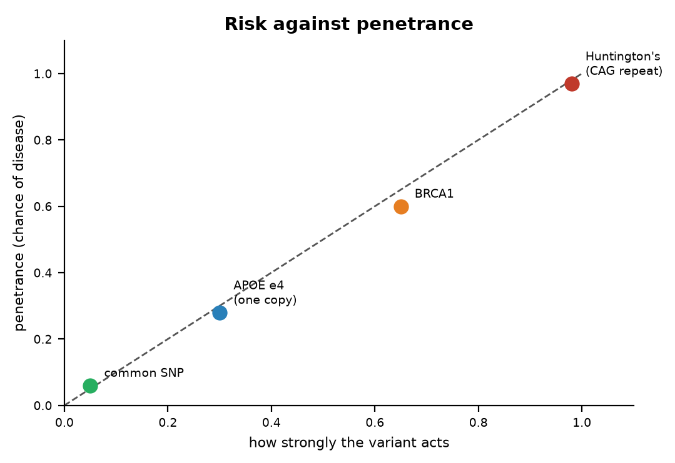
Figure 41. Risk against penetrance.
The numbers are settled. A 2017 study in JAMA that followed nearly 10,000 carriers reported that women with a harmful BRCA1 variant had a 72 percent chance of breast cancer by age 80, and a 44 percent chance of ovarian cancer; for BRCA2 the figures were 69 percent and 17 percent. The general population figure for breast cancer is about 12 to 13 percent. Around one woman in 300 to 400 carries such a variant; in Ashkenazi Jewish populations it is about one in 40, because three particular variants became common in a small founding population, and these three are the ones the spit kit is allowed to report. Men who carry BRCA2 variants have raised risks of prostate and male breast cancer, and pass the variant to half their children.
The word for a 72 percent chance is penetrance: the fraction of people carrying a variant who go on to have the condition. It is the single most useful number on any genetic report and the one most often missing.

Through a Family
Here is how the question travels through a family, using the invented one. Suppose Ruth’s sister had breast cancer at 48. That is early, and it is the kind of history that gets a clinic’s attention. The right first test is the sister’s, because if she does not carry a BRCA variant the family’s concern mostly dissolves. If she does, Ruth has a 50 percent chance of carrying it, since sisters share one copy of each chromosome from each parent on average. If Ruth carries it, Anna has a 50 percent chance, and if Anna does, Theo has a 50 percent chance. Ruth is 78 and has lived through most of the years in which the risk falls, so a result would say more about Anna than about her. Anna’s spit kit reported that she does not carry the three Ashkenazi variants, which in a family with no Ashkenazi ancestry is true and useless. A clinical test sequences both genes in full. This chain, with the affected relative tested first and the rest tested in cascade, is how the clinics actually work.
Huntington’s disease is the other end of the chart, where penetrance is nearly complete. James Gusella’s group had placed the gene on chromosome 4 in 1983, using blood from very large families around Lake Maracaibo in Venezuela that Nancy Wexler had spent years collecting. The gene itself took a further ten years and six laboratories, and was published in Cell on 26 March 1993. It is called HTT, and the mutation is a stutter: the three letters CAG, repeated. Fewer than 27 repeats is normal. Forty or more, and the disease will come if you live long enough, usually beginning in the thirties or forties, sooner for longer repeats. Between 36 and 39 it may or may not. The repeat tends to lengthen when passed through fathers, so the disease can arrive earlier in each generation, a pattern known as anticipation.
A predictive test has existed since 1993, and one based on linked markers since 1986. Most people at 50 percent risk choose not to take it; studies of uptake in the countries that offer it put the figure at roughly 10 to 20 percent. There is no treatment that changes the course. Wexler, whose mother died of the disease and who led the hunt for the gene, said publicly in 2020 that she has it herself. The text, in this one case, reads like a sentence, and most people who could read it decline.
APOE sits between the two. In 1993 Allen Roses’s group at Duke reported that one common form of the gene, known as ε4, was over-represented in people with late-onset Alzheimer’s disease. The gene comes in three common forms, ε2, ε3 and ε4, and about a quarter of people of European ancestry carry at least one ε4; two or three percent carry two. One copy raises the risk of Alzheimer’s roughly threefold. Two copies raise it roughly eight to twelvefold, though the effect is smaller in people of African ancestry and larger in East Asians. And still it is not a sentence. Many people with two copies die old and clear-headed, and most people with Alzheimer’s have no ε4 at all. A 2024 paper in Nature Medicine argued that carriers of two copies almost all show the disease’s biomarkers by their sixties and should be regarded as having a genetic form of it; that reading is contested, and I would call it working. What changed in 2023 is that the result became actionable: the antibody drugs lecanemab and donanemab cause brain swelling more often in ε4 carriers, so the label now advises testing before treatment.

Drugs and Newborns
The most immediately practical reports on any genome concern drugs, and this is a settled corner of the subject. Clopidogrel, sold as Plavix and given to millions after a stent, is a prodrug: it does nothing until an enzyme, CYP2C19, converts it. People with two loss-of-function copies of CYP2C19 make little active drug and get little protection, which is why the FDA put a boxed warning on the label in March 2010. About two percent of Europeans are poor metabolizers by this measure, and about 13 to 15 percent of East Asians. The HIV drug abacavir causes a dangerous hypersensitivity reaction in people who carry the HLA-B\57:01 allele, one inherited variant of that gene, present in about five to eight percent of Europeans; a trial published in the New England Journal of Medicine in 2008 showed that screening before prescribing eliminated the confirmed reactions, and testing is now standard everywhere the drug is used. Warfarin is the old blood thinner with the narrow safe dose, and variants in CYP2C9 and VKORC1* account for about a third of the difference in dose between one patient and another; the label has carried a dosing table since 2010, though trials of genotype-guided dosing have given mixed results.
The list goes on. TPMT and the thiopurine drugs used for leukemia and Crohn’s disease; DPYD and the chemotherapy fluorouracil, where a poor metabolizer can die of a standard dose, and where European regulators recommended testing in 2020; HLA-B\15:02* and the epilepsy drug carbamazepine in people of Han Chinese and Southeast Asian ancestry, on the label since 2007. A consortium of clinicians has published dosing guidelines for these pairs since 2009. The useful thing would be for the genotype to already be in the chart when any of these drugs is prescribed. The science is done; the implementation, in most hospitals, is not.
Two more reports belong on the list, both about the beginning of life. Carrier screening asks whether a healthy adult carries one copy of a recessive variant that would matter if their partner carried one too. It began with Tay-Sachs disease in 1971, in Ashkenazi communities in Baltimore and Washington, and the disease has since almost vanished in those communities, partly through an anonymous matching scheme called Dor Yeshorim founded in 1983. By 2021 the American College of Medical Genetics and Genomics recommended offering everyone who is pregnant or planning to be a panel of 113 genes. This is the one form of genetic testing where a result has an obvious use and no waiting.
Newborn screening began in 1963 with Robert Guthrie in Buffalo, a drop of heel-prick blood on filter paper, and a bacterial test for phenylketonuria, the disease Chapter 44 described as genetic and managed by diet. Most rich countries now screen every baby for thirty to fifty conditions from the same blood spot. The next step is under way: in October 2024 Genomics England began the Generation Study, which will sequence the whole genomes of 100,000 newborns in England and look for more than 200 rare conditions that appear in early childhood and can be treated. The heel-prick and the genome are not the same test. Guthrie’s spot looks for a handful of diseases that a diet or a drug can change this month. A whole genome looks at both parental sets, about 6.2 billion letters, and can return findings the parents did not ask about and cannot act on for decades. That difference is why the Generation Study publishes a list of conditions it will report, and why everything else on the file stays off the letter home.
What such a program should do with the rest of the genome, the adult-onset findings and the risks that are only odds, is the unsettled part, and it is where the next chapter begins.
↑ Back to Contents

Chapter 71: What It Cannot Tell You — Small Effects and Chance

A Height Chart
A school nurse’s wall has a chart of heights, and a boy of fifteen is standing against it. There is an old formula for guessing how tall he will end up: average the parents’ heights and add six and a half centimeters for a boy. It is right to within about eight centimeters most of the time, which is to say it is not very right. In 2022 a consortium led by Loïc Yengo published, in Nature, the largest genetic study of anything ever done: 5.4 million people, 12,111 places in the text that each nudge height a little. Put together into a single polygenic score, those variants explain about 40 percent of the variation in adult height among people of European ancestry. Among people of East Asian ancestry the same score explains about 10 to 20 percent, and among people of African ancestry less again.
Hold onto that result, because it is the best case. Height is easy to measure, almost everyone’s has been recorded, twin studies put its heritability, the share of variation across a population that traces to genes as chapter 43 defined it, at about 80 percent, and there is no shame in it, so millions of people gave their data. Even so, after 5.4 million people, the best score in the world reads about half of the heritable part, and only for the population it was built in. The parents’ heights, on the wall chart, do about as well. Everything that follows in this chapter is a harder problem than height.

Variants That May Not Act
The first thing a genome cannot tell you is whether a variant will act. Chapter 70 gave the BRCA1 figure of 72 percent, and it is a good figure, but it was measured in families that were studied because they were full of cancer. Those families share other things besides the one variant: modifier genes, habits, exposures. When biobanks began sequencing hundreds of thousands of people who were not selected for anything, and simply counted how many carriers of a given variant had the disease, the penetrance came out lower, often much lower, for one gene after another. The same letter, spotted by accident in a healthy person, means less than it did when it turned up in a family with the disease. This is called ascertainment bias, and it is the reason a variant on a spit-kit report and the same variant in a clinic’s file are not the same fact.
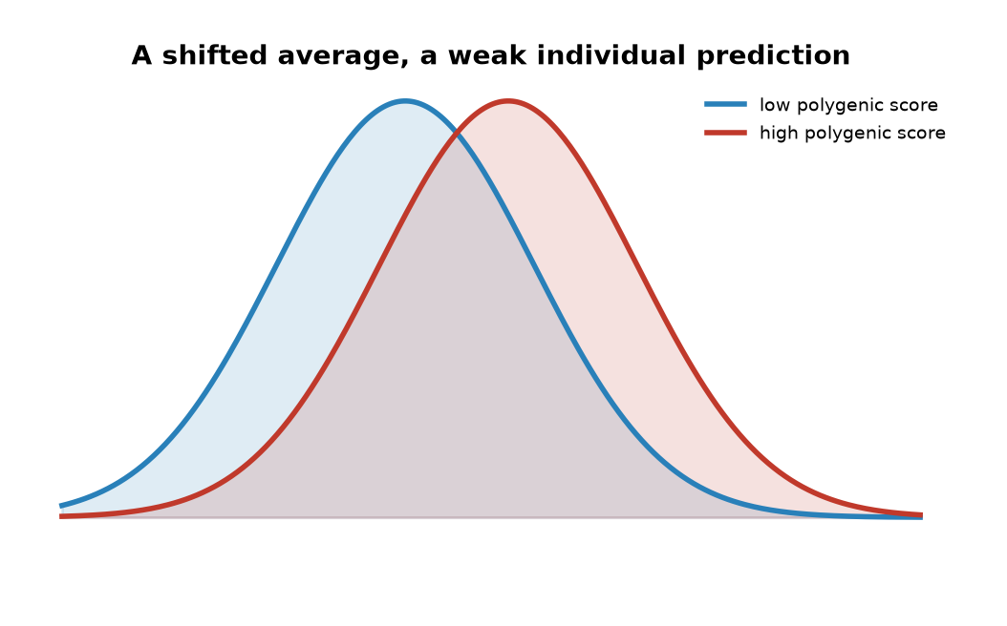
Figure 42. Two overlapping bell curves.

Small Pieces
The second thing is the size of the pieces. Twin studies had said height was 80 percent heritable, and the first genome-wide association studies, in 2008, found about 40 variants that explained 5 percent of the variance, the spread in height from person to person that those variants could account for. A news feature in Nature that year dubbed it the case of the missing heritability, and the phrase stuck. Most of it has since been recovered, but only by admitting what it was: thousands of variants of tiny effect, each too small to see until the sample reached the millions. In 2010 Peter Visscher’s group showed that all the common variants taken together, even the ones no study had flagged, accounted for about 45 percent of the variance in height. The rest is a working account: rare variants that chips do not catch, structural changes, and a suspicion that the twin estimates were too high, because twins share environments and because tall people marry tall people, which inflates what looks like genetics.
The third thing is the phrase “the gene for.” In 2007 Timothy Frayling’s group reported that a variant in a gene named FTO was associated with body weight, and the headlines nicknamed it the fat gene. Each copy of the risk variant is worth about one to one and a half kilograms on average. Against the range of human weight that is a rounding error, though across a whole population it is real. Then in 2014 it turned out that the variant, although it sits inside FTO, does its work by altering two neighboring genes, IRX3 and IRX5. The gene for obesity was not even the gene. Most of what a genome says about a common trait is like this: a long list of minor nudges, many of them acting on genes other than the one they sit in.
This is why the prediction gap for common disease is what it is. In 2018 Sekar Kathiresan’s group built a score from 6.6 million variants for coronary artery disease and showed that about 8 percent of people carried a score giving them threefold the average risk, the same order as a single-gene disorder like familial hypercholesterolaemia, the inherited high-cholesterol condition from chapter 68. That is a real finding and it will be used. But most heart attacks happen to people with average scores, because there are so many more of them, and adding the score to the things a doctor already knows, cholesterol, pressure, smoking, age, moves only a few percent of patients into a different risk band. A 313-variant score for breast cancer, published in 2019, puts the top one percent of women at about three times the average risk. These are odds, and modest ones, for most people.
The gap is wider outside Europe. A 2019 analysis in Nature Genetics by Alicia Martin and colleagues counted that about four-fifths of participants in association studies to that date were of European ancestry, and that scores built on them performed about four and a half times worse in people of African ancestry. The reason is technical and stubborn: the markers on a chip are mostly proxies, standing in for causal variants that sit near them, and which proxy stands for what differs between populations. Until the studies are as large elsewhere as they are in Europe, a polygenic score is a European instrument. I would call this settled, and the fix a matter of money and time.

Intelligence
Then there is the argument that will not go away, which is intelligence. The largest studies here measure years of schooling, because it is recorded for everyone. A 2018 study of 1.1 million people, and a 2022 study of three million, produced scores that explain about 12 to 16 percent of the variance in educational attainment in independent samples of European ancestry. For scores on intelligence tests themselves, the figure is a few percent. When the same scores are checked within families, by comparing siblings who drew distinct cards from the same parents, the direct effect shrinks by about half. A 2018 paper in Science from Iceland showed why: the variants a parent carries but does not pass on still predict the child’s schooling, because they shape the home. Genetic nurture, the authors called it. The score is partly reading the parents’ genes, partly the neighborhood, and partly the fact that people with similar education marry each other.
The controversy is loud and I will state the positions rather than pretend it away. Robert Plomin’s 2018 book Blueprint argued that DNA is, in his phrase, a fortune-teller, and that the scores will only get better. Kathryn Paige Harden’s 2021 book The Genetic Lottery accepted the heritability and argued that it is a reason for more equal treatment, not less, since nobody chose their draw. A fringe uses the scores to make claims about groups, which the data cannot support even in principle, because the scores do not transfer across ancestries, as the previous paragraphs described. My own view, marked as mine: a score that explains a few percent of test performance in one population, halves within families, and cannot be ported, is a research instrument. It is not a fortune, and I think using it on a child would tell you less than ten minutes with the child.

Chance
The fourth thing a genome cannot tell you is what chance will do. Identical twins share every letter, and when one has schizophrenia the other has it about half the time. For type 1 diabetes the figure is somewhere between 30 and 50 percent, for multiple sclerosis about a quarter. Half or more of the outcome, for these conditions, is not in the text at all: it is in the somatic mutations that Chapter 40 described, in infections, in the noise of development that gives twins different fingerprints. In 2015 Cristian Tomasetti and Bert Vogelstein argued in Science that most of the variation in cancer risk between tissues tracks the number of cell divisions in that tissue, that is, the number of chances for a copying error. Their framing was contested, but the point under it was not: a great deal of what happens to a body is the copy going wrong after birth, which no genome read at birth can foresee.
Now suppose Anna, instead of a spit kit, had her whole genome sequenced for some unrelated reason. The laboratory would see all of it, including things she had not asked about. In 2013 the American College of Medical Genetics and Genomics published a list of genes in which a harmful variant should be reported whether or not the patient asked: 56 genes at first, 73 by 2021, and 81 in the 2023 version. They are the ones where knowing changes what you do: BRCA1 and BRCA2, the Lynch syndrome genes for bowel cancer, the genes for inherited cardiomyopathies, diseases that weaken the heart muscle, and long QT, a rhythm disorder of the heartbeat, LDLR for familial hypercholesterolaemia, RYR1 for a fatal reaction to anaesthetics. Somewhere between one and three percent of people sequenced for another reason turn out to carry one. Since 2014 a patient has been allowed to say no in advance.
Many will say no, and the reason has a name. In 2007 James Watson had his own genome read by 454 Life Sciences at a cost of about $1 million, as Chapter 54 recorded, and published it in Nature in April 2008 with one deletion. He asked that his APOE status be masked, because a grandmother had died of Alzheimer’s disease and he did not want to know. In 2009 a group in Australia pointed out, in the European Journal of Human Genetics, that his ε4 status could be read anyway from the variants on either side of the gene, because letters travel in blocks. A further two million letters around APOE were then removed from the public file. You cannot hide one word in a text where words travel in sentences. The Council of Europe wrote the right not to know into its 1997 convention on biomedicine, and the Huntington’s families had been exercising it since 1986. A person of seventy-eight might rather not hear the odds. That is a right, and it is the same right Watson asked for.
A polygenic score is a sum. Each variant contributes a fraction of a centimeter, or a fraction of a percent of risk, and the sum shifts a bell curve by a little. Two people with the same score can differ by a hand’s breadth in height, or by a lifetime in health, because the score is an average over millions and a person is one draw. The curves in Figure 41 overlap for that reason. A shift you can measure in a population is still a guess about the person standing in the room.
That is Anna’s own text and what it can and cannot say to her. There is another question, and it is about who, besides Anna, can read it.
↑ Back to Contents

Chapter 72: Who Else Is Reading — Police, Insurers and States

An Arrest in Sacramento
On 24 April 2018 the police in Sacramento County, California, arrested a 72-year-old former police officer named Joseph James DeAngelo at his home in the suburb of Citrus Heights. Between 1974 and 1986, under names the newspapers had given him, the East Area Rapist, the Original Night Stalker, and finally the Golden State Killer, one man had committed at least 13 murders and about 50 rapes across California. His DNA from several scenes had been matched to each other years earlier. It had never matched anyone in the national offender database, because he had never been convicted of anything.
What changed was not the evidence. It was where investigators looked. Paul Holes, an investigator in Contra Costa County, and Barbara Rae-Venter, a retired patent lawyer who had taught herself genetic genealogy, had a laboratory convert semen from a 1980 double murder in Ventura into the kind of profile a consumer chip makes, several hundred thousand markers rather than the twenty short repeats the police use. They uploaded it to GEDmatch, a free website founded in 2010 by two hobbyists, Curtis Rogers and John Olson, where about a million people had posted their raw spit-kit files to find relatives. The upload found matches at about the level of third cousins. From those the team built family trees back into the nineteenth century, looked for a man of the right age who had lived in the right places, and identified one. Officers collected DNA from a car door handle while he shopped, and then from a tissue in his rubbish, and matched it to the crime scenes. He pleaded guilty in June 2020 to 13 murders and 13 kidnappings and was sentenced to life without parole.
None of the cousins had agreed to help the police. None had been asked. They had uploaded their files to find a great-aunt, and the site’s terms of service had not contemplated the alternative.

Figure 43. Server racks in a data center.

The Arithmetic of Cousins
The arithmetic of why this works was published in Science in October 2018 by Yaniv Erlich and colleagues. Using a database of 1.28 million profiles, they calculated that a search for a person of European descent in the United States turned up a match at third-cousin level or closer about 60 percent of the time. A database holding just two percent of a population, they calculated, would give nearly everyone in that population such a match. A third cousin shares a pair of great-great-grandparents with you, and a typical person has, on one estimate, close to 200 of them. You cannot opt your cousins out, and the two percent has been passed in the United States for people of European ancestry. The rest of the population is being drawn in as the databases grow.
The rules were written afterward. In 2019 GEDmatch let police use the site to find a suspect in an assault in Utah, a crime outside its stated limit of murder and rape, and in May of that year it switched every user to opt-out of police matching unless they chose otherwise; the pool available to investigators dropped from about a million to a few tens of thousands overnight, and has since recovered to a few hundred thousand. In December 2019 the site was bought by Verogen, a forensic company, which was in turn bought by Qiagen in 2023. FamilyTreeDNA admitted in early 2019 that it had been letting the FBI upload profiles. The two largest companies, 23andMe and Ancestry, say they refuse police access without a court order and have fought the orders they received. The US Department of Justice issued an interim policy in November 2019 limiting the method to violent crimes and unidentified remains, and only after the offender database had failed. Maryland passed the first state law in 2021, requiring a judge’s authorization. By 2023 the method had been credited with several hundred identifications, of suspects and of bodies.
Here are the two positions at their strongest. For: the crimes solved were real, some of the people identified had gone free for forty years, and the method has also cleared the wrongly convicted and named the unidentified dead, whose families had waited just as many years. Against: it puts every person with a cousin into a permanent lineup, without consent and without a warrant, on the strength of a hobby website’s terms of service; and the American doctrine that what you share with a third party is no longer private, from a 1979 case about telephone records, was written before anyone shared a genome. In 2018 the Supreme Court held in Carpenter v. United States that mobile-phone location records need a warrant. Whether genetic matches do has not been decided. I think the use is good and the process is bad, and that the answer is a warrant and a judge, which is what Maryland did.

Insurance and Ownership
The law that most Americans believe protects them was signed on 21 May 2008. The Genetic Information Nondiscrimination Act, GINA, had taken thirteen years to pass after Louise Slaughter first introduced it in 1995, and it went through the House by 414 votes to one. Its first title bars health insurers from using genetic information to set premiums or eligibility. Its second bars employers with 15 or more workers from using it in hiring, firing or promotion, or from asking for it. Both are real protections and both have gaps that fit a genome through.
GINA says nothing about life insurance, disability insurance, or long-term-care insurance. An insurer in most American states may ask on the application whether you have had a genetic test, and may use the answer; declining to disclose a result you know is fraud. GINA does not cover the military, or companies with fewer than 15 employees. And it protects only information about a disease you do not yet have. Once a condition has appeared, GINA stops, and the protection against being refused health cover for it comes from the 2010 Affordable Care Act instead. In 2020 Florida became the first state to bar life, disability and long-term-care insurers from using genetic test results; most states have not followed. Britain took a different route: since 2001 a voluntary agreement between the government and the insurers’ association has barred the use of predictive test results, with a single exception, a Huntington’s disease result on a life policy above £500,000. Canada passed a criminal statute in 2017 and its Supreme Court upheld it in 2020. So Anna’s report carries unequal legal weight depending on which side of which border she is standing on, and in her own country the gap is exactly where she might one day need cover.
Ownership is a stranger question, and the case that defines it began before the double helix. Henrietta Lacks was born on 1 August 1920 in Roanoke, Virginia, and in January 1951, with cervical cancer, she traveled to the Johns Hopkins Hospital in Baltimore, the only major hospital in reach that would treat Black patients. A piece of her tumor was sent, without her knowledge, to the laboratory of George Gey, who had been trying for decades to keep human cells alive in glass. Hers kept dividing. They doubled about every day and they have never stopped. She died on 4 October 1951, aged 31. Her cells, named HeLa from the first letters of her names, were used to test Jonas Salk’s polio vaccine in 1952 and 1953, were the first human cells cloned, went into orbit, showed Harald zur Hausen the papillomavirus that causes cervical cancer, and appear in more than 100,000 published papers. By one estimate the total mass of HeLa cells grown since 1951 runs to tens of millions of tonnes. Her family found out in 1973, when researchers asked them for blood to help sort out which cultures around the world had been contaminated by HeLa.
Rebecca Skloot’s 2010 book made the story public. In March 2013 a laboratory in Germany published the full HeLa genome without asking the family, and withdrew it after protest; in August 2013 the National Institutes of Health agreed that requests to use the genome would pass through a committee including two family members. In October 2021 the estate sued Thermo Fisher Scientific, one of many companies selling HeLa products, for unjust enrichment, the legal claim that a company had profited unfairly at her family’s expense. The case settled on 31 July 2023, on the eve of what would have been her 103rd birthday, on confidential terms, and further suits against other companies followed. The settlement is a settlement, not a ruling. The ruling that stands in American law is Moore v. Regents of the University of California, decided in 1990: a man whose spleen cells were turned into a patented cell line had no property right in them once they left his body, though his doctors should have told him what they were doing. Under that rule you own the tube until you post it.

Companies and States
Consumer companies sit under the same rule with a contract on top. When a customer accepts the terms, the company gets a license to the data, and about four in five customers have ticked the box that allows research use, which is what the GlaxoSmithKline deal in 2018 was buying. The federal medical-privacy law, HIPAA, does not apply to a company that is not a health-care provider. When 23andMe entered bankruptcy in March 2025 the question became whether fifteen million people’s genotypes were an asset like the office chairs, and the court’s answer was yes, with a privacy ombudsman appointed to watch the sale. In the weeks after the filing about 1.9 million customers asked for their data to be deleted, a figure reported in the proceedings. The buyer promised to keep the old privacy policy. A promise is what it was.
The deletion button has a limit that a password does not. In 2013 Yaniv Erlich’s group showed in Science that anonymous men whose genomes sat in a public research database could be named by taking the repeats on their Y chromosome, searching genealogy websites where hobbyists had posted the same repeats next to surnames, and combining the result with the age and state that the database also listed. No password was involved. Your genome is a fixed identifier that you share, in halves and quarters, with everyone related to you, and it cannot be reissued.
States hold the biggest collections of all. Britain founded the first national police DNA database in April 1995, and after laws of 2001 and 2003 allowed profiles to be kept from anyone arrested, it held about 4.5 million by 2008, including hundreds of thousands of people never charged. In December 2008 the European Court of Human Rights ruled unanimously, in S and Marper v. the United Kingdom, that indefinite blanket retention of innocent people’s profiles breached the right to private life. Britain deleted about 1.7 million profiles under a 2012 statute and the database now holds roughly six million. The American system, CODIS, an acronym for the Combined DNA Index System, went national in 1998 and by 2024 held more than 17 million offender profiles and several million more from people merely arrested; the Supreme Court held in June 2013, five to four, that a cheek swab on arrest for a serious offense is no different in kind from a fingerprint. One point in the databases’ favor deserves saying: a police profile is twenty short repeats in non-coding regions, chosen because they say nothing about health, and it is a much thinner reading than a spit kit. The genealogy method, by contrast, uses the full chip.
Elsewhere the numbers are larger and the consent thinner. Human rights groups and newspapers have reported that China has collected DNA from tens of millions of men for a national Y-chromosome database, and from most of the adult population of Xinjiang in 2016 and 2017. Kuwait passed a law in 2015 requiring DNA from every citizen and visitor, and its constitutional court struck it down in 2017. Even the newborn heel-prick cards of Chapter 70 have been read by people the parents did not have in mind: Texas destroyed about five million stored blood spots after a 2009 lawsuit revealed they had been kept and shared without consent, and in 2022 a New Jersey public defender reported that police had obtained a suspect’s newborn spot to make a DNA match.
So the answer to who else can see this is: the company, its buyer, the researchers who licensed it, the cousins’ website if the file is uploaded there, the police through the cousins whether it is uploaded or not, an insurer if it asks and she answers, and anyone who breaks in. The cells copy the text with an error or two per division and forget nothing. The server copies it without error and forgets nothing either, and the second kind of copy, it turns out, is the one she has less control over. What remains, for the rest of this Part, is the question that all the reading has been leading to: whether the text, once read, should be corrected.
↑ Back to Contents

Chapter 73: Fixing What Is Broken — Editing Patients

A Thawed Vial
A vial of cloudy fluid, thawed a few minutes earlier in a bath of warm water, is being pushed through a line into a vein. The patient is in a hospital bed in an isolation room and has been there for about three weeks. On the vial’s label are the patient’s name, a batch number, and a warning that it must not be irradiated. The wholesale acquisition cost of what is in it, the published United States list in December 2023, was $2.2 million.
The fluid is the patient’s own blood-forming stem cells. They were drawn from the bloodstream some months earlier, shipped to a factory, edited, tested, frozen, and shipped back.
The name on the label is Casgevy. The longer name, exagamglogene autotemcel, shortens to exa-cel. It is the first medicine built with CRISPR, the bacterial scissors from Chapter 55. The United Kingdom approved it on 15 November 2023. The American Food and Drug Administration followed on 8 December 2023, for sickle cell disease. Transfusion-dependent beta-thalassaemia, a related failure of the same blood protein, was added in the United States on 16 January 2024.
What the edit does is worth stating exactly, because it is not what most people assume. It does not repair the sickle mutation in HBB. The Glu6Val change described in Chapter 36 is still there in every edited cell. Instead the scissors cut an enhancer, a DNA switch that can turn a gene’s activity up or down, sitting beside a different gene, BCL11A, whose protein normally switches off the fetal form of hemoglobin in the months after birth. Break the switch and the cells revert to making fetal hemoglobin, which does not sickle. The cure is a detour, not a correction. It works because a fetus does not have sickle cell disease, and the edit keeps one part of the patient a fetus, in one narrow biochemical sense, for life.
Before the vial can go in, the patient’s own bone marrow has to be cleared to make room. That is done with busulfan, a chemotherapy drug, at doses that cause hair loss, mouth sores, weeks in isolation, and usually infertility. Then the vial. Then a wait of several weeks while the edited cells find their way to the marrow and start producing blood. In the trial that supported approval, 29 of the 31 sickle cell patients who could be evaluated went at least twelve consecutive months without a severe pain crisis. Some of them had been having several a year since childhood.

Somatic and Germline
The first distinction in this Part is the one that everything else rests on, and it is settled in law, in ethics statements, and in practice. Edit a person’s blood cells, liver cells, eye cells, or muscle cells, and the change lives and dies with that person. That is somatic editing, from the Greek word for body. Edit an egg, a sperm, or an early embryo, and the change is in every cell of the resulting person, including the cells that will make the next generation’s eggs and sperm. That is germline editing. The first is medicine, of an expensive and slightly heroic kind. The second is the subject of the next chapter, and of about seventy national laws that forbid it.
Everything approved so far is somatic. The prices, in US dollars and with their years, say what kind of medicine this is.
Medicine | Year | What it does | Launch list
Luxturna | 2017 | Working RPE65 under the retina, both eyes | about $850,000
Zolgensma | 2019 | Working SMN1 for spinal muscular atrophy | $2.125 million
Zynteglo | 2022 | Edited stem cells for beta-thalassaemia | $2.8 million
Hemgenix | 2022 | Working F9 for hemophilia B | $3.5 million
Roctavian | 2023 | Working F8 for hemophilia A | $2.9 million
Casgevy | 2023 | CRISPR-edited stem cells for sickle cell | $2.2 million WAC
Lyfgenia | 2023 | Gene-addition for sickle cell | $3.1 million

Those figures are published lists, not hospital bills. England’s published list for Casgevy is £1,651,000, bought at a confidential discount. Then, in 2025, one baby, one edit, one patient, no product name, and no price list at all.
That baby is KJ Muldoon, and he turns the list from a set of products into a method. He was born in August 2024 in Pennsylvania with a severe deficiency of the liver enzyme CPS1, which clears ammonia from the blood. Untreated, about half of babies with the severe form die in infancy, and the survivors are often brain-damaged by the ammonia. His two mutations in CPS1 were, in effect, his own; nobody had built a therapy for them, and nobody ever would have on commercial terms. A team at the Children’s Hospital of Philadelphia and the University of Pennsylvania, led by Rebecca Ahrens-Nicklas and Kiran Musunuru, designed a base editor for one of the two mutations, tested it in cells and in mice carrying his variant, made a clinical-grade batch, and had the FDA’s permission to dose him within about six months of diagnosis. The first infusion went in on 25 February 2025, when he was about seven months old, and the New England Journal of Medicine paper of 15 May 2025 reports a second infusion at about eight months. Later public accounts of the case have spoken of a third dose. I will follow the paper’s own summary, which is two infusions, and not pretend the summaries agree on a third. By then he could eat more protein and needed less of the drug that mops up ammonia. Nobody used the word cure. The word the team used was personalized.
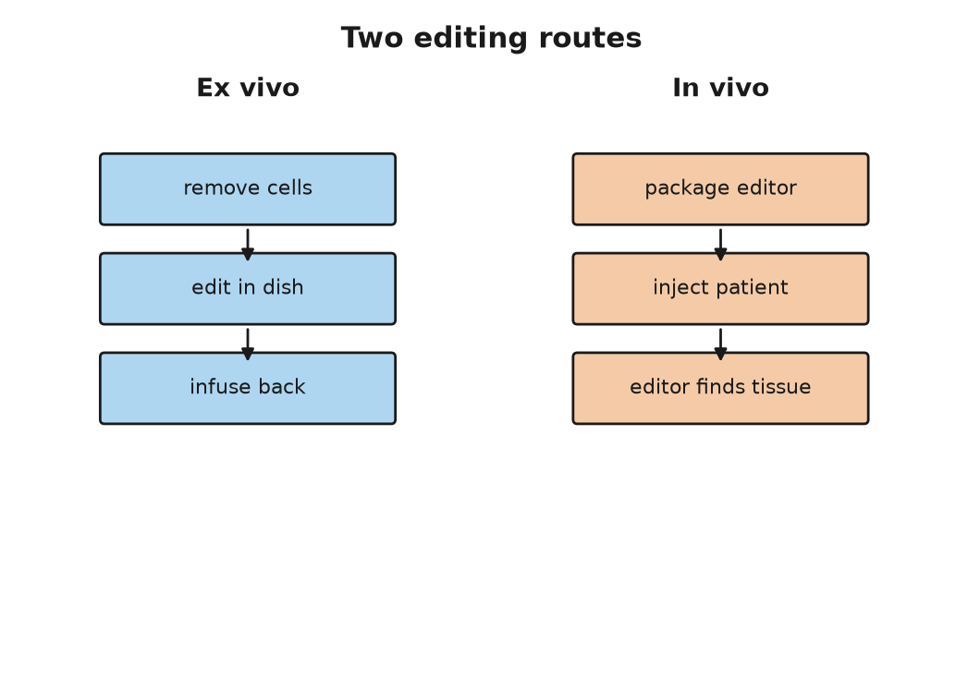
Figure 44. Ex vivo and in vivo editing routes.

Delivery
The hard part of somatic editing is not the editing. The scissors, the base editors, and the prime editors of Chapter 55 are, by now, well understood. The hard part is the post. You have to get a few thousand letters of instructions, or a protein and a guide, into the right cells of a living person, and nowhere else, without the immune system noticing, and in a quantity that does something.
There are two routes, and the diagram for this chapter shows them side by side. Ex vivo, “outside the body,” is the Casgevy route: take the cells out, edit them in a dish where you can check your work, put them back. It works for blood, because blood-forming stem cells can be harvested from a vein and re-seeded into marrow, and it is the reason blood diseases came first. It does not work for a liver, a heart, or a brain, which cannot be taken out. In vivo, “inside the body,” means putting the editing machinery into a person and trusting it to find the address.
For in vivo delivery there are, at present, two kinds of envelope. The first is a virus, usually an adeno-associated virus, AAV, a small harmless passenger virus that most people have met without knowing. Its own DNA is replaced with the gene you want to deliver, and the virus does the rest. Luxturna, Zolgensma, Hemgenix, and Roctavian all use AAV. Its limits are real. The capsule holds only about 4,700 letters, roughly enough for two or three ordinary genes end to end, which excludes many large genes. A third or more of adults already carry antibodies against the common AAV types and cannot be dosed, or cannot be dosed twice, because the first dose immunizes them against the second. And at the very high doses needed to reach muscle throughout the body, AAV has killed. In a trial of a gene therapy for X-linked myotubular myopathy, a rare muscle disease, several boys who received the highest dose died of liver failure between 2020 and 2021, and the program was later halted.
The second envelope is a fat droplet, a lipid nanoparticle, of the kind that carried the mRNA vaccines of 2020. Those vaccines were a DNA-adjacent tool, not an edit. They sent a temporary RNA instruction for a viral protein, and they did not rewrite anyone’s genome. The same class of envelope can now carry an editor instead. The difference is permanence: a vaccine’s instruction fades in days, and an editor’s change, if it lands, stays for the life of that cell and its daughters. The particle carries messenger RNA that tells the cell to make the editor for a day or two and then disappears. It can be dosed again. And it has one enormous convenience: injected into a vein, most of it ends up in the liver, because the liver’s job is to pull fat particles out of the blood. For a disease of the liver, the parcel delivers itself. That is why the first in vivo CRISPR trial, in 2021, was for a liver disease. Six patients with transthyretin amyloidosis, in which the liver makes a misfolded protein that clogs the heart and nerves, received a single infusion of lipid particles carrying instructions for Cas9 and a guide aimed at TTR. At the higher dose the amount of the protein in their blood fell by an average of 87 percent, and the results appeared in the New England Journal of Medicine in June 2021. KJ Muldoon’s editor arrived in the same kind of particle for the same reason: CPS1 is a liver enzyme.
Beyond the liver, delivery is a working problem, not a solved one. Getting an editor into the brain, past the blood-brain barrier, at scale, is not done. Getting it into every muscle fiber of a body with muscular dystrophy is not done safely. Getting it into the lining of the lung, for cystic fibrosis, has been tried since 1993 with inhaled vectors and has never produced a durable benefit. The list of approved products is a map of the organs that are easy to reach: the eye, which is small and closed and largely ignored by the immune system; the blood, which can be taken out; and the liver, which the parcel finds by itself.

Seven Thousand Rare Diseases
About 7,000 diseases are counted as rare, most of them caused by a fault in a single gene, and most of them affecting a few hundred or a few thousand people worldwide. Added together, the best current estimate, from a 2020 analysis of the Orphanet database, is that between 3.5 and 5.9 percent of people carry one of them, which is roughly 260 to 450 million people, and the round number of 300 million is the one usually quoted. In a class of forty, the odds are that one or two classmates have a rare disease. Almost none of them will ever have a product built for them, because there are not enough of any one of them to pay for the trial.
That is what KJ Muldoon’s case changes, or might. The argument, made openly by the Philadelphia team and taken up by the FDA, runs like this. The lipid particle was one already used in other trials. The base editor was a published enzyme. The only new thing was the twenty-letter guide that told it where to go. If the envelope and the enzyme can be qualified once, as a platform, then a new patient with a new mutation needs a new guide and a few months of testing, not a new decade. In 2025 the FDA’s leadership described in print a possible “plausible mechanism” pathway for exactly this kind of case, in which a treatment for a very limited number of patients could be authorized on the strength of a well-understood mechanism, a demonstrated effect in the patient’s own cells or in an animal model, and close monitoring, rather than a randomized trial that could never be run. Whether that becomes a regulation, and how safety is policed when every patient is a trial of one, was still being argued as this book went to press.
The money is the other half. A million-dollar price for a one-time treatment can be cheaper than the alternative. A person with severe sickle cell disease in the United States runs up lifetime medical costs estimated at about $1.7 million, and dies on average in their forties. But the arithmetic only works if someone pays up front, and in the American system the payer is often a state Medicaid program with an annual budget. In 2025 the federal Medicare and Medicaid agency began an arrangement under which the makers of the sickle cell therapies are paid partly on results, and by which states could pool the risk. In England the published list is £1,651,000. The National Health Service agreed a confidential discount and began treating patients in 2024 for thalassaemia and in 2025 for sickle cell. In the countries where most sickle cell disease actually is, in sub-Saharan Africa and India, where perhaps 300,000 babies are born with it every year, none of this is available, and at any price with six zeros in it none of it will be. A cure that exists and cannot be delivered is a new kind of inequality, and it is settled that it is a real one.
As of late 2026 the first CRISPR medicine is spreading slowly, not flooding. The company that sells Casgevy reported that in 2025 a few dozen people received the infusion, with a few hundred more somewhere on the path from referral to cell collection. Prime editing that same year was still two patients reported in a journal. That is a start, and it is still a start in the countries that can staff a transplant unit. The countries where most sickle cell disease is born have not been reached.
I think the fair way to describe the state of somatic editing in 2026 is this. For a short list of diseases of the blood, the eye, and the liver, we can fix what is broken, at great cost and with real risk, and the fix holds. For a much longer list, the fix is designable in principle and the parcel is the problem. And for one baby, the fix was designed for him alone, which is the thing nobody expected to see this soon. All of it dies with the patient. The question of whether to make a fix that does not is the one this book has been putting off since Chapter 30, and it is time to stop.
↑ Back to Contents

Chapter 74: The Line We Said We Would Not Cross — Editing Embryos

A Summit in London
The Francis Crick Institute sits behind St Pancras station in London, a building of glass and pale stone that its critics compared to a beached submarine. On the morning of 6 March 2023 its auditorium was filling for the Third International Summit on Human Genome Editing, three days of talks that had been waiting, in a sense, since the Second, in Hong Kong in November 2018, when a man from Shenzhen stood up and told the room that two edited girls had already been born.
One of the first speakers was not a scientist. Victoria Gray, the Mississippi woman who in July 2019 had been the first sickle cell patient treated with CRISPR-edited cells, told the room what her life had been before and after. The choice of opening was not an accident. The organizers wanted the world to see the somatic side of the ledger, the side with a cured patient on it, before anyone talked about embryos. When the organizing committee issued its closing statement on 8 March, it said that somatic editing was working and needed to be made affordable, and that heritable human genome editing “remains unacceptable at this time.” The phrase “at this time” was doing a lot of work, and everyone in the room knew it.
The line between somatic and germline, drawn in the last chapter, is the line the summit was defending. What follows is the case for crossing it, put as strongly as I can, then the case against, put the same way, then the two things that are already on the far side of the line and have been for years, and then what I think.

The Case For and Against
The case for begins with a couple. Invent two people for a paragraph: a man and a woman who both have sickle cell disease, each carrying two copies of the HBB variant, who want a child of their own. Every child they conceive will have the disease. There is no embryo to select, because all of them carry two copies. The same is true for a parent who carries two copies of the Huntington’s expansion in HTT, the fatal brain disease from Chapter 70, which is rare but not unknown, and for any couple in which one partner has two copies of a dominant condition. For these families, embryo selection, the workhorse of the last thirty-five years, has nothing to offer. Germline editing is the only route to a child who is genetically theirs and free of the disease. The number of such couples is small, and I have not found a reliable estimate, but it is not zero.
The case for goes on. We already accept risk to future people for the sake of their parents’ wishes. IVF, short for in vitro fertilization, was itself done first, in 1978, without anyone knowing what it would do to Louise Brown. Mitochondrial replacement, described below, is a heritable change and has been legal in Britain since 2015. Selection against a disease and correction of a disease have the same aim. If somatic editing of a child’s blood is a cure, and everyone agrees it is, then editing the same letter one generation earlier, so that the child never has the disease and never needs the cure, is at worst the same act done sooner. And the 2020 report of the International Commission on the Clinical Use of Human Germline Genome Editing, convened by the US National Academies and Britain’s Royal Society, laid out a narrow pathway: serious single-gene diseases, no other option, an edit to a common variant known to be harmless, with proof that the edit is exactly what was intended and nothing else, before any pregnancy. That is not “never.” It is “not yet, and only like this.”
The case against begins with consent. The person most affected by a germline edit does not exist when the decision is made and cannot be asked. The standard reply, that nobody consents to being born with any genome, is true and does not settle it, because a natural genome is nobody’s choice and an edited one is somebody’s. Then irreversibility: a somatic edit that goes wrong harms one patient, and a germline edit that goes wrong is inherited. Then mosaicism, which is the technical objection with teeth. Cas9, the cutting enzyme from Chapter 55, injected into a fertilized egg does not always act before the first cell division. If it acts at the two-cell or four-cell stage, some cells are edited and some are not, and the resulting person is a patchwork whose cells cannot all be tested before birth. He Jiankui’s twins were, on the evidence he himself presented, mosaic. Then off-target cuts and unintended damage at the target itself: in 2020 several groups reported that Cas9 in human embryos sometimes removed large pieces of the chromosome around the cut, at rates that were not small. And then the argument that is not technical at all: that the same technique which removes a disease can, in the next laboratory, add a preference, and that a society which allows the first will not find the place to stop before the second. The next chapter is about how little of the second is actually possible, but the slope argument is not about what is possible now.
There is also the practical objection that the summit’s statement leaned on. For almost every family that fears passing on a single-gene disease, embryo selection already works, is legal almost everywhere, and does not involve touching the text at all.
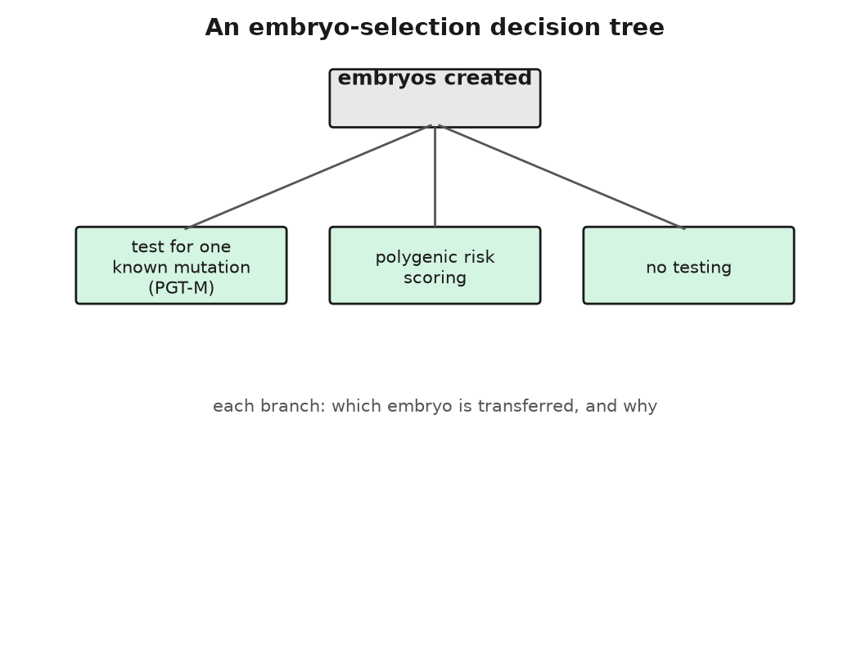
Figure 45. An embryo-selection decision tree.

Already Across the Line
Selection is the first thing already on the far side of the line, and it has been there since 1990. In April of that year Alan Handyside and colleagues at the Hammersmith Hospital in London reported in Nature that they had taken a single cell from each of several three-day-old IVF embryos, amplified a piece of the Y chromosome by PCR, the DNA-copying method from Chapter 52, and transferred only female embryos to two women who carried X-linked diseases, disorders carried on the X chromosome. Both women became pregnant with twin girls. It went by the name preimplantation genetic diagnosis then and is called preimplantation genetic testing for monogenic disease, PGT-M, now. It has been used for cystic fibrosis since 1992, for Huntington’s, for BRCA1 and BRCA2, and for several hundred other conditions. The embryo is not edited. It is read, and the ones that carry the variant are not used. The moral weight of that is real, and people disagree about it, but it involves no new text and no new risk to the child who is born.
The embryos that are not transferred do not vanish. A typical IVF cycle produces several, one or two go in, and the rest are frozen in tanks of liquid nitrogen, in straws labeled with a name and a date. Estimates of how many sit in American tanks run from about a million to several million; there is no census. Some will be thawed for a later pregnancy. Some will be donated. Some will be discarded. Some stay because nobody answers the storage invoice. As of late 2026 that leftover stock is the quiet background to everything sold as embryo selection. The single-gene tests, and the polygenic scores below, are offered on the embryos a couple already has, including the ones that would otherwise never leave the tank.
What has changed since about 2019 is that companies began selling selection on the basis of the polygenic scores described in Chapter 71, for conditions that are not single-gene at all. Genomic Prediction, founded in 2017 in New Jersey, reported in 2021 the first baby chosen with such a score. Orchid, founded in 2019 in California, sequences the whole genome of each embryo from a few cells and reports risk scores for diabetes, heart disease, schizophrenia, several cancers, and more, at a price reported as a few thousand dollars per embryo. There are others.
What the scores can actually do is measurable, and it is not nothing, but it is small. A 2019 paper in Cell by Ehud Karavani, Shai Carmi, and colleagues worked out the expected gain from choosing the top-scoring embryo among ten for height: about 2.5 centimeters. For IQ, using the scores then available: about 2.5 points, with a wide spread. A 2021 paper in the New England Journal of Medicine by Patrick Turley and colleagues listed the reasons the numbers are worse in practice. A couple rarely has ten viable embryos to choose from. The scores were built on people of European ancestry and predict less well in everyone else. A score for one thing drags others with it, in directions nobody has measured. And the score ranks the embryos against each other, not against anyone’s hopes. The European Society of Human Genetics said in 2021 that offering polygenic embryo selection was unproven and premature. The companies say their customers are adults making informed choices. Both are true. The gap between what is sold and what is shown is, I think, the widest in this book, and the marketing has a way of not mentioning the centimeters.
The second thing already on the far side of the line is mitochondrial replacement. About one in 5,000 people is born with a serious disease caused by a fault in the 16,569 letters of mitochondrial DNA, which passes only from mother to child, as Chapter 42 explained. The fix is to move the nucleus of the mother’s egg, or of the fertilized egg, into a donor egg whose own nucleus has been removed and whose mitochondria are healthy. The child carries the nuclear DNA of both parents and the mitochondrial DNA of the donor, which is why the newspapers called them “three-parent” babies, a phrase the embryologists dislike because the donor contributes about 0.1 percent of the child’s genes and none of the ones that make a face.
It is heritable, if the child is a girl, and it was made legal on purpose. The House of Commons voted 382 to 128 on 3 February 2015 to allow it, the Lords agreed on 24 February, and the regulations came into force in October 2015. The Newcastle Fertility Center received the first license in March 2017. On 16 July 2025 the Newcastle team reported in the New England Journal of Medicine that eight babies had been born in Britain by pronuclear transfer, the nucleus-swap technique just described, all healthy at the time of writing, with the mother’s faulty mitochondria undetectable in most of them and present at low but measurable levels in a few, which is the thing to watch. Australia passed a similar law in 2022. The United States has not; a rider attached to the federal budget every year since December 2015 forbids the FDA from even considering an application for a heritable modification, and mitochondrial replacement is caught by it. A boy born in 2016 to a Jordanian couple treated by a New York doctor working in Mexico is, as far as the record shows, the first child born by the method, and the rider is the reason it was done in Mexico.

The Rules
The international rules are a patchwork with a clear center. A 2020 survey in the CRISPR Journal found that of 96 countries with relevant policy, 70 prohibited heritable human editing outright and none permitted it; the rest were silent or ambiguous. The Council of Europe’s Oviedo Convention has banned heritable modification since 1997. China, after 2018, wrote a criminal offense for it into its penal code in 2021. The World Health Organization published a governance framework in 2021 and set up a registry of trials. The summit statement of 2023 was the scientific community’s own line: not now, and not until the technical bar of the 2020 report has been met and there is a public consensus that it should be done at all.
He Jiankui was released in April 2022 after his three years. He set up a laboratory, announced plans for gene therapy research, and has posted regularly about his intentions since, including statements in 2024 and 2025 that he wanted to work on embryo editing to reduce Alzheimer’s risk. I stick to the record and note only that nobody has reported him doing any such thing, and that the children he did edit are, as far as anyone outside a narrow circle in China knows, alive and unstudied.
So here is what I think, marked as mine. Somatic editing is medicine and should be paid for like medicine. Embryo selection for serious single-gene disease is a reasonable thing for a family to choose and a reasonable thing for a family to refuse. Polygenic embryo selection is a product ahead of its evidence; I would not buy it, but I would not forbid adults from buying it either, provided the centimeters are in the brochure. Mitochondrial replacement has been done carefully, for a small number of families with no alternative, and the results so far justify it. Germline editing of the nuclear text I would keep where the summit left it, for the reason the summit gave: almost everyone it could help can be helped by selection instead, and the few who cannot are not yet enough to justify the first mistake. But I do not think “never” is a serious position, and I notice that the people who use the word tend to have no one in their family with two copies of anything. The line will move when the risk is shown to be smaller than the harm it prevents, and not before, and the arguing about where that point is will be done by people who are not yet born. The harder argument is not about disease at all, and it starts with a very strong little boy in Berlin.
↑ Back to Contents

Chapter 75: Enhancement — Better Humans, and the Accounting

A Boy in Berlin
The boy was born in Berlin in 1999, and the first thing anyone noticed was his legs. Newborns are soft; this one had the defined thigh and calf muscles of a compact athlete, and within days his twitches were strong enough to be worth a neurologist. The neurologist was Markus Schuelke at the Charité hospital, and over the next four years he and colleagues in Berlin and at Johns Hopkins worked out why. In June 2004 they published the answer in the New England Journal of Medicine. The boy carried two broken copies of MSTN, the gene for myostatin, a protein whose job is to tell muscle to stop growing. He made none of it. By the age of four and a half he could hold a three-kilogram weight in each hand with his arms stretched out sideways, and the cross-section of his thigh muscles was about twice that of other children his age. His mother, reported as a former professional athlete, carried one broken copy. She was, the paper noted, unusually strong.
Myostatin was not new. Se-Jin Lee and Alexandra McPherron at Johns Hopkins had knocked it out in mice in 1997 and produced animals with two to three times the normal muscle mass, which the newspapers called Schwarzenegger mice. Belgian Blue and Piedmontese cattle, the double-muscled breeds that look as though they have been inflated, turned out to carry natural MSTN mutations, an 11-letter deletion in the Belgian Blue’s case. Whippets carry a 2-letter deletion; dogs with one copy are over-represented among racing winners, and dogs with two, known as bully whippets, are heavily muscled and prone to cramp. All of this is settled, and it produces the first entry on a list that this chapter is really about: the list of things that some people already are, by accident of birth, that the rest of us are not, and that an editor could in principle write in.

The Short List
The list is shorter than the films suggest, and each entry has a footnote.
Eero Mäntyranta was a Finnish cross-country skier who won seven Olympic medals between 1960 and 1968, three of them gold. His blood carried, by report, about 50 percent more hemoglobin than a normal man’s, and in 1993 Albert de la Chapelle’s group in Helsinki found out why: a single-letter change in EPOR, the gene for the receptor that responds to erythropoietin, the hormone that tells the marrow to make red cells. The mutation truncated the receptor and removed its off switch. About thirty members of his extended family carried it. It is the nearest thing in humans to a natural blood-doping allele, and Mäntyranta spent the rest of his life, until his death in 2013 at 76, explaining that he had not cheated. The footnote is that thick blood clots. What the allele cost his family over their lifetimes is not on record in any detail, and that absence is itself a warning about how little we know of the price of these things.
CCR5-Δ32 is a 32-letter deletion that removes a protein from the surface of immune cells. About 10 percent of people of northern European descent carry one copy, and about 1 percent carry two. HIV uses the CCR5 protein as a door; people with two deleted copies have no door, and are almost immune to the common strains of the virus. That is why, in February 2007 in Berlin, a doctor named Gero Hütter gave an HIV-positive leukemia patient named Timothy Ray Brown a marrow transplant from a donor with two copies of Δ32. Brown’s leukemia was cured, and so, as far as anyone could tell for the rest of his life, was his HIV. He stopped his antiviral drugs and the virus never came back. He died in September 2020 of a return of the leukemia, still free of HIV, and a handful of people have since been cured the same way. It is also the allele He Jiankui tried to write into two embryos in 2018, which is why it belongs in this chapter and not only in the last. The footnote is West Nile virus: people with two Δ32 copies are several times more likely to fall seriously ill if they catch it, and there are hints, less certain, of worse outcomes with influenza and some other infections. A 2019 paper claiming that Δ32 homozygotes, people with two deleted copies, die younger was retracted the same year when its genotyping proved faulty, so that particular cost is not shown. But the door HIV uses is a door the immune system built for a reason.
ACTN3 encodes a protein in fast-twitch muscle fibers. About 18 percent of people worldwide carry two copies with a stop codon, a signal that halts the gene’s instructions early, and make none of it, and they are fine. But among elite sprinters and power athletes the two-copy version is almost absent, which Kathryn North’s group in Sydney reported in 2003, and among endurance athletes it may be slightly enriched. The footnote is the size of the effect: it shifts the odds of being a champion by a modest amount, and it makes nobody fast on its own.
BHLHE41, also known as DEC2, carries in a few families a variant, P385R, a change at position 385 in the protein, that Ying-Hui Fu’s group at the University of California, San Francisco, reported in Science in 2009. The people who carry it sleep about six hours a night, feel rested, and have done so all their lives; mice engineered with the same variant sleep less too. Fu’s group has since identified several other short-sleep variants in other genes. The footnote is that nobody knows what, if anything, the two saved hours cost over a lifetime, because the families are small and the question is hard.
LRP5 is a gene in a signaling pathway that controls bone growth, and two families reported in 2002, one of them in the New England Journal of Medicine, carry variants that give them bones several times denser than normal. Their members have walked away from car accidents that break other people’s hips, and it has been reported that some of them have trouble swimming, because they sink. The footnote, so far, is modest: an enlarged jaw in some, a bony ridge on the palate in others. Osteoporosis drugs acting on the same pathway followed.
And then PCSK9, which is the free lunch, or the nearest thing to one. In 2006 Jonathan Cohen and Helen Hobbs at the University of Texas Southwestern reported in the New England Journal of Medicine that about 2.6 percent of Black participants in a large heart study carried a nonsense mutation, a change that stops the gene’s instructions partway through, in PCSK9, a gene whose protein removes LDL receptors from the surface of liver cells. Carriers had LDL cholesterol, the “bad” cholesterol that clogs arteries, 28 percent lower than everyone else and, over fifteen years, 88 percent fewer coronary events, meaning heart attacks and related heart trouble. A woman was later found with both copies broken, an LDL cholesterol of about 14 milligrams per deciliter, roughly a tenth of the usual figure, and no apparent ill effect at all. Two antibody drugs that block the protein were approved in 2015, a gene-silencing RNA treatment that mutes the gene for six months at a time followed in 2020, and in 2022 a company named Verve dosed the first patients with a base editor that writes a stop into PCSK9 in the liver, permanently, in a single infusion, with results reported in 2023. The trial had its troubles and was paused and redesigned; the point is that the natural allele told the drug designers exactly what to build.
The oldest and best-documented entry on the list is not usually put on it, because it is so common. Anna’s switch, from her father, is an enhancement by any definition: a new ability, useful, heritable, no evident cost. It was written by copying errors and dairy farming, not by anyone.
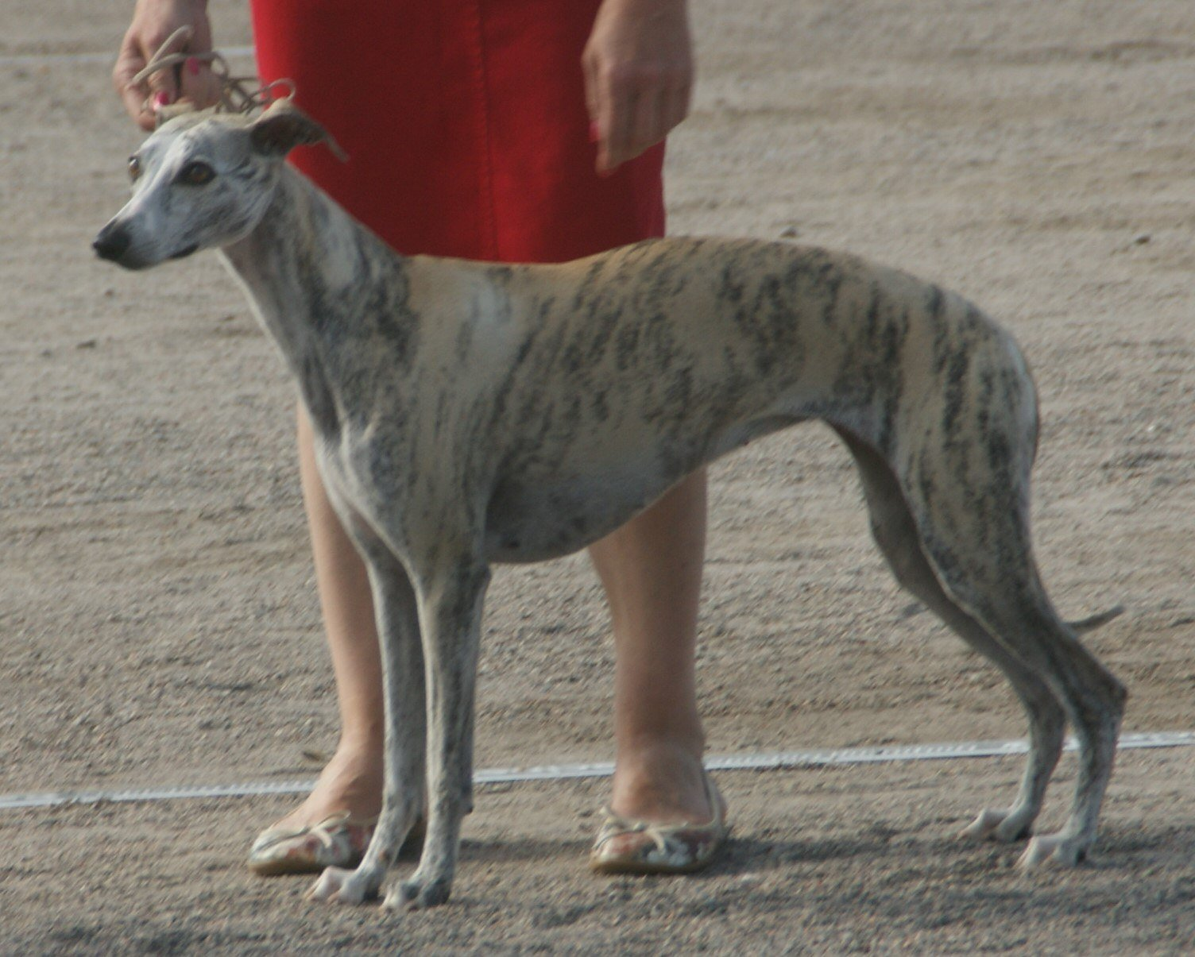
Figure 46. A whippet, the deep chest and narrow waist the breed was selected for.

The Accounting
Now the accounting. Every entry above except the last two comes with a trade, and the trades are the same shape as the one this book has met before. Sickle cell is the pattern: one copy of the HBB variant protects against severe malaria, two copies cause the disease, and the variant is common in exactly the places where malaria has been. CCR5-Δ32 blocks one virus and opens the door to another. EPOR wins medals and thickens blood. Myostatin loss builds muscle, and in cattle causes calving problems severe enough that most Belgian Blue calves are delivered by Cesarean, and in humans nobody knows what it does to tendons and hearts over sixty years, because the boy from Berlin is only in his twenties.
What we call superhuman, in other words, is mostly a menu of trade-offs that evolution has already priced, with a small number of items that look, on present evidence, like pure gain: PCSK9 loss, dense bones, Anna’s switch. That is the right way to hold the whole subject. The alleles exist, they are in people walking around today, and an editor that can write one letter into a liver cell can write these. What it cannot do is remove the footnote.

Doping and Intelligence
Gene doping is where the argument stops being theoretical. The World Anti-Doping Agency put gene doping on its prohibited list in 2003, before anyone had done it, defined broadly as the non-therapeutic use of genes or cells to improve performance. A product called Repoxygen, a virus carrying an erythropoietin gene that had been developed for anemia, turned up in 2006 in the German trial of an athletics coach, in emails in which he tried to obtain it. No case of a gene-doped athlete has ever been confirmed, and detecting one is hard, because the added gene makes the athlete’s own protein. Somatic editing of an athlete’s EPOR or MSTN is, as of 2026, technically closer than most sports bodies would like to admit, and if it happens it will come to light the way East German doping did, by paperwork and defections, not by a test.
Then intelligence, which is the item on every list and the one with the least behind it. Chapter 71 gave the numbers. The largest study of educational attainment, with 3 million people in 2022, produced a polygenic score that predicts about 12 to 16 percent of the variance, the person-to-person differences, in years of schooling, and within a family, comparing siblings, about half of that, because the rest is the family’s money and the schools. The score is built from thousands of variants of tiny effect, scattered across the text, most of them in regulatory regions whose function nobody has worked out, and none of them a lever. There is no MSTN for thinking. There is no single letter that makes a mind, and there is no evidence, working or speculative, that one is waiting to be found. Anyone who sells the possibility of an edited genius is selling something they have not seen.
Which leaves the honest position, and I will mark it as mine. The natural superhuman alleles are real, few, and mostly bought at a price. Somatic editing to copy one of them into an adult who wants it, with eyes open, is a question of medical ethics and sporting rules, not of the future of the species. Germline editing to write one of them into a child is the line of the last chapter, with less excuse. And the enhancement that would matter most, if anyone could offer it, is the one nobody can find in the text. The next chapter is about what a hundred years of all this might look like, and the first thing to say is that the text will not be waiting for us to decide.
↑ Back to Contents

Chapter 76: The Next Hundred Years — A Forecast to 2126

A Wall in 2126
It is 2126, as of the guesses one can make in late 2026, and a child has been born in a hospital that is, in most respects, recognizable. The lights are the same. The mother is tired. What is different is that on the wall a display is already showing the child’s genome, both copies of the 3.1 billion letter text, read from a few of the child’s cells in the last hour of labor and compared, before the cord is cut, with the text of both parents and with a reference built from several hundred million other people. Nothing about the cutting of the cord has changed. The reading is simply done, the way a birth weight is done, and it will say, within the hour, which of the sixty or seventy new letters this child carries were in neither parent, and whether any of them matter.
What that wall would mean is narrower than a parent standing in front of it will want. It would name the new letters that neither parent carried, the copying errors of one conception, and whether any of them sit in a gene a pediatrician can already treat. It would, if anyone asked, show the drug-response letters of Chapter 70. It would not say how tall the child will be, or how long the child will live, or what kind of person the child will become. A polygenic score on that screen would shift a curve. It would not place the infant. The display is a reading of a text that will keep being copied, and miscopied, in every tissue, for the rest of that life.
I do not know that this is what 2126 will look like. Nobody does, and I have spent seventy-five chapters being careful about numbers, so I am not going to stop now. What I can do is sort the guesses by how much stands behind them today, using the three words this book has used since its Prologue, and then say, marked as mine, what I would bet on. The reader in 2126, if there is one, may score it.

What Is Already Happening
Some of this is already being done at a scale where the only uncertainty is how far it spreads.
Newborn genomes are already being read. Genomics England began its Generation Study in October 2024 with the aim of sequencing 100,000 newborns and reporting on more than 200 treatable childhood conditions. A baby in intensive care can have a diagnostic genome within a day or two, and the record, set in 2022, was under eight hours. The blood-spot screening that Robert Guthrie started in 1963 tested for one disease. A genome tests for all of them at once, and the price is within sight of what a routine hospital test costs. I would put universal newborn sequencing in the rich world within twenty years, not a hundred, and the argument about what to report from it, which Chapter 71 described, will go on for the whole century.
Once a child’s text is on the wall, the cures that can follow it will keep spreading. As of late 2026 that spreading is still a trickle: a few dozen Casgevy infusions in a year, a handful of bespoke editors, two prime-edited patients in a journal. Somatic cures for single-gene diseases will extend from the blood, eye, and liver of Chapter 73 into whatever organs the delivery problem yields, and the KJ Muldoon model, one patient, one guide, will become a service line in a few dozen hospitals. The cost will fall, because it has fallen for everything else in this book: the $2.7 billion genome became the $200 genome in about twenty years, and the manufacturing that makes Casgevy cost $2.2 million is young. I would expect a child born in 2126 with sickle cell disease to be treated in infancy, in Lagos as well as London, and I would expect the disease to be, like polio, something grandparents remember. The present census is not that future. It is the start of it.
The same reading will sit in front of a prescription. Prescribing by genome is settled in principle and merely slow in practice. A 2023 trial in the Lancet, across seven European countries, gave nearly 7,000 patients a twelve-gene panel before prescribing and found about 30 percent fewer serious drug reactions than in patients treated the usual way. The panel costs less than a night in hospital. By 2126 the idea of prescribing a drug without knowing the patient’s CYP2C19 status, the drug-response gene from Chapter 70, will look the way prescribing without knowing their weight looks now.
Farms will have made the same shift earlier. Engineered crops and livestock are already the default in the countries that grow most of the world’s calories, as Chapter 63 counted. The edited tomato and the PRRS-resistant pig are the front of a queue. I would expect the distinction between genetically modified and conventional to have dissolved by mid-century, not because the arguments were won but because the edited varieties will be the ones that survive the climate they are grown in.
The reading will not stop at people. Sewage was the proving ground: cities began reading their wastewater for the COVID virus in 2020, and in June 2022 the poliovirus turned up in London’s sewage before a single case had been diagnosed, which set off a vaccination campaign. Some of that public reading was done on nanopore sequencers, devices the size of a USB stick, of the kind Chapter 54 described. In January 2022 two groups, one working at Copenhagen Zoo and one at a zoo in England, showed that the DNA drifting in the air could identify the animals nearby. Water, air, soil, the surfaces of hospitals, the breath of the person next to you on the train: the cost of reading is heading toward the cost of the tube, and by 2126 the ambient genome of a city will be a public utility, monitored the way air quality is now. What that does to privacy, Chapter 72 has already said.
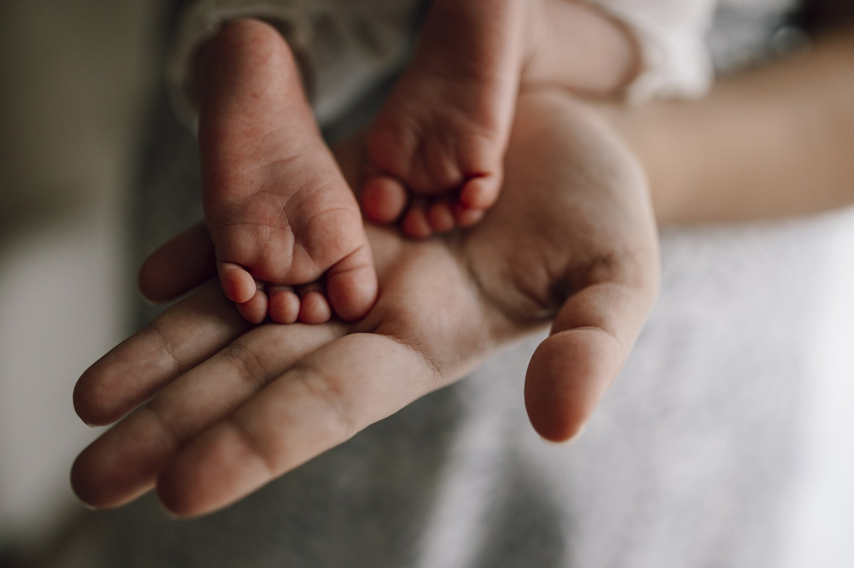
Figure 47. A newborn’s feet in an adult hand, one person at the scale the last chapter is guessing about.

The Working Guesses
Other guesses have a best current account and a real gap, and they should stay in that order.
Polygenic embryo selection, sold since 2019, will be normal in some countries and illegal in others, and I would guess the line will fall roughly where the line on commercial surrogacy falls now, with the same tourism across it. The pressure will not wait for the centimeters to grow. As of late 2026 a couple who already has leftover embryos in a tank can be sold a ranking of them. Once a child’s genome is on a wall, the same scores will look, to some parents, like a report card. They will not be one. The scores will get better as the biobanks of Chapter 68 pass ten million people and stop being mostly European, and the gain from picking the best of ten embryos will rise from two and a half centimeters to something a brochure can print without shame. It will never be large, because the gap between the embryos a couple actually has is the gap between siblings, and siblings differ, as Chapter 41 showed, in ways that no score can see.
Partial reprogramming is the working scenario I would watch most closely, because it is the one that could change what a century means. In 2006 Shinya Yamanaka showed that four proteins could turn an adult cell back into something like an embryonic one, as Chapter 61 described. In December 2016 Juan Carlos Izpisua Belmonte’s group at the Salk Institute reported in Cell that switching those four factors on briefly and repeatedly, without letting the cells complete the reversal, made mice with a premature-aging disease live about 30 percent longer and left their tissues looking younger by several measures. In December 2020 David Sinclair’s group at Harvard reported in Nature that three of the four factors, delivered by virus into the eyes of old mice, let damaged optic nerves regrow and returned some lost vision. In January 2022 a company called Altos Labs launched with about $3 billion of private money and several of the people who had done the work, to try to make it a medicine. The first human trials, for eye conditions, were being planned as this book went to press.
What is working here is real: the epigenetic marks of Chapter 39 drift with age, the drift can be measured as a clock, and in mice the clock can be partly rewound without turning the cell into a tumor. What is not shown is that it can be done safely in a whole human body, that the gain is more than modest, or that it does anything for the cell’s DNA, which has been accumulating the copying errors of Chapter 40 the whole time and is not rewound by any of this. My guess is that partial reprogramming becomes a treatment for particular tissues, the eye first, joints and skin perhaps, within thirty years, and that it adds years of health to old age rather than decades to life. The text still sets the ceiling.
De-extinction as a conservation tool is working in the sense that the animals exist. Colossal’s gray wolves with twenty edits, born in late 2024 and shown in April 2025, are not dire wolves, as Chapter 58 said, but the same company’s cloning of red wolves, of which fewer than twenty remained in the wild, is conservation by any name. The black-footed ferret Elizabeth Ann, cloned in December 2020 from cells frozen in 1988, and her successors, who have since produced kits, put genetic diversity back into a species that had been reduced to seven founders. By 2126, I would guess, every endangered mammal has a cell line in a freezer and a cloning protocol, and the word extinct will need a footnote.
Synthetic organisms in industry are already there in modest form. Yeast engineered by Jay Keasling’s group to make the malaria drug artemisinin entered production in 2013, and precision fermentation now makes insulin, rennet, vanilla flavoring, and the heme in a plant-based burger. The 473-gene cell of 2016 and the rewritten yeast chromosomes of 2023 are the far end of the same road. What is not shown is that a wholly designed organism can do anything better than an edited natural one, and the working answer may be that it cannot, and that synthetic biology in 2126 will mostly mean very heavily edited yeast.
The copy is never exact, and mixing two copies is a different kind of inexactness. As of late 2026 a chimera, in the laboratory sense, is an animal whose body holds cells from two genomes that did not start in the same fertilized egg. That is not a pig kidney sewn into a person, which surgeons in New York, Maryland, and Xi’an have already tried, and it is not a gene-edited pig that is still wholly a pig, of the kind Chapter 64 already put on the farm. Human cells in early pig embryos have been reported, in 2017 and again in 2023 from a group in Guangzhou, as sparse contributions stopped weeks before birth. Mice given a human immune system after they are born have been ordinary laboratory animals for years. Mini-organs grown in a dish, organoids, are real enough to test drugs and, in a few early trials, to put islet-like clusters back into a person; they are not a spare heart on a shelf. I would guess that by mid-century a few people receive pig organs, that a mostly-human kidney grown inside a pig remains a working hope with a real gap, and that the line the 2021 international stem-cell guidelines drew, a substantial human contribution to an animal brain, is still the line worth keeping.
Space does not wait for a spare organ. A year on a station, as the 2019 NASA twins paper in Science showed, thins bone and muscle, shifts fluid into the head, and can swell the back of the eye. China flew four mice to its station in late 2025; one female later had litters on the ground. That is not a child conceived in orbit, and it is not a redesigned human. I would bet on better exercise, drugs, and shielding by 2035. The radiation of deep space will add copying errors. It will not, on any schedule I would sign, grow extra limbs or a new species.

Allowed, Not Shown
Past those, the guesses are allowed and not shown.
As of late 2026 the germline remains where the 2023 summit left it: not now, and gated by the 2020 pathway, the heritable-genome-editing report’s own requirement of a long medical reason and broad oversight before an edited embryo is brought to term. Germline editing for a few diseases, in a few countries, for the small number of couples for whom embryo selection cannot work: I would guess it happens before 2050, that the first cases are for sickle cell or thalassaemia where both are common, and that the arguments of Chapter 74 are re-run in full each time. I would also guess that by 2126 the practice is rare, legal in some places, and has changed nobody’s view of what a person is, which is what happened with IVF.
Inequality by genome is the guess people fear most: the rich selecting and editing while the poor do not, until the gap becomes heritable. A 1997 film put that picture on a screen. The guess is allowed, and it is unlikely to arrive in that costume, for a dull reason: the traits that money most wants, intelligence and temperament, are the ones with no lever, as the last chapter said, and the ones with a lever, disease, are the ones public health systems have the strongest reason to pay for. The inequality that is actually coming, and is already here, is the one Chapter 73 described: a cure that exists in one country and not in another.
Human variants for space or climate are the far end. The genes that let a bacterium survive radiation, the Tibetan EPAS1 variant for thin air, the enlarged spleen of the Bajau sea nomads for diving, heat tolerance borrowed from the slick-coat cattle of Chapter 64: all of these have been proposed, in print, as edits for a species that means to live off Earth or on a hotter one. None has been tried, none is close, and the delivery problem alone puts them beyond this century for adults. For embryos, they are the enhancement slope of Chapter 74 with a rocket attached. I would put nothing on it before 2100, and I notice that the people most enthusiastic about it are not, on the whole, the people who would be edited.
And the designer argument, in the end, may resolve itself, because the strongest evidence in this book is that we do not know what we want. Every allele on the list in Chapter 75 was a trade. The one clear enhancement in human history, the lactase switch, was not designed and could not have been, because nobody eight thousand years ago knew what a gene was or that cheese was coming. Evolution has not stopped. It wrote EPAS1 into the Tibetans within the last few tens of thousands of years, the lactase switch within ten thousand, and it is working now on whatever gets people through cities, sugar, and antibiotics, at a pace no one can see within a lifetime. Whatever we design will sit on top of that, and will be judged by it. The judgment will mostly be that we were cautious about the wrong things.
So, marked as mine, my guess for 2126. Every child’s text is read at birth, and most single-gene diseases are fixed in infancy or before. Prescribing, farming, and public health are done by sequence. Old age is longer and better by a decade or two, not by a century. Embryo selection is ordinary, edited embryos are rare, and the species is recognisably the one that mailed the tube. The thing that will have changed most is not the text but our relation to it: from something that happened to us to something we read, argue about, and occasionally, with great care, correct.
And the text will not have noticed. In the hour after the child of 2126 is born, in the lining of the child’s gut, cells are dividing, and each division copies about 6.2 billion letters, both parental sets, and the copying enzyme checks its work, and a second set of enzymes checks it again, and about one letter in a billion still comes out wrong. It has been doing that for something like 3.8 billion years, through every editor, every summit, every price list, and every book. Everything that lives, including the reader, is what those errors added up to.
We may learn to correct a few of them. We will not make the copying perfect, and I think, if it ever came to it, we would be wrong to try.
↑ Back to Contents

PART XI
Life Elsewhere
If life is chemistry that copies itself, nothing in the chemistry says it had to happen only once. This Part leaves Earth to ask where else the copying could have started, how we would know, and what finding it would teach us about ourselves.

Chapter 77: What Life Needs — Water, Energy and the Short List

The Meat That Would Not Stay Sterile
In 1956, at the agricultural experiment station in Corvallis, Oregon, a microbiologist named Arthur Anderson was testing a new way to preserve food. The idea was simple. Seal the meat in a can, hit it with a dose of gamma rays large enough to shred the DNA of anything living inside, and the meat should keep forever. The cans were irradiated. Some of them spoiled anyway.
Anderson cultured what was growing in them and found a pink bacterium that shrugged off radiation thousands of times stronger than the dose that would kill a person. It was later named Deinococcus radiodurans, roughly “terrible berry that withstands radiation.” Its trick is not armor. The radiation breaks its chromosome into hundreds of pieces, just as it would break ours. The bacterium carries several copies of its genome and a repair system good enough to stitch the fragments back into working order within hours.
That is the right place to begin a Part about life elsewhere, because it resets the question. When people ask whether a planet could support life, they usually picture a person standing on it, and then ask whether the person could breathe. That is the wrong test. Most of the history of life on Earth, as Part I and Part III described, was microbes, and microbes have turned out to be much harder to kill than we assumed. The question is not “Could we live there?” It is “What does the copying chemistry of the first ten chapters actually require?”
The answer is a short list. This chapter goes through it.

The Definition, One More Time
Chapter 1 settled on a working definition: life is chemistry that copies itself, imperfectly, and lets the imperfections be judged. NASA’s astrobiologists use a version of the same idea, worked out by a panel in the 1990s and usually quoted as “a self-sustaining chemical system capable of Darwinian evolution.”
That definition is useful here because it tells you what to look for and what not to. It does not say “made of cells,” or “based on DNA,” or “breathes oxygen.” Those are facts about the one example we have. It says that somewhere there must be chemistry that stores information, copies it with small errors, and runs for long enough that the errors can be sorted by what survives. Everything else on the short list follows from what that chemistry needs to keep going.
There are four items. A liquid to do the chemistry in. A supply of energy. The right elements. And time, with enough stability that the copying is not wiped out before it gets anywhere.

A Liquid to Work In
Chemistry that copies needs molecules that can meet, react, separate and meet again. In a solid, molecules are locked in place. In a gas, they are too far apart and anything large falls apart or drifts away. A liquid is the middle state: dense enough that molecules collide all the time, loose enough that they keep moving.
On Earth the liquid is water, and Chapter 2 explained why it is unusually good at the job. It dissolves salts and many small organic molecules. It stays liquid over a wide range of temperatures. It is polar, which is what lets oily molecules gather into membranes, the trick that makes a cell possible. And ice floats, so a freezing lake or ocean is insulated by its own lid instead of freezing solid from the bottom up. That last fact will matter enormously in Chapter 80.
Could another liquid do it? This is a working question, not a settled one. Liquid ammonia dissolves many of the same things water does, and stays liquid at colder temperatures. Liquid methane and ethane exist on the surface of Saturn’s moon Titan, at about minus 179 degrees Celsius. They are poor solvents for the kind of charged and polar molecules our chemistry uses, but that does not prove a different chemistry could not use them. Nobody knows. What can be said is that water is common in the universe, because it is made of the first and third most abundant chemically active elements, hydrogen and oxygen, and that every living thing we have ever found depends on it. So the search starts with water, and keeps the other liquids on a second list.

Energy, Which Means Electrons Moving
Chapter 2 also made the point that biological energy is, at bottom, electrons moving downhill: from a molecule that holds them loosely to one that holds them tightly, with the cell skimming off some of the energy on the way. Chapter 4 traced the machinery, the proton battery every cell on Earth runs on.
That gives a much broader picture of “energy” than sunlight. Plants and many microbes use light. But a large share of Earth’s microbes have never seen the Sun. At hydrothermal vents on the ocean floor, and in fractured rock kilometers underground, microbes live on chemical energy alone: hydrogen made when water reacts with iron-rich rock, combined with carbon dioxide; or iron, sulfur and methane compounds that hold electrons at different strengths and can be made to trade them.
Chemists call this a redox gradient, short for reduction and oxidation, the two halves of an electron changing hands. A place where two kinds of chemistry meet without being at balance, such as hot reduced fluid from rock pouring into cold oxidized seawater, is a place where there is energy to harvest. Chapter 3 described why some origin-of-life researchers think life began at exactly that kind of boundary.
For the search, this is the most important single idea in the Part. It means a world does not need sunlight on its surface to have energy for life. It needs a liquid in contact with chemistry that is out of balance. That is why the most promising places in the solar system, outside Earth, include oceans buried under kilometers of ice.

The Elements: CHNOPS and a Few Friends
Biologists have an ugly acronym for the elements most of life’s mass is made of: CHNOPS, for carbon, hydrogen, nitrogen, oxygen, phosphorus and sulfur. Chapter 2 explained why carbon is the backbone: it makes four strong bonds, it bonds to itself in long chains and rings, and those bonds are strong enough to last but weak enough to be rearranged by enzymes at ordinary temperatures. Chapters 35 and 36 showed the same six elements at work in DNA: the sugar-phosphate backbone, the nitrogen-rich bases, the hydrogen bonds between them.
The cosmic supply is not the problem. Hydrogen, oxygen, carbon and nitrogen are among the most common elements in the universe. Comets and some meteorites carry complex organic molecules made without any life at all. Chapter 84 will look at the most recent and cleanest evidence, a sample returned from the asteroid Bennu in 2023.
The scarce ones may be phosphorus and, for some chemistries, a handful of metals. Phosphorus sits in the backbone of DNA and RNA and in ATP, the molecule cells use as small change for energy. It is much rarer than carbon in the universe and, on Earth, tends to be locked into minerals that dissolve poorly. Several origin-of-life chemists think the availability of phosphorus may be one of the real bottlenecks for life, here or anywhere. That is a working idea, and it is one reason the detection of phosphates in the ocean spray of a small moon of Saturn, in 2023, made such news. Chapter 80 tells that story.
What about silicon, the element science fiction offers as the alternative to carbon? It sits under carbon in the periodic table and also makes four bonds. But silicon-silicon bonds are weaker than carbon-carbon bonds, silicon’s bond with oxygen is so strong that it tends to end up locked in rock, and its oxide is a solid, sand, rather than a gas like carbon dioxide that can be breathed in and out. Silicon life is not impossible in any proven sense. It is just much less likely than carbon life, and nobody has a convincing design for its chemistry. Like the other liquids, it stays on the second list.

Time, and a Place That Holds Still
The fourth item is the least discussed and maybe the most important. Chapter 4 described the gap between the first cells and the first complex ones: something like two billion years in which life was entirely microbial. Chapter 16 described the mass extinctions that repeatedly cleared the board. Life on Earth needed hundreds of millions of years to get started and billions to get interesting, and it got them because the planet stayed habitable the whole time.
That requires a stable star, an orbit that does not swing the planet between frying and freezing, and some way of keeping the climate in range. On Earth that last job is done partly by a slow geological thermostat. Carbon dioxide is pulled out of the air when rain weathers rock, and returned by volcanoes. When the planet warms, weathering speeds up and draws down more carbon dioxide, which cools it again. When it cools, weathering slows and volcanic carbon dioxide builds up. The loop runs on timescales of hundreds of thousands of years, and it needs plate tectonics, liquid water and land.
Whether a planet has to have all that machinery to keep life going for billions of years is a working question. It is part of a larger argument, taken up in Chapter 83, about whether Earth is ordinary or rare.

The Edges of the Envelope
Here is what Earth’s own microbes say about how wide the list really is. These are measured limits, not guesses.
Heat. The record for growth is held by an archaeon called Methanopyrus kandleri, strain 116, which in 2008 was shown to multiply at 122 degrees Celsius under high pressure, in water that would boil at the surface. Earlier, in 2003, another archaeon nicknamed Strain 121 had been shown to survive a sterilizing autoclave.
Cold. Microbes keep metabolizing in brine channels inside sea ice and in permafrost at well below zero degrees Celsius, as long as salt keeps a little liquid water around them.
Acid and alkali. Microbes thrive in mine drainage with a pH near zero and in soda lakes with a pH above eleven.
Depth. Living cells have been recovered from rock several kilometers below the surface, and from sediments far beneath the sea floor, where they divide perhaps once in centuries. Some estimates put the total mass of this deep biosphere at a sizable fraction of all the microbial life on Earth.
Dryness and radiation. Deinococcus, from the meat can, also survives severe drying, which may be the real reason it can repair so much damage: drying breaks DNA too. The tardigrade, a half-millimeter animal with eight stubby legs, can dry itself into a dormant state called a tun and survive vacuum, extreme cold and heavy radiation. In 2007, on a European satellite mission called FOTON-M3, dried tardigrades were exposed directly to space for ten days, and some revived and reproduced afterward.
These organisms are called extremophiles, lovers of the extreme, although that is our label, not theirs. To the archaeon at a vent, 100 degrees is normal and the sea floor at 4 degrees is the extreme. The lesson is that life, once it exists, adapts to an extraordinarily wide range of conditions, provided liquid water is present at least some of the time. Dormancy is not growth. A tardigrade in space is surviving, not living. But it does show that the boundaries are wider than anyone in 1950 would have drawn them.

Habitable Is Not Inhabited
There is a trap in all of this, and it is worth naming before the next chapters walk into it.
Showing that a place has liquid water, energy, the right elements and time shows that it is habitable: that life as we know it could live there. It does not show that life began there, or that it ever arrived. Habitable is a statement about conditions. Inhabited is a statement about history.
On Earth, the two are nearly the same, because life has had four billion years to reach every corner. Almost every habitable niche on this planet has been colonized, from the boiling vents to the clouds, and that makes it easy to forget that the colonization took time and had to start somewhere. A sterile habitable world is perfectly possible. Chapter 3 described how hard the origin is to explain even on a planet where we know it happened. Whether a habitable place usually becomes inhabited is the deepest unknown in this Part, and the only way to answer it is to find a second example, or a convincing lack of one.
So when the following chapters say that Mars once had lakes, or that a moon of Saturn has a salty ocean with energy and phosphorus, read it as “the first three boxes are ticked.” The fourth box, whether anything is actually there, is the one the missions are trying to open.

The Punchline
The list of what life needs is short: a liquid, almost certainly water; a source of energy, which can be chemical as well as light; carbon and a handful of other common elements, with phosphorus possibly the scarce one; and a long, stable stretch of time.
Earth’s extremophiles show that, once life exists, it can work at the edges of all four. Nothing on the list is rare in the universe. Water, carbon and chemical energy are found almost everywhere we look. What remains unknown is the one step that is not on the list: how often the ingredients actually start copying themselves.
The next chapter takes the first item, liquid water, and asks where in a planetary system it can exist. The answer is a zone around each star, and it is less tidy than the textbooks make it sound.
↑ Back to Contents

Chapter 78: The Goldilocks Problem — Habitable Zones and the Planets in Them

Twins That Went Wrong
Venus and Earth are nearly the same size. Venus has about 95 percent of Earth’s diameter and 82 percent of its mass. Both formed from the same disk of gas and dust, at about the same time, from much the same rocks. If you had looked at the inner solar system from far away four billion years ago, you might have called them twins.
Today the surface of Venus is about 465 degrees Celsius, hot enough to melt lead, under an atmosphere of carbon dioxide about 90 times as heavy as ours, with clouds of sulfuric acid. The Soviet Venera landers that reached the surface between 1970 and 1982 lasted between about 20 minutes and two hours before the heat and pressure killed them. Earth, meanwhile, has oceans and forests and you.
The difference is not mostly size or composition. It is mostly distance. Venus orbits at about 72 percent of Earth’s distance from the Sun and receives nearly twice as much sunlight. Somewhere in its history, any water it had evaporated, the water vapor trapped heat, which evaporated more water, and the planet ran away into the furnace it is now. Water vapor high in the atmosphere was broken apart by ultraviolet light, and the hydrogen escaped into space. The water is gone for good.
Mars sits on the other side, at about 1.52 times Earth’s distance. Chapter 79 will show that it once had rivers and lakes. Now it is a cold desert with an atmosphere less than one percent as dense as ours.
Three rocky planets, three outcomes, and the main variable is how much starlight each one gets. That is the idea behind the habitable zone.

The Zone, Defined
The habitable zone is the range of distances from a star at which a rocky planet with the right kind of atmosphere could keep liquid water on its surface. Astronomers also call it the Goldilocks zone, after the porridge that was neither too hot nor too cold.
The inner edge is set by the runaway greenhouse that happened to Venus. Move a watery planet closer to its star and at some point the oceans start to evaporate faster than the planet can shed the heat. The outer edge is set by the opposite problem. Farther out, a planet needs more and more carbon dioxide in its air to stay warm, and at some distance carbon dioxide itself starts to freeze out as clouds and frost, and its greenhouse warming stops being able to keep up.
The classic calculation was made by the climate scientist James Kasting and colleagues in 1993 and updated by Ravi Kopparapu and colleagues in 2013. For a star like the Sun, the conservative version of the zone runs from roughly 0.95 to 1.7 times Earth’s distance. More optimistic versions, which allow for the possibility that early Venus and early Mars were both habitable for a while, stretch it from about 0.75 to 1.8. Earth is inside every version. Venus, at 0.72, lies just inside the inner edge of even the most generous one, and Mars is near the outer edge.
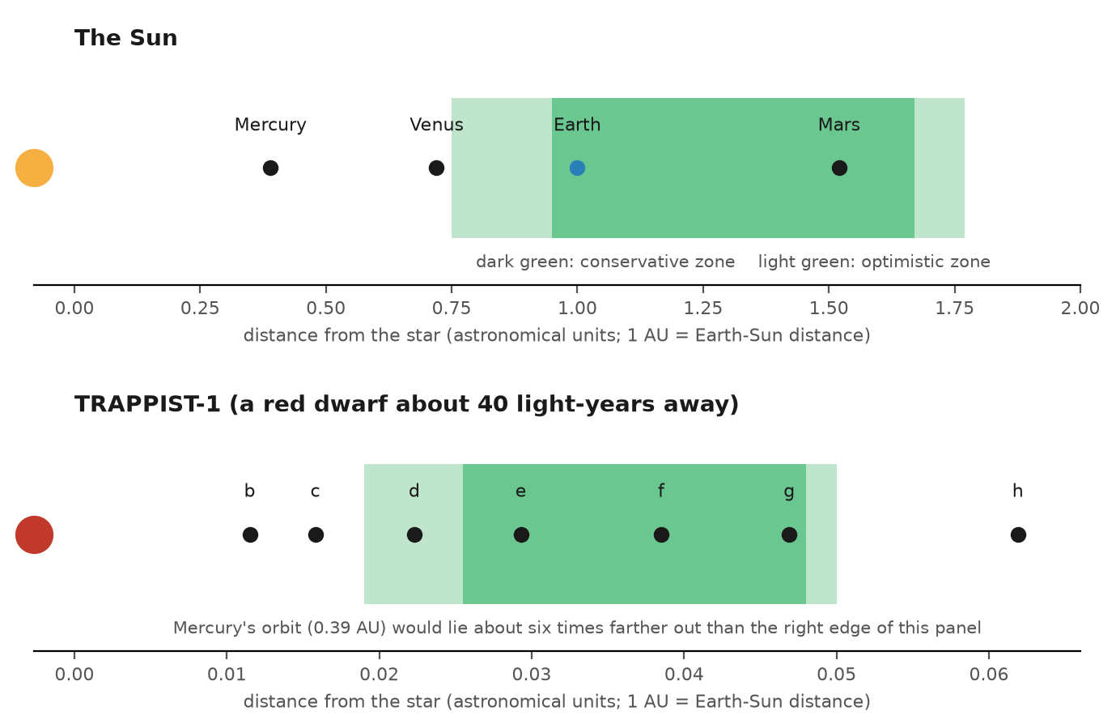
Figure 48. The habitable zone around the Sun compared with the zone around a small red dwarf like TRAPPIST-1, drawn to different scales. The red dwarf’s zone is so close to the star that it fits well inside the orbit of Mercury.
The physics behind the zone is nothing more than energy balance, which is the same physics a radiator or a greenhouse runs on. A planet warms until it radiates as much energy as it absorbs. The amount it absorbs falls with the square of the distance from the star: twice as far, a quarter of the light. That is why the zone scales with the star’s brightness. A star a hundred times brighter than the Sun has its zone about ten times farther out, because the square root of 100 is 10. A star a hundred times dimmer has its zone about ten times closer in.

What the Zone Leaves Out
The habitable zone is a useful first filter. It is not a list of planets with life, and even as a list of planets with liquid water it is rough. At least four things can push a planet out of or into habitability without changing its distance.
Atmosphere. Without an atmosphere, liquid water cannot exist on a surface at all; it boils off or freezes. The Moon sits in the middle of the Sun’s habitable zone and is dry and airless. Too much atmosphere can be just as bad. A thick envelope of hydrogen can keep a planet warm far beyond the outer edge, which is one reason the edges are fuzzy.
Mass. A small planet loses its internal heat quickly, its volcanism dies, and its atmosphere leaks away to space. Mars is about a tenth of Earth’s mass and seems to have lost its global magnetic field about four billion years ago. NASA’s MAVEN orbiter, in Mars orbit since 2014, has measured the planet’s air being stripped by the solar wind today and concluded that much of the ancient atmosphere was lost that way. Too large, and a planet tends to hold on to a deep envelope of hydrogen and helium and become a small Neptune instead of a big Earth.
Clouds and chemistry. Clouds can reflect light and cool a planet or trap heat and warm it, and the climate models disagree about how they behave near the edges of the zone.
Time. Stars brighten as they age. The Sun is about 30 percent brighter now than it was when Earth formed, which raises a puzzle of its own: early Earth should have been frozen, and it was not. Geologists call this the faint young Sun problem, and the leading explanation is a stronger greenhouse effect from more carbon dioxide and methane in the early air. Looking forward, the brightening continues at roughly ten percent per billion years. In something like a billion years, the inner edge of the Sun’s habitable zone will move outward past Earth and the oceans will start to go the way of Venus’s. Earth’s habitable lifetime is long, but it is not forever.
And then there is the most important exception of all, which is that the habitable zone is a zone for surface water. It says nothing about water under ice, heated from inside by a planet’s own warmth or by tides. Chapter 80 is about worlds far outside the Sun’s habitable zone that have more liquid water than Earth does.

Small Red Stars
Most stars are not like the Sun. About three in every four stars in the Milky Way are red dwarfs, also called M dwarfs: stars between about a tenth and a half of the Sun’s mass, and between a thousandth and a few percent of its brightness. They are dim, cool and very long-lived. A red dwarf can shine steadily for hundreds of billions or trillions of years, far longer than the universe has existed.
Their habitable zones are tiny and close in. For a small red dwarf, the zone may sit at a few percent of Earth’s distance from the Sun, and a planet there completes an orbit in days. That has two consequences that matter for life.
First, such a planet is probably tidally locked. Just as the Moon always shows Earth the same face, a close-in planet tends to end up with one side always facing its star, in permanent day, and the other in permanent night. Early models suggested the night side would freeze the atmosphere out. Later models showed that an atmosphere of reasonable thickness can carry heat around the planet and keep it from collapsing. A tidally locked world might have a habitable ring around the boundary between day and night, or a single warm ocean under the star. That is speculative but physically allowed.
Second, red dwarfs are violent when young. They flare often and strongly, and for their first billion years or so they put out much more ultraviolet and X-ray light, relative to their total output, than the Sun does. A planet in the habitable zone of a red dwarf takes that blast from close range. It may lose its atmosphere and much of its water before the star settles down. Whether the planets of red dwarfs can keep any air at all is one of the most pressing questions in the field right now, and as Chapter 81 shows, the James Webb Space Telescope has started answering it.

The Planets We Have Found
Until 1995, the number of planets known around other Sun-like stars was zero. The first was found in 1995 by Michel Mayor and Didier Queloz at the Geneva Observatory: a planet about half the mass of Jupiter orbiting the star 51 Pegasi every 4.2 days, far too close and hot for life. It earned them a share of the Nobel Prize in Physics in 2019.
By September 2026 NASA’s Exoplanet Archive listed more than 6,300 confirmed planets around other stars. Most were found by two methods.
The transit method watches a star’s brightness. If a planet’s orbit happens to be lined up edge-on from our point of view, the planet passes in front of the star once per orbit and dims it slightly. Earth passing in front of the Sun would dim it by less than one part in ten thousand. NASA’s Kepler space telescope, which stared at one patch of sky from 2009 to 2013 and then worked a series of shorter campaigns until 2018, found most of the planets known today this way. Its successor, TESS, launched in 2018, surveys the whole sky for planets around nearby, bright stars.
The radial velocity method watches a star wobble. A planet and its star both orbit their shared center of mass, so the star moves slightly toward and away from us, and its light is shifted very slightly blue and red by the Doppler effect. Earth makes the Sun wobble at about nine centimeters per second, slower than a walking tortoise. The best spectrographs today can reach below a meter per second.
From Kepler’s statistics, astronomers have tried to estimate how common rocky planets in the habitable zones of Sun-like stars are. A widely cited 2021 analysis by Steve Bryson and colleagues put the figure, for the conservative zone, somewhere between about a third and three fifths of a planet per star, with uncertainties wider than the estimates themselves. The exact number is uncertain. The order of magnitude is not. In a galaxy of a few hundred billion stars, temperate rocky planets number in the billions.
Some of them are close. Proxima Centauri, the nearest star to the Sun at about 4.2 light-years, has a planet, Proxima b, at least as massive as Earth, inside its habitable zone. It orbits a flaring red dwarf every 11.2 days and is not known to transit, so its atmosphere, if any, cannot be studied the easy way. About 40 light-years away, the red dwarf TRAPPIST-1 has seven Earth-sized planets, all of which do transit, three or four of them in or near the habitable zone. They have become the most studied small planets outside the solar system, and Chapter 81 will say what the Webb telescope has found there.

Settled, Working, Speculative
It helps to sort this chapter by confidence.
Settled. Liquid water on a surface requires a certain range of energy from a star, and that range defines a zone that scales with the star’s brightness. Rocky planets are common, and many orbit in the habitable zones of their stars.
Working. The exact edges of the zone, the role of clouds, how much atmosphere small planets keep, and whether red dwarf planets can hold air at all. The value of the fraction of stars with temperate rocky planets, to better than a factor of two or three.
Speculative. That planets in the zone usually have oceans, or plate tectonics, or a carbon thermostat like Earth’s. These are reasonable hopes, not measurements, and we have exactly one example of a planet that has all of them.

The Punchline
The habitable zone is the band around a star where a planet could keep liquid water on its surface. Earth is in the middle of the Sun’s zone, and Venus and Mars, at its edges, show what happens when the balance tips one way or the other.
The zone is a filter, not a verdict. It ignores atmosphere, mass, clouds, the age of the star, and water under ice. Within those limits it has done its job: it has told astronomers that temperate, rocky planets are not rare. There are billions in our galaxy alone, and a few of the nearest are now being looked at closely.
But the best place to test whether habitable means inhabited is not light-years away. It is the planet next door, which had water, lost it, and has been visited by more spacecraft than any other world. The next chapter goes to Mars.
↑ Back to Contents

Chapter 79: Mars — The Planet That Dried Out

Leopard Spots
On 21 July 2024, NASA’s Perseverance rover drilled into a reddish rock in an ancient river channel on Mars. The rock was about a meter long, shaped roughly like an arrowhead, and the rover team had nicknamed it Cheyava Falls, after a waterfall in the Grand Canyon. It was full of white veins of calcium sulfate, the mineral left behind when water once seeped through cracks. What had made the team stop, though, were the spots.
Scattered across the rock were pale patches a millimeter or so across, each ringed by a dark rim. The team called them leopard spots. On Earth, spots like that form in sediments when chemical reactions shift iron and other elements around, and very often the reactions are run by microbes, which gain energy by moving electrons between iron, sulfur and organic matter. Perseverance’s instruments found that the rims were rich in two minerals: vivianite, an iron phosphate, and greigite, an iron sulfide. Its spectrometer had also picked up signs of organic carbon in the rock.
The core sample was named Sapphire Canyon. It went into a sealed titanium tube inside the rover. In September 2025, after more than a year of analysis, the team published its paper in Nature. The careful phrase the team used was “potential biosignature”: a feature that could have been made by life, for which the non-biological explanations are possible but look less likely. NASA’s leadership called it the clearest sign of life yet found on Mars.
It may be. This chapter explains why the scientists themselves are being so careful, why the answer is sitting in a tube on another planet, and why, as of 2026, nobody knows when the tube will come home.

A Wet Young Mars
The first close images of Mars, from Mariner 4 in 1965, showed a cratered surface that looked like the Moon, and the disappointment was immediate. Six years later Mariner 9 went into orbit and mapped the whole planet, and the picture changed. There were enormous canyons, giant volcanoes and, most important, channels that looked as though they had been cut by flowing water.
Since then, the evidence for an ancient wet Mars has become overwhelming. The two rovers Spirit and Opportunity, which landed in January 2004, found minerals that form only in water, including hematite spheres that the team called blueberries, and sulfates that suggested the water had sometimes been acidic. Orbiters mapped clays, which form when water alters rock over long periods. River deltas, ancient lake shorelines and gravel conglomerates, rounded pebbles that can only be made by flowing streams, all point the same way.
The working picture is this. More than about 3.5 billion years ago, Mars had a thicker atmosphere and, at least at times, lakes, rivers and perhaps a northern sea. That is roughly the same period in which Chapters 3 and 4 placed the origin of life on Earth. Then Mars lost most of its air. Its global magnetic field shut down, the solar wind stripped the upper atmosphere, and the small planet, with less internal heat than Earth, lost the volcanic activity that might have replaced it. The water froze into the ground and the polar caps, or escaped to space.
If life began on Mars in that early window, it might have died out, or it might have retreated underground where liquid water could persist. Either way, the place to look for its traces is in rocks from the wet period.

Viking: The Experiment That Said Yes
The first serious attempt to look was the most ambitious. Viking 1 landed on Mars on 20 July 1976, seven years to the day after Apollo 11 landed on the Moon. Viking 2 followed on 3 September. Each carried a biology package with three experiments designed to detect living microbes in the soil.
The most famous was the Labeled Release experiment, designed by the engineer Gilbert Levin. It dripped a nutrient broth tagged with radioactive carbon-14 onto a soil sample and watched for radioactive gas. If microbes ate the nutrients, they should breathe out radioactive carbon dioxide. They seemed to. Gas came off at once. When the experiment was repeated with soil that had been heated to sterilize it, the gas did not come off. By the criteria written before launch, that was a positive result.
But another instrument, a gas chromatograph-mass spectrometer, heated the soil and looked for organic molecules, the carbon compounds any life would be made of. It found essentially none, to a sensitivity of parts per billion. Life without organic molecules made no sense. Most of the Viking team concluded that the soil contained some reactive chemical that mimicked metabolism. Levin argued for the rest of his life that Viking had found life.
The likely culprit turned up 32 years later. In 2008 NASA’s Phoenix lander, near the north pole, found perchlorate in the soil, a salt of chlorine and oxygen that is a strong oxidizer when heated. Perchlorate and the chemicals radiation makes from it can break down organic molecules, which may also explain why Viking’s oven found nothing: heating the soil with perchlorate in it would have burned up any organics before they could be measured. Most researchers now think the Labeled Release result was chemistry, not biology, and that Viking’s organics test was blinded by the same salt.
Viking taught a lesson that has shaped every mission since. You cannot design a single experiment that says “life” with certainty, because a planet’s own chemistry can fake most of what a microbe does. You need to understand the environment first.

ALH84001: The Rock on the White House Lawn
On 27 December 1984, a team collecting meteorites from the ice of the Allan Hills in Antarctica picked up a potato-sized greenish rock. It was cataloged as ALH84001 and, about a decade later, identified as a piece of Mars: its trapped gases matched the Martian atmosphere measured by Viking. It had crystallized about four billion years ago, was knocked off Mars by an impact about 17 million years ago, and fell on Antarctica about 13,000 years ago.
On 7 August 1996, a team led by David McKay at NASA’s Johnson Space Center announced in Science that the rock contained possible evidence of ancient Martian life. There were tiny globules of carbonate minerals, organic molecules called polycyclic aromatic hydrocarbons, chains of magnetite crystals of the sort some Earth bacteria make, and, in electron microscope images, worm-shaped objects a few tens of nanometers long. President Bill Clinton spoke about the rock on the South Lawn of the White House.
Each piece of evidence was challenged, and over the next decades each found a plausible non-biological explanation. The worm shapes are far smaller than any known cell, too small to hold the machinery Chapter 38 described. The magnetite and the carbonate can form without life. In 2022, a study led by Andrew Steele showed that the rock’s organic molecules most likely formed when hot water reacted with minerals, a purely geological process. Today very few researchers think ALH84001 contains fossils.
But it changed the field. It helped create NASA’s astrobiology program, and it showed that pieces of Mars do reach Earth. About 400 Martian meteorites are now known. That fact will matter when Chapter 84 asks whether life could have traveled between the planets.

Curiosity: The Lake That Could Have Been Lived In
In August 2012 NASA landed Curiosity, a rover the size of a small car, in Gale Crater, a 154-kilometer basin with a mountain of layered sediment in the middle. Its job was not to look for life but to find out whether Mars had ever been able to support it.
Within months it had the answer. In mudstone at a site called Yellowknife Bay, it drilled out powder that showed clays, low salinity, a neutral pH, and a mix of chemicals in different states of oxidation, the redox gradient that Chapter 77 described as an energy source. The team announced in 2013 that Gale Crater had once held a lake that microbes like some on Earth could have lived in. Habitable, in the strict sense: the first three boxes ticked.
Curiosity has since found more. In 2018 it reported organic molecules, including sulfur-bearing ring compounds, preserved in mudstone about three billion years old. In 2025 its team reported the largest organic molecules yet found on Mars: decane, undecane and dodecane, chains of 10 to 12 carbon atoms, in a rock sample drilled years earlier and stored on board. On Earth, chains like that are often fragments of fatty acids, which are made by life, although they can also be made without it. And Curiosity has measured methane in the air of Gale Crater, with a low background that seems to rise and fall with the seasons and occasional spikes. The European Space Agency’s Trace Gas Orbiter, which can measure methane from above with great sensitivity, has seen almost none high in the atmosphere. Where the methane comes from, and where it goes, is one of the open puzzles of Mars.
None of this is evidence of life. All of it is consistent with a planet that once had the conditions for it, and that preserves organic molecules in its rocks better than anyone expected.

Perseverance and the Tubes
Perseverance landed on 18 February 2021 in Jezero Crater, a basin 45 kilometers wide that once held a lake fed by a river. The river’s delta, a fan of layered sediment, is still visible from orbit. River deltas on Earth are among the best places to preserve traces of microbial life, because they bury fine sediment quickly.
The rover was designed for a two-part plan. It would study the rocks itself, and it would collect the most promising samples into sealed tubes for a later mission to bring back to Earth, where laboratories with equipment far too large to send to Mars could examine them. By 2026 it had filled 33 tubes, including 27 rock cores, along with samples of soil and atmosphere and empty “witness” tubes that record any contamination the rover carried from Earth. Ten tubes were set down on the crater floor in a backup depot in late 2022 and early 2023, in case the rover failed.
Sapphire Canyon, the core from Cheyava Falls, is one of the tubes still on board. Here is why its scientists say “potential.” The minerals in the leopard spots, vivianite and greigite, form on Earth mainly when microbes reduce iron and sulfate while consuming organic matter. They can also form without life, but usually at higher temperatures, and the rocks of the Bright Angel formation, where Cheyava Falls sits, show no sign of having been heated. So the biological explanation fits better. But “fits better” is not “proven,” and a mudstone on Mars cannot be put under the microscopes, isotope instruments and repeated independent tests that a claim of extraterrestrial life demands. That needs the rock on Earth.

The Return That Did Not Happen
The plan to bring the tubes home was called Mars Sample Return, a joint program of NASA and the European Space Agency. It required a lander, a small rocket to launch the samples into Mars orbit, and an orbiter to catch them and fly them back. It would have been the first launch from the surface of another planet.
It was also expensive. In 2023 an independent review estimated its cost at 8 to 11 billion dollars and said the original schedule had no realistic chance of being met. NASA spent 2024 and 2025 looking for cheaper designs and narrowed the options to two, estimated at roughly 6 to 8 billion dollars each. In January 2026, Congress passed NASA’s budget for fiscal year 2026 without funding the program. The money was redirected to a broader line for future Mars missions. Mars Sample Return, as designed, is effectively canceled.
That leaves the tubes waiting. A different American return mission may yet be designed. China, meanwhile, plans a mission of its own, Tianwen-3, to launch in late 2028 and bring Martian samples to Earth around 2031. It would land at a site of China’s choosing, not at Jezero. And the European rover Rosalind Franklin, delayed for years and now planned for launch in late 2028 and landing in 2030, carries a drill designed to reach two meters below the surface, deep enough to get beneath the layer where radiation and perchlorate destroy organic molecules.

What Would Count
Suppose a sample does come back. What would convince scientists that something in it was alive once?
No single test. The standard that has emerged since ALH84001 is a combination: shapes that look like cells or microbial mats, at sizes that make sense; chemistry that matches what cells do, such as minerals made by microbial redox reactions; organic molecules with patterns that chemistry alone tends not to produce, such as chains of a preferred length or molecules of one handedness, a point Chapter 84 returns to; and isotope ratios showing that light carbon atoms were preferred over heavy ones, a fingerprint of enzymes. Each line can be faked by geology. All of them together, in the same place, would be hard to fake.
NASA has even written down a seven-step scale for life detection, from “a signal is detected” to “independent follow-up confirms the result is biological.” Cheyava Falls, on that scale, is in the early steps: a signal detected, contamination largely ruled out, non-biological explanations considered but not excluded.

The Punchline
Mars was wet when Earth’s life was young, and then it dried out and lost its air. Viking’s experiment seemed to say yes and was most likely fooled by perchlorate. ALH84001’s fossils most likely turned out to be minerals. Curiosity showed that Gale Crater once held a habitable lake and that Martian rocks keep organic molecules for billions of years.
Perseverance has found, in a rock called Cheyava Falls, the best candidate yet: chemistry that on Earth is usually made by microbes, in rocks that were never heated. It is a potential biosignature, not a discovery. The core that could settle it is sealed in a tube on Mars, and the mission to bring it home has lost its funding.
If Mars disappoints, there is another kind of place to look, one that the habitable zone of Chapter 78 leaves out entirely. Some of the largest bodies of liquid water in the solar system are hundreds of millions of kilometers past Mars, under ice. They are the subject of the next chapter.
↑ Back to Contents

Chapter 80: Oceans Under Ice — Europa, Enceladus and Titan

Seventeen Kilometers a Second
On 9 October 2008, NASA’s Cassini spacecraft, which had been orbiting Saturn for four years, dived toward a small white moon called Enceladus and flew straight through a fountain of ice coming out of its south pole. It passed about 25 kilometers above the surface at 17.7 kilometers per second, about twenty times faster than a rifle bullet. In the few seconds it spent inside the spray, an instrument called the Cosmic Dust Analyzer caught individual ice grains. Each one hit a metal plate so hard that it vaporized into a puff of charged fragments, and the instrument weighed the fragments.
Enceladus is only about 500 kilometers across. It is about as wide as Great Britain. At Saturn’s distance, sunlight is about a hundredth of what Earth gets, and the moon’s surface is about minus 200 degrees Celsius. By the habitable zone of Chapter 78, it should be dead and frozen solid. Yet it was spraying water into space.
Seventeen years later, in October 2025, a team led by Nozair Khawaja published its analysis of those grains. They were freshly ejected, only minutes old when they hit Cassini, and they carried organic molecules that had not been seen before in Enceladus’s spray: esters, ethers, and chains and rings of carbon, with hints of nitrogen and oxygen built in. These are the kinds of compounds that form in warm water reacting with rock. Two years earlier another team had found phosphates in the moon’s ice. Put together with what Cassini had already learned, they described a small world with a salty ocean, a source of chemical energy, organic chemistry and phosphorus. Three boxes ticked, and the third one ticked more firmly than anywhere else outside Earth.
This chapter is about how worlds far outside any habitable zone can have liquid water, and the three moons that are now the main targets of the search.

Heat From Squeezing
The habitable zone assumes that a planet’s warmth comes from its star. For moons of giant planets there is a second source: tides.
A moon in a slightly elongated orbit is pulled harder by its planet when it is close and less hard when it is far. The changing pull stretches and relaxes the moon’s interior every orbit, like a rubber ball squeezed in a hand. The flexing turns orbital energy into heat. If neighboring moons keep tugging the orbit so that it never becomes perfectly circular, the heating never stops.
The idea earned one of the best-timed predictions in planetary science. In March 1979, three researchers, Stanton Peale, Patrick Cassen and Ray Reynolds, published a paper arguing that tidal heating should melt the interior of Jupiter’s moon Io and might make it volcanically active. The paper appeared three days before Voyager 1 flew past Io. Voyager’s images showed eight erupting volcanoes. Io is now known to be the most volcanic body in the solar system.
Farther out from Jupiter, the same heating is gentler. It is not enough to melt rock, but it can be enough to keep water liquid beneath a shell of ice. Ice is a good insulator, and it floats, as Chapter 77 pointed out, so a frozen surface protects the water below it. Add the heat of radioactive elements decaying in the rocky core, and several moons of Jupiter and Saturn appear to hold oceans that have been liquid for billions of years.
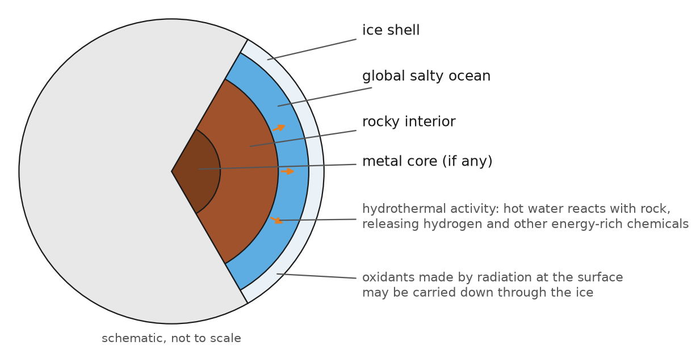
Figure 49. A schematic cross-section of an icy ocean moon such as Europa or Enceladus: a shell of ice over a global salty ocean, in contact with a rocky interior where hot water may react with rock at the seafloor. Thicknesses are illustrative, not to scale.

Europa: More Water Than Earth
Europa is slightly smaller than our Moon. Its surface is bright, young ice crossed by long reddish cracks, with very few craters, which means something keeps resurfacing it. The idea that an ocean lies beneath was proposed in the late 1970s and strengthened by Voyager images, but the decisive evidence came from NASA’s Galileo spacecraft, which orbited Jupiter from 1995 to 2003.
Galileo carried a magnetometer. As Europa moved through Jupiter’s powerful, tilted magnetic field, the magnetometer detected a second, induced field coming from Europa itself, which flipped as Jupiter’s field changed direction. That is what happens when a changing magnetic field passes through an electrical conductor. Ice does not conduct well. Salty water does. In 2000 the Galileo team, led by Margaret Kivelson, reported that the best explanation was a global layer of salt water under the ice.
The current picture is an ice shell perhaps 15 to 25 kilometers thick, though estimates range from a few kilometers to more, over an ocean perhaps 60 to 150 kilometers deep. That ocean would hold about twice as much water as all of Earth’s oceans combined. Its floor is rock, which is important. Water in contact with rock can react with it, as it does at Earth’s hydrothermal vents, releasing hydrogen and other chemicals that hold energy.
The surface adds another energy source. Jupiter’s radiation belts bombard Europa’s ice and split water molecules, producing oxygen and hydrogen peroxide, which are oxidants. If the ice shell slowly overturns, it could carry these oxidants down to the ocean, where they could meet the reduced chemicals coming up from the rock. That is the redox gradient of Chapter 77, built across a whole world. In 2023 the James Webb Space Telescope found carbon dioxide concentrated in a region of disrupted terrain called Tarr Regio, in a form that suggests the carbon came up from inside. Sodium chloride, ordinary table salt, had already been identified on the surface.
When Galileo’s fuel ran low in 2003, NASA deliberately crashed it into Jupiter. The reason was planetary protection: the spacecraft might have carried Earth microbes, and an accidental crash on Europa could contaminate the ocean everyone wanted to explore.

Enceladus: The Ocean That Sprays Itself Into Space
Enceladus was a surprise. Nobody expected a moon that small to be active. In 2005, Cassini’s magnetometer noticed that Saturn’s magnetic field was being disturbed near the moon’s south pole, and later that year cameras showed jets of ice spraying from four long, warm fractures the team named the tiger stripes. More than a hundred individual jets have since been mapped. Some of the spray falls back as snow. The rest feeds a faint ring around Saturn, the E ring.
Over the following decade Cassini built up the case, one measurement at a time.
The spray is salty water, not just ice, and its grains include sodium salts that mean the water has been in contact with rock.
In 2015, tiny grains of silica, a few nanometers across, were traced to the moon. On Earth, grains like that form when water hotter than about 90 degrees Celsius dissolves rock and then cools. The likely explanation is hydrothermal activity on Enceladus’s seafloor.
Also in 2015, careful measurement of how the moon wobbles as it orbits showed that its ice shell is not attached to its core. The ocean is global.
In 2017, Cassini reported molecular hydrogen in the plume. On Earth, the reaction between hydrogen and carbon dioxide to make methane is one of the oldest ways microbes make a living. The hydrogen shows that a chemical energy source of that kind exists in Enceladus’s ocean today.
In 2023, a team led by Frank Postberg found sodium phosphates in ice grains of the E ring, at concentrations at least a hundred times higher than in Earth’s oceans. Phosphorus, the element Chapter 77 marked as the possible bottleneck, is there.
And the 2025 work on fresh grains added more complex organic molecules, the kind that could be steps on the road to biochemistry, or simply the products of hot water on rock.
Cassini itself was destroyed in September 2017, steered into Saturn for the same planetary-protection reason as Galileo. Its instruments were never designed to detect life. A future mission, which the European Space Agency has chosen as the theme of one of its large missions in the 2040s, would fly through the plume, or land near the tiger stripes, with instruments that can tell biology from chemistry. The appeal is obvious. On Europa you have to get through the ice. Enceladus sends its ocean up to you.

Titan: The Strangest Familiar World
Titan, Saturn’s largest moon, is bigger than the planet Mercury and is the only moon in the solar system with a thick atmosphere. Its air is mostly nitrogen, like ours, and about one and a half times as dense at the surface. But at minus 179 degrees, water is rock-hard ice. The liquid on Titan is methane and ethane, which rain from the clouds, carve river channels and fill lakes and seas near the poles. The largest, Kraken Mare, is bigger than the Caspian Sea.
On 14 January 2005, the European Huygens probe parachuted through Titan’s haze and landed on a damp plain strewn with rounded pebbles of water ice. It sent back data for about 72 minutes from the surface before Cassini, its relay, sank below the horizon. It remains the most distant landing ever made.
Titan’s atmosphere is a vast organic chemistry factory. Sunlight and particles from Saturn’s magnetic field break up methane and nitrogen high in the air, and the fragments recombine into larger molecules that drift down as an orange haze and coat the surface with sand-like organic grains. The moon may also have a water ocean deep beneath its ice crust: Cassini measured the way Titan flexes under Saturn’s tides, and the flexing is too large for a solid interior.
That gives Titan two very different chances. One is life as we know it, in the buried water ocean, which is probably hard to reach. The other is life as we do not know it, in the methane lakes on the surface, using some chemistry that works in a nonpolar solvent at extreme cold. In 2015, chemists proposed a kind of membrane, nicknamed an azotosome, made from small nitrogen-bearing molecules, that might work in liquid methane. In 2017 the ALMA radio telescope detected one candidate building block, acrylonitrile, in Titan’s atmosphere. Later calculations, in 2020, suggested that such membranes would not actually assemble under Titan’s conditions. The idea of methane life is speculative, and it remains unsupported by any evidence. But Titan is the one place where it could be tested.
NASA’s Dragonfly mission is designed to do some of that testing. Dragonfly is a rotorcraft, a nuclear-powered drone about the size of a car with eight rotors, which can fly comfortably in Titan’s dense air and low gravity. It is scheduled to launch in July 2028 and arrive in 2034, landing near a crater called Selk, where an impact may once have melted water ice and mixed it with surface organics. It will fly from site to site, sampling surface material and analyzing its chemistry. It is not a life detector. It is a prebiotic chemistry laboratory, sent to the best natural experiment in the solar system on what happens when organic molecules and water meet without life getting there first.

Who Is Going
As of 2026, three missions are on their way to the outer solar system, or soon will be.
Europa Clipper launched on 14 October 2024. After a flyby of Mars in 2025 and one of Earth in December 2026, it is scheduled to enter orbit around Jupiter in April 2030 and then make 49 close flybys of Europa, some as low as 25 kilometers. It carries ice-penetrating radar to measure the shell, a magnetometer to measure the ocean, and instruments to analyze dust and gas it passes through. Its question is whether Europa is habitable, not whether it is inhabited.
The European Space Agency’s JUICE mission launched in April 2023 and will arrive at Jupiter in 2031. It will fly past Europa twice and then go into orbit around Ganymede, the largest moon in the solar system, which is also thought to have a buried ocean, probably sandwiched between layers of ice.
Dragonfly is being built for its 2028 launch to Titan.
None of them can detect life directly. All of them will narrow down where a later mission should look, and what instruments it should carry.

The Punchline
The habitable zone was drawn for water on a surface. Some of the largest bodies of liquid water in the solar system are under ice, kept warm by tides and radioactive decay, around planets far outside the Sun’s zone.
Europa probably has twice as much water as Earth’s oceans, in contact with rock, with oxidants arriving from above. Enceladus sprays its ocean into space, and Cassini found in the spray salt, hydrogen, silica from hot water, phosphates and complex organic molecules. Titan has organic chemistry on a planetary scale, methane lakes that might host a chemistry unlike ours, and possibly a water ocean beneath.
Our own solar system may therefore hold not one second chance for life but several. To look farther, around other stars, we cannot send spacecraft. We can only read starlight. The next chapter explains how a planet’s air can be read from light-years away, and what happened the first time someone claimed to have read a sign of life in it.
↑ Back to Contents

Chapter 81: Reading Alien Air — Starlight, Biosignatures and the K2-18 b Affair

Carl Sagan Looks for Life on Earth
On 8 December 1990, NASA’s Galileo spacecraft, on its way to Jupiter, swung past Earth to borrow some of its orbital speed. The astronomer Carl Sagan saw an opportunity in the maneuver. Here was a robotic probe carrying the kind of instruments that might one day visit an unknown world. Why not point them at Earth and ask, without cheating, whether they could tell that it was inhabited?
In 1993 Sagan and his colleagues published the answer in Nature, under the title “A search for life on Earth from the Galileo spacecraft.” Galileo saw an atmosphere rich in oxygen. It saw methane, at a concentration enormously higher than it should be in air full of oxygen, since the two react and destroy each other; something had to be replenishing the methane fast. It saw a sharp rise in reflected light just beyond the red end of the visible spectrum over land, which is the signature of chlorophyll-bearing plants. And it picked up narrowband radio transmissions, modulated in ways no natural source produces. The team’s conclusion: life was likely, and some of it was probably technological.
The exercise did two things. It showed that a planet can announce its biology in its light. And it showed that the strongest evidence was not any single gas but a combination that could not last without something keeping it going. This chapter is about how astronomers are trying to repeat Sagan’s test on planets around other stars, where the probe is replaced by a telescope trillions of kilometers away.

Starlight Through a Planet’s Air
The trick is the transit, described in Chapter 78. When a planet passes in front of its star, most of the starlight that would have reached us is blocked by the solid planet. But a thin ring of light passes through the planet’s atmosphere on the way. Molecules in that air absorb light at particular wavelengths, fingerprints set by the quantum energy levels of molecules, the same physics the earlier volumes of this series use to read the light of stars. At those wavelengths the planet looks very slightly larger, because its atmosphere is opaque there.
So astronomers measure the depth of the transit, the dip in starlight, at many wavelengths at once. A plot of transit depth against wavelength is called a transmission spectrum. Bumps in it are molecules.
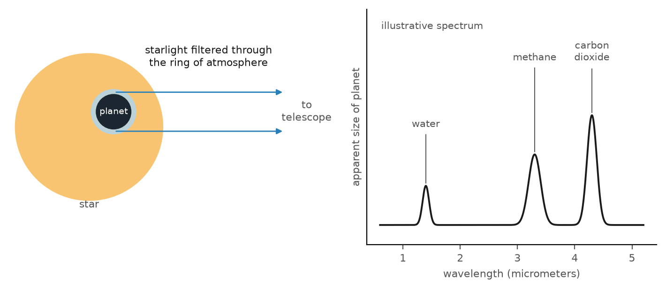
Figure 50. The principle of transmission spectroscopy. During a transit, a thin ring of starlight filters through the planet’s atmosphere. Wavelengths that the atmosphere’s molecules absorb are dimmed slightly more, so the planet appears larger at those wavelengths, producing bumps in the measured spectrum.
The signals are tiny. For an Earth-sized planet in front of a Sun-like star, the extra dimming from the atmosphere would be less than a part per million. The method works best for planets with puffy atmospheres around small stars, because the planet blocks a larger fraction of the star. That is one reason so much attention goes to red dwarfs.
The first atmosphere of a planet outside the solar system was detected this way in 2001, when the Hubble Space Telescope saw sodium in the air of a hot Jupiter called HD 209458 b. The real change came with the James Webb Space Telescope, launched on 25 December 2021, with a 6.5-meter gold-coated mirror and instruments built for infrared light, where many important molecules have their strongest fingerprints. In 2022, in its first months of science, Webb found carbon dioxide in the atmosphere of a hot giant planet called WASP-39 b, with a clarity no previous telescope had come close to.

What Counts as a Biosignature
A biosignature is anything that is best explained by life. For a planet’s air, that means gases, or combinations of gases, that living things make and geology does not, or not in the same amounts.
Oxygen is the obvious candidate. Earth’s air is about 21 percent oxygen only because photosynthesis keeps it topped up, as Chapter 4 explained in describing the first pollution disaster. Without life, oxygen reacts with rock and volcanic gases and disappears in a few million years. Ozone, which forms from oxygen in sunlight, is easier to detect at some wavelengths and serves as a proxy.
But oxygen alone can be faked. On a planet that loses its water, ultraviolet light from the star splits water molecules, the hydrogen escapes, and the oxygen is left behind. This false positive is expected to be most likely around the violent young red dwarfs of Chapter 78, which is exactly where the planets easiest to observe are.
The strongest biosignature is a combination out of balance. The chemist James Lovelock argued this in 1965, while working with NASA on how to detect life on Mars. A lifeless planet’s atmosphere drifts toward chemical equilibrium, a state in which nothing reacts any more. Life holds an atmosphere away from equilibrium. Oxygen and methane together, which Galileo saw on Earth, are the textbook example: they destroy each other, so if both are present in quantity, something must be producing both all the time.
Other candidates include nitrous oxide, made by soil microbes, and a family of sulfur compounds made on Earth almost only by marine life. The most famous of these is dimethyl sulfide, or DMS, the molecule that gives the seaside its smell. It is produced mostly by plankton. Remember that molecule.

What Webb Has Found So Far
Webb’s most important result on small planets so far is a negative one, which is useful precisely because it narrows the search.
TRAPPIST-1, the red dwarf with seven Earth-sized planets, was an early target. In 2023, measurements of the heat glowing from the innermost planet, TRAPPIST-1 b, showed a dayside at about 230 degrees Celsius, consistent with bare rock and no thick atmosphere to carry heat around. The second planet, TRAPPIST-1 c, which some had hoped might be a Venus-like world with a thick carbon dioxide atmosphere, turned out not to have one either.
The planet in the middle of the habitable zone, TRAPPIST-1 e, is harder. Its first four transits, analyzed in 2025, ruled out a thick atmosphere dominated by hydrogen and made thick carbon dioxide atmospheres like those of Venus or ancient Mars unlikely. They could not distinguish bare rock from a nitrogen-rich atmosphere with traces of other gases, like Earth’s. A longer program of transits is running, and additional observations in 2026 have not changed the picture. The biggest obstacle is the star itself. Red dwarfs are covered in dark spots and bright patches, and those can imprint false features on a transmission spectrum. Separating star from planet is now one of the main jobs of the field.
Other results have been more encouraging. In 2024, Webb detected what appears to be a genuine secondary atmosphere, probably of carbon dioxide or carbon monoxide, around 55 Cancri e, a scorching rocky planet covered in molten lava. It is no home for life, but it showed that a rocky planet can hold on to an atmosphere close to its star. And measurements of LHS 1140 b, a temperate planet about 49 light-years away, have offered tentative hints of a nitrogen-rich atmosphere that need confirmation.

The K2-18b Affair
Then there is the story that made headlines around the world.
K2-18 b orbits a red dwarf about 124 light-years away in the constellation Leo. It was found in 2015 by Kepler’s second mission. It is about 8.6 times the mass of Earth and about 2.6 times its diameter, too big to be a rocky planet like ours and too small to be a gas giant: a type astronomers call a sub-Neptune, which has no counterpart in our solar system. It orbits in its star’s habitable zone.
In 2021, Nikku Madhusudhan and colleagues at the University of Cambridge proposed that some sub-Neptunes could be what they named hycean worlds: planets with a global ocean of water under a hydrogen-rich atmosphere. In September 2023, Webb observations analyzed by Madhusudhan’s team detected methane and carbon dioxide in K2-18 b’s atmosphere, with no ammonia, a combination they said fitted a hycean world. The same paper reported a weak hint of DMS.
In April 2025 the team published new observations, with a different Webb instrument at longer wavelengths, and reported a signal they attributed to DMS or its close relative dimethyl disulfide, at a statistical significance of about three sigma. They described it as the strongest evidence yet for possible biological activity beyond the solar system, while saying that more data were needed. The story went around the world.
A word about sigma. It measures how likely a signal is to be a fluke of random noise, assuming the analysis is otherwise correct. Three sigma means roughly a three-in-a-thousand chance of a fluke. That sounds convincing, but particle physicists, who have been burned many times, require five sigma, less than one chance in a million, before calling something a discovery. And sigma says nothing about systematic errors: a wrong model of the star, the instrument or the atmosphere can produce a three-sigma signal that is entirely false.
Within months, independent teams reanalyzed the same data. They used different methods to process the raw images, different models of the atmosphere, and different lists of molecules that might be present. One study, published in 2025 in the Astronomical Journal, found that most of its analyses did not favor DMS at all, and its title said the claim did not meet the standards of evidence. A joint analysis of all the available Webb data, across the whole wavelength range, found no significant evidence for DMS or its relative, and estimated that about 25 more transits with the longer-wavelength instrument would be needed to settle the question. Other teams pointed out that simple hydrocarbons such as ethylene and propyne, which can be made without life, have similar fingerprints in the same part of the spectrum, and a 2026 analysis in Nature Astronomy found that many such gases fit the noisy mid-infrared data as well as DMS does, or better. How the raw mid-infrared data were binned turned out to matter as much as which molecules were tried.
Meanwhile, two other facts weakened the biological reading. In 2024, DMS was found in the gas around comet 67P, measured years earlier by the European Rosetta mission, and it has also been found in interstellar space. So DMS can be made without life. And several modeling groups showed that K2-18 b’s observed gases can be explained without any ocean, either by a deep hydrogen-rich atmosphere with no surface at all, or by a planet with a magma ocean under its air.
As of 2026, the consensus is that K2-18 b has methane and carbon dioxide in its atmosphere, that it is not known whether it has an ocean, and that DMS has not been detected. Madhusudhan’s team continues to collect data. This is how science is supposed to work. A bold claim was made in public with its uncertainties stated, other researchers tested it with the same data, and the claim did not hold up at the level needed. Nobody behaved badly. But it is a preview of how the first real biosignature claim will go, and a reason to expect that it will take years, not a press conference, to settle.

Bigger Mirrors
The next generation of instruments is being built to do what Webb can only start.
The European Southern Observatory’s Extremely Large Telescope, under construction on a mountaintop in Chile’s Atacama Desert, has a main mirror 39 meters across made of 798 hexagonal segments. Its first light is now planned for March 2029, with science beginning in late 2030. It will be able to study the reflected light of some nearby rocky planets directly, including perhaps Proxima b.
The European Space Agency’s Ariel mission, due to launch in 2029, will survey the atmospheres of about a thousand known planets, most of them large and hot, to learn how planetary atmospheres work in general.
NASA’s Nancy Grace Roman Space Telescope, launched on 30 August 2026, is mainly a cosmology mission, but it carries a coronagraph, an instrument that blocks a star’s light to reveal faint planets beside it, as a technology test.
The big prize is a telescope designed from the start to find life. NASA calls it the Habitable Worlds Observatory: a space telescope with a mirror perhaps six to eight meters across and a coronagraph good enough to suppress a Sun-like star’s light by a factor of ten billion, so that an Earth-like planet next to it can be seen directly. Its goal is to find and image about 25 potentially Earth-like planets around nearby Sun-like stars and take spectra of their reflected light, looking for oxygen, water, methane and the Lovelock imbalance. In 2026 it is still a concept in technology development, aimed at the 2040s.

The Punchline
A planet’s atmosphere can be read from light-years away. During a transit, starlight filtered through the planet’s air carries the fingerprints of its molecules. Webb has made this routine for large planets and has begun to do it for small ones.
The best biosignature is a combination of gases that should destroy each other but persists, as oxygen and methane do on Earth, which Carl Sagan’s Galileo test detected in 1990. Single gases, including oxygen, can be faked by geology and stellar light.
So far, Webb has found that the inner TRAPPIST-1 planets are probably bare rock and that TRAPPIST-1 e has no thick hydrogen or carbon dioxide atmosphere. The claimed detection of DMS on K2-18 b has not survived independent analysis. No biosignature has been confirmed anywhere. The telescopes able to find one around a Sun-like star are being built.
Gases are one way a planet can announce life. There is another, which only works if the life has learned to build transmitters. The next chapter is about listening.
↑ Back to Contents

Chapter 82: Listening for Neighbors — SETI and the Search for Technology

Wow!
A few days after 15 August 1977, an astronomer named Jerry Ehman sat at his kitchen table in Ohio with a stack of computer printouts. He was a volunteer for the Big Ear, a radio telescope run by Ohio State University in a field near Delaware, Ohio. Big Ear did not move. It scanned the sky as Earth turned, and a computer printed the strength of the signal in each of 50 radio channels as a column of numbers and letters, with the letters standing for higher values.
Most of the printout was ones and spaces: noise. In one column, Ehman found a short string, 6EQUJ5, rising and then falling. It meant a signal had swept through the telescope’s beam exactly as a point in the sky should, over 72 seconds, in a single narrow channel, at a strength about thirty times the background. He circled it in red pen and wrote in the margin: “Wow!”
The channel was close to 1420 megahertz, the frequency at which cold hydrogen atoms emit radio waves, which is exactly where some astronomers had argued, eighteen years earlier, that a civilization trying to be heard would broadcast. Big Ear and many other telescopes went back to the spot, in the constellation Sagittarius, dozens of times over the following decades. The signal never repeated.
In 2025, a team that re-examined the Wow! signal using archived data from the Arecibo Observatory proposed that it was most likely natural: a cold cloud of hydrogen, briefly brightened by a burst from some distant object behind it. The case is not closed. But that has been the pattern of every promising signal in sixty years of listening. This chapter explains what the search is, what it has covered, and why silence so far tells us much less than it seems to.

A Frequency Everyone Knows
The modern search began with a two-page paper. In September 1959, two physicists at Cornell University, Giuseppe Cocconi and Philip Morrison, published “Searching for Interstellar Communications” in Nature. Their argument was short. Radio waves cross interstellar space easily. The galaxy is quiet at radio wavelengths in a band between the noise of electrons in our own galaxy and the noise of Earth’s atmosphere. And any civilization that knows physics knows the 1420-megahertz line of hydrogen, the most common element. If they wanted to be found, that was where they would call. “The probability of success is difficult to estimate,” Cocconi and Morrison wrote, “but if we never search, the chance of success is zero.”
The next spring, a young radio astronomer named Frank Drake, working independently, pointed the 85-foot telescope of the National Radio Astronomy Observatory at Green Bank, West Virginia, at two nearby Sun-like stars, Tau Ceti and Epsilon Eridani. He called it Project Ozma, after the princess of the land of Oz. He listened for about 150 hours between April and July 1960 and heard nothing but one false alarm from a secret military aircraft. In November 1961, Drake hosted a small meeting at Green Bank to discuss the subject. To organize the agenda, he wrote an equation on the blackboard. Chapter 83 will look at it.
The field took a name: SETI, the search for extraterrestrial intelligence. The band between the hydrogen line at 1420 megahertz and the hydroxyl lines near 1662 megahertz was nicknamed the water hole, since hydrogen and hydroxyl together make water. It seemed a natural meeting place for water-based life.

Sixty Years of Listening
The search has been run on a shoestring for most of its history. NASA began a formal search, the High Resolution Microwave Survey, on 12 October 1992, the five-hundredth anniversary of Columbus’s landing in the Americas. Congress canceled it within a year, after a senator dismissed it as “the Great Martian Chase.” Since then most SETI has been privately funded.
The SETI Institute, founded in California in 1984, ran Project Phoenix, which from 1995 to 2004 examined about 800 nearby stars with some of the world’s largest radio telescopes, and found nothing. With money from the Microsoft co-founder Paul Allen, it built the Allen Telescope Array in northern California, which began observing in 2007. From 1999 to 2020 a project called SETI@home let millions of volunteers lend their home computers to sift data from Arecibo, then the largest single-dish radio telescope in the world. In 1974 Arecibo had also sent the most famous deliberate message from Earth, a picture of 1,679 bits aimed at a star cluster 25,000 light-years away. The telescope collapsed in December 2020.
The largest search in history began on 20 July 2015, when the investor Yuri Milner and the physicist Stephen Hawking announced Breakthrough Listen, a 100-million-dollar, ten-year program. It bought time on the 100-meter Green Bank Telescope in West Virginia and the 64-meter Parkes telescope in Australia, later added the MeerKAT array in South Africa, and runs an optical search for laser pulses as well. Its computers can examine billions of narrow radio channels at once.
In 2020 Breakthrough Listen reported on its survey of 1,327 nearby stars: no signals. In 2019, while observing Proxima Centauri, the nearest star, it recorded a narrow signal at 982 megahertz that appeared only when the telescope was pointed at the star. It was named BLC1, for Breakthrough Listen Candidate 1. A careful study published in 2021 traced it to interference from electronic equipment on Earth. In 2025 the project listened to the interstellar comet 3I/ATLAS as it passed through the solar system, after some speculation that it might be artificial, and heard nothing.

How Big Is the Haystack?
Sixty years of silence sounds like strong evidence that nobody is there. It is not, and the reason is worth understanding.
A search has to choose where to point, at what frequencies to listen, how narrow a signal to look for, how faint a signal it can detect, and for how long. Each choice cuts down the volume of possibilities it covers. In 2018, the astronomer Jason Wright and two students calculated how much of this many-dimensional haystack all the radio searches to date had examined. Their answer was a small fraction: they compared it to looking for fish by examining a hot tub’s worth of water out of all of Earth’s oceans. Later searches have added more, but the comparison still holds in spirit.
The detection limits matter too. Earth’s own unintentional radio leakage, from television and radar, would be very hard to detect at the distance of even the nearest stars with present instruments. Most searches could detect only a strong beacon deliberately aimed at us, or an extremely powerful transmitter. A civilization exactly like ours, a few hundred light-years away, would probably go unheard.
So the honest summary is: we have ruled out very loud, persistent beacons pointed at us from a few thousand of the nearest stars, at the frequencies we chose. That is not nothing. But it is a small corner of the possibilities.

Little Green Men and Natural Lighthouses
Every candidate signal so far has turned out to be one of two things: interference from our own technology, or a natural object we had not understood.
The classic natural example is from 1967. At Cambridge, a graduate student named Jocelyn Bell noticed a tiny bit of “scruff” on the paper chart recording of a new radio telescope. It turned out to be a train of pulses arriving every 1.34 seconds, so regular that she and her supervisor half-seriously labeled the source LGM-1, for Little Green Men. Within months she had found more of them in other parts of the sky, which made aliens much less likely. They were pulsars: spinning neutron stars, the collapsed cores of exploded stars, sweeping a beam of radio waves past Earth like a lighthouse. The discovery won a Nobel Prize in 1974, although not for Bell.
The lesson has been learned many times since. The universe is full of natural processes that produce surprising signals, and most of them have been found by people who were looking for something else. A SETI claim has to rule out every natural explanation and every possible human source. That is very hard to do.

Beyond Radio: Technosignatures
In recent years the field has broadened its name and its methods. Instead of “intelligence,” which is hard to define and impossible to observe directly, astronomers now speak of technosignatures: any observable sign of technology.
Lasers are one. A pulsed laser, focused by a telescope, could outshine its own star for a billionth of a second. Optical SETI searches for such flashes.
Waste heat is another. In 1960 the physicist Freeman Dyson pointed out in Science that a civilization using a large fraction of its star’s energy would have to radiate the waste as infrared heat. A star wrapped in energy-collecting structures, later called a Dyson sphere, would look dimmer in visible light and brighter in infrared than it should. Searches of infrared sky surveys have looked for such stars. In 2024, a project called Hephaistos reported seven red dwarfs with puzzling infrared excesses. Within months, other astronomers showed that at least some of them were likely contaminated by distant, dusty galaxies in the same direction.
Strange dimming is a third. In 2015, the astronomer Tabetha Boyajian and a group of citizen scientists reported that a star called KIC 8462852, now known as Tabby’s star, sometimes dimmed by as much as 22 percent, irregularly, in a way no planet could cause. Briefly, the idea of alien megastructures made headlines. Follow-up observations showed that the dimming was deeper in blue light than in red, which is what dust does and what a solid structure would not do.
Atmospheres can carry technosignatures too. The same telescopes that look for biosignatures could, in principle, detect industrial gases such as chlorofluorocarbons, which nature does not make, in the air of a nearby planet. Earth’s own atmosphere has been carrying such a signal since the 1930s.
And there are objects. In 2017, the first known interstellar object, ʻOumuamua, passed through the solar system, oddly elongated and accelerating slightly as if pushed. One astronomer suggested it might be an artificial light sail. Most researchers concluded that the acceleration was caused by gas escaping from an icy body, even though no gas was seen directly. The third known interstellar visitor, 3I/ATLAS, discovered in July 2025, is clearly a comet, with a tail. It was still listened to.

What Would Happen
Suppose a signal does survive all the checks. What then?
Researchers in the field have drawn up a set of principles, first agreed in 1989 and revised since. A detection should be confirmed independently by other observatories before it is announced. It should be announced publicly, to everyone, not kept secret. And no reply should be sent until there has been international consultation. These are agreements among scientists, not laws.
The likeliest form of a detection is also the least dramatic. It would almost certainly be one-way. Even a signal from a nearby star would take decades to answer, and from most of the galaxy, thousands of years. We would learn that someone existed, or had existed, since the signal would be old. We would probably not learn what they were saying.

The Punchline
SETI has been listening since 1960, mostly at radio frequencies near the 1420-megahertz line of hydrogen, and more recently for laser flashes, waste heat and other technosignatures. Every candidate, from the Wow! signal of 1977 to BLC1 in 2019, has either failed to repeat or been traced to a natural source or to our own technology.
The silence is real, but the search has covered only a small part of the possibilities, and most searches could detect only a deliberate, powerful beacon aimed our way. A civilization like ours at a few hundred light-years could go unnoticed.
Still, there is a deeper version of the silence that does not depend on radio telescopes at all. If the galaxy is old and life is common, someone should have spread across it long ago, and should be here already. In 1950, over lunch, a physicist asked where they are. The next chapter takes his question seriously.
↑ Back to Contents

Chapter 83: Where Is Everybody — The Fermi Paradox and the Great Filter

Lunch at Los Alamos
In the summer of 1950, four physicists walked to lunch at the Fuller Lodge at Los Alamos, New Mexico. They were Enrico Fermi, who had built the first nuclear reactor; Edward Teller, who was then working on the hydrogen bomb; Herbert York, later the first director of the Lawrence Livermore laboratory; and Emil Konopinski. On the walk they talked about a recent rash of flying saucer reports in the newspapers and a cartoon in The New Yorker that blamed aliens for the disappearance of New York City’s trash cans. They joked about it, and moved on to other subjects.
Then, in the middle of lunch, Fermi asked suddenly: “But where is everybody?”
The others laughed, because they understood at once what he meant. York later recalled that Fermi followed up with a quick series of rough calculations about how likely Earth-like planets were, how likely life was, and how long it would take a civilization to spread. The conclusion was that, if any of those numbers were reasonable, we should have been visited long ago, and many times.
Fermi never wrote it down. The account was pieced together decades later from the memories of the three other men, collected by the Los Alamos scientist Eric Jones in 1985. But the question has outlived nearly everything else said at that lunch. This chapter takes it seriously, because it is the place where everything in the book so far, from the origin of life to the future of technology, meets the evidence of an empty sky.

Why the Question Bites
Fermi’s argument does not depend on radio telescopes. It depends on time.
The Milky Way is about 100,000 light-years across and something like 13 billion years old. Earth is about 4.5 billion years old, and Chapter 78 showed that temperate rocky planets are common. Many of them must be billions of years older than ours.
Now suppose that even one civilization, anywhere in the galaxy, ever developed the ability to travel between stars, even slowly. Suppose its ships traveled at one percent of the speed of light, much slower than many studies think possible, and that each colony waited a few thousand years before sending out ships of its own. The wave of colonization would cross the galaxy in something like ten million to a hundred million years. That sounds long. It is less than one percent of the galaxy’s age.
In 1975, the astronomer Michael Hart made the argument formally in a paper titled “An explanation for the absence of extraterrestrials on Earth.” He called the absence Fact A: there are no intelligent beings from outer space on Earth now. Hart argued that every explanation for Fact A that depended on aliens choosing not to come had to apply to every alien civilization, forever, without exception, which seemed implausible. His conclusion was that we are probably the first, or the only, technological civilization in our galaxy. In 1980 the physicist Frank Tipler extended the argument to self-copying robotic probes, which would not even need living travelers. That is a striking application of this book’s theme: once something can copy itself, it spreads.
The argument is not airtight. But it changes the question. The puzzle is not why we have not heard anyone. It is why, if technological life is common, the galaxy is not already full.

The Drake Equation
Frank Drake’s equation, mentioned in Chapter 82, was written in 1961 to organize a meeting, not to calculate an answer. But it is the clearest way to see where the uncertainty lies. It estimates the number of civilizations in our galaxy whose signals we could detect now, N, as a product of seven factors:
N = R* × fp × ne × fl × fi × fc × L
R* is the rate at which stars form in the galaxy, about one to a few per year. fp is the fraction of stars with planets. ne is the number of planets per planetary system that could support life. fl is the fraction of those on which life actually begins. fi is the fraction of those on which intelligence evolves. fc is the fraction of those that develop detectable technology. And L is the length of time such a civilization remains detectable.
In 1961 every factor was a guess. Since then, astronomy has measured the first three. Star formation is known to within a factor of two or so. The fraction of stars with planets turns out to be close to one: almost every star has planets. The number of temperate rocky planets per star, from Kepler, is something like a few tenths, as Chapter 78 described.
The last four factors are biology and history, and they are as unknown now as they were in 1961. We have one example of a planet where life began, one example of life producing intelligence, one example of intelligence producing radio, and no idea how long our own civilization will last. Each of those factors could be close to one or smaller than one in a billion. With a range like that, the equation can produce any answer from millions of civilizations to far less than one per galaxy.
In 2018, Anders Sandberg, Eric Drexler and Toby Ord at Oxford did something simple that had rarely been done. Instead of plugging in single best guesses, they used the full range of scientific uncertainty for each factor and multiplied the ranges. The result was a distribution, not a number, and a large part of it lay below one. Their conclusion was that, given what we actually know, there is a substantial probability that we are alone in the galaxy, and perhaps in the observable universe. The paradox, they argued, partly dissolves. It only seems strange that the sky is empty if you assumed, without evidence, that the unknown factors were large.

The Great Filter
In 1996, the economist Robin Hanson gave the problem its most useful shape. Consider all the steps between dead rock and a civilization spreading across the galaxy. A planet must form in the right place. Life must start. It must evolve the kind of cells that can build complex bodies. Those bodies must produce intelligence. Intelligence must produce technology. And technology must survive itself long enough to spread.
Since the galaxy seems empty, Hanson argued, at least one of those steps must be extremely improbable. He called it the Great Filter. The urgent question is where the filter lies: behind us, or ahead of us.
This book has spent eighty chapters on candidates for a filter behind us.
The origin of life itself. Chapter 3 showed how hard the step from chemistry to copying is to explain. It might be the improbable step. Against that, life appeared on Earth quickly. Chapter 4 placed the last universal common ancestor of all living things at about 4.2 billion years ago, according to a 2024 analysis, only a few hundred million years after Earth became habitable. That looks as though life starts easily. But a 2012 analysis by David Spiegel and Edwin Turner pointed out a catch: we could only exist on a planet where life started early enough for intelligence to evolve before the Sun becomes too bright. So an early start on Earth is weaker evidence than it seems.
The complex cell. Chapter 12 described the merger in which one cell swallowed another and kept it as an engine, the origin of the eukaryotes. As far as anyone can tell, it happened once in four billion years. Every plant, animal and fungus descends from that single event. Bacteria, for all their chemical brilliance, never built a brain.
Intelligence. Chapter 17 asked whether evolution, run again, would repeat itself. Some features evolve over and over, like eyes and flight. Technological intelligence has evolved exactly once, in one lineage of one ape, after more than half a billion years of animal evolution. That might mean it is rare.
A filter ahead of us is less comfortable. It would mean that civilizations like ours commonly reach our stage and then destroy themselves, or stall, before spreading. Part V of this book discussed the technologies, from artificial intelligence to self-copying machines, that thoughtful people worry about. Part X discussed the power to rewrite our own genetic text. It is not hard to imagine ways for a species with nuclear weapons, engineered pathogens and minds it does not understand to end itself.
That is why, in 2008, the Oxford philosopher Nick Bostrom wrote an essay explaining why he hoped the search for life on Mars would find nothing. If life turned out to have started twice in one solar system, the origin of life would not be the filter, and the improbable step would more likely lie later, perhaps ahead of us. A barren Mars would be good news.

Other Answers
The literature on the Fermi paradox now runs to hundreds of proposed solutions. They fall into a few families.
They are here, or have been, and we have not noticed. Probes might be small, quiet or dormant. The solar system has been searched only lightly for artifacts. There is no evidence for this, and the large majority of UFO reports that have been investigated have ordinary explanations.
They exist but stay home, or stay quiet. In 1973 the radio astronomer John Ball proposed the zoo hypothesis: that advanced civilizations deliberately leave developing ones alone, as we might leave a nature reserve undisturbed. The science fiction writer Liu Cixin gave a darker version in his 2008 novel The Dark Forest, in which every civilization hides because revealing itself invites destruction. The problem with all such answers is Hart’s: they have to apply to every civilization, without exception, for billions of years.
They exist but do not spread. Perhaps interstellar travel is too expensive, or perhaps civilizations turn inward, into simulated worlds, long before they would think of colonizing. Again, this has to hold for all of them.
We are early. This is the most interesting of the recent answers, because it rests on measurement. Stars like the Sun will keep forming for billions of years, and red dwarfs will shine for trillions. A 2015 study by Peter Behroozi and Molly Peeples estimated that Earth formed before about 92 percent of all the Earth-like planets the universe will ever have. Hanson and colleagues developed this in 2021 into a model they called grabby aliens, in which expanding civilizations eventually fill the universe, and the reason we see none is that we are near the beginning of the story and they have not reached us yet. Whether that is right is speculative. But it reminds us that the universe is young compared with how long it will be habitable.
And there is the simplest answer of all: that the steps from chemistry to civilization are, together, so improbable that there is no one else in the galaxy to see.

Settled, Working, Speculative
Settled: there is no confirmed evidence of extraterrestrial technology, on Earth, in the solar system or in any signal. The galaxy is old enough that a civilization able to travel between stars, even slowly, could have spread across it many times.
Working: the values of the astronomical factors in the Drake equation. They are now measured roughly, and they say that habitable planets are common.
Speculative: everything else. Every solution to the Fermi paradox, including the claim that we are alone, rests on factors that have exactly one example, ours.

The Punchline
Fermi’s question, asked over lunch in 1950, is not about radio telescopes. It is about time. A galaxy this old, with this many temperate planets, should have been filled long ago by anyone who could copy themselves across interstellar space. It does not seem to have been.
Either something on the road from chemistry to civilization is extremely improbable, a Great Filter, or something about civilizations keeps them all at home, or we are among the first. When the real uncertainties are taken into account, the possibility that we are alone in the galaxy is not strange; it is one of the likely outcomes.
All of this turns on one factor more than any other: how often life begins. One example cannot tell us. A second example, a life that began independently of ours, would settle it at once. The last chapter of this Part asks how we would recognize a second genesis if we found one, and why it might already be hiding in a sample tube.
↑ Back to Contents

Chapter 84: A Second Genesis — Panspermia, Mirror Life and What One More Example Would Prove

Pasteur’s Tweezers
In 1848, a 25-year-old chemist in Paris named Louis Pasteur was studying the crystals of a salt of tartaric acid, a compound that forms in wine barrels. Two forms of the acid were known. One rotated polarized light to the right. The other, chemically identical as far as anyone could tell, did not rotate it at all. Pasteur looked at the crystals of the second form under a magnifying glass and noticed that they came in two shapes, each the mirror image of the other, like a left and a right hand. Patiently, with tweezers, he sorted them into two piles. Dissolved separately, one pile rotated light to the right and the other rotated it to the left. Mixed together, they canceled.
He had discovered that molecules can have handedness. A molecule built around a carbon atom with four different groups attached can exist in two forms that are mirror images and cannot be superimposed, as your left hand cannot be fitted into a right-hand glove. Chemists call this chirality, from the Greek for hand.
Here is the strange part, which Pasteur himself spent years thinking about. Chemistry without life makes both hands in equal amounts. Life does not. Every protein in every living thing on Earth is built from left-handed amino acids. The sugars in DNA and RNA are all right-handed. Part VI showed the consequence: the double helix twists one way because its sugars are one-handed, and the enzymes that copy it fit only that twist.
Handedness is one of the clearest ways to tell life’s chemistry from ordinary chemistry. It may also be one of the best ways to tell whether life somewhere else began on its own, or is a distant cousin of ours. That is the question of this last chapter of the Part.

One Tree, One Code
All the life ever studied on Earth is one family. Chapter 4 told the story of the last universal common ancestor, dated by a 2024 study to about 4.2 billion years ago. Chapter 38 described the genetic code, the table that translates three-letter words of DNA into amino acids. With small variations, every living thing uses the same table, the same four letters, the same twenty amino acids, the same handedness, the same energy currency.
That is the strongest single piece of evidence for common descent, and it means that, in a strict sense, biology is a science with one example. Every generalization about life, from what it needs to how it evolves, has been made by studying one family tree. The question of Chapter 83, how often life begins, cannot be answered from one tree, because we would have to exist on a planet where it began at least once, whether that was likely or not.
A second example would change that at once. If life began twice in one solar system, independently, then it is not a fluke. Given the number of planets described in Chapter 78, it would almost certainly be common across the universe.
But the second example would have to be independent. And there is a complication.

Rocks Between Planets
The idea that life traveled to Earth from somewhere else is old. The Swedish chemist Svante Arrhenius proposed in the early 1900s that bacterial spores could drift between stars pushed by the pressure of starlight. He called it panspermia, seeds everywhere. In 1973 Francis Crick, co-discoverer of the double helix in Part VI, and the chemist Leslie Orgel proposed, half seriously, directed panspermia: that Earth might have been seeded deliberately by another civilization. Neither idea has any evidence behind it, and both have the drawback that they move the problem of the origin of life somewhere else without solving it.
A more modest version, lithopanspermia, is taken much more seriously. Large impacts throw rock off planets, and some of that rock lands on other planets. Chapter 79 described ALH84001, one of about 400 known meteorites from Mars. Mars rocks have been landing on Earth throughout its history. A microbe deep inside such a rock could, in principle, survive the shock of ejection, the years or millions of years in space, and the heat of entry, since the inside of a large meteorite stays cool.
The survival experiments support the idea partly. In 1984 NASA’s Long Duration Exposure Facility carried bacterial spores into orbit. When it was retrieved nearly six years later, a small fraction of the protected spores were still alive. In Japan’s Tanpopo experiment, dried pellets of Deinococcus radiodurans, the bacterium from the meat can of Chapter 77, were left outside the International Space Station, and some cells in the thicker pellets survived for three years. Millions of years remain much harder, because cosmic radiation slowly destroys DNA. But the trip from Mars can be much shorter, and in the early solar system impacts were far more frequent.
So if life is found on Mars, the first question will be whether it is related to us. A Mars microbe that used DNA, the same code and left-handed amino acids would most likely be a cousin, sharing an ancestor with Earth life through a meteorite, in one direction or the other. It would tell us that life can travel. It would not tell us that life is common. A Mars microbe with a different code, different building blocks or the opposite handedness would be a second genesis.

Ingredients From the Sky
Whatever the answer, the raw materials clearly arrive from space.
On 28 September 1969, a meteorite broke up over the town of Murchison in Australia, and more than 100 kilograms of fragments were collected. It turned out to be packed with organic molecules, including dozens of amino acids, some of which life uses and many it does not. The worry with any meteorite is contamination: it has landed on a planet covered in life.
That is why sample return missions matter. In December 2020 the Japanese Hayabusa2 spacecraft brought back material from the asteroid Ryugu, and in 2023 researchers reported finding uracil, one of the four letters of RNA, in it.
On 24 September 2023, NASA’s OSIRIS-REx capsule landed in the Utah desert with about 120 grams of rock and dust from the asteroid Bennu, collected and sealed in space. In January 2025, two papers described what it contained. There were 14 of the 20 amino acids that life uses to build proteins. There were all five nucleobases used in DNA and RNA: adenine, guanine, cytosine, thymine and uracil. There was a great deal of ammonia, and minerals showing that salty water had once evaporated inside the asteroid’s parent body, leaving behind a sequence of salts, including phosphates, of a kind found in dried-up lake beds on Earth. The authors were careful to say that Bennu contains no life and never did. It contains the ingredients, made without life, in an environment that had liquid water.
The amino acids in Bennu had one more lesson. Unlike in some earlier meteorites, they came in nearly equal amounts of left and right hands. So whatever made life on Earth choose one hand, it was probably not handed to us ready-made from space. It happened later, during the origin itself or soon after.

A Shadow Biosphere
There is another place a second genesis could be hiding: here.
In 2005, the physicist Paul Davies and the astrobiologist Charles Lineweaver suggested that Earth might host a shadow biosphere, microbes descended from a separate origin, using different chemistry, which we have missed because every test we use for life is designed for our kind. Most of Earth’s microbes cannot be grown in a laboratory, and the methods for finding them rely on DNA sequences. A microbe without DNA would be invisible to those methods.
The idea had its one famous test in December 2010, when a NASA-funded team published a paper in Science claiming that a bacterium from Mono Lake in California, called GFAJ-1, could use arsenic in place of phosphorus in its DNA. It would not have been a second genesis, but it would have been a different chemistry. Other laboratories repeated the experiments within two years and found that the bacterium was simply very good at scavenging traces of phosphorus while tolerating arsenic. On 24 July 2025, Science retracted the paper, stating that its data did not support its conclusion; the authors disagreed. No shadow biosphere has been found. But nobody has searched very thoroughly either.

Venus, Again
The most unexpected candidate in recent years was the planet Chapter 78 called the twin that went wrong. The surface of Venus is hopeless for life. But about 50 to 60 kilometers up, in its cloud layer, temperatures and pressures are close to Earth’s at sea level, although the droplets are concentrated sulfuric acid.
In September 2020, a team led by Jane Greaves reported detecting phosphine, a molecule of one phosphorus atom and three hydrogens, in the clouds of Venus, at a concentration of about 20 parts per billion. On Earth, phosphine is made in significant amounts only by microbes living without oxygen, and by industry. The claim was challenged at once. Reanalysis of the data reduced the signal, other observations at different wavelengths set strict upper limits, and some argued that the signal was sulfur dioxide or an artifact of processing. The original team has continued observing and reports recovering a signal in later campaigns, with a further campaign approved for 2026.
As of 2026 the phosphine on Venus is neither confirmed nor ruled out. Even if confirmed, it would be an unexplained chemical anomaly, not a detection of life. The episode, like K2-18 b in Chapter 81, is a lesson in how hard a single-molecule biosignature is to make stick.

Mirror Life
The last idea in this Part is not about finding a second genesis but about making one, and it brings the Part back to Part X.
Since chirality is a choice, a mirror-image cell is chemically possible: a bacterium built entirely from right-handed amino acids and left-handed sugars. Laboratories have already made mirror-image versions of some proteins and of short strands of DNA and RNA, and research toward mirror-image ribosomes, the protein-building machines of Chapter 38, has begun. A complete mirror bacterium is probably still a decade or more away.
In December 2024, a group of 38 scientists, including some who had worked toward that goal, published a warning in Science. A mirror bacterium, they argued, might not be recognized by the immune systems of humans, animals or plants, since those systems detect invaders by the shapes of their molecules. It might also escape the viruses and predators that keep ordinary bacteria in check. If it escaped, it could spread unchecked. They recommended that mirror bacteria not be created at all unless compelling evidence showed they would be safe, and they called for a global conversation about where to draw the line. The discussions continued through 2025 and 2026, and several research funders have said they will not support work aimed at building a mirror cell.
It is a striking moment in the long story this book has told. Chemistry that copies itself ran for four billion years with one handedness. Now one of its products has learned enough to make the other, and has had to decide whether it should.

The Punchline
All known life is one family, with one code and one handedness. That makes biology a science with a single example, and it is why the question of how often life begins cannot be answered from Earth alone.
A second genesis would answer it. Life on Mars or in an icy moon with different chemistry, or a shadow biosphere on Earth, would show that the origin of life is not a fluke. Life on Mars with our chemistry would more likely be a cousin, carried by meteorite, which would show that life can travel but not that it is common.
Meanwhile, the sky delivers ingredients: Bennu brought amino acids, all five nucleobases, ammonia, phosphates and evidence of water, in a mix with no handedness. Venus’s phosphine is unresolved. And on Earth, the ability to build a mirror-image cell has arrived before the wisdom about whether to use it.
No second example has yet been found. The tubes on Mars, the plumes of Enceladus and the light of nearby planets are the places it may be waiting. The book ends where it began, with a copy and a question, in the Epilogue.
↑ Back to Contents

Epilogue: Two Tubes

The Kitchen Table, Once More
It is an evening in the autumn of 2026, and the three of them are at Anna’s kitchen table again. They are still invented. Theo is fifteen and has just been told, at school, that there might once have been life on Mars. He wants to know why nobody is going to get the rock.
Anna has the news open on her laptop. It is not quite that nobody is going to get the rock, she says. It is that nobody has paid for the trip yet. The rock is in a tube, and the tube is in a rover, and the rover is still driving.
Ruth, who was born in the years when a leading scientist could still call DNA a stupid molecule, points out that there is another tube in this house, or was. Anna mailed it in the spring. It came back as a web page: ancestry to one decimal place, a variant that makes one disease a little more likely, a variant that lets her drink milk, a second cousin in Ohio.
Two tubes. The one on Mars might hold the first evidence that life has begun more than once. The one that went through the mail held the latest pages of a text that began only once, as far as anyone knows, about four billion years ago, and has been copied without a break ever since. Theo is the most recent copy at the table.
This book has been about the distance between those two tubes. It is a good place to stop and look back along the thread.

The Thread, Pulled Tight
Chapter 1 gave the working definition: life is chemistry that copies itself, imperfectly, and lets the imperfections be judged. Eighty-four chapters later, it still holds, and it is worth seeing how much it carries.
Chemistry. Part I showed that the atoms of life are among the most common in the universe, that its energy is electrons moving downhill, and that its first cells may have been built at the boundary between hot rock and cold water. Part XI found the same ingredients nearly everywhere we have looked: amino acids and all five nucleobases in the dust of an asteroid, phosphates and organic molecules in the spray of a small moon of Saturn, water under the ice of Europa. The chemistry is not rare.
That copies itself. Schrödinger guessed in 1943 that heredity must be written in a stable molecule whose pattern does not repeat, an aperiodic crystal. Ten years later the molecule turned out to be a ladder whose two halves each carry the information to rebuild the other. Part VI followed the copying machine down to its proofreaders, and Part VIII showed us doing the same trick in a test tube.
Imperfectly. The copying enzymes and their repair crews get about one letter in a billion wrong. Every child carries sixty or seventy new mistakes. Most do nothing, some do harm, and a very few help. Without them there would be no variation, no evolution, no diversity of life, and no one to read this book. The copy is never exact, and that is not a flaw in the system. It is the system.
And lets the imperfections be judged. Darwin found the judge in 1859 without knowing what was being judged. Mendel found the units without knowing what they were made of. The Modern Synthesis joined the two, and the double helix explained both. Parts II to IV showed what the judging built: engines inside cells, bodies, brains, our own branch, still being edited by milk, altitude and disease.

The Turn
Somewhere in the last seventy years, the thread did something it had never done before. A product of the copying learned to read the text, and then to write it.
Part VIII told how that happened, from a virus read letter by letter in 1977 to bacterial scissors turned into an editing tool in 2012. Part X brought it to the kitchen table: a full genome for a few hundred dollars, a child in Philadelphia treated with an edit designed for him alone, and an argument, not settled, about whether we should ever edit the text we pass to our children. Part XI added one more case, a warning signed by scientists in 2024 that a mirror-image cell, chemistry copied in reverse, should probably never be built.
Those are new questions. For four billion years, nothing alive could choose what to copy. Now one species can, a little, and it is learning, slowly, how little it knows about what it wants. Part V asked whether the copying could jump from chemistry to machines, and whether a mind is the kind of pattern that could survive the jump. Nobody knows. But the question only makes sense because of everything before it: a mind is what the copying chemistry built when it began to model itself.

The Question That Is Left
Which brings the thread back to the tube on Mars, and to Fermi’s lunch.
Every generalization in this book has been drawn from one family tree. One code, one handedness, one ancestor, one origin. Chapter 83 showed why that matters. If life starts easily, the galaxy should hold many origins, and the silence of the sky needs a special explanation. If it starts rarely, the silence is what we should expect, and the copy on this planet may be the only one in a very large space.
We do not know which. What we do know is how to find out. A rock from Jezero Crater with traces of microbes that used a different code. A plume from Enceladus with molecules of only one handedness and the wrong one. A spectrum from a planet around a nearby star with oxygen and methane together, out of balance. Any one of them would turn biology from a science of one example into a science of two, and the second example would change the first. We would know, at last, which features of life are necessary and which are accidents of our history.
None of that is close. The missions are slow, the telescopes are years away, and the tube on Mars may wait a long time. But the instruments exist, the targets have been chosen, and for the first time in history the question has an experiment attached.

Theo’s Turn
At the table, Theo has moved on. He wants to know whether he could send his own tube in, and whether it would show anything Anna’s did not.
It would, Anna says. Not much. Sixty or seventy letters that are new in him, that neither she nor his father carries. Mistakes, in the copying, made somewhere in the cells that became him. Most of them do nothing. One or two might matter someday, to him or to someone downstream of him.
He is not impressed. He wants to know what they are for.
They are not for anything, Ruth says, and the whole book has been her answer. They are just what happens when chemistry copies itself and does not get it quite right. Everything on this planet that has ever lived is what those mistakes added up to: the bacterium that survives a can of irradiated meat, the friar’s peas, the flies in the bottle, the woman at the mailbox, the boy at the table, and whatever, if anything, once left leopard spots in a rock on Mars.
In the hour that the three of them sit there, in the lining of each of their guts, cells divide, and each division copies about six billion letters, and checks them, and checks them again, and gets a few wrong. It has been doing that for about four billion years. It is doing it now, in you.
The copy is never exact. That is how we got here, and it is the only way anything ever will.
↑ Back to Contents

Appendix: Core Ideas Worth Keeping
This book covered a lot of ground, from the first copying molecules to the air of planets around other stars. If you remember nothing else, remember these.

Life is chemistry that copies itself, imperfectly
Every definition of life fails at the edges, but this one works well enough: a chemical system that stores information, copies it with small errors, and lets the errors be sorted by what survives. It describes a process, not a substance. See Chapter 1.

Order is paid for with disorder
A living thing keeps itself organized by exporting disorder to its surroundings, as heat and waste. Life does not break the second law of thermodynamics. It runs on it, like a waterwheel runs on falling water. See Chapters 1 and 2.

Biological energy is electrons moving downhill
Food, sunlight and the chemistry of hot rock all come down to electrons moving from where they are held loosely to where they are held tightly. Every cell on Earth stores that energy in the same way, as a battery of protons across a membrane. See Chapters 2 and 4.

Selection has no foresight
Natural selection is a filter, not a designer. Variants that happen to work in the current situation become more common, and that is all. It builds things that look designed because it has had billions of years and keeps whatever works. See Chapters 7 and 9.

Most of the history of life was microbes
For about three billion years, life was single cells. Complex cells came from one merger, in which a cell kept another as an engine. Bodies, brains and everything you can see are the last fifth of the story. See Chapters 4, 12 and 13.

Evolution is still running, including in us
Lactase persistence, high-altitude adaptation and resistance to disease all spread through human populations within the last few tens of thousands of years. Selection did not stop when civilization started. See Chapters 19 and 20.

Heredity is written in a four-letter text
DNA is a two-stranded molecule whose letters pair A with T and G with C. Each strand carries the information needed to rebuild the other, which is how the shape explains the copying. See Chapters 31 to 37.

The copy is never exact
Copying enzymes and repair systems leave about one wrong letter in a billion. Every child carries sixty or seventy new mutations. Those errors are the raw material of all evolution and the cause of much disease. See Chapters 37 and 40.

Genes are not destiny, and not irrelevant
Some traits depend on a single gene, many on thousands of small effects, and nearly all on environment and chance as well. Heritability describes populations, not individuals. A polygenic score shifts an average; it does not place one person. See Chapters 43, 44 and 71.

Reading the text became cheap; writing it is beginning
A human genome cost about three billion dollars to read the first time and costs a few hundred dollars now. Editing tools from bacteria now cure some diseases in individual patients. Whether we should edit the text passed to children is not a scientific question alone. See Chapters 54 to 56 and 73 to 75.

Habitable is not inhabited
Liquid water, an energy source, the right elements and time make a place habitable. They do not show that life ever began there. Water-bearing worlds turn out to be common, including oceans under the ice of moons far from the Sun. See Chapters 77, 78 and 80.

No sign of life beyond Earth has been confirmed
Mars has a promising potential biosignature, sealed in a sample tube. Claims of biosignatures on Venus and on the exoplanet K2-18 b have not survived independent checks. Sixty years of listening have found no technology. The absence of evidence is still mostly an absence of looking. See Chapters 79, 81 and 82.

One example is not enough
All known life shares one ancestor, one code and one handedness. Until a second, independent origin is found or convincingly ruled out, nobody can say whether life is common or rare in the universe. See Chapters 83 and 84.
↑ Back to Contents

Glossary
Terms are explained where they first appear. This list is a reminder, with the chapter where each term is developed.
AAV — adeno-associated virus, a small virus used as an envelope to carry a gene into a patient’s cells. See Chapter 73.
Abiogenesis — the origin of living things from non-living chemistry. See Chapter 3.
Adaptation — a trait that spread because it improved survival or reproduction in a particular environment. See Chapter 7.
Allele — one of the alternative versions of a gene at a given position. See Chapter 43.
Amino acid — a small building-block molecule; twenty kinds are strung together to make proteins.
Archaea — one of the three domains of life: single cells without a nucleus, chemically distinct from bacteria, including many extremophiles. See Chapter 4.
ATP — adenosine triphosphate, the molecule cells use as small change for energy. See Chapters 2 and 36.
Base — one of the four chemical units, adenine, thymine, guanine, or cytosine, that form the “letters” of DNA. See Chapter 35.
Base editing — a form of gene editing that changes one letter without cutting both strands of the DNA. See Chapter 56.
Base pair — two bases joined across the double helix, A with T or G with C. See Chapter 33.
Biosignature — any feature, such as a gas, a mineral or a chemical pattern, best explained by life. A potential biosignature is one for which non-biological explanations have not been ruled out. See Chapters 79 and 81.
Cambrian explosion — the burst of animal body plans in the fossil record beginning about 539 million years ago. See Chapter 14.
Cas9 — the protein in the CRISPR system that cuts DNA where a guide RNA tells it to. See Chapter 55.
Centromere — the pinched region of a chromosome where the two copies are held together before a cell divides.
Chirality — handedness: the property of a molecule that exists in two mirror-image forms that cannot be superimposed. Life on Earth uses left-handed amino acids and right-handed sugars. See Chapter 84.
Chromatin — DNA wound around histones, compact spool-like proteins that help pack it tightly. See Chapter 35.
Chromosome — a single long DNA molecule, together with its packaging proteins; humans have forty-six. See Chapter 35.
Clone — an organism grown from the nucleus of one donor cell, so that its nuclear DNA matches that donor. Identical twins are natural clones. See Chapter 60.
Codon — a group of three DNA or RNA letters that specifies one amino acid or a stop signal. See Chapter 38.
Coevolution — the evolution of two or more species in response to each other, as in predators and prey or hosts and parasites. See Chapter 18.
Convergent evolution — the independent evolution of similar features in unrelated lineages, such as eyes or wings. See Chapter 17.
CRISPR — a bacterial immune system, repurposed as a programmable gene-editing tool guided by RNA. See Chapter 55.
Diploid — having two parental sets of chromosomes, the usual state of a body cell. In a person that is about 6.2 billion letters. See Chapter 41.
Dominant — a version of a gene that shows its effect when only one copy is present. It does not mean common, and it does not mean healthy. See Chapter 43.
Drake equation — Frank Drake’s 1961 product of factors estimating the number of detectable civilizations in the galaxy. See Chapter 83.
Endosymbiosis — one cell living inside another; the origin of mitochondria and chloroplasts. See Chapter 12.
Enhancer — a stretch of DNA that boosts a gene’s activity, sometimes from far away along the chromosome. See Chapter 39.
Entropy — a measure of disorder, or of the number of ways a system’s parts can be arranged. Living things keep their own entropy low by exporting it. See Chapter 1.
Enzyme — a protein (occasionally an RNA) that speeds up a chemical reaction.
Epigenetics — chemical marks on DNA or its packaging proteins that change gene activity without changing the underlying letters. See Chapter 44.
Eugenics — the program, named by Francis Galton in 1883, of trying to improve a population by encouraging some people to have children and discouraging or preventing others. See Chapter 49.
Eukaryote — a cell with a nucleus and internal compartments, or an organism made of such cells. Plants, animals and fungi are eukaryotes. See Chapter 12.
Event — in plant biotechnology, one particular insertion or edit of a trait in one line; regulators approve events, not abstract genes. See Chapter 63.
Evo-devo — evolutionary developmental biology, the study of how changes in the genes that build bodies produce new forms. See Chapter 15.
Exon — a coding segment of a gene, the part kept once the non-coding pieces are cut out. See Chapter 39.
Exoplanet — a planet orbiting a star other than the Sun. More than 6,000 have been confirmed. See Chapter 78.
Extremophile — an organism that thrives in conditions extreme by human standards, such as boiling water, acid or deep rock. See Chapter 77.
Fermi paradox — the contrast between the apparent ease with which a technological civilization could spread across the galaxy and the absence of any evidence that one has. See Chapter 83.
Fitness — in evolution, reproductive success: how many copies of an organism’s genes reach the next generation. See Chapter 7.
Franklin, Rosalind — the scientist at King’s College London (1920–1958) who used X-rays to work out the shape of DNA. Photo 51 and her measurements underpinned the 1953 model. Her paper with Raymond Gosling appeared in the same issue of Nature as Watson and Crick’s. See Chapter 32.
Gene — a stretch of DNA that specifies a protein or a functional RNA molecule.
Gene-edited — of a crop, a plant whose own DNA has been cut and repaired, usually with CRISPR or TALENs, without leaving a gene from another species. Contrast transgenic. See Chapter 63.
Genetic drift — random change in how common a gene variant is, caused by chance in which individuals happen to reproduce. See Chapter 7.
Genome — the complete set of DNA in an organism.
Genome-wide association study (GWAS) — a search that compares hundreds of thousands of common variants across many people with and without a trait, looking for positions that differ more often than chance. See Chapter 68.
Genotyping — reading a chosen set of positions where people already differ, rather than the whole genome. A spit-kit chip does this. See Chapter 69.
Germline — the cells that give rise to eggs or sperm; changes here pass to offspring. See Chapter 74.
Great Filter — Robin Hanson’s name for an improbable step, somewhere between dead chemistry and a spreading civilization, that would explain why the galaxy appears empty. See Chapter 83.
Guide RNA — a short RNA strand that leads Cas9, or a base editor, to one address in the DNA. See Chapter 55.
Habitable zone — the range of distances from a star at which a planet could keep liquid water on its surface. See Chapter 78.
Haplogroup — a branch on the maternal or paternal tree, defined by a shared set of mitochondrial or Y-chromosome variants, used to group people by deep ancestry along one line. See Chapter 42.
Haploid — having one parental set of chromosomes, as in an egg or a sperm, or in the reference genome of about 3.1 billion letters.
Heritability — the fraction of variation in a trait, within a specific population, attributable to genetic differences. See Chapter 43.
Heterozygous — carrying two different alleles of a gene, one from each parent.
Histone — a spool-like protein that DNA winds around for compact packaging.
Homozygous — carrying two identical alleles of a gene.
Horizontal gene transfer — the passing of genes between organisms other than from parent to offspring, common in bacteria. See Chapter 4.
Hycean world — a proposed type of planet with a global water ocean under a hydrogen-rich atmosphere. None has been confirmed. See Chapter 81.
Hydrothermal vent — an opening in the seafloor where water heated by contact with hot rock flows out, rich in dissolved chemicals that hold energy. See Chapters 3 and 80.
Intron — a non-coding segment of a gene, cut out before the gene’s message is used. See Chapter 39.
Kin selection — evolution of behavior that helps relatives, who share copies of the same genes. See Chapter 9.
LUCA — the last universal common ancestor of all living things, estimated to have lived about 4.2 billion years ago. See Chapter 4.
Manhattan plot — a graph of a genome-wide association study, chromosomes along the floor, each variant a point whose height is how unlikely the association would be by chance; a real signal stands up as a tower. See Chapter 68.
Mass extinction — the loss of a large fraction of Earth’s species in a geologically short time; there have been five major ones. See Chapter 16.
Meiosis — the cell division that produces eggs or sperm, each with half the usual number of chromosomes. See Chapter 41.
Meme — Richard Dawkins’s term for a unit of culture that is copied from mind to mind. See Chapter 9.
Messenger RNA (mRNA) — the RNA copy of a gene that carries instructions to the ribosome, the cell’s protein-making machine. See Chapter 38.
Mirror life — hypothetical organisms built from molecules of the opposite handedness to all known life. See Chapter 84.
Mitochondrial DNA — the small circular genome inside the mitochondria, 16,569 letters in people, inherited from the mother. See Chapter 42.
Mitosis — ordinary cell division, producing two genetically identical daughter cells.
Modern Synthesis — the joining of Darwin’s natural selection with Mendel’s genetics in the 1930s and 1940s. See Chapter 8.
Mutation — a permanent change to the sequence of DNA letters. See Chapter 40.
Nanopore sequencing — reading a DNA strand by threading it through a protein pore and watching each letter disturb an electrical current. See Chapter 54.
Natural selection — the process by which heritable variants that improve survival or reproduction become more common over generations. See Chapter 7.
Nucleotide — the basic unit of DNA or RNA: a sugar, a phosphate, and a base.
Nucleus — the compartment of a cell that holds its DNA.
Pangenome — a reference genome built from many individuals rather than one, to capture human variation more fully. See Chapter 67.
Panspermia — the idea that life, or its seeds, travels between planets or stars. Lithopanspermia is transfer inside rocks thrown off by impacts. See Chapter 84.
Penetrance — the probability that a person carrying a particular genetic variant actually develops the associated trait or disease. See Chapter 70.
Perchlorate — a chlorine-oxygen salt found in Martian soil that destroys organic molecules when heated. See Chapter 79.
Phenotype — an observable trait, as distinct from the genetic makeup that produces it.
Photo 51 — the May 1952 X-ray fiber photograph of wet (B-form) DNA, taken by Raymond Gosling under Rosalind Franklin at King’s College London. The white X on the film is the signature of a helix. See Chapter 32.
Plasmid — a small ring of DNA, used by bacteria and by genetic engineers to carry a gene from one cell to another. See Chapter 50.
Point mutation — a change to a single DNA letter. See Chapter 40.
Polygenic — influenced by many genes acting together, each with a small effect.
Polygenic score — a single number that adds up many small genetic effects on a trait. It shifts an average. It does not place one person. See Chapter 71.
Polymerase — an enzyme that builds a new strand of DNA or RNA using an existing strand as a template.
Polymerase chain reaction (PCR) — a way to copy a chosen stretch of DNA over and over in a tube, with no cell required. See Chapter 52.
Preimplantation genetic testing (PGT) — the reading of an embryo’s DNA during IVF so that one embryo can be chosen for transfer. See Chapter 74.
Prime editing — a form of gene editing that nicks one strand and writes a short new sequence from a template carried on the guide RNA. See Chapter 56.
Promoter — the DNA address where the copying of a gene into RNA begins.
Protocell — a simple membrane-bound bubble of chemistry, a possible step between chemistry and the first cells. See Chapter 3.
Quantum tunneling — the ability of a particle, such as a proton or electron, to cross an energy barrier it classically could not. See Chapters 5 and 40.
Recessive — a version of a gene whose effect is hidden when a dominant version is also present. Two copies are needed for the trait to show. See Chapter 43.
Recombination — the exchange of DNA segments between paired chromosomes during meiosis. See Chapter 41.
Red dwarf — a small, cool, dim star, also called an M dwarf; about three in four stars in the Milky Way. See Chapter 78.
Red Queen — the idea that species must keep evolving just to keep up with their parasites, predators and competitors. See Chapters 10 and 18.
Redox — reduction and oxidation: the transfer of electrons between molecules, the basis of all biological energy. See Chapters 2 and 77.
Restriction enzyme — a bacterial enzyme that cuts DNA at a specific sequence. See Chapter 50.
Ribosome — the cellular machine, built of RNA and protein, that translates mRNA into protein. See Chapter 38.
RNA world — the hypothesis that early life used RNA both to store information and to catalyze reactions, before DNA and proteins. See Chapter 3.
Semiconservative replication — the copying scheme in which each new DNA molecule contains one old strand and one newly made strand. See Chapter 33.
SETI — the search for extraterrestrial intelligence, mostly by listening for radio signals. See Chapter 82.
Sexual selection — selection driven by competition for mates or by mate choice. See Chapter 10.
Shadow biosphere — hypothetical microbes on Earth descended from a separate origin of life. None has been found. See Chapter 84.
Sigma — in statistics, a measure of how unlikely a signal is to be a fluke of random noise; physicists require five sigma to claim a discovery. See Chapter 81.
Somatic cell — any cell of the body other than the germline; changes here do not pass to offspring.
Splicing — the removal of introns from a freshly built RNA transcript. See Chapter 39.
Stacked trait — two or more engineered traits, such as herbicide tolerance and insect resistance, combined in one seed. See Chapter 65.
Strange loop — Douglas Hofstadter’s term for a system that, by moving through levels, comes back to represent itself. See Chapter 22.
Tautomer — an alternative chemical form of a molecule, differing in the position of a hydrogen atom. See Chapter 40.
Technosignature — any observable sign of technology, such as a radio signal, laser flashes, waste heat or industrial gases. See Chapter 82.
Telomere — a repetitive, protective stretch of DNA at the end of a chromosome. See Chapter 37.
Tidal heating — heat generated inside a moon or planet by the changing pull of a nearby body. See Chapter 80.
Tidal locking — the state in which a body always turns the same face toward the body it orbits. See Chapter 78.
Transcription — the copying of a DNA gene into RNA. See Chapter 38.
Transcription factor — a protein that binds DNA to help control transcription.
Transfer RNA (tRNA) — an adaptor molecule that matches a codon to its amino acid during translation. See Chapter 38.
Transgenic — carrying DNA from another species, as Roundup Ready soy carries a bacterial gene. Contrast gene-edited. See Chapter 63.
Transit method — finding planets by the small dip in a star’s brightness when a planet passes in front of it. See Chapter 78.
Translation — the process by which a ribosome builds a protein from an mRNA sequence. See Chapter 38.
Transmission spectrum — the measurement of how a planet’s apparent size during transit varies with wavelength, revealing the molecules in its atmosphere. See Chapter 81.
Transposon — a DNA sequence capable of copying and inserting itself elsewhere in the genome. See Chapter 39.
↑ Back to Contents

Further Reading
These are the books discussed in this one, plus a few that go further, grouped by the Parts they extend. Each is a good next step for a reader who wants more.

Origins and Evolution (Parts I to IV)
Principles of Geology, by Charles Lyell (John Murray, 1830–1833) — the book Darwin took on the Beagle, and the source of the deep time his theory needed. See Chapter 6.
On the Origin of Species, by Charles Darwin (John Murray, 1859) — still readable, still the best single argument for natural selection. See Chapters 6 and 7.
What Is Life?, by Erwin Schrödinger (Cambridge University Press, 1944) — the physicist’s question behind Chapter 1, and behind the whole book.
The Selfish Gene, by Richard Dawkins (Oxford University Press, 1976) — evolution from the gene’s point of view, the subject of Chapter 9.
The Extended Phenotype, by Richard Dawkins (Oxford University Press, 1982) — the more technical sequel, for readers who want to go further into Chapter 9.
The Evolution of Cooperation, by Robert Axelrod (Basic Books, 1984) — the computer tournaments behind Chapter 11.
Wonderful Life, by Stephen Jay Gould (W. W. Norton, 1989) — the Burgess Shale and the case for contingency, one side of the argument in Chapter 17.
The Beak of the Finch, by Jonathan Weiner (Alfred A. Knopf, 1994) — evolution watched in real time on the Galápagos, expanding on Chapter 20.
Life’s Solution, by Simon Conway Morris (Cambridge University Press, 2003) — the case for convergence, the other side of Chapter 17.
In the Blink of an Eye, by Andrew Parker (Free Press, 2003) — one bold explanation for the Cambrian explosion of Chapter 14.
Endless Forms Most Beautiful, by Sean B. Carroll (W. W. Norton, 2005) — the genes that build bodies, the subject of Chapter 15.
Life on the Edge, by Johnjoe McFadden and Jim Al-Khalili (Bantam Press, 2014) — quantum biology at book length, going further into Chapter 5.
The Vital Question, by Nick Lane (Profile Books, 2015) — energy, vents and the origin of complex cells, behind Chapters 3, 4 and 12.
Who We Are and How We Got Here, by David Reich (Pantheon, 2018) — ancient DNA and the human story of Chapters 19 and 58.

Minds and Machines (Part V)
Gödel, Escher, Bach, by Douglas R. Hofstadter (Basic Books, 1979) — the original strange loop, the source of Chapter 22.
The Mind’s I, edited by Douglas R. Hofstadter and Daniel C. Dennett (Basic Books, 1981) — the anthology behind Chapter 25.
Metamagical Themas, by Douglas R. Hofstadter (Basic Books, 1985) — essays on patterns, self-reference and analogy.
The Society of Mind, by Marvin Minsky (Simon & Schuster, 1986) — a mind built from many mindless parts.
The Intentional Stance, by Daniel C. Dennett (MIT Press, 1987) — how we attribute beliefs and desires, and why it works.
Mind Children, by Hans Moravec (Harvard University Press, 1988) — the robot future of Chapter 29, in its author’s words.
Consciousness Explained, by Daniel C. Dennett (Little, Brown, 1991) — the multiple-drafts model of Chapters 24 and 27.
Fluid Concepts and Creative Analogies, by Douglas R. Hofstadter and the Fluid Analogies Research Group (Basic Books, 1995) — analogy as the core of thought, behind Chapter 23.
Darwin’s Dangerous Idea, by Daniel C. Dennett (Simon & Schuster, 1995) — natural selection as a universal acid, the subject of Chapter 24.
I Am a Strange Loop, by Douglas R. Hofstadter (Basic Books, 2007) — the self as a pattern, returning to Chapter 22.
Surfaces and Essences, by Douglas R. Hofstadter and Emmanuel Sander (Basic Books, 2013) — analogy at full length.

The Molecule and the Edit (Parts VI to X)
The Eighth Day of Creation, by Horace Freeland Judson (Simon & Schuster, 1979) — the long history of how the molecule was worked out, from the phage group through the code. The one to open if Part VI felt too short.
In the Name of Eugenics, by Daniel J. Kevles (Alfred A. Knopf, 1985) — the history behind Chapter 49, and the right next book if that chapter is the one that stays.
Rosalind Franklin: The Dark Lady of DNA, by Brenda Maddox (HarperCollins, 2002) — the biography; Chapter 32 is a sketch beside it.
Life’s Greatest Secret, by Matthew Cobb (Profile Books, 2015) — the race to crack the genetic code, at the length that story deserves.
The Gene: An Intimate History, by Siddhartha Mukherjee (Scribner, 2016) — much of the same ground as Parts VI to X in a different voice. Read it as another account, not as a correction of the dates and counts given here.
The Code Breaker, by Walter Isaacson (Simon & Schuster, 2021) — Jennifer Doudna and the CRISPR story of Chapters 55 and 56.

Life Elsewhere (Part XI)
Rare Earth, by Peter D. Ward and Donald Brownlee (Copernicus, 2000) — the argument that complex life is rare, one answer to Chapter 83.
The Eerie Silence, by Paul Davies (Allen Lane, 2010) — SETI, the shadow biosphere and what the silence means, behind Chapters 82 and 84.
Five Billion Years of Solitude, by Lee Billings (Current, 2013) — the people and telescopes behind the search for other Earths of Chapters 78 and 81.
The Zoologist’s Guide to the Galaxy, by Arik Kershenbaum (Penguin Press, 2021) — what evolution suggests alien life might be like, if it exists.
↑ Back to Contents

Bibliography
This is the formal reference list behind the book: the original papers its account of life rests on, for readers who want to trace an idea back to its source. Entries with a full date rather than volume and page numbers are recent papers cited as first published.
Adamala, Katarzyna P., et al. “Confronting Risks of Mirror Life.” Science 386, no. 6728 (2024): 1351–1353.
All of Us Research Program Genomics Investigators. “Genomic Data in the All of Us Research Program.” Nature (2024).
Alvarez, Luis W., Walter Alvarez, Frank Asaro, and Helen V. Michel. “Extraterrestrial Cause for the Cretaceous-Tertiary Extinction.” Science 208, no. 4448 (1980): 1095–1108.
Anderson, A. W., H. C. Nordan, R. F. Cain, G. Parrish, and D. Duggan. “Studies on a Radio-Resistant Micrococcus. I. Isolation, Morphology, Cultural Characteristics, and Resistance to Gamma Radiation.” Food Technology 10 (1956): 575–578.
Avery, Oswald T., Colin M. MacLeod, and Maclyn McCarty. “Studies on the Chemical Nature of the Substance Inducing Transformation of Pneumococcal Types.” Journal of Experimental Medicine 79, no. 2 (1944): 137–158.
Axelrod, Robert, and William D. Hamilton. “The Evolution of Cooperation.” Science 211, no. 4489 (1981): 1390–1396.
Behroozi, Peter, and Molly S. Peeples. “On the History and Future of Cosmic Planet Formation.” Monthly Notices of the Royal Astronomical Society 454, no. 2 (2015): 1811–1817.
Bryson, Steve, et al. “The Occurrence of Rocky Habitable-Zone Planets around Solar-like Stars from Kepler Data.” Astronomical Journal 161, no. 1 (2021): 36.
Bycroft, Clare, et al. “The UK Biobank Resource with Deep Phenotyping and Genomic Data.” Nature 562 (2018): 203–209.
Charbonneau, David, Timothy M. Brown, Robert W. Noyes, and Ronald L. Gilliland. “Detection of an Extrasolar Planet Atmosphere.” Astrophysical Journal 568, no. 1 (2002): 377–384.
Cocconi, Giuseppe, and Philip Morrison. “Searching for Interstellar Communications.” Nature 184 (1959): 844–846.
Crick, Francis H. C., and Leslie E. Orgel. “Directed Panspermia.” Icarus 19, no. 3 (1973): 341–346.
Davies, Paul C. W., and Charles H. Lineweaver. “Finding a Second Sample of Life on Earth.” Astrobiology 5, no. 2 (2005): 154–163.
Dyson, Freeman J. “Search for Artificial Stellar Sources of Infrared Radiation.” Science 131, no. 3414 (1960): 1667–1668.
Franklin, Rosalind E., and Raymond G. Gosling. “Molecular Configuration in Sodium Thymonucleate.” Nature 171 (1953): 740–741.
Glavin, Daniel P., et al. “Abundant Ammonia and Nitrogen-Rich Soluble Organic Matter in Samples from Asteroid (101955) Bennu.” Nature Astronomy 9 (2025): 199–210.
Gori, Jennifer L., et al. “Prime Editing for p47phox-Deficient Chronic Granulomatous Disease.” New England Journal of Medicine 394, no. 12 (2026): 1195-1203. Published online 7 December 2025.
Greaves, Jane S., et al. “Phosphine Gas in the Cloud Decks of Venus.” Nature Astronomy 5 (2021): 655–664.
Greene, Thomas P., et al. “Thermal Emission from the Earth-Sized Exoplanet TRAPPIST-1 b Using JWST.” Nature 618 (2023): 39–42.
Green, Richard E., et al. “A Draft Sequence of the Neanderthal Genome.” Science 328, no. 5979 (2010): 710–722.
Hart, Michael H. “An Explanation for the Absence of Extraterrestrials on Earth.” Quarterly Journal of the Royal Astronomical Society 16 (1975): 128–135.
Hsu, Hsiang-Wen, et al. “Ongoing Hydrothermal Activities within Enceladus.” Nature 519 (2015): 207–210.
Huerta-Sánchez, Emilia, et al. “Altitude Adaptation in Tibetans Caused by Introgression of Denisovan-like DNA.” Nature 512 (2014): 194–197.
Hu, Renyu, et al. “A Secondary Atmosphere on the Rocky Exoplanet 55 Cancri e.” Nature 630 (2024): 609–612.
Hurowitz, Joel A., et al. “Redox-Driven Mineral and Organic Associations in Jezero Crater, Mars.” Nature 645 (2025): 332-340. Published online 10 September 2025.
International Human Genome Sequencing Consortium. “Initial Sequencing and Analysis of the Human Genome.” Nature 409 (2001): 860–921.
Jeffreys, Alec J., Victoria Wilson, and Swee Lay Thein. “Hypervariable ‘Minisatellite’ Regions in Human DNA.” Nature 314 (1985): 67–73.
Jinek, Martin, Krzysztof Chylinski, Ines Fonfara, Michael Hauer, Jennifer A. Doudna, and Emmanuelle Charpentier. “A Programmable Dual-RNA-Guided DNA Endonuclease in Adaptive Bacterial Immunity.” Science 337, no. 6096 (2012): 816–821.
Kasting, James F., Daniel P. Whitmire, and Ray T. Reynolds. “Habitable Zones around Main Sequence Stars.” Icarus 101, no. 1 (1993): 108–128.
Khawaja, Nozair, et al. “Detection of Organic Compounds in Freshly Ejected Ice Grains from Enceladus’s Ocean.” Nature Astronomy 9 (2025): 1662-1671. Published online 1 October 2025.
Kivelson, Margaret G., et al. “Galileo Magnetometer Measurements: A Stronger Case for a Subsurface Ocean at Europa.” Science 289, no. 5483 (2000): 1340–1343.
Kopparapu, Ravi Kumar, et al. “Habitable Zones around Main-Sequence Stars: New Estimates.” Astrophysical Journal 765, no. 2 (2013): 131.
Lovelock, James E. “A Physical Basis for Life Detection Experiments.” Nature 207 (1965): 568–570.
Löwdin, Per-Olov. “Proton Tunneling in DNA and Its Biological Implications.” Reviews of Modern Physics 35, no. 3 (1963): 724–732.
Madhusudhan, Nikku, et al. “Carbon-Bearing Molecules in a Possible Hycean Atmosphere.” Astrophysical Journal Letters 956, no. 1 (2023): L13.
Madhusudhan, Nikku, et al. “New Constraints on DMS and DMDS in the Atmosphere of K2-18 b from JWST MIRI.” Astrophysical Journal Letters 983, no. 2 (2025): L40.
Margulis (Sagan), Lynn. “On the Origin of Mitosing Cells.” Journal of Theoretical Biology 14, no. 3 (1967): 225–274.
Mayor, Michel, and Didier Queloz. “A Jupiter-Mass Companion to a Solar-Type Star.” Nature 378 (1995): 355–359.
McKay, David S., et al. “Search for Past Life on Mars: Possible Relic Biogenic Activity in Martian Meteorite ALH84001.” Science 273, no. 5277 (1996): 924–930.
Mendel, Gregor. “Versuche über Pflanzen-Hybriden.” Verhandlungen des naturforschenden Vereines in Brünn 4 (1866): 3–47.
Meselson, Matthew, and Franklin W. Stahl. “The Replication of DNA in Escherichia coli.” Proceedings of the National Academy of Sciences 44, no. 7 (1958): 671–682.
Miller, Stanley L. “A Production of Amino Acids under Possible Primitive Earth Conditions.” Science 117, no. 3046 (1953): 528–529.
Moody, Edmund R. R., et al. “The Nature of the Last Universal Common Ancestor and Its Impact on the Early Earth System.” Nature Ecology & Evolution 8 (2024): 1654–1666.
Musunuru, Kiran, et al. “Patient-Specific In Vivo Gene Editing to Treat a Rare Genetic Disease.” New England Journal of Medicine 392, no. 22 (2025): 2235-2243. Published online 15 May 2025.
Nurk, Sergey, et al. “The Complete Sequence of a Human Genome.” Science 376, no. 6588 (2022): 44–53.
Peale, Stanton J., Patrick Cassen, and Ray T. Reynolds. “Melting of Io by Tidal Dissipation.” Science 203, no. 4383 (1979): 892–894.
Postberg, Frank, et al. “Detection of Phosphates Originating from Enceladus’s Ocean.” Nature 618 (2023): 489–493.
Sagan, Carl, W. Reid Thompson, Robert Carlson, Donald Gurnett, and Charles Hord. “A Search for Life on Earth from the Galileo Spacecraft.” Nature 365 (1993): 715–721.
Sandberg, Anders, Eric Drexler, and Toby Ord. “Dissolving the Fermi Paradox.” arXiv:1806.02404 (2018).
Schrödinger, Erwin. What Is Life? The Physical Aspect of the Living Cell. Cambridge: Cambridge University Press, 1944.
Sheikh, Sofia Z., et al. “Analysis of the Breakthrough Listen Signal of Interest blc1 with a Technosignature Verification Framework.” Nature Astronomy 5 (2021): 1153–1162.
Slocombe, Louie, Max Sacchi, and Jim Al-Khalili. “An Open Quantum Systems Approach to Proton Tunnelling in DNA.” Communications Physics 5 (2022): 109.
Spiegel, David S., and Edwin L. Turner. “Bayesian Analysis of the Astrobiological Implications of Life’s Early Emergence on Earth.” Proceedings of the National Academy of Sciences 109, no. 2 (2012): 395–400.
Steele, Andrew, et al. “Organic Synthesis Associated with Serpentinization and Carbonation on Early Mars.” Science 375, no. 6577 (2022): 172–177.
Takai, Ken, et al. “Cell Proliferation at 122°C and Isotopically Heavy CH4 Production by a Hyperthermophilic Methanogen under High-Pressure Cultivation.” Proceedings of the National Academy of Sciences 105, no. 31 (2008): 10949–10954.
Tipler, Frank J. “Extraterrestrial Intelligent Beings Do Not Exist.” Quarterly Journal of the Royal Astronomical Society 21 (1980): 267–281.
Turing, Alan M. “Computing Machinery and Intelligence.” Mind 59, no. 236 (1950): 433–460.
UK Biobank Whole-Genome Sequencing Consortium. “Whole-Genome Sequencing of 490,640 UK Biobank Participants.” Nature 645 (2025): 692-701. Published online 6 August 2025.
Waite, J. Hunter, et al. “Cassini Finds Molecular Hydrogen in the Enceladus Plume: Evidence for Hydrothermal Processes.” Science 356, no. 6334 (2017): 155–159.
Watson, James D., and Francis H. C. Crick. “Genetical Implications of the Structure of Deoxyribonucleic Acid.” Nature 171 (1953): 964–967.
Watson, James D., and Francis H. C. Crick. “Molecular Structure of Nucleic Acids: A Structure for Deoxyribose Nucleic Acid.” Nature 171 (1953): 737–738.
Wilkins, Maurice H. F., Alexander R. Stokes, and Herbert R. Wilson. “Molecular Structure of Deoxypentose Nucleic Acids.” Nature 171 (1953): 738–740.
Wilmut, Ian, Angelika E. Schnieke, Jim McWhir, Alexander J. Kind, and Keith H. S. Campbell. “Viable Offspring Derived from Fetal and Adult Mammalian Cells.” Nature 385 (1997): 810–813.
Woese, Carl R., and George E. Fox. “Phylogenetic Structure of the Prokaryotic Domain: The Primary Kingdoms.” Proceedings of the National Academy of Sciences 74, no. 11 (1977): 5088–5090.
Wolfe-Simon, Felisa, et al. “A Bacterium That Can Grow by Using Arsenic Instead of Phosphorus.” Science 332, no. 6034 (2011): 1163–1166. Retracted 24 July 2025.
Wright, Jason T., Shubham Kanodia, and Emily Lubar. “How Much SETI Has Been Done? Finding Needles in the n-Dimensional Cosmic Haystack.” Astronomical Journal 156, no. 6 (2018): 260.
Zieba, Sebastian, et al. “No Thick Carbon Dioxide Atmosphere on the Rocky Exoplanet TRAPPIST-1 c.” Nature 620 (2023): 746–749.
↑ Back to Contents

Photo Credits
The diagrams are original. Figures 48 to 50 were drawn for this book. The photographs are from Wikimedia Commons, under the license named with each one.
Figure 1. An opened spit-kit box, the collection tube still sealed in its bag. “Home DNA Testing Kit Tube (47400098641).jpg,” by Tony Webster, CC BY 2.0. https://commons.wikimedia.org/wiki/File:Home_DNA_Testing_Kit_Tube_(47400098641).jpg
Figure 2. The Eagle, Bene’t Street, Cambridge. “Cmglee Cambridge Friar House from The Eagle.jpg,” by Cmglee, CC BY-SA 4.0. https://commons.wikimedia.org/wiki/File:Cmglee_Cambridge_Friar_House_from_The_Eagle.jpg
Figure 5. Colonies of bacteria on a plate. “Agarplate redbloodcells edit.jpg,” by Bill Branson, National Cancer Institute, public domain. https://commons.wikimedia.org/wiki/File:Agarplate_redbloodcells_edit.jpg
Figure 15. A bare field in winter. “Dülmen, Umland, Sonnenaufgang im Winter -- 2013 -- 9899.jpg,” by Dietmar Rabich, CC BY-SA 4.0. https://commons.wikimedia.org/wiki/File:D%C3%BClmen,_Umland,_Sonnenaufgang_im_Winter_--_2013_--_9899.jpg
Figure 16. A drawing of Mendel’s pea flowers and pods. “Fairbanks - Mendel Axial and Terminal Flowers and Pods.jpg,” by Daniel J. Fairbanks, CC BY 4.0. A botanical drawing, not a photograph. https://commons.wikimedia.org/wiki/File:Fairbanks_-_Mendel_Axial_and_Terminal_Flowers_and_Pods.jpg
Figure 18. The abbatial church of the Augustinian abbey of St Thomas in Old Brno. “Basilica of the Assumption of Our Lady, Abbatial church, Brno.jpg,” by Jan Sapák, CC BY-SA 4.0. https://commons.wikimedia.org/wiki/File:Basilica_of_the_Assumption_of_Our_Lady,_Abbatial_church,_Brno.jpg
Figure 19. A fruit fly, Drosophila melanogaster. “D-Melanogaster 2.jpg,” by Francisco Romero Ferrero, CC BY-SA 4.0. https://commons.wikimedia.org/wiki/File:D-Melanogaster_2.jpg
Figure 20. Field workers of the Eugenics Record Office at Cold Spring Harbor, June 1912. “First Annual Field Workers’ Conference, Eugenics Record Office, Cold Spring Harbor, Long Island, New York, June 20 and 21,1912.jpg,” public domain. https://commons.wikimedia.org/wiki/File:First_Annual_Field_Workers%27_Conference,_Eugenics_Record_Office,_Cold_Spring_Harbor,_Long_Island,_New_York,_June_20_and_21,1912.jpg
Figure 27. A blood collection tube and needle. “Vacutainer with blood collection tube.jpg,” by Whispyhistory, CC BY 3.0 US. https://commons.wikimedia.org/wiki/File:Vacutainer_with_blood_collection_tube.jpg
Figure 29. A limestone cave mouth, not confirmed as Denisova Cave. “Таинственная пещера.jpg,” by Xenochka, CC BY-SA 4.0. https://commons.wikimedia.org/wiki/File:%D0%A2%D0%B0%D0%B8%D0%BD%D1%81%D1%82%D0%B2%D0%B5%D0%BD%D0%BD%D0%B0%D1%8F_%D0%BF%D0%B5%D1%89%D0%B5%D1%80%D0%B0.jpg
Figure 30. A ewe with her lamb in a barn. “A ewe and her lamb at Reed Ranch (40871239920).jpg,” U.S. Fish and Wildlife Service, public domain. https://commons.wikimedia.org/wiki/File:A_ewe_and_her_lamb_at_Reed_Ranch_(40871239920).jpg
Figure 31. A litter of puppies. “Havanese Litter.png,” by Cartman0052007, CC BY 3.0. https://commons.wikimedia.org/wiki/File:Havanese_Litter.png
Figure 32. An electron microscope in a laboratory, about 1980. “U.S. Department of Energy - Science - 276 003 003 (16625682631).jpg,” U.S. Department of Energy, public domain. https://commons.wikimedia.org/wiki/File:U.S._Department_of_Energy_-_Science_-_276_003_003_(16625682631).jpg
Figure 33. Ears of corn. “CORN HARVEST close up of ear (48980552538).jpg,” Alabama Extension, CC0. https://commons.wikimedia.org/wiki/File:CORN_HARVEST_close_up_of_ear_(48980552538).jpg
Figure 34. Tomatoes on a market stall. “Fresh tomatoes stacked at market stall.jpg,” by TopmanJnr1, CC BY-SA 4.0. https://commons.wikimedia.org/wiki/File:Fresh_tomatoes_stacked_at_market_stall.jpg
Figure 35. The exterior of a poultry barn, red walls and a metal roof, not the birds inside. “Red chicken barn Canada.jpg,” Chicken Farmers of Canada, CC BY 2.0. https://commons.wikimedia.org/wiki/File:Red_chicken_barn_Canada.jpg
Figure 36. The entrance of the Svalbard Global Seed Vault. “Entrance to Svalbard Global Seed Vault in 2008.jpg,” by Dag Endresen, CC BY. https://commons.wikimedia.org/wiki/File:Entrance_to_Svalbard_Global_Seed_Vault_in_2008.jpg
Figure 37. DNA sequencers in a laboratory. “Illumina Hiseq 2000 sequencers, BGI Hong Kong sequencing room.JPG,” by Scotted400, CC BY 3.0. https://commons.wikimedia.org/wiki/File:Illumina_Hiseq_2000_sequencers,_BGI_Hong_Kong_sequencing_room.JPG
Figure 40. A consumer saliva collection tube on a kit instruction card, a different company from the one Chapter 69 names. “Wonder Who I Am - Flickr - Lisa Zins.jpg,” by Lisa Zins, CC BY 2.0. https://commons.wikimedia.org/wiki/File:Wonder_Who_I_Am_-_Flickr_-_Lisa_Zins.jpg
Figure 43. Server racks in a data center. “NOIRLab HQ Server Racks (6V6A0395-CC).jpg,” NOIRLab/NSF/AURA/T. Slovinský, CC BY 4.0. https://commons.wikimedia.org/wiki/File:NOIRLab_HQ_Server_Racks_(6V6A0395-CC).jpg
Figure 46. A whippet. “Whippet 2018 6.jpg,” by Canarian, CC BY-SA 4.0. https://commons.wikimedia.org/wiki/File:Whippet_2018_6.jpg
Figure 47. A newborn’s feet in an adult hand. “Newborn feet nestled gently in a parent’s hand highlighting the bond of love and care at home.jpg,” by Shixart1985, CC BY 2.0. https://commons.wikimedia.org/wiki/File:Newborn_feet_nestled_gently_in_a_parent%27s_hand_highlighting_the_bond_of_love_and_care_at_home.jpg
↑ Back to Contents

Index
References are to chapter numbers; each is a link.
23andMe, 72
Adaptation, 7, 9, 17, 20, 26, 58
ALH84001, 79, 84
Alvarez, Luis and Walter, 16
Amino acids, 2, 3, 4, 22, 33, 34, 35, 36, 38, 43, 44, 50, 51, 56, 57, 63, 84, Epilogue
Ancient DNA, 19, 58, 62
Archaea, 4, 12, 77
Arecibo, 82
Arrhenius, Svante, 84
Arsenic life, 84
Asilomar, 50
ATP, 2, 4, 36, 42, 77
Avery, Oswald, 34
Axelrod, Robert, 11
Base editing, 55
Bateson, William, 46, 47, 49
Bennu, 77, 84
Biobank, 68, 71, 76
Biosignature, 79, 81, 82, 84
BRCA1, Prologue, 69, 70, 71, 74
Breakthrough Listen, 82
Cambrian explosion, Prologue, 14, 15, 17, 20
Cancer, 11, 13, 32, 37, 40, 55, 56, 59, 65, 66, 68, 70, 71, 72, 74
Casgevy, 56, 73, 76
Cassini, 80
Chargaff, Erwin, 31, 33, 34
Charpentier, Emmanuelle, 55
Cheyava Falls, 79
Chirality, 79, 84, Epilogue
Chloroplasts, 4, 12
Cloning, Prologue, 10, 51, 52, 58, 59, 60, 61, 64, 65, 66, 72, 76
Codon, 36, 38, 40, 51, 57, 75
Consciousness, 2, 22, 24, 25, 26, 27, 28, 29
Convergent evolution, 17, 21
Cooperation, Prologue, 3, 9, 11, 13, 19
Crick, Francis, 1, 30, 31, 32, 33, 34, 37, 38, 40, 51, 74, 84
CRISPR, Prologue, 20, 55, 56, 61, 63, 64, 73, 74
Curiosity rover, 79
Darwin, Charles, Prologue, 6, 7, 8, 10, 11, 15, 18, 22, 24, 40, 41, 44, 45, 46, 47, 48, 49, 62, Epilogue
Dawkins, Richard, 9
Deinococcus radiodurans, 77, 84
Denisovans, 19, 20, 58
Dennett, Daniel, 7, 21, 24, 25, 27
Dimethyl sulfide (DMS), 81
Dinosaurs, 6, 10, 16, 17, 20
DNA fingerprinting, 51, 53
Dolly the sheep, 59, 60, 61, 64
Domestication, 49, 62
Doudna, Jennifer, 55
Dragonfly, 80
Drake equation, 83
Drake, Frank, 82, 83
Dyson sphere, 82
Enceladus, 80, 84, Epilogue
Endosymbiosis, 12
Entropy, 1
EPAS1, 20, 58, 76
Epigenetics, 39, 44, 50, 76
Eugenics, Prologue, 49
Eukaryotes, 4, 12, 83
Europa, 80, Epilogue
Europa Clipper, 80
Evo-devo, 15
Exoplanets, 78
Extinction, Prologue, 16, 17, 58, 77
Extremophiles, 77
Fermi, Enrico, 83, Epilogue
Fermi paradox, 83
Franklin, Rosalind, 30, 31, 32, 33, 34, 37, 79
Galileo spacecraft, 80, 81
Galápagos, 6, 15, 20
Galton, Francis, 43, 44, 47, 48, 49
Game theory, 11
Gene therapy, 56, 73, 74
Genetic code, 4, 22, 36, 38, 57, 84
Genetic drift, 7, 8, 18, 23, 38, 76, 80, 84
Genome-wide association study, 68, 71
Gould, Stephen Jay, 9, 14, 17, 24
Great Filter, 83
Habitable zone, 78, 79, 80, 81
Haldane, J. B. S., 8, 9
Hamilton, W. D., 9, 10, 50, 57, 66
He Jiankui, 61, 74, 75
Heritability, 43, 44, 71
Hofstadter, Douglas, 22, 23, 24, 25
Hox genes, 15
Human Genome Project, 54, 66
Huygens probe, 80
Hydrothermal vents, 3, 77, 80
Insulin, 50, 51, 76
James Webb Space Telescope, 78, 80, 81
Jezero Crater, 79, Epilogue
K2-18 b, 81, 84
Kepler space telescope, 78, 81, 83
Lactase, 20, 36, 58, 76
Lamarck, Jean-Baptiste, 44, 49
LUCA, 4, 5, 83, 84
Lyell, Charles, 6
Mars, Prologue, 29, 32, 77, 78, 79, 80, 81, 83, 84, Epilogue
Mars Sample Return, 79
Mass extinctions, Prologue, 16, 17, 77
McClintock, Barbara, 39, 41
Meiosis, 41, 42, 69
Mendel, Gregor, 8, 40, 42, 43, 45, 46, 47, 48, 49, Epilogue
Messenger RNA, 38, 39, 57, 60, 73
Methane, 2, 77, 78, 79, 80, 81, Epilogue
Miescher, Friedrich, 34
Miller-Urey experiment, 2
Mirror life, 4, 84, Epilogue
Mitochondria, 4, 12, 35, 36, 38, 42, 51, 58, 60, 67, 74
Modern Synthesis, 8, 15, 48, Epilogue
Moravec, Hans, 28, 29
Morgan, Thomas Hunt, 8, 15, 41, 48, 49
Multicellularity, 11, 12, 13, 14
Natural selection, 3, 5, 6, 7, 8, 9, 10, 11, 18, 19, 20, 21, 22, 24, 27, 29
Neanderthals, 19, 52, 54, 58
Panspermia, 84
Pääbo, Svante, 19, 58
PCR, Prologue, 52, 53, 54, 58, 74
Perchlorate, 79
Perseverance rover, 79
Phosphine, 84
Phosphorus, 2, 31, 32, 33, 34, 35, 36, 56, 77, 79, 80, 84, Epilogue
Photo 51, 32
Photosynthesis, 5, 11, 81
Plate tectonics, 77, 78
Polygenic score, 49, 68, 71, 74, 75, 76
Prime editing, 55, 73
Proxima Centauri, 78, 81, 82
Pulsars, 82
Quantum biology, 5
Quantum tunneling, 3, 5, 40, 65
Red dwarfs, 78, 81, 82, 83
Red Queen, 10, 18
Restriction enzymes, 52, 53
Ribosome, 3, 4, 38, 39, 51, 84
RNA world, 3
Robots, 28, 29, 52, 68, 81, 83
Sanger, Frederick, 42, 51, 52, 54, 57, 66, 67, 68
Schrödinger, Erwin, Prologue, 1, Epilogue
Selfish gene, 9
SETI, 82
Sex, Prologue, 7, 9, 10, 11, 12, 18, 41, 42, 47, 48, 53, 60
Sexual selection, 10
Shadow biosphere, 84
Sickle cell, 18, 20, 36, 38, 43, 52, 56, 73, 74, 75, 76
Stem cells, 37, 55, 56, 61, 73
Strange loop, 22, 23, 25, 26
Tardigrades, 77
Technosignatures, 82
Titan, 77, 80
TRAPPIST-1, 78, 81
Turing, Alan, 25
Venus, 78, 81, 84
Viking landers, 79
Wallace, Alfred Russel, 6, 65
Watson, James, 1, 30, 31, 32, 33, 34, 37, 40, 50, 52, 54, 66, 71
Wilkins, Maurice, 31, 32, 34
Wow! signal, 82
↑ Back to Contents

Also by Lothar J. Musiol
Physics, Actually
Physics, Actually, Volume 1: Motion, Forces, Time, and Relativity
Physics, Actually, Volume 2: Gravity, Cosmology, and the Limits of Spacetime
Physics, Actually, Volume 3: The Standard Model, Chaos, and the Edge of Knowledge
Life, Actually: From the First Cell to the Edited Genome and the Search for Life Elsewhere
Math, Actually
Math, Actually, Volume 1: From Arithmetic to Calculus
Math, Actually, Volume 2: From Multivariable Calculus to Set Theory & Logic
Math, Actually, Volume 3: From Differential Equations to Abstract Algebra
Math, Actually, Volume 4: From Category Theory to the Frontier
Quanta, Actually
Quanta, Actually, Volume 1: The Quantum World
Quanta, Actually, Volume 2: The Quantum Conversation
Quanta, Actually, Volume 3: Complete Quantum Electrodynamics Course
Science Sparks
Science Sparks: Physics, Life, and Mathematics — The Same Few Rules, Told in Highlights
Look First
Look First, Volume 1: The Universe Has No Now
Look First, Volume 2: A Trip Is Not a New Life
Electrical Engineering Series
Foundations of Electronics (Book 1)
Circuits, Components, and Control (Book 2)
Semiconductor Physics and Devices (Book 3)
RF, Microwave, and Transceivers (Book 4)
Communications, Wireless, and SDR (Book 5)
Power and Energy (Book 6)
Packaging, Layout, EMC, and Test (Book 7)
History
The Dolphins' View of History
Fiction
The Murder That Hadn't Happened Yet (The Relativistic Investigation Bureau, Book 1)
The Warning That Was Sent Too Late (The Relativistic Investigation Bureau, Book 2)
Schrödinger’s Paperwork (Lolly Wren’s Curious Science Adventures, Book 1)
The Permitted Options (Lolly Wren’s Curious Science Adventures, Book 2)
Protocol Flamingo (The Invasion Storybooks, Book 1), as George Herbert Fontaine
How-To
Your First Book That Sells
Your First YouTube Channel That Rocks
↑ Back to Contents

